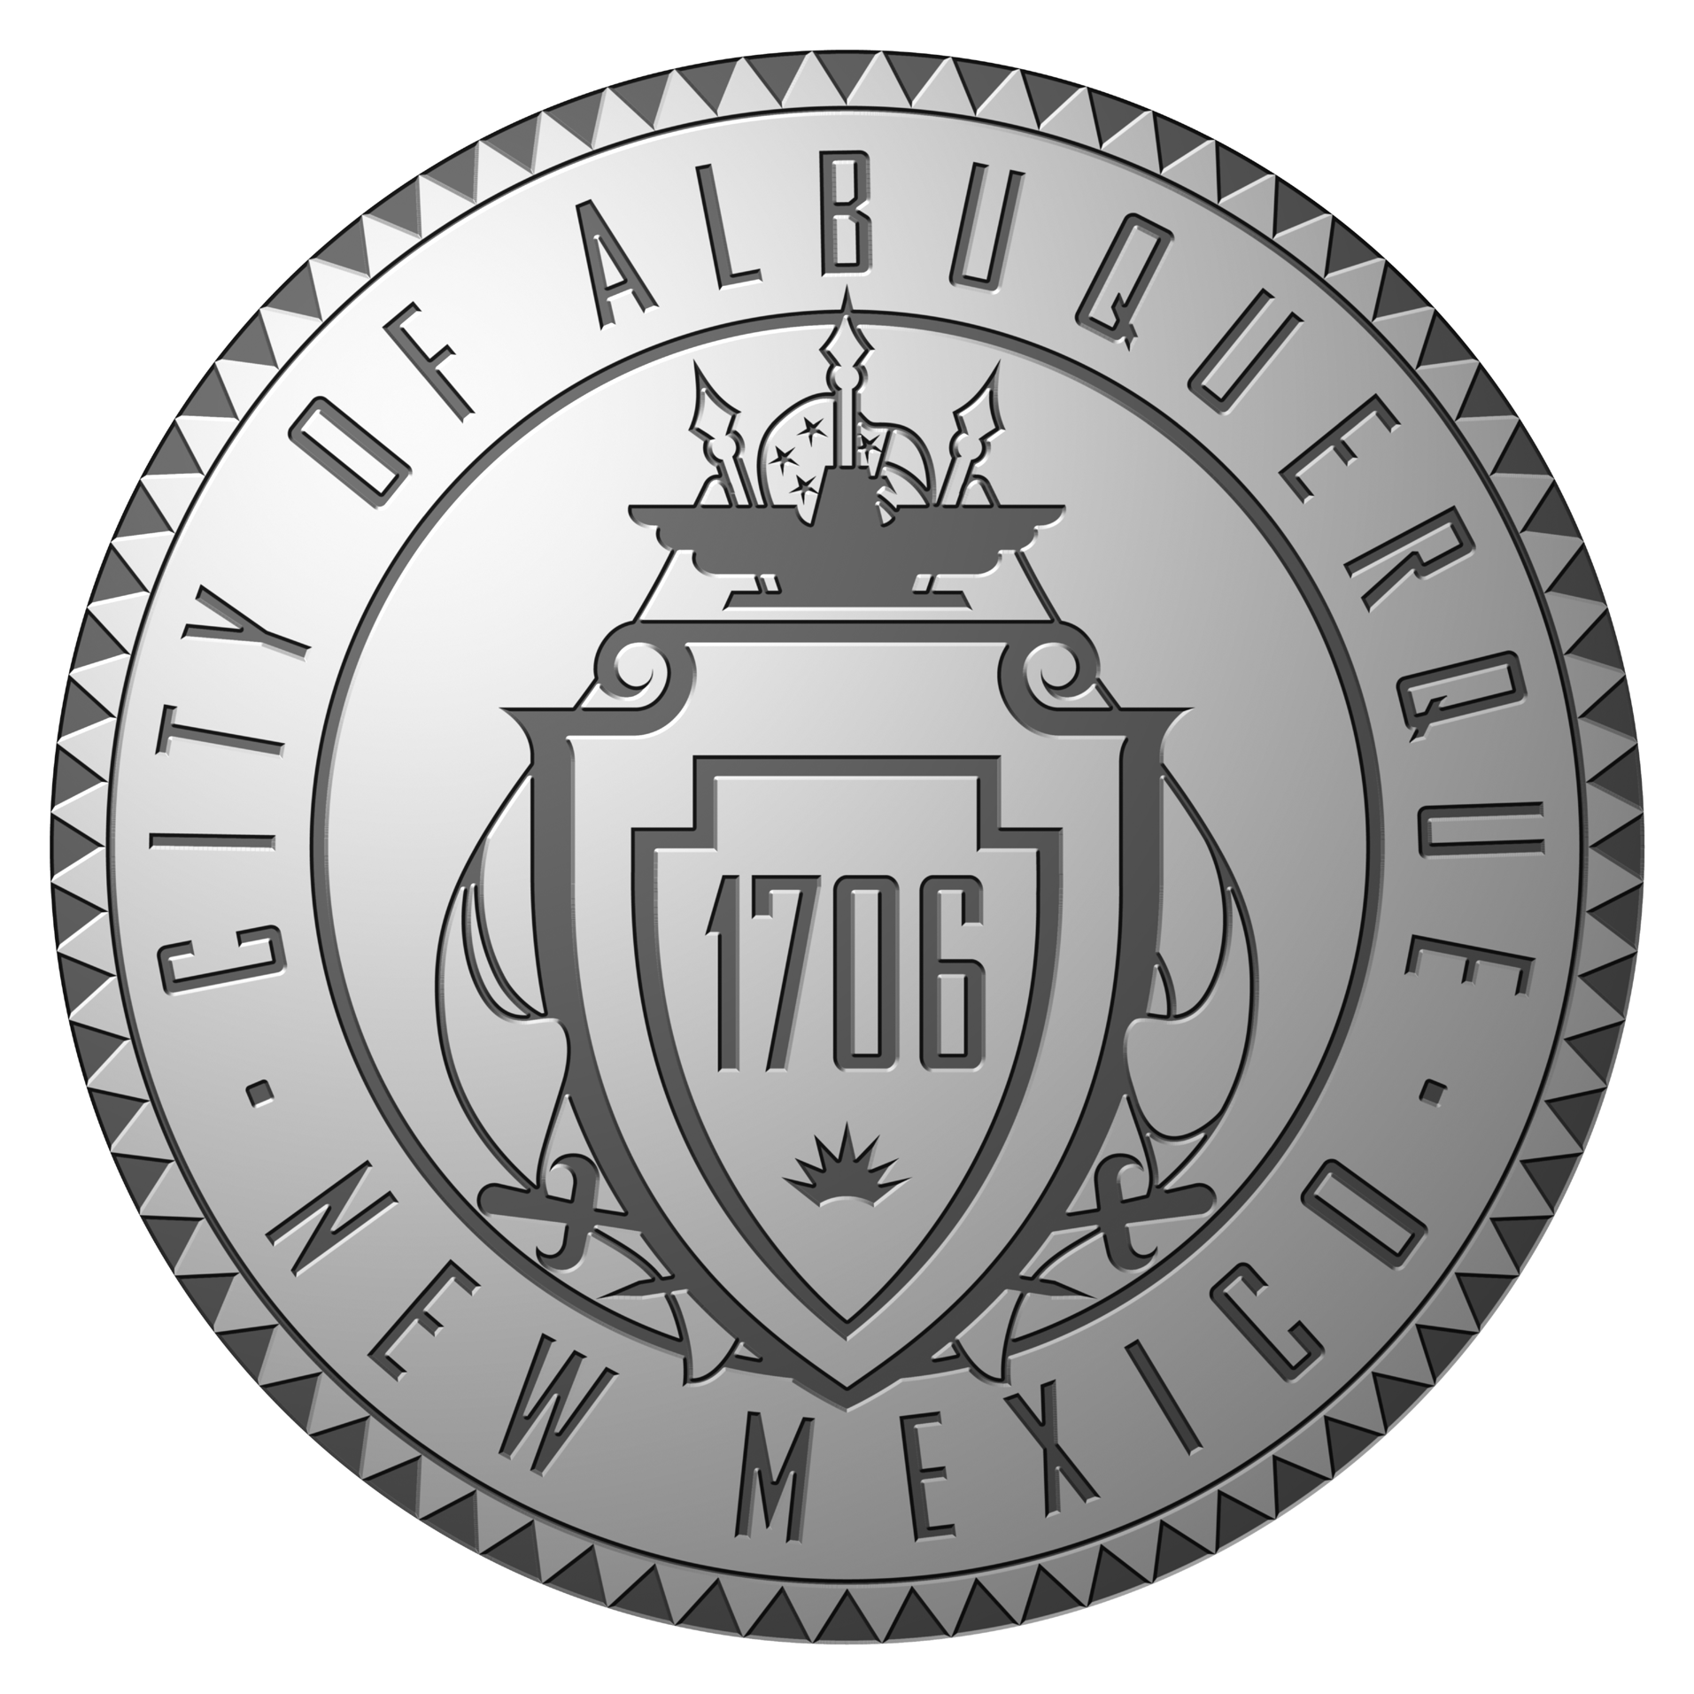
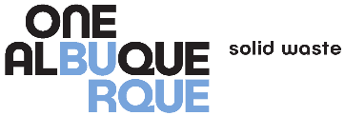

City of Albuquerque

Solid Waste Management Department

Household Hazardous Waste Collection Program
For City of Albuquerque/Bernalillo County Residents
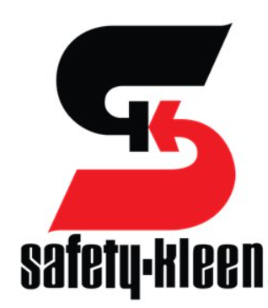
2720 Girard Blvd. NE
Albuquerque, NM 87107

Participation Form
This information is utilized by the City of Albuquerque Landfill Disposal Divisions Department solely for the purpose of gathering demographic information to continuously improve the services it provides to you.
Date: March 30, 2024
Name: | Phone:
Address (No PO Box):
Resident of City of Albuquerque: Bernalillo County: |  | Zip Code:

How did you hear about this event: _____________________________________?

What did you bring in for disposal? Please answer in the section below:
Check for Yes
Latex Water Based Paints
Oil Based Paints, Finishes, and Stains
Flammable Solvents and Fuels
Aerosol Spray Cans
Pesticides, Herbicides, and Poisons
Automotive Antifreeze
Automotive Oils
Corrosives, Cleaners, and Photographic Chemicals
Automotive and Motorcycle Batteries
Oxidizers, Fertilizers, and Pool Chemicals
Batteries
Fluorescent Bulbs (Please indicate if 4 foot, 8 foot, or other and quantity of each)
I certify that I am a resident of Bernalillo County and that the materials I am bringing in for reuse, recycling, and/or ultimate disposal are not biomedical, radioactive, pyrophoric (spontaneously reactive when in contact with air), or explosive materials. I further certify that these materials are exactly what I have described them to be on this form:

Signature: ________________________________________________

