City of Albuquerque

Solid Waste Management Department

Household Hazardous Waste Collection Program

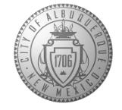

**Participation Form**

This information is used exclusively by the City of Albuquerque Solid Waste Department to collect demographic data, helping to continually enhance the services it offers you.

|  |  |
| --- | --- |
| Date: **May 31, 2025** | |
| Resident of City of Albuquerque: Bernalillo County: | Zip Code: |

How did you hear about this event? _____________________________________

What did you bring for disposal? Please check all that apply:

Check for Yes Quantity:

|  |  |  |
| --- | --- | --- |
| Latex Water Based Paints |  |  |
| Oil Based Paints, Finishes, and Stains |  |  |
| Flammable Solvents and Fuels |  |  |
| Aerosol Spray Cans |  |  |
| Pesticides, Herbicides, and Poisons |  |  |
| Automotive Antifreeze |  |  |
| Automotive Oils |  |  |
| Corrosives, Cleaners, and Photographic Chemicals |  |  |
| Automotive and Motorcycle Batteries |  |  |
| Oxidizers, Fertilizers, and Pool Chemicals |  |  |
| Batteries |  |  |
| Fluorescent Bulbs |  |  |
| Other – Please describe: |  |  |

I confirm that the items I’m bringing for reuse, recycling, or disposal are not biomedical, radioactive, explosive, or materials that react when exposed to air. I also confirm that I’ve described them truthfully on this form.

**Signature: ________________________________________________**

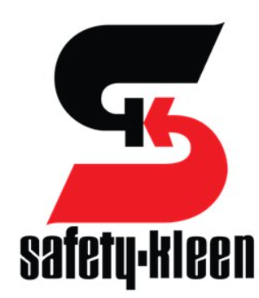

2720 Girard Blvd. NE

Albuquerque, NM 87107