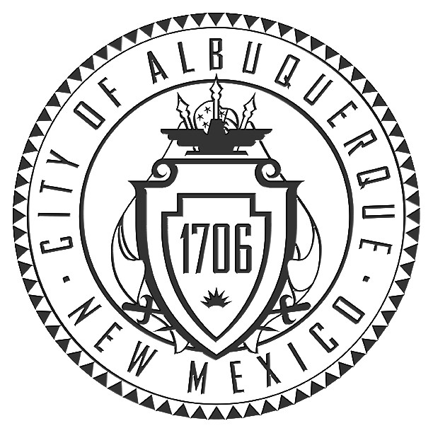

City of Albuquerque
Department of Senior Affairs
Manzano Mesa Multigenerational Center
510 Elizabeth SE Albuquerque, NM 87123

Martin J. Chávez, Mayor Winston Brooks, Superintendent
City of Albuquerque Albuquerque Public Schools

December 10, 2008

Dear Educators,

We invite you to participate in the twenty-seventh annual “A Senior Citizen I Know” Essay Contest. The contest is designed to celebrate Older Americans month in May. All elementary school children, grades one through five, are invited to write an essay about a senior citizen that they know. The contest promotes understanding and appreciation between generations. This is a wonderful way to incorporate good writing skills into your curriculum.

The 'Senior Citizen I Know Essay Contest' supports Language Arts standards in Strand III for grades 1-5 in Writing Strategies, Conventions and Applications.

Please make copies of the enclosed rules and distribute to your grade level chairpersons. The deadline for entries in this year’s contest is February 11, 2009. Thirty citywide winners will be selected to receive awards at our annual awards ceremony and reception held on Thursday, May 7, 2009.

Good Luck to each of you in having one of the thirty winning essays.

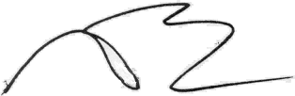

Martin J. Chávez, Mayor Winston Brooks
City of Albuquerque APS Superintendent

City of Albuquerque
Department of Senior Affairs
Manzano Mesa Multigenerational Center
510 Elizabeth SE Albuquerque, NM 87123

Martin J. Chávez, Mayor Winston Brooks, Superintendent
City of Albuquerque Albuquerque Public Schools

December 10, 2008

Attention: Grade Level Chairperson

As part of the Older Americans’ Month celebration during May, Albuquerque Public Schools and the Department of Senior Affairs are conducting the Twenty-seventh Annual Essay Contest for first through fifth grade students only. The topic of the essay is “A Senior Citizen I Know.”

The “Senior Citizen I Know Essay Contest” supports Language Arts standards in Strand III for grades
1 -5 in Writing Strategies, Conventions and Applications.

The purpose of this contest is to promote positive relationships between elementary school students and senior citizens. Each student who enters the contest will receive a Certificate of Participation and a coupon from McDonald’s Restaurants. I hope that you will encourage your teachers and students to participate in this intergenerational activity. (Please copy and distribute this information to teachers at your grade level.)

Listed below are the rules, selection process and judging criteria for the contest.

RULES: All rules must be followed or essays will be DISQUALIFIED!

- All essays must be the original work of the student.

- Essays may be up to 300 words in length.

- Essays may be typed or hand-written on the Official Entry Form (one sided)

- The first page must list the child’s:

Name

Grade
Age
Boy or Girl
Teacher
School
Title of Essay (“A Senior Citizen I Know” is the subject)

- The original essays will be scanned and complied into a booklet.

- Essays written in a foreign language must also submit a translated English copy.

SELECTION PROCESS:

- Preliminary judging will be the responsibility of each school.

- Each grade level is to be judged separately.

- Suggestions for judges at each school include: PTA members, UNM students, senior citizens, and non participating teachers and/or students.

- Essays from one boy and one girl in each grade will be selected at each school.
A total of ten winning essays (two per grade level) from each school are to be sent to Gay Blech, LBJ Middle School, 6811 Taylor Ranch Rd NW, Albuquerque, NM 87120, by Wednesday, February 11, 2009. A note must accompany the entries stating the total number of students who wrote essays for the contest. Based on the numbers submitted, the appropriate number of Certificates of Participation and McDonald’s coupons will be forwarded to each school by May.

- A panel of judges will select the 30 city winners.

- Selected winning essays will be on display throughout the city and will also be published in a booklet.

JUDGING CRITERIA:

- The message about the senior citizen should be clear.
- The impact of the message should be appealing.
- The contest rules must be followed.
- The essay should demonstrate skills appropriate for the grade level.

Thirty city winners will be chosen from APS, private schools, and home schooled students in Albuquerque. The winners and their families will be invited to an awards reception sponsored by Lovelace Senior Plan on Thursday, May 7, 2009 at 4:30pm Manzano Mesa Multigenerational Center. Each winner will receive a gift from Wells Fargo Bank, a pass to Cliff’s Amusement Park, and a Certificate of Award from Mayor Chávez and Superintendent Winston Brooks. Teachers and principals of the winning students will also be recognized on that date.

If you have any questions or need additional information regarding the contest, please contact Department of Senior Affairs’ Contest Coordinator, Angelina Poulin, apouling@cabq.gov or 275-8731; Assistant Coordinator, Corinne Elwell, celwell@cabq.gov or 291-6211.

Sincerely,

Angelina Poulin, Contest Coordinator Rigo Chavez.
Department of Senior Affairs Community Relations Office
City of Albuquerque Albuquerque Public Schools

