Mental Health Response Advisory Committee (MHRAC)
Meeting Minutes
September 20, 2022
Via Zoom

Board Members in Attendance
Rachel Biggs Albuquerque Health Care for the Homeless
Max Kauffman Disability Right of New Mexico
Paula Burton NAMI Peer Representative
Emily Jaramillo Albuquerque Fire Department
Mariela Ruiz-Angel Albuquerque Community Safety
Mary Perez UNM Psychiatry & Behavioral Sciences
David Ley New Mexico Solutions
Gilbert Ramirez CABQ-Dept. of Family & Comm. Services
Betty Whiton NAMI
Nils Rosenbaum APD Behavioral Science Services
Laura Nguyen Albuquerque Ambulance

Introduction to MHRAC
The Mental Health Response Advisory Committee (MHRAC) was created by the Court Approved Settlement Agreement (CASA). We’ve been around since day one and have a focus on three areas, resources, and resources being available to access different things within the city that APD and first responders can use as it impacts homelessness and mental health issues. We are also involved in training and policy; training is one of those things we made a tremendous impact on. As far as the training that is offered. Policies are one of those things where the MHRAC is involved with assisting in writing and approving and recommending policy as it relates again to the narrow focus; we think narrow, but sometimes it gets pretty wide-focused on how law enforcement interacts with those experiencing homelessness and those experiencing a mental health crisis.

Roll Call, Max Kauffman
Eleven (11) of the Board Members were present (names listed above)

Welcome first-time guests
Deirdre Ewing
New Executive Director for the Civilian Police Oversight Agency (CPOA).

Amy Miller Bowman
I am with Molina Healthcare

Approval of meeting minutes
1st Motion – Betty Whiton
2nd Motion – David Ley
Minutes from the July meeting were approved

Public Comment (Two minutes per person)
None

Nomination of New Board Members, if any, Rachel/Max
No nominations were made

Albuquerque Community Safety Department update, Jasmine Desiderio & Mariela Angel-Ruiz
- Our information and data are available on the ACS Website
www.cabq.gov/acs/reports
- Since we launched our program we have taken over 15,000 calls for service; of those 15,594 calls, 500 were diverted from APD
- We wanted to provide some type of perspective on how far we've come in the past year. At the bottom, you'll see that we have Portland, San Francisco, and Denver. Those are similar alternative response programs. We have taken more calls for service in less amount of time than those programs that have been implemented in those particular areas across the nation

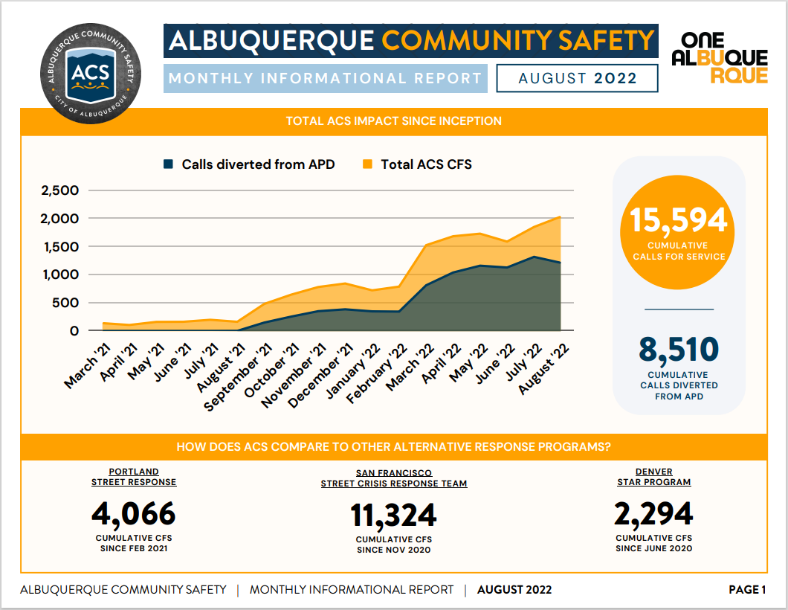

- Also, this is an additional breakdown of where we sit with our numbers as you can still see a lot of our calls. Most of our calls for service include those who are unsheltered. We are taking more welfare checks and wellness checks, especially if they are related to behavioral health issues mental and behavioral health.
Betty
Q. How many Mobile Crisis Teams (MCT) do you have?

Jasmine
A. ACS has licensed Clinicians co-response with APD, specifically the CIU/MCT who are sworn, officers.

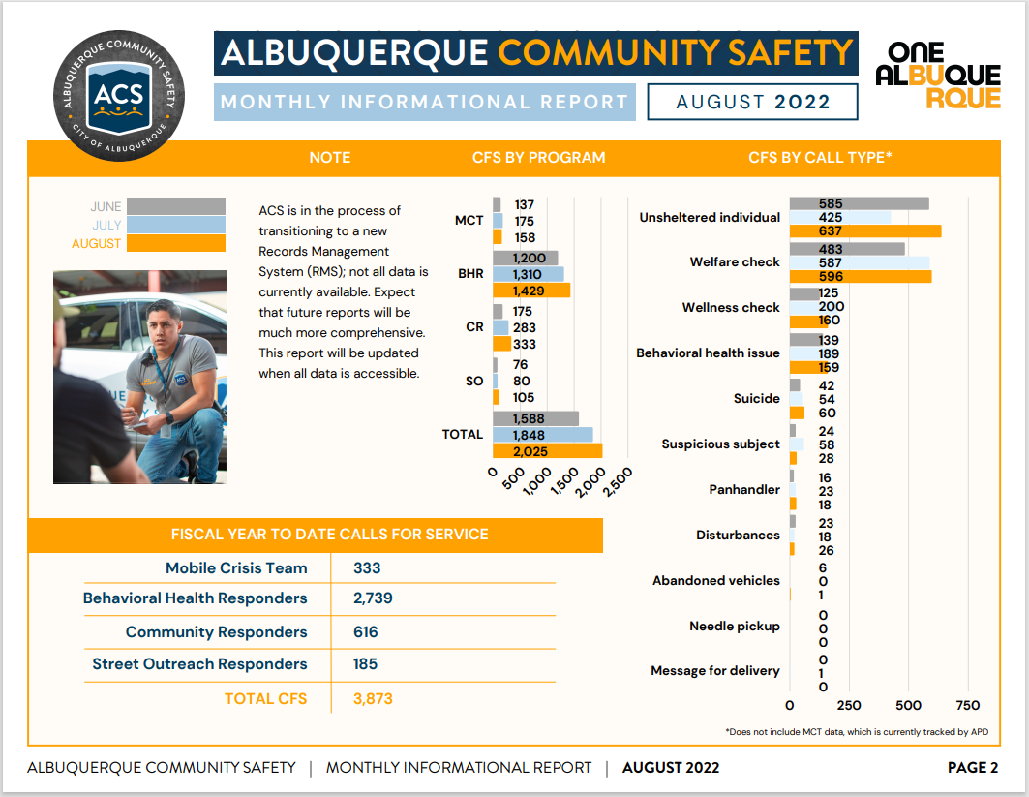

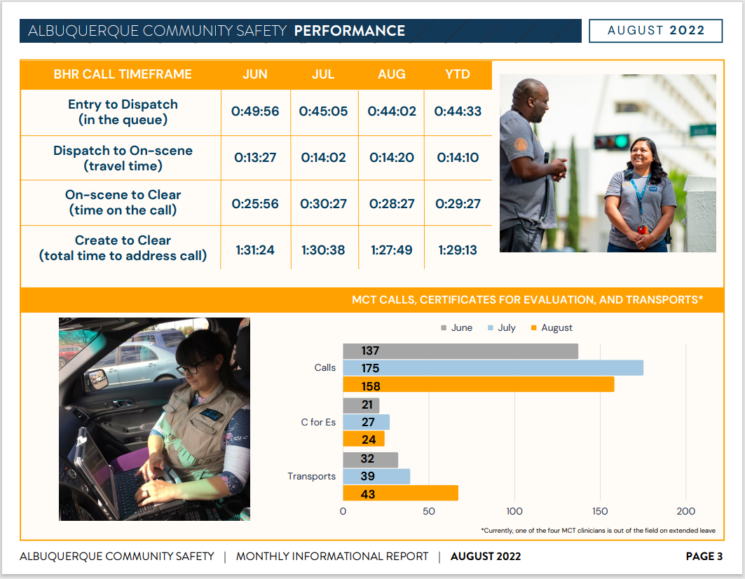
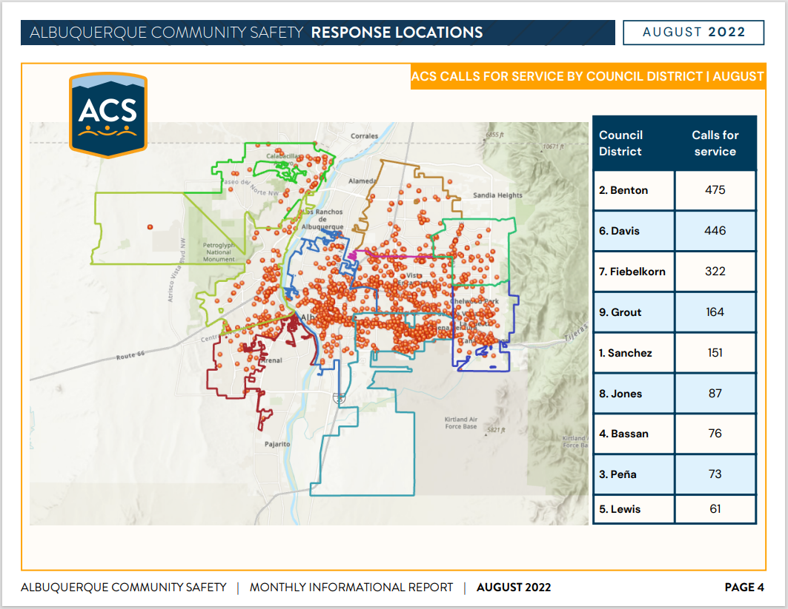

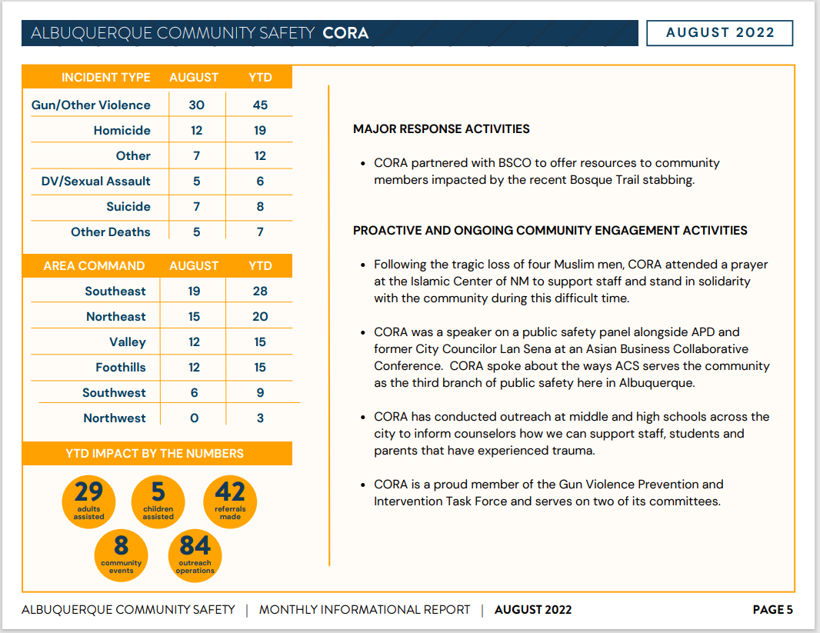
Jasmine
- We take most of our calls in Benton’s District, which is the Downtown area.
- On the last slide, these are calls that CORA takes. So CORA is the closest we'll get to case management. These are the type of calls they've been helping with and being called out by AFR or APD.

Jasmines Updates
- As of September 7, of this year, we have been implemented for one full year.
- We are providing our QPR training for all of our staff

Mariela Updates
- We are getting ready to start with evaluations
- We are bringing on a contractor
- Our Behavioral Health First Responders group is potentially unionizing

Gary Housepian
Q. Does ACS track whether they discovered that they needed to contact law enforcement once they made contact and the reason why?

Mariela
A. Yes, all of that is in the description. So like if ACS gets out to a call that is either high level or they just are needing police, it's all recorded and all of that is tracked through our CAD not just for police but for AFR, we also track if like another outside group may have joined us for anything. All of that's tracked through our CAD system and our databases.
We have a new database, but we're having a hard time right now pulling data so you're still seeing this condensed version; I think once everything gets settled, we'll be able to pull some new numbers.

Mariela
I wanted to clear up some miscommunication or misconceptions; ACS does not have an enforcement branch or an enforcement hand under ACS. We don't do enforcement whatsoever.

If you encounter that situation, we do have enforcers in the city; they do not live under ACS, they live under different departments and their role is to give notices or warnings to individuals that might need to move especially around homelessness and if they are trespassing.

Max
I attended a community-type meeting, at the International District and the discussion was about misdemeanors and the intersectionality of race and disability. ACS was brought up and some of the people attending said APD was refusing to call out ACS. The community feels that there is resistance from APD to bringing in ACS. Someone suggested that maybe the police feel that ACS is taking their job. This is an issue the community is feeling.

Lt. Gonzales
From a police officer’s perspective, we work well with ACS. We call or email each other and bounce things off each other. They have been an amazing resource for APD/CIU. A lot of police are happy about the burden ACS has taken off the field officers.

Max
I don’t get the sense that they felt there were any issues with CIU and ACS; it was about their interactions with non-CIU officers and I can’t say for sure that this is the impression I got from these people at the International District meeting.

Sgt. Tinney
- I review all the cases that come in asking for being assigned and I get so many that they sent to us and ACS or that they mentioned in their police report that they called ACS. The only complaint I hear from officers about ACS is that there's not more available.
- I was also working with our APD Impact Team, they do investigation follow-up. They showed me how they get cases and we were looking at the same system for one month; they get 25 cases and we get 600, so it shows that officers are looking for behavioral health and other options and how to approach it and they’re flagging it and identifying it.

Gibson Health Hub, Family and Community Services, Elizabeth Holguin

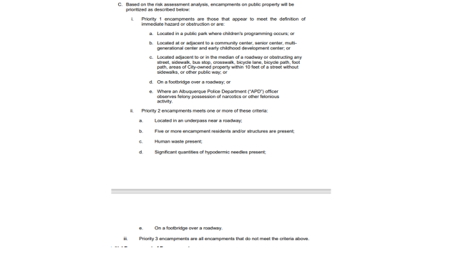

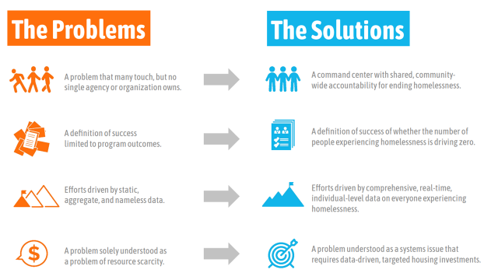

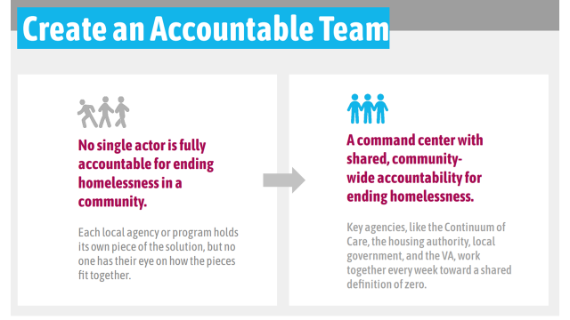
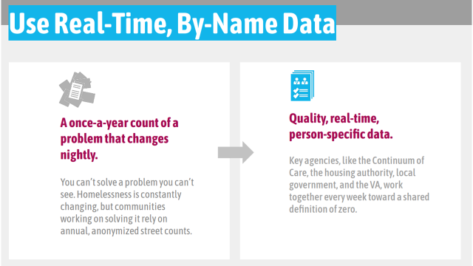
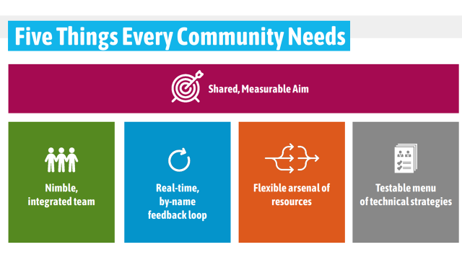
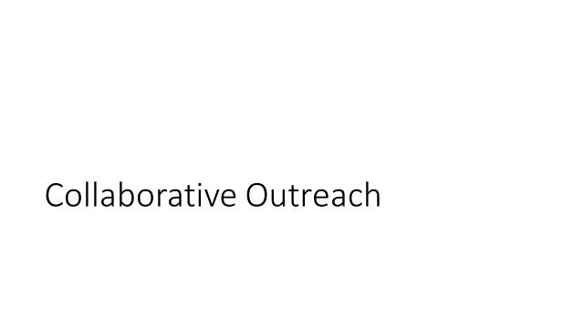
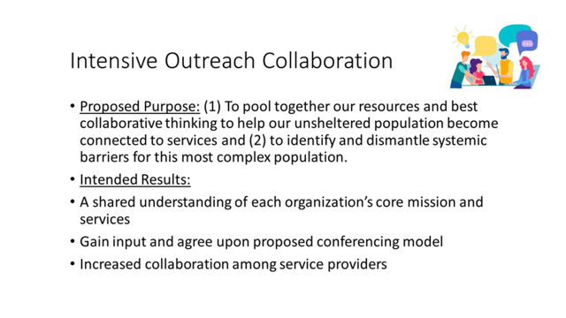
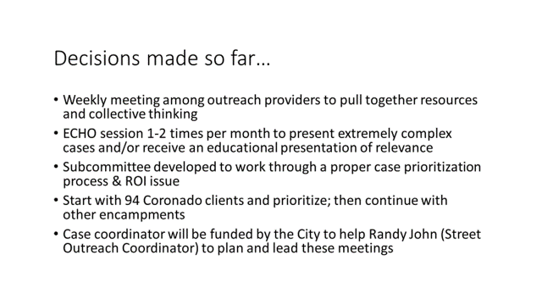
Elizabeth Holguin
A longer version of this presentation will be given Thursday evening at the City Council Chambers.

Elizabeth Holguin
- We are close to purchasing our first hotel to convert into housing units
- We are actively working on leasing some other hotels for the winter just to help people have a place in winter that do not wish to go to shelters

Proposed Policy/Procedure for Certificates of Evaluations
Breeann Rocha, Director of the ACTs Program at New Mexico Solutions
- We also serve Valencia County and Sandoval counties so it’s a little different with their department
- We would fax to just one sub-station and they would dispatch it from there
- Option preferably is to email with encryption instead of just one fax number
- My experience with C for E’s is that they are not consistent
- There is a new process where we get a response via text confirming receipt of C for E or a text saying they are working on it
Lt. Gonzales
- We are teaching the officers that they need to attempt contact with the writers for C for E’s before they go out and try to make contact.
- The fax issue, one of the reasons we changed that is because some would get faxed to substations and just sit there sometimes for hours, sometimes days.
- That was the spirit behind emailing them
Sgt. Tinney
- If a provider faxes it to dispatch it will still get sent out, but if the provider asks an officer directly, the officer will direct the provider to an email.
- There is no state statute in New Mexico saying there is no limit to how long the C for E is, there indefinite, you could write one and it just lasts 10 years until someone's found, but from all the research around the country, most of the certificates for evaluation or court orders only last 72 hours. And so we made some processes to make sure if there's a C for E lastly past that and wasn't able to be served, then it goes to one of the detectives in the crisis intervention unit, who can then work with the provider because this person's difficult to locate or might have a more difficult situation that needs a detective to look at or dedicate the time that's not available to the field. We changed the wording to just APD will look at it, and field officers have 72 hours to respond. And then once that's done, it's going to be up to a detective to either cancel it or reach out to the provider to figure out more.
- What officers are being taught, if they get a new Certificate of Evaluation the first officer should reach out to get more information from the writer of the C for E
DC Brown
SpiderTech is what gets generated for every call for service that will notify the caller that their call has been received and let them know an officer is en route and they are not sitting around having to wait. There is a survey at the end asking how if they were satisfied or dissatisfied with the service.

Changes to the CASA, DOJ, Monitoring, and Self-Monitoring. How will it impact MHRAC?
Max
- There are several paragraphs that have moved into self-monitoring.
- It does not have a direct effect on MHRAC
- The city still has to comply with the Casa even if they're self-monitoring some aspects of it. It doesn't mean that we stopped what we're doing or that we need to change what we're doing.
Elizabeth Martinez
- The city does have to continue to comply and is required to self-assess and will be required under a self-assessment plan that was filed with the court to file its own compliance reports every six months. Those reports will be provided in the draft to DOJ and the monitor before they're filed with the court for us to review and for the monitor, to make comments as he deems appropriate on those paragraphs that are being self-assessed. I believe the self-assessment plan was attached to the notice that was filed with the court and that it was provided to the representatives of the Amici and stakeholders when I sent it out to you all. We can review that with you and we can set up a meeting to review that with you more carefully so that you can then discuss it with your membership.
- The paragraphs that have gone into suspended monitoring and into self-assessment are not the paragraphs that cover the MHRAC and its responsibilities. Those are still being monitored by the independent monitor and independent monitoring team
Lt. Gonzales
I want to reiterate what was just said and also mention that the paragraphs that are going are possibly going into self-monitoring are not the CIU or MHRAC paragraphs. Behavioral Sciences is one of them, but it shouldn't affect the MHRAC at all. I think it's just a process of proving that APD can self-monitor post-settlement agreement.

Elizabeth Martinez
- This is essentially a training period and a part of preparing APD for that process, post-full compliance. So it's actually a very, very positive step in the reform process.
- We look forward to meeting with those of you in MHRAC when we set up a meeting; it is important that folks understand what is going on, and what precisely is covered by the self-assessment suspended monitoring agreement that was reached, and folks should understand that the paragraphs that are going into this suspended monitoring by the independent monitor, and self-assessment by APD are paragraphs that APD and the city have been in full compliance with for more than two years and some of these have been in full and effective compliance for more than five years. So this is really a very, very positive step for APD

CIU, APD, and BSS Report and update, Commander Dietzel
Lt. Gonzales
I just wanted to thank Lisa Chavez for doing such an excellent job; she is our COAST representative. We have been referring a lot of our referrals to ACS which is nice, but Lisa has been handling the whole city for the past few weeks. So we just ask people to be patient with COAST/Lisa.
Sgt. Tinney
- The Coordinators have been doing a lot of training; they have reached out to the Veterans Administration and they’re doing training there today.
- Lisa/COAST is out there busting it.
- Both sides got to go to the CIT International Conference and they presented there plus get more information
- One thing I thought was unique, the US Marshals reached out to us because they had an individual that made a potential threat; they were reaching out to us to look for ways to not prosecute him by getting him into help. They heard about the program and we started working with them to do a threat assessment and get the guy into services. I thought that was very interesting and unique that even federal law enforcement is looking for ways to do jail diversion. We will be having ongoing meetings with federal partners and local law enforcement partners to do threat assessments and threat management.

Sub-Committees Report and update
Training Sub-Committee –
David Ley
No Update

Inforshare Sub-Committee –
Max
Trying to figure out how to coordinate information sharing with FCS and staying abreast with development on responses to chronic homelessness and how MHRAC can be involved.

Rachel
Add Elizabeth Holguin, FCS, and the Encampment Policy to the next agenda

MHRAC Final Discussion (5 minutes)
Gilbert
The upcoming Summit on Fentanyl will be happening on October 12th or 13th. If you are interested in attending please sign-up; it is an in-person event at the Convention Center and there will be free parking. There will be folks speaking from the DA’s office, police providers, policy leaders, and folks who lived experience.

Paula
Reminder for sub-committees, end of year report ready, the Annual Report review of our efforts is coming up

Next meeting: Tuesday, October 18, 2022

