Mental Health Response Advisory Committee (MHRAC)
Meeting Minutes
May 17, 2022
Via Zoom

Board Members in Attendance
Rachel Biggs ABQ. Health Care for the Homeless
Betty Whiton NAMI
David Ley New Mexico Solutions
Gilbert Ramirez CABQ-Dept. of Family & Comm. Services
Laura Nguyen Albuquerque Ambulance
Matt Dietzel APD Crisis Intervention Division
Paula Burton NAMI Peer Representative
Rob Nelson APD/CIU/C.O.A.S.T
Emily Jaramillo Albuquerque Fire Department
Joe Aranda Hopeworks

Introduction to MHRAC
The Mental Health Response Advisory Committee (MHRAC) was created by the Court Approved Settlement Agreement (CASA). We’ve been around since day one and have a focus on three areas, resources, and resources being available to access different things within the city that APD and first responders can use as it impacts homelessness and mental health issues. We are also involved in training and policy; training is one of those things we made a tremendous impact on. As far as the training that is offered. Policies are one of those things where the MHRAC is involved with assisting in writing and approving and recommending policy as it relates again to the narrow focus; we think narrow, but sometimes it gets pretty wide focused on how law enforcement interacts with those experiencing homelessness and those experiencing a mental health crisis.

Roll Call, Max Kauffman
Ten of the Board Members were present (names listed above)

Welcome first-time guests
No new guests

Approval of meeting minutes
1st Motion – David Ley
2nd Motion – Laura Nguyen
Minutes for the March meeting were approved

Public Comment (Two minutes per person)
Rachael Biggs: Introduction of Mary Perez who is a regular attendee and is Chief Nursing Officer for behavioral health at UNM Hospital.

Mary Perez: I think there are things we can be doing better, so, as a representative of UNMH, I want to make sure that we’re doing the best job that we can for the community.
David Ley: Made a comment in reference to UNM’s inconsistency to attend MHRAC meetings and asked Mary if she would be able to be with MHRAC for a while if she is voted onto the committee.

Mary Perez: Mary stated she realizes there has been an inconsistency in UNM attendance to MHRAC and would like to change that and asked to be a part of the panel representing UNMH to try to assist in making needed changes.

Nils: Vouched for the great work Mary is known for and expressed she would be great for the Panel as he knows her to be loyal and will bring that to the panel.

Gilbert Ramirez: Gilbert stated he has had the opportunity to Mary work with Mary on projects related to COVID and feels she would be a great representative to have on the MHRAC Committee.

Nomination of new board members, if any, Rachel/Max
David Ley: Motioned to approve Mary Perez to the Committee
Betty Whiton: 2nd the motion.

Rachael B. Welcomed Mary to the Committee

Albuquerque Community Safety Department update, Jasmine Desiderio
Jasmine Desiderio (Stand in for Mariela Ruiz who is out on vacation): ACS has taken over 8,000 calls from September 2021 to April 2022. She states they have gone live with MARK 43, the records management system, which will enable them to enter outcomes on calls received. ACS has hired new responders who are currently in training and will be active by end of June.

David Ley: Q: If someone has a grievance against ACS or MCT employee, how does that work to file the grievance, and is that something we would be able to hear about in the future so that we have an idea of how things are going?

Jasmine: A: Basically, a lot of the reports management system or complaints would actually follow the same guidance through APD and AFR. We haven’t had any complaints so this is the process that would be new to us should we receive one. We did receive or are able to receive IPRA requests and would also be obliged to follow those. But the complaints itself is probably something we’d have to work on within our own department. And I feel the way APD and AFR receive theirs is online and I’m sure that is something we would be working on.

David Ley: Q: Would it be possible to put on the request for future data elements in your reports and can we get a report if there have been any complaints?

Jasmine: A: We have 0 complaints and will be able to provide any information in the future.

Rachael: Agreed that would be good to get updates.

Emily: One option to file a grievance or give Kudos to any City employee is through 311 then they would route the call to the appropriate Department.

Rachel: The CPOA Website is really easy to navigate if you have a complaint.
Betty: Q: How many teams total have you trained and how many are actually out there working?

Jasmine: A: We currently have nine behavioral health teams out in the field, so 18 individuals are taking actively taking calls. We have some crisis responders in teams of 2 and 14 or 15 individuals currently being trained.

Betty: Q: I have heard that ACS will be serving the County as well, is that correct?

Jasmine: A: Yes, we have been taking calls from the County. We are Citywide, so if those calls come from the Sheriff’s office, we would be hopefully taking those calls as well.

Laura: Q: What is the hours of operation and will that change once the new responders begin working?

Jasmine: A: 7 am to 8 pm 7 days a week. We had planned on going 24 hours but we did not get the funding and were cut in our request for funds.

CHAT: Q: What is the Credentials for the team and do you suspect an impact on credentials with the proposed budget cuts?

Jasmine: A: We can hire folks from very minimal experience and minimal education and those would be our community responders up into our behavioral health responders that require bachelors, or a masters. Our Mobile Crisis Team are independently licensed clinicians and we have licensed social workers.

Gibson Health Hub, Family and Community Services, Cristina Parajon
Three updates:
1st---We have received the applications for the RFP and are still in the process of looking through those to select the organization that will run the Gateway Center. We released 2 scopes—1st scope is for the Gateway Shelter itself, and that’s for phase one which is serving 50 individuals, but when we build out the full Gateway it will be 100 individuals and about 25 families. The 2nd scope is for the first responder drop-off, which is for people of all genders, and will be serving those low acuity individuals and helping to connect them to services.

2nd—The Gateway Center sits within the Gibson Health Hub which has a broad range of other services that are already currently being offered so we have the hospital behavioral health center and substance abuse treatment.

3rd-- We have released the Good Neighborhood Agreement, which is with those five neighborhood associations surrounding the Gibson Health Hub as well as the District 6 President. We will be meeting with them on June 1st to discuss that Good Neighbor Agreement, see what needs to be changed, and talk with the neighborhoods to find out what their needs are for the shelter. We also are very close to completing demolition for the Gateway Center and that includes the first responder drop off. We have also released the Lived Experience Report. The report is with about 23 different individuals experiencing homelessness from Casa Q, the Transgender Resource Center, the Pastor Landries Compassion Center, and First Nations. Those individuals gave us input on what kind of services they wanted inside of their shelter in addition to the architectural and design interior design aspect of the shelter to make it more welcoming. The link will be posted in the chat that describes the way the shelter will be designed.

Laura: Q: Have you solicited any applications to fill some of that extra space from any community partners interested in joining you?

Christina: A: Yes, we do have some contracts pending to be in that space.
Betty: Q: Do you plan to be employing certified peer support workers?

Christina: A: Yes, are contracting with an organization that will be doing the hiring for the Gateway Center. There will be case managers, housing managers, and peer support workers there.

Rachel Biggs: Q: I will ask you, once those RFPs are decided on, and things start to move forward with the SOPs, if there is anything that seems relevant, it would be really helpful to have those come to the info share subcommittee at some point.

Christina: A: Yes, that is what we are planning for the First Responder Drop Off

EMS Transport Guidelines, DC Emily Jaramillo, AFR
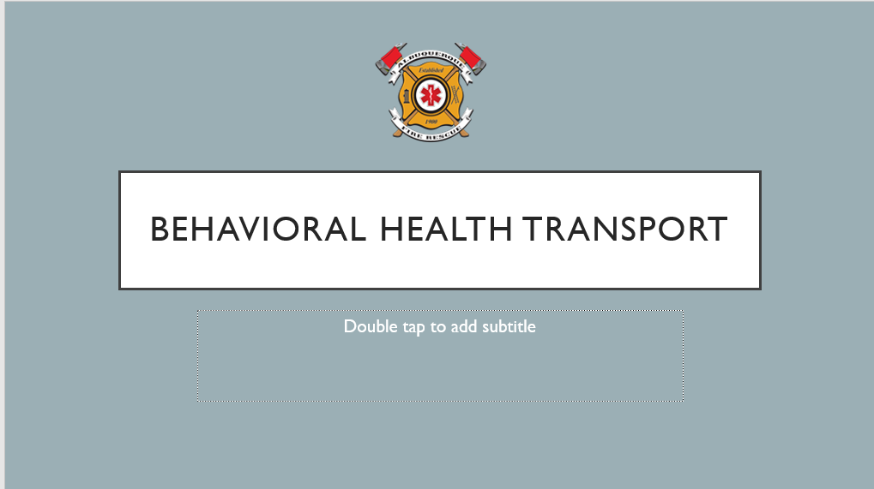

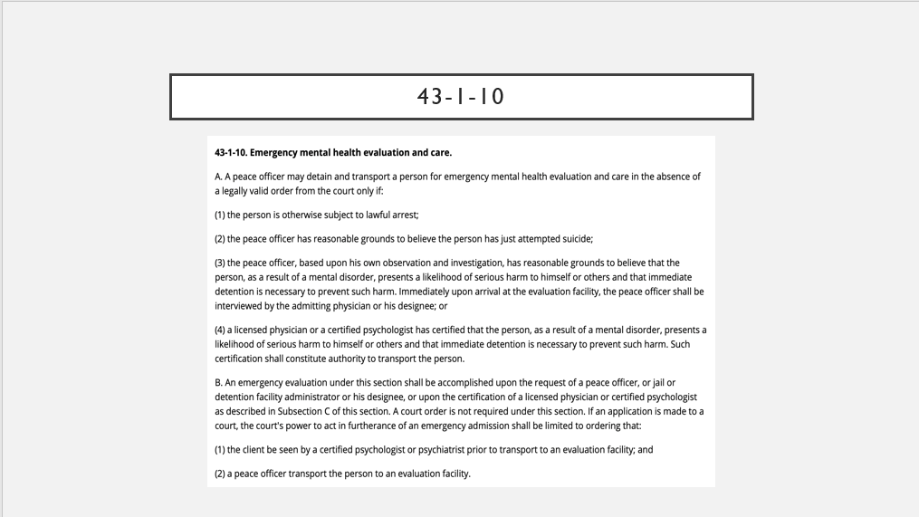

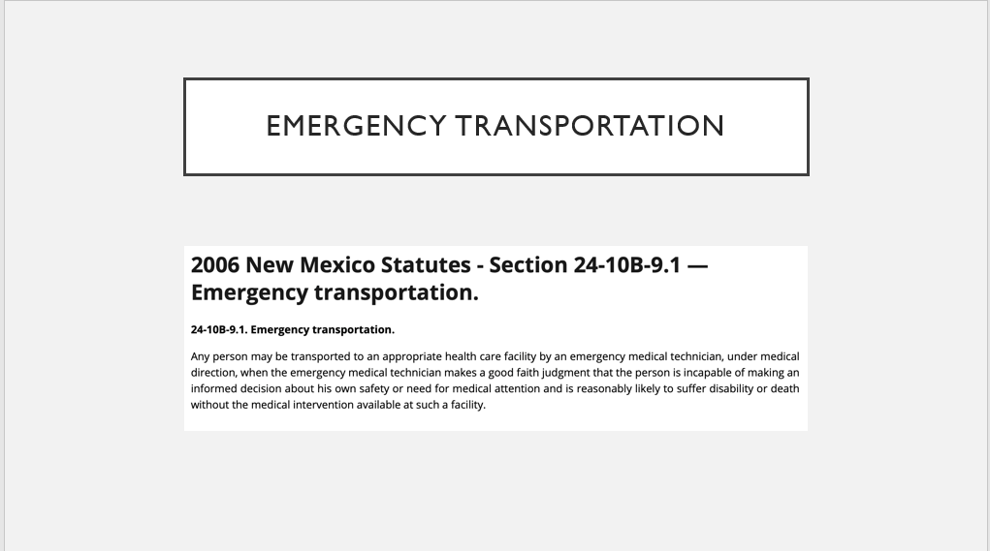

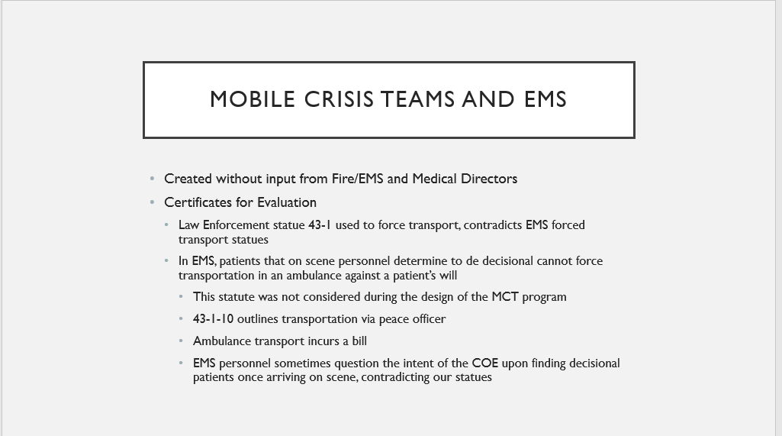

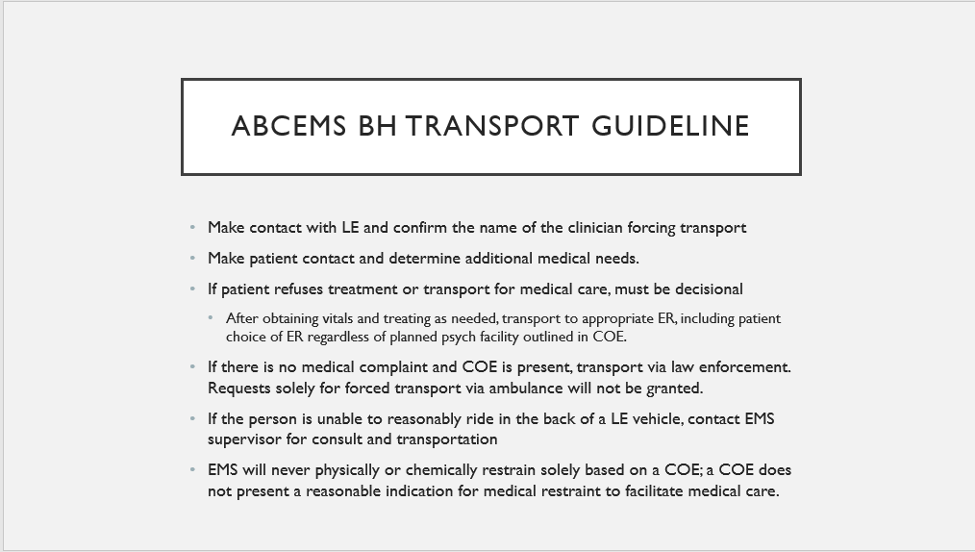

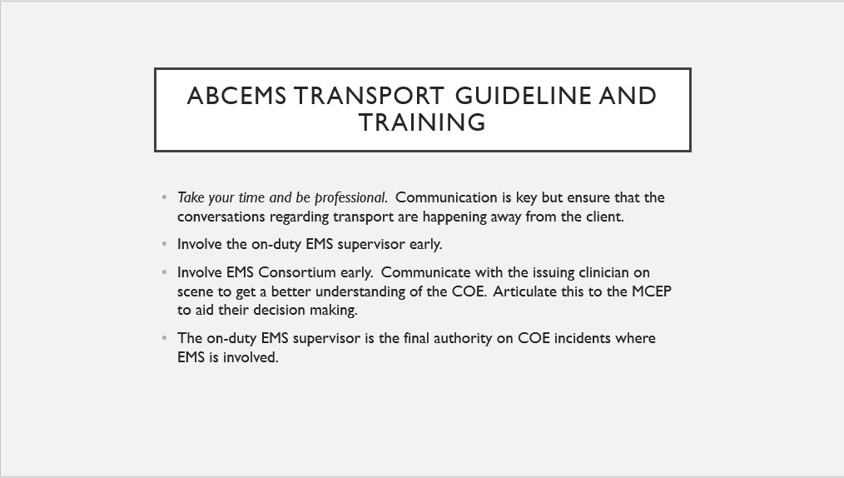

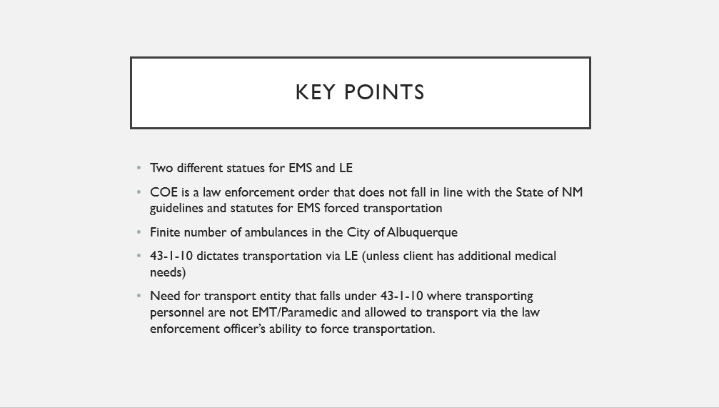

Emily: Pointed out comparisons between APD and AFR Statues on Transportation

APD---can force transportation through the Certificates for Evaluation

AFR—if there is no medical complaint and COE is present, transport via law enforcement

If the patient refuses treatment or transport for medical care and must be decisional

If the person is unable to reasonably ride in the back of a LE vehicle (i.e. Wheelchair-bound, elderly, children 12 and under…), contact EMS Supervisor for consult and Transportation.

Laura: “Sometimes a certificate can be written by a clinician who ideally has a great deal of history with this person and comprehensive knowledge of their situation and their behavioral health needs and any risks to their own or other's health or safety, so I don’t want to create a dynamic in the system where responders on the scene feel, for whatever reason, that the certificate can be disregarded, and that sort of leads me to my next question. So the example you explained where there’s a certificate for evaluation but the person is deemed decisional, are the providers on the scene, reliably explaining to that patient, that while they do have the right to refuse transport by EMS, they are still under that certificate which orders force transport by a peace officer?”

Emily: “I think that’s going to be person dependent. We have some firefighters that will and I’m sure it’s the same for Albuquerque Ambulance that will sit and explain that to the client. I think that this would also be the responsibility of MCT. There should be a clinician there that can also be the intermediary between the two where they can explain that, and it might be better coming from the clinician. But I think that’s a great thing we can add with our firefighters is the explanation that just because you’re denying and not going with us does not mean that you can’t, you’re still going to have to go in with enforcement.”
Laura: “I’m wondering from a training perspective, whether this might be worth developing some training for AFR and everyone in the system to really understand Certificates of Evaluations and the role the clinician plays and better understand each other’s obligations and limitations and the need to clearly communicate with each other”.

Emily: Yes, that is something we do with every CIT class.

Commander Dietzel: “We have been looking at these issues for some time and I think it’s time we should start getting some solutions. APD officers, State Officers, and whoever is there on the scene should be able to delegate their authority to transport-- but we still have that billing issue. We are forcing them to get transported and they have to pay the bill. Maybe it’s time the city starts looking at a contract with the transport authority that operates 24/7 as an ambulance service that we can call to situations like this.

Emily: “I think we need that 4th option and I don’t think just because someone is in a wheelchair or elderly needs to be riding in an ambulance. I think that a comfortable ride in the back of an SUV or a wheelchair-capable van would also provide that need.”

Chief Chris Ortiz (EMS): Reiterated the Statute on transportation in following the patient’s will, however, if a patient makes a statement, in the presence of EMS, “I’m going to kill myself” then EMS’ are bound by their guidelines to transport that patient even involuntarily.

CIU, APD, and BSS Report and update, Commander Dietzel
Commander Dietzel: The monitor report was favorable to APD in terms of overall progress, a good portion of the progress was on the use of force. Crisis Intervention had a couple of paragraphs returned.

CIU has been going out a lot to calls regarding suicidal individuals and some of the calls are from the individual in crisis; the CIU detectives were able to talk them down and prevent a bad outcome.

Mark LeClair: Presented “Hero Resource Bags” The bags are designed for officers who are going to calls for service and encountering someone who is living with autism. The bags contain sunglasses, a fidget spinner, a dry erase board, and a communication board that has pictures to tell the officers if they are angry, sad, hot, cold… This is designed for officers to be able to communicate with the individual and helps to deescalate if the individual is going through a crisis and unable to communicate their stressors.

COAST Update, Rob Nelson
Rob: Announced the changes in COAST call signs 1, 2, and 5 which have made it easier for officers to identify when COAST is out in their area command. The group was informed COAST has resumed going out to outreaches in the various command areas.

Sub-Committees Report and update
Info Share--- Commander Dietzel: This month’s meeting focused on transport issues which were clarified at tonight’s MHRAC meeting

Training Sub-Committee—David Ley: “Our last meeting was at the end of March. We did have a meeting with the folks from ACS at my request and suggestion, just to discuss their training plans. We did have a kind of last-minute discussion with Commander Dietzel about an interesting kind of unique issue that is something that I want to celebrate on behalf of the department. There was a MOE training done by the State about “wandering persons”, there's some term for that. The person in the training video, that is not APD, said that with folks with Alzheimer’s, you should sometimes play along with their delusions in order to get them to comply with you. That’s counter to the person-centered and more informed approach that APD has taken over the past years and commander diesel's team identified that this was not consistent with their current approach, and came to us, talked about it, and developed a plan where they're going to put out a kind of correction through some additional training materials that will go out to the to all the officers. I thought it was cool that the department just kind of self-corrected on this, identified it, raised it, and came up with a solution, and it feels like a positive way for the department and for our collaboration. So you know again, Commander, I just wanted to thank you and praise your department for identifying and seeing this in such a neat way

MHRAC Final Discussion (5 minutes)
Betty: Welcomed Mary Perez

Next meeting: Tuesday, June 21, 2022

