Mental Health Response Advisory Committee (MHRAC)
Meeting Minutes
March 19, 2024
Via Zoom
Board Members in Attendance
Cmdr. M. Dietzel Crisis Intervention Division
Dr. Nicole Duranceaux APD Behavioral Science Services
Betty Whiton NAMI
Mariela Ruiz-Angel /Jodie Esquibel Albuquerque Community Safety
Chief Emily Jaramillo Albuquerque Fire Rescue
Mary Perez UNM Psychiatry & Behavioral Sciences
Robert Salazar Peer Representation
Coty Maxwell Crisis Intervention Division
Dr. David Ley New Mexico Solutions
Paula Burton Peer Representative
Ryan Delaware Albuquerque Health Care for the Homeless
Bernice Varela Crossroads for Women

Introduction to MHRAC
The Mental Health Response Advisory Committee (MHRAC) was created by the Court Approved Settlement Agreement (CASA). We’ve been around since day one and have a focus on three areas, resources, and resources being available to access different things within the city that APD and first responders can use as it impacts homelessness and mental health issues. We are also involved in training and policy; training is one of those things we made a tremendous impact on. As far as the training that is offered. Policies are one of those things where the MHRAC is involved with assisting in writing approving, and recommending policy as it relates again to the narrow focus; we think narrow, but sometimes it gets pretty wide-focused on how law enforcement interacts with those experiencing homelessness and those experiencing a mental health crisis.

Fathom Summary
First Time Guests
Jane Garland of NAMI, Lt. Chandler Houston of APD, Jamie Dautis of YDI, and Lisa Schatz-Vance, City Legal, were welcomed. Jane was nominated and approved to join MHRAC to represent NAMI alongside Betty Whiton.
MHRAC Ordinance Proposal Update
Attorney Andrew Magida presented a draft ordinance to codify MHRAC, soliciting feedback. Key points included nine voting members representing agencies, lived experience requirements, and administrative support from APD. Transitioning from CASA and ensuring independence were priorities.
Community Engagement Team (CET) Update
YDI's Jamie Dautis detailed CET's crisis response services and 40-60 monthly referrals. APD was encouraged to refer appropriately to stabilize clients before higher levels of care. Collaboration between agencies on housing and acute needs was emphasized.
CIU, APD, and BSS Updates
ACS and APD provided updates including ACS's new outreach efforts. CIU's had 450 monthly referrals, and recognition of clinicians Mike Lucero, Josh Isler, and Oakley. A partnership between groups to help those in need was highlighted.

Gibson Health Hub Update aka Gateway Center
Gilbert shared the newly issued RFP for a sobering center operator. Construction is ongoing for a 2024/25 opening. Widespread sharing of the opportunity was encouraged to submit proposals.

MHRAC Final Discussion
Thank you and Farewell to Commander Dietzel and attorney Andrew Magida who were thanked for their long-standing support of MHRAC as they depart from their roles. The continued progress and advocacy on issues of homelessness and behavioral health were celebrated.

Roll call of Board Members, Commander Dietzel
Eleven of fifteen MHRAC Board Members were in attendance.

Welcome First-Time Guests
Lt. Chandler Houston, Albuquerque Police Department Police Academy
He has replaced Lt. Jen Chacon who is back out in the field

Jane Garland, Vice President, NAMI Albuquerque
Was nominated by Betty Whiton as another NAMI representative at the MHRAC meetings.

Jamie Dautis, YDI
I work with YDI; I am affiliated with the Community Engagement Team (CET) and our Street Outreach Program

Lisa Schatz-Vance, City Legal
The new assistant city attorney for the Office of Civil Rights. Lisa will be taking over Andrew Magida's duties related to MHRAC going forward. Her background has been with systemic reform involving individuals with disabilities. I also have familiarity with the issues that the MHRAC has been addressing during its existence.

Approval of Meeting Minutes
1st Motion – David Ley
2nd Motion – No second motion was asked for
Minutes from the February 2024 meeting were approved.

Public Comment (Two minutes per person), David Ley
- There was an article in the paper about a challenging incident of a person in our community who was in an Officer Involved Shooting (OIS) and then took his own life in the process.
- Our committee has established some developing process with APD such that when there are officer-involved shootings that impact homelessness or mental health issues that we work with the department.
- We're able to, because of litigation, to review the incidents and identify any potential policy or training changes related to behavioral health or homelessness that might come out of those incidents.

Nomination of New Board Members, (if any)
- Betty Whiton nominated Jane Garland who is presently the Vice President of the National Alliance on Mental Illness, (NAMI) Albuquerque as an MHRAC Board Member. David Ley 2nd this motion.
- Jane has stepped into Betty’s role as facilitator for NAMI and the Sharing Your Story with Law Enforcement (SYSLE) program.
- Jane not only does all the training with APD CIT but also with other organizations for first responders.
- Jane is extremely hardworking, dependable, and wonderful.
Community Engagement Team (CET), Jamie Dautis
- CET provides short-term crisis intervention and stabilization for children, youth, adults, and their families.
- CET has the staff and the ability to respond to crises and provide referrals to other services, like crisis safety planning, and individual service planning.
- We have a prescriber who does mental health diagnosis and medication management.
- We also do mental health screenings, and our services are available 24 hours a day, 7 days a week.
- We aim to assist in stabilizing clients before the crisis happens so that it does not reach and escalate to the point of hospitalization or a higher level of care.
- If people need a food box, a mental health assessment, or any type of, I want to say housing, (but we are trying to refrain from it). We are trying to get more housing assessments done because housing is a big deal among the homeless; homelessness is a big issue.
- Upon receiving the referral, our intake MIS Coordinator who is designated on call will initiate contact with that individual.
- Contact will be initiated within 24 hours and then designate whether or not we need to dispatch to that individual and not deem the crisis.
- We are not equipped to handle acute care situations at this time nor do we function as a housing provider. We can forward those to other housing agencies like Heading Home, Hopeworks, etc.
- We have two peer support workers on staff right now, and we are seeing anywhere from 40-60 referrals a month.
- Because we are short-term we are only able to meet with the individual four times, but we can stretch it to six or seven if it is a housing situation. If we can, we help them get an ID, Social Security card, Birth Certificate, any type of vital records, or any type of medical help from our prescriber.
- We have not transported anyone to the hospital. We transport them to and from their medical appointments.
- We get the majority of our referrals from the Albuquerque Community Safety (ACS) team.
- We don’t have to do a full intake all the time, we can do brief encounters that consist of a sleeping bag, a hygiene pack, a resource card, or any type of further dialogue or information that they might need to further themselves out of a situation that they are in.

MHRAC Ordinance Update, Andrew Magida and Lisa Schatz-Vance – Lschatzvance@cabq.gov
- I will emphasize that this is a very rough draft and the primary purpose of presenting this information to you is not to tell you what the bill is going to be but to solicit your input and see how you feel about it.
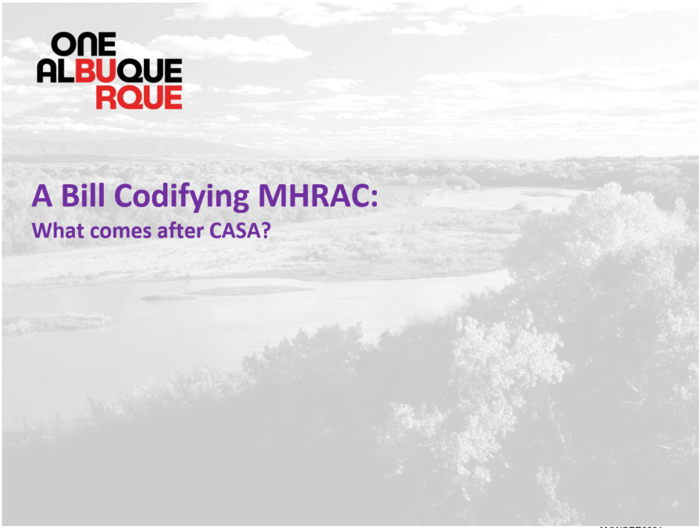
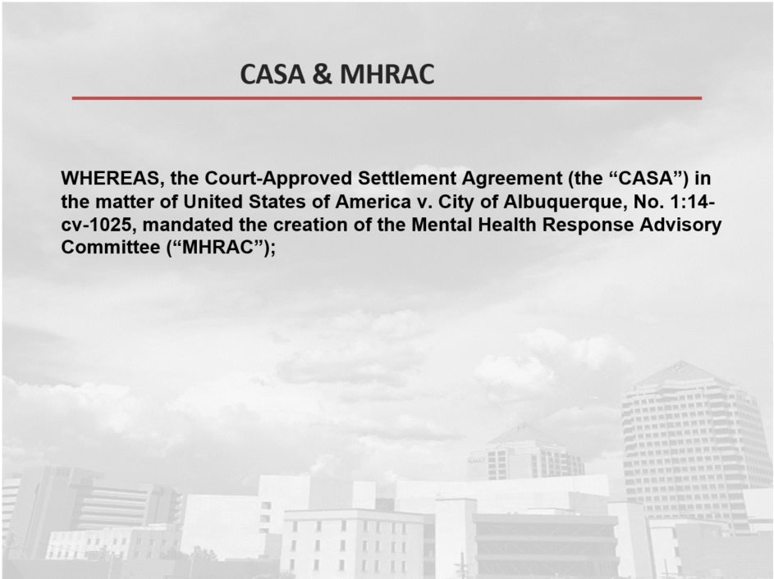
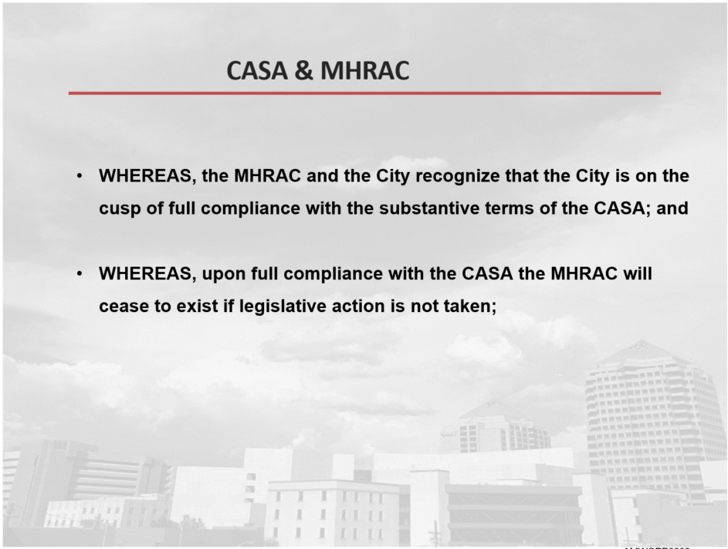
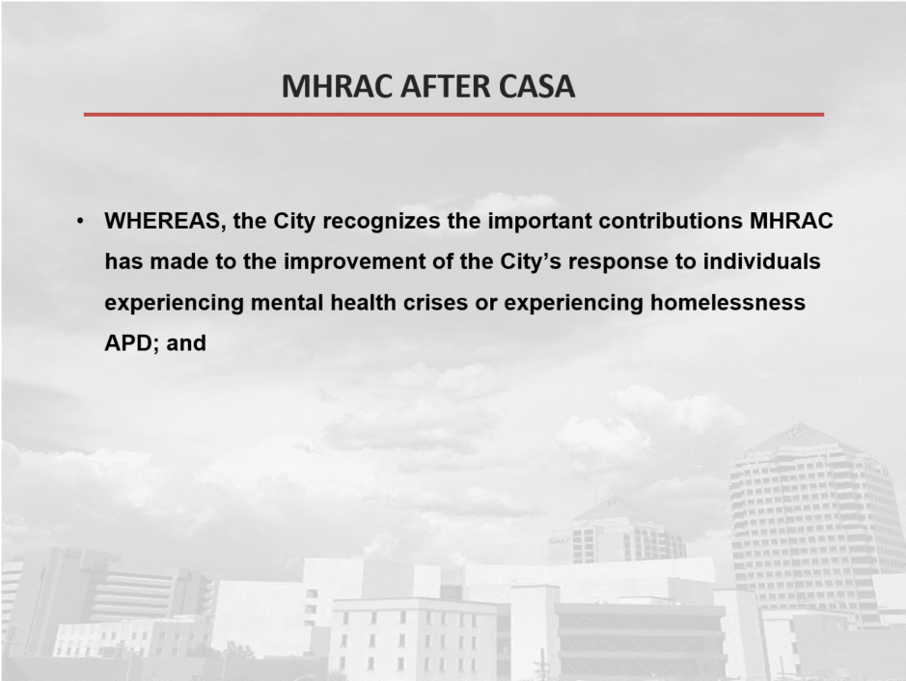
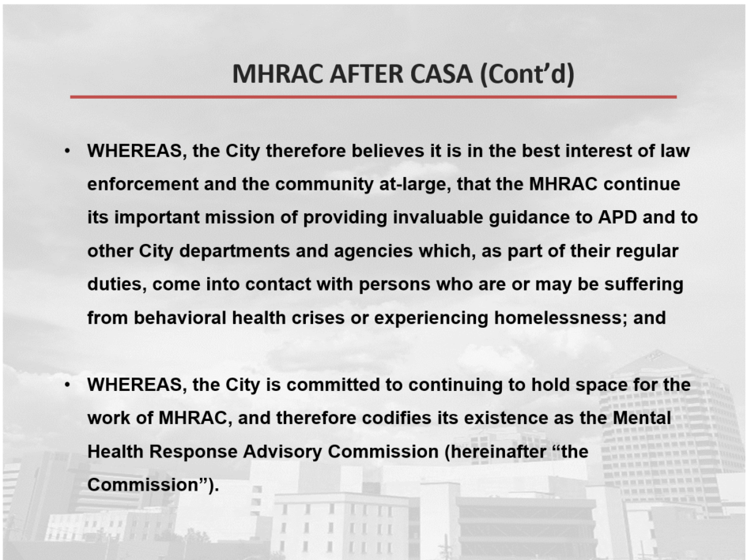
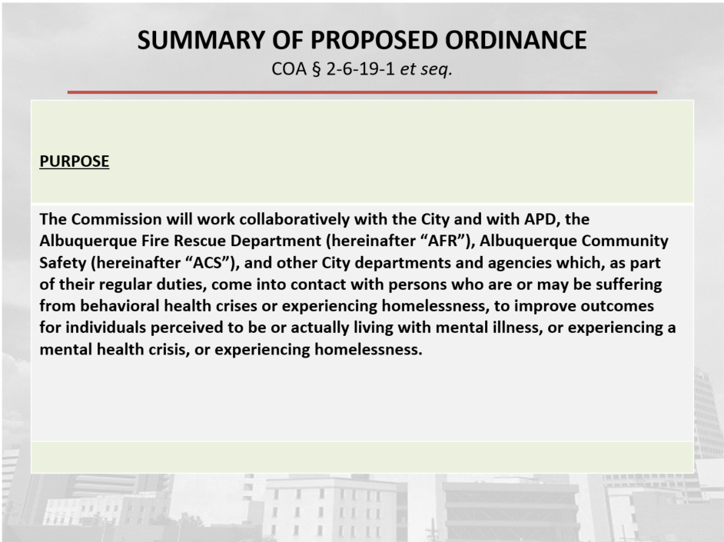
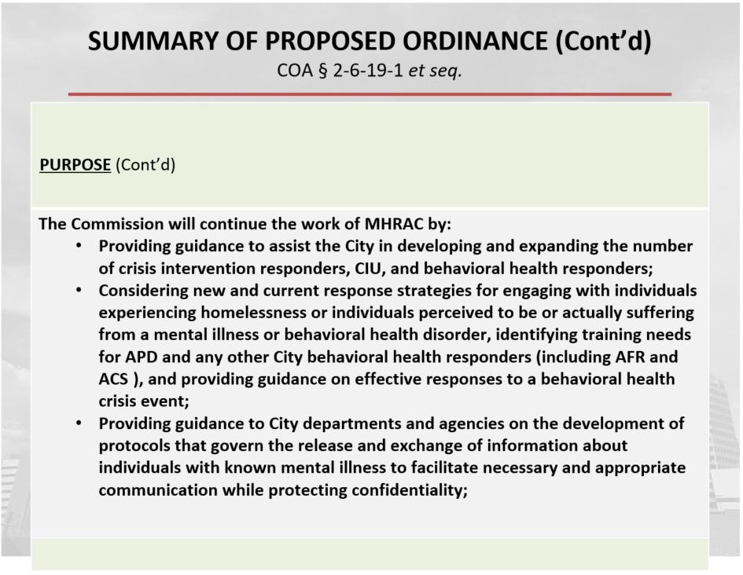
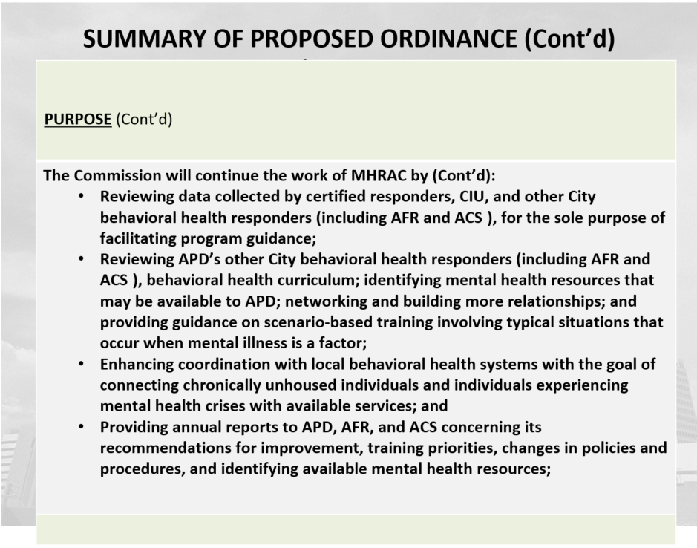
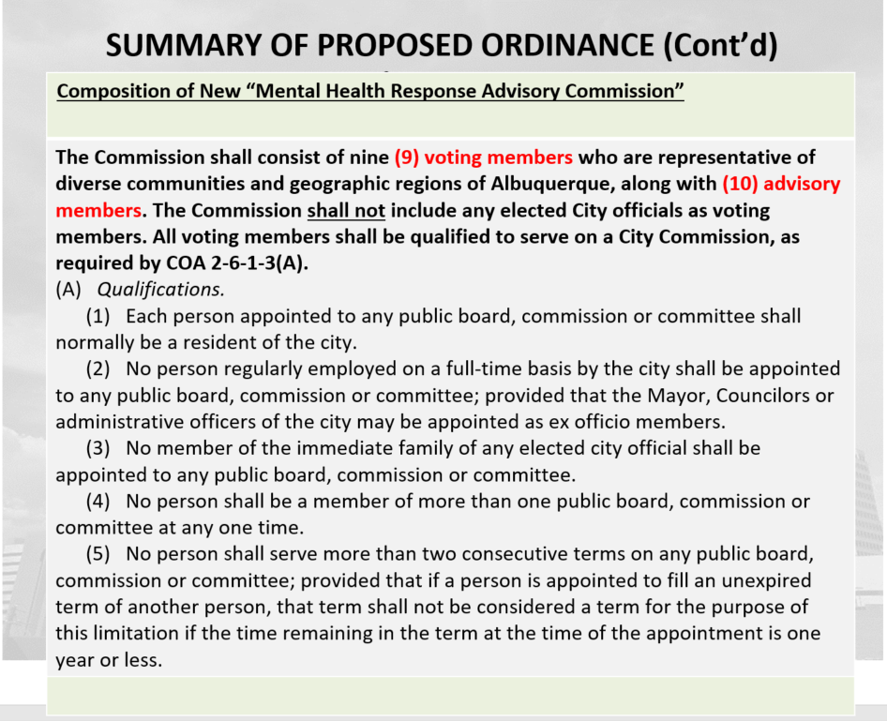
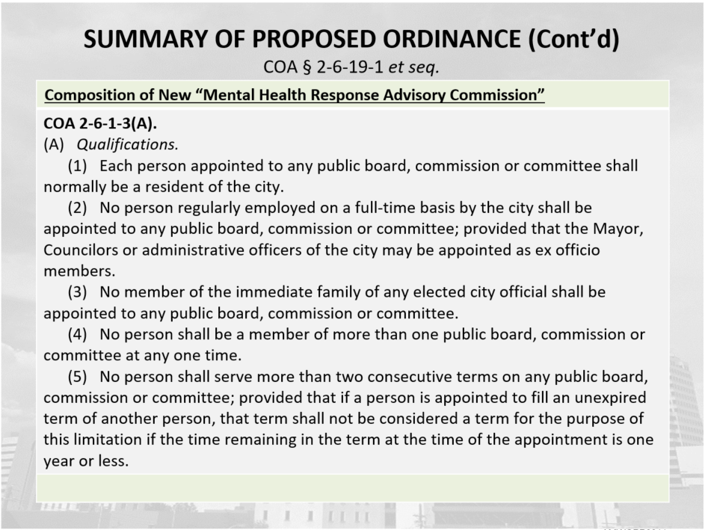
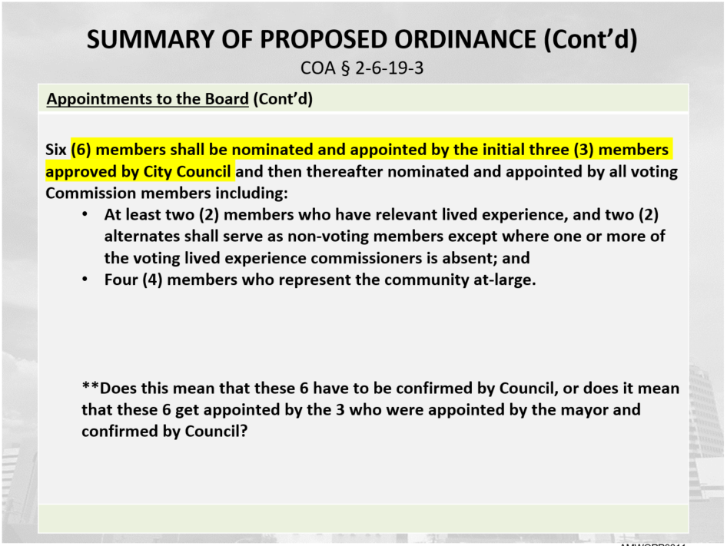
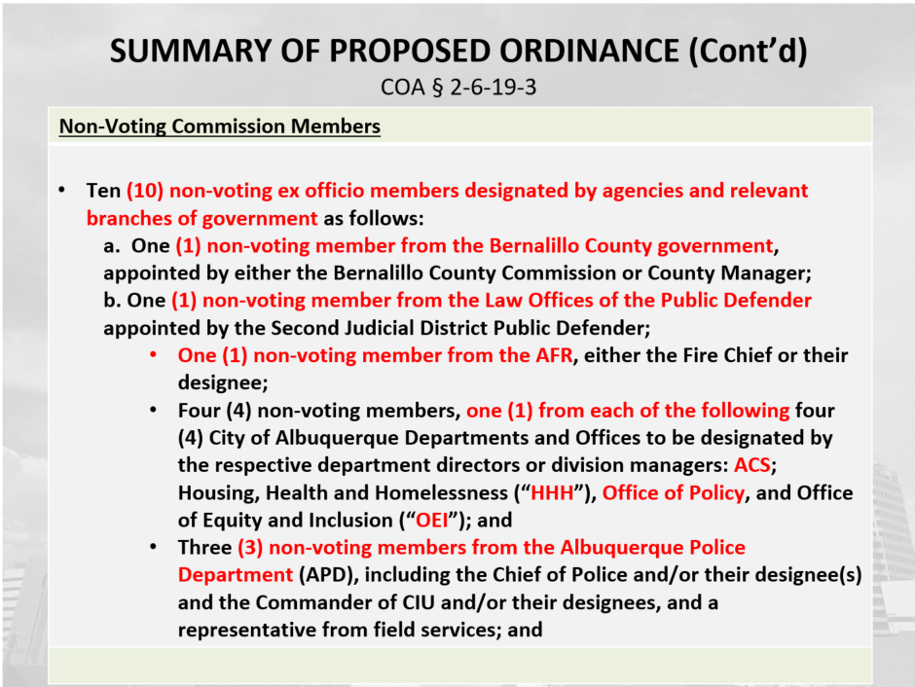
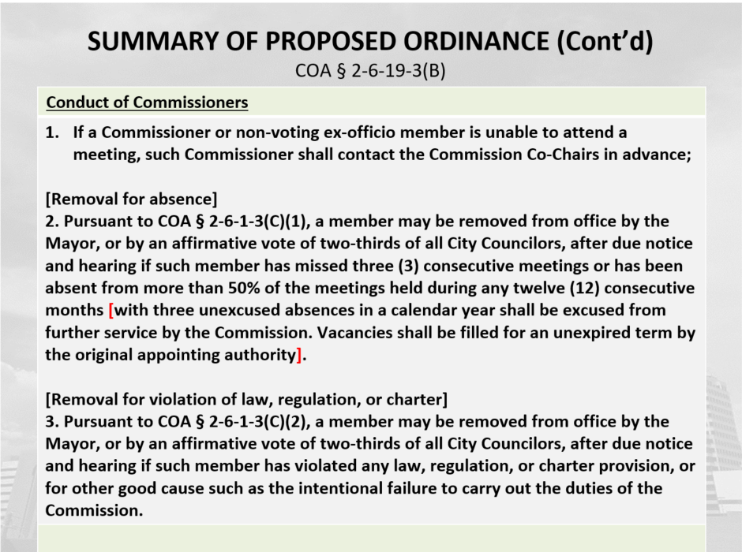
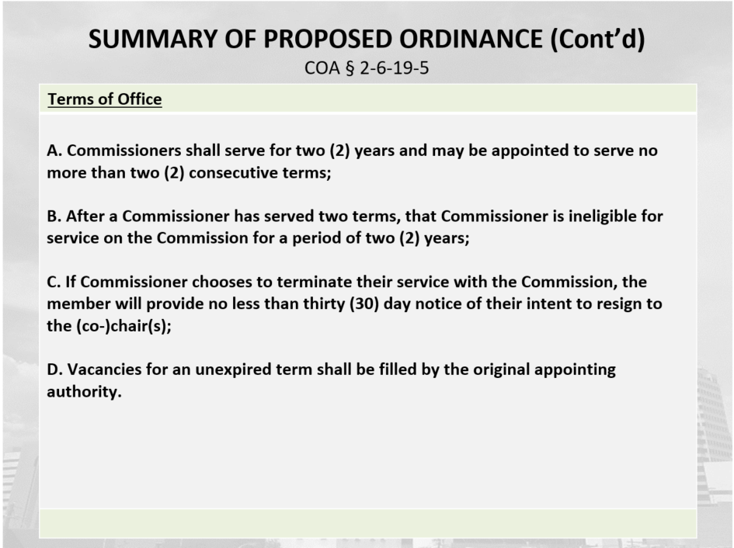
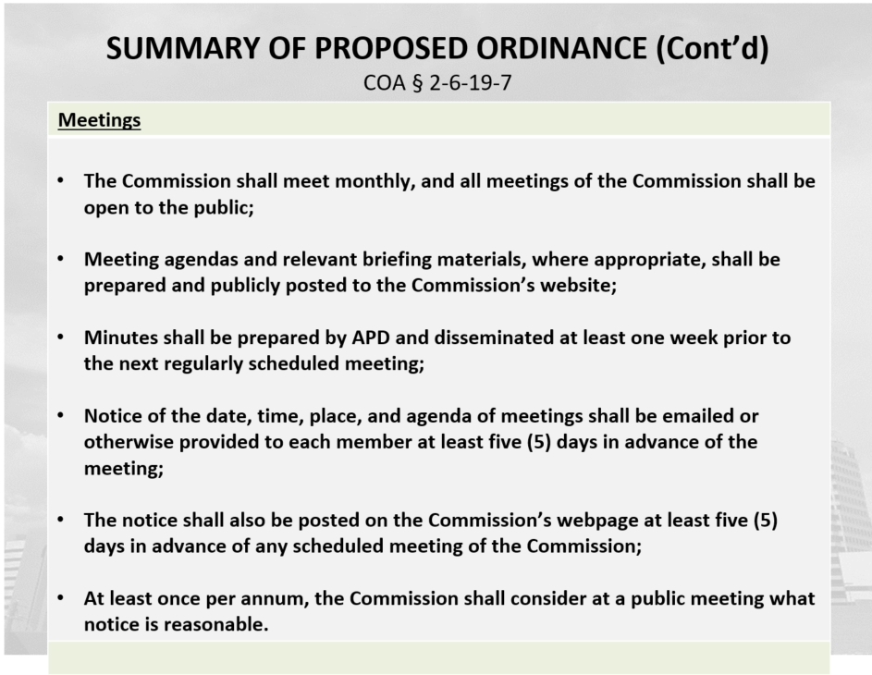
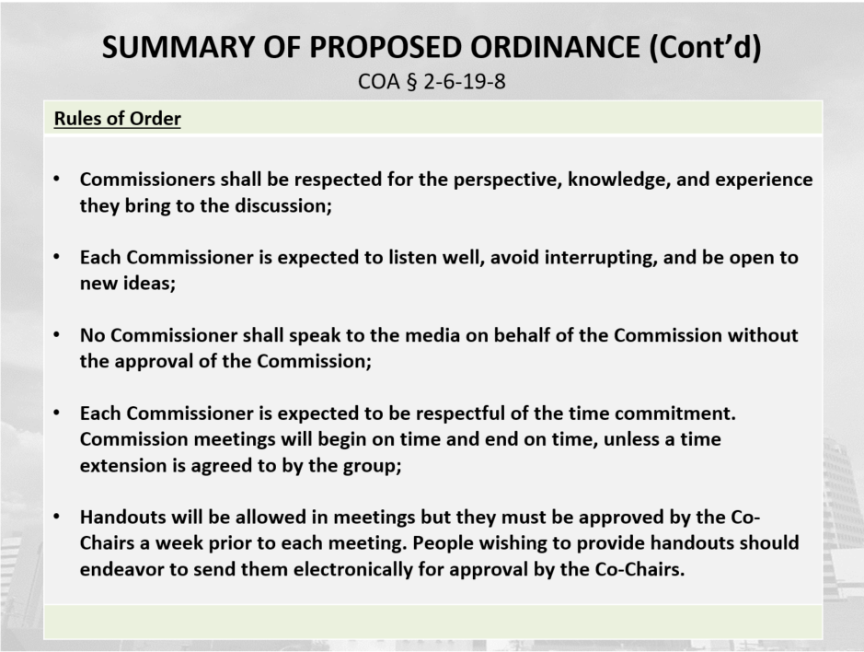
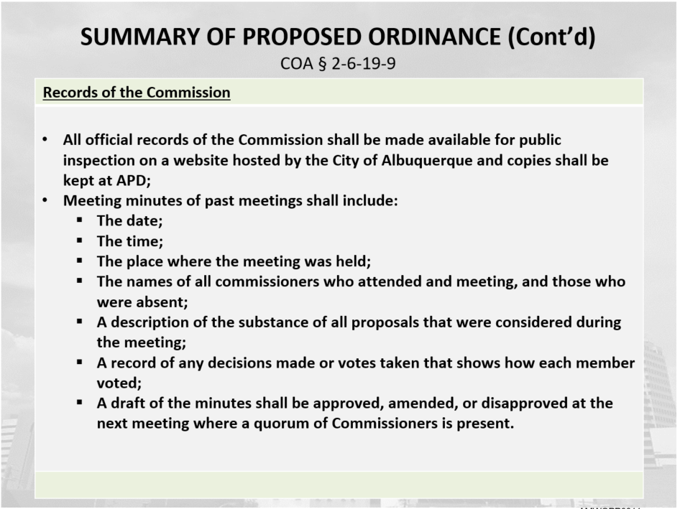
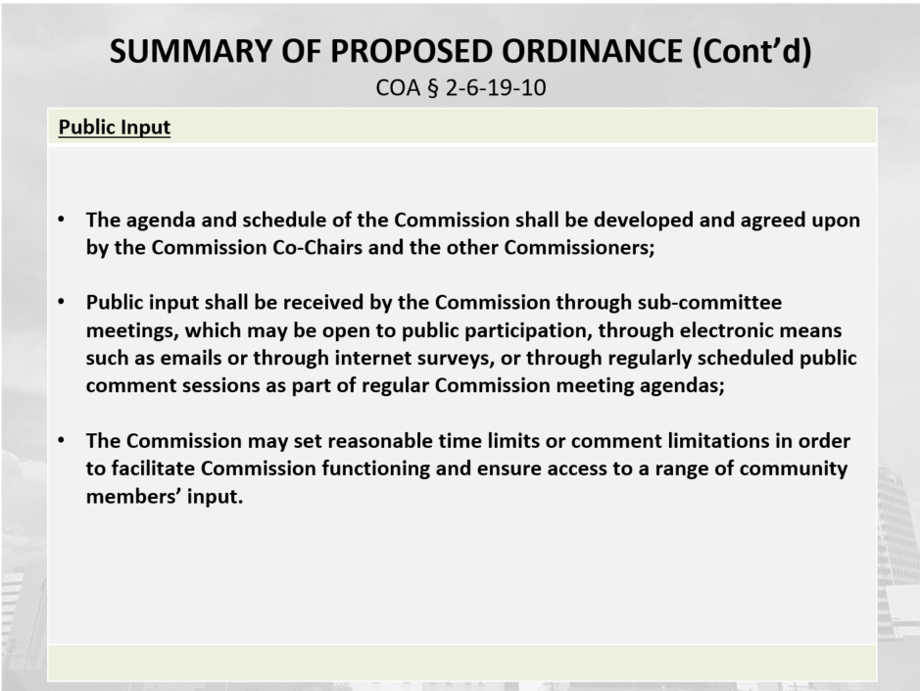
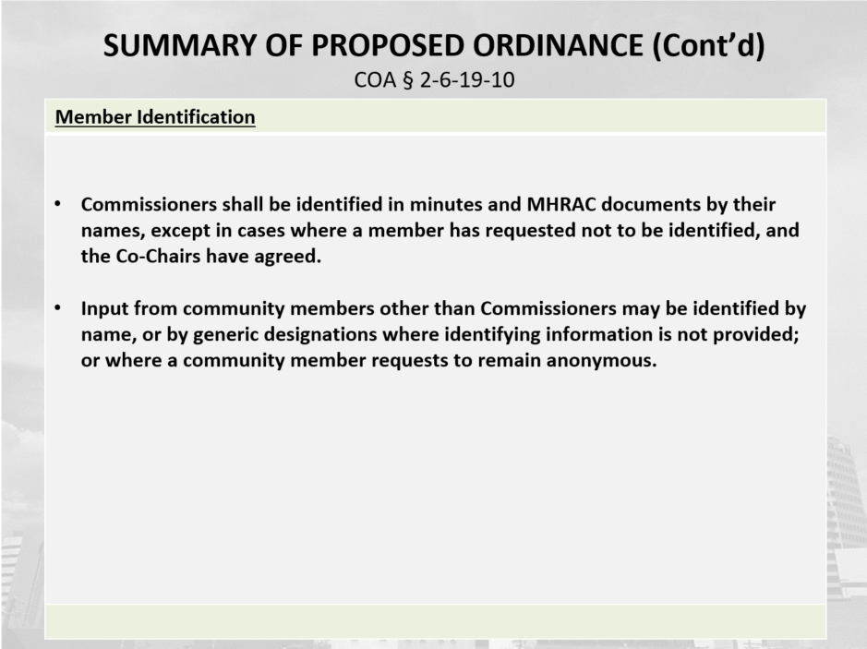
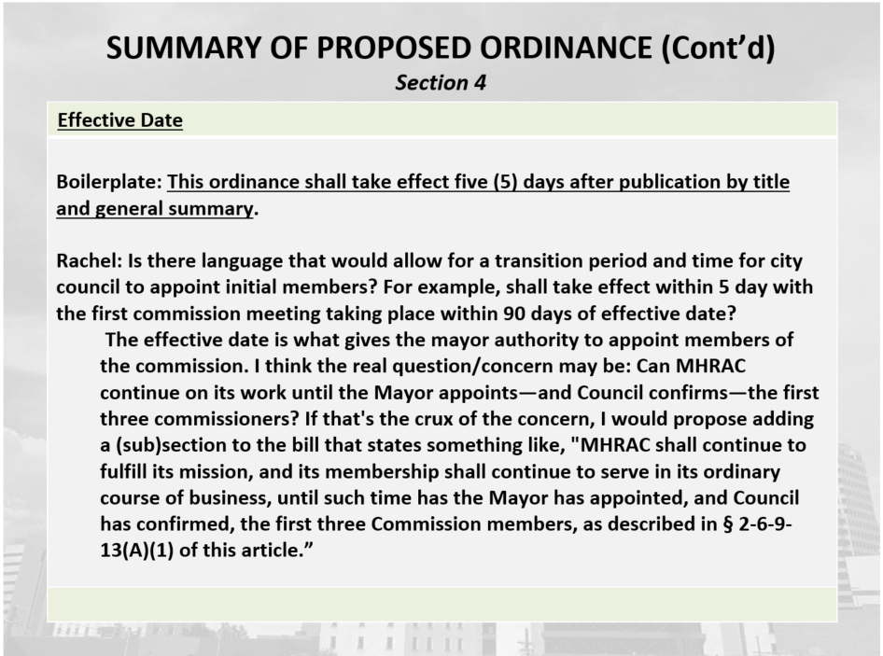

Albuquerque Community Safety Department (ACS) Update, Jodie Esquibel
- We have the new Academy starting.
- ACS is extending the Emergency Transport Service to exhaust the funds of the contract that is existing and in place so it will run during the graveyard shift beyond the end of the month.
- We started little pop-ups for Connect; we are calling it Connected Care. We are doing targeted areas.

Gibson Health Hub, Family and Community Services, Gilbert Ramirez
- Our RFP for the Medical Sobering Center dropped this Sunday with our legal.
- We are looking for a medical provider.
- The new RFP for the Medical Sobering Center Operations was shared so you can find all the information among other information.
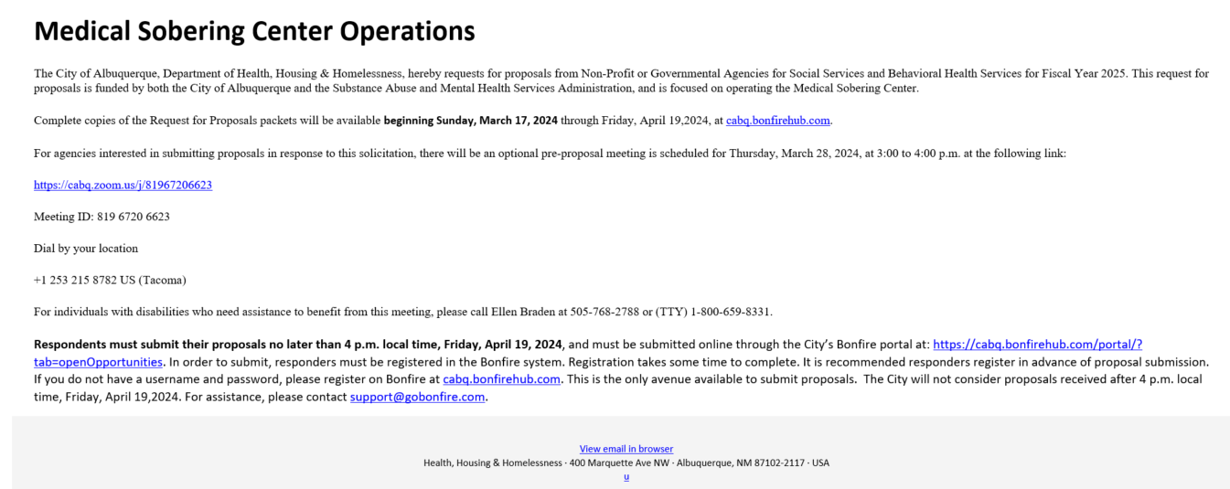
- Construction is still underway for the Medical Respite and Sobering Center. The framing is up so we are still looking at winter 2024 or in 2025 for opening.
- Construction has continued to be an anomaly out there with meeting deadlines. We hope to bring an operator on board to work with us on those final pieces of construction and staffing and getting them on board.

CIU, APD, and BSS Report and update, Commander Dietzel, Dr. Duranceaux, Lt. Lowry, and Sgt. Tinney
- Our Non-sworn Professional Staff of the month was clinician Mike Lucero. The Community Outreach Officer of the month was Detective Josh Isler, and the CIU therapy dog, Oakley. They will get an award at the Chief's office on April 2nd.
- Our newest Clinician Tricia Baca was introduced and welcomed to APD BSS/CIU.
- CIU update on monthly referrals is 450. Of those 102 were assigned for to the Follow-up Team and 50 went to outside resources, leading to 298. We still have referrals we are going through.

MHRAC Training and Infoshare Sub-Committee Update, David Ley
- We met on Monday, February 29th.
- Now that we have combined the two meetings and as we move forward is an ordinance we’ll have to pay attention and be thoughtful about having enough voting members at the sub-committee meeting that it could constitute a quorum and then violate the Open Meetings Act (OMA).

MHRAC Final Discussion
- Commander Dietzel announced his last day to be Monday, April 1st. He will be retiring after 19 years of service to the Albuquerque Police Department.
- Attorney Andrew Magida is leaving the City of Albuquerque to further pursue his career.
- Both were congratulated and applauded.

Next meeting: April 16, 2023

