Mental Health Response Advisory Committee (MHRAC)
Meeting Minutes
February 15, 2022
Via Zoom

Board Members in Attendance
Maxwell Kauffman Disability Rights New Mexico
Rachel Biggs ABQ. Health Care for the Homeless
Betty Whiton NAMI
David Ley New Mexico Solutions
Cassandra Bailey APD Crisis Intervention Division
Gilbert Ramirez CABQ-Dept. of Family & Comm. Services
Laura Nguyen Albuquerque Ambulance
Matt Dietzel APD Crisis Intervention Division
Paula Burton NAMI Peer Representative
Rob Nelson APD/CIU/C.O.A.S.T
Robert Salazar NAMI Vice President
Breeann Rocha New Mexico Solutions
Joe Aranda Hope Works
Nil Rosenbaum, MD APD Behavioral Health Division
Bonnie Mount UNM Dept. of Psychiatry

Introduction to MHRAC
The Mental Health Response Advisory Committee (MHRAC) was created by the Court Approved Settlement Agreement (CASA). We’ve been around since day one and have a focus on three areas, resources, resources being available to access different things within the city that APD and first responders can use as it impacts homelessness and mental health issues. We are also involved in training and policy; training is one of those things we made a tremendous impact on. As far as the training that is offered. Policies are one of those things where the MHRAC is involved with assisting in writing and approving and recommending policy as it relates again to the narrow focus; we think narrow, but sometimes it gets pretty wide focused on how law enforcement interacts with those experiencing homelessness and those experiencing a mental health crisis.

Welcome first-time guests
Sarah Boyd
Peer Support Specialist with New Mexico Solutions ACT Team

Charles Reado
Deputy Director of the State Office of African-American Affairs

Elizabeth Olguin
Deputy Director for Homeless Solutions and Clinical Advisor for the City

Davi Chene
Division Manager, ACS

Abigail Stiles
Senior Policy Analyst with the City of Albuquerque, City Council

Rachelle Tisdale
Master of Social Work Student

Chandler Huston
Sergeant for the Albuquerque Police Department and here as a guest to talk about the APD Wellness Program

Approval of meeting minutes
1st Motion – David Ley
2nd Motion – Joseph Aranda
All were in favor of minutes

Public Comment (Two minutes per person, 15 minutes total)
None

Albuquerque Community Safety Department Update, Mariela Ruiz-Angel
ACS is a third branch to public safety.
The ACS PowerPoint Presentation is the Monthly Informational Report that is on the ACS Website.

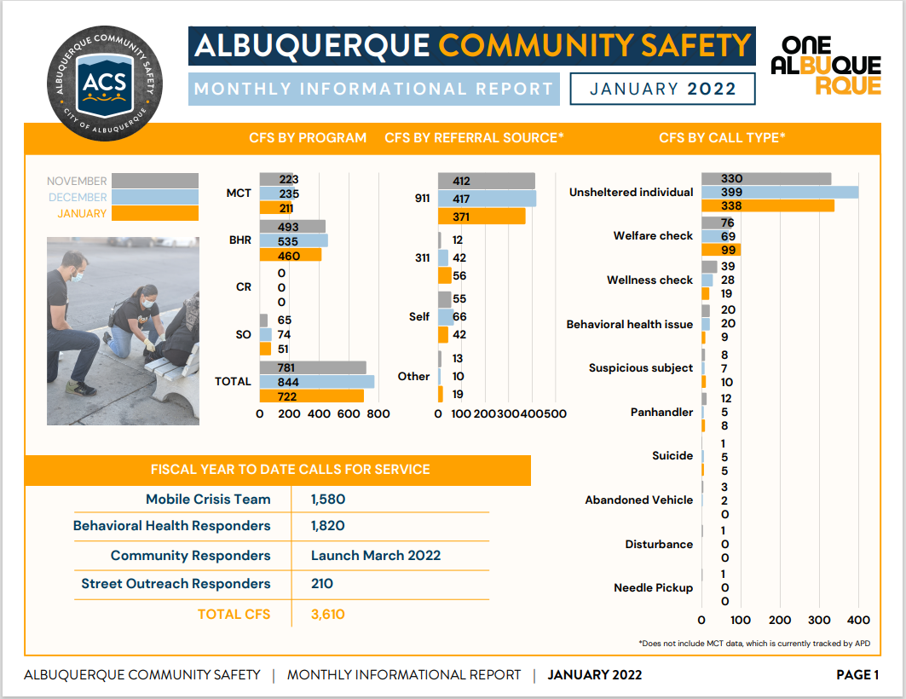
We’re starting to see an uptick in certain types of drugs and certain types of activity happening. We still get the ghost calls/no person found and declined for services, but are they are becoming less.

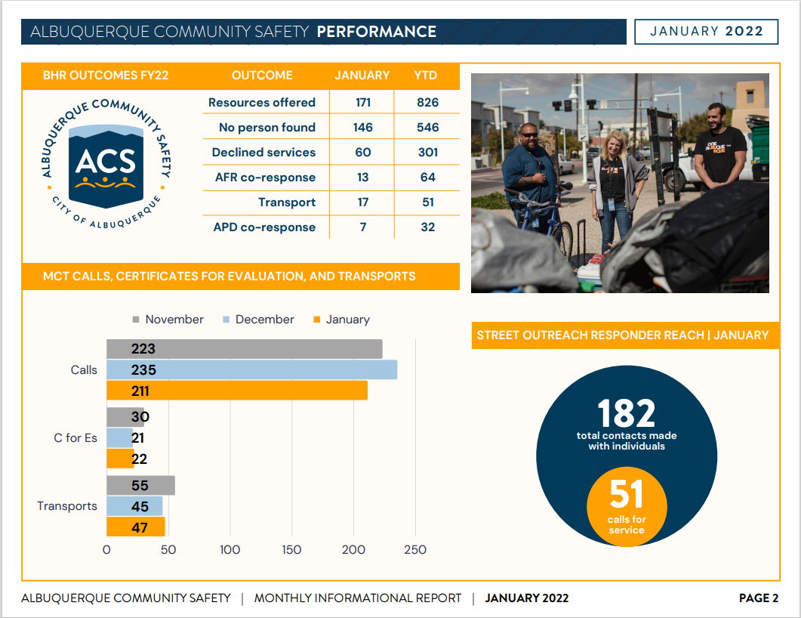

Instead of sending people to the hospital, ACS tries to work around that to get them different services.

ACS has seen an uptick in people trafficking at big parks.

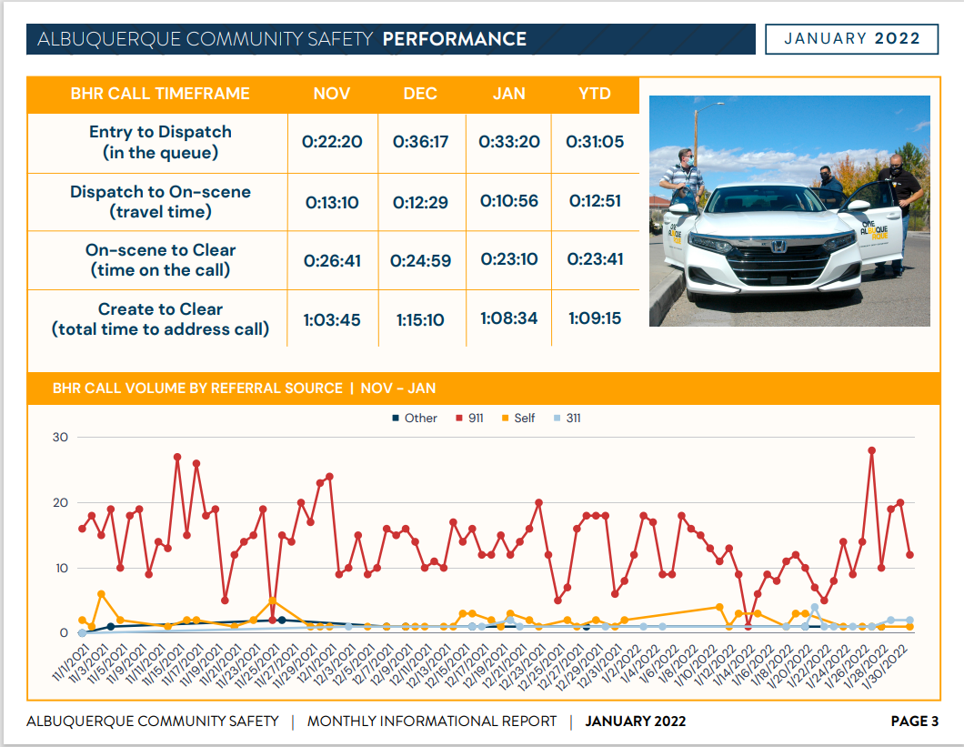

Page 3 slide shows where we're at when we enter for dispatch, and then how long it takes ACS to clear a call. There is a little up and down in our calls but we’re starting to see a pattern of about an hour.

BHR = Behavioral Health Responders. These are folks who have a background; it might be a clinician, or peer support worker; folks that are a little more embedded.

David Ley
Q. I think you have a good idea, but just to understand correctly; you are going to have a Behavioral Health Responder that is assigned to be at dispatch whose job responsibility is to monitor behavioral health calls coming into dispatch and try to help dispatch gets those call effectively to ACS?

Mariela
A. Yes, sir, and we won't be adding any additional personnel we were already at a place where we could have a team of 3, so we will go back to a team of 2. What we would like to consider is that this is a rapid experiment and see how it goes. We will give it a little bit of time. I think PD is excited about this also; it gives us an opportunity to cross collaborate, understand each other’s roles, and figure out how ACS can help them. I could understand if there is some fear; if they send the wrong person to the call it could go sour. We have already identified a couple of responders who will be working the peak hours.
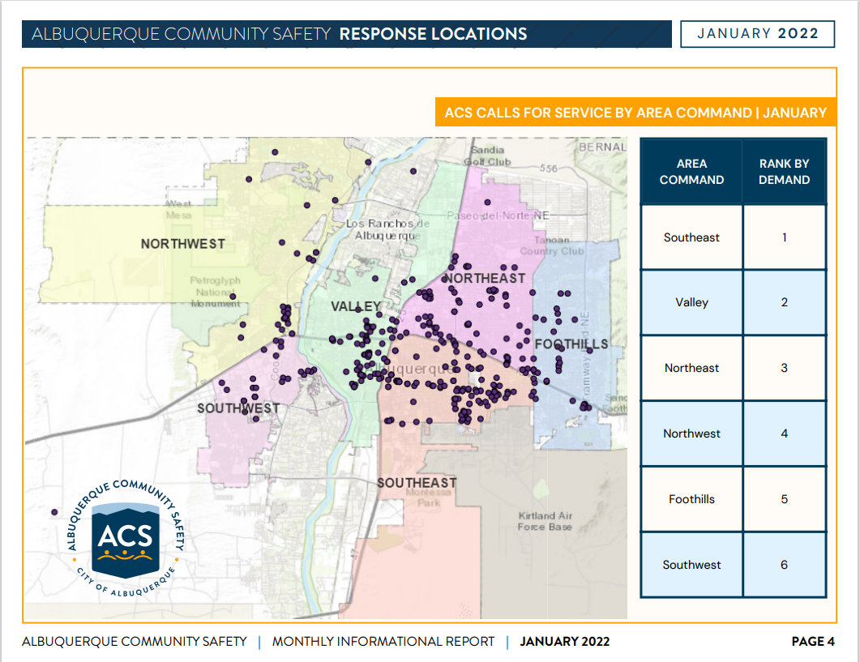

We’re trying to focus on areas we have been dispatched to on a regular basis. The conversations around focusing teams and units in certain areas is coming up a lot more, as we want people to have a better relationship with folks in those neighborhoods plus it allows for a quick turnaround on calls and we get to know people better in those neighborhoods so it allows for a better relationship.

ACS WIN will be on ongoing report.

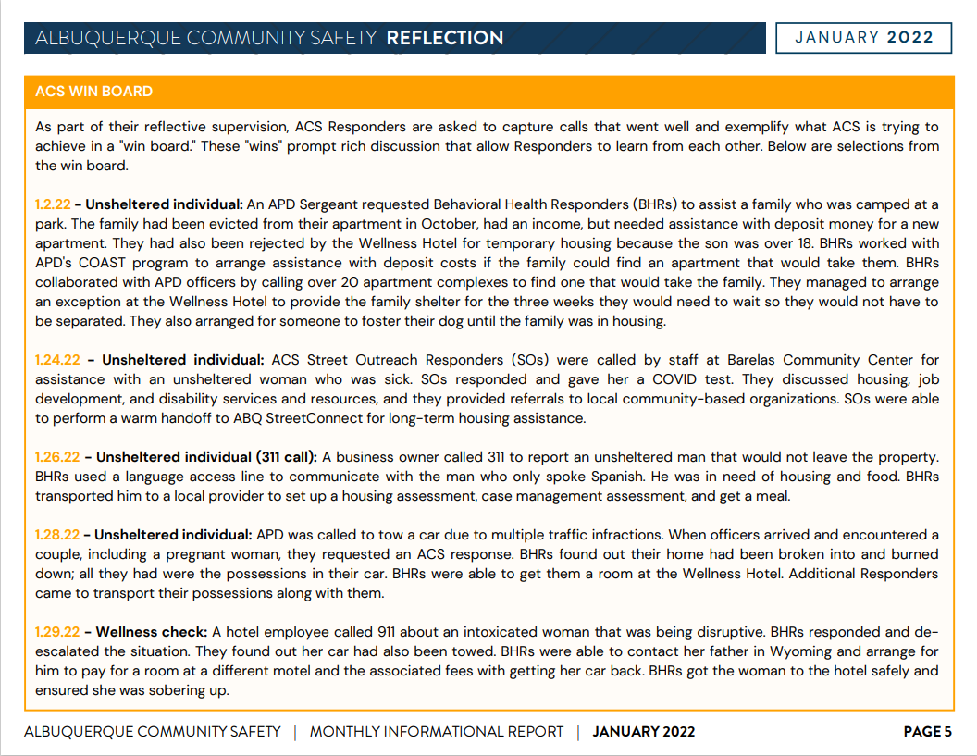

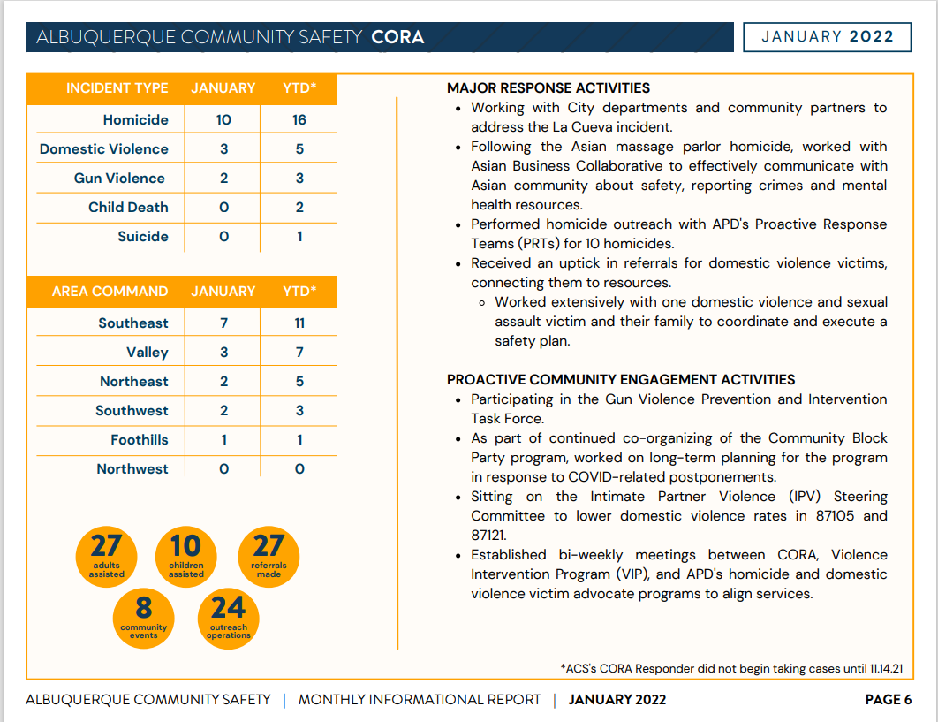

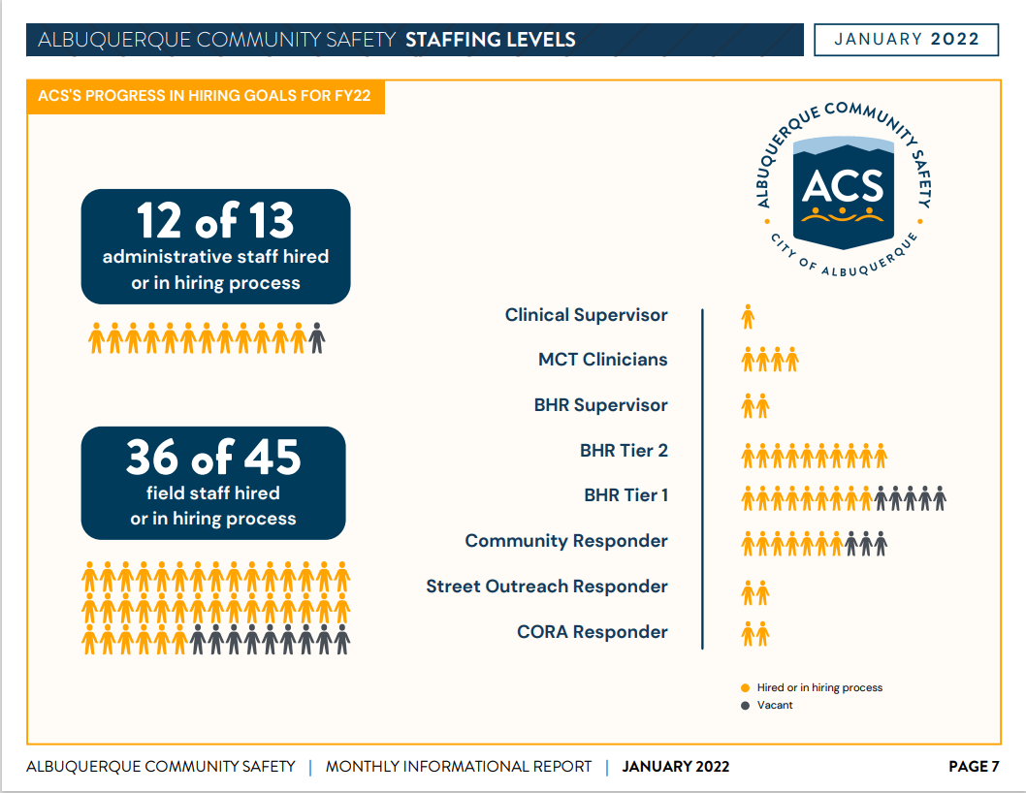

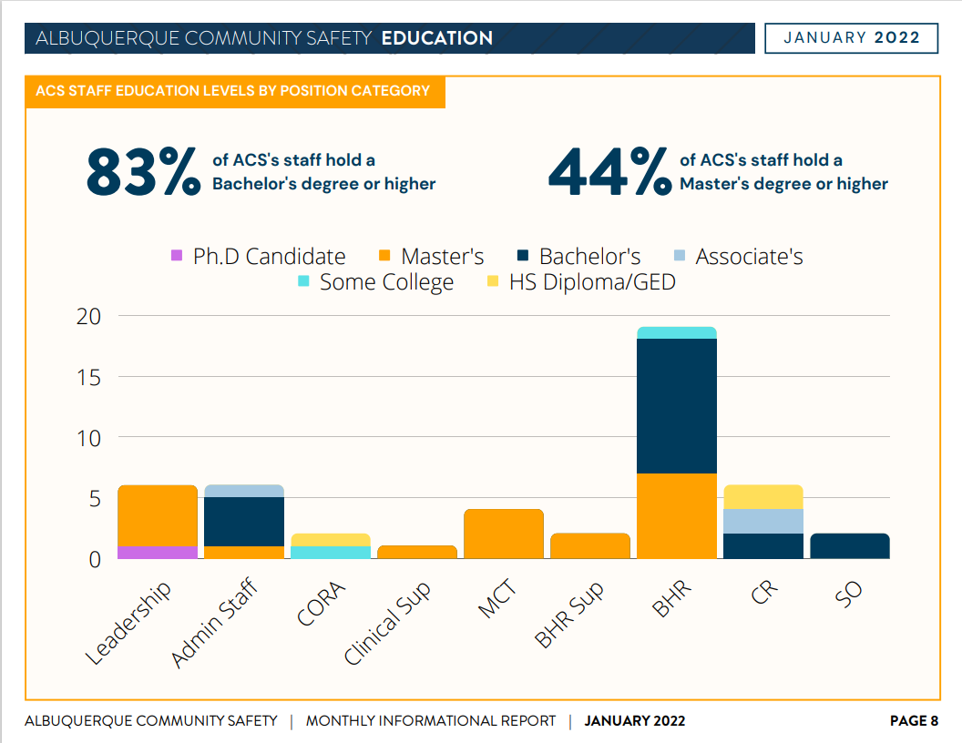

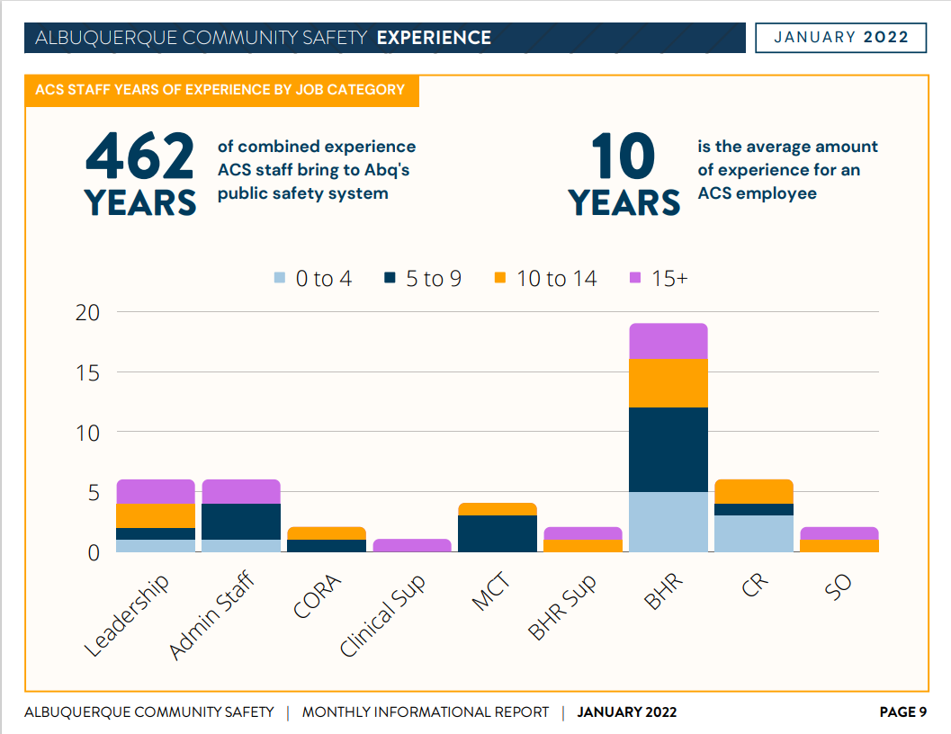

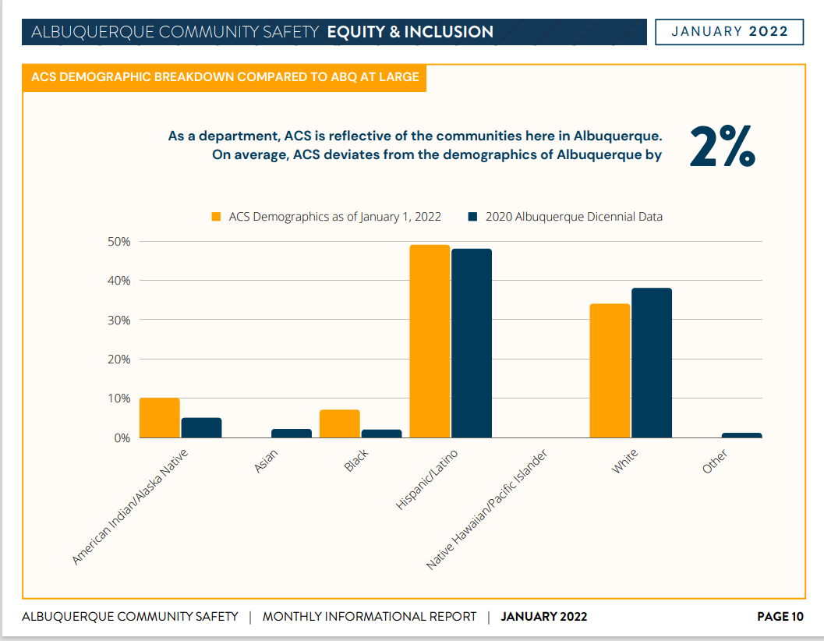

We’re trying not to deviate too far from what the demographics are from our community. This slide shows we’re trending well by hiring more minorities than what we have here in Albuquerque.

Wendy Linebrink-Allison
Q. Since the PSAP call takers are on headsets - how will this BHR know when it is a BH call and offer some guidance to the responders?

Mariela
A. We’re actually on the same CAD System so we are looking at the CAD while the calls are coming in which allows ACS to start to see what the situation is as the call starts to come through.

Matt Cross-Guillen
Q. With this initial success, has there been any reaction from APD as they should have fewer calls to respond to?

Mariela
A. There have been so many calls to APD that it does not feel noticeable yet. We’ve been sending more people out to work with officers, and I think that is where they are noticing it.

Wendy Linebrink-Allison
Q. As all this began to evolve, as a part of the 988 system that is coming up, I am wondering if there will be interoperability between our call center and other call centers within New Mexico communities will you be able to share some of the procedures, practices, and learning opportunities that you have had?

Mariela
A. Absolutely.

Charles Raedo
Q. Do any of the responders from the southwest community know a little about traditions of culture or is it more about addressing the mental health issues?

Mariela
A. Many of our ACS responders come from the community they are working in.

Jeremy Lihte
Q. How has that been getting these individuals to behavioral health providers or case management?

Mariela
We getting data ready for that. We don’t have enough services or enough providers; we do have success with a small percentage. It is hard to find housing for them or DV=Domestic Violent centers.

New Mexico Leaders in Recovery, Jeremy Lihte
We received a Behavioral Health Star Award for everything that our group is doing as Collective New Mexico Leaders in recovery. We are a collaboration of treatment partners throughout New Mexico. We come up with ideas and push those to people who make the decisions. There is a lot we have been working on, but the most common trend we are seeing is people are being alternatively sentenced to mental health or behavioral health treatment programs that just don’t exist, such as a year-long commitment.

Nomination of New Board Members, Max Kauffman, and Rachel Biggs
Rachel and I discussed considering new members for the board and I think we are ready for this growth. We discussed three (3) nominees that we vetted and agreed on and they are here tonight. First, it makes sense that ACS should be on this board because we have Crisis Intervention Division (CIU) and COAST. And, in the future AFR representation as well.

Max
Is there anyone opposed to having Mariela onboard?

Hearing no opposition, Mariela you are on the board.

Max
Rachel and I would like to nominate Wendy to the board

Q. Wendy, will you accept the nomination?

Wendy
I would be honored and I accept the nomination.
David Ley
I will second the motion (to nominate Wendy).

Max
If there is no opposition, Wendy is on the board.

Max
Rachel and I would like to nominate Charles Reado.

Charles Reado
My background, Master Level Social Worker, Masters in Business Administration, and currently a Deputy Director of the State Office of African-American Affairs. I worked in Law Enforcement, Child Protection Services, Mental Health Care Administrator, Therapist, and a former Marine Corp Sergeant.

Max
Q. Does anyone have any opposition to Charles Reado joining the board?

There was no opposition, so with that Charles Reado is on the board.

SOP and Policy Discussion, Max Kauffman
- SOP 2-18 Contact with Persons with Disabilities
I think it is critical knowing a medical diagnosis to understand the social meaning that we attach is also influenced by race, gender, and class. I see the importance of this SOP is more than just accommodating a diagnosis it’s about reducing potential adverse outcomes and respecting the rights of individuals with a disability.
I also think that in all interactions with the public, the officer should first consider if this person’s disability is open, obvious, and apparent. And, does it show a need for accommodation.
I suggest that the SOP require that the officer ask if they need a disability-related accommodation.
The SOP should recognize, physical and mental disabilities may not be immediately apparent to a responding officer and in which case has the individual asserted verbally or non-verbally that they need an accommodation. Is that accounted for in the SOP?
I am wondering if there is a difference in procedure between wellness checks and arrests.
Commander Dietzel
Wellness checks are really about the intent of the call.
Detective C. Bailey
Based on my 15 years of field experience I agree with Commander Dietzel in the wellness checks are about the intent of the call. It would at the discretion of the officer to say this person was so out of it, we don’t feel they were trying to attack us with the intent to really hurt us but that they were scared or just so inebriated unless someone got seriously injured during that interaction. But, I have rarely seen an encounter of that sort or an arrest has been made.
Max
Q. Prior to when the sign language interpreter arrives, what kind of auxiliary aids do officers have, and how are they used and preserved for evidence?
David Ley
A. I have asked that question before and was informed, pen and paper.
Commander Dietzel
Confirmed David Ley's answer.
Max
Q. Would it be useful to have advanced technology such as higher-tech auxiliary aids for officers to accommodate those with disabilities and language barriers?
Commander Dietzel
A. It would help to have higher tech auxiliary aids.
Mariela
ACS is getting a lot of calls where high-tech auxiliary aids would be beneficial.
Max
In regards to video recording, it should specify that the lapel camera ought to capture both interpreter signing and the entire interview at the same time to adequately record the conversation.
One of the recommendations I would throw in there is to have the preferred language of the individual as not every person who is hard of hearing or deaf understands English sign language.
We talk about Miranda, and I think consent to search was mentioned. We often place the burden of communication on the deaf person; to me, this is a bias that increases the stress on a deaf person in crisis and probably makes it more difficult to communicate that distress. I am concerned about the advisement of Miranda rights and consent to search under it. Given the constricted vocabulary and syntax of ASL. I think it’s really complicated and not as simple as just having a language interpreter.

Commander Dietzel
If the MHRAC comes back with feedback on this policy it will open that dialogue with the policyholder.

Wendy
I just wanted to incorporate in one other component as a survivor of interpersonal violence, oftentimes, when you're talking about language barriers, there's a whole other level of the component in the language that somebody is comfortable talking about when other people are around. If the opportunity to have an iPad where the person is intimidated to speak verbally because their perpetrator is in the surrounding area and might feel comfortable writing it down. It's also about those people that don't feel comfortable talking because they've been told they're not allowed to talk

Laura Nguyen
Q. What weight is given to anyone that are encountered, that any disability they describe is in fact the case, right?
Commander Dietzel
A. For APD to make that accommodation, it needs to be pretty obvious; and this has been an issue for criminal investigations for years.

1:05:00 Max
Without it being clear on the SOP, my suggestion is to air on the side of non-waiver when you talk about Miranda and consent to search unless an attorney and interpreter are both present and video recorded. I did some research on Miranda on deaf persons and it's actually not very good; the research is not very supportive of people that are ASL fluent are getting inadequate advisement and null it knowingly making a waiver of those rights so that that would be my intern suggestion to like solid policies worked out.
I have an idea with ACS and MCT in mind; it would be helpful if you did have a tablet on hand with video relay services that can utilize a crisis line for the deaf and hard-of-hearing person(s). I have found one; it is called Deaf Lead, it is a 24/7 crisis line and they work with law enforcement and homeless shelters. It would be great to have that service available while someone is on their way to the call.

-Agora and NMCAL crisis line access to 911
Max
In our Infoshare Sub-Committee, we have discussed the recommendation that the crisis line should be allowed on the 911 queue. We provided feedback via email about the NMCAL=New Mexico Crisis and Access Line.

Wendy
It would be a viable solution to have ACS staff sort through behavioral health calls within dispatch.

Paula
Q. What is the current average wait on a 911?

Commander Dietzel
A. I don’t have that answer; I can ask Erika to come out next month and talk about this.

Detective Bailey
Talked about the resource shortage, along with field officers, and how CIU works in collaboration with AFR, PRT, and Bernalillo County on Crisis calls so we are doing what we can with what we have.

Max
I want to put it on everyone here to think of solutions that the MHRAC can offer up to the city to lessen the crisis.

Detective Bailey
The Crisis Intervention Unit Home Visit Team collaborates a lot with our Coordinator Team who goes to the Academy and trains the new police cadets and they are incorporating that into their scenarios. We also work with UNM Residence (students) by proactive trying to educate through scenarios that have happened in Albuquerque that our officers have actually responded to.
Robert Salazar
He feels that there is no representation of peers on the board that can help make the changes in accountability and other areas when case managers are not doing their job.

Max
Rachel did want me to mention that we are thinking about greater peer membership within the MHRAC. Rachel has reached out to a few and so I think at the next meeting we will be talking about nominating some peers to be a part

-US interagency Council Guidance on Homelessness and Omicron
Max
The Interagency Council Guidance on Homelessness in light of Omicron, the sub-committee recommended that the city adopt that guidance.

Q. I sent that out to everyone in the sub-committee; are there any other thoughts on that, or is everyone okay to proceed with that recommendation?

Hearing none, I think we will go ahead and adopt that recommendation.

Gibson Health Hub, Family and Community Services, Cristina Parjon
Elizabeth Holguin was introduced as the new Deputy Director of Homelessness Solutions and clinical services.
The appeal for the Gibson Health Hub zoning hearing took place, and we're waiting to hear on a decision in the next 2 weeks.
The RFP for the gateway shelter and also the first responder drop-off are coming out later this month.
We also have a newsletter that is pretty consistently out there every month and is a great way to stay up to speed with the activities there at Gibson Health Hub, including our Behavioral Health Services and any other new programs such as the Trauma Recovery Center that is now up and running.
APD Wellness Program, Sgt. Chandler Huston
This program is to address the rising level of officer suicides since 2018 and the higher levels of PTSD so a mental wellness component is in it. There is also a physical wellness component due to the number one disease killer for police officers is cardiac disease.
The mental wellness component right now is all sworn police officers will go to a mental wellness checkup visit with Dr. Rosenbaum's group annually. In the past, only specialized units were mandated to do that and everyone else, including the patrol officers who are always the first ones on scenes, were never mandated to do that so we’ve incorporated that into the Program. There is another component for critical incidents; it's a checkup where if an officer responds to a child's death or an officer-involved shooting, they are mandated to go see Dr. Rosenbaum's, group with some peer support follow-up. Any calls with any other type of deaths, suicides, homicides, the same protocol will apply there. There's an incentive to help officers be practiced in having good mental wellness through attending one of the mental wellness classes the city offers, like a mindfulness class, where they can earn 5-hours per calendar quarter.
The physical wellness component, AFR has already been doing this but we are sending officers once a year to employee health for a comprehensive workup to accomplish our ocean mandates for hearing tests, respirator tests but also, for them to get a full workup including EKG, and then we've incorporated an optional where we're just trying to encourage them to exercise three times a week or total of 120 minutes in a calendar quarter they can earn up to 10-hours of time off just to help motivate them to get them out there exercising. That's for officers that are not required to work out on duty or mandated to work out, just for the officers who have the option too.

Max
Q. I know the APOA has been a huge proponent of officer peer support; is that somehow incorporated in this?

Sgt. Chandler
A. Yes, Melissa Schultz is our peer support coordinator and is on the officer wellness committee. In critical incidents, an officer would go see Dr. Rosembaum one time, and then Peer Support would reach out to that officer two times.

Laura
Q. With this yearly check-in, does that include supervisors, leaders, administrators… or are we just checking on the folks who are currently out in the field?

Sgt. Chandler
A. Yes, everyone from the Chief down.

MHRAC Agreement, Max Kauffman
Regarding the By-laws, Rachel and I have reached out to Sarita, the Chief Administrative Officer for the City of Albuquerque, asking how the city would want to handle voting. As it is right now, APD gets one vote, and every other department gets one vote. As the board grows, it is worth considering how this is going to play out in terms of an ordinance.
Q. How can we coordinate with the city to propose an ordinance that the city council will like?

Sub-Committees Report and Update, Commander Dietzel
Thank you all who attend the Infoshare Sub-committee; it is getting better every time.

MHRAC Final Discussion
None

Next meeting: Tuesday, April 19, 2022

