Mental Health Response Advisory Committee (MHRAC)
Meeting Minutes
November 21, 2023
Via Zoom

Board Members in Attendance
Rachel Biggs Albuquerque Health Care for the Homeless
Commander Dietzel Crisis Intervention Division
Chief E. Jaramillo Albuquerque Fire Rescue
Mariela Angel-Ruiz /Jodie Jepson Albuquerque Community Services
Paula Burton Peer Representative
David Ley New Mexico Solutions
Gilbert Ramirez Family & Community Services
Robert Salazar NAMI Representative
Coty Maxwell CIU Detective
Mary Perez UNM Psychiatry and Behavioral Sciences
Dr. N. Duranceaux Behavioral Science Services
Introduction to MHRAC
The Mental Health Response Advisory Committee (MHRAC) was created by the Court Approved Settlement Agreement (CASA). We’ve been around since day one and have a focus on three areas, resources, and resources being available to access different things within the city that APD and first responders can use as it impacts homelessness and mental health issues. We are also involved in training and policy. Training is one of those things we made a tremendous impact on. Policies are one of the things where the MHRAC is involved with assisting in writing, approving, and recommending policy as it relates again to the narrow focus; we think narrow, but sometimes it gets pretty wide-focused on how law enforcement interacts with those experiencing homelessness and those experiencing a mental health crisis.

Roll Call
There were eleven Board members present, ten MHRAC members, and one (1) representative.
Jodie Jepson was a representative for Mariela Ruiz-Angel.

Welcome First-Time Guests
Officer Sam Rhodes
Albuquerque Police Department, Crisis Intervention Division, Mobile Crisis Team (MCT)

Bernice Varela
Crossroads for Women, Executive Director

Approval of Meeting Minutes
1st Motion – David Ley
2nd Motion – Gilbert Ramirez
Minutes from the October 2023 meeting were approved by the MHRAC Board Members.

Public Comment/Announcement
None

Nomination of New Board Members (if any)
None

Fathom Meeting AI Summary:
ACS Academy and Training Updates
- ACS has 14 new cadets starting a 6-week training academy
- Integrating new components like 4-hour homeless engagement training and street medicine training
- Aligning training with court injunction requirements for offering beds/transportation and tailored engagements
ACS Winter Response
- Seeing increased calls and need for transportation to shelters during the graveyard shift
- Preparing staff for cold weather safety protocols
- Working on gathering data on transports and outcomes
- ACS using Sun Van from the City for overnight transportation
- Fire dept interested in accessing van for transport after responding to illegal fires
- Effort to consolidate transportation access across depts
Gibson Health Hub Updates
- Housing Navigation Center has 46 guests currently, housed 25 since opening
- Launched real-time shelter bed availability tracker for providers
- Construction underway for Medical Sobering Center, Medical Respite Center
- Preparing to bring on contractor for Gateway Engagement Center services
- Planning for leadership transition with the Director, Carol Pierce’s announcement of Retirement by the end of December
APD Crisis Intervention Unit Updates
- Continued work on MCT collaboration with ACS for clinician coverage
- CIU received 401 referrals and assigned 80 new cases
- Positive feedback in recent IMR report
MHRAC Ordinance Discussion
- Working on an ordinance to codify MHRAC outside of CASA
- Will present draft at January meeting for feedback
- Continued discussion planned for the February meeting
Next Steps:
- Send training manual to MHRAC members
- Provide transport data at the next meeting
- Send Officer-Involved Shootings (OIS) Subcommittee update to MHRAC members
- Finalize the agenda for Monday's MHRAC subcommittee meeting
- Draft ordinance presentation for the January MHRAC meeting

2023 APD Report, Dr. Peter Vielehr, APD Director of Analytics
https://www.cabq.gov/mental-health-response-advisory-committee/mental-health-response-advisory-committee-documents/mental-health-response-advisory-committee-documents/?11162023

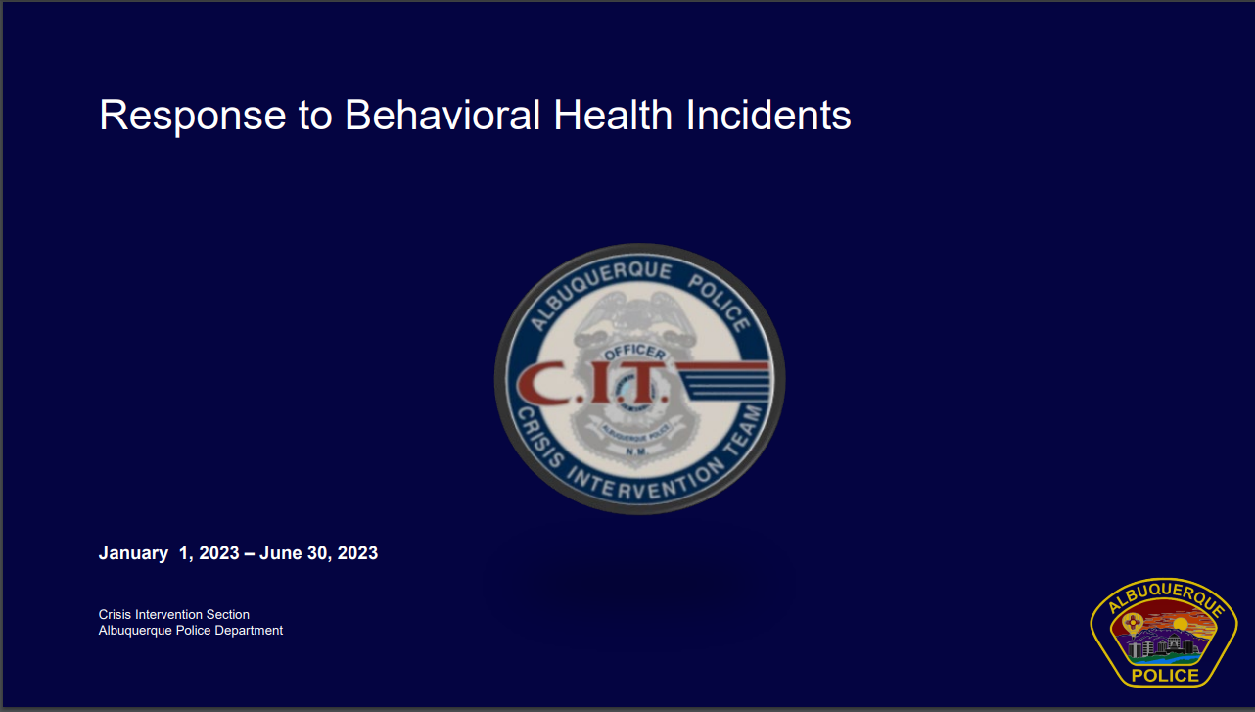

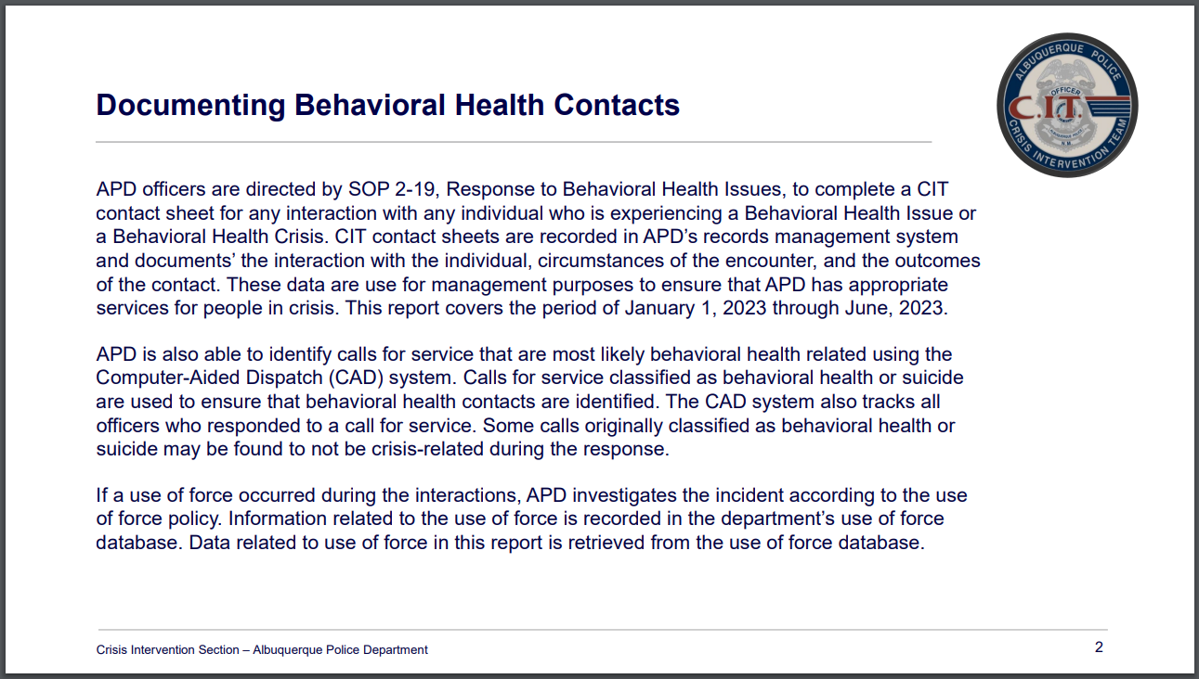
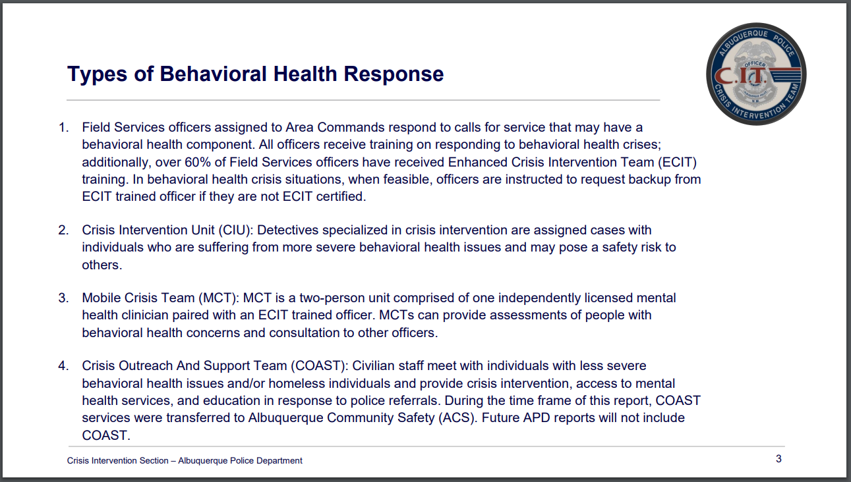

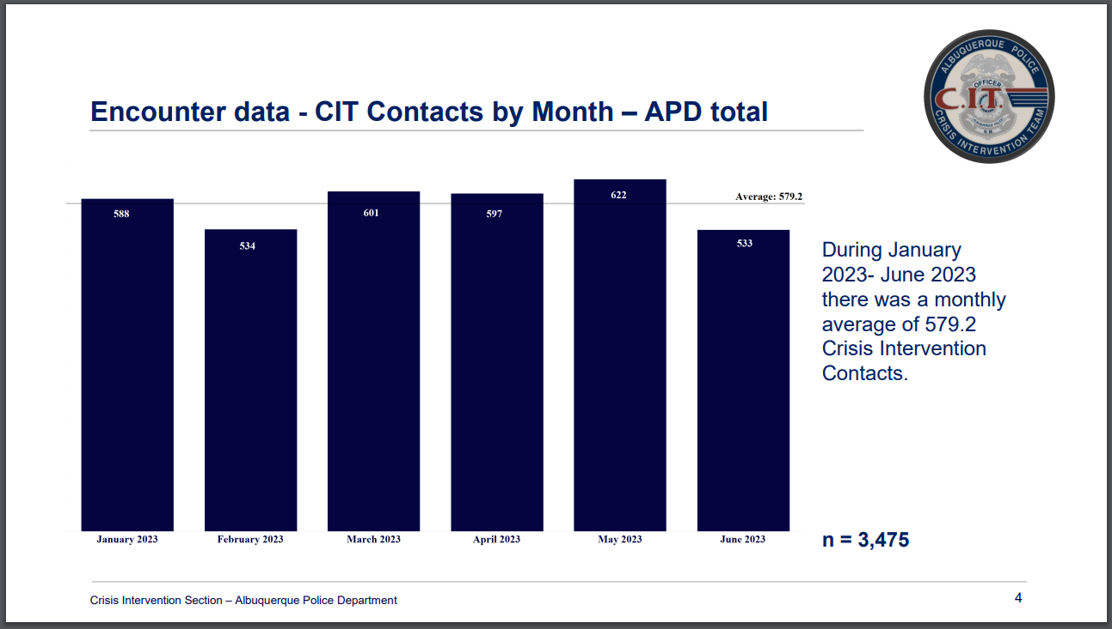
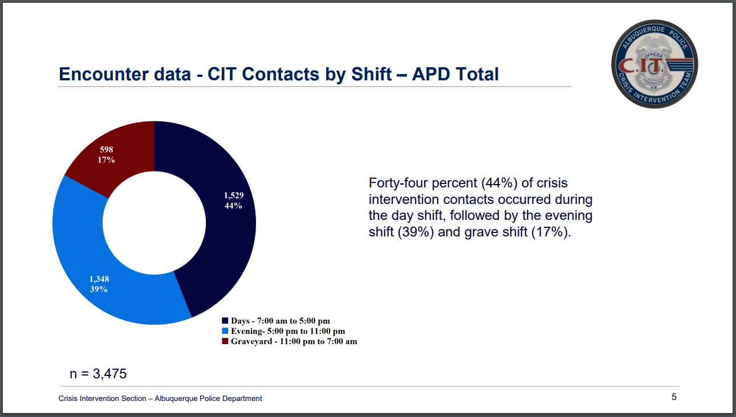

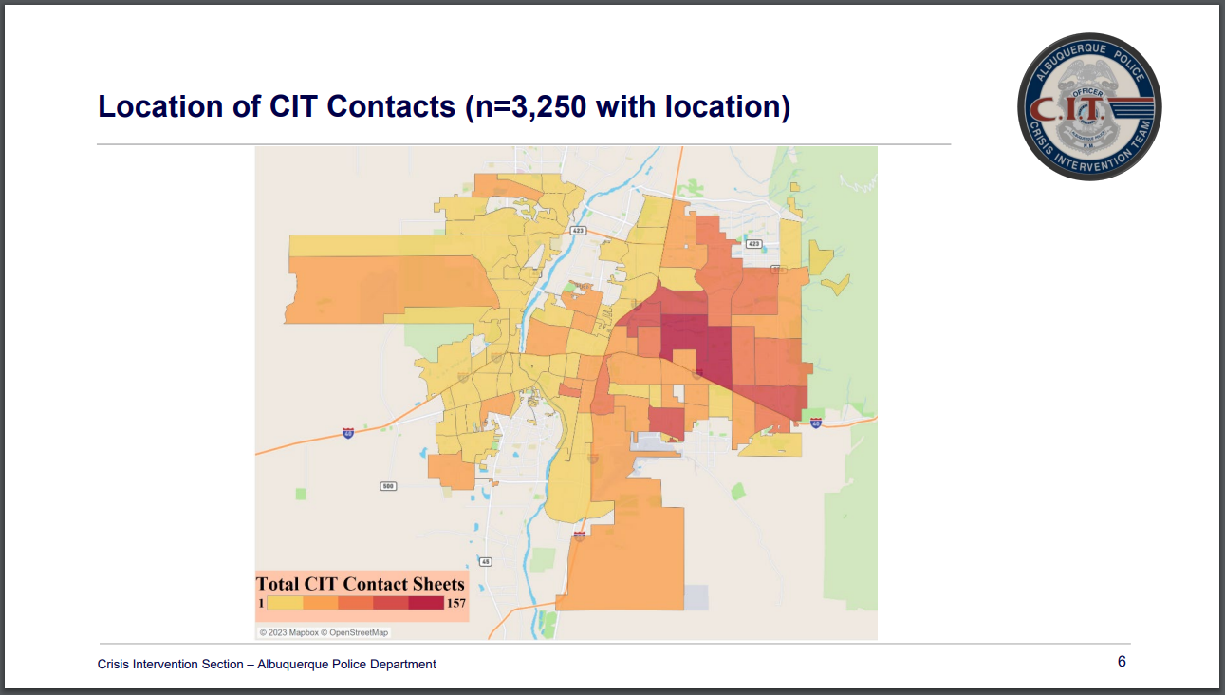
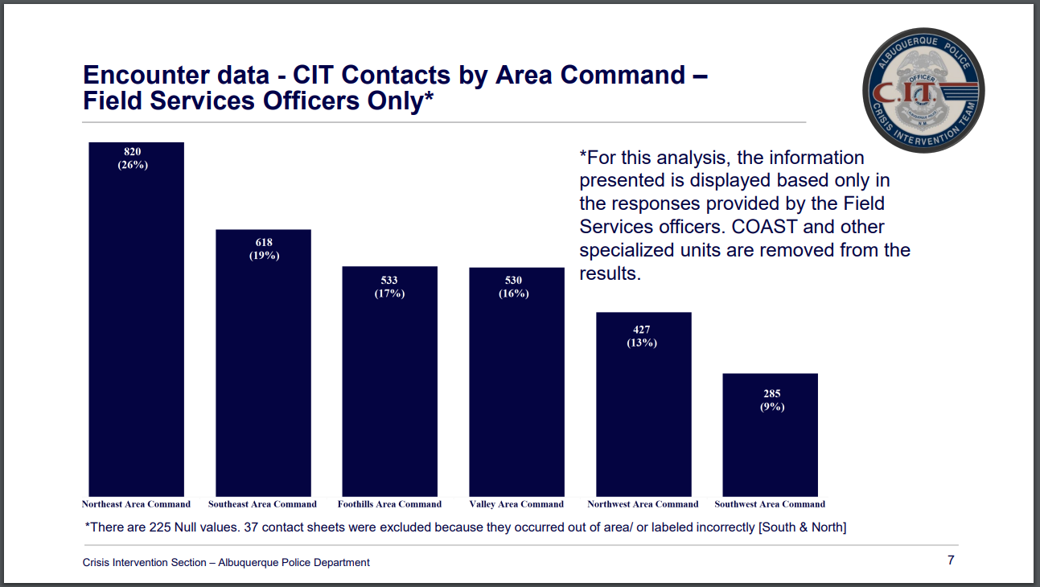

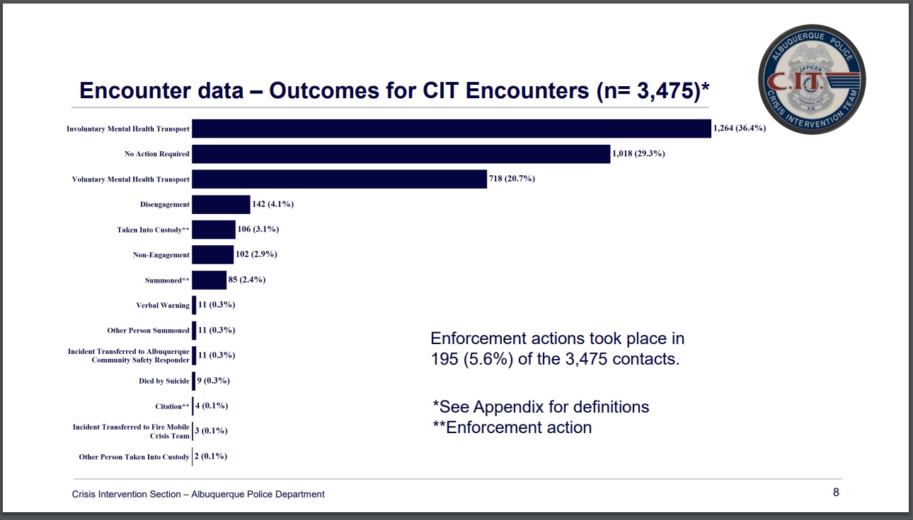
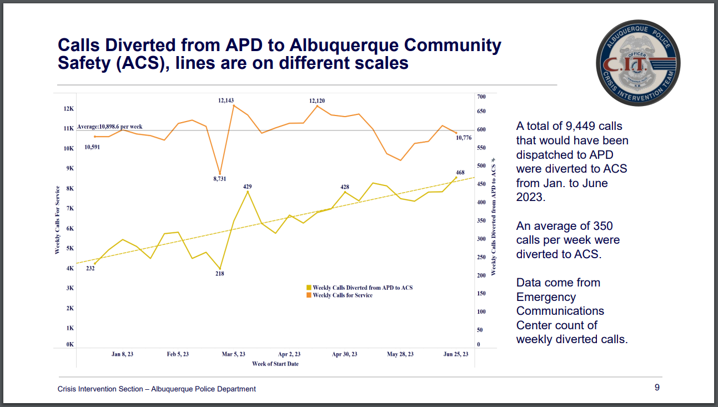

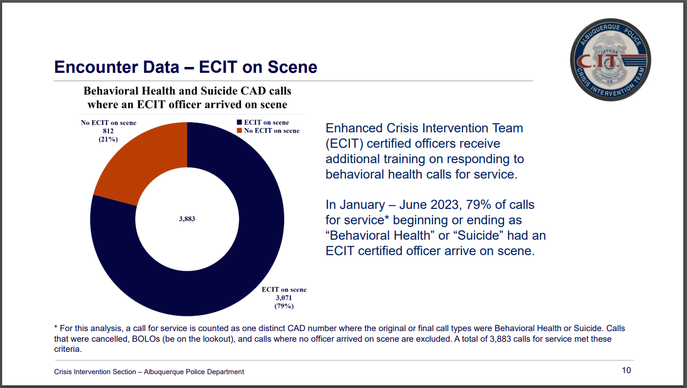
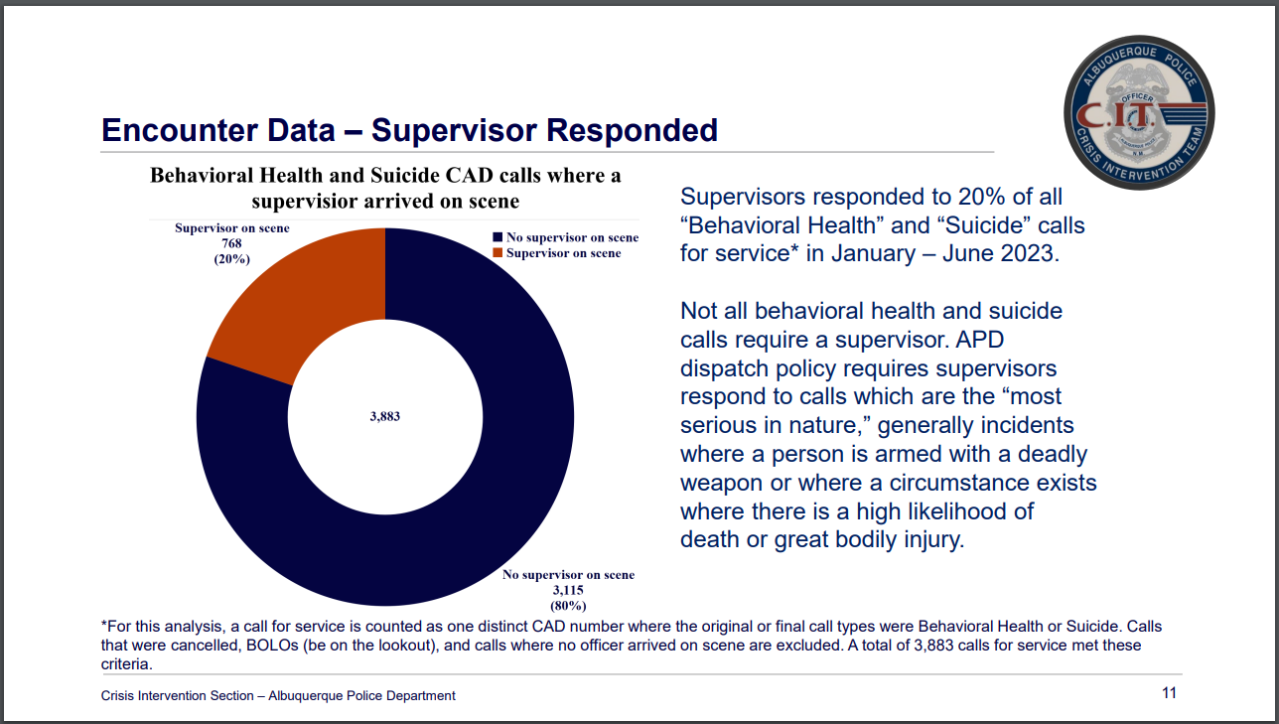

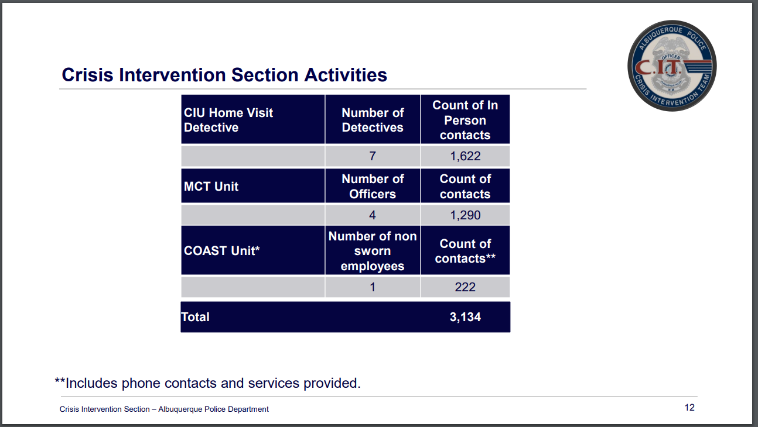
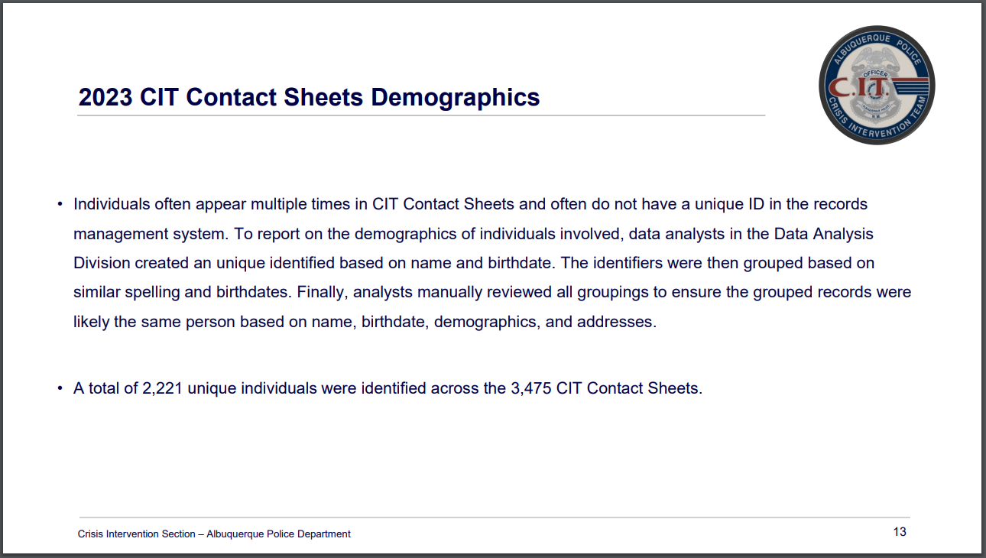

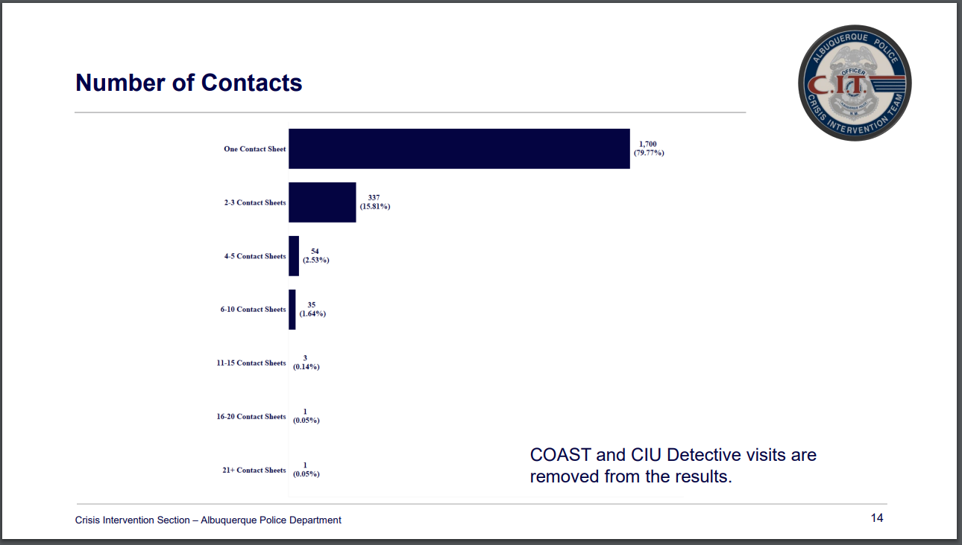
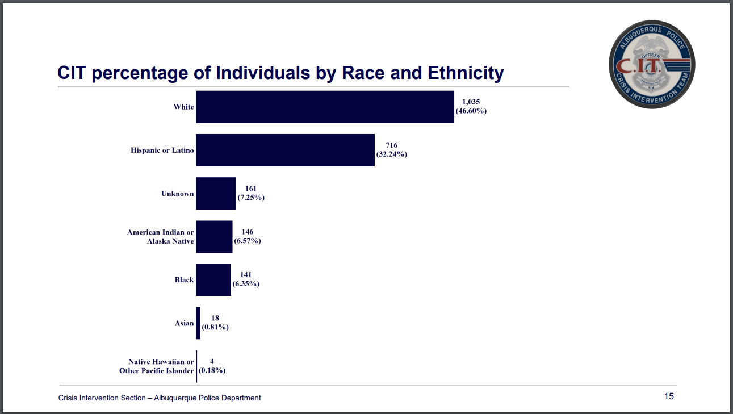

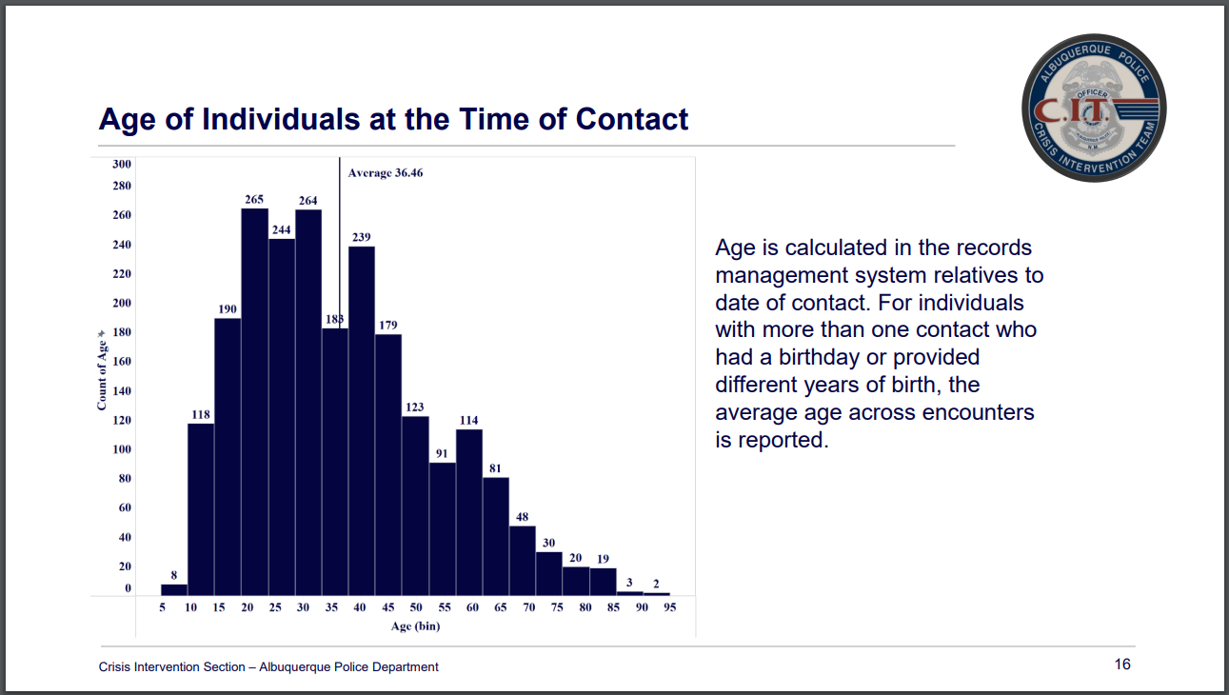
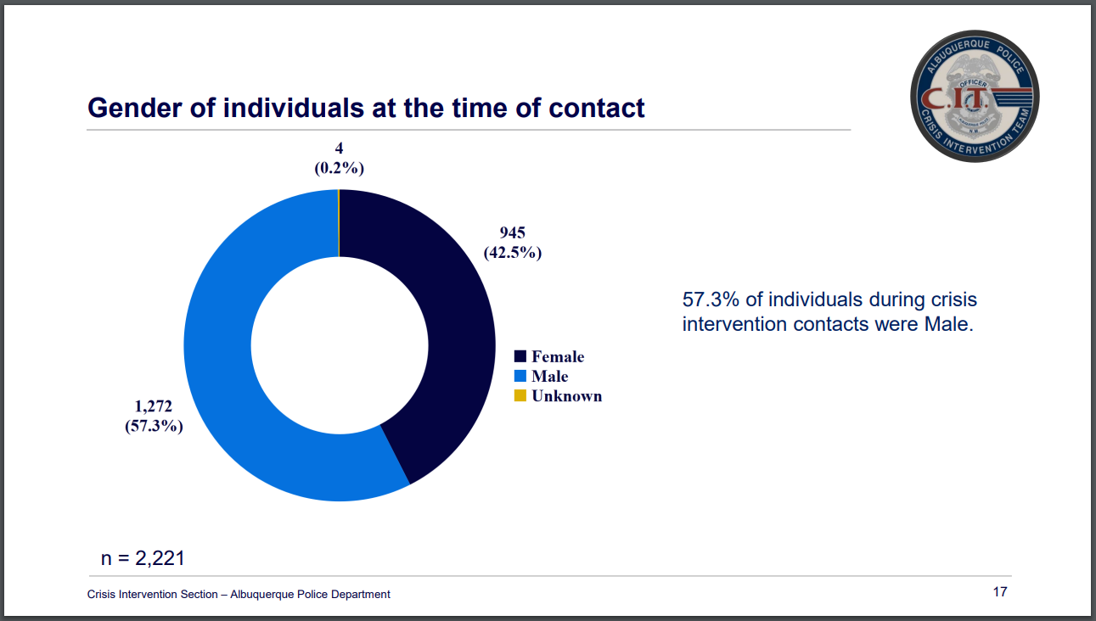

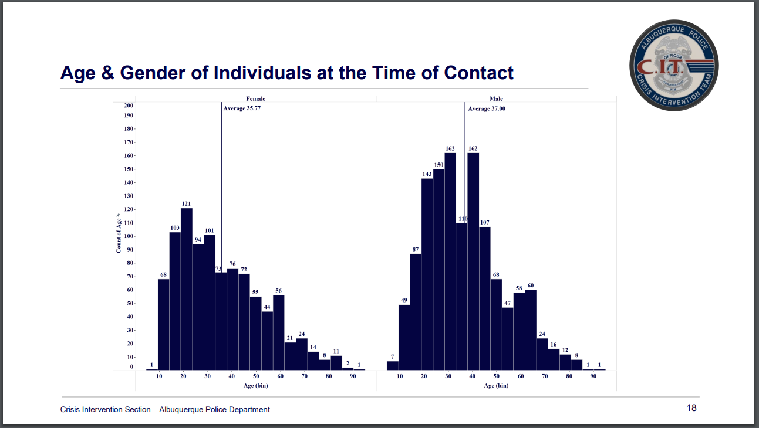
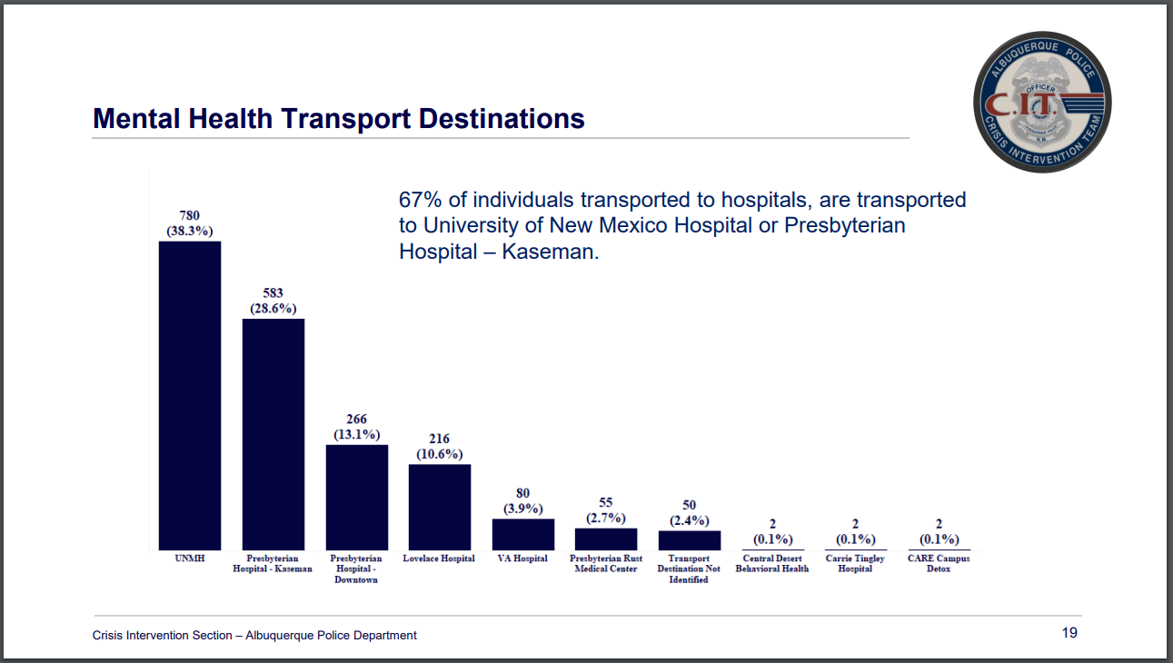

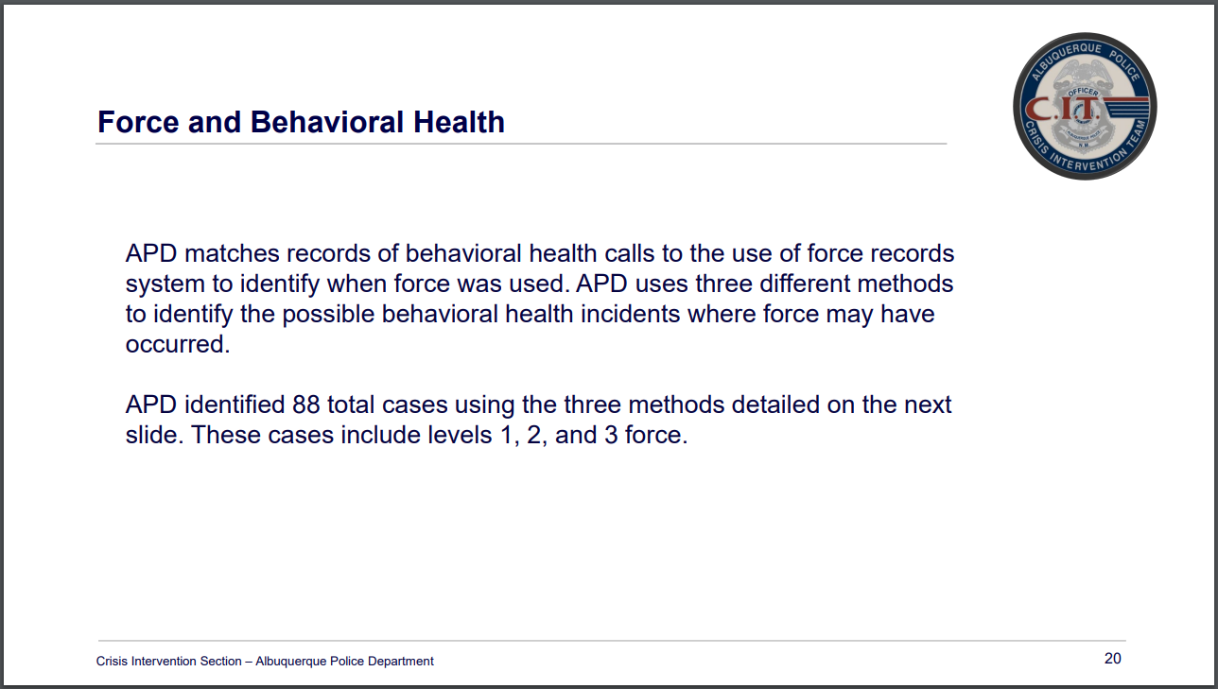
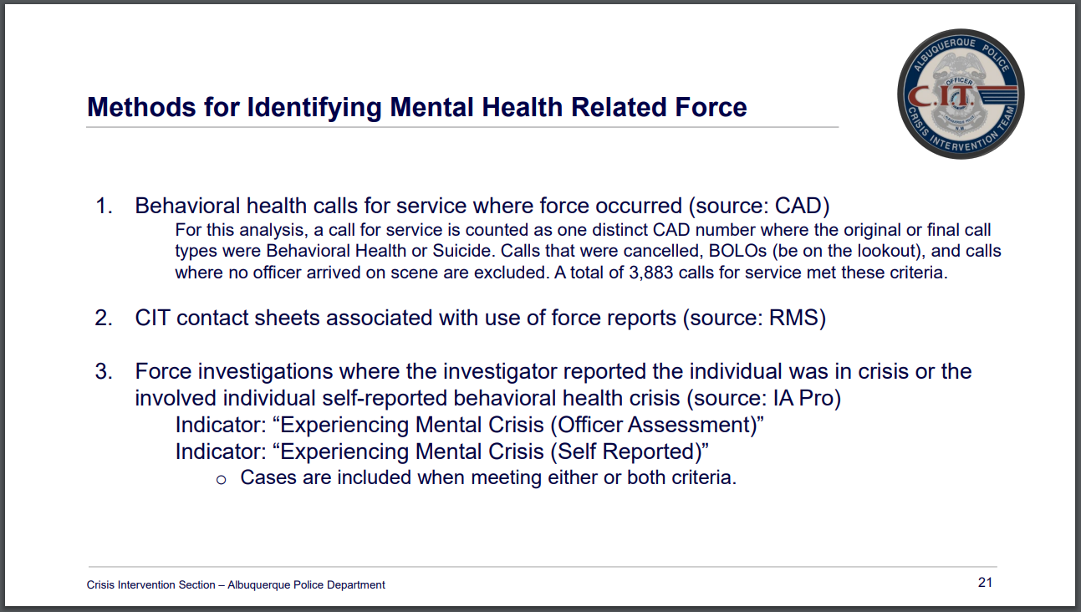

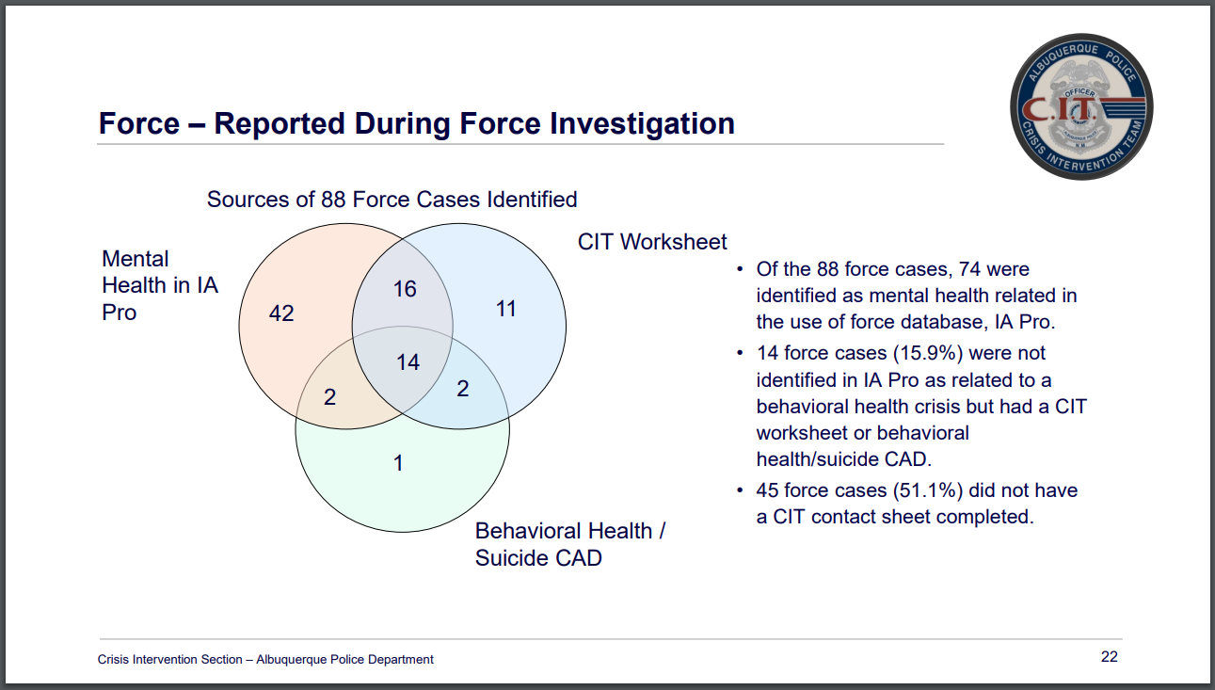
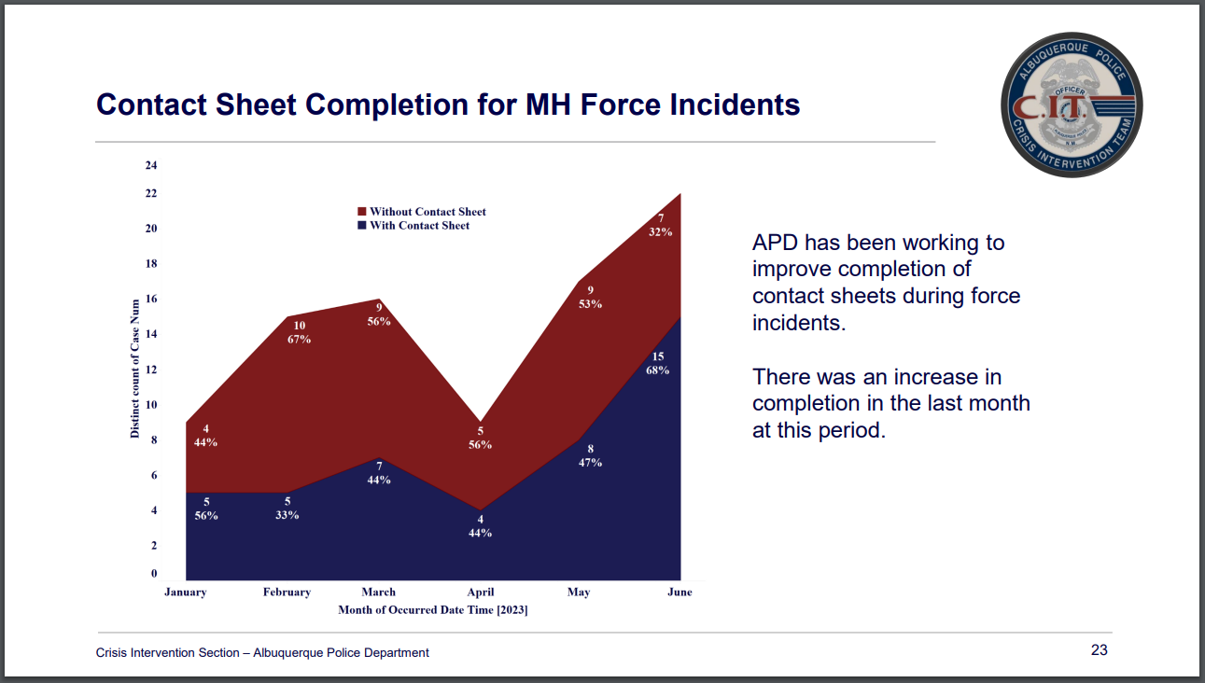

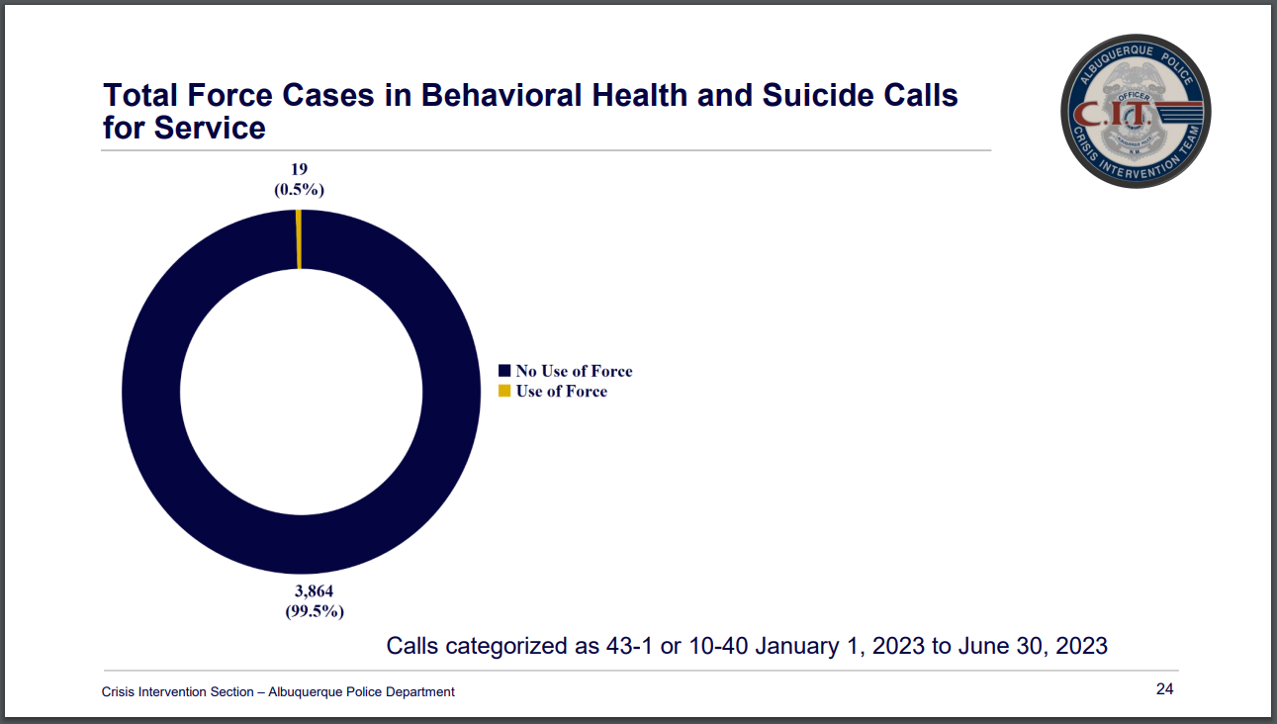
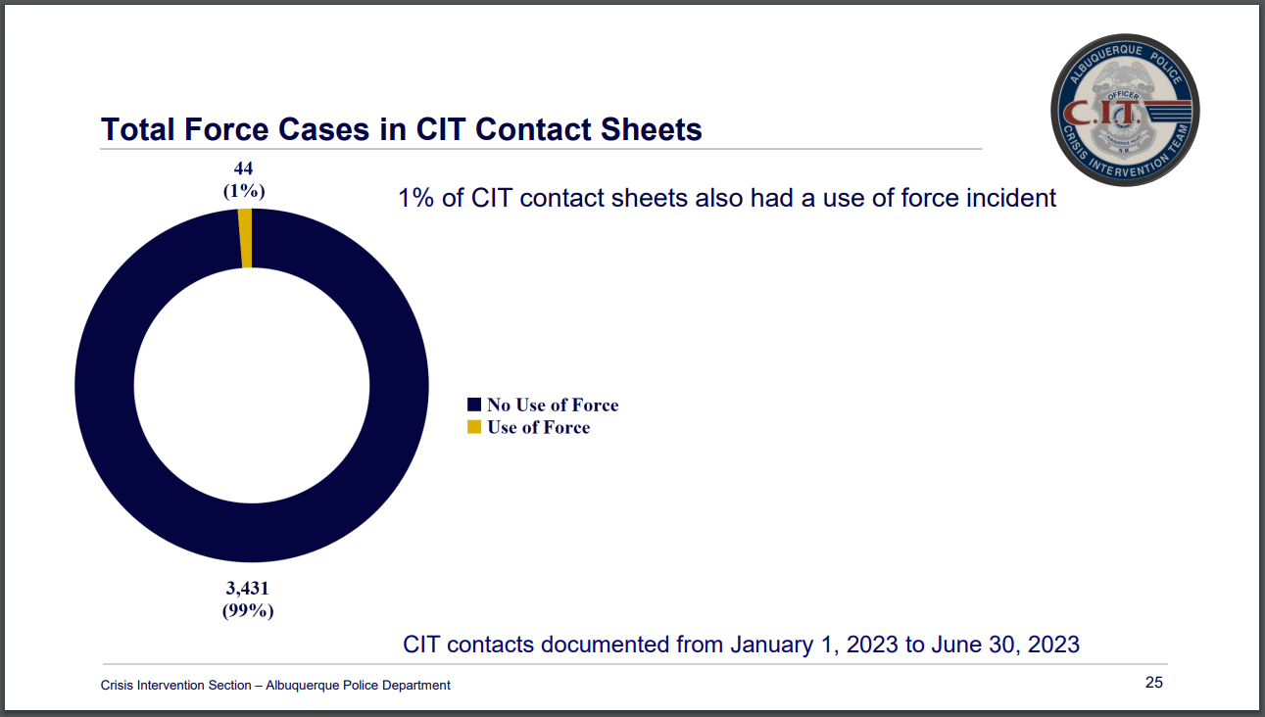

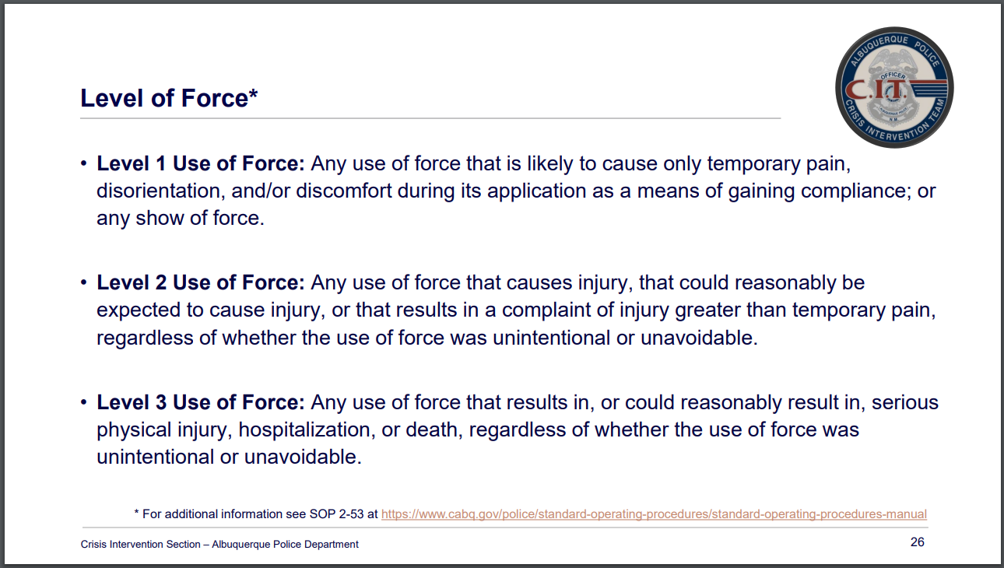
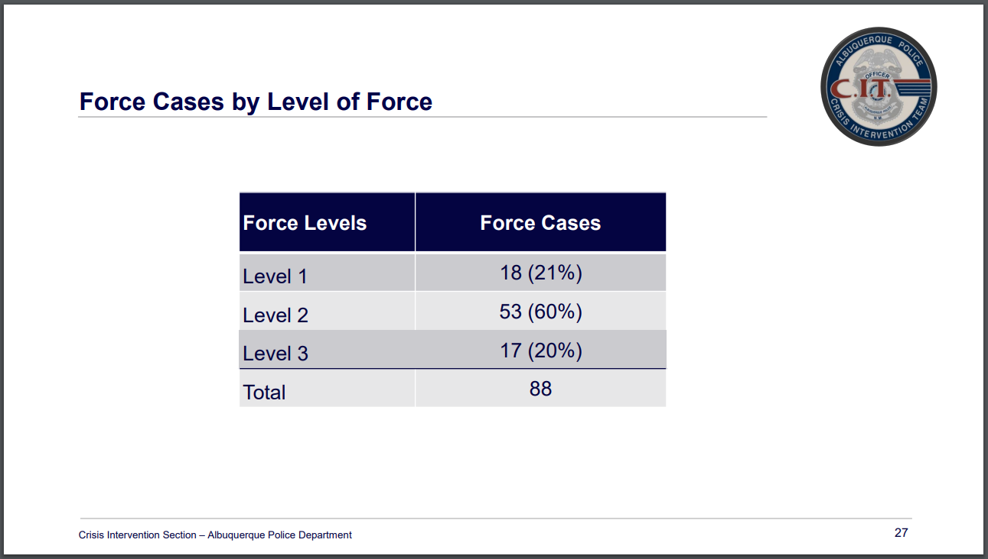

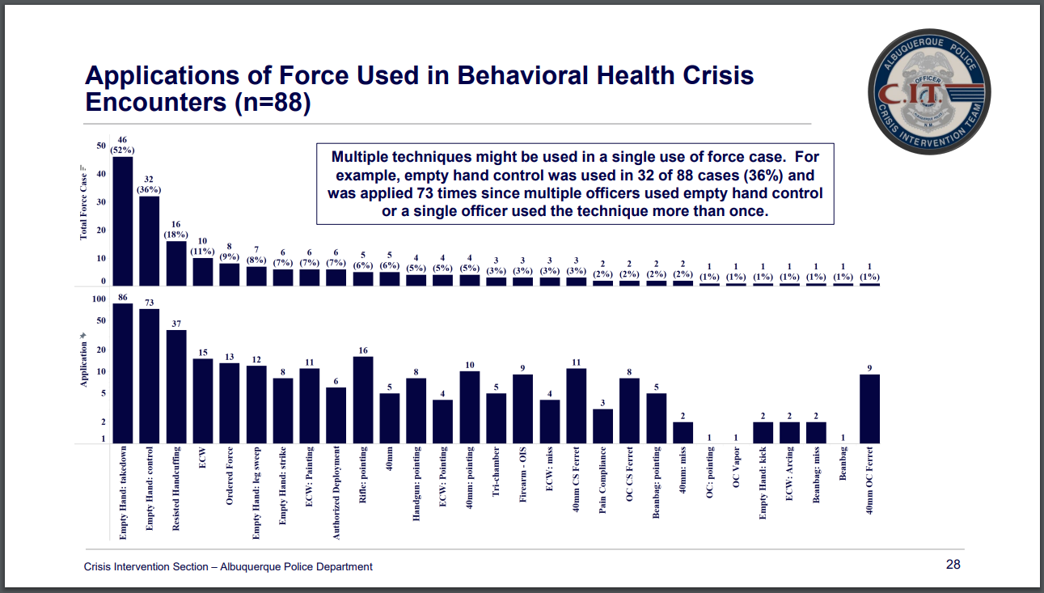
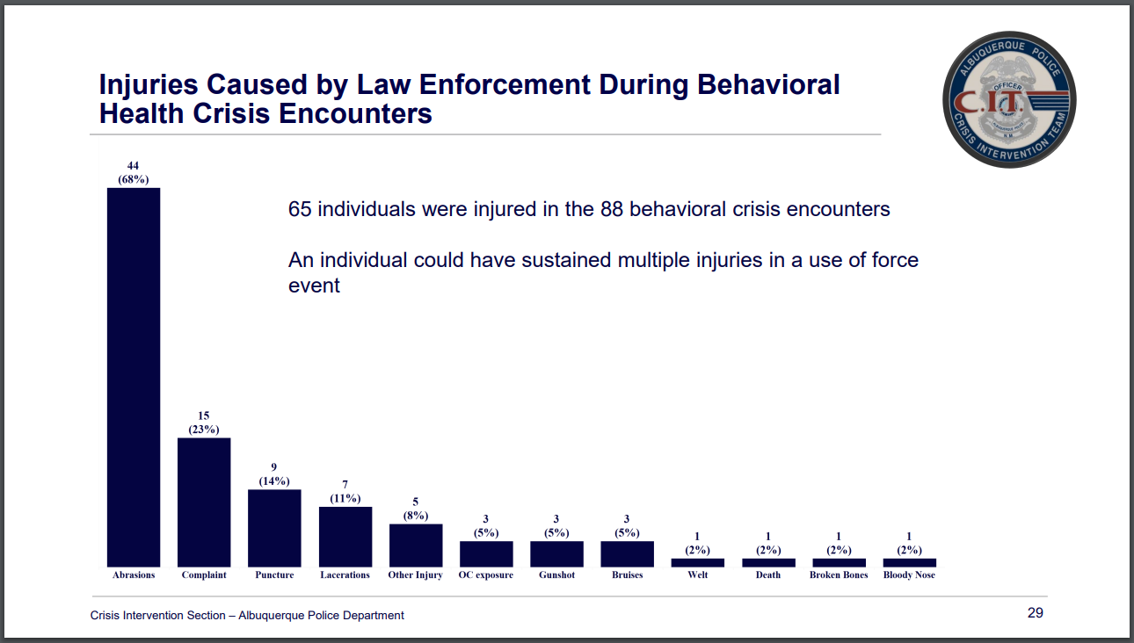

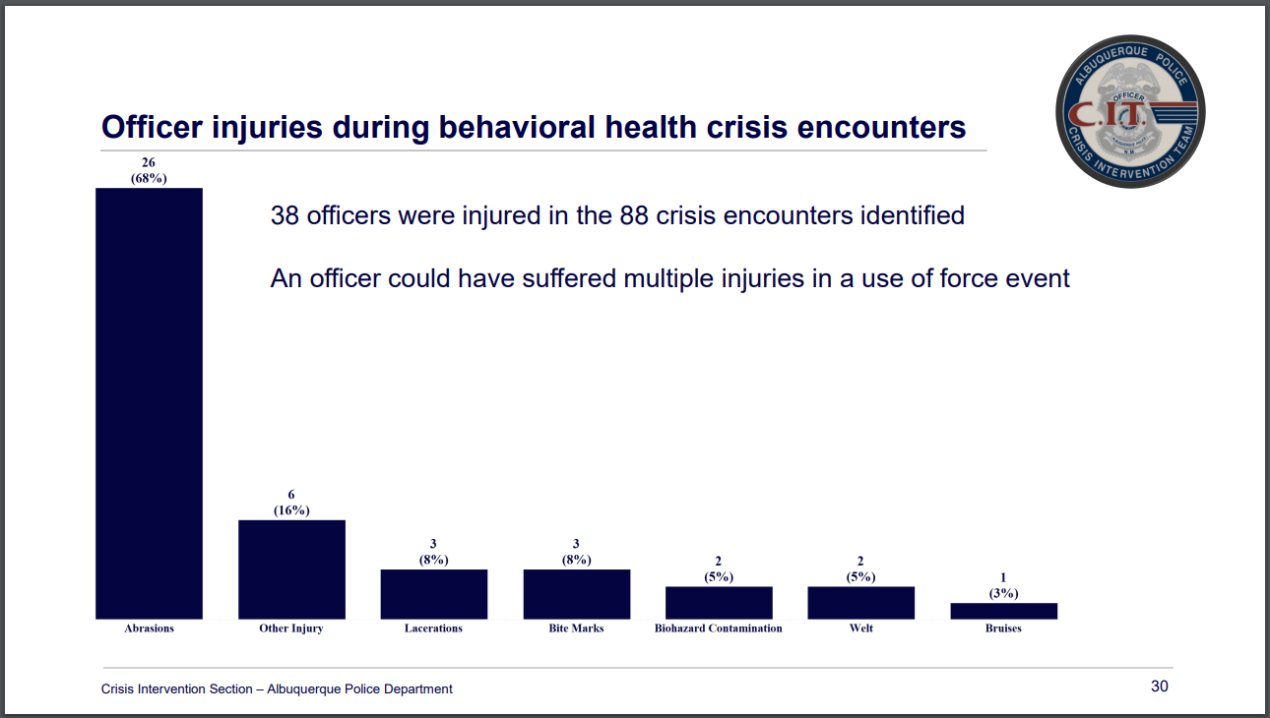
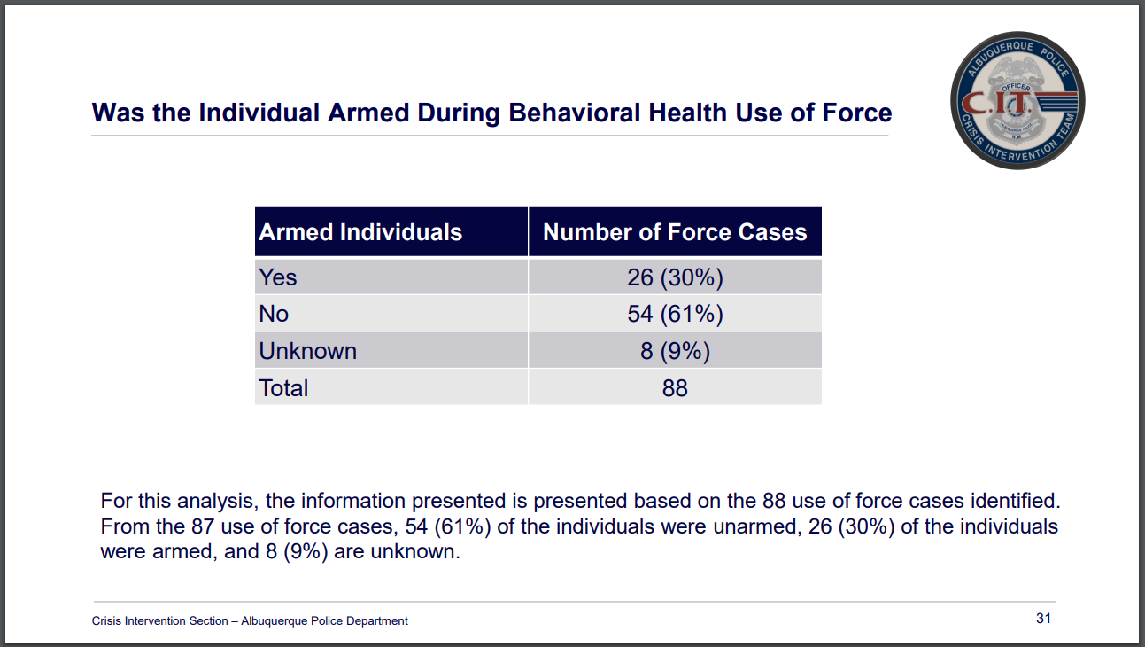

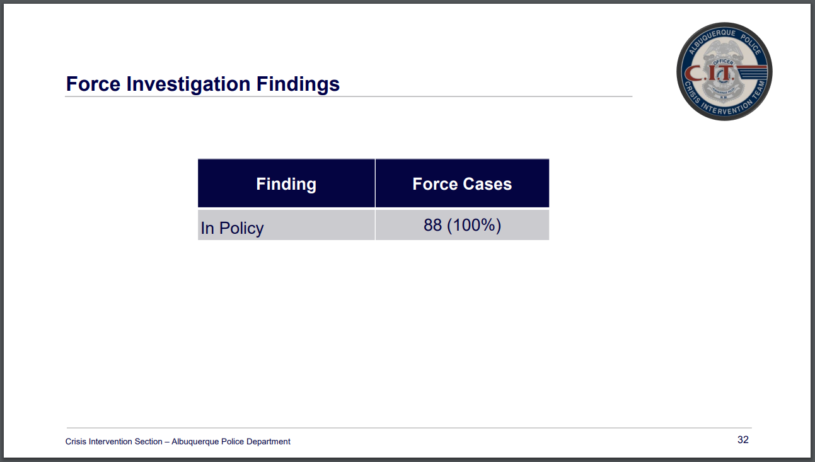
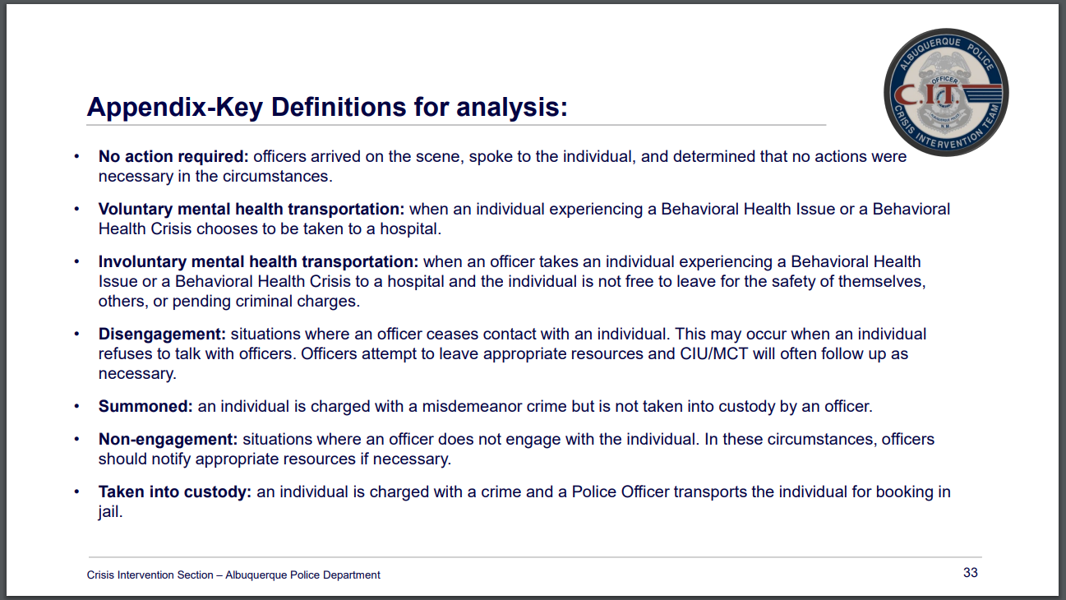

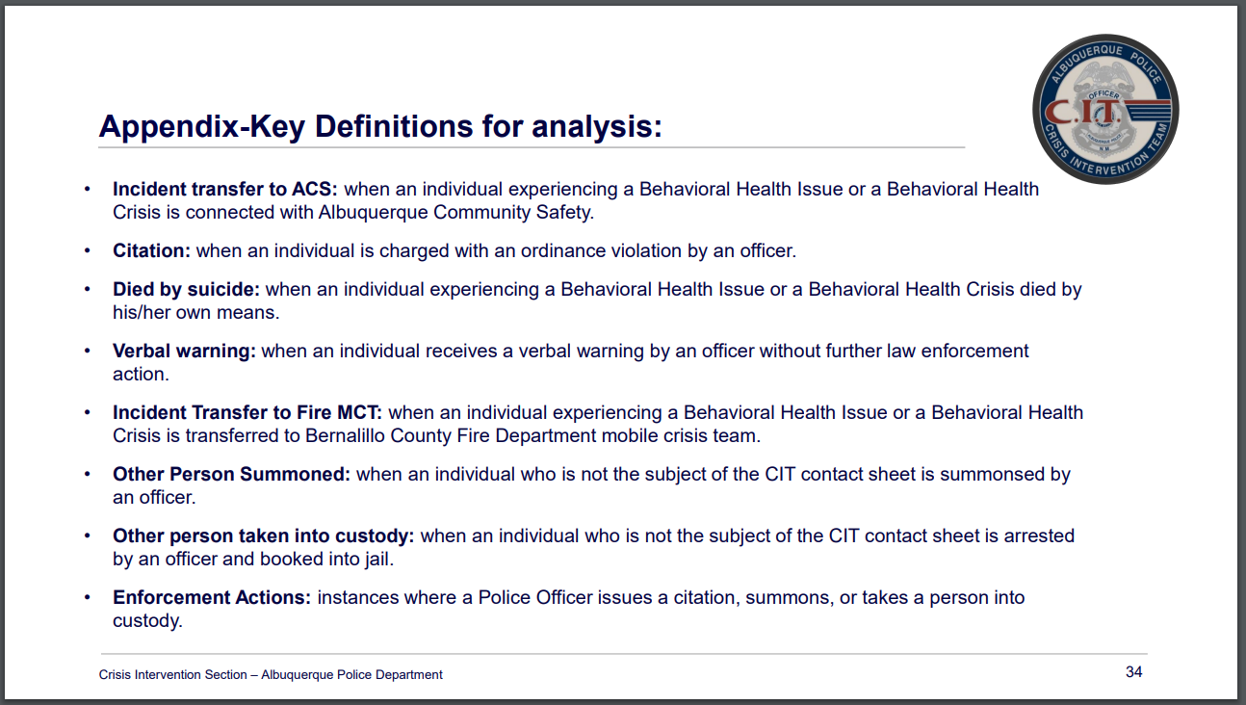
CABQ Human Rights Board & Mental Health, Anami Dass, Chair for Sub-committee
- I am a harm reductionist in the International District of Albuquerque.
- I was appointed to the Human Rights Board in March of 2023
- The Human Rights Board is the governing body of the Office of Civil Rights which is made up of seven members.
- We function in a way that is kind of hard to describe but we are essentially in charge of monitoring and investigating anything in the city relating to the human rights ordinance, mostly charges in discrimination and intergroup hostility.
- The process that the Office of Civil Rights has for handling discrimination complaints is a bit interesting in that it seems to be trying very hard to keep complaints from reaching court and the Board is part of that system.
- When a complaint is taken by the Office of Civil Rights, if it is found to be within our jurisdiction, the respondent will be notified and invited to settle before we have an investigation as a Board. If they decline to settle or if a settlement can’t be reached there will be an investigation done by the Human Rights Board. It mostly functions during one of the meetings. The respondent and the complainant will have the opportunity to present any evidence relating to the case to the Board. We will then close the meeting, discuss it as a Board, reopen the meeting, and vote. It is a specific part of that whole system that we participate in as a board. That is our main immediate function.

Albuquerque Community Safety (ACS) Update, Jodie Jebson
- We have a new employee, Renai Edwards, Division Manager of Organizational Growth and Community Relations.
- Renai has a lot of background and knowledge and is already off and running on great stuff.
- Today was the first day of training for the last ACS academy class of the year. We have 14 cadets/academy folks.
- There are some new components to the ACS academy; Lynn has been working hard on some different training.
- Jasmine Desiderio, ACS Deputy Director, has sent that training manual for the ACS academy off to someone at the MHRAC.
- We are integrating some additional training and presentations.
- My new role is the Homeless Liaison Administrator; I oversee the homelessness responders within the division.
- I am integrating a four-hour block of homeless engagements and then we’re also integrating some of the street medicine components that will be integrated into ACS for next year. So, that is just going to add another component to the responders.
- With the injunction, we are ensuring that we are offering beds and transportation. But we are going beyond that by going a little deeper.
- Our new building which is located on San Mateo and Catherine should be ready in the Spring of 2024

Gibson Health Hub, Family & Community Services Update, Dr. Azka Naru, Gateway Manager
- It’s a large hospital so we refer to that as the Gibson Health Hub because we have 11 tenants and other accredited hospitals on site. Gateway tends to be the city-driven programs underneath that.
- The Housing Navigation Center, Medical Sobering, Receiving Center, and Medical Respite are all projects running parallel with each other.
- Our Housing Navigation Center, and Engagement Center, are where service providers will be. The Receiving area is for first responders and is well underway. We hope to have it fully running with a contractor provider by January.
- We opened the Housing Navigation Center in August. We currently have 50 beds, and 46 guests. We have housed 25 guests already. Since October 1st, we have housed eight guests.
- On average, we are seeing 71 days of stay before folks are exiting. We are tracking that because we designed it as a 90-day program with the ability for extension.
- We are tracking where guests are going. Some have needed assistance getting back to their state of origin.
- The majority of our guests were able to exit before 30 days.
- Case Management is a crucial component.
- We are working with providers to offer services to folks who are being housed, from job readiness, career counseling, health education, resume building, and completion of high school diploma or GED program access. And then Workforce if they need that to sustain housing once they are well.
- The Receiving area is where first responders can bring folks between the hours of 5 pm and 8 am when there is nothing available, or if they need transportation to another shelter because they already have a bed there, or do they need to stay the night until the morning for an agency to be open and they can be connected.
- We have Housing Navigation for families, which is a hotel.
- The link to make a referral is up and running for our partners who have access and a login.
- We now have an additional 35 beds and we are working on a few more for winter. These are for folks who may not be linked to the full service of case management or anything else but they will be able to get a warm bed to stay out of freezing in the elements.
- We have launched a live bed tracker for our first responders. You will be able to see where the location is, and the number of how many beds are available.
- We included our partners, so this is only as good as our partners are for filling it out. We have some agreements with them to be able to do it every morning and by the end of every business day. This gives us the most up-to-date information.
- Hospitals use the same platform to know where the hospital beds are.
- Currently, we’re working to onboard a contractor provider; we hope to have that contract solidified by January and they will be the ones who will be triaging. We are looking at BSW-level as well as community health worker-level folks to come in and be able to take those individuals.
- We hired a new volunteer coordinator; Rachel Hernandez, she has already organized a ton of volunteers specific for those who are unhoused.
- We have partnered with ACS and loaned them a Sunvan vehicle to be part of the transportation for folks who don’t make the bus times so they can be taken to a shelter to keep them out of the cold.
- As for the Soberering Center, the City Council approved the acceptance of our federal dollars of 2.2 million for the construction. Construction is well on its way, and we are set to hopefully be done by mid-summer which will add 50 beds of support to Medical Sobering.
- The Request for Proposal (RFP) is still set to go out in January or February at the latest.
- The Respite Center had a kickoff meeting about 1-1/2 weeks ago so construction is set to start in December 2023. The respite beds will also add capacity for folks who are healing and post-discharge hospital but also unhoused and have nowhere to do that.
- The Westside Emergency Housing Center (WEHC) has been averaging about 465 folks at the shelter. We have the capacity for more, so beds are still available.
- We are working on new beds for the WEHC facility so I think those are being ordered.
- We are also making some improvements to the overall facility. We’ve added intensive case management for our aging population; we have a partnership with the state level in our area on aging where we’re leveraging some contracts there to make sure those folks are getting the case management they need to be in the most appropriate area because some of them probably do need to be in a higher level of care than just to a shelter; they are kind of invisible because they aren’t in those systems.
- If you get a chance, go to our landing site by searching for the City of Albuquerque Gateway or https://www.cabq.gov/health-housing-homelessness/gateway-center-at-gibson-health-hub
- This is where you can find information on our five projects.

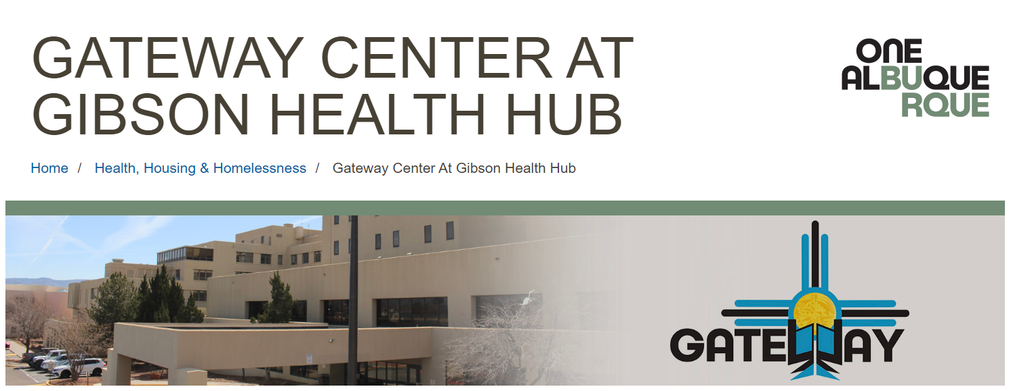

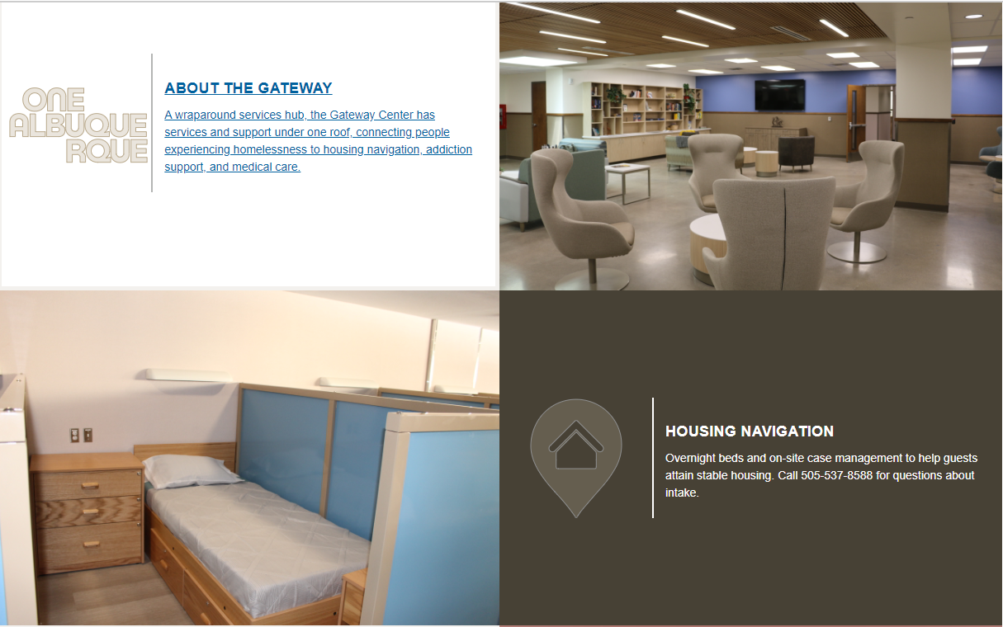
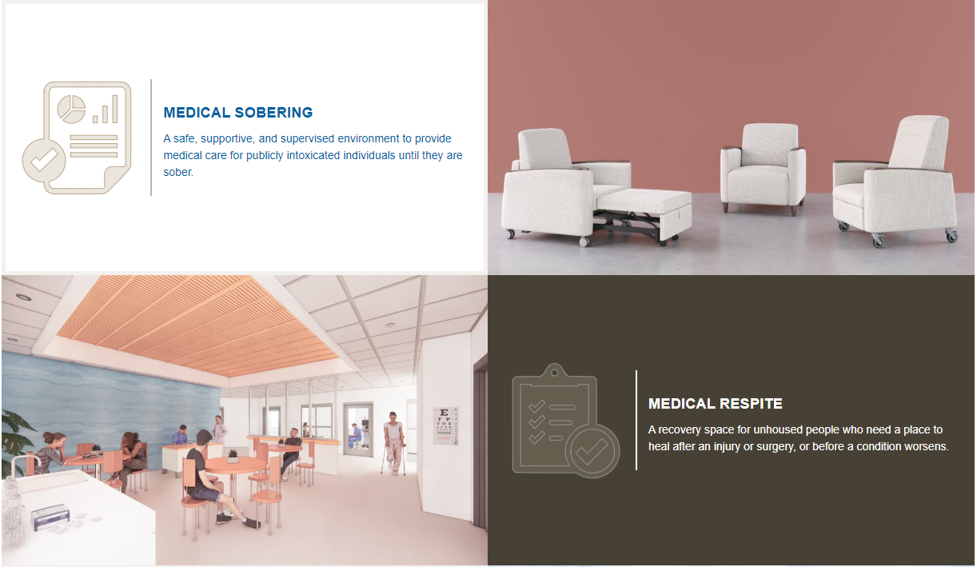
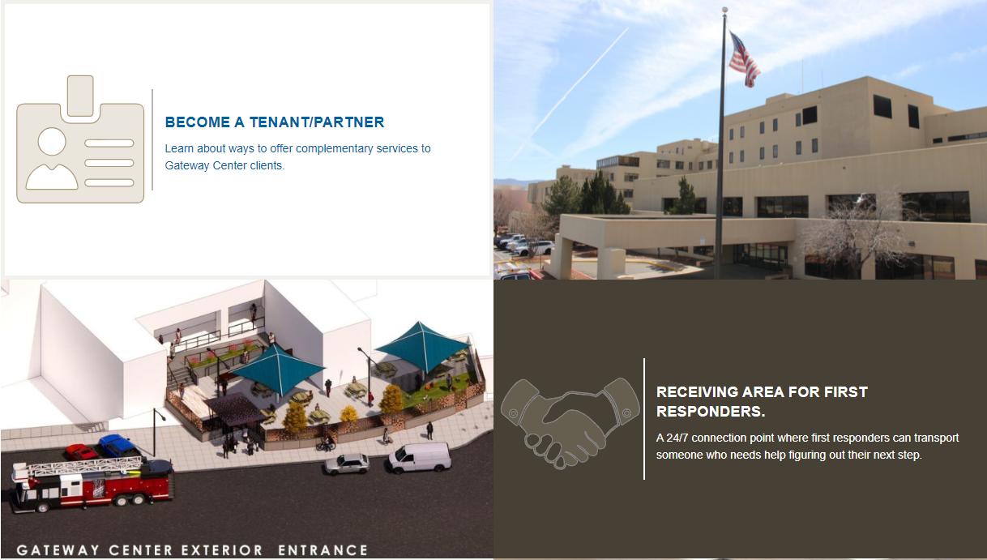
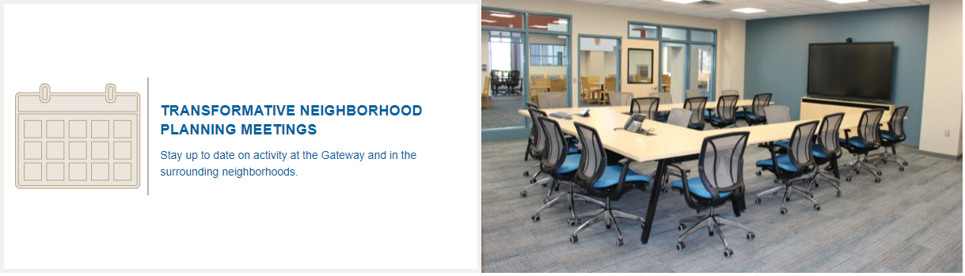
CIU, APD, and BSS Report and Update, Commander Dietzel, Dr. Duranceaux, Lt. Lowry, Sgt. Tinney
- Lieutenant Lowry nominated the Crisis Intervention Division for the Team of the Month for November. We were recognized in the chief’s office. It was a nice little ceremony.
- Commander Dietzel is retiring in the late Spring or early summer at the latest.
- Our unit got 401 referrals and we assigned 80 new cases.
- We were lucky to be able to go to the New Mexico Safe School Summit. Besides the added training, we were able to talk to people about threat assessments and how we could better serve the juvenile population.
- We are thankful to the YMCA and Brenda, who helped us by getting four turkey boxes full for Thanksgiving dinners for needy families. The Homevisit team delivered those to the consumers today.
- The final IMR came out, and the CIU did have lots of good things on it.
- We are working with ACS Clinician Supervisor, John Dodd and Diane Dosil with BCSO to try and better accommodate when an officer is off. We have a clinician, but no cover for that clinician. They have been Our CIU Follow-up detectives can work closely with clinicians to ensure appropriate use. Our CIU Follow-up detectives can work closely with clinicians to ensure appropriate use or possibly go with BCSO officers who are available to them.
- Athens Clark County Georgia came out this last month and they shadowed our unit to learn more about it. They also met with ACS because they are trying to improve their response there.

MHRAC Sub-Committee Report and Updates
Training and Infoshare Sub-Committee
- We combined the Training Sub-committee and Inforshare Sub-committee into one and we will be meeting monthly.
- We had our first meeting in October and it was good but we did not have a set agenda.
- If you have agenda items, please send them to Rachel, Commander Dietzel, or David.
- We are encouraging folks if you haven’t attended a subcommittee and you are interested, please reach out so we can send you an invite.
- A preliminary draft of the Training Sub-committee annual report has been emailed to Paula Burton, Subcommittee Co-chair, and Rachel Biggs, MHRAC Co-Chair, to review. We will get it in before the end of the year.

MHRAC Final Discussion, Rachel Biggs
- We had our first Officer-Involved Shooting (OIS) meeting. We have a sub-committee getting started with that and we are thankful to Commander Dietzel and DC Cori Lowe for bringing it together. We will meet again in January.
- We are working on an ordinance, and Andrew Magida has been very helpful in helping us look at our bylaws and update them into an ordinance to codify. We want to outlive the CASA.

The meeting was Transcribed by Fathom and revised by Brenda Vigil-Gallegos. Board Members, for a copy of the “unrevised” transcription, email bvigil-gallegos@cabq.gov

Next meeting: January 16, 2024

