Mental Health Response Advisory Committee (MHRAC)
Meeting Minutes
November 15, 2022
Via Zoom

Board Members in Attendance
Rachel Biggs Albuquerque Health Care for the Homeless
Cmdr. M. Dietzel Crisis Intervention Division
Mariela Ruiz-Angel Albuquerque Community Safety
David Ley New Mexico Solutions
Gilbert Ramirez CABQ-Dept. of Family & Comm. Services
DC Emily Jaramillo Albuquerque Fire Rescue
Laura Nguyen Albuquerque Ambulance
Robert Salazar NAMI Representation
Dr. Nils Rosenbaum APD Behavioral Science Services

Introduction to MHRAC
The Mental Health Response Advisory Committee (MHRAC) was created by the Court Approved Settlement Agreement (CASA). We’ve been around since day one and have a focus on three areas, resources, and resources being available to access different things within the city that APD and first responders can use as it impacts homelessness and mental health issues. We are also involved in training and policy; training is one of those things we made a tremendous impact on. As far as the training that is offered. Policies are one of those things where the MHRAC is involved with assisting in writing and approving and recommending policy as it relates again to the narrow focus; we think narrow, but sometimes it gets pretty wide-focused on how law enforcement interacts with those experiencing homelessness and those experiencing a mental health crisis.

Roll Call, Max Kauffman
Nine (9) of the Board Members were present (names listed above)

Welcome first-time guests
Susan Buechele, LCSW, Psychotherapist in Albuquerque
Laura Windham, Social Worker

Approval of meeting minutes
1st Motion – David Ley
2nd Motion – Rachel Biggs
Minutes from the October meeting were approved.

Public Comment (Two minutes per person)
None

Nomination of New Board Members, if any, Rachel/Max
No nominations were made

Albuquerque Community Safety Department (ACS) Update, Mariela Ruiz-Angel
Our information and data are available on the ACS Website www.cabq.gov/acs/reports
- We're getting pulled in lots of different ways and excited about that.
- We're excited about all the successes we've had.
- One of the successes, and it's very small, but it's something that we are loving is the connections that we've had with people out in the community.
- We are about to hit 20,000 calls which are above average on where we thought we were going to be going into year two, so we're feeling really strong.
- We are getting ready for an evaluation.
- One of the things that we're also considering is an app on how to potentially bill for Medicaid.
- We are seeing more welfare checks coming; it means we are building that relationship with APD.
- The Fire Department has been the backbone of helping us stand up.
- We are staffed up to be able to handle seven days a week from 6 am to 8 pm.
- We are still citywide. There are pockets of areas to the Westside where we have been getting hit a little bit harder. We try to spend more time in certain areas, especially downtown. We are starting to spread our wings a little bit in areas that we didn’t have the capacity to do.
- We officially have a downtown unit
- We received new funding this year, $2.1 million has been put in reserves
- ACS and FCS are trying to get something sustainable to give the community an understanding of where you can take people during this winter season for emergency warming.
- We have a link on our Website on the left-hand side if you had an engagement with us and you need to pull a report.
- There is also a link if there has been any sort of complaint

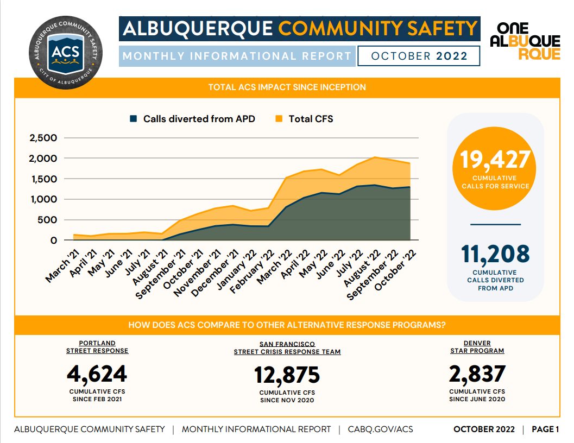
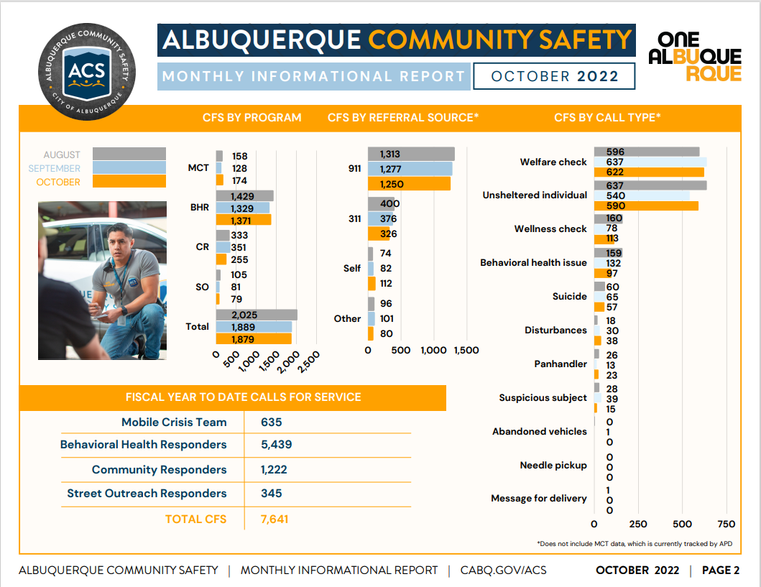
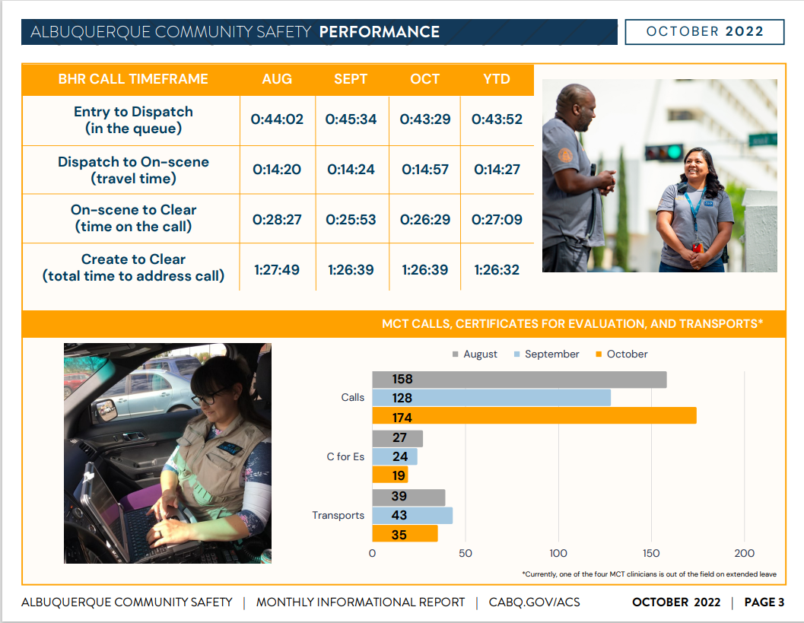
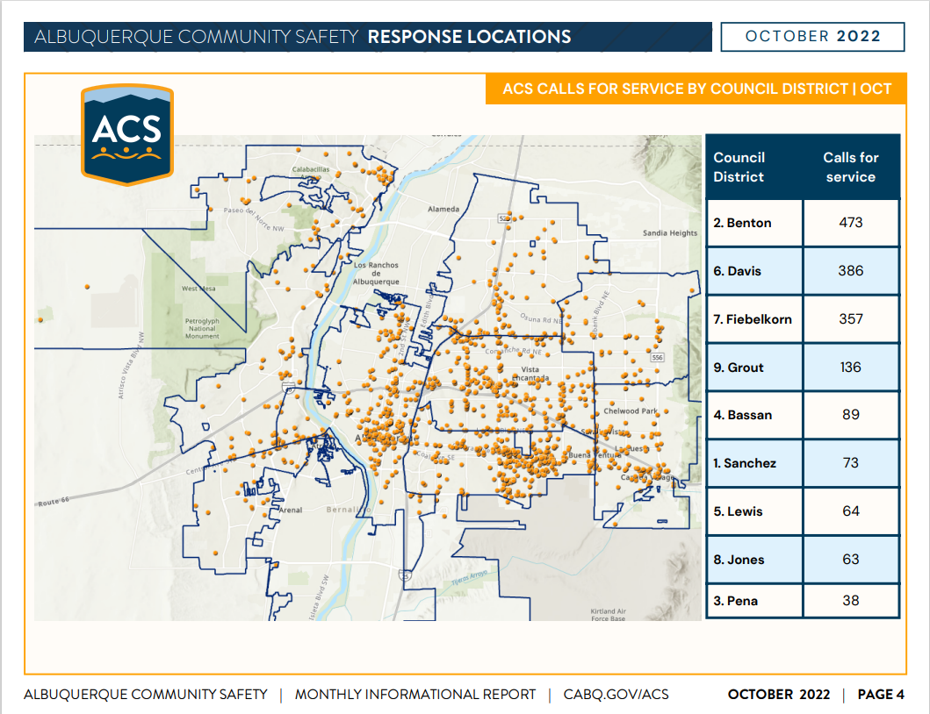
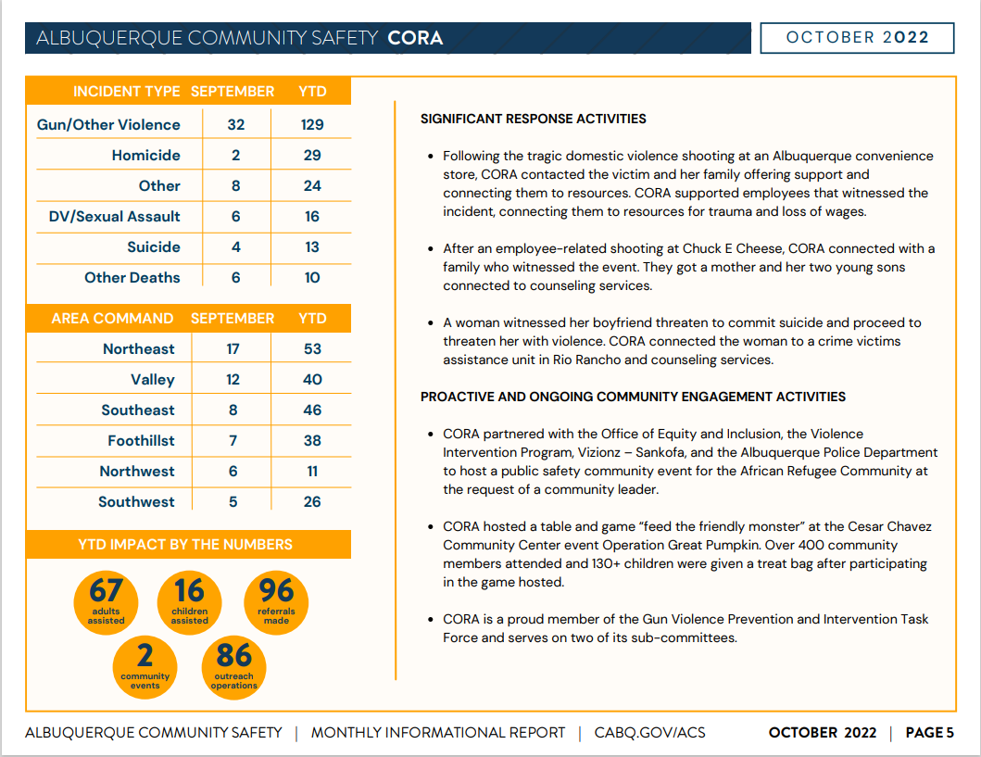
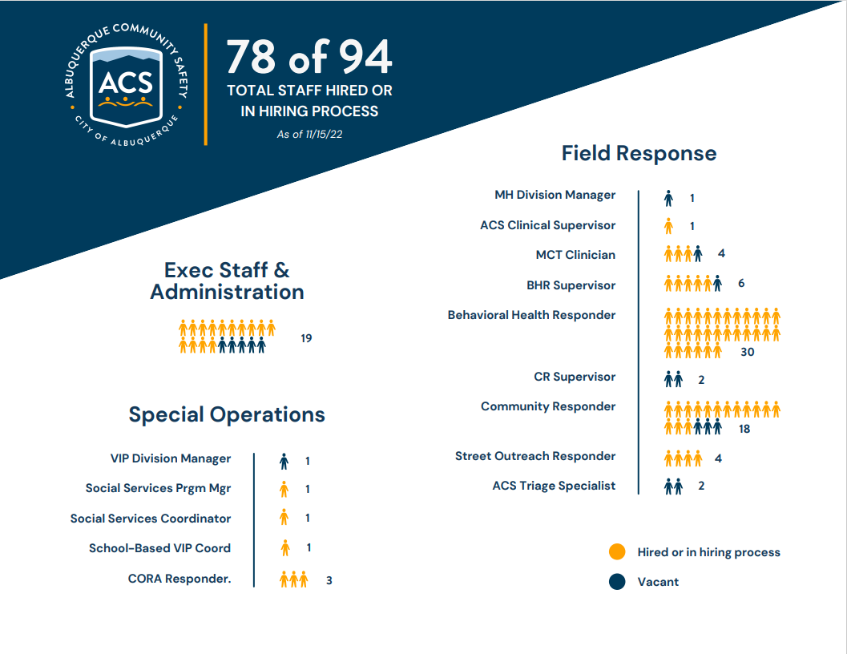

Gibson Health Hub, Family and Community Services, Cristina Parajon and Elizabeth Holguin
- We continue to meet with our first responders to put together that operation plan for the first responder’s drop-off and to have more details of how that system will work.
- We continue to push for opening in sometime early 2023
- We received the DOJ letter and we thank you for acknowledging our presence and communication with the MHRAC. Cristina has been attending every MHRAC meeting. Elizabeth will be attending to give a broader homeless update going forward so people can be aware of all the other things we are working on.
- FCS Director, Carol Pierce is working closely with ACS Director, Mariela, along with community volunteers on warming centers. We are working on getting blankets, sleeping bags, jackets, hats, and socks, to different centers throughout the city.
- Elizabeth went to Houston with several of the FCS staff. Also attending was Jenny Metzler from Healthcare for the Homeless and Alex Pisano from New Mexico Coalition. We learned how they house people; it is a unique way of looking at things and setting priorities.
- We are developing a PowerPoint of takeaways.
- In addition, I was able to go to New Orleans to view the Covenant House. There are about 37 locations around the country. It is a young adult shelter. As many of you know, we have three city councilors that are championing the young adult’s shelter here in Albuquerque, as it was identified as a gap in the CYFD study. We have already begun working with architects to make a floor plan and figure out the best evidence-based design and we are still in search of a piece of land but we've already done a couple of appraisals.
- We had attempted to provide outreach so we gathered that list and did a survey several weeks before Coronado Park was closed. We formulated a case conferencing team to increase collaboration with all of our service providers. We have hired a case consultant; she is a neutral party from Mercia Valley. She has a lot of years of experience as a social worker and has done a lot of case management for this population. She is bringing a lot of good ideas and viewpoints to the group and helping. There are two purposes not only to start getting those people housed but also to break down barriers to housing, try to streamline the process, and help people to realize all the ways that they can work together so that we can more efficiently house people and share resources
Rachel
- In our annual letter, we will add to our acknowledgments about Christina’s participation.
- I would also like to keep the encampments as a standing item under the Family and Community Services Update on the MHRAC Agenda.

Behavioral Science Services Referral Listing, Dr. Rosenbaum
Per the CASA, the MHRAC is to review it periodically for accuracy.

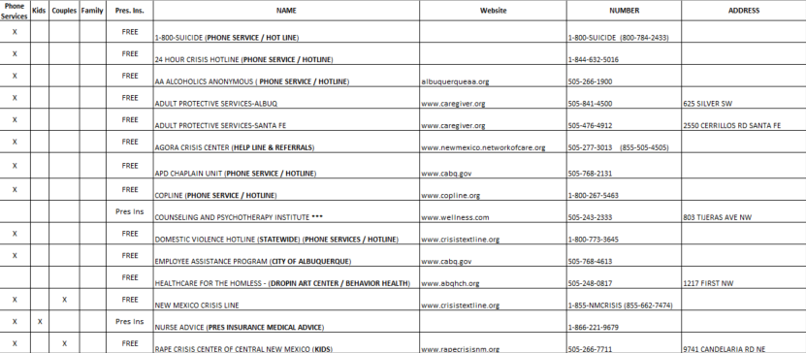
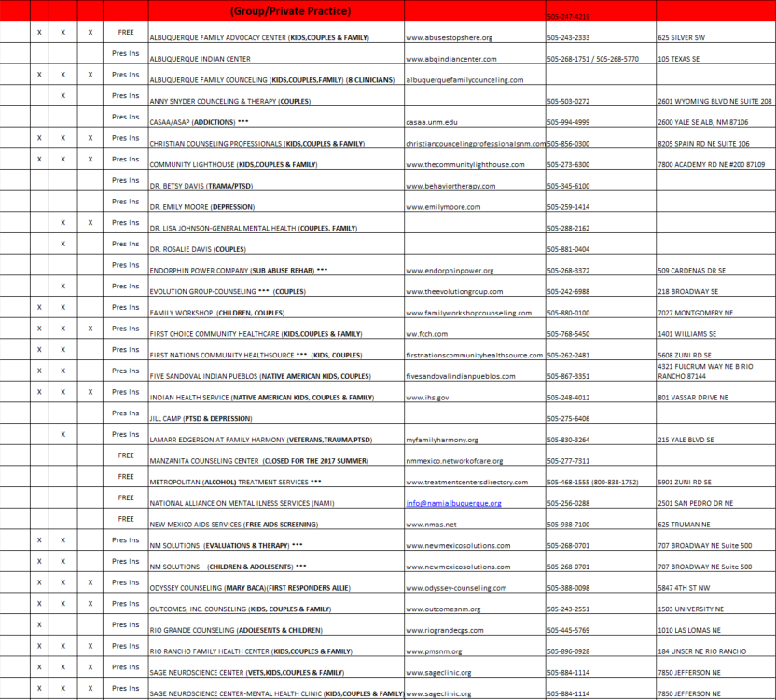
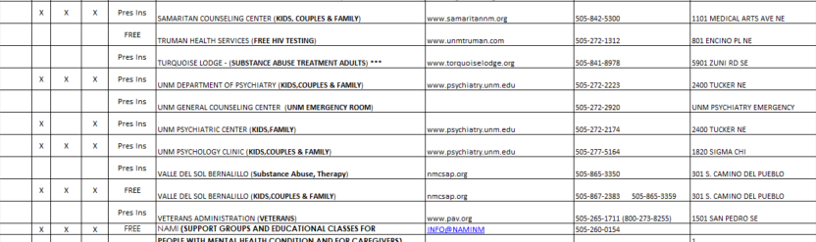

Rachel
Would like for Health Care for the Homeless section to be updated; it has old information.

APD Crisis Data Report December 2021, Commander Dietzel
https://www.cabq.gov/police/documents/december-2021-june-2022_final.pdf

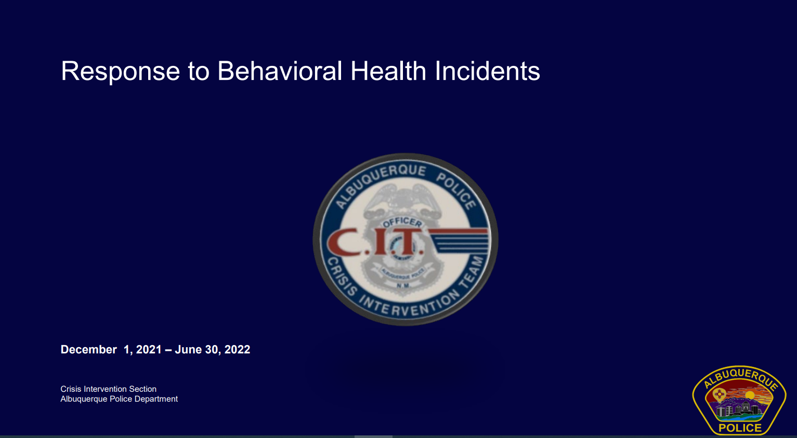

- There is a new data and analytics division that runs all this now which is great because we have people who are trained to run this program
- This runs from December 1 to June 30, instead of January to July. I know December 1 is a weird date but it is because APD transitioned away from an old records management system that we've had since 2008, 2009, to a new report writing system, and so as part of that we were able to move the CIT data report into the same program as the police reports. This is great because it allows officers to write reports in one place. The Crisis Intervention Reports and Incident Reports are in one program. It's caused a slight increase in compliance in terms of fill-out.
- There is a lot of exposition here which is great because if you don’t understand our system too well this can stand by itself without a presentation.
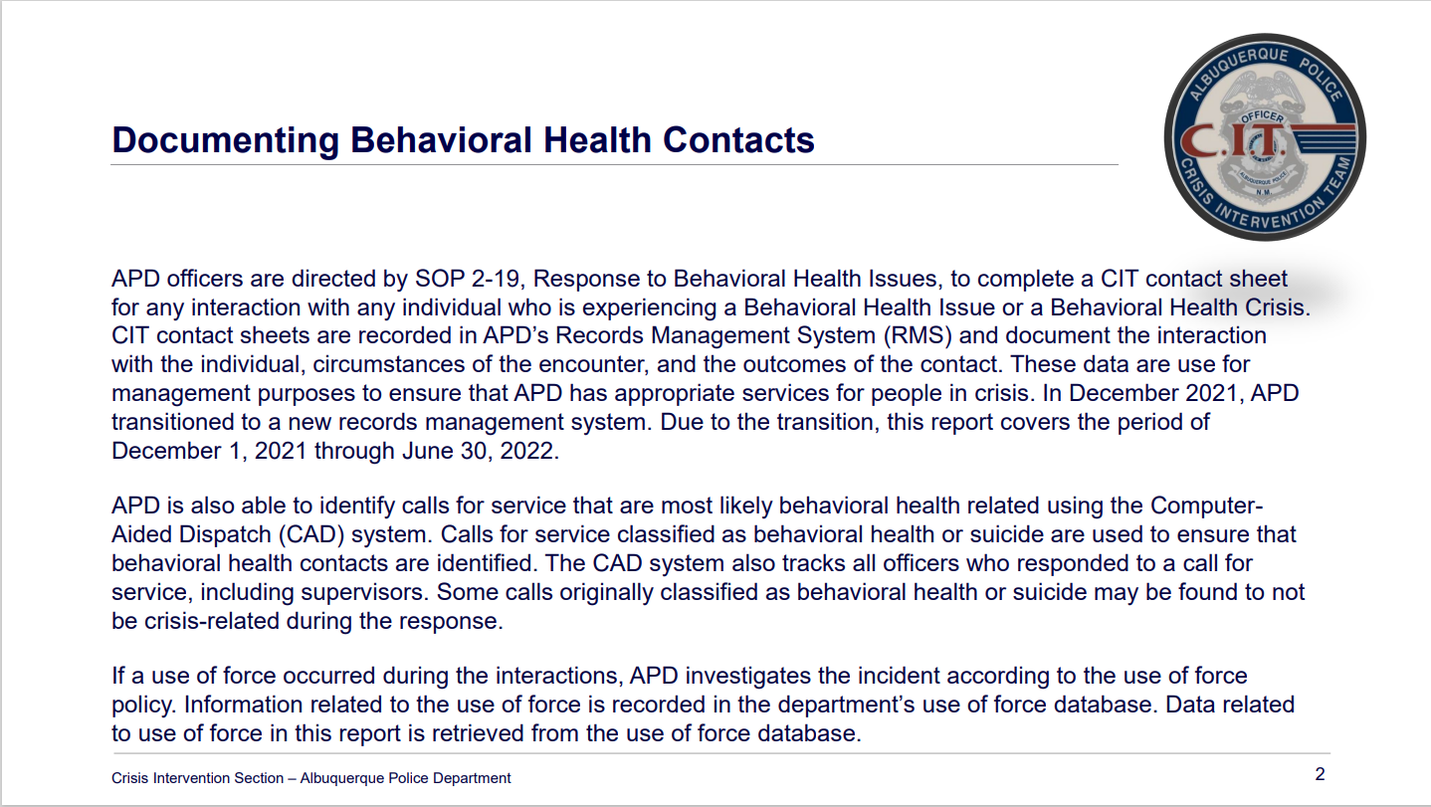

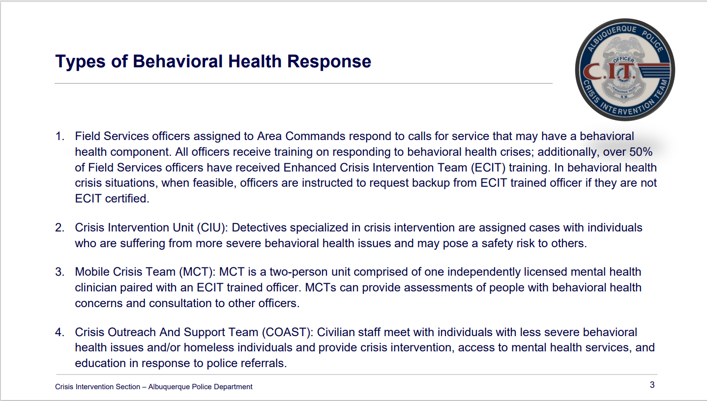
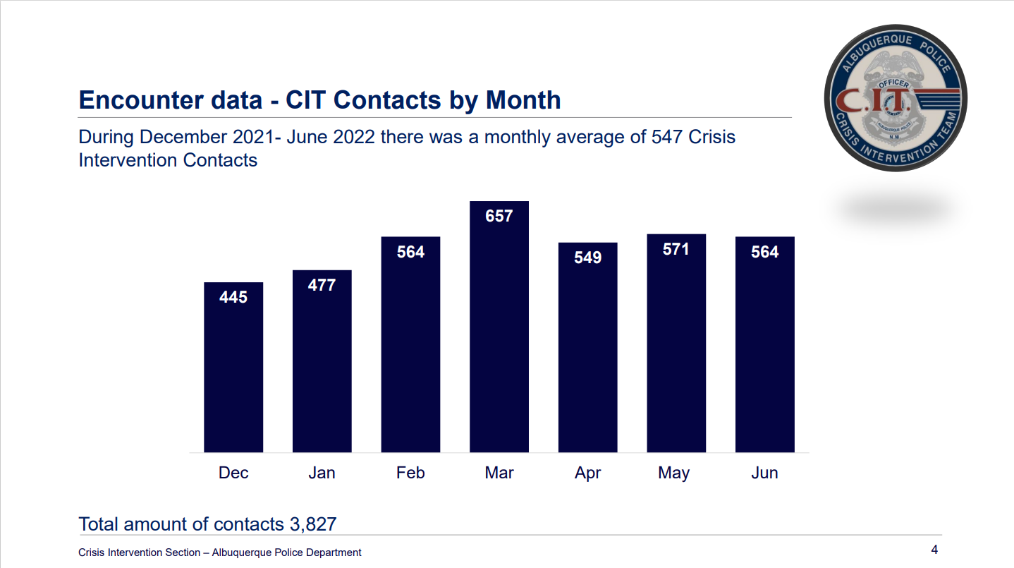

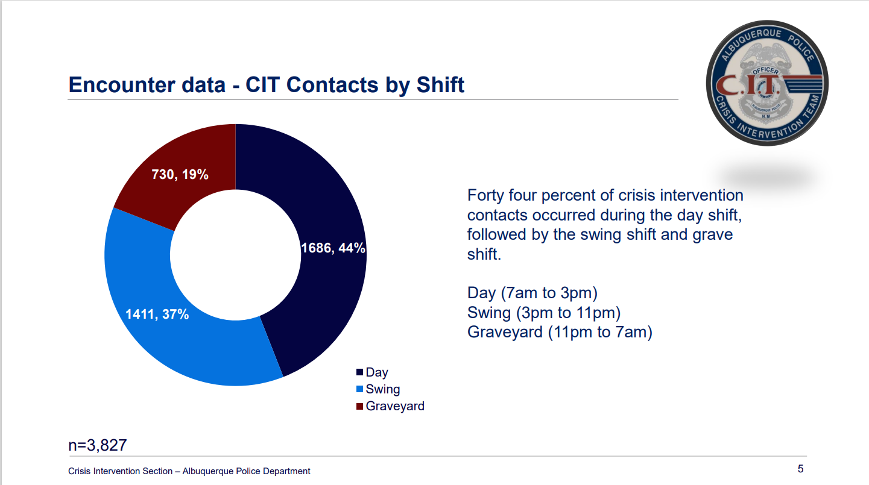
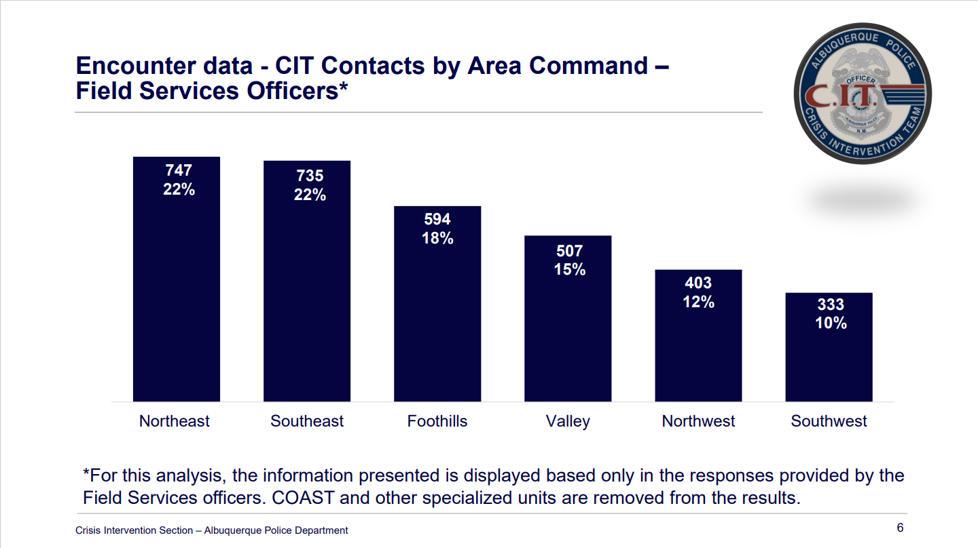

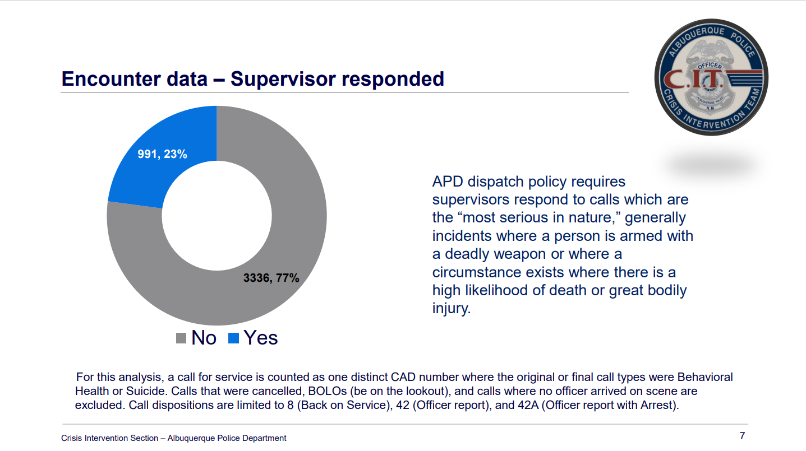
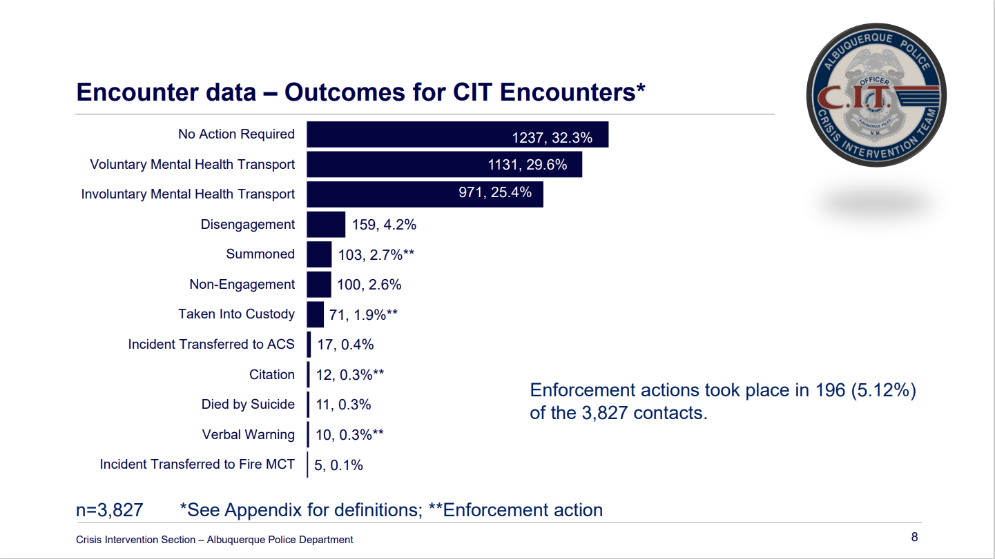

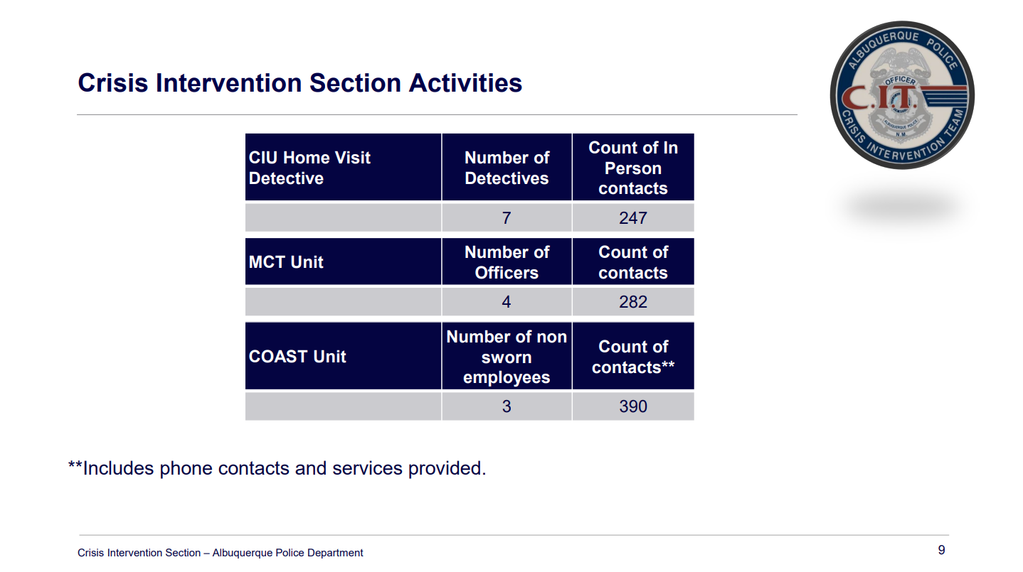
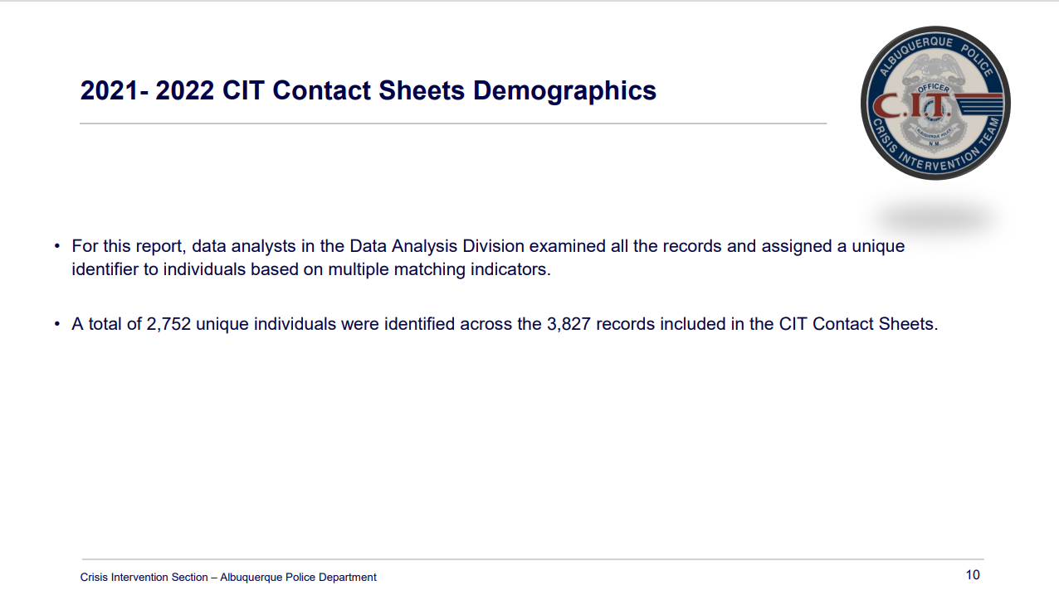

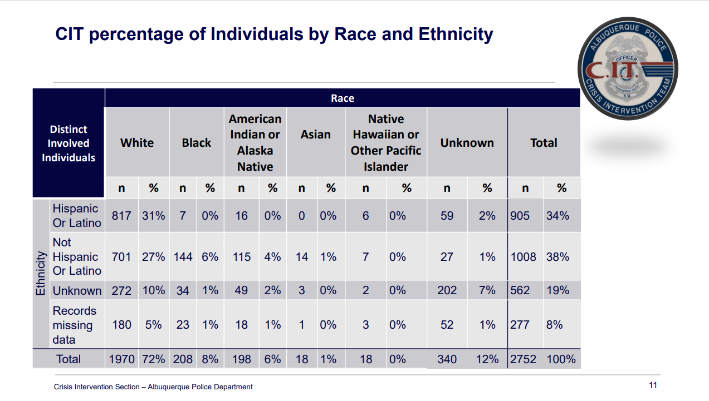

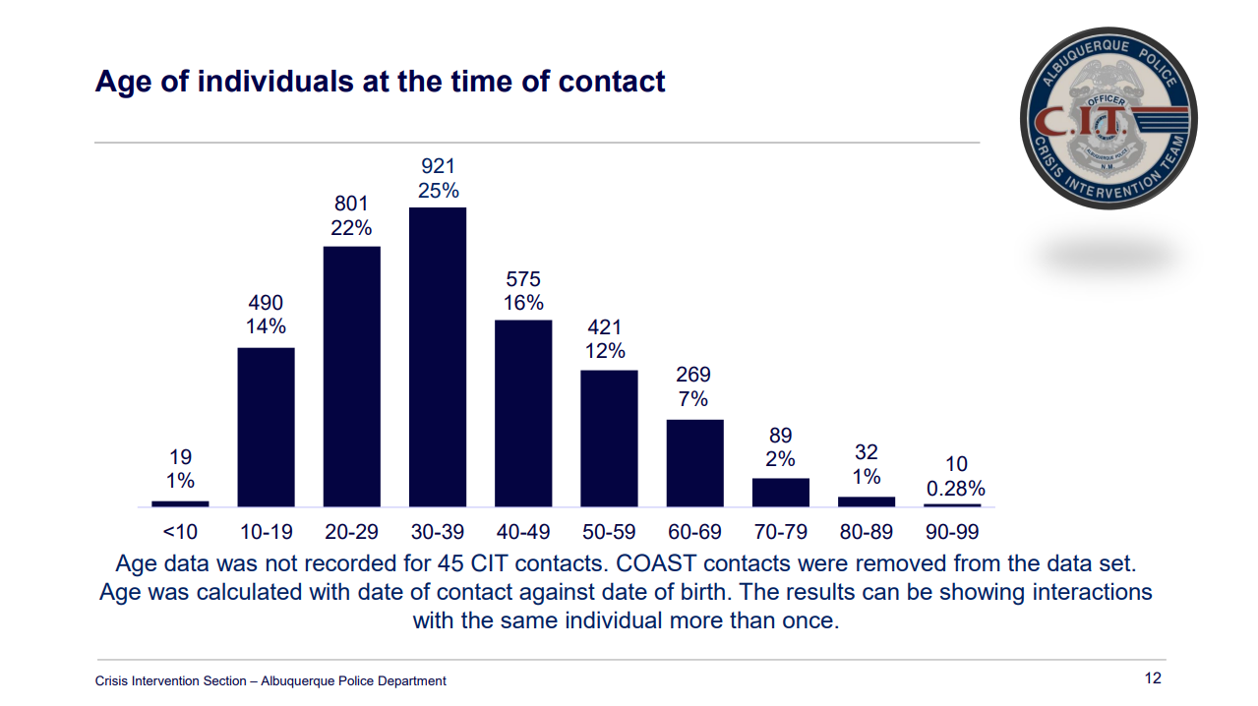

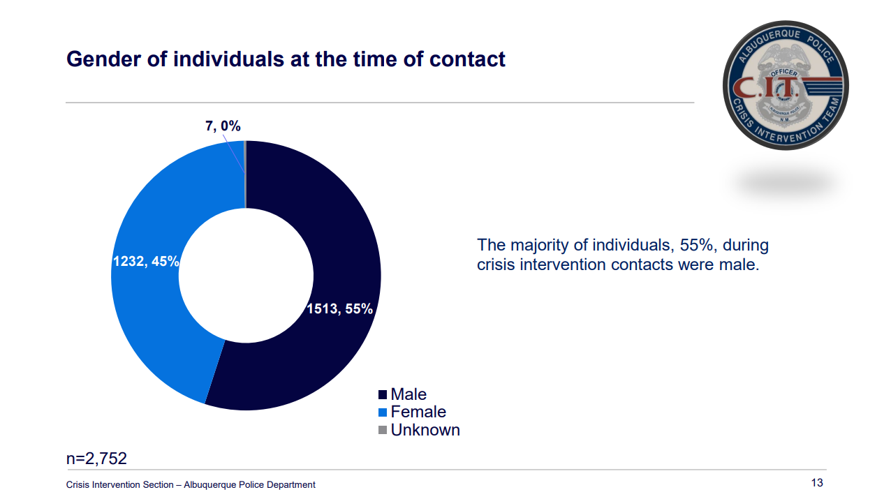
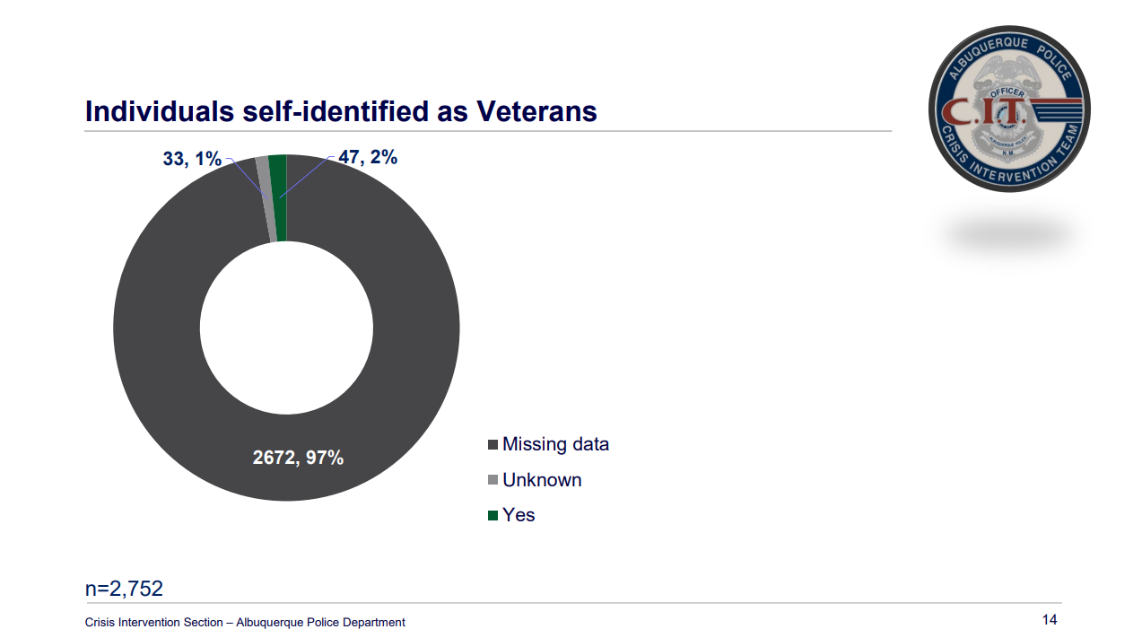

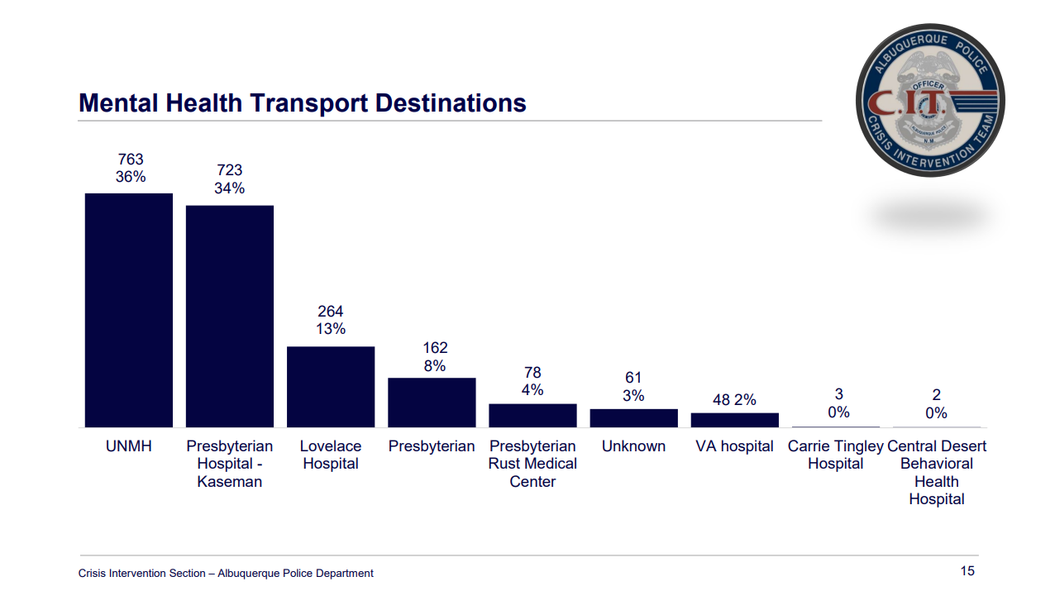
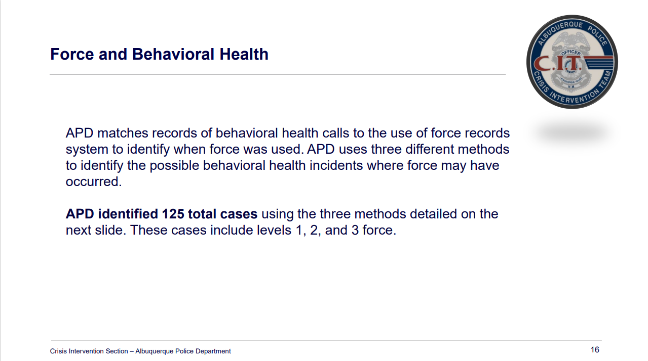

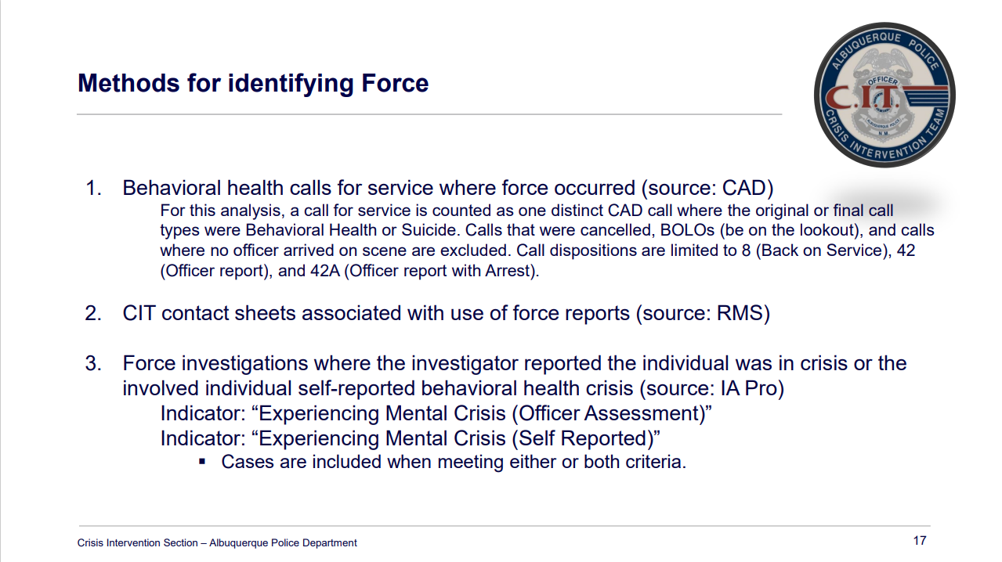

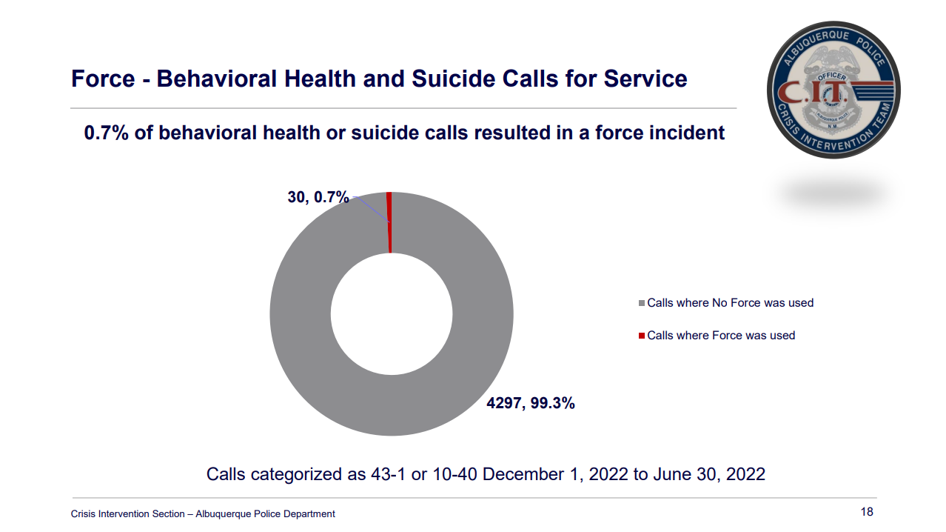

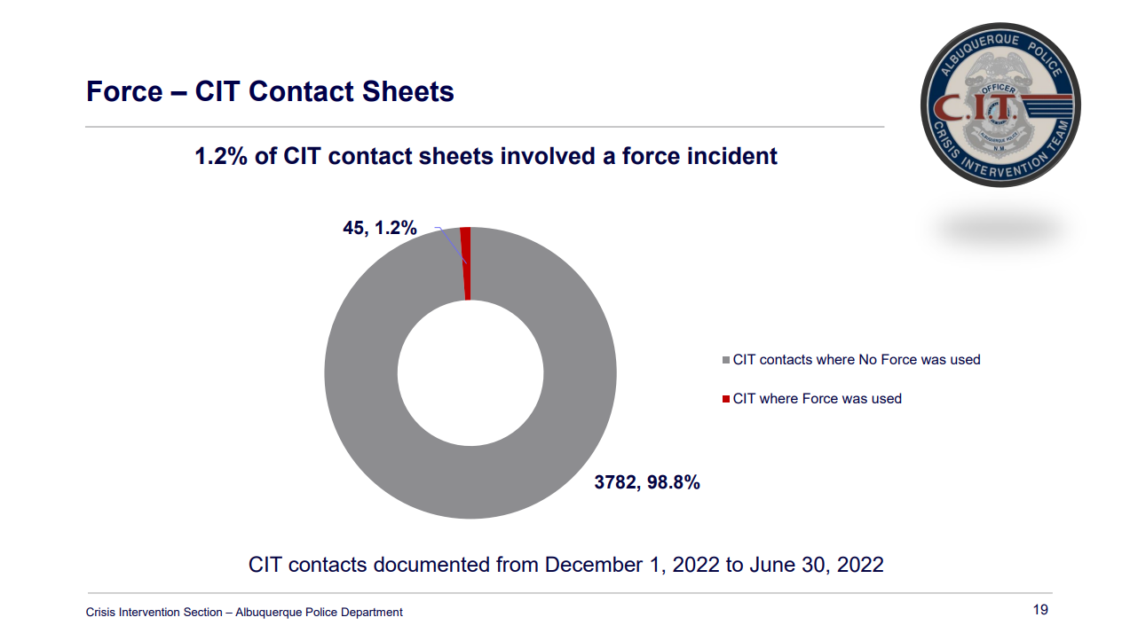
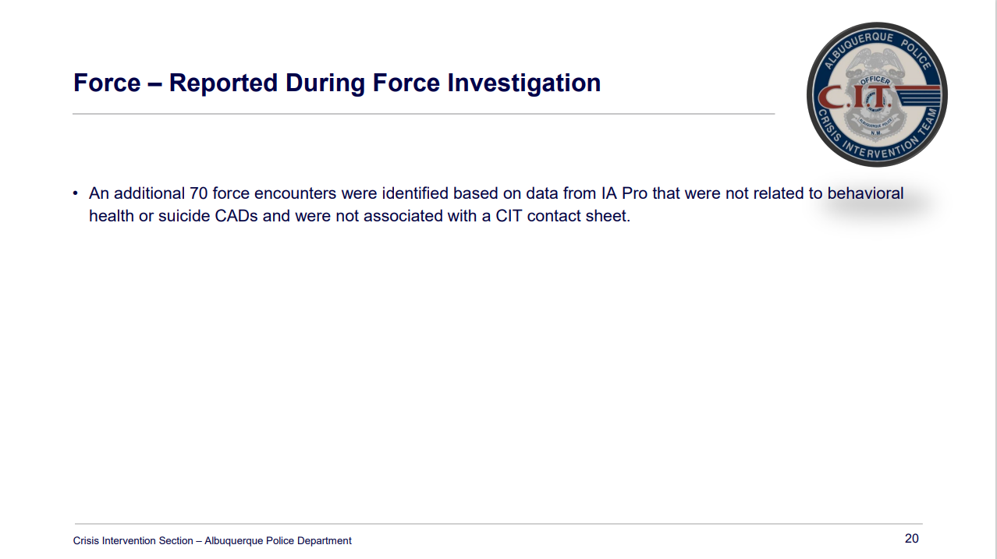

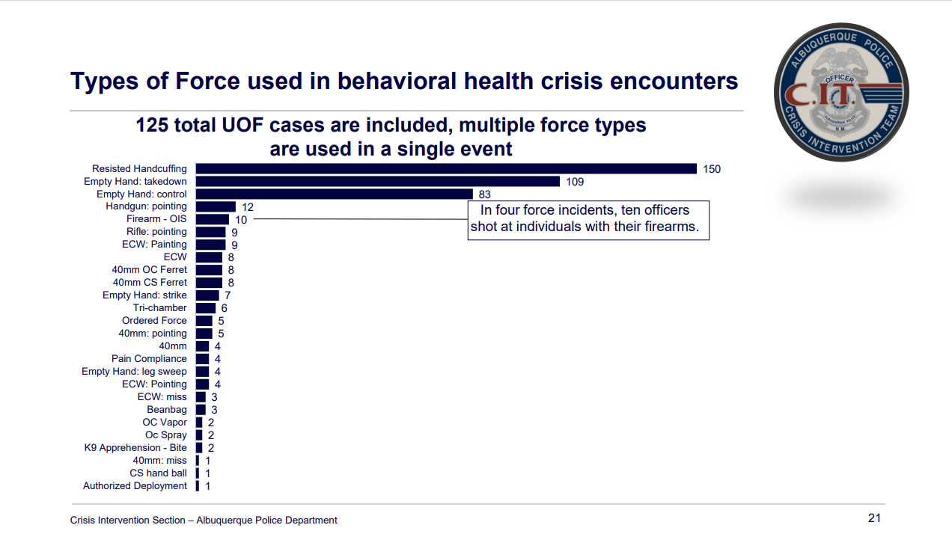
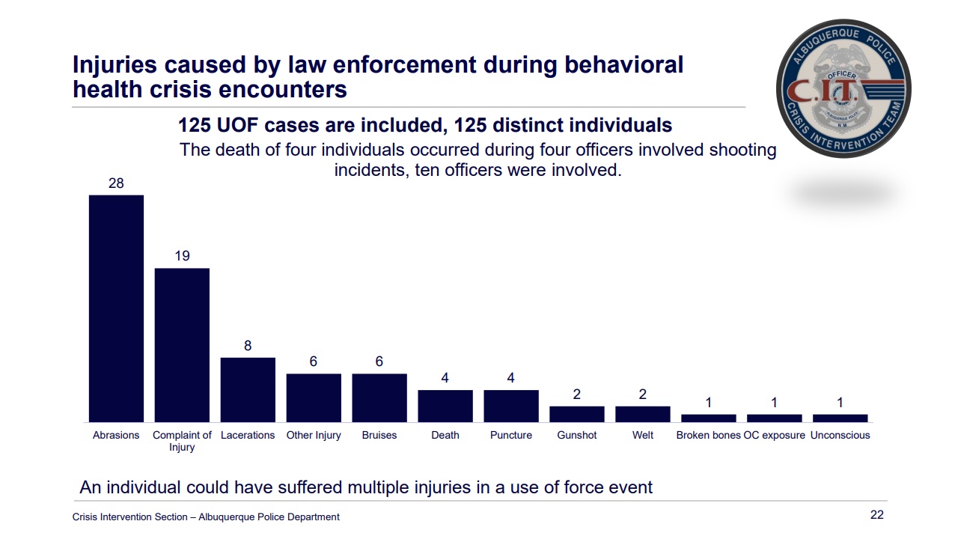

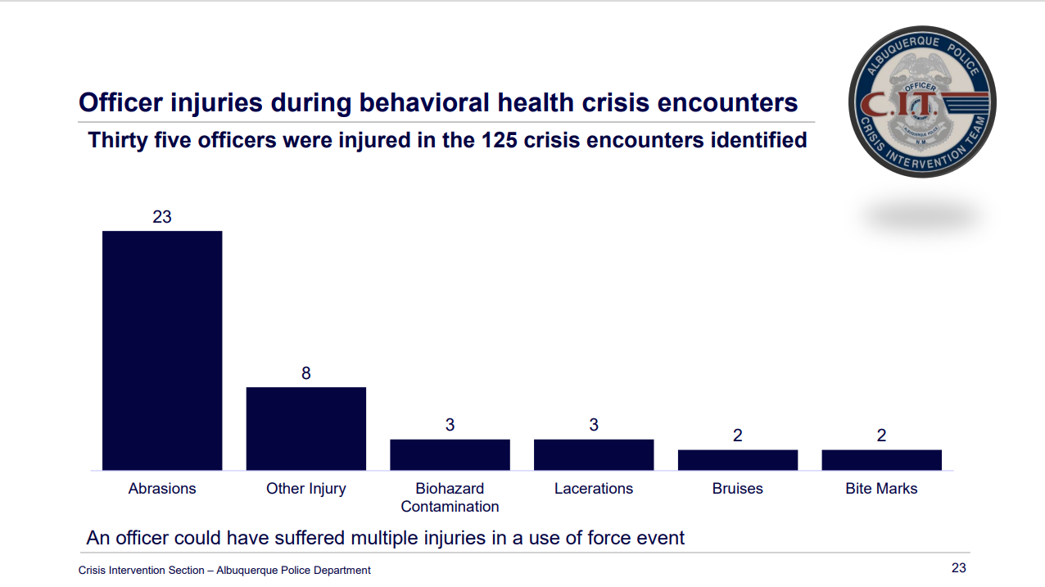
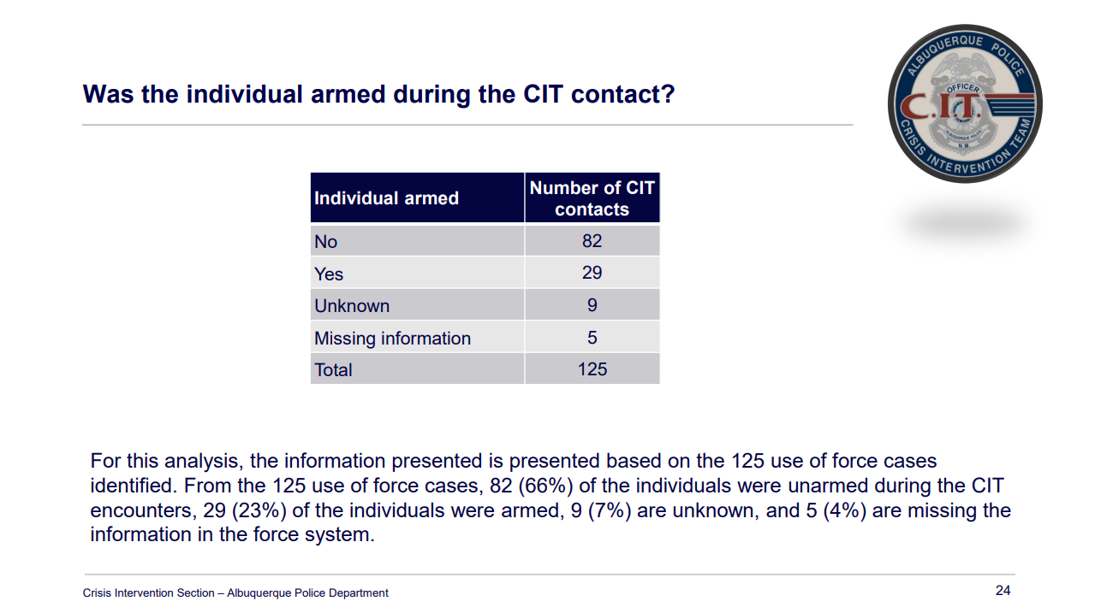

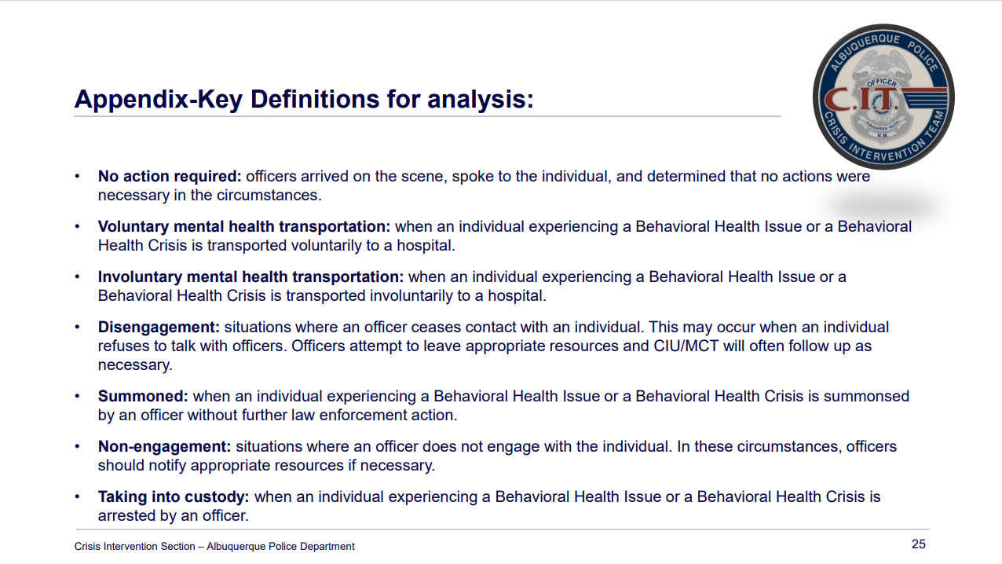
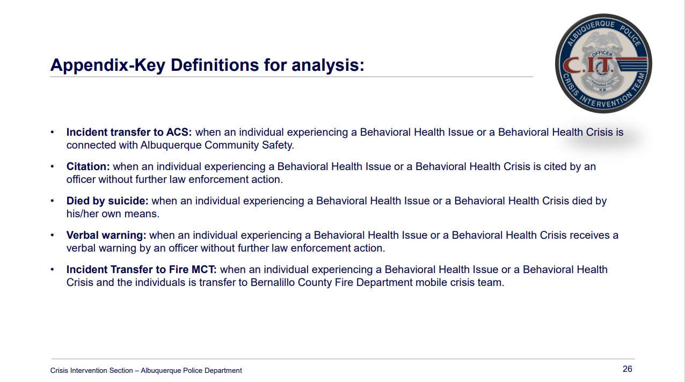

End-of-Year Annual Reports Update
- MHRAC “draft” Annual Report
Pursuant to the Court Approved Settlement Agreement (“CASA”) in U.S. v. The City of Albuquerque, the Mental Health Response Advisory Committee (MHRAC) was created to “assist in identifying and developing solutions and interventions that are designed to lead to improved outcomes for individuals perceived to be or suffering from mental illness or experiencing a mental health crisis.” See Second Amended and Restated Court-Approved Settlement Agreement [Doc. 465-1], ¶ 111 (July 30, 2019). Additionally, it is the responsibility of MHRAC to “analyze and recommend appropriate changes to policies, procedures, and training methods regarding police contact with individuals with mental illness.” Id.
Since MHRAC’s last annual report, the Committee has been incredibly active in engaging with stakeholders and the City of Albuquerque (“CABQ”) to fulfill the Court’s purposes for Committee under the CASA. Discussions at MHRAC have been fruitful and the feedback from participants has been overwhelmingly positive. This is despite the administrative challenges that came with a transition of MHRAC leadership at the start of 2022, which could not have been successful without the support dedicated MHRAC members. Credit is also due to the support rendered by the parties to the CASA who believe in the importance of MHRAC to help improve outcomes. MHRAC is grateful for the parties’ and Court’s continued interest in the success of MHRAC.
MHRAC is happy to report to the Court that relationships with CABQ has improved overall for the purpose of collaboration and inter-departmental coordination. The effort to get to this point has not been without its challenges, however, and some concerns remain to be worked out in 2023. It was an early success of 2022 for MHRAC to establish stronger lines of communication with the city’s relatively new department, the Albuquerque Safety Department (ACS), and in fact creating MHRAC membership space for ACS. While connection with ACS improved, it did not go without notice that MHRAC was missing vital collaboration with CABQ on issues affecting those experiencing homelessness.
Most troubling, here, was the lack of involvement MHRAC had with the Mayor’s decision to remove encampments at Coronado Park. MHRAC has repeatedly sought involvement on issues such as Coronado Park, well before 2022. Prior to the encampment sweep of Coronado Park, MHRAC co-chair, Max Kauffman, alerted counsel for CABQ of MHRAC’s desire to be involved in the process to support the City in making the process as successful as it could be. Counsel for CABQ declined to respond and the encampment sweep proceeded unexpectedly without the critical input MHRAC was willing to offer. Although this was incredibly disappointing and damaging, MHRAC does recognize the subsequent efforts of the Family and Community Services Department Director, Carol Pierce, to attend MHRAC and offer the departments intention to work more closely with CABQ. Additionally, the department’s Deputy Director of Homeless Solutions, Elizabeth Holguin, has been instrumental in helping to keep MHRAC at the table of decisions related to chronic homelessness. MHRAC sincerely hopes the dialogue on the pertinent issues continues to go in this positive direction, but the rebuffing of MHRAC’s efforts to engage in the Coronado Park sweep remains a concern with respect to future decisions.
MHRAC continues to enjoy a productive relationship with APD, and CIU in particular. It is incredibly encouraging that APD has utilized MHRAC to workshop difficult issues officers come across in the community, and consider the feedback MHRAC gives. MHRAC believes this is exemplary of how reform happens in a productive and respectful manner. However, MHRAC is far from its potential to assist APD in reform efforts. Both fatal and non-fatal uses of force continue to occur in circumstances involving a behavioral health crisis. At a Status Conference the Court held on October 5, 2022, MHRAC alerted the Court and parties that it appears MHRAC is missing crucial data to interpret trends and outcomes of such uses of force—which appear to happen outside of CIU. Since then, APD has committed to supplying MHRAC with this data so MHRAC can deliver more targeted advice to improve outcomes. This too is encouraging and commendable.
Looking forward to the coming year, MHRAC will seek to improve its process and impact. Focus for MHRAC needs to continue to be in the recruitment of active participants and the establishment of current bylaws acceptable to CABQ for a congruent codification into City Ordinance. MHRAC will also build on the success of publishing policy feedback and will continue to improve transparency for the public on the policy review process. In the coming year, MHRAC will work to detail the process for feedback to CABQ policies pertaining to the CASA on its website. MHRAC will continue to seek guidance and support from CABQ to see that MHRAC becomes a permanent fixture beyond the life of the CASA.
MHRAC thanks the Court and the parties for the time and attention to this, and MHRAC hopes to report on its continued success in the coming reporting periods.

- MHRAC Information Sharing, Policy, and Resources Subcommittee Annual Report 2022
Prepared by: MHRAC Information Sharing and Resource Subcommittee, November 2022
Committee Members: Karen Navarro, Rob Nelson, Lisa Chavez, Delia Munoz, Gilbert Ramirez, Kevin Arthun, Maxwell Kaufman, Jeremy Lithe, Ellen Braden, Paula Burton, Mary Perez, Emily Jaramillo, and Matt Dietzel
Information Sharing, Policy, and Resources Subcommittee
The purpose of this MHRAC Subcommittee is to help develop protocols that govern and release and exchange of information about individuals with known mental illnesses and to protect their confidentiality. This subcommittee also provides feedback on Albuquerque Police Department policies regarding APD’s response to individuals experiencing homelessness or behavioral health crisis. Additionally, this subcommittee works to help APD identify new mental health resources in the Albuquerque area.
Subcommittee meeting topics in 2022 included:
- City Encampment Response
- The impact of the new Suicide and Crisis Lifeline, 988
- The MHRAC Resource Card Update
- APD’s Response to individuals diagnosed with Dementia
- APD’s Crisis Intervention Division Handbook
- Process for Policy Review
- Recap of CID’s presentations at CIT International in Pittsburg, PA
- Monthly updates from the Albuquerque Community Safety Department
Major Projects of the Subcommittee in 2022
Resource Card Update
Thanks to the hard work of subcommittee members Karen Navarro, Delia Munoz, Kevin Arthun and Jeremy Lithe, the updated and revised 2022 version of the MHRAC Resource Card was printed in September. The cards include information broken down by category including recovery services, food assistance, drop in centers, victims of violence and much more. The first print run was 5,000 cards which have been distributed to all APD substations, several libraries and many other locations throughout the city and county. The Albuquerque Community Safety Department also printed additional copies of the card for their responders. Due to APD demand, an additional printing is expected in December.
Policy Reviews
This year, the subcommittee gained an additional responsibility, the review of APD policies. With this change, and consistent with APD’s policy of 14 day policy review by MHRAC, policies are reviewed either in this subcommittee or at the larger MHRAC meeting, depending on when the policy is sent to the board. Policies Discussed included:
- APD SOP 2-80 Arrest, Arrest Warrants and Booking Procedures
- APD SOP 2-59 Extreme Risk Firearm Protection Orders
- APD Special Order 22-46 Process for Responding to an Unlawful Encampment on Public Property
- APD SOP 2-85 Certificates for Evaluation
- Albuquerque Community Safety Policy Reviews
Goals in 2023
- Review and update the MHRAC Resource Card
- Explore a Spanish Language version of the Card
- Continue to advise on the Gibson Health Hub/Gateway Center
- Continue to collaborate with UNM and Bernalillo County on the Crisis Triage Center

Rachel
Infoshare Sub-committee Annual Report - I am hearing no objections to approving unanimously the Inforshare Report.

David Ley
Training Sub-committee Annual Report – We are reviewing a draft on Monday, November 28th, and we will present it at the December meeting.

Rachel
Let the meeting notes reflect that we have approved the Infoshare Annual Report and we have tentatively approved the MHRAC Annual Report pending any new comments from members that are not here tonight by 5 pm on Friday. We’ll send out that email.

CIU, APD, and BSS Report and update, Commander Dietzel
The CIT 40-Hour is going on right now. The Coordinators are working hard during that training. The HomeVisits Team continues to be amazing; they are helping tons of people out there.

Sub-Committees Report and Updates
Commander Dietzel-Infoshare Sub-committee
- The big thing we focused on this month was the Infoshare Annual Report. I am starting to work on policy revision for 2023, so the sub-committee will start getting very busy in January.

David Ley – Training Sub-Committee
- We are scheduled to meet Monday, November 28th.

MHRAC Final Discussion (5 minutes)
Will we be needing a December MHRAC meeting? I would like to hear the thoughts from the committee members or do we settle anything that we need to settle over email?

The recommendation is to postpone the meeting and meet by email. Typically the meeting attendance is low that week so we may not have a quorum. No one disagreed and therefore the next MHRAC meeting will take place in January of 2023 and we will deal with any MHRAC business over email.

Next meeting: January 17, 2023

