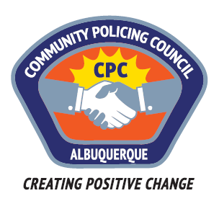

Agenda of the Northwest Area Community Policing Council
Regular Meeting
Tuesday, March 21, 2017
Northwest Area Command
10401 Cibola Loop NW
Albuquerque, NM 87120

- Call to order
- Approval of agenda
- Approval of February Minutes
- Area Command Update
  - New officer Q&A
- CPOA/POB Update
- Presentation: APD CASA Update – Agency’s 5th Report
- Old Business
  - Recommendation responses
- New Business

- Matters from the public
- Adjournment

