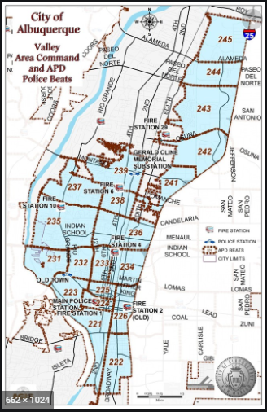 | VALLEY AREA COMMAND MONTHLY NEWSLETTER  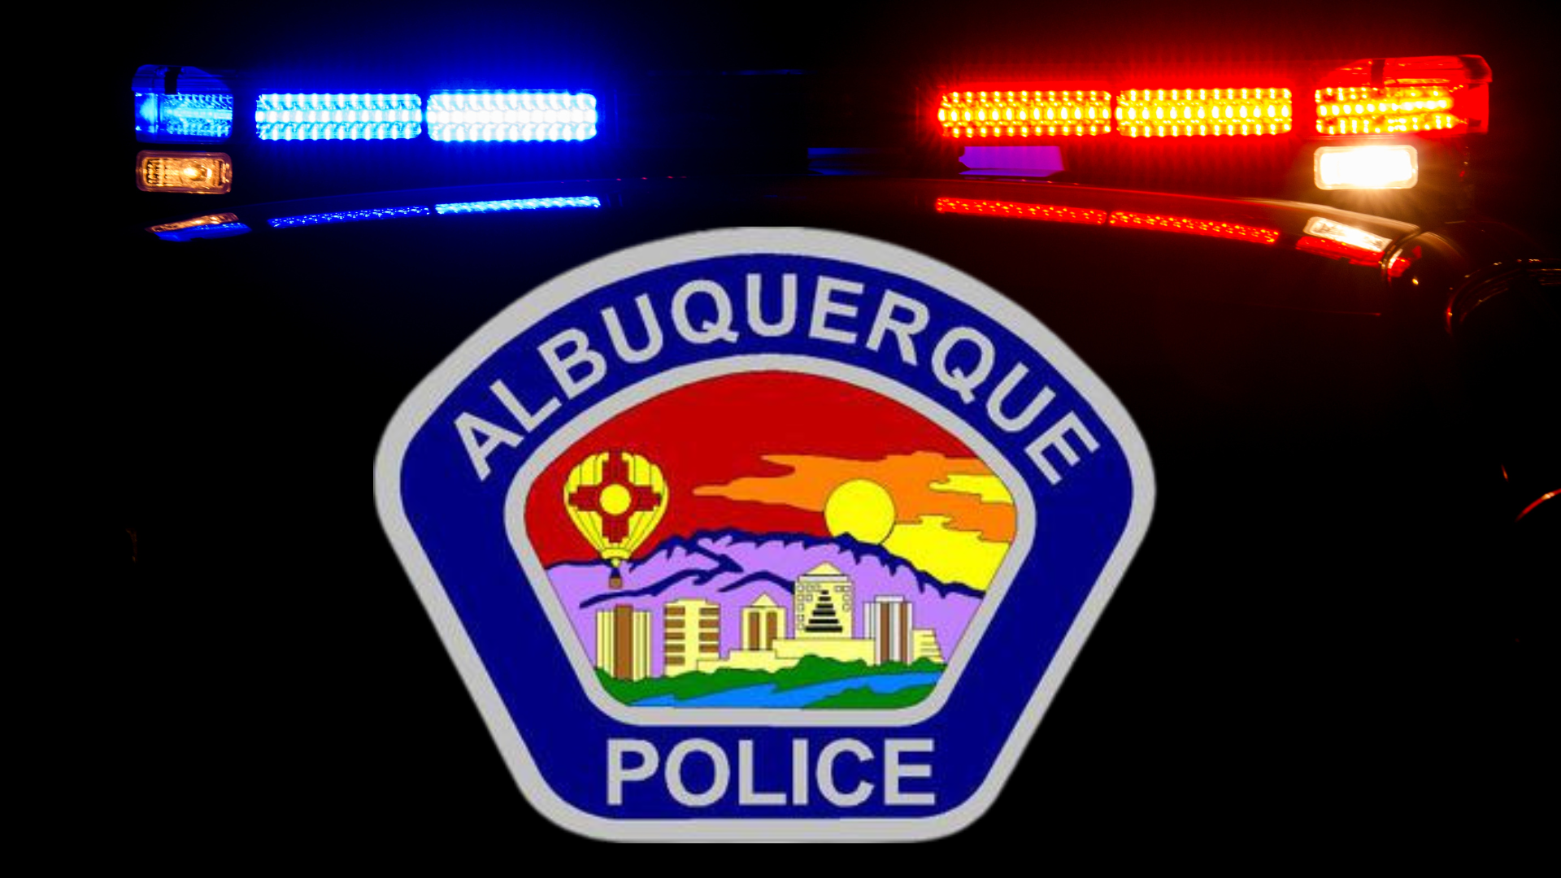  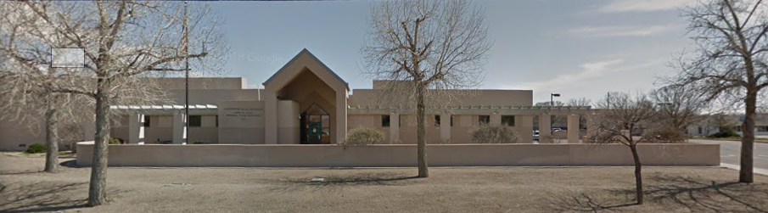  The Valley Area Command is overseen by  Commander Nick Wheeler  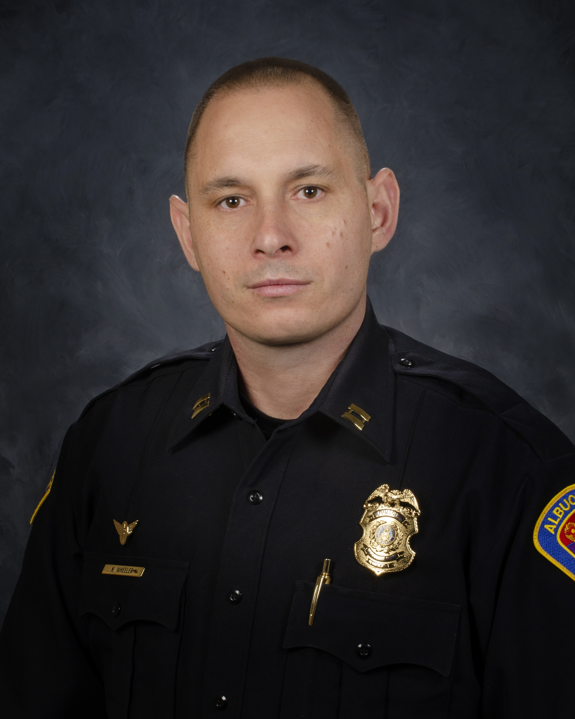
  April
  2024
  Gerald Cline Substation
  5408 2nd St NW
  Albuquerque, NM 87107
  505-761-8800
  The Valley area is bordered by the Albuquerque city limits to the north and south, Interstate 25 to the east and the Rio Grande, Los Ranchos de Albuquerque, and the North Valley to the west
 | Commander’s Corner  I have noticed that community members and visitors have been reluctant to contact please due to fear of retaliation, lack of care or belief that nothing will be done when it comes to violations of law. Please continue to report violations or concerns to the police department via or Emergency Communication Center, Police Substations or through our new, updated app which can be found in your app store. (Atlas 1). You will create an account. Once an account has been created, you will click on the myABQPD bubble and you will be able to call the police, go to our website and send a message to our team to report non-emergent situations.  I again invite and will continue to stress the importance of community involvement with our department. I invite you to take part of our monthly Citizen Policing Council meetings that occur the third Thursday of each month. If you would like to participate in any discussion, have interest in joining the board or would like to attend please contact Kelly Mensah at kmensah@cabq.gov and he will get you all of the details.  We have been in our new bid assignments for a little over a month now. Everyone new to the area command has seen to be settling in nicely and are extremely motivated. We continue taking numerous people to jail related to drug use in open air settings. Those individuals using drugs without care in open spaces, along roadways and even in front of police buildings has made it evident that the fentanyl crisis is huge. If you have friends and/or loved ones please ensure they get the help and support they need. You can also reach out to the following local resource centers:  Turning Point Recovery – (505) 217-1717  New Season Treatment Center – (505) 445-2400  The Evolution Group – (505) 242-6988  State of Heart Recovery – (505) 206-0288  (ACS) Albuquerque Community Safety  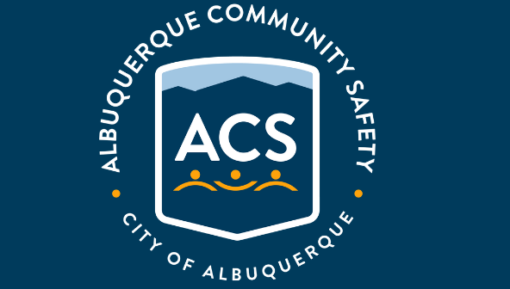  Albuquerque Community Safety Administration (ACS) – Call 311, 242-COPS or 768-4227 acs@cabq.gov – ACS sends trained professionals to non-violent and non-medical 911 calls for service involving issues such as mental/behavioral health, homelessness, and addiction as well as non-behavioral issues such as abandoned vehicles and needle pick-ups.  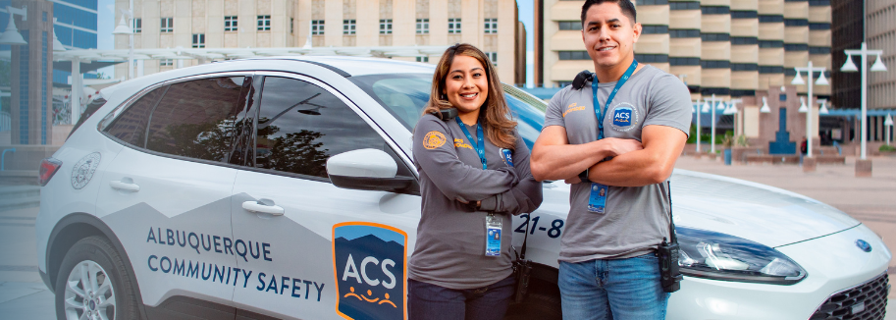
    - 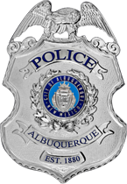
  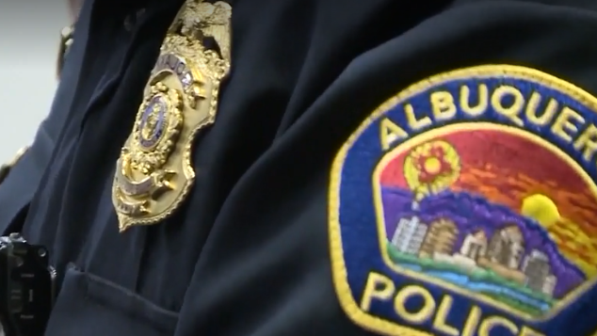
  V
  A
  L
  L
  E
  Y
  AREA
  COMMAND
  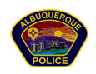

Valley Crime Prevention Specialist  Brittany Martinez  5408 2nd St NW  Albuquerque, NM 87107  505-761-8805  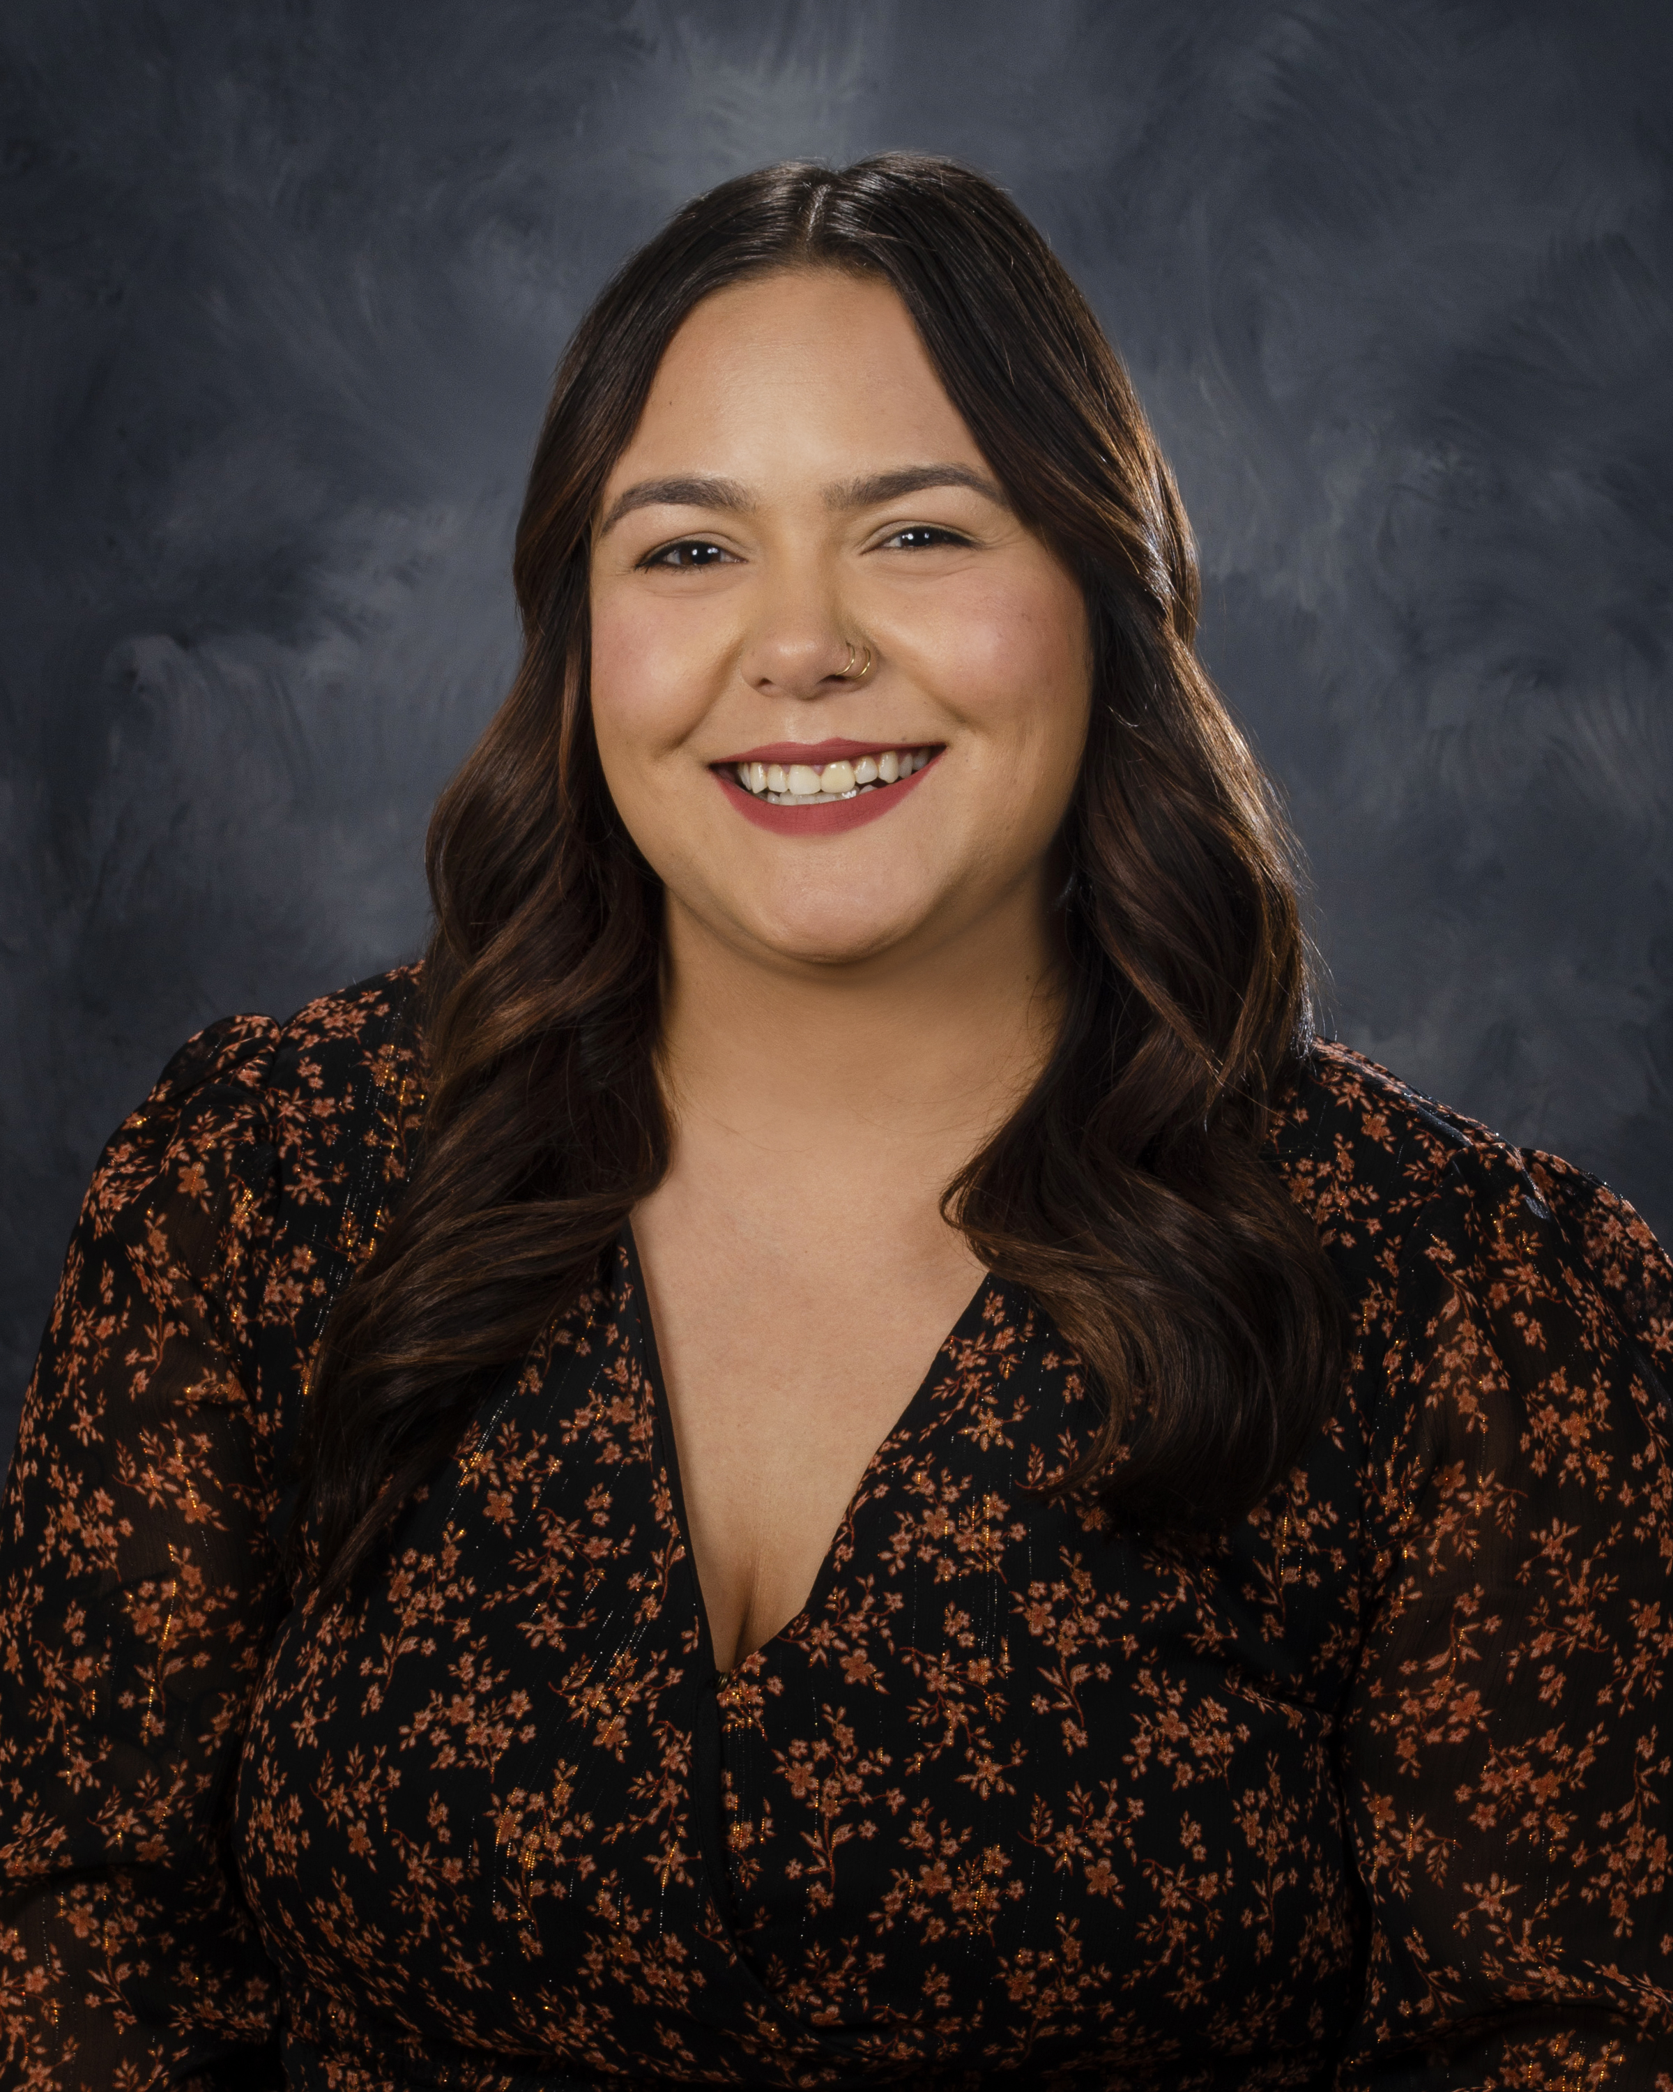  Brittany Martinez, our Valley Crime Prevention Specialist is here to help answer any questions you may have related to crime prevention, neighborhood watch, or APD involved community events.  brimartinez@cabq.gov  505-761-8805   | Crime Mapping Info & (Safety TIPS)    The Valley Area Command uses the Computer Aided Dispatch (CAD) data to determine crimes that happen in the area. When a response is indicated, the information received from the caller will be entered into the CAD for a response. The information from the caller allows ECC staff to determine the priority of the call, how many officers to dispatch, and it provides the officers with vital information so they can determine what action to take as they respond to a call for service.  Residential Burglaries  (TIP)-It is always good practice to make it look like someone is home at all times. Turn a radio on to a talk show station when you are gone, this will make it appear that someone is inside of your home.  Commercial Burglaries  (TIP)-If your business is closed, we recommend that you check your property periodically, be sure to leave lights on and clean up any debris or growth around the property. These small steps may deter a criminal.  Auto Burglaries  (TIP)-Be sure you are keeping your belongings out of site and remove anything of value. It is a great idea to pack a bag with items you need for the day and take it with you when you get out of the vehicle.  Stolen Vehicles  (TIP)-Using devices such as kill switches, alarms, clubs and locking doors and windows, also try to park in an area with good lighting to try to deter a criminal.  Carjacking  (TIP)- Always be aware of your surroundings. Pay special attention when you are at a standstill such as when you are at a stop light or in a parking lot. Keep doors locked, roll up your windows and notice who is in the immediate area.  Robbery to an Individual  (TIP)-Use situational awareness, look around, walk with confidence, make eye contact and read peoples body language. If you do find yourself in this situation give them whatever possession they are demanding, remember, possessions can always be replaced – you, cannot.  Commercial Robbery  (TIP)- Train your employees to be on the lookout for suspicious behavior and report it immediately. Start training your brain to make note of how someone looks and what they are wearing, including their shoes. Many criminals will change their clothing but they will not change their shoes.  Robbery By Gunpoint  (TIP)- After the robbery occurs call 911 and lock your doors. If there are witnesses ask if they can stay to give a description of the offender. Do not discuss what you saw with others, wait to give a description to the officer.  Residential Robbery  (TIP)- Always identify who is at the door before opening it. Keep doors locked at all times. Keep an eye out for suspicious persons/vehicles in the neighborhood.  Remember if you see something say something!  Homeless Encampments/Services  You can report homeless encampments by calling 311 or through the solid waste email:  sw-encampment@cabq.gov  To get more information on homeless assistance go to:  https://www.cabq.gov/family/services/homeless-services  Services Offered  There are many resources that we can provide to you, such as, informational pamphlets, Training on topics such as personal safety, scams, anti-bullying etc., CPTEDs (Crime Prevention Through Environmental Design), starting a Neighborhood Watch, CFMH (Crime Free Multi-Housing) and we can take McGruff to your public event or school or set up a table with informational pamphlets and promotional items. All of these services are free of charge.  Crime Statistics — City of Albuquerque    Information about Albuquerque crime statistics  Crime Statistics — City of Albuquerque (cabq.gov)  Crime Prevention Corner  Happy April everyone!  With the warm weather here, that means we all tend to get out and enjoy nature more!  Here are some tips for when you are out and about!  - Check the weather forecast  - Research the trail  - Pick a trail that matches your physical ability  - Wear proper clothing  - Know what time the sun sets  - Share your hiking plan with someone  - Wear supportive clothing  - Pack the essentials (Food, Water, Clothing, First-Aid, etc.)  - Learn basic navigation skills  - Be aware of your surroundings  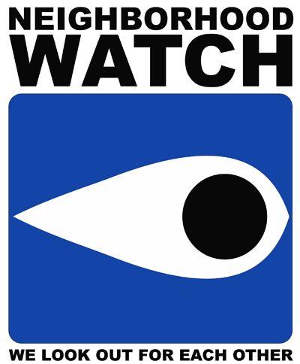  If you are interested in starting a neighborhood watch, please contact Brittany Martinez at  505-761-8805  Atlas One  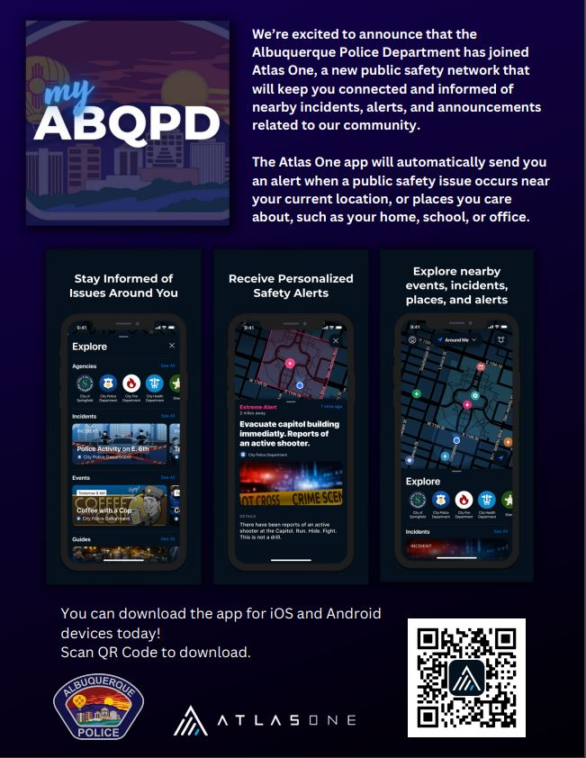  Reminder: A new app called Atlas One from APD has replaced the old app (which no longer functions or sends APD information). If you're interested in using it, there's a helpful guide available at https://youtu.be/OEQ1MfJyWCo. This guide has step-by-step instructions to help you get started.  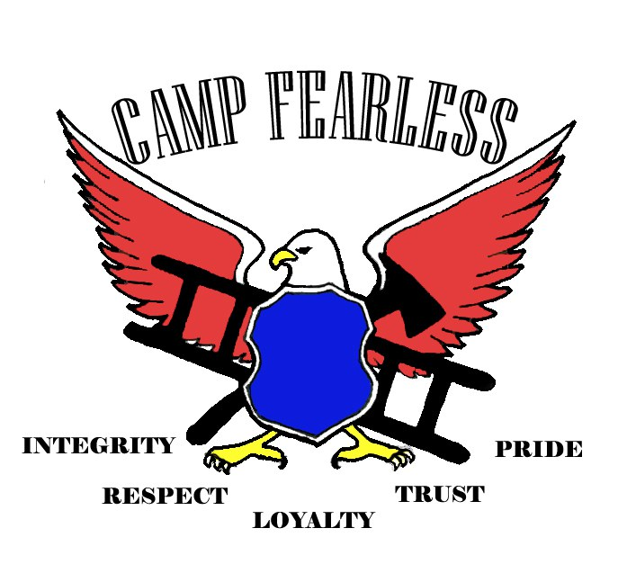  2024 CAMP FEARLESS  - Five, four-day camps  - Time: 8:00 a.m. - 4:30 p.m.  - Camps are free  - Registration opens on May 1, 2024, at noon.  The Albuquerque Police Department (APD), in collaboration with Albuquerque Fire and Rescue, the New Mexico National Guard, and the City of Albuquerque will be hosting a summer leadership camp, Camp Fearless.  Camp Fearless is for youth between the ages of 8-13. The goals of Camp Fearless will focus on building positive relationships and self-image, engaging with positive role models, leadership, physical fitness, and team building so participants are equipped with skills to develop successful and healthy lifestyles.  Please contact Angelina Navarro, Community Engagement Manager for more information or questions. Angelinanavarro@cabq.gov
    - Crime Mapping
  On the crime mapping website, you can run any crimes that you would like to look at in your neighborhood or throughout the city of Albuquerque. You can also sign up to receive alerts in your specific area.
  Crimemapping.com
  Date | Location
  June 3-6 | Northwest Area
  June 10-13 | Southwest Area
  July 8-11 | Valley Area
  July 22-25 | Northeast Area
  July 29-Aug. 1 | Foothills/SE Area
 |   The Crime Stoppers program began 35 years ago when an Albuquerque Police Detective partnered with the media to reenact an unsolved homicide. Tips from that news story ultimately led to an arrest and Crime Stoppers was born.  Today, the Albuquerque Metro Crime Stoppers (AMCS) model has been replicated in over 1,200 programs in all fifty states and more than 20 countries.  Tips to Albuquerque Metro Crime Stoppers have led to the arrest of 2,001 fugitives and helped close over 7,300 cases in the Albuquerque area.  AMCS has paid out over $500,000 in rewards since 1976.  Crime Stoppers is the only program guaranteed by law to protect the identity of tipsters. Because of this, tipsters are exempt from taxes on reward payments.  Crime Stoppers is a 501(c) 3 non-profit organization and receives no government funding. 100% of the funding for rewards, tip line operations and advertisement is provided through donations from individuals, businesses and community organizations.  To Submit a Tip:  Call 505-843-STOP or visit the Albuquerque Metro Crime Stoppers website. All information provided is anonymous.  Substation Hours  All police substations are open to the public the hours of operation are from 8:00 AM to 5:00 PM.  APD Records Division offers over the phone reports for a final police report – written by an APD officer or yourself. Please contacts records personnel at 505-768-2020.  Albuquerque Police Department Records Division — City of Albuquerque (cabq.gov)  In-person hours: Monday-Friday, 8am-4pm  Phone hours: Monday-Friday 8am-4:30pm  Valley Area Command  5408 2nd St NW  Albuquerque, NM 87107  505-761-8800  Southwest Area Command  6404 Los Volcanes NW  Albuquerque, NM 87121  505-831-4705  Southeast Area Command  800 Louisiana SE  Albuquerque, NM 87108  505-256-2050  Northwest Area Command  10401 Cibola Loop NW  Albuquerque, NM 87114  505-768-4850  Northeast Area Command  8201 Osuna NE  Albuquerque, NM 87109  505-823-4455  Foothills Area Command  12800 Lomas NE  Albuquerque, NM 87112  505-332-5240  Needles/Sharps Containers/Drug Disposal  Please be advised large quantities of used needles and/or full sharps containers are not accepted at the Valley Substation. We have a small container located in the lobby. If you have more than a few needles the closest drop-off location to our substation is the North Valley Public Health Office located at 7704 2nd St NW. Call the substation nearest you to see if they accept needles/sharps. Pills are accepted at all substations (No liquids accepted).  For more information visit: cabq.gov/police
    - File a Report
  Online Report
  cabq.gov/police/file-a- police-report-online
  (TRU )Telephone
  Reporting Unit
  242-2677 (COPS)

