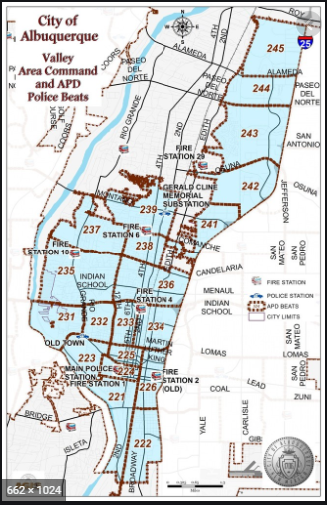 | VALLEY AREA COMMAND MONTHLY NEWSLETTER  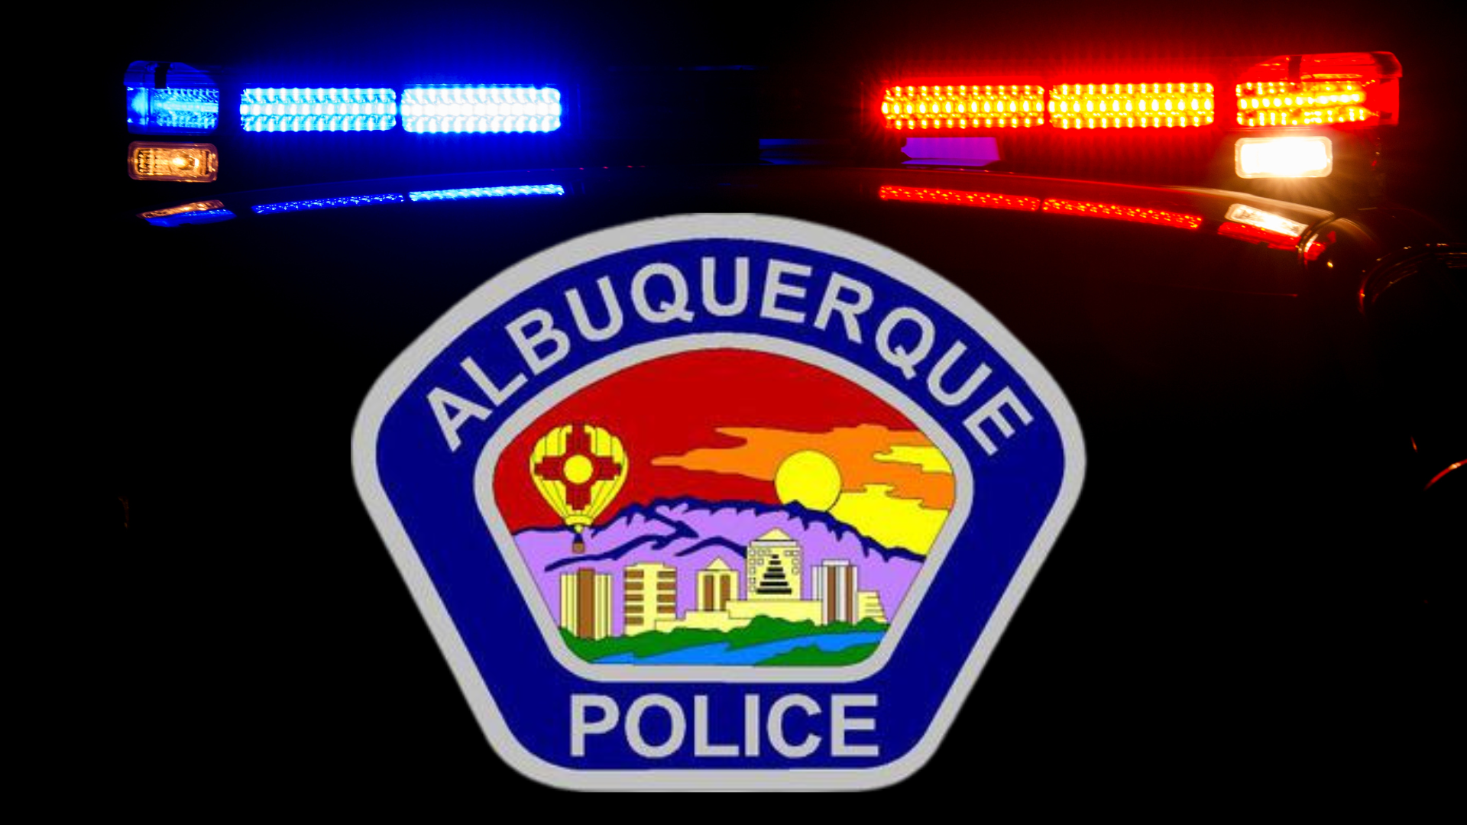  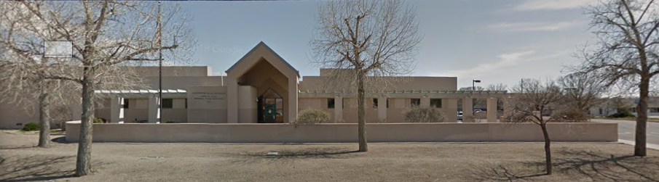  The Valley Area Command is overseen by  Commander Nick Wheeler  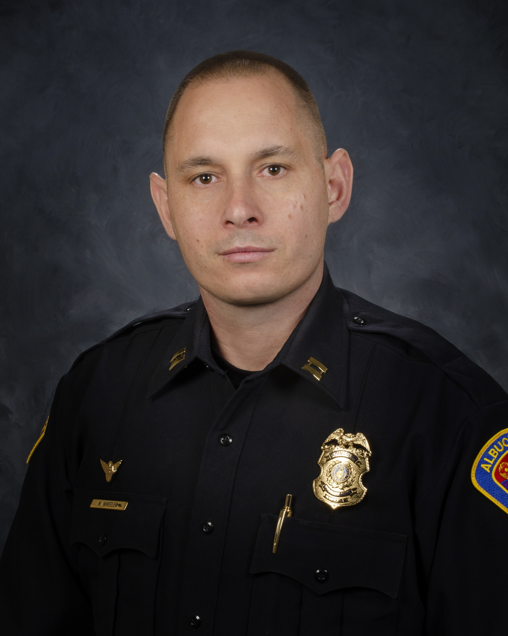
  March 2023
  Gerald Cline Substation
  5408 2nd St NW
  Albuquerque, NM 87107
  505-761-8800
  The Valley area is bordered by the Albuquerque city limits to the north and south, Interstate 25 to the east and the Rio Grande, Los Ranchos de Albuquerque, and the North Valley to the west
 | Commander’s Corner  The City of Albuquerque and the Valley Area Command welcome the  TOP Track Athletes of the Country for the Indoor Track Meet Championships.  These meets are being held in the Convention Center and will be going through March 11th. We have NCAA participants, Mountain West Participants and other national teams in attendance. I want to wish everyone luck and I am proud to have you in our City.  In February our Art Walk returned downtown. Those who participated were informed that as of April 7th, you MUST have a business permit and be Officially registered with the Art Walk to participate. In previous years, vendors and artists have set-up on the sidewalks throughout the downtown area which was never the intent of the Art Walk. The goal was to bring those artists and vendors into already established businesses to showcase everyone’s work. My Officers, staff from City Planning and staff from the Art Walk will reminding everyone during our March 3rd ART Walk about the new rules. If you would like to participate, please see the attached link. I hope everyone comes out and enjoys and celebrates the outstanding work of New Mexico residents. ABQ Artwalk  Please continue to report violations or concerns to the police department via or Emergency Communication Center, Police Substations or through our new, updated app which can be found in your app store. (Atlas 1). You will create an account. Once an account has been created, you will click on the myABQPD bubble and you will be able to call the police, go to our website and send a message to our team to report non-emergent situations.  I hope everyone stays safe. Please feel free to contact me if you have any questions. ​  Commander Nick Wheeler  Albuquerque Police Department  Valley Area Command  5408 2nd Street NW  (Office) 505-761-8800    
    - 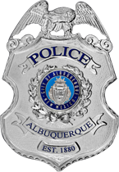
  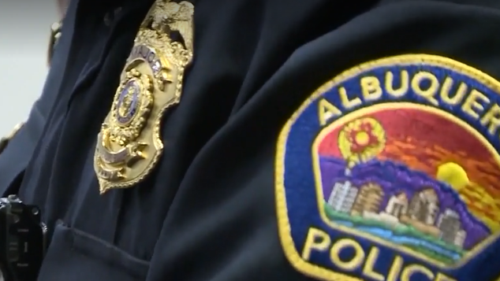
 | Valley Area Command Crime Statistics  02/01/2023 to 02/28/2023  MONTH OF February 2023  *Information Disclaimer*  This information is pulled from daily Calls for Service, which reflects all calls made to APD’s 911 Emergency Communications Center. It does not reflect all crimes that police investigate, nor the final outcome of crimes investigated. Furthermore it may not reflect the true location of crimes as they may have occurred in a different location from which they are reported.
    - Definitions
  Burglary – Unauthorized entry of any vehicle, watercraft, aircraft, dwelling or other structure, moveable or immovable, with the intent to commit a felony or theft therein.
  Robbery – Consists of the theft of anything of value from the person of another or from the immediate control of another, by use or threatened use of force or violence.
  Motor Vehicle Theft – Consists of a person taking any vehicle or motor vehicle intentionally and without consent of the owner.
  Auto Burglary | 33
  Commercial Burglary | 15
  Residential Burglary | 16
  Auto Theft | 67
  Robbery – Auto | 3
  Robbery – Commercial | 7
  Robbery – Individual | 9
  Robbery - Residential | 0

  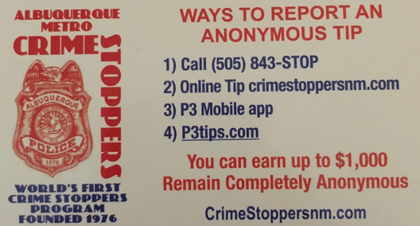  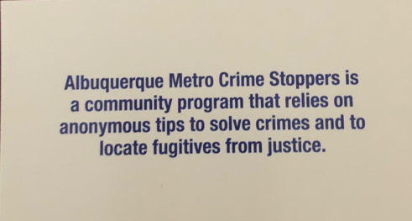  Valley Crime Prevention Specialist  Lamont Davis  5408 2nd St NW  Albuquerque, NM 87107  505-761-8805  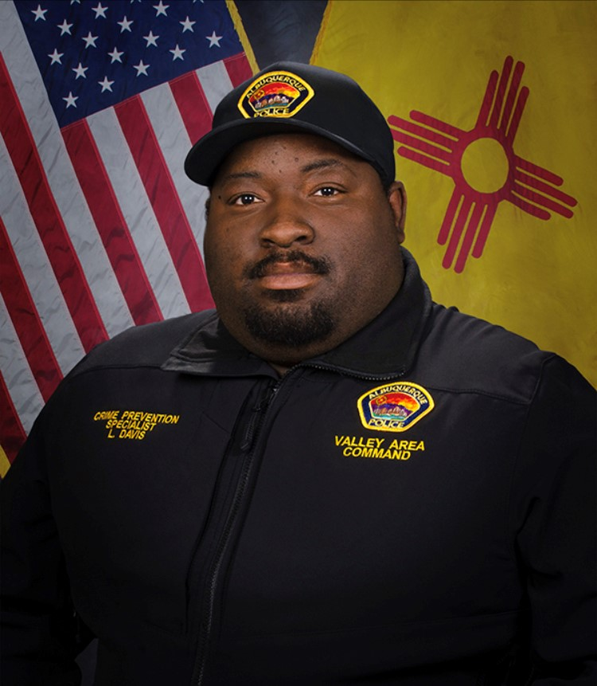  Lamont Davis, our Valley Crime Prevention Specialist is here to help answer any questions you may have related to crime prevention, neighborhood watch, or APD involved community events.  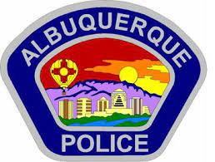   | Crime Mapping Info & (Safety TIPS)  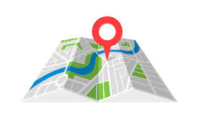  The Valley Area Command uses the Computer Aided Dispatch (CAD) data to determine crimes that happen in the area. When a response is indicated, the information received from the caller will be entered into the CAD for a response. The information from the caller allows ECC staff to determine the priority of the call, how many officers to dispatch, and it provides the officers with vital information so they can determine what action to take as they respond to a call for service.  Residential Burglaries  (TIP)-It is always good practice to make it look like someone is home at all times. Turn a radio on to a talk show station when you are gone, this will make it appear that someone is inside of your home.  Commercial Burglaries  (TIP)-If your business is closed, we recommend that you check your property periodically, be sure to leave lights on and clean up any debris or growth around the property. These small steps may deter a criminal.  Auto Burglaries  (TIP)-Be sure you are keeping your belongings out of site and remove anything of value. It is a great idea to pack a bag with items you need for the day and take it with you when you get out of the vehicle.  Stolen Vehicles  (TIP)-Using devices such as kill switches, alarms, clubs and locking doors and windows, also try to park in an area with good lighting to try to deter a criminal.  Carjacking  (TIP)- Always be aware of your surroundings. Pay special attention when you are at a standstill such as when you are at a stop light or in a parking lot. Keep doors locked, roll up your windows and notice who is in the immediate area.  Robbery to an Individual  (TIP)-Use situational awareness, look around, walk with confidence, make eye contact and read peoples body language. If you do find yourself in this situation give them whatever possession they are demanding, remember, possessions can always be replaced – you, cannot.  Commercial Robbery  (TIP)- Train your employees to be on the lookout for suspicious behavior and report it immediately. Start training your brain to make note of how someone looks and what they are wearing, including their shoes. Many criminals will change their clothing but they will not change their shoes.  Robbery By Gunpoint  (TIP)- After the robbery occurs call 911 and lock your doors. If there are witnesses ask if they can stay to give a description of the offender. Do not discuss what you saw with others, wait to give a description to the officer.  Residential Robbery  (TIP)- Always identify who is at the door before opening it. Keep doors locked at all times. Keep an eye out for suspicious persons/vehicles in the neighborhood.  Remember if you see something say something!  Homeless Encampments/Services  You can report homeless encampments by calling 311 or through the solid waste email:  sw-encampment@cabq.gov  To get more information on homeless assistance go to:  https://www.cabq.gov/family/services/homeless-services  Services Offered  There are many resources that we can provide to you, such as, informational pamphlets, Training on topics such as personal safety, scams, anti-bullying etc., CPTEDs (Crime Prevention Through Environmental Design), starting a Neighborhood Watch, CFMH (Crime Free Multi-Housing) and we can take McGruff to your public event or school or set up a table with informational pamphlets and promotional items. All of these services are free of charge.  Crime Prevention Corner  The Crime Prevention Specialist is here to help you to try to deter crime and educate you on various topics. Below is information on Keeping the Burglars at Bay:  Crime Prevention Corner  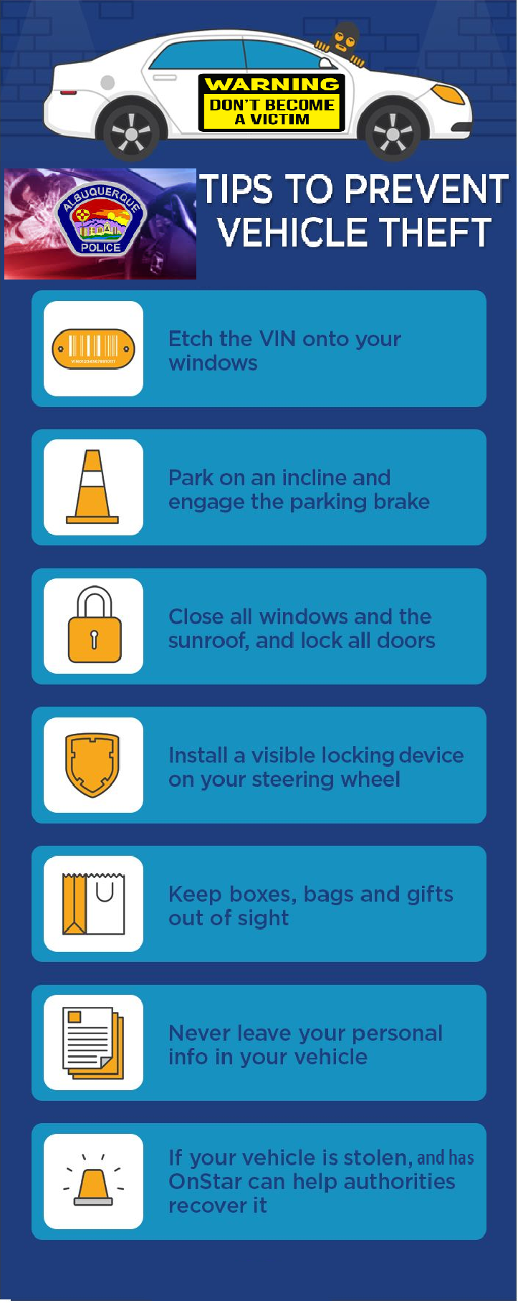  Auto Theft  Auto theft is a problem for all Americans, but the citizens of New Mexico face a particular issue that affects our auto theft rate.  Crime Prevention Tips  - Auto Theft Awareness  - Door to Door Solicitation  - How to Report a Crime  - Personal Safety  - Residential Burglary Prevention  Due to the fact that we are adjacent to an International Border, we are always ranked high on the list for theft rates. Typically, vehicles are stolen for one of three reasons. They are used to joy ride, sell for parts, or driven across the border for resale. However, you can take a variety of steps to insure that you are not a victim of auto theft. Observe the following tips to reduce the chances of your vehicle from being stolen.  - Lock your car and take your keys with you even when parked in your driveway.  - Do not hide a spare key on the vehicle  - Motion-sensor lights mounted over the garage will discourage thieves and alert you to the presence of unwanted "visitors" at night. In side your home, these devices can even be wired to set off an audio alarm.  - Park in a well-lighted area, close to a corner with foot-traffic. To make your vehicle more easily visible, back into the parking space, and, if possible park at the end of the row and toward the light source  - Roll up the windows completely.  - Remove keys from ignition.  - Avoid leaving a vehicle parked unattended in a public parking lot for a long time.  - When parking in attended lots or parking garages, leave only the ignition key with the attendant. Older-model vehicle keys and other attached keys could be duplicated.  - Make sure the attendant or valet is actually the authorized attendant. Never have a tag with your name/address on the keyring.  - Always park with the wheels turned toward the curb and apply the emergency brake. This will prevent towing.  - Place valuables out of sight.  - If you have a garage, use it. Vehicles are least safe parked at the curb, more safe in the driveway and most safe in the garage.  - Lock your garage door.  - Do not leave your car running while it is unattended.  - Back your car into the driveway. If you drive forward into the driveway, a car thief could raise the hood to hot wire the car, and it would appear to the neighbors that you were just working on the car.  - Do not leave the car title in the vehicle. Doing so makes it easy for the thief to sell the car.  - Etch VIN number on windshields, and write it in crayon under the hood and trunk. Also, print the VIN on some business cards and hide in a few locations in the unit: down door panels and behind seats.  VIC Cards  The APD Crime Prevention Unit has Vehicle Information Cards (V.I.C.) that are available to the public. These cards are for you to record information about your vehicle including the year, make, model, color(s), identifying marks, license plate number and state, VIN, who the registered owner is, the insurance covailable to the public. These cards are for you to record information about your vehicle including the year, make, model, color(s), identifying marks, license plate number and state, VIN, who the registered owner is, the insurance company and the policy number.  Contact the Crime Prevention Unit at (505) 768-2006 to obtain these cards for each of your vehicles. Crime prevention specialists suggest that each member of the family who is licensed to drive, carry on their person a completed card for each family vehicle. The purpose of the card is so any victim of a vehicle theft or carjacking who carries a card can report vital identification information on the vehicle as quickly as possible, without waiting for an officer to arrive to take a report.  V.I.C. cards are not legal documents and should not be accepted for personal identification or legal transactions involving motor vehicles.  APD hopes that eventually every motor-vehicle owner in the metropolitan area will keep and use the V.I.C. cards to assist law enforcement in tracking and returning stolen vehicles before they permanently disappear, are damaged, or are used in the commission of another crime.  Free V.I.C. cards are available at each APD substation, and will be distributed by APD sworn and civilian personnel, or call (505) 768-2006 to receive cards by mail.  Cards in limited amounts are available to clubs, businesses and organizations. However, businesses and other groups wanting large amounts should arrange to order and pay for them on their own through Richard's Printing, 719 San Mateo NE.  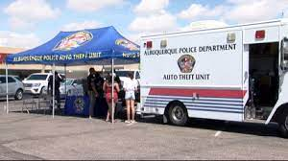  Theft Prevention Devices  After years of false alarms, people have stopped paying attention to alarms. Any serious anti-theft device must do more than just make noise. If you want an audio alarm; use it in conjunction with other forms of prevention.  The longer it takes to steal a car, the more attention a thief will attract. Look for devices that are: highly visible, hard to defeat, and will prevent the car from starting or will kill the engine shortly after it is stolen. To prevent "hot-wiring," protect the steering column.  - A kill switch is a simple toggle device that shuts off the engine's ignition system.  - Steering wheel locks are visible from outside the car and prevent the steering wheel from being turned more than a few degrees.  - Collars are devices that prevent the steering column from being stripped.  - Brake locks prevent the brake from being engaged and therefore the transmission cannot be removed from the park position.  - Wheel locks prevent the vehicle from being moved in any direction.  - Etching vehicle parts with your VIN number can also be a deterrent. Professional thieves shy away from vehicles that have had the vehicle identification number (VIN) etched into the doors, windows, windshield, engine block, and other parts.  More than two-thirds of all auto thefts take place at night, and over half occur in residential areas including apartment complexes. Statistically, most cars are stolen between the hours or 1 a.m. and 5 a.m.  The goal in preventing auto theft is to establish multiple layers of protection for you vehicle. Thieves are looking for the least path of resistance. Although no method is foolproof, consider where you park, theft prevention devices, and etching. However, spending money on anti-theft devices does not help if drivers don't follow the basic precaution of locking their cars, taking the key, and activating the anti-theft device.  Contact NM Motor Vehicle Department  In addition to reporting the theft to APD, you may also wish to contact the NM Motor Vehicle Department (Albuquerque: 841-2455) to cancel the registration. This is to prevent the stolen unit from being re-registered by the thief, using falsified documents. Sometimes vehicles reported stolen are actually "borrowed" by a relative or friend. Advise police immediately of the report status change.  APD Valley Area Crime Prevention (505) -761-8805  Other Services:  Sharps Disposal (Needles) – Call 311 https://www.cabq.gov/environmentalhealth/sharps-disposal  Albuquerque Community Safety Administration (ACS) – Call 311, 242-COPS or 768-4227 acs@cabq.gov – ACS sends trained professionals to non-violent and non-medical 911 calls for service involving issues such as mental/behavioral health, homelessness, and addiction as well as non-behavioral issues such as abandoned vehicles and needle pick-ups.  Valley Community Policing Council:  Hello and Welcome Everyone,  Our next meeting is on March 23th  As always we have both in-person and virtual attendance. The link to join the meeting is:  https://cabq.zoom.us/webinar/register/WN_7Z1iT-WbR9-9-s1dEYOjiA  Our physical location is the Johnny Tapia Community Center and we run from 6:00pm to 8:00pm.  In the not too distant future we will be rotating our meetings to different community centers for three months at a time. We will keep you informed.  If you need more information please contact us at cpcvalley@gmail.com.    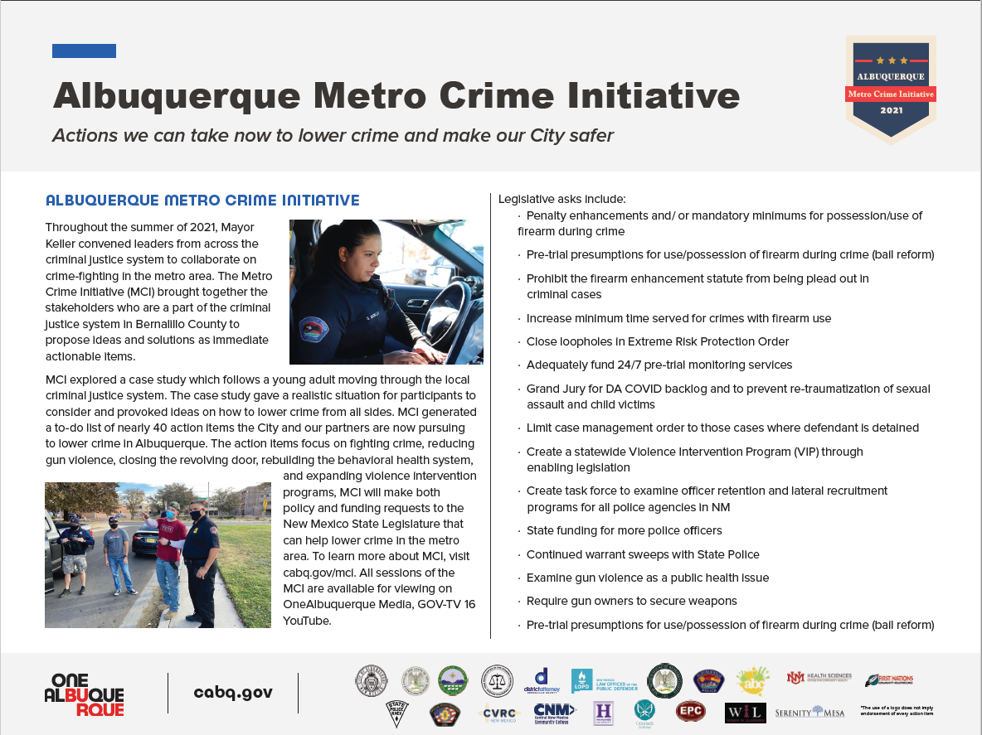  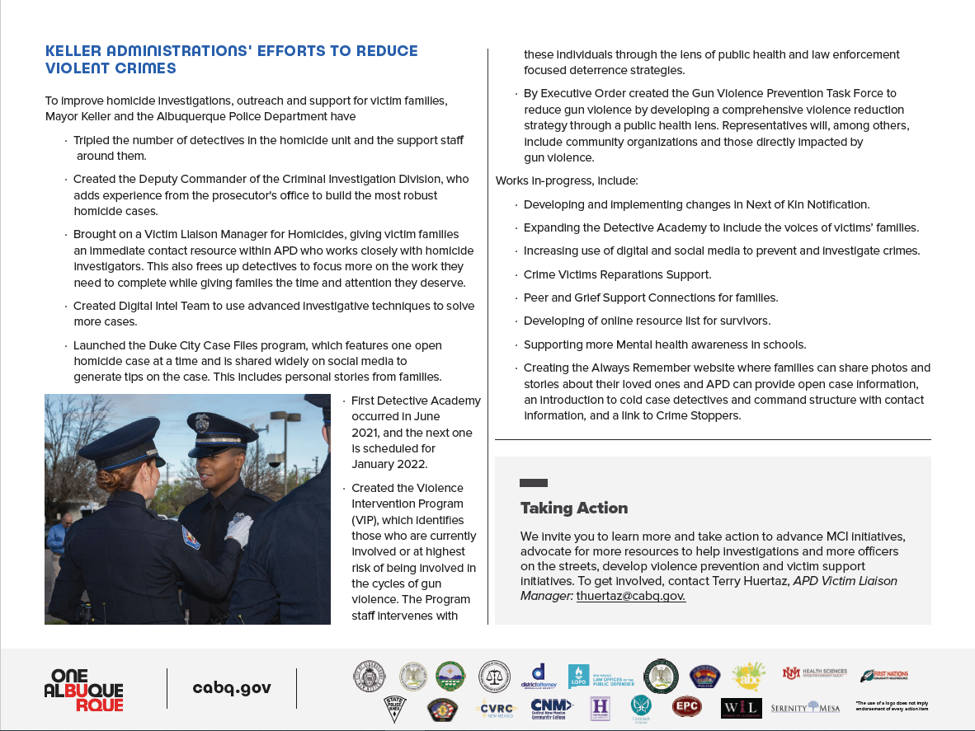
    - Crime Mapping
  On the crime mapping website you can run any crimes that you would like to look at in your neighborhood or throughout the city of Albuquerque. You can also sign up to receive alerts in your specific area.
  Crimemapping.com
 | Substation Hours  All police substations are open to the public the hours of operation are from 8:00 AM to 5:00 PM.  If you need an Accident Report form or a copy of an Accident Report you can call with your case number to have it mailed to you via US Mail they are not provided through email. When you come in to get a report make sure to bring in your ID and Case #. For any other report call the substation to make sure it is available before coming by 761-8800.  The Old Town Substation is now open Monday-Thursday 8:00 AM to 5:00 PM and on Friday 8:00 AM to 8:00 PM and on weekends from 11:00 PM to 7:00 PM.  Valley Area Command  5408 2nd St NW  Albuquerque, NM 87107  505-761-8800  Southwest Area Command  6404 Los Volcanes NW  Albuquerque, NM 87121  505-831-4705  Southeast Area Command  800 Louisiana SE  Albuquerque, NM 87108  505-256-2050  Northwest Area Command  10401 Cibola Loop NW  Albuquerque, NM 87114  505-768-4850  Northeast Area Command  8201 Osuna NE  Albuquerque, NM 87109  505-823-4455  Foothills Area Command  12800 Lomas NE  Albuquerque, NM 87112  505-332-5240  Needles/Sharps Containers/Drug Disposal  Please be advised large quantities of used needles and/or full sharps containers are not accepted at the Valley Substation. We have a small container located in the lobby. If you have more than a few needles the closest drop-off location to our substation is the North Valley Public Health Office located at 7704 2nd St NW. Call the substation nearest you to see if they accept needles/sharps. Pills are accepted at all substations (No liquids accepted).  For more information visit: cabq.gov/police
    - File a Report
  Online Report
  cabq.gov/police/file-a- police-report-online
  (TRU )Telephone
  Reporting Unit
  242-2677 (COPS)
  APD App
  