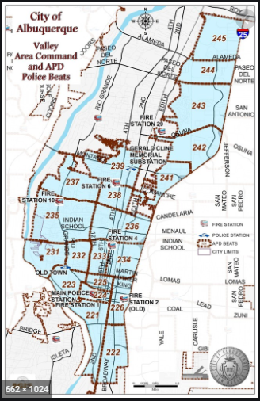 | VALLEY AREA COMMAND MONTHLY NEWSLETTER  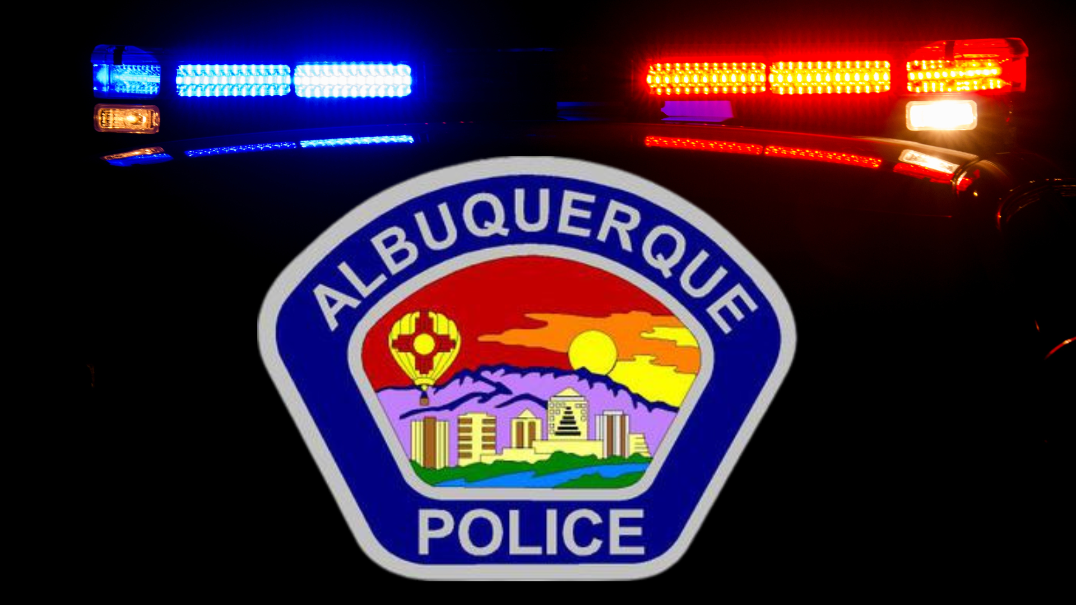  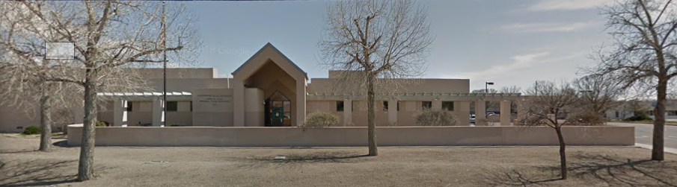  The Valley Area Command is overseen by  Interim Commander Jose Sanchez  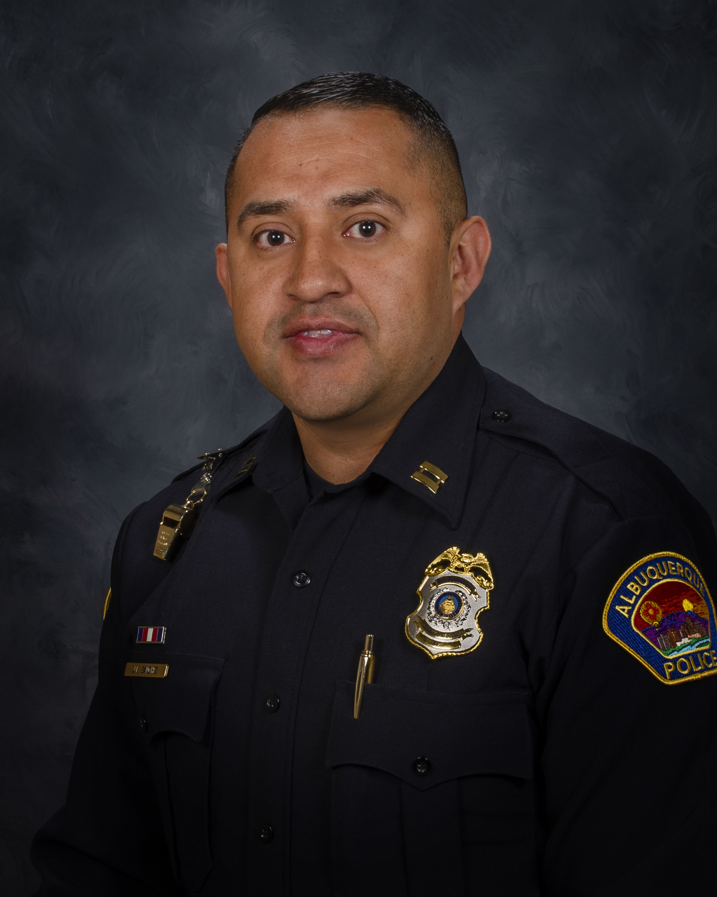
  June
  2024
  Gerald Cline Substation
  5408 2nd St NW
  Albuquerque, NM 87107
  505-761-8800
  The Valley area is bordered by the Albuquerque city limits to the north and south, Interstate 25 to the east and the Rio Grande, Los Ranchos de Albuquerque, and the North Valley to the west
 | Commander’s Corner  Hello, I want to take a few moments to introduce myself. I have been with the Albuquerque Police Department for 18 years. Through this amazing and challenging career, I have been a part of the Emergency Response Team, Honor Guard, and have spent my career interacting with the community by serving entirely with the Field Services Bureau. For the past three years I have been working with the Downtown Public Safety District. That position allowed me to build strong relationships with our community to address issues affecting Downtown. I am striving to build the same relationships with you to address issues affecting us all in an effort to make for a safer community.  I recently retired from the military after serving 21 combined years with the US Navy and the Air National Guard. This was a bittersweet decision, but as the stars are aligning and I am offered new challenges in my career I wanted to devote my time to serving you. I have a vision of working with you to reinvigorate our communities by asking that you work with us by participating in Community Policing Councils, coffee-with-a cop, and conversations about problems, ideas, and solutions. In order to have constructive community policing, we need to build strong partnerships and have trust in one another. I am excited for this new opportunity in leadership and to work alongside you.  If you have questions, comments, or concerns you can reach me at josesanchez@cabq.gov or 505-252-2589.  The Downtown Public Safety District or commonly referred to as the Downtown Unit will be overseen by Interim Deputy Commander Ashley Stephenson. D. Cmdr. Stephenson may be reached at astephenson@cabq.gov or 505-228-3463.  Message from Chief Medina:  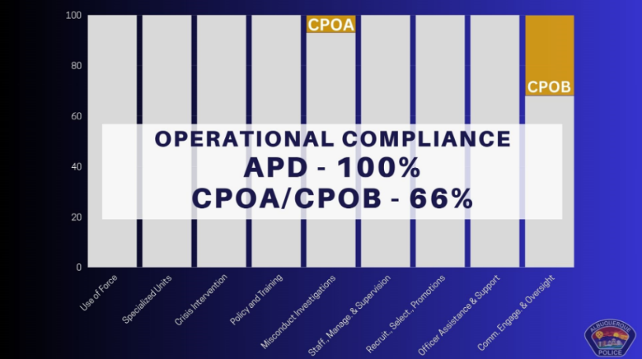  Hello everyone! I’d like to start off by sharing more on the good news that The Albuquerque Police Department has met all requirements in the Court-Approved Settlement Agreement with the U.S. Department of Justice, marking the biggest milestone since the reform process started in January 2015.  I’d like to thank the officers who stayed with the Albuquerque Police Department and fought through these changes to make sure that we improved the services that we deliver to the citizens of the city of Albuquerque. Reform shall never end for any police department. We should always be evolving to see how we could become a better police department, more in tune with the community, and always changing to meet the needs of an ever-changing society.  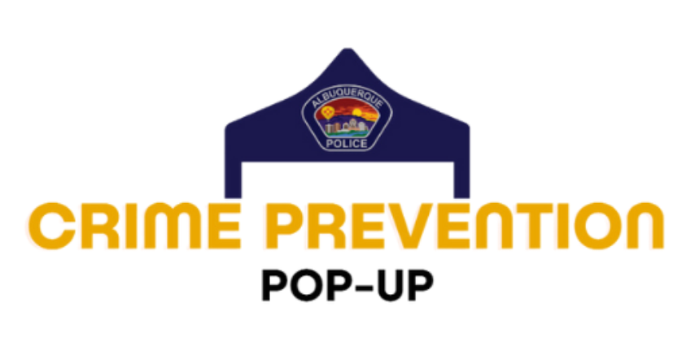  Some terms of the settlement agreement that are outside the control of APD, dealing with civilian oversight, have not yet been met. But the monitor’s report means APD can move toward self-monitoring with all of its remaining sections that have not already been dismissed by the Court.  Looking ahead, we are kicking off a new program just in time for the summer months bringing Crime Prevention Pop-Ups to neighborhoods and parks.  APD is partnering with Albuquerque Metro Crime Stoppers in an effort to make crime prevention information accessible, build stronger community connections and  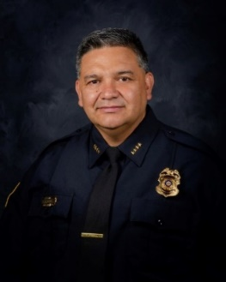  create an opportunity for community members to share their concerns; these events will be taking place throughout the summer.  We will have booths showcasing crime prevention, neighborhood watch, auto theft VIN etching and free wheel lock distribution, as well as more information on Crime Stoppers.  Please visit APD’s website, www.cabq.gov/police, for more information on the upcoming dates. – Chief Harold Medina  (ACS) Albuquerque Community Safety  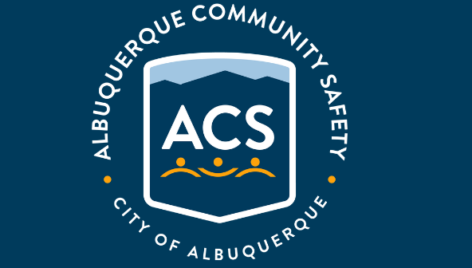  Albuquerque Community Safety Administration (ACS) – Call 311, 242-COPS or 768-4227 acs@cabq.gov – ACS sends trained professionals to non-violent and non-medical 911 calls for service involving issues such as mental/behavioral health, homelessness, and addiction as well as non-behavioral issues such as abandoned vehicles and needle pick-ups.  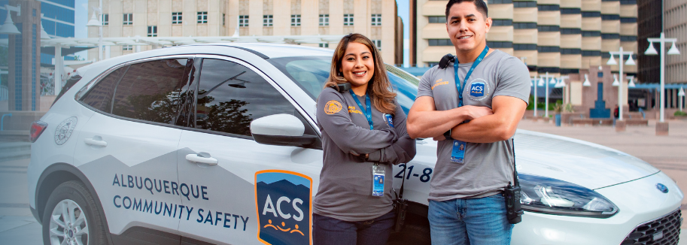
    - 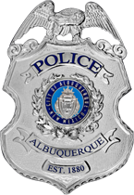
  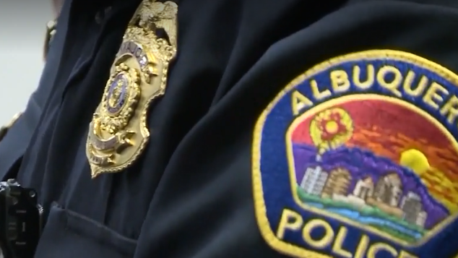
  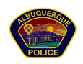

Valley Crime Prevention Specialist  Brittany Martinez  5408 2nd St NW  Albuquerque, NM 87107  505-761-8805  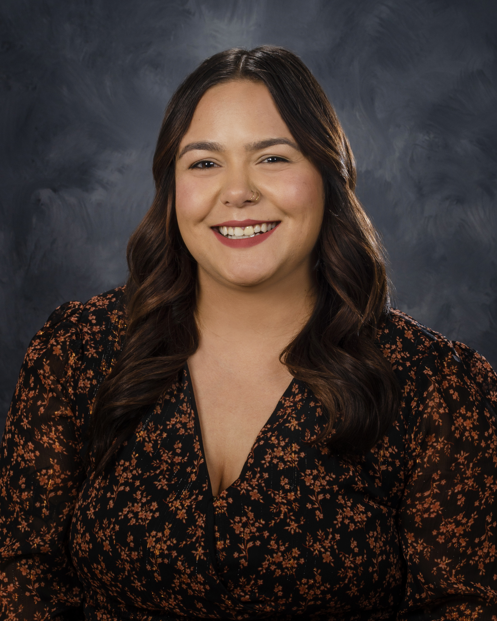  Brittany Martinez, our Valley Crime Prevention Specialist is here to help answer any questions you may have related to crime prevention, neighborhood watch, or APD involved community events.  brimartinez@cabq.gov  505-761-8805   | Crime Mapping Info & (Safety TIPS)    The Valley Area Command uses the Computer Aided Dispatch (CAD) data to determine crimes that happen in the area. When a response is indicated, the information received from the caller will be entered into the CAD for a response. The information from the caller allows ECC staff to determine the priority of the call, how many officers to dispatch, and it provides the officers with vital information so they can determine what action to take as they respond to a call for service.  Crime Statistics — City of Albuquerque  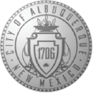  Information about Albuquerque crime statistics  Crime Statistics — City of Albuquerque (cabq.gov)  Valley Community Policing Council (CPC)  The idea is simple: Build relationships and work with communities to address their concerns and priorities.  We are successfully fighting crime when we work hand-in-hand with communities to implement solutions that keep people safe. Our officers are working with neighborhoods, business owners, faith-based organizations, schools, and more to tailor proven public safety strategies to meet the needs of specific areas. APD Community Policing comprises three key components: Problem Solving, Community Partnerships and Organizational Transformation.  Problem Solving: Solving problems means, first, identifying issues that need to be addressed and then determining resolutions and devoting effort to meeting needs for a successful outcome. The SARA (Scanning, Analysis, Response, and Assessment) model is one of the most familiar processes for problem-oriented policing (POP). APD is using this model.  Community Partnerships: Partnerships between law enforcement and the individuals and organizations they serve to develop solutions to problems and increase trust in police. APD will focus on creating partnerships with a diverse section of the Albuquerque community and will work with key community stakeholders including, but not limited to:  - Other law enforcement agencies  - Social service providers  - Business community  - Educational institutes  - Local prosecutors  - Faith-based organizations  - Neighborhood interest groups  - Youth organizations  These partnerships will identify community challenges and focus on developing a strong road map to address those challenges (problem solving).  For more information, please visit: Community Policing Councils — City of Albuquerque (cabq.gov)  Crime Prevention Corner    The Summer is here which means warm weather and getting out of town!  Here are some Travel safety tips for you to remember this year!  - Ask a trusted family member, friend, or neighbor to keep a watchful eye on your home.  - Have your mail held at the local post office until your return.  - Put lights on timers to give the impression that someone is home.  - Lock your room and remember not to give out your room number.  - Be friendly but be vigilant. Watch for and report any suspicious behavior.  - Plan your route – stay within well-traveled routes and walk in groups. There’s safety in numbers.  - Be proactive – make a backup plan in case the group gets separated during a family outing and have a scheduled meeting place and time.  - Let trusted family members know where you are going and your route if you are going out hiking.  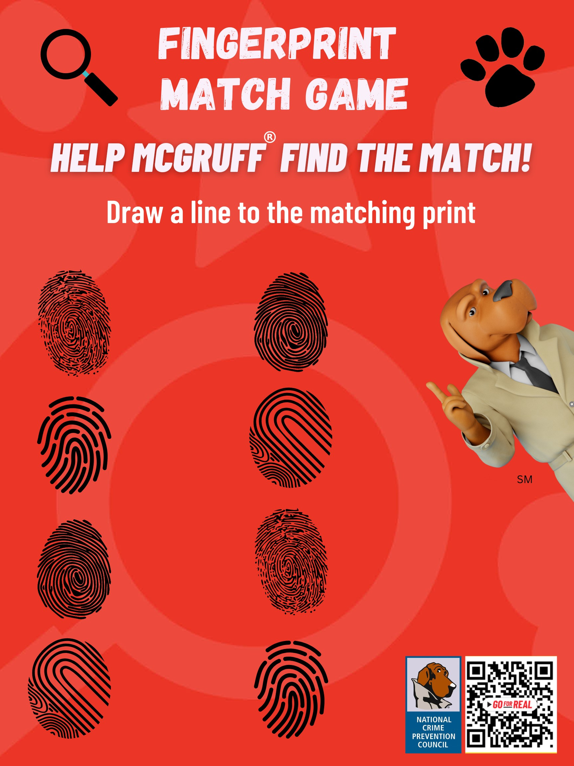  UPCOMING EVENTS    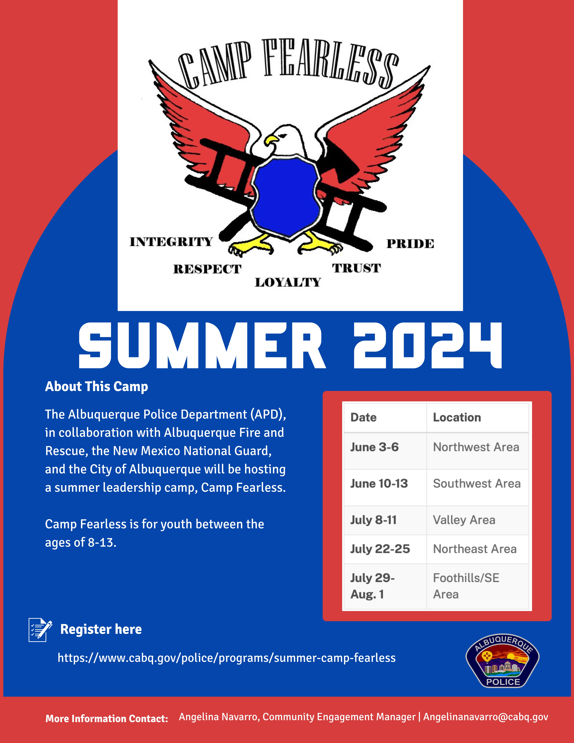  Atlas One  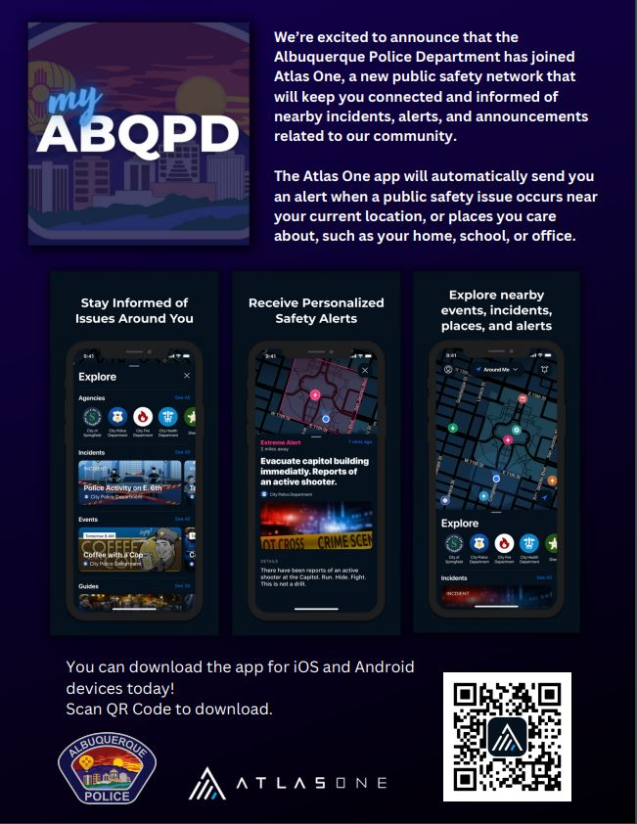  Reminder: A new app called Atlas One from APD has replaced the old app (which no longer functions or sends APD information). If you're interested in using it, there's a helpful guide available at https://youtu.be/OEQ1MfJyWCo. This guide has step-by-step instructions to help you get started.  APD Continues Advancements in Technology, Launches New Mobile App Providing Real-time Information — City of Albuquerque (cabq.gov)
    - Crime Mapping
  On the crime mapping website, you can run any crimes that you would like to look at in your neighborhood or throughout the city of Albuquerque. You can also sign up to receive alerts in your specific area.
  Crimemapping.com
 | 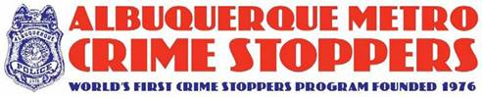  The Crime Stoppers program began 35 years ago when an Albuquerque Police Detective partnered with the media to reenact an unsolved homicide. Tips from that news story ultimately led to an arrest and Crime Stoppers was born.  Today, the Albuquerque Metro Crime Stoppers (AMCS) model has been replicated in over 1,200 programs in all fifty states and more than 20 countries.  Tips to Albuquerque Metro Crime Stoppers have led to the arrest of 2,001 fugitives and helped close over 7,300 cases in the Albuquerque area.  AMCS has paid out over $500,000 in rewards since 1976.  Crime Stoppers is the only program guaranteed by law to protect the identity of tipsters. Because of this, tipsters are exempt from taxes on reward payments.  Crime Stoppers is a 501(c) 3 non-profit organization and receives no government funding. 100% of the funding for rewards, tip line operations and advertisement is provided through donations from individuals, businesses and community organizations.  To Submit a Tip:  Call 505-843-STOP or visit the Albuquerque Metro Crime Stoppers website. All information provided is anonymous.  Substation Hours  All police substations are open to the public the hours of operation are from 8:00 AM to 5:00 PM.  APD Records Division offers over the phone reports for a final police report – written by an APD officer or yourself. Please contacts records personnel at 505-768-2020.  Albuquerque Police Department Records Division — City of Albuquerque (cabq.gov)  In-person hours: Monday-Friday, 8am-4pm  Phone hours: Monday-Friday 8am-4:30pm  Valley Area Command  5408 2nd St NW  Albuquerque, NM 87107  505-761-8800  Southwest Area Command  6404 Los Volcanes NW  Albuquerque, NM 87121  505-831-4705  Southeast Area Command  800 Louisiana SE  Albuquerque, NM 87108  505-256-2050  Northwest Area Command  10401 Cibola Loop NW  Albuquerque, NM 87114  505-768-4850  Northeast Area Command  8201 Osuna NE  Albuquerque, NM 87109  505-823-4455  Foothills Area Command  12800 Lomas NE  Albuquerque, NM 87112  505-332-5240  Needles/Sharps Containers/Drug Disposal  Please be advised large quantities of used needles and/or full sharps containers are not accepted at the Valley Substation. We have a small container located in the lobby. If you have more than a few needles the closest drop-off location to our substation is the North Valley Public Health Office located at 7704 2nd St NW. Call the substation nearest you to see if they accept needles/sharps. Pills are accepted at all substations (No liquids accepted).  For more information visit: cabq.gov/police
    - File a Report
  Online Report
  cabq.gov/police/file-a- police-report-online
  (TRU )Telephone
  Reporting Unit
  242-2677 (COPS)

