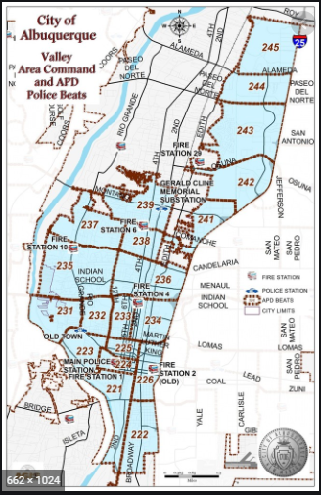 | VALLEY AREA COMMAND MONTHLY NEWSLETTER  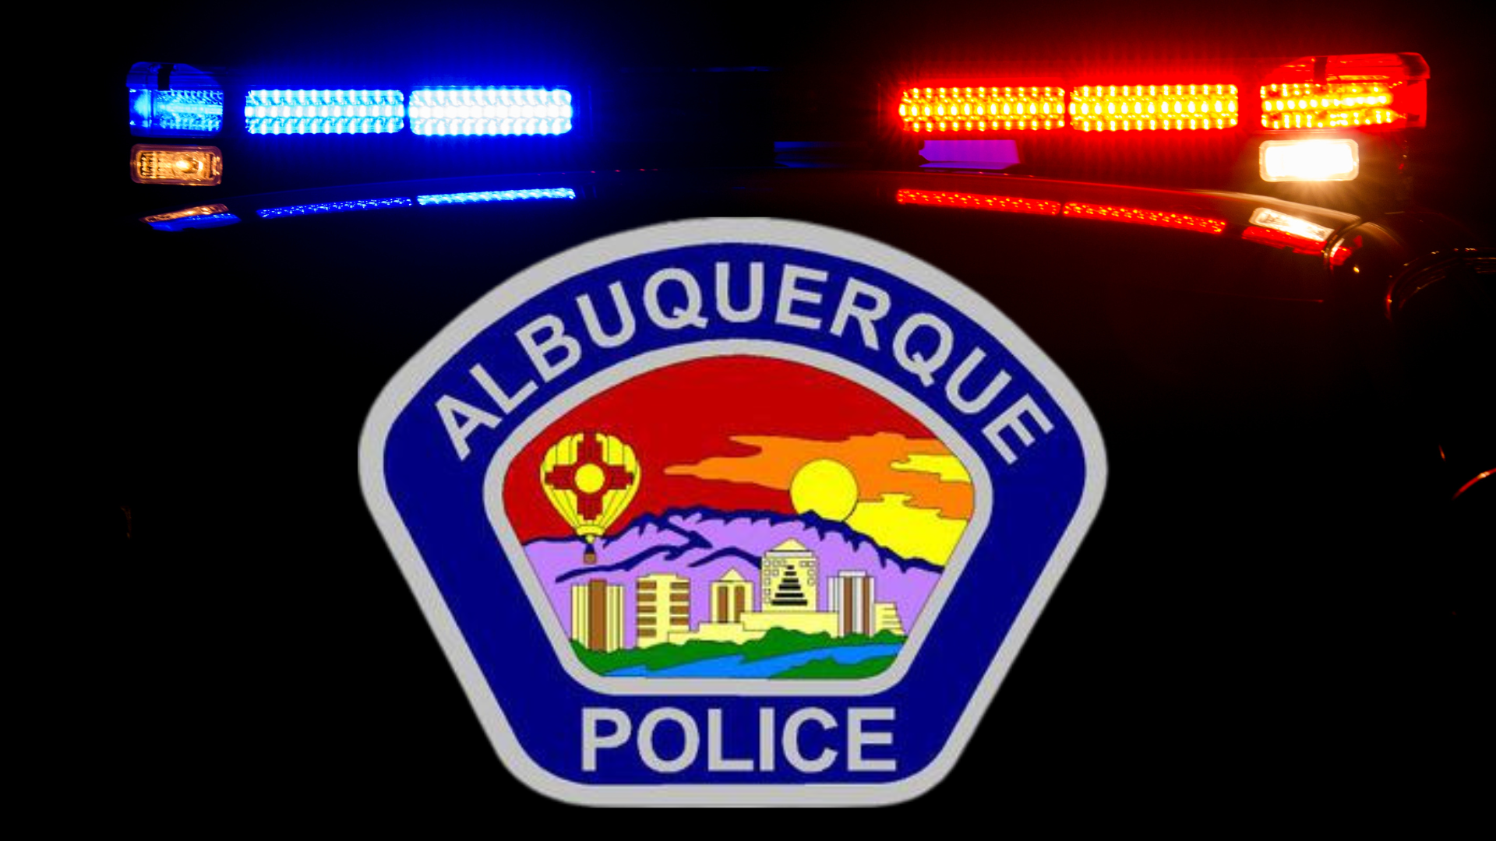  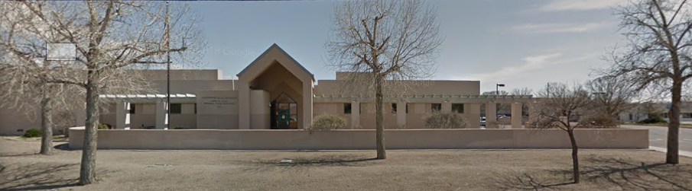  The Valley Area Command is overseen by  Commander Nick Wheeler  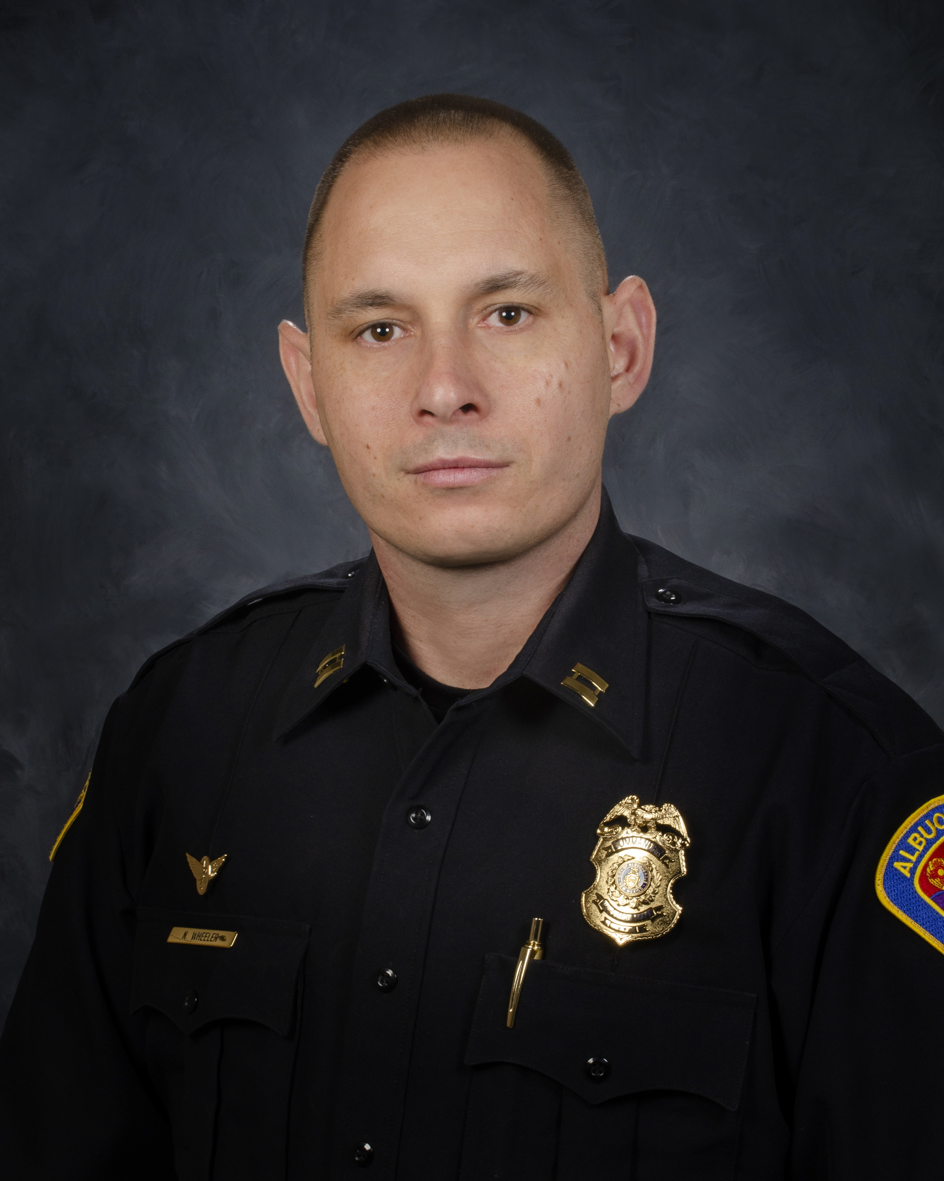
  March
  2024
  Gerald Cline Substation
  5408 2nd St NW
  Albuquerque, NM 87107
  505-761-8800
  The Valley area is bordered by the Albuquerque city limits to the north and south, Interstate 25 to the east and the Rio Grande, Los Ranchos de Albuquerque, and the North Valley to the west
 | Commander’s Corner  I am excited to introduce our new Valley Area Command Crime Prevention Specialist, Brittany Martinez. She previously worked at our Family Advocacy Center and has worked with several community resource groups building strong relationships. She will be attending Crime Prevention Through Environmental Design (CPTED) certification in June so until the she will be assisted by our other specialists. Her contact is posted on the side of this document and she is available to questions related to neighborhood watch, crime free multi-housing, trespassing signs, neighborhood signs related to speeding or soliciting and anything related to community events within the Valley Area Command.  I wanted to show our top 3 vehicle makes that are being currently stolen throughout our Area Command. If you have any of the three or know someone who does, please remind them to lock their vehicles, leave valuables out of the vehicle and/or hide them and utilize vehicle tracking devices if possible. The top utilized device that communicates with Law Enforcement very quickly is Low-Jack. There are also numerous services through dealerships, Apple Air Tag, Bouncie GPS Car Tracker, Land Air Sea Tracker and many more on-line.  - Hyundai (usually Sonota, Santa Fe, Elantra and Optima)  - Chevrolet (Usually Silverado’s)  - Ford (Usually SuperDuty’s)  Remember to park your vehicle in sight, lit areas and near cameras if possible. If you see something suspicious, please report the activity to police.  Again, please reach out to me if you have any questions about anything going on in the Valley Area Command. My email is nwheeler@cabq.gov. Please be safe!  Crime Statistics — City of Albuquerque    Information about Albuquerque crime statistics  Crime Statistics — City of Albuquerque (cabq.gov)  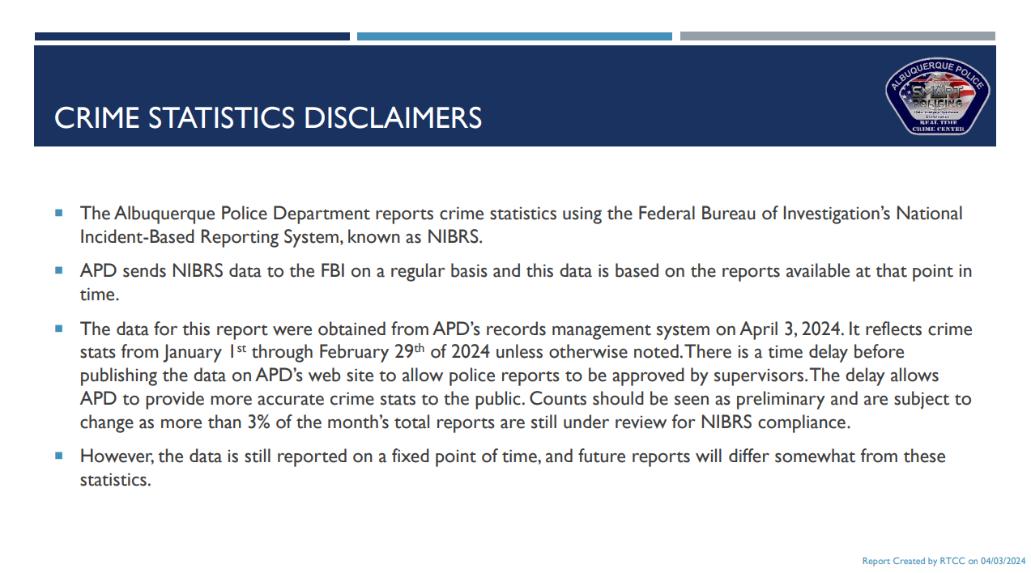  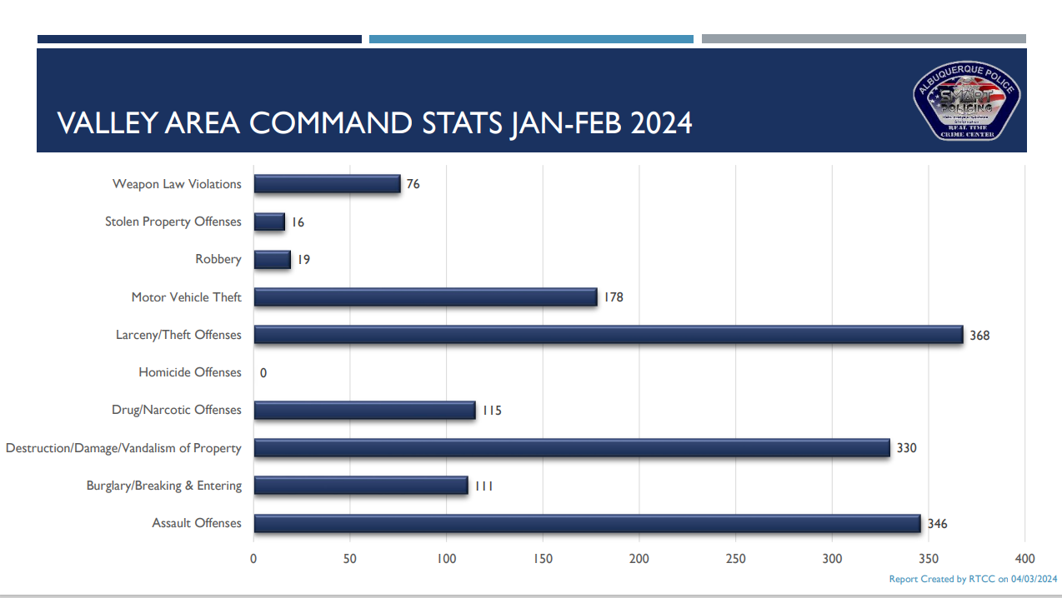    Community Policing  The idea is simple: Build relationships and work with communities to address their concerns and priorities.  We are successfully fighting crime when we work hand-in-hand with communities to implement solutions that keep people safe. Our officers are working with neighborhoods, business owners, faith-based organizations, schools, and more to tailor proven public safety strategies to meet the needs of specific areas. APD Community Policing comprises three key components: Problem Solving, Community Partnerships and Organizational Transformation.  Problem Solving: Solving problems means, first, identifying issues that need to be addressed and then determining resolutions and devoting effort to meeting needs for a successful outcome. The SARA (Scanning, Analysis, Response, and Assessment) model is one of the most familiar processes for problem-oriented policing (POP). APD is using this model.  Community Partnerships: Partnerships between law enforcement and the individuals and organizations they serve to develop solutions to problems and increase trust in police. APD will focus on creating partnerships with a diverse section of the Albuquerque community and will work with key community stakeholders including, but not limited to:  - Other law enforcement agencies  - Social service providers  - Business community  - Educational institutes  - Local prosecutors  - Faith-based organizations  - Neighborhood interest groups  - Youth organizations  These partnerships will identify community challenges and focus on developing a strong road map to address those challenges (problem solving).  Community Policing Councils — City of Albuquerque (cabq.gov)  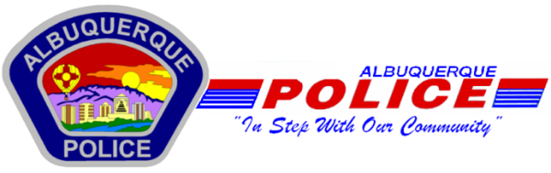  Other Services:  Sharps Disposal (Needles) – Call 311 https://www.cabq.gov/environmentalhealth/sharps-disposal  (ACS) Albuquerque Community Safety  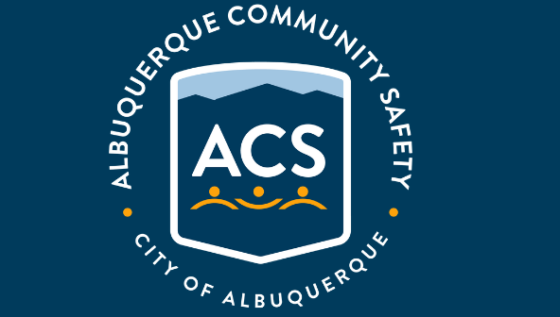  Albuquerque Community Safety Administration (ACS) – Call 311, 242-COPS or 768-4227  acs@cabq.gov – ACS sends trained professionals to non-violent and non-medical 911 calls for service involving issues such as mental/behavioral health, homelessness, and addiction as well as non-behavioral issues such as abandoned vehicles and needle pick-ups.  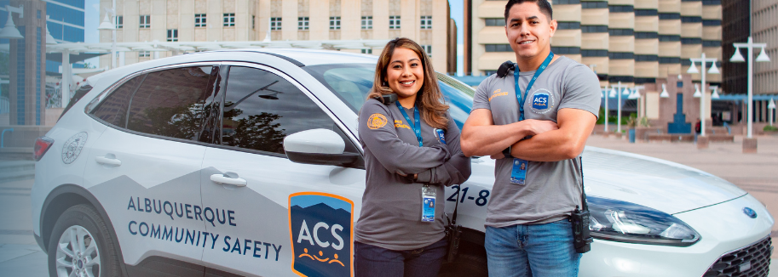
    - 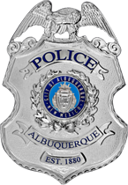
  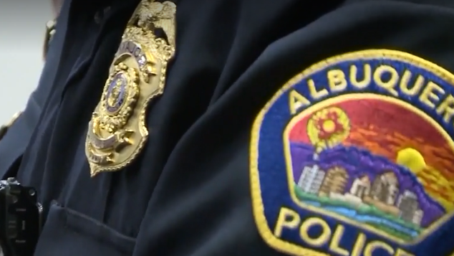
  V
  A
  L
  L
  E
  Y
  AREA
  COMMAND
  

  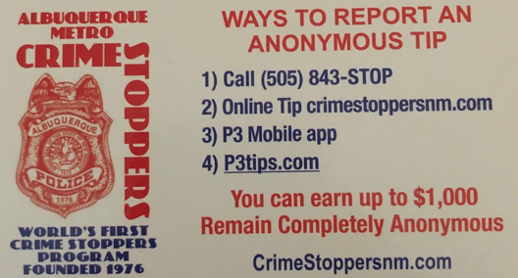  Valley Crime Prevention Specialist  Brittany Martinez  5408 2nd St NW  Albuquerque, NM 87107  505-761-8805  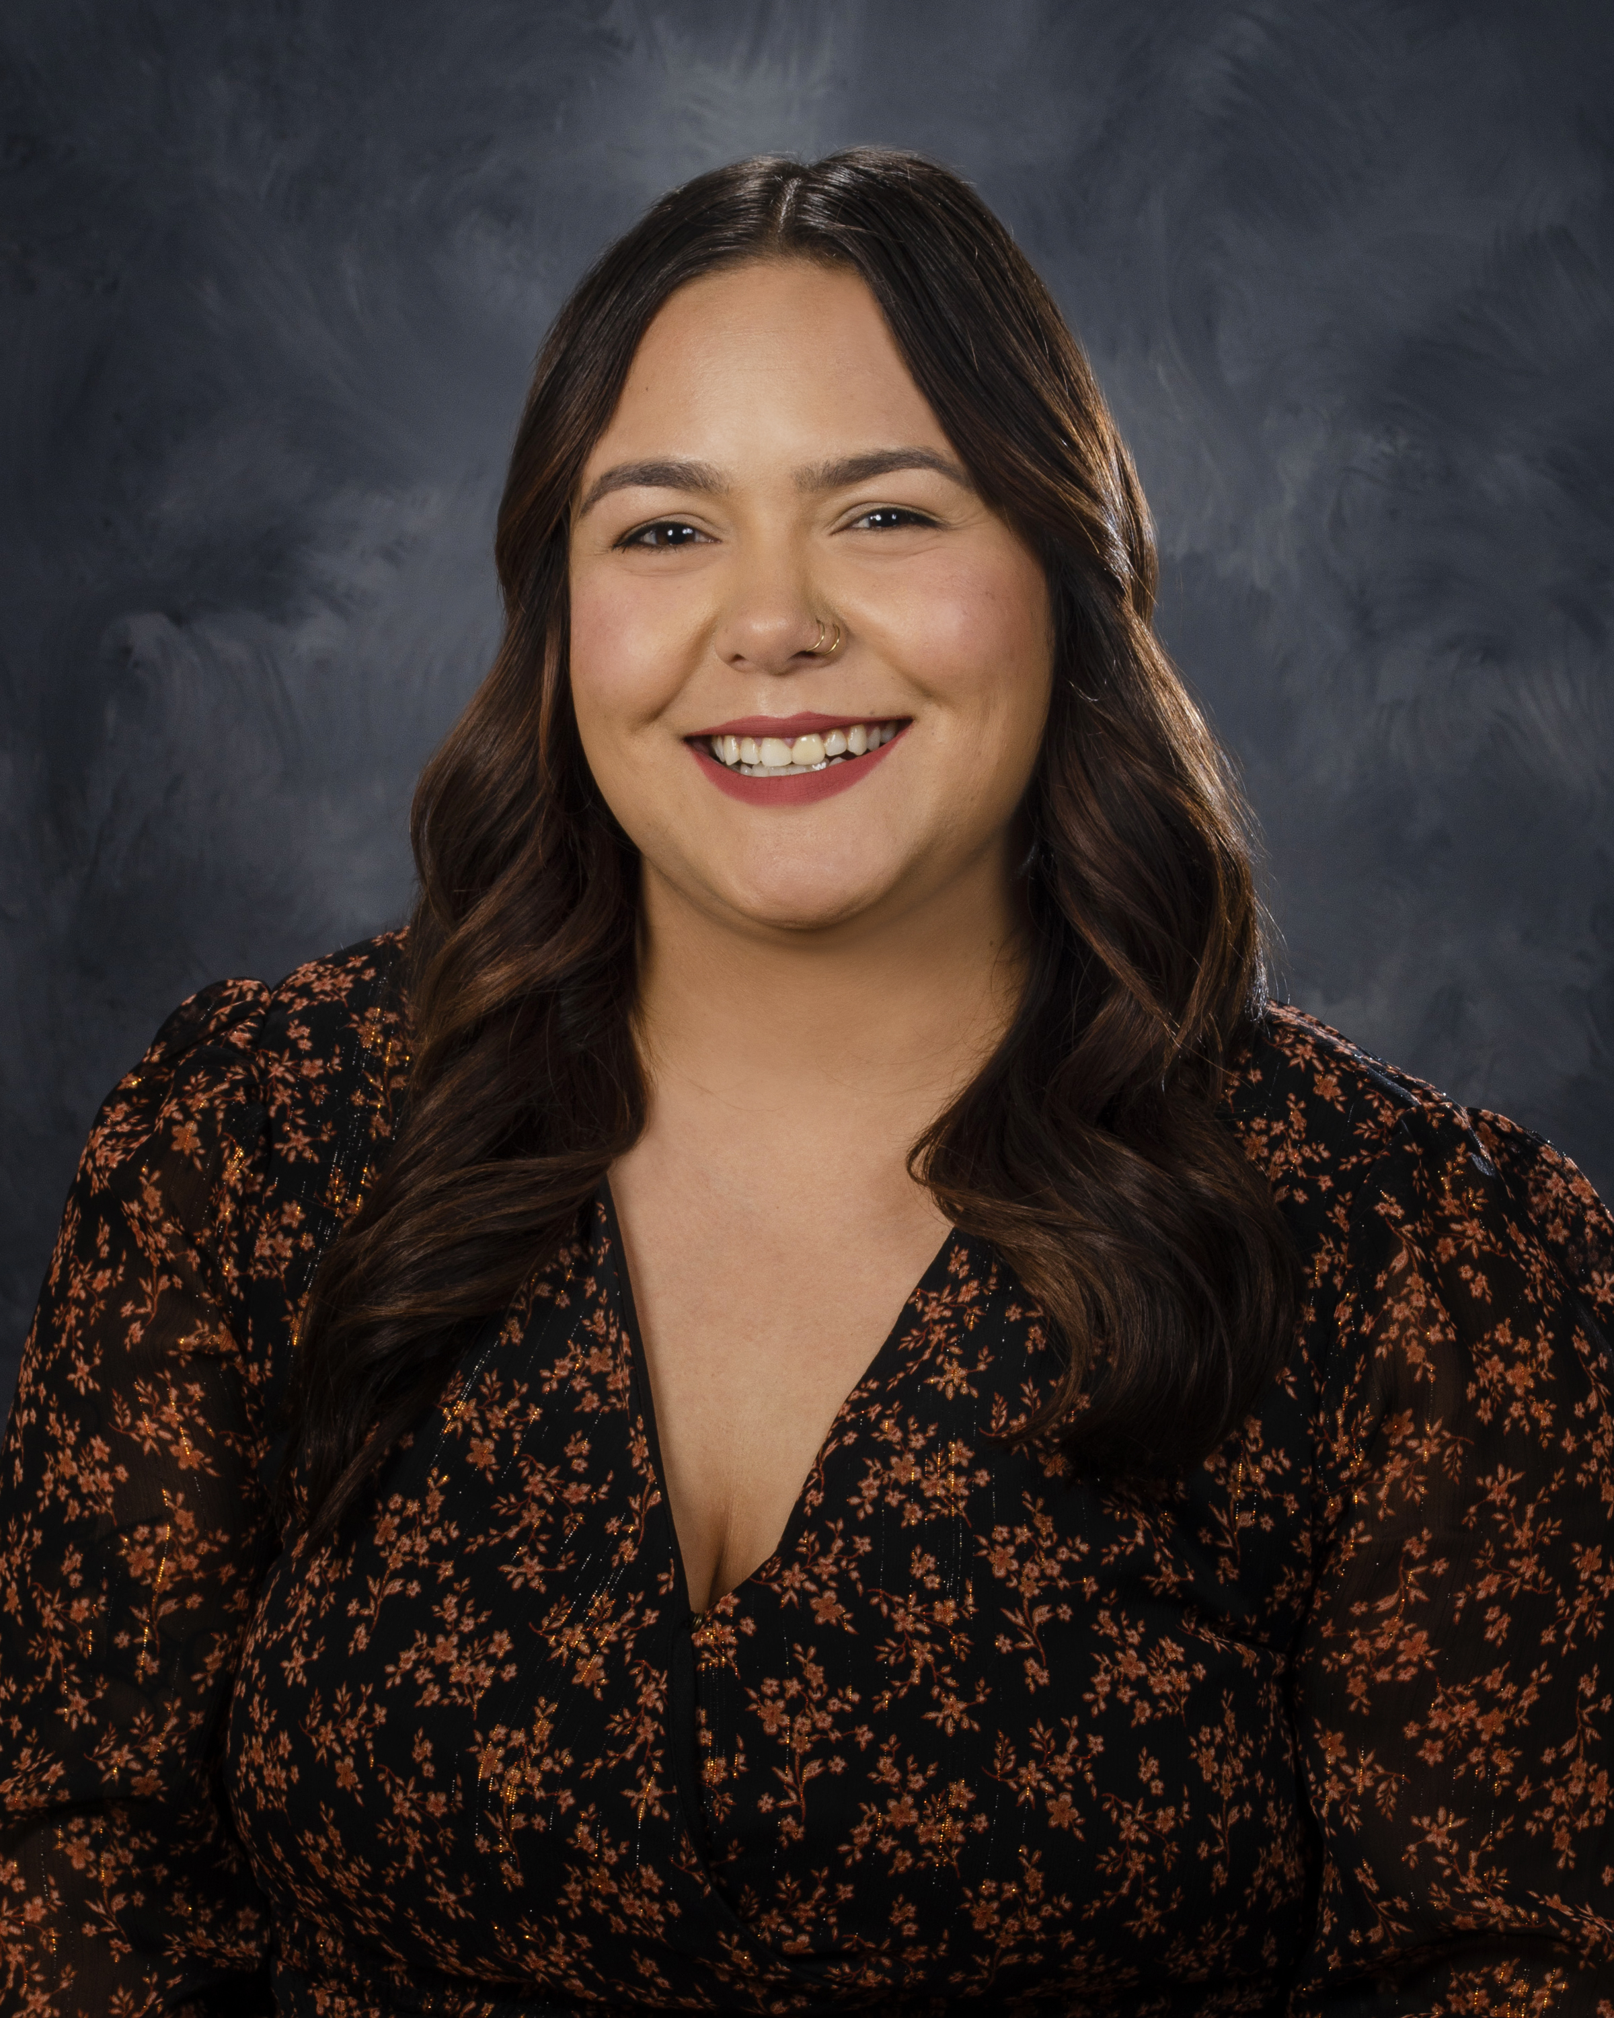  Brittany Martinez, our Valley Crime Prevention Specialist is here to help answer any questions you may have related to crime prevention, neighborhood watch, or APD involved community events.  brimartinez@cabq.gov  505-761-8805   | Crime Mapping Info & (Safety TIPS)    The Valley Area Command uses the Computer Aided Dispatch (CAD) data to determine crimes that happen in the area. When a response is indicated, the information received from the caller will be entered into the CAD for a response. The information from the caller allows ECC staff to determine the priority of the call, how many officers to dispatch, and it provides the officers with vital information so they can determine what action to take as they respond to a call for service.  Residential Burglaries  (TIP)-It is always good practice to make it look like someone is home at all times. Turn a radio on to a talk show station when you are gone, this will make it appear that someone is inside of your home.  Commercial Burglaries  (TIP)-If your business is closed, we recommend that you check your property periodically, be sure to leave lights on and clean up any debris or growth around the property. These small steps may deter a criminal.  Auto Burglaries  (TIP)-Be sure you are keeping your belongings out of site and remove anything of value. It is a great idea to pack a bag with items you need for the day and take it with you when you get out of the vehicle.  Stolen Vehicles  (TIP)-Using devices such as kill switches, alarms, clubs and locking doors and windows, also try to park in an area with good lighting to try to deter a criminal.  Carjacking  (TIP)- Always be aware of your surroundings. Pay special attention when you are at a standstill such as when you are at a stop light or in a parking lot. Keep doors locked, roll up your windows and notice who is in the immediate area.  Robbery to an Individual  (TIP)-Use situational awareness, look around, walk with confidence, make eye contact and read peoples body language. If you do find yourself in this situation give them whatever possession they are demanding, remember, possessions can always be replaced – you, cannot.  Commercial Robbery  (TIP)- Train your employees to be on the lookout for suspicious behavior and report it immediately. Start training your brain to make note of how someone looks and what they are wearing, including their shoes. Many criminals will change their clothing but they will not change their shoes.  Robbery By Gunpoint  (TIP)- After the robbery occurs call 911 and lock your doors. If there are witnesses ask if they can stay to give a description of the offender. Do not discuss what you saw with others, wait to give a description to the officer.  Residential Robbery  (TIP)- Always identify who is at the door before opening it. Keep doors locked at all times. Keep an eye out for suspicious persons/vehicles in the neighborhood.  Remember if you see something say something!  Homeless Encampments/Services  You can report homeless encampments by calling 311 or through the solid waste email:  sw-encampment@cabq.gov  To get more information on homeless assistance go to:  https://www.cabq.gov/family/services/homeless-services  Services Offered  There are many resources that we can provide to you, such as, informational pamphlets, Training on topics such as personal safety, scams, anti-bullying etc., CPTEDs (Crime Prevention Through Environmental Design), starting a Neighborhood Watch, CFMH (Crime Free Multi-Housing) and we can take McGruff to your public event or school or set up a table with informational pamphlets and promotional items. All of these services are free of charge.  Crime Prevention Corner    March is here which means warmer weather coming and that means time to get outside and work on some home projects! Don’t only think about the landscaping, it’s also a great time to do a self-assessment on home security and see what you could possibly do to change some things in and around your home.  The Home Security Checklist developed by the National Crime Prevention Council and included in this newsletter can help you do just that; or our Crime Prevention Team is available to survey your property and provide you with recommendations as well.  Our team uses Crime Prevention through Environmental Design as a model for our assessments. Crime Prevention through Environmental Design (CPTED) advocates that the effective use of the built environment can lead to a reduction in crime and improve the quality of life for neighborhoods.  CPTED is a successful strategy that can be applied to business, industry, residential and public properties. The following components encompass a holistic CPTED approach to design:  Natural Surveillance: The ability to see and be seen – visibility.  Access Control: Placement of physical barriers, limited entrances/exits, and locks make it more difficult for a potential offender to commit a crime.  Territorial Reinforcement: Creates a sense of ownership and empowerment by members of a community to monitor their neighborhood and protect their space.  Maintenance: A well maintained space shows ownership and will attract legitimate, law abiding users.  If you would like a CPTED survey of your business or residential property please call the Valley Area Command and speak with Brittany Martinez, Crime Prevention Specialist, (505) 761-8805 or brimartinez@cabq.gov  Atlas One  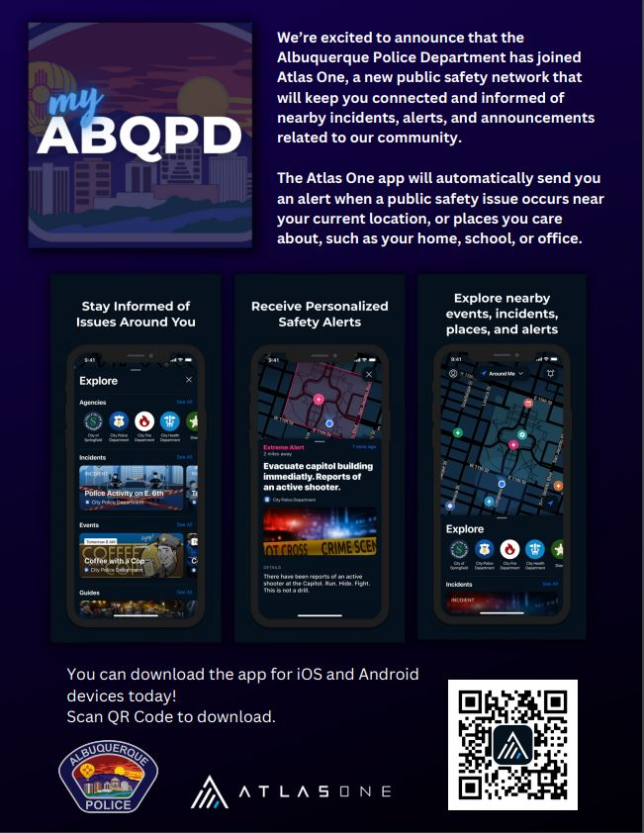  Reminder: A new app called Atlas One from APD has replaced the old app (which no longer functions or sends APD information). If you're interested in using it, there's a helpful guide available at https://youtu.be/OEQ1MfJyWCo. This guide has step-by-step instructions to help you get started.  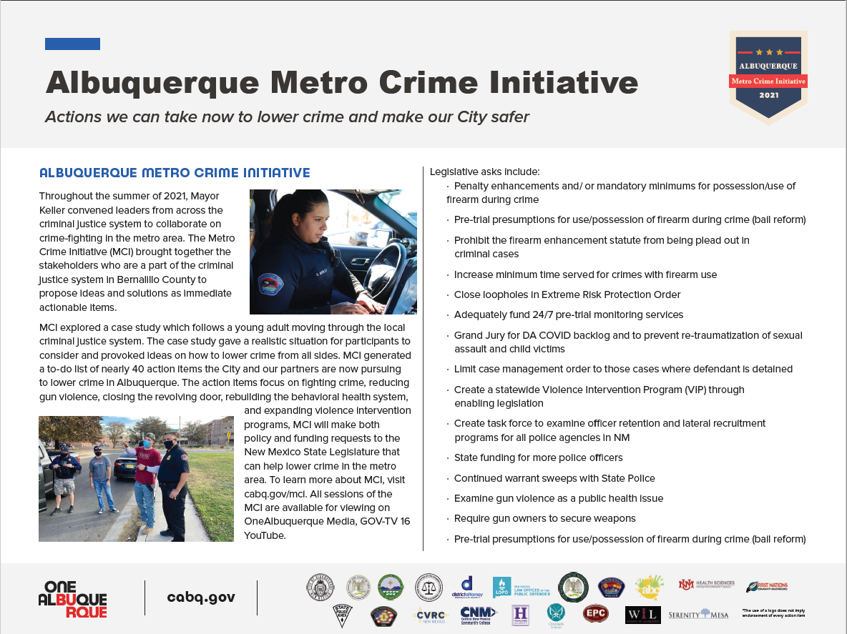  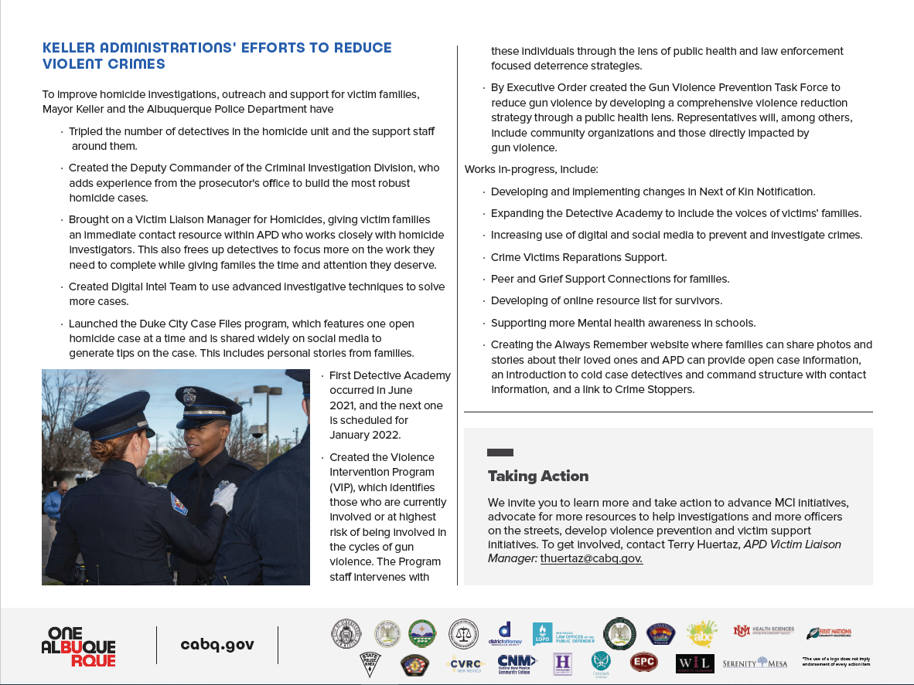
    - Crime Mapping
  On the crime mapping website you can run any crimes that you would like to look at in your neighborhood or throughout the city of Albuquerque. You can also sign up to receive alerts in your specific area.
  Crimemapping.com
 | 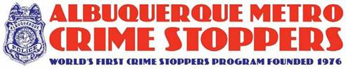  The Crime Stoppers program began 35 years ago when an Albuquerque Police Detective partnered with the media to reenact an unsolved homicide. Tips from that news story ultimately led to an arrest and Crime Stoppers was born.  Today, the Albuquerque Metro Crime Stoppers (AMCS) model has been replicated in over 1,200 programs in all fifty states and more than 20 countries.  Tips to Albuquerque Metro Crime Stoppers have led to the arrest of 2,001 fugitives and helped close over 7,300 cases in the Albuquerque area.  AMCS has paid out over $500,000 in rewards since 1976.  Crime Stoppers is the only program guaranteed by law to protect the identity of tipsters. Because of this, tipsters are exempt from taxes on reward payments.  Crime Stoppers is a 501(c) 3 non-profit organization and receives no government funding. 100% of the funding for rewards, tip line operations and advertisement is provided through donations from individuals, businesses and community organizations.  To Submit a Tip:  Call 505-843-STOP or visit the Albuquerque Metro Crime Stoppers website. All information provided is anonymous.  Substation Hours  All police substations are open to the public the hours of operation are from 8:00 AM to 5:00 PM.  If you need an Accident Report form or a copy of an Accident Report you can call with your case number to have it mailed to you via US Mail they are not provided through email. When you come in to get a report make sure to bring in your ID and Case #. For any other report call the substation to make sure it is available before coming by 761-8800.  The Old Town Substation is now open Monday-Thursday 8:00 AM to 5:00 PM and on Friday 8:00 AM to 8:00 PM and on weekends from 11:00 PM to 7:00 PM.  Valley Area Command  5408 2nd St NW  Albuquerque, NM 87107  505-761-8800  Southwest Area Command  6404 Los Volcanes NW  Albuquerque, NM 87121  505-831-4705  Southeast Area Command  800 Louisiana SE  Albuquerque, NM 87108  505-256-2050  Northwest Area Command  10401 Cibola Loop NW  Albuquerque, NM 87114  505-768-4850  Northeast Area Command  8201 Osuna NE  Albuquerque, NM 87109  505-823-4455  Foothills Area Command  12800 Lomas NE  Albuquerque, NM 87112  505-332-5240  Needles/Sharps Containers/Drug Disposal  Please be advised large quantities of used needles and/or full sharps containers are not accepted at the Valley Substation. We have a small container located in the lobby. If you have more than a few needles the closest drop-off location to our substation is the North Valley Public Health Office located at 7704 2nd St NW. Call the substation nearest you to see if they accept needles/sharps. Pills are accepted at all substations (No liquids accepted).  For more information visit: cabq.gov/police
    - File a Report
  Online Report
  cabq.gov/police/file-a- police-report-online
  (TRU )Telephone
  Reporting Unit
  242-2677 (COPS)

