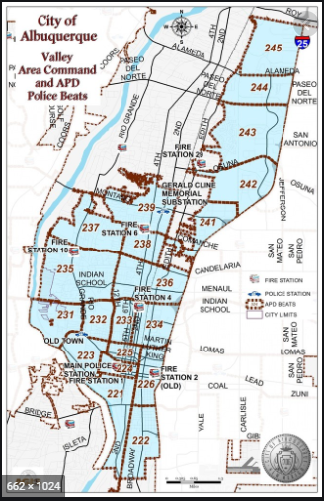 | VALLEY AREA COMMAND MONTHLY NEWSLETTER    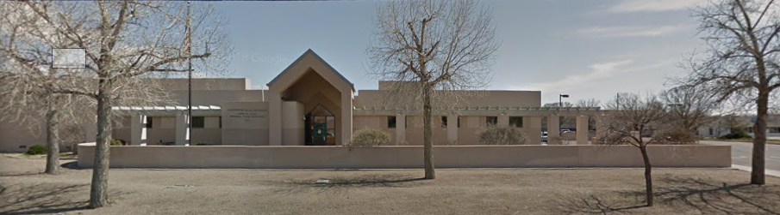  The Valley Area Command is overseen by  Commander Nick Wheeler  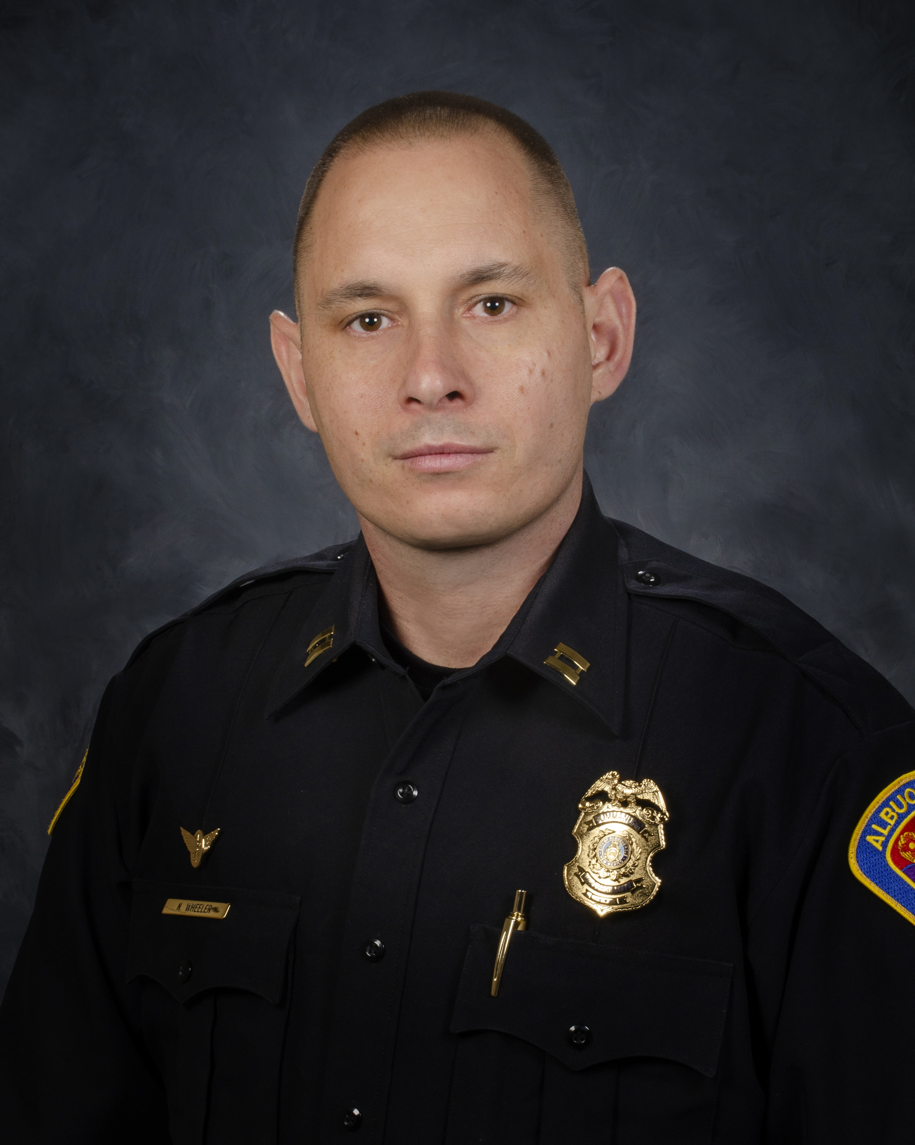
  November 2023
  Gerald Cline Substation
  5408 2nd St NW
  Albuquerque, NM 87107
  505-761-8800
  The Valley area is bordered by the Albuquerque city limits to the north and south, Interstate 25 to the east and the Rio Grande, Los Ranchos de Albuquerque, and the North Valley to the west
 | Commander’s Corner  I hope everyone had a wonderful Thanksgiving. Remember it is a time to be with family and friends and to share with those who are less fortunate. On Black Friday, our Holiday Business Operation began. We are assigning additional resources to our large shopping areas. The primary goal of this operation is to deter would-be criminals from entering the area and to respond quickly to any calls for service in those areas.  Our enforcement numbers continue to rise due to proactive police work and our crime numbers continue to decrease. With the holidays here, I would remind everyone to ensure valuable items, purses, electronic devices and shopping bags are out of sight and or locked in a trunk. This will dissuade criminals from targeting your vehicles.  I would encourage everyone out-and-about to stop our APD Officers and engage in conversation. We love to hear from our Citizens about what we are doing well and need to improve on. Communication is the way we continue to build our relationships and improve our overall quality of life.  Again, please reach out to me if you have any questions about anything going on in the Valley Area Command. My email is nwheeler@cabq.gov. Please be safe!  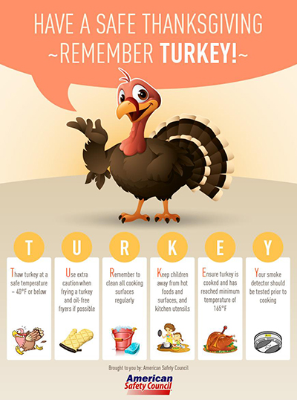  Crime Statistics — City of Albuquerque  Information about Albuquerque crime statistics  Crime Statistics — City of Albuquerque (cabq.gov)    Community Policing  The idea is simple: Build relationships and work with communities to address their concerns and priorities.  We are successfully fighting crime when we work hand-in-hand with communities to implement solutions that keep people safe. Our officers are working with neighborhoods, business owners, faith-based organizations, schools, and more to tailor proven public safety strategies to meet the needs of specific areas. APD Community Policing comprises three key components: Problem Solving, Community Partnerships and Organizational Transformation.  Problem Solving: Solving problems means, first, identifying issues that need to be addressed and then determining resolutions and devoting effort to meeting needs for a successful outcome. The SARA (Scanning, Analysis, Response, and Assessment) model is one of the most familiar processes for problem-oriented policing (POP). APD is using this model.  Community Partnerships: Partnerships between law enforcement and the individuals and organizations they serve to develop solutions to problems and increase trust in police. APD will focus on creating partnerships with a diverse section of the Albuquerque community and will work with key community stakeholders including, but not limited to:  - Other law enforcement agencies  - Social service providers  - Business community  - Educational institutes  - Local prosecutors  - Faith-based organizations  - Neighborhood interest groups  - Youth organizations  These partnerships will identify community challenges and focus on developing a strong road map to address those challenges (problem solving).  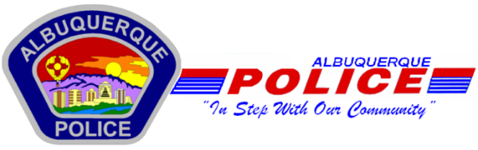  Other Services:  Sharps Disposal (Needles) – Call 311 https://www.cabq.gov/environmentalhealth/sharps-disposal  (ACS) Albuquerque Community Safety    Albuquerque Community Safety Administration (ACS) – Call 311, 242-COPS or 768-4227 acs@cabq.gov – ACS sends trained professionals to non-violent and non-medical 911 calls for service involving issues such as mental/behavioral health, homelessness, and addiction as well as non-behavioral issues such as abandoned vehicles and needle pick-ups.  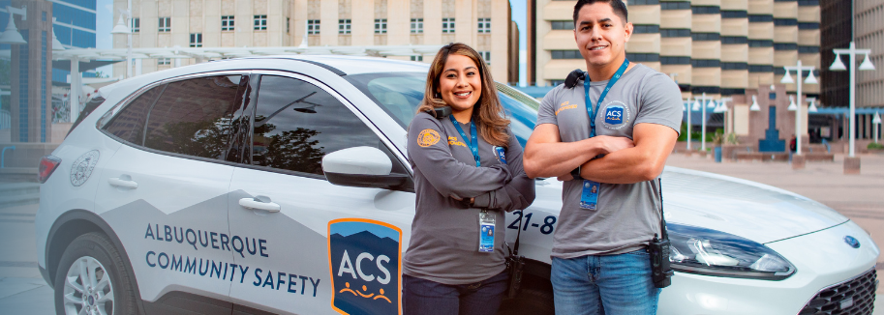
    - 
  
  V
  A
  L
  L
  E
  Y
  AREA
  COMMAND
  
   | Crime Statistics  Information about Albuquerque crime statistics:  www.cabq.gov

  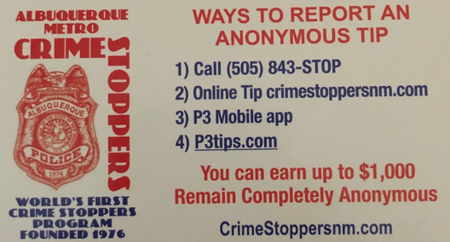  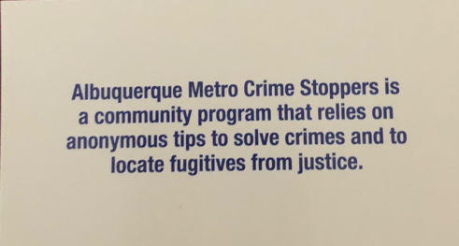  Valley Crime Prevention Specialist  Lamont Davis  5408 2nd St NW  Albuquerque, NM 87107  505-761-8805  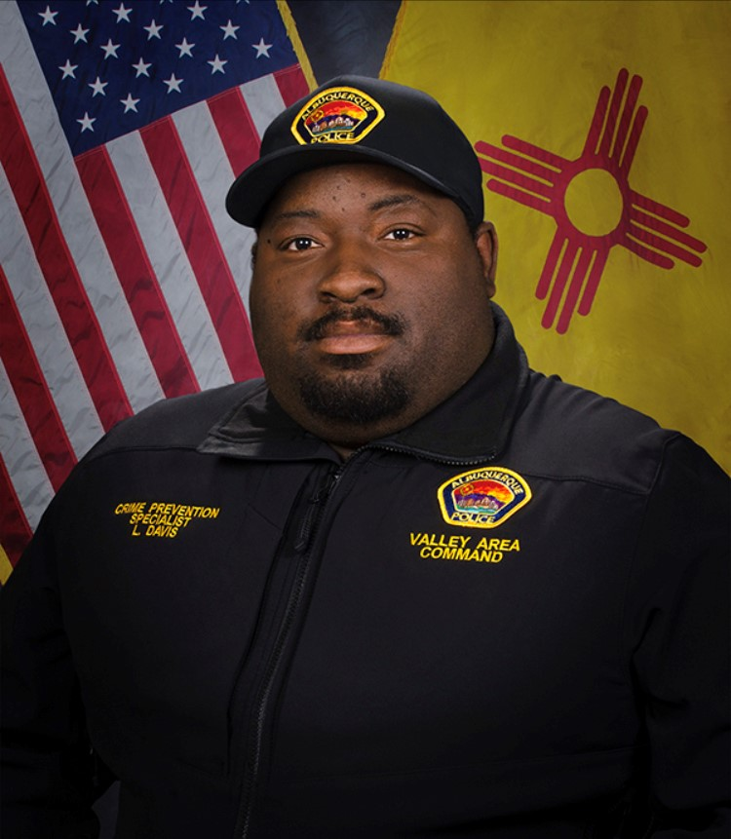  Lamont Davis, our Valley Crime Prevention Specialist is here to help answer any questions you may have related to crime prevention, neighborhood watch, or APD involved community events.   | Crime Mapping Info & (Safety TIPS)  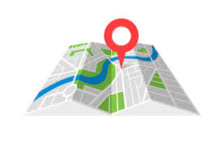  The Valley Area Command uses the Computer Aided Dispatch (CAD) data to determine crimes that happen in the area. When a response is indicated, the information received from the caller will be entered into the CAD for a response. The information from the caller allows ECC staff to determine the priority of the call, how many officers to dispatch, and it provides the officers with vital information so they can determine what action to take as they respond to a call for service.  Residential Burglaries  (TIP)-It is always good practice to make it look like someone is home at all times. Turn a radio on to a talk show station when you are gone, this will make it appear that someone is inside of your home.  Commercial Burglaries  (TIP)-If your business is closed, we recommend that you check your property periodically, be sure to leave lights on and clean up any debris or growth around the property. These small steps may deter a criminal.  Auto Burglaries  (TIP)-Be sure you are keeping your belongings out of site and remove anything of value. It is a great idea to pack a bag with items you need for the day and take it with you when you get out of the vehicle.  Stolen Vehicles  (TIP)-Using devices such as kill switches, alarms, clubs and locking doors and windows, also try to park in an area with good lighting to try to deter a criminal.  Carjacking  (TIP)- Always be aware of your surroundings. Pay special attention when you are at a standstill such as when you are at a stop light or in a parking lot. Keep doors locked, roll up your windows and notice who is in the immediate area.  Robbery to an Individual  (TIP)-Use situational awareness, look around, walk with confidence, make eye contact and read peoples body language. If you do find yourself in this situation give them whatever possession they are demanding, remember, possessions can always be replaced – you, cannot.  Commercial Robbery  (TIP)- Train your employees to be on the lookout for suspicious behavior and report it immediately. Start training your brain to make note of how someone looks and what they are wearing, including their shoes. Many criminals will change their clothing but they will not change their shoes.  Robbery By Gunpoint  (TIP)- After the robbery occurs call 911 and lock your doors. If there are witnesses ask if they can stay to give a description of the offender. Do not discuss what you saw with others, wait to give a description to the officer.  Residential Robbery  (TIP)- Always identify who is at the door before opening it. Keep doors locked at all times. Keep an eye out for suspicious persons/vehicles in the neighborhood.  Remember if you see something say something!  Homeless Encampments/Services  You can report homeless encampments by calling 311 or through the solid waste email:  sw-encampment@cabq.gov  To get more information on homeless assistance go to:  https://www.cabq.gov/family/services/homeless-services  Services Offered  There are many resources that we can provide to you, such as, informational pamphlets, Training on topics such as personal safety, scams, anti-bullying etc., CPTEDs (Crime Prevention Through Environmental Design), starting a Neighborhood Watch, CFMH (Crime Free Multi-Housing) and we can take McGruff to your public event or school or set up a table with informational pamphlets and promotional items. All of these services are free of charge.  Crime Prevention Corner  Cooking  Unattended cooking is the leading cause of home fires and home fire injuries in the U.S. When cooking, remember to keep an eye on the range.    Fires and fire alarm activations can be caused by individuals using any type of cooking appliance, which includes: stoves, ovens, microwave ovens, toaster ovens, rice cookers, crock pots etc.  YOU can help prevent fires and fire alarm activations caused by cooking by following these fire safety prevention tips:  - Never leave the cooking area unattended  - If you have to leave the stove, microwave or other cooking appliance for any reason turn the appliance off.  - Turn handles to the center of the stove to prevent spills  - Have a lid handy to smother a pan fire  - Use approved pot holders, not apron or towels  - Avoid grease buildup on appliances and surrounding surfaces  - Clean appliances regularly. Watch for grease overflows that can start fires.  - Don't place towels, napkins or other paper products around the stove surface  - Don't wear loose clothing  If You Have a Grease or Other Related Fire  - NEVER TRY TO MOVE OR CARRY A PAN THAT IS ON FIRE (It is a common reaction to move or throw a burning pan into a sink. This often results in serious burns to individuals and can spread the fire)  - Carefully turn the heat off and place a cover over the pan. Do not remove the lid until the pan has cooled down  - Never use water on a grease fire. It will cause the fire to spread.  - If the fire is small you may be able to extinguish it with the use of baking soda (Bicarbonate of soda). NEVER use baking powder, flour, starch or sugar.  - If possible use an approved portable fire extinguisher to extinguish the fire.  Grilling FAQ's Can I store and use a propane grill on my apartment balcony?  No. Gas-fired grills shall not be used on any balcony or under any overhanging portion or within 10 feet of any structure  Can I use my charcoal grill on my balcony?  Hibachi, gas-fired grills or similar devices used for cooking, heating or any other purpose shall not be used or kindled on any balcony. As or under any overhanging portion or within 10 feet of any structure.  Can I use my electric grill on my balcony?  Listed electric ranges and grills, or similar electrical apparatus are permitted.  Most Importantly... Be Prepared for a Fire!  One of the best ways to protect yourself and your family is to have a working smoke alarm that alerts you of a fire. A smoke alarm greatly reduces your chances of dying in a fire.  Make and practice a home fire escape plan and set a meeting place outside. Make sure everyone in your family knows at least two escape routes from their bedrooms.  Know how to correctly use your fire extinguisher. Call 911 immediately to report a fire emergency.  Turkey Fryer Fire Safety  The popularity of turkey fryers has grown in the U.S. in the past couple of years. For safety's sake, buy a fried turkey from a grocery store, specialty food store, or restaurant instead of frying it yourself. If you must fry one yourself, follow the safety tips below to prevent fires and burn injuries.  First read the manufacturer's instructions.  - Place the turkey fryer on a level surface, in an open area away from homes, fences, sheds, and other structures that are combustible.  - Never place the fryer on a wooden deck or porch or in a garage or carport.  - Leave at least 2 feet between the fryer and the propane tank.  - Keep the fryer in full view at all times.  - Keep children and pets away from the fryer.  - Check the oil temperature often. If you see smoke coming from the oil, turn off the gas right away.  - Completely thaw and dry the turkey before frying. Adding a partially frozen or wet turkey to the pot makes the oil splatter a lot, causing a fire or explosion hazard.  - Cover bare skin before adding or removing food from the fryer.  - Raise and lower food slowly to avoid splattering or spilling oil.  - Use the right amount of oil.  - If the fryer catches fire, call 911 right away. Do not try to put it out with water.  Turkey Fryer Fire Facts  - Cooking fires peak on Thanksgiving Day.  - Between 1998 and 2005, the Consumer Product Safety Commission had 112 reports of fires or burns related to turkey fryers.  - Most fires from turkey fryers occur while the oil is being heated, before the turkey is added.  - Contact with hot oil can cause serious burns.  Scams & Fraud Alerts  Types of scams and fraud alerts from the Office of Consumer Protection  Please be aware of the following scam & fraud alerts in our community:  Types of Scams  There are many types of scams listed below to find out how they work, how to avoid them, and what to do if you have experienced being scammed.  - Identity Theft  - Social Security Imposters  - IRS and Government Imposter Scams  - Grandparent Scams  - Online Dating/Romance Scams  - Tech Support Scams  - Healthcare Scams  - “You’ve Won” Scams  - Home Repair Scams  - Work-at-Home Scams  - Money Mule Scams  - Charity Scams  - Unwanted Calls  - Student Loan Debt Relief Scams  Coronavirus Scams & Information  - Coronavirus: Scammers follow the headlines (FTC)  - FBI Sees Rise in Fraud Schemes Related to the Coronavirus (COVID-19) Pandemic  - COVID Scams in Albuquerque  - Beware of Fraudulent Coronavirus Tests, Vaccines and Treatments  - Report fraudulent COVID-19 products to FDA-COVID-19-Fraudulent-Products@fda.hhs.gov  Stimulus Payment Information  - Are you concerned that an identity thief stole your stimulus check?  - Stimulus Payments on Prepaid Cards  - Prepaid Card Stimulus Money Alert  Identity Theft  Information about identity theft and how to prevent it.  How It Works  Someone gets your personal information and runs up bills in your name. They might use your Social Security or Medicare number, your credit card, or your medical insurance — along with your good name.  How would you know? You could get bills for things you didn’t buy or services you didn’t get. Your bank account might have withdrawals you didn’t make. You might not get bills you expect. Or, you could check your credit report and find accounts you never knew about.  How to Prevent It  - Protect your information. Put yourself in another person’s shoes. Where would they find your credit card or Social Security number? Protect your personal information by shredding documents before you throw them out, by giving your Social Security number only when you must, and by using strong passwords online.  - Read your monthly statements and check your credit.When you get your account statements and explanations of benefits, read them for accuracy. You should recognize what’s there. Once a year, get your credit report for free from AnnualCreditReport.com or 1-877-322-8228. The law entitles you to one free report each year from each credit reporting company. If you see something you don’t recognize, you will be able to deal with it.  - Take steps to protection your identity and credit. Go to ftc.gov/idtheft or Identitytheft.gov/SSA to learn what to do if you have been scammed.  If You Have Been Victimized by Identity Theft  - File a police report. Some businesses require a police report to remove fraudulent debts from a victim’s account. Filing a report may help you in the future if the someone uses your identity  - Create an Identity Theft Report and get a personal recovery plan at IdentityTheft.gov  - Freeze your credit report by going to website for each of the 3 big credit reporting agencies (Experian, Transunion and Equifax) and following the links to freeze your credit  - Call the three national credit-reporting organizations immediately to place a fraud alert on your name and Social Security Number:  - Equifax 1-800-525-6285  - Experian (formerly TRW) 1-800-301-7195  - Trans Union 1-800-680-7289  - Social Security Administration fraud line 1-800-269-0271  - Get more information from free identity theft resources from the FTC  Home Repair Scams  Information about Home Repair Scams.  How It Works  Someone knocks on your door or calls you. They say they can fix your leaky roof, install new windows, or provide the latest energy-efficient solar panels. They might find you after a flood, windstorm or other natural disaster. They pressure you to act quickly, might ask you to pay in cash, or offer to get you financing.  But here’s what happens next: they run off with your money and never make the repairs. Or they do shoddy repairs that make things worse. Maybe they even put you in a bad financing agreement that puts your house at risk.  How to Prevent It  Stop. Check it out. Before making home repairs, ask for references, licenses and insurance. Get three written estimates. Don’t start work until you have a signed contract. And don’t pay by cash or wire transfer.  Research the company. Ask for references from prior customers, check out the Better Business Bureau website for reports of problems.  If you lost money you should act immediately:  - Call the gift card or debit card company immediately. The contact number is on the back of the card. If reported immediately, you may be able to stop the transfer of funds, otherwise it may not be possible to stop the funds from being withdrawn. It is also important to alert the card company of fraud.  - If you sent cash, report it immediately to the postal service or whatever company you used. If you act quickly you may be able to stop delivery by giving the tracking number to the delivery company.  - If you wired the money, contact the wire service company and report the fraud.  - If you provided your bank account information or sent a check, contact your financial institution and place a stop payment on the check and alert them of the fraud.  - If you gave personal information to the scammer you may be subject to identity theft. Learn what to do.  - Report the scam to the Attorney General’s Office Toll Free 1-844-255-9210 and the State of New Mexico Construction Industries Division.  - Report home repair scams to the Federal Trade Commission.  Tech Support Scams  Information about Tech Support Scams.  How It Works  You get a call from someone who says he’s a computer technician. He might say he’s from a well-known company like Microsoft, or maybe your internet service provider. He tells you there are viruses or other malware on your computer. He says you’ll have to give him remote access to your computer or buy new software to fix it.  But is the caller who he says he is? Judging by the complaints to the Federal Trade Commission, no. These scammers might want to sell you useless services, steal your credit card number, or get access to your computer to install malware, which could then let them see everything on your computer.  Scammer have the technology to “spoof” a caller id, making it look like one Microsoft or Apple is really calling. Scammers can also post phony customer support number on-line for well-known companies.  How to Prevent It  - Hang up. Never give control of your computer or your credit card information to someone who calls you out of the blue.  - Do not click or call a number that pops up on your screen warning or a computer problem.  - Do not rely on caller id – it can easily be spoofed.  - Never share passwords with anyone who contacts you.  - Keep security software up to date.  - If you need help, contact a computer technician that you trust. Do not just rely on an online search.  If you have been scammed:  - Change any passwords you shared and scan your computer for malware.  - If you gave your credit card number, tell you credit card company and file a dispute of charges.  - Check your statement and contact your credit card company to dispute and reverse any charges for bogus services.  - If you get a call from the company for a “refund”, hang up because that could be part two of the scam.  Report scams to the Federal Trade Commission  Valley Community Policing Council:  Hello and Welcome Everyone,  Our next meeting is on November 23th  As always we have both in-person and virtual attendance. The link to join the meeting is:  https://cabq.zoom.us/webinar/register/WN_7Z1iT-WbR9-9-s1dEYOjiA  Our physical location is the Johnny Tapia Community Center and we run from 6:00pm to 8:00pm.  In the not too distant future we will be rotating our meetings to different community centers for three months at a time. We will keep you informed.  If you need more information please contact us at cpcvalley@gmail.com.    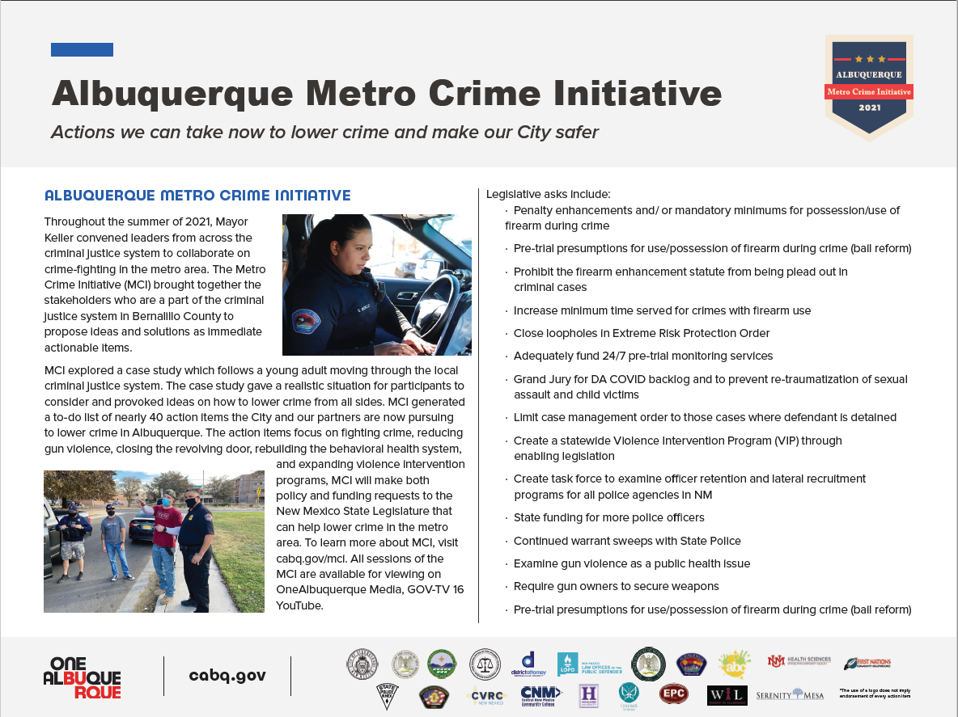  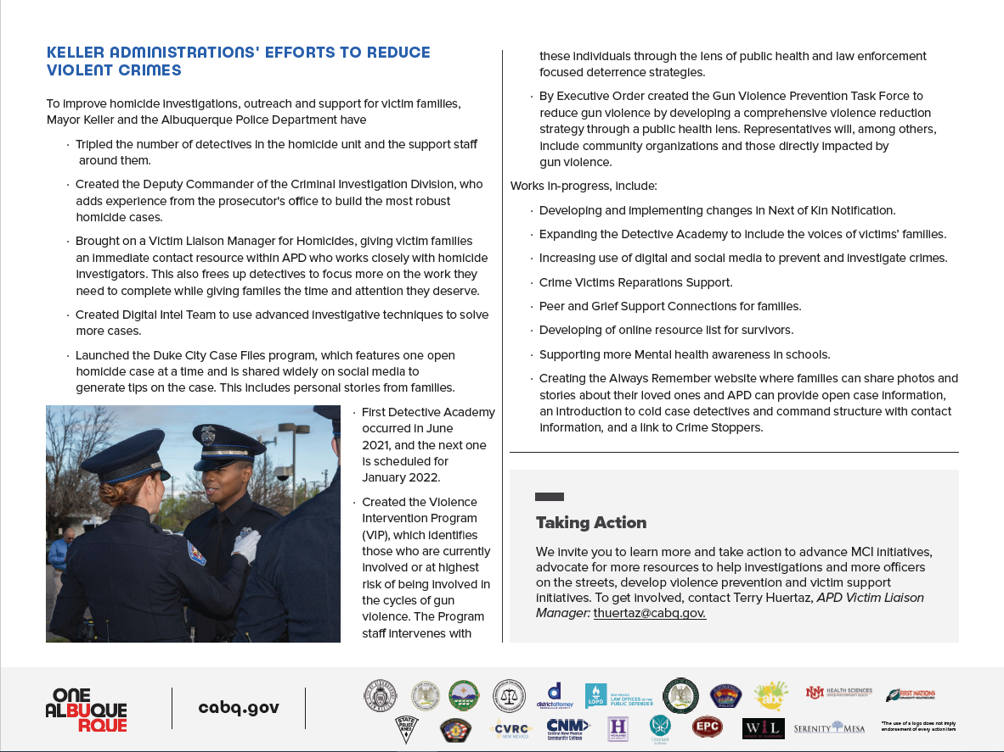
    - Crime Mapping
  On the crime mapping website you can run any crimes that you would like to look at in your neighborhood or throughout the city of Albuquerque. You can also sign up to receive alerts in your specific area.
  Crimemapping.com
 | Substation Hours  All police substations are open to the public the hours of operation are from 8:00 AM to 5:00 PM.  If you need an Accident Report form or a copy of an Accident Report you can call with your case number to have it mailed to you via US Mail they are not provided through email. When you come in to get a report make sure to bring in your ID and Case #. For any other report call the substation to make sure it is available before coming by 761-8800.  The Old Town Substation is now open Monday-Thursday 8:00 AM to 5:00 PM and on Friday 8:00 AM to 8:00 PM and on weekends from 11:00 PM to 7:00 PM.  Valley Area Command  5408 2nd St NW  Albuquerque, NM 87107  505-761-8800  Southwest Area Command  6404 Los Volcanes NW  Albuquerque, NM 87121  505-831-4705  Southeast Area Command  800 Louisiana SE  Albuquerque, NM 87108  505-256-2050  Northwest Area Command  10401 Cibola Loop NW  Albuquerque, NM 87114  505-768-4850  Northeast Area Command  8201 Osuna NE  Albuquerque, NM 87109  505-823-4455  Foothills Area Command  12800 Lomas NE  Albuquerque, NM 87112  505-332-5240  Needles/Sharps Containers/Drug Disposal  Please be advised large quantities of used needles and/or full sharps containers are not accepted at the Valley Substation. We have a small container located in the lobby. If you have more than a few needles the closest drop-off location to our substation is the North Valley Public Health Office located at 7704 2nd St NW. Call the substation nearest you to see if they accept needles/sharps. Pills are accepted at all substations (No liquids accepted).  For more information visit: cabq.gov/police
    - File a Report
  Online Report
  cabq.gov/police/file-a- police-report-online
  (TRU )Telephone
  Reporting Unit
  242-2677 (COPS)
  APD App
  