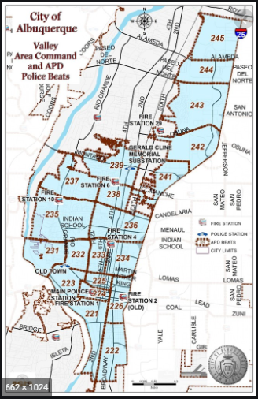 | VALLEY AREA COMMAND MONTHLY NEWSLETTER  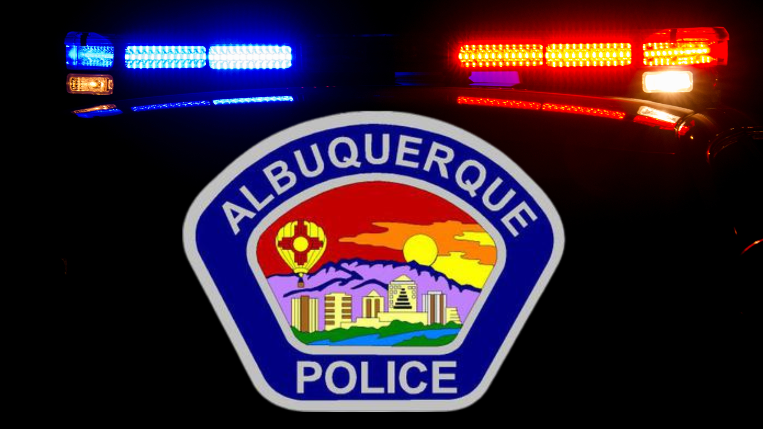  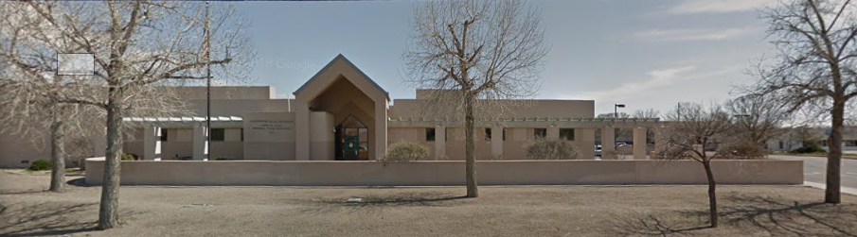  The Valley Area Command is overseen by  Commander Nick Wheeler  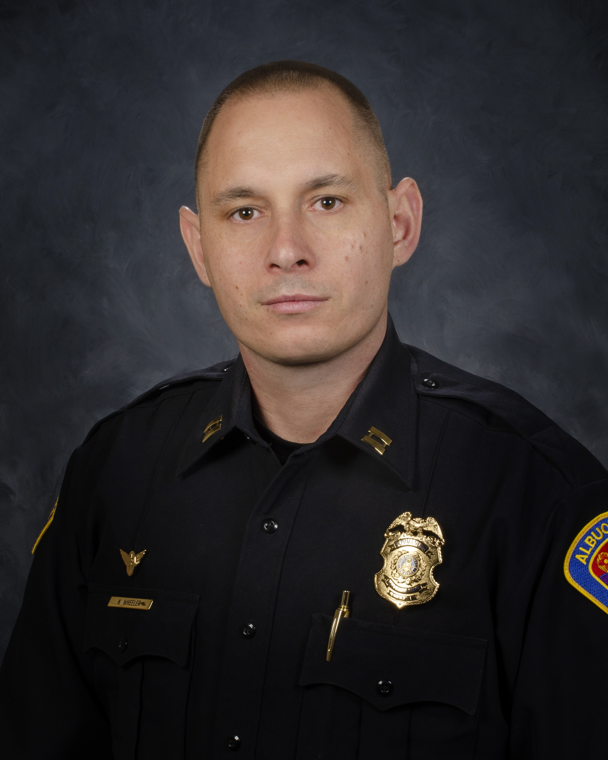
  September 2023
  Gerald Cline Substation
  5408 2nd St NW
  Albuquerque, NM 87107
  505-761-8800
  The Valley area is bordered by the Albuquerque city limits to the north and south, Interstate 25 to the east and the Rio Grande, Los Ranchos de Albuquerque, and the North Valley to the west
 | Commander’s Corner  September is an extremely sad month for our Nation due to the horrific terrorist attacks that were committed on September 11th, 2001. More than 300 people were killed and more than 6,000 were injured in New York, Arlington Virginia and Shanksville Pennsylvania. There is not a day that goes by that I don’t think about these victims.  Here locally we have erected a memorial site in honor of those Albuquerque area Fire Fighters who lost their lives responding to 9/11. The two towers just under 10 feet tall and 2 ½ feet wide are located at the joint Albuquerque Fire Rescue Station 20/Albuquerque Police Substation. This is at 7520 Corona Avenue NE. If you have a moment to visit the memorial, it is very impressive and will remind you of the sacrifices all first responders have experienced.  As our temperature begins to cool, I want to remind everyone to ensure your vehicle doors, residence doors and business doors are locked prior to you leaving. It has always been an issue of the unhoused entering unlocked property to be warm and get out of the elements. If you see someone who appears to be struggling with homelessness and would benefit from the many resources available to them, please contact 311 and ask for an Albuquerque Community Safety (ACS) response. They will arrive, triage the situation and ensure everyone contacted is provided the correct resource.  The Valley’s crime stats remain lower than the previous year. I want to ensure we continue that path and “Win” the year. Please remember to report anything suspicious to the law enforcement. We cannot do our jobs without your assistance.  If you have any questions, please email me at nwheeler@cabq.gov. Please be safe and take care of each other.  Other Services:  Sharps Disposal (Needles) – Call 311 https://www.cabq.gov/environmentalhealth/sharps-disposal  (ACS) Albuquerque Community Safety    Albuquerque Community Safety Administration (ACS) – Call 311, 242-COPS or 768-4227 acs@cabq.gov – ACS sends trained professionals to non-violent and non-medical 911 calls for service involving issues such as mental/behavioral health, homelessness, and addiction as well as non-behavioral issues such as abandoned vehicles and needle pick-ups.  
    - 
  
  V
  A
  L
  L
  E
  Y
  AREA
  COMMAND
  
 | Valley Area Command Crime Statistics  08/01/2023 to 08/31/2023  MONTH OF August 2023  *Information Disclaimer*  This information is pulled from daily Calls for Service, which reflects all calls made to APD’s 911 Emergency Communications Center. It does not reflect all crimes that police investigate, nor the final outcome of crimes investigated. Furthermore it may not reflect the true location of crimes as they may have occurred in a different location from which they are reported.
    - Definitions
  Burglary – Unauthorized entry of any vehicle, watercraft, aircraft, dwelling or other structure, moveable or immovable, with the intent to commit a felony or theft therein.
  Robbery – Consists of the theft of anything of value from the person of another or from the immediate control of another, by use or threatened use of force or violence.
  Motor Vehicle Theft – Consists of a person taking any vehicle or motor vehicle intentionally and without consent of the owner.
  Auto Burglary | 32
  Commercial Burglary | 25
  Residential Burglary | 3
  Auto Theft | 32
  Robbery – Auto | 3
  Robbery – Commercial | 6
  Robbery – Individual | 3
  Robbery - Residential | 3

  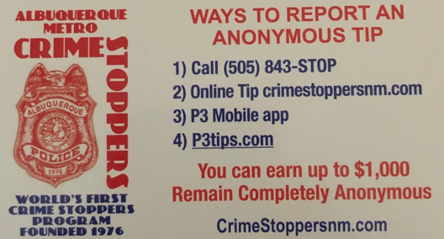  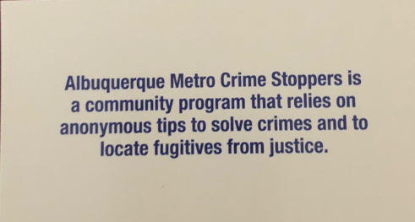  Valley Crime Prevention Specialist  Lamont Davis  5408 2nd St NW  Albuquerque, NM 87107  505-761-8805  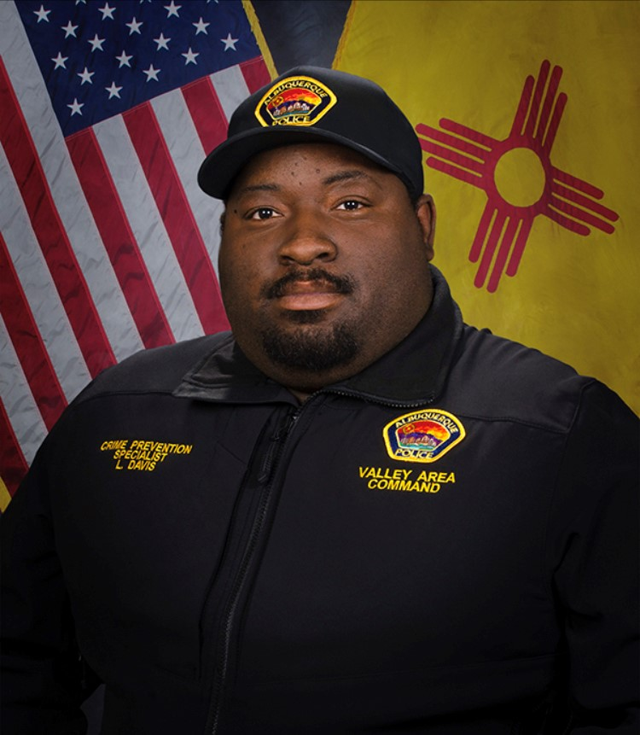  Lamont Davis, our Valley Crime Prevention Specialist is here to help answer any questions you may have related to crime prevention, neighborhood watch, or APD involved community events.   | Crime Mapping Info & (Safety TIPS)    The Valley Area Command uses the Computer Aided Dispatch (CAD) data to determine  crimes that happen in the area. When a response is indicated, the information  received from the caller will be entered into the CAD for a response.  The information from the caller allows ECC staff to determine the priority  of the call, how many officers to dispatch, and it provides the officers with  vital information so they can determine what action to take as they respond  to a call for service.  Residential Burglaries  (TIP)-It is always good practice to make it look like someone is home at all times.  Turn a radio on to a talk show station when you are gone, this will make  it appear that someone is inside of your home.  Commercial Burglaries  (TIP)-If your business is closed, we recommend that you check your  property periodically, be sure to leave lights on and clean up any debris or  growth around the property. These small steps may deter a criminal.  Auto Burglaries  (TIP)-Be sure you are keeping your belongings out of site and remove anything of value. It is a great idea to pack a bag with items you need for the day and take it with you when you get out of  the vehicle.  Stolen Vehicles  (TIP)-Using devices such as kill switches, alarms, clubs and locking doors  and windows, also try to park in an area with good lighting to try to deter a criminal.  Carjacking  (TIP)- Always be aware of your surroundings. Pay special attention when you are  at a standstill such as when you are at a stop light or in a parking lot.  Keep doors locked, roll up your windows and notice who is in the immediate area.  Robbery to an Individual  (TIP)-Use situational awareness, look around, walk with confidence, make  eye contact and read peoples body language. If you do find yourself in this  situation give them whatever possession they are demanding, remember,  possessions can always be replaced – you, cannot.  Commercial Robbery  (TIP)- Train your employees to be on the lookout for suspicious behavior and  report it immediately. Start training your brain to make note of how someone  looks and what they are wearing, including their shoes. Many criminals will  change their clothing but they will not change their shoes.  Robbery By Gunpoint  (TIP)- After the robbery occurs call 911 and lock your doors.  If there are witnesses ask if they can stay to give a description of the offender.  Do not discuss what you saw with others, wait to give a description to the officer.  Residential Robbery  (TIP)- Always identify who is at the door before opening it.  Keep doors locked at all times. Keep an eye out for suspicious persons/vehicles  in the neighborhood.  Remember if you see something say something!  Homeless Encampments/Services  You can report homeless encampments by calling 311 or through the solid waste email:  sw-encampment@cabq.gov  To get more information on homeless assistance go to:  https://www.cabq.gov/family/services/homeless-services  Services Offered  There are many resources that we can provide to you, such as, informational  pamphlets, Training on topics such as personal safety,  scams, anti-bullying etc., CPTEDs (Crime Prevention Through Environmental Design)  starting a Neighborhood Watch, CFMH (Crime Free Multi-Housing) and we can  take McGruff to your public event or school or set up a table with informational  pamphlets and promotional items. All of these services are free of charge.  Crime Prevention Corner  Crime Prevention & Safety  Information about of Albuquerque Police Department's crime prevention efforts and  The Neighborhood Watch Organizing Program.  Crime Prevention  We have over 2000 neighborhoods in Albuquerque participating in the program, and we would like to organize (or "reorganize") your neighborhood on a block-by-block basis.  Initially, we look for someone who would be willing to host in their home  an organizing meeting for their block. If you would like to be a host, follow  this procedure:  Talk with some of your neighbors on your block to see if there is general  Interest in participating in a Neighborhood Watch.  If so, and if you are willing to host the initial organizing meeting, call us to schedule at (505) 768-2006.  We will then work with you to set up the meeting. (Toward the end of the organizing meeting, the neighborhood will officially select someone to be the Block Captain,  Who is our contact person with the group from that point onward.)  We have a wide variety of activities for organized Neighborhood Watch groups,  ranging from participation in the annual National Night Out celebration the first  Tuesday of each August, to your Block Captain's option to join the  Albuquerque Block Captain's Association (ABCA).  The Albuquerque Block Captain's Association was formed on June 1, 1985.  Any block captain of a Neighborhood Watch group organized through  APD Crime Prevention is eligible to join. The ABCA conducts two  informational/business conferences each year and publishes its own newsletter,  "The ABCA Alert." The ten-page twice-per-year publication is sent  ABCA members and contains a variety of crime prevention information.  For more information, please contact APD Crime Prevention at (505) 768-2006.  Crime Prevention Programs  For scheduling or information, call (505) 768-2006. The Neighborhood  Crime Prevention Program of the Albuquerque Police Department offers  Neighborhood Watch, plus other Crime Prevention programs to clubs,  organizations, businesses any community group:  General Presentation - This summary program urges neighbors to join with the  criminal justice system to help themselves become less vulnerable targets  for criminals. Speaking to civic organizations, church groups,  neighborhood associations, service clubs and other groups about the problem of  residential burglary, our staff encourages those attending to host Neighborhood  Watch organizing meetings for their neighborhoods.  Neighborhood Watch (Organizing Meeting) - Presented to residents  of a one block area  (20-25 houses maximum), our staff discusses residential burglary prevention and  home security with particular attention to doors, windows, and other potential  Points of illegal entry. Those attending are registered in the Operation  Identification program and are informed of area crime data. By selecting a  Block Captain to function as a neighborhood leader in crime prevention,  the organized neighborhood may then purchase NOAC (Neighborhood Organized  Against Crime) street signs featuring the "Watching Eye."  This program is presented only in neighborhoods and residential areas.  Personal Safety - Away from the residence; in your vehicle; at your residence.  Crime Prevention through Environmental Design (CPTED) - This newest  crime prevention program discusses an approach in which the  environment and structures of proposed projects are analyzed to  determine what changes and use of technology may result in fewer crime  Problems in the foreseeable future.  Business Crime Prevention Programs - Armed Robbery, Shoplifting,  Commercial Fraud, Violence in the Workplace, Surviving Bank Robbery  (Alarm Response), "Home Visit" Safety (each topic is a separate presentation).  APD Crime Prevention - (505) 768-2006  Summer Safety  Summer is an exciting time for children, school is out and it’s time to have fun but  Summer also brings life threatening and dangerous threats. Swimming and playing  outside all day are popular activities during the summer so it is important that  parents teach their children about water safety and ensure  they keep properly hydrated.  Water Safety  Practice constant, adult supervision around any body of water,  including pools and spas.  Drowning is the second leading cause of accidental death  in New Mexico for ages 1 to 44 years old. Each year  over 8,000 people drown in this country. Nearly 4,000  of those drownings occur during the summer months of June, July, and August.  Stay away from all ditches, arroyos and channels.  - No swimming  - No playing nearby  - Swim only at swimming pools  - Don't attempt a swimming rescue in the arroyo or river  - You could become the next victim.  - Call 911 immediately  - If caught in the water, point feet downstream and wait for help.  Flood Safety Awareness  Flash floods are the #1 weather related killer with approximately  140 deaths recorded in the U.S. each year. Flooding causes more damage  in the United States than any other severe weather related event,  an average of $5 billion a year. Flooding can occur in any of the  50 states or U.S. territories at anytime of the year.  Flash flooding is a result of heavy localized rainfall from slow moving  intense thunderstorms. Flash floods often result from small creeks and  streams overflowing during heavy rainfall. These floods often become  raging torrents of water which rip through city streets, arroyos, and  valleys sweeping everything with them. Flash flooding usually occurs  within 6 hours of a heavy rain event.  In hilly terrain, flash floods can strike with little or no advance warning.  Within minutes, distant rain may be channeled into arroyos and ravines,  turning a quiet stream into a rampaging torrent.  Flood Safety Tips  - Don't drive through flooded areas!  - Even if it looks shallow enough to cross. The large majority of deaths due  - to flash flooding occur with people driving through flooded areas.  - Water only a foot deep can displace a 1500 lb. vehicle. Two feet of water  - can easily carry most automobiles. Roads concealed by water  - may not be intact.  - Do not cross flowing stream on foot where water is above your ankles.  - Do not allow children to play around arroyos, drainage ditches,  - storm drains, or other flooded areas!  Be prepared! Stay tuned to NOAA Weather Radio for the latest statements,  watches and warnings concerning heavy rain and flash flooding  in your area, report it to the National Weather Service.  Heat Related Illnesses  Heat Exhaustion  Heat exhaustion is a result of excessive heat and dehydration.  The signs of heat exhaustion include paleness, dizziness, nausea, vomiting,  fainting, and a moderately increased temperature (101-102 degrees F) which,  in this case, is not truly a fever, but caused by the heat.  TREATMENT: Rest and water may help in mild heat exhaustion,  and ice packs and a cool environment (with a fan blowing at the child)  may also help. More severely exhausted patients may need IV fluids,  especially if vomiting keeps them from drinking enough.  Heat Stroke  Heat stroke is the most severe form of heat illness. It can occur even in  people who are not exercising, if the weather is hot enough. These people  have warm, flushed skin, and do not sweat. Athletes who have heat stroke after  vigorous exercise in hot weather, though, may still be sweating considerably.  Whether exercise-related or not, though, a person with heat stroke usually  has a very high temperature (106 degrees F or higher), and may be  delirious, unconscious, or having seizures.  TREATMENT: These patients need to have their temperature reduced quickly,  often with ice packs, and must also be given IV fluids for re-hydration;  Call 911 immediately. The patient may have to stay in the hospital for  observation since many different body organs can fail in heat stroke.  Preventing Heat-Related Illnesses  You can prevent heat-related illnesses. The important thing is to stay well-hydrated,  to make sure that your body can get rid of extra heat, and to be sensible about  exertion in hot, humid weather.  Your sweat is your body's main system for getting rid of extra heat.  When you sweat, and the water evaporates from your skin, the heat that  evaporates the sweat comes mainly from your skin. As long as blood is  flowing properly to your skin, extra heat from the core of  your body is "pumped" to the skin and removed by sweat evaporation.  If you do not sweat enough, you cannot get rid of extra heat well, and  you also can't get rid of heat as well if blood is not flowing to the skin.  Dehydration will make it harder for you to cool of in two ways: if you are  dehydrated you won't sweat as much, and your body will try to  keep blood away from the skin to keep your blood pressure at the  right level in the core of your body. But, since you lose water  when you sweat, you must make up that water to keep from  becoming dehydrated. If the air is humid, it's harder for your sweat to evaporate  -- this means that your body cannot get rid of extra heat as well when it's muggy  as it can when it's relatively dry.  The best fluid to drink when you are sweating is water. Although there is  a little salt in your sweat, you don't really lose that much salt with  your sweat, except in special circumstances.  "Sport drinks" such as Gatorade® will also work, but water is usually  easier to obtain.  It's also important to be sensible about how much you exert yourself  in hot weather. The hotter and more humid it is, the harder it will be  for you to get rid of excess heat. The clothing you wear makes a  difference, too: the less clothing you have on, and the lighter  that clothing is, the easier you can cool off.  Drink Plenty of Water!!!  Valley Community Policing Council:  Hello and Welcome Everyone,  Our next meeting is on September 25th  As always we have both in-person and virtual attendance.  The link to join the meeting is:  https://cabq.zoom.us/webinar/register/WN_7Z1iT-WbR9-9-s1dEYOjiA  Our physical location is the Johnny Tapia Community Center  and we run from 6:00pm to 8:00pm.  In the not too distant future we will be rotating our meetings to  different community centers for three months at a time.  We will keep you informed.  If you need more information please contact us at cpcvalley@gmail.com.    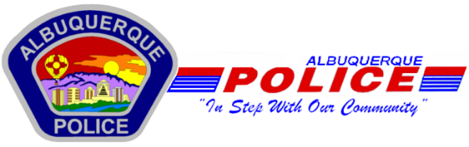  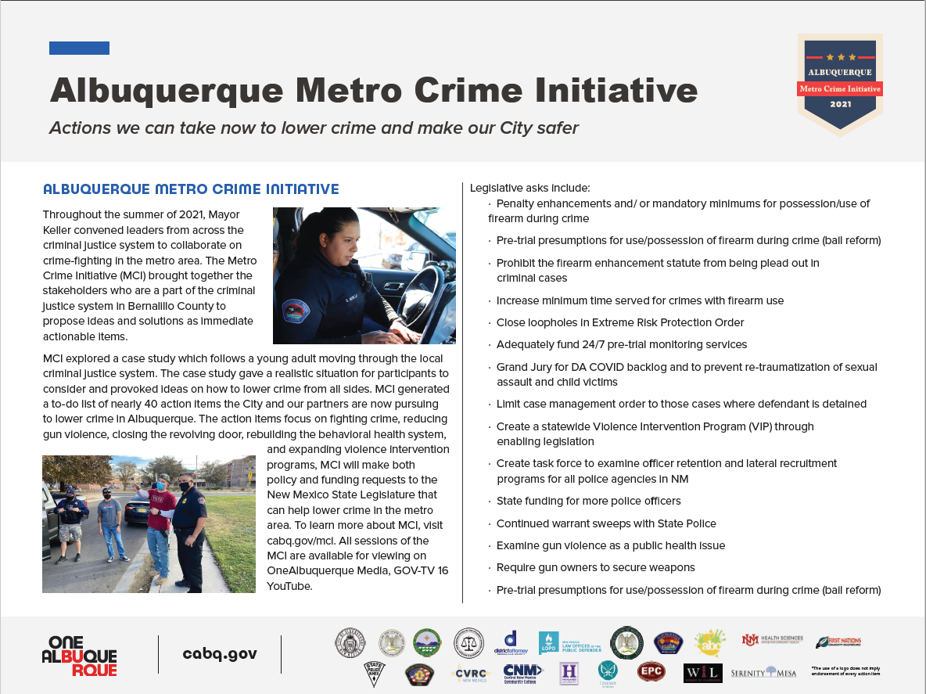  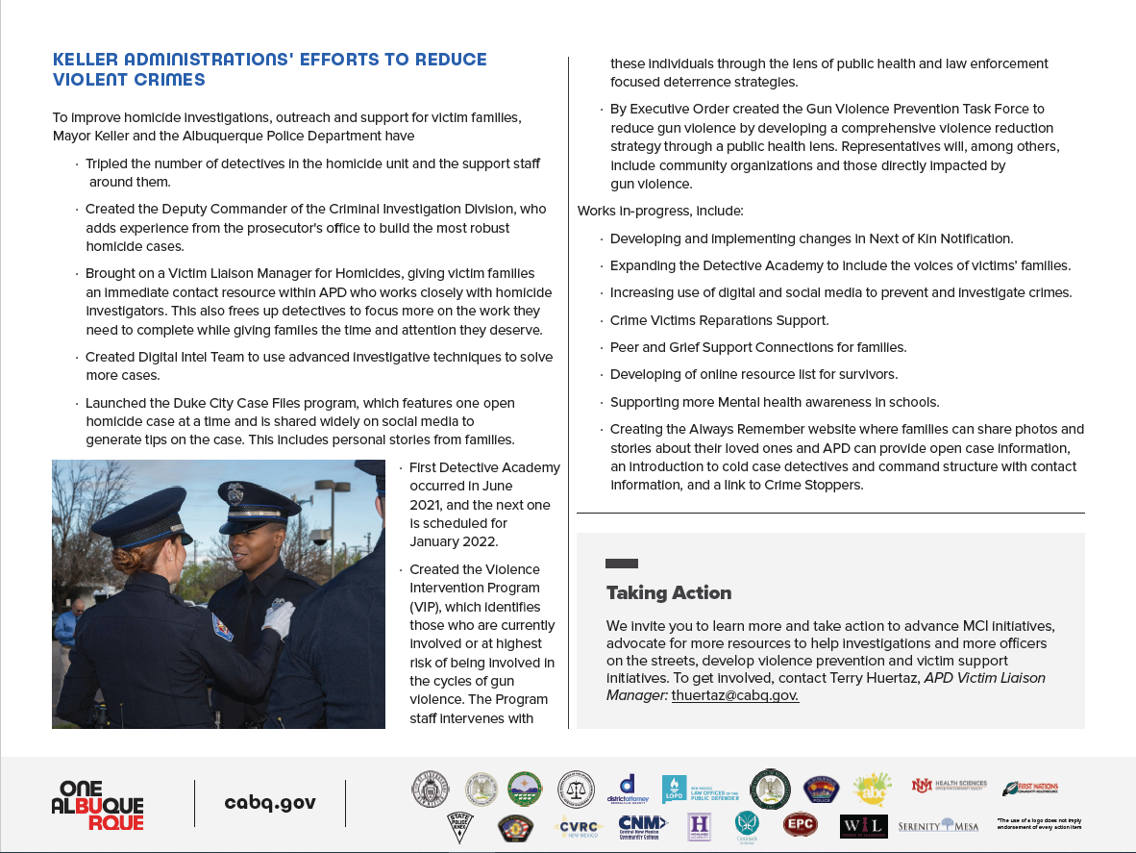
    - Crime Mapping
  On the crime mapping website you can run any crimes that you would like to look at in your neighborhood or throughout the city of Albuquerque. You can also sign up to receive alerts in your specific area.
  Crimemapping.com
 | Substation Hours  All police substations are open to the public the hours of operation are from 8:00 AM to 5:00 PM.  If you need an Accident Report form or a copy of an Accident Report you can call with your  case number to have it mailed to you via US Mail they are not provided through email.  When you come in to get a report make sure to bring in your ID and Case #.  For any other report call the substation to make sure it is available before coming by 761-8800.  The Old Town Substation is now open Monday-Thursday 8:00 AM to 5:00 PM and  on Friday 8:00 AM to 8:00 PM and on weekends from 11:00 PM to 7:00 PM.  Valley Area Command  5408 2nd St NW  Albuquerque, NM 87107  505-761-8800  Southwest Area Command  6404 Los Volcanes NW  Albuquerque, NM 87121  505-831-4705  Southeast Area Command  800 Louisiana SE  Albuquerque, NM 87108  505-256-2050  Northwest Area Command  10401 Cibola Loop NW  Albuquerque, NM 87114  505-768-4850  Northeast Area Command  8201 Osuna NE  Albuquerque, NM 87109  505-823-4455  Foothills Area Command  12800 Lomas NE  Albuquerque, NM 87112  505-332-5240  Needles/Sharps Containers/Drug Disposal  Please be advised large quantities of used needles and/or full sharps containers are not accepted  at the Valley Substation. We have a small container located in the lobby.  If you have more than a few needles the closest drop-off location  to our substation is the North Valley Public Health Office located at 7704 2nd St NW.  Call the substation nearest you to see if they accept needles/sharps.  Pills are accepted at all substations (No liquids accepted).  For more information visit: cabq.gov/police
    - File a Report
  Online Report
  cabq.gov/police/file-a- police-report-online
  (TRU )Telephone
  Reporting Unit
  242-2677 (COPS)
  APD App
  