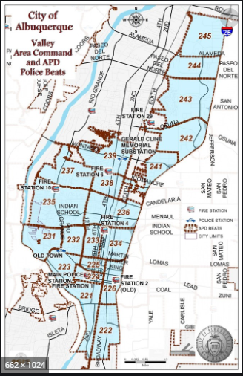 | VALLEY AREA COMMAND MONTHLY NEWSLETTER  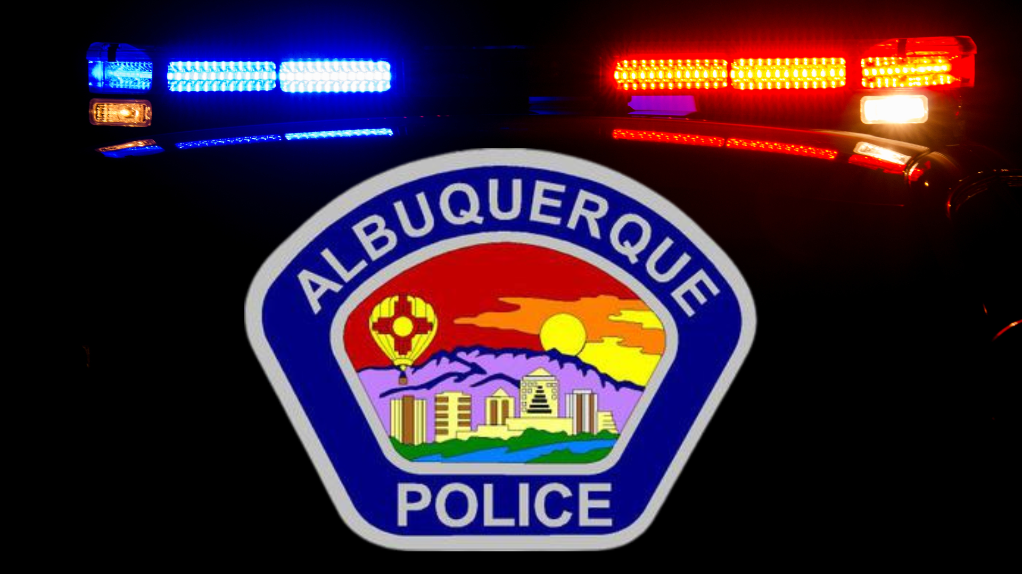  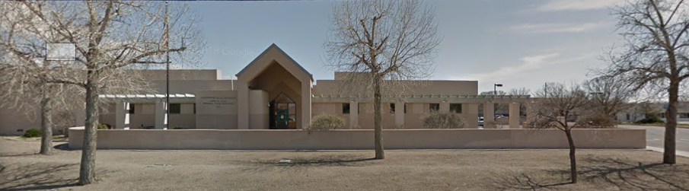  The Valley Area Command is overseen by  Commander Nick Wheeler  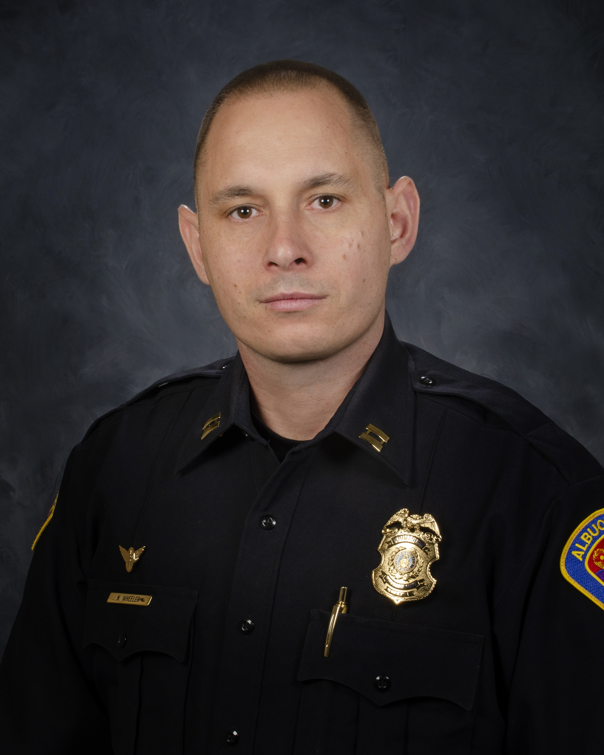
  October 2023
  Gerald Cline Substation
  5408 2nd St NW
  Albuquerque, NM 87107
  505-761-8800
  The Valley area is bordered by the Albuquerque city limits to the north and south, Interstate 25 to the east and the Rio Grande, Los Ranchos de Albuquerque, and the North Valley to the west
 | Commander’s Corner  Halloween month is an exciting time for children and their parents. I want to ensure everyone has a safe and fun experience. My officers will be actively patrolling the neighborhoods throughout the Valley Area Command to show a presence during the trick-or-treat events. Please feel free to flag my officers down to express any concerns. The Valley Crime Prevention Specialist has added safety tips for Halloween in this newsletter. If you have any questions about that, please reach out to Lamont Davis.  The Albuquerque Police Department is actively posting updated crime stats and trends for citizens to review. They are broken down by area command. Homicide weekly updates and suspect demographics are also posted for review. If you are interested in learning about specific crimes in your neighborhood or throughout the City, please go to the City of Albuquerque’s Police Website. It is extremely user friendly. If you have any issues accessing it and/or would like to see something additional to the site, please let me know.  https://www.cabq.gov/police/crime-statistics  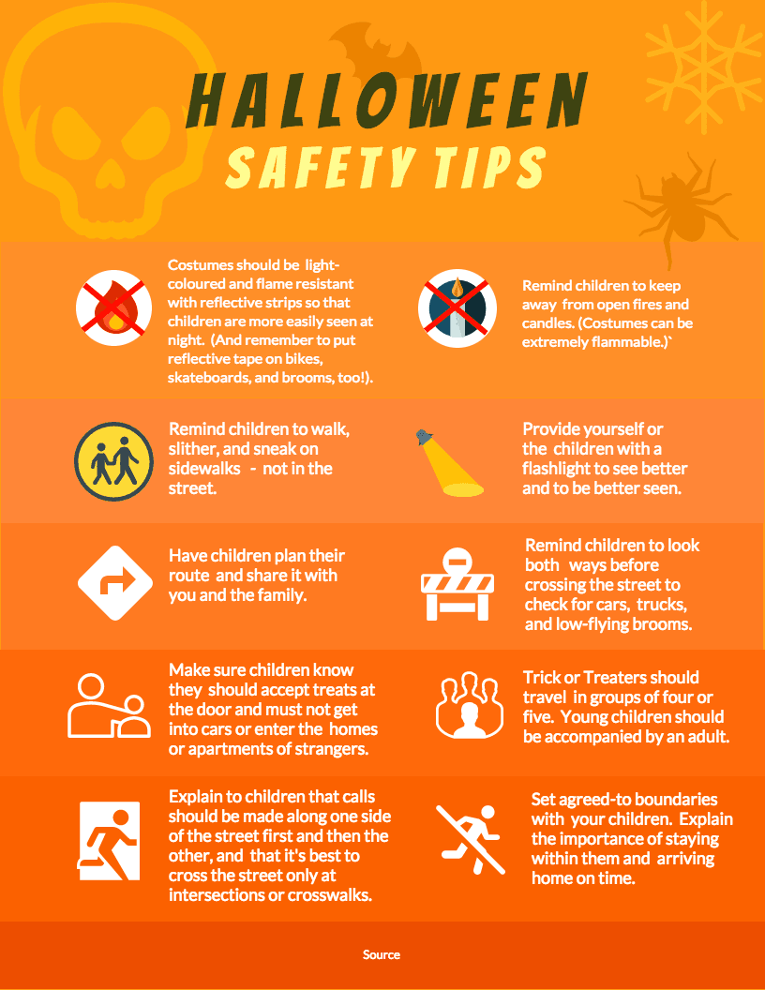  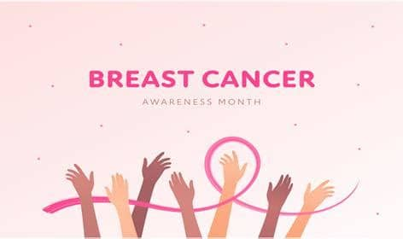  Other Services:  Sharps Disposal (Needles) – Call 311 https://www.cabq.gov/environmentalhealth/sharps-disposal  (ACS) Albuquerque Community Safety  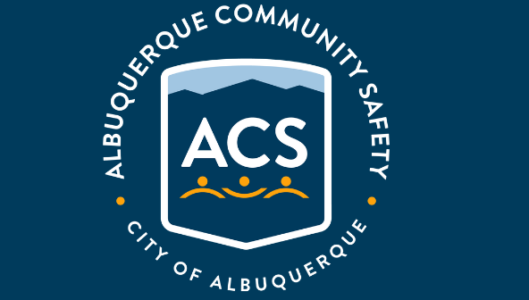  Albuquerque Community Safety Administration (ACS) – Call 311, 242-COPS or 768-4227 acs@cabq.gov – ACS sends trained professionals to non-violent and non-medical 911 calls for service involving issues such as mental/behavioral health, homelessness, and addiction as well as non-behavioral issues such as abandoned vehicles and needle pick-ups.  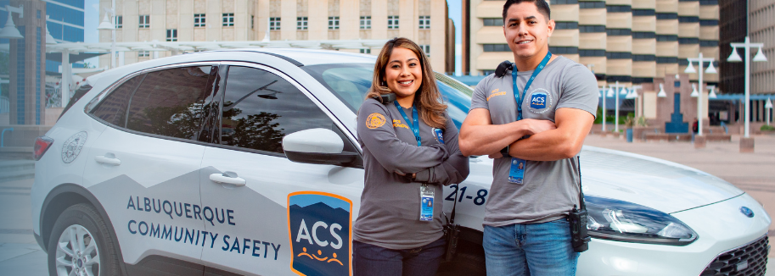
    - 
  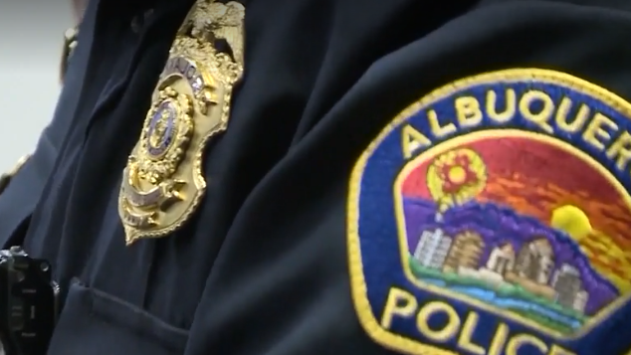
  V
  A
  L
  L
  E
  Y
  AREA
  COMMAND
  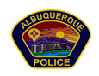
 | Valley Area Command Crime Statistics  09/01/2023 to 09/30/2023  MONTH OF September 2023  *Information Disclaimer*  This information is pulled from daily Calls for Service, which reflects all calls made to APD’s 911 Emergency Communications Center. It does not reflect all crimes that police investigate, nor the final outcome of crimes investigated. Furthermore it may not reflect the true location of crimes as they may have occurred in a different location from which they are reported.
    - Definitions
  Burglary – Unauthorized entry of any vehicle, watercraft, aircraft, dwelling or other structure, moveable or immovable, with the intent to commit a felony or theft therein.
  Robbery – Consists of the theft of anything of value from the person of another or from the immediate control of another, by use or threatened use of force or violence.
  Motor Vehicle Theft – Consists of a person taking any vehicle or motor vehicle intentionally and without consent of the owner.
  Auto Burglary | 32
  Commercial Burglary | 25
  Residential Burglary | 25
  Auto Theft | 71
  Robbery – Auto | 3
  Robbery – Commercial | 6
  Robbery – Individual | 3
  Robbery - Residential | 3

  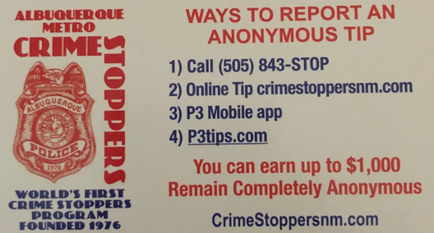  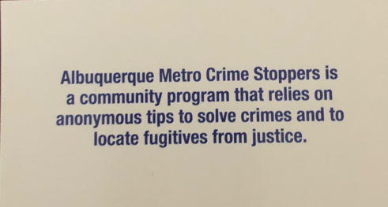  Valley Crime Prevention Specialist  Lamont Davis  5408 2nd St NW  Albuquerque, NM 87107  505-761-8805  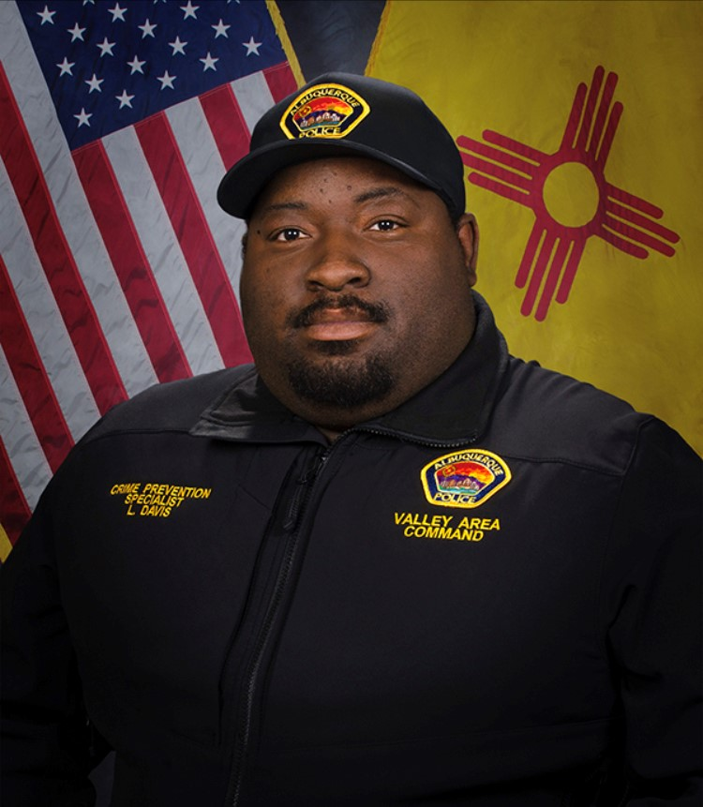  Lamont Davis, our Valley Crime Prevention Specialist is here to help answer any questions you may have related to crime prevention, neighborhood watch, or APD involved community events.   | Crime Mapping Info & (Safety TIPS)  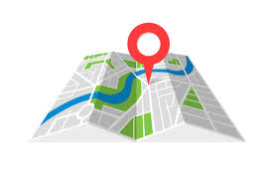  The Valley Area Command uses the Computer Aided Dispatch (CAD) data to determine  crimes that happen in the area. When a response is indicated, the information  received from the caller will be entered into the CAD for a response.  The information from the caller allows ECC staff to determine the priority  of the call, how many officers to dispatch, and it provides the officers with  vital information so they can determine what action to take as they respond  to a call for service.  Residential Burglaries  (TIP)-It is always good practice to make it look like someone is home at all times.  Turn a radio on to a talk show station when you are gone, this will make  it appear that someone is inside of your home.  Commercial Burglaries  (TIP)-If your business is closed, we recommend that you check your  property periodically, be sure to leave lights on and clean up any debris or  growth around the property. These small steps may deter a criminal.  Auto Burglaries  (TIP)-Be sure you are keeping your belongings out of site and remove anything of value. It is a great idea to pack a bag with items you need for the day and take it with you when you get out of  the vehicle.  Stolen Vehicles  (TIP)-Using devices such as kill switches, alarms, clubs and locking doors  and windows, also try to park in an area with good lighting to try to deter a criminal.  Carjacking  (TIP)- Always be aware of your surroundings. Pay special attention when you are  at a standstill such as when you are at a stop light or in a parking lot.  Keep doors locked, roll up your windows and notice who is in the immediate area.  Robbery to an Individual  (TIP)-Use situational awareness, look around, walk with confidence, make  eye contact and read peoples body language. If you do find yourself in this  situation give them whatever possession they are demanding, remember,  possessions can always be replaced – you, cannot.  Commercial Robbery  (TIP)- Train your employees to be on the lookout for suspicious behavior and  report it immediately. Start training your brain to make note of how someone  looks and what they are wearing, including their shoes. Many criminals will  change their clothing but they will not change their shoes.  Robbery By Gunpoint  (TIP)- After the robbery occurs call 911 and lock your doors.  If there are witnesses ask if they can stay to give a description of the offender.  Do not discuss what you saw with others, wait to give a description to the officer.  Residential Robbery  (TIP)- Always identify who is at the door before opening it.  Keep doors locked at all times. Keep an eye out for suspicious persons/vehicles  in the neighborhood.  Remember if you see something say something!  Homeless Encampments/Services  You can report homeless encampments by calling 311 or through the solid waste email:  sw-encampment@cabq.gov  To get more information on homeless assistance go to:  https://www.cabq.gov/family/services/homeless-services  Services Offered  There are many resources that we can provide to you, such as, informational  pamphlets, Training on topics such as personal safety,  scams, anti-bullying etc., CPTEDs (Crime Prevention Through Environmental Design)  starting a Neighborhood Watch, CFMH (Crime Free Multi-Housing) and we can  take McGruff to your public event or school or set up a table with informational  pamphlets and promotional items. All of these services are free of charge.  Crime Prevention Corner  Domestic Violence and  Sexual Assault Commission Advanced by City Leaders  On October 19, 2022, Mayor Tim Keller with City Councilors  Tammy Fiebelkorn, Renee Grout, Trudy Jones, and Klarissa Peña  will put forward legislation to establish a Domestic Violence and  Sexual Assault Commission to address domestic violence  and better support survivors.  - Review the DVSA Commission Ordinance  - Review the press release  What is Domestic Violence?  Domestic Violence is a pattern of behavior which establishes  power and control over another person often through fear,  manipulation, humiliation, isolation, intimidation, the threat  of physical violence, and/or the use of physical violence.  Intimate Partner Domestic Violence Comes in  Many Forms  Examples of abusive behavior include:  - Emotional Abuse  - Financial Abuse  - Psychological Abuse  - Physical Abuse  - Sexual Abuse  - Spiritual Abuse  - Technological Abuse  - Verbal Abuse  Domestic Violence is an Alarming Crime and Public Health Problem in our Country and Community  The impact of domestic violence is wide ranging, directly affecting individuals  and society as a whole, here in this community, throughout the United States  and the world, Racism, homophobia, transphobia, ageism and discrimination  based on physical ability, nationality or other factors help to perpetuate  domestic violence and make finding safety even more difficult for some victims.  - During the COVID-19 Pandemic, domestic violence incidents in  - Albuquerque increased by 8%, as well as an increase in incidents  - involving strangulation.  - As many as 20% of homicides in 2021 were domestic violence related, according to Albuquerque Police Department,  - According to a 2015 report by the New Mexico Coalition of  - Sexual Assault Program, 1 in 3 women and 1 in 7 men in New Mexico are victims of domestic violence in their lifetime.  - According to the New Mexico Coalition Against Domestic Violence,  - domestic violence is the leading cause of injury to women;  - According to a study by Futures without violence, physical abuse  - during childhood increases the risk of future victimization among  - women and the risk of future perpetration of abuse by men more than two-fold  - Only 1 out of 10 incidents of domestic violence is ever reported,  - according to S.A.F.E House,  You are not alone. 24/7 help is available. Find local resources below.  Reasons Why People Stay in  Abusive Relationships  - They may not recognize that their partner’s behaviors are unhealthy or abusive.  - They may fear consequences if they decide to leave their relationship.  - They may feel that they’ve done something wrong, that they deserve the abuse.  - They may be financially dependent on their abusive partner.  Reasons Why People are Abusive  to their Partners  - Abusive people believe their own feelings and needs should be  - the priority in the relationship.  - Abuse is a learned behavior – and it is also choice to abuse.  - Domestic violence stems from a desire to gain and maintain  - power and control over an intimate partner.  - Tactics of abuse may be aimed at dismantling equality in the  - relationship in order to make their partners feel less valuable  - and undeserving of respect.  Ways to Support a Friend  Experiencing Domestic Violence  - Acknowledge that their situation is difficult, scary, and brave of them  - to regain control from  - Help them create a safety plan, or encourage them to contact a local  - or national hotline  - Do not post information about them on social media that could  - be used to identify them or where they spend time  In an Emergency, call 911  Call the police as soon as you can—assault, even by a family member  is a crime. Get medical attention, ask the medical staff to photograph your  injuries and keep detailed records in the event legal action is necessary.  Contact the court system about civil protective orders.  Leave the scene immediately or as soon as possible.  Domestic Violence Resources &  Assistance  If you are in immediate danger, leave or have someone you can trust stay with  you and call a crisis hotline for assistance, location of a women's shelter,  counseling, and crisis intervention.  Valley Community Policing Council:  Hello and Welcome Everyone,  Our next meeting is on October 25th  As always we have both in-person and virtual attendance.  The link to join the meeting is:  https://cabq.zoom.us/webinar/register/WN_7Z1iT-WbR9-9-s1dEYOjiA  Our physical location is the Johnny Tapia Community Center  and we run from 6:00pm to 8:00pm.  In the not too distant future we will be rotating our meetings to  different community centers for three months at a time.  We will keep you informed.  If you need more information please contact us at cpcvalley@gmail.com.  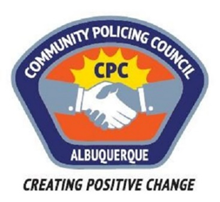  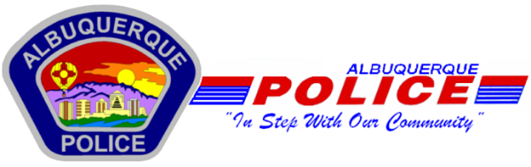  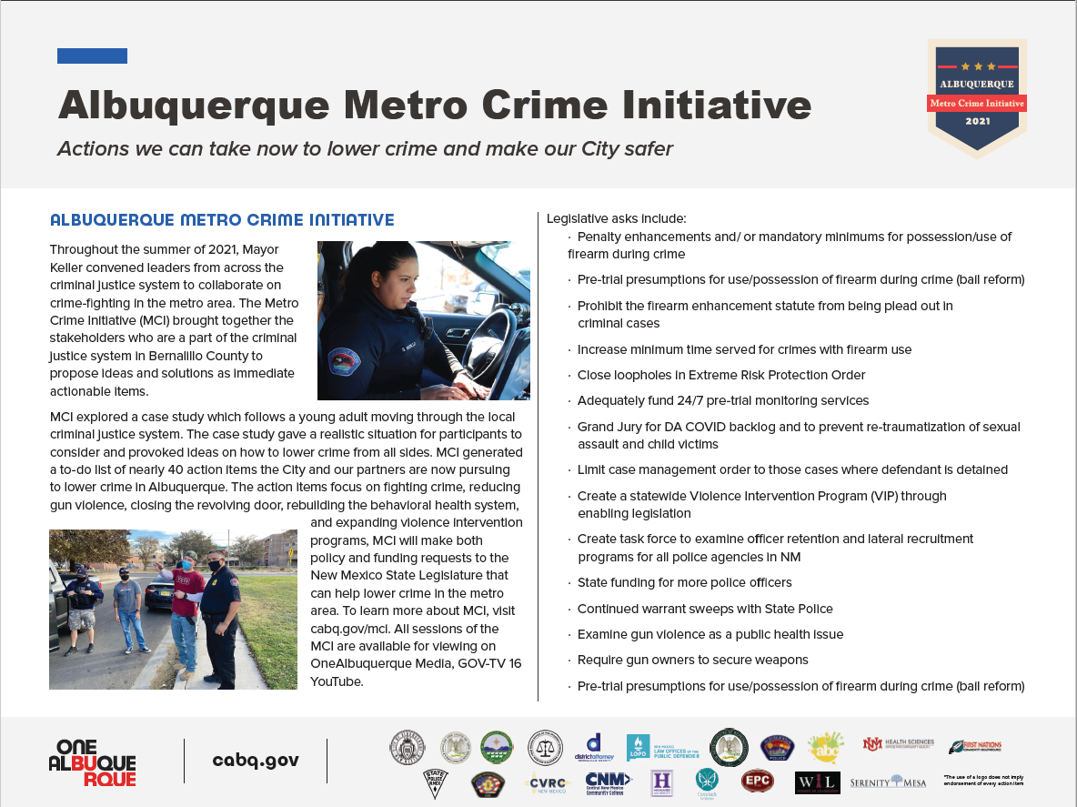  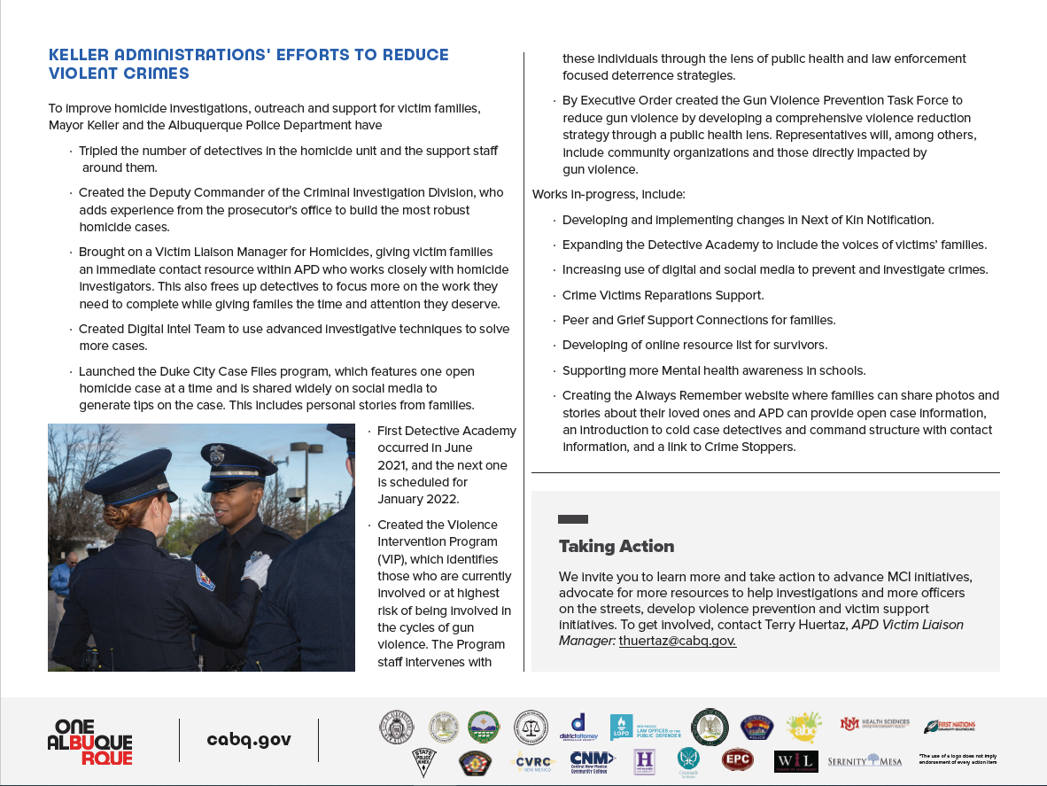
    - Crime Mapping
  On the crime mapping website you can run any crimes that you would like to look at in your neighborhood or throughout the city of Albuquerque. You can also sign up to receive alerts in your specific area.
  Crimemapping.com
  Agency Name | Agency Contact Information | Additional Information
  Albuquerque Family Advocacy Center | 505-243-2333 | Providing a safe setting to assist victims of  domestic violence, child abuse, sexual assault  And their families.
  2nd Judicial District Court, Office of District Attorney: Victim Impact Program | 505-841-7020 | Help with the trauma and the burden the  Victim suffers as a result of the commission of a crime.
  2nd Judicial District Court: Restraining Orders | 505-841-8400 | 2nd Judicial District Court: Restraining Orders
  A Child's Voice | 505-916-2007 | An agency designed to meet the mental health  needs of families including; parents, infants,  toddlers, children, teens  and their caregivers.
  Adult Protective Services Statewide Intake | 505-476-4912 or 1-866-654-3219 | Call if you suspect an adult is being abused,  neglected, or exploited.
  AGORA NM Crisis Center | 505-277-3013 or 1-855-505-4505 | Compassionate, non-judgmental help  for anyone in need of emotional support.
  Albuquerque Community Safety | Emergencies: 911  Non-emergencies: 311 | If you are experiencing a mental health, housing,  substance use or other non-violent crisis,  call 911. ACS will send a trained professional  to help you address the need and make sure  you get connected to the right services. If it can  wait for a follow-up, call 311.
  Albuquerque Sexual Assault Nurse Examiners (SANE) | 625 Silver, SW – 2nd Floor  505-883-8720 | SANE serves sexual assault and domestic violence  victims by providing immediate, compassionate,  culturally sensitive, and comprehensive medical  treatment and forensic evaluation by nurse experts.
  All Faiths Children Advocacy Center: Safehouse | 1709 Moon NE  505-271-0329 | Child-sensitive interviews and inter-agency  coordination for the effective investigation of  child abuse cases and crimes witnessed by children.
  APD Victim Assistance Unit Albuquerque | 505-243-2333 | Helps crime victims get help with medical expenses,  counseling, a restraining order, pre-court preparation,  advocacy with landlords, referrals for self-defense  courses, and whatever they choose to do.
  Barrett House | 505-246-9244 | Shelter and supportive services to women  and children experiencing homelessness.
  Childhelp National Child Abuse Hotline | 1-800-4-A-CHILD (1-800-422-4453) | Childhelp National Child Abuse Hotline
  New Mexico Crime Victim Reparation Commission | Albuquerque Area:  505-841-9432  Statewide:  1-800-306-6262 | Ask for the Victim Advocate
  Crisis Text Line | Text HOME to 741741 to reach a Crisis Counselor | Crisis Text Line
  CYFD Statewide Central Intake: Child Abuse Hotline | 1-855-333-SAFE (1-855-333-7233) or call #SAFE (#7233) from a mobile phone | #SAFE cannot receive text messages
  Domestic Violence Resource Center | 625 Silver Ave SE, Suite 190  505-248-3165 (24-hour line) | Walk in: M- F 8 a.m. - 5 p.m.
  Enlace Comunitario | 2425 Alamo Drive SE  505-246-8972 | Services available for Spanish speakers
  Esperanza Shelter | 505-473-5200 or 800-473-5220 | 24 hour crisis hotline. Safe, confidential housing,  counseling, food, clothing and  supplies—for you and your children, if you have kids.
  Family Promise | 505-268-0331 | Helps families who are experiencing homelessness  in the Albuquerque community to achieve  sustainable independence.
  First Nations Community Healthsource: CARES for Trafficking Victims | 505-697-0039  505-705-3356 | Care of services to survivors of human trafficking  that includes advocacy, client-centered case  management and linkages to care.
  First Nations Community Healthsource: EAST for Native American victims of sex trafficking. | 505-515-3924 | Dedicated to supporting  Native American/Alaskan Native  victims of sex trafficking in Albuquerque,  New Mexico and the surrounding Tribal communities
  First Nations Community Healthsource: Nurse Advice Line | 505-715-4206 | New Mexico’s urban Indian health center and  a Federally Qualified Health Center in Albuquerque.
  Haven House | 505-896-4869 or  1-800-526-7157 | 24-hour Crisis Hotline
  Joy Junction | 505-877-6967 | Offering a safe place to sleep, a warm meal, or  simply spreading awareness about homelessness.
  Kirtland Airforce Base: Sexual Assault Prevention and Response Office (SAPRO) | 505-846-7272 | 24-hour Hotline. The SARC serves as the single  point of contact for integrating and coordinating  sexual assault victim (survivor) care for  Team Kirtland members.
  Life Link: NM Human Trafficking Hotline | 505-GET-FREE  505-438-3733 | Easy-to-remember local number for human  trafficking victims to contact in order  to get help, information, or resources.
  National Domestic Violence Hotline | 1-800-799-SAFE (7233)  (TTY): 1-800-787-3224 | 24/7/235 compassionate support, crisis intervention  information, educational services and  referral services in more than 200 languages.
  National Human Trafficking Hotline | 1-888-373-7888 | Find social and legal services for victims  and survivors of human trafficking,
  National Resource Center on Domestic Violence | 1-800-537-2238 | A comprehensive source of information  for those wanting to educate themselves  and help others on the many issues  related to domestic violence.
  National Runaway Safeline | 1-800-RUNAWAY or  1-800-786-2929 | 24/7 support for youth and parents.
  National Sexual Assault Hotline | 1-800-656-HOPE  (1-800-565-4673) | 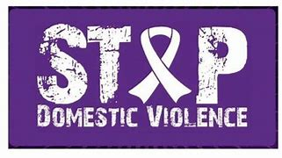  RAINN (Rape, Abuse & Incest National Network)  anti-sexual violence organization operates the  DoD Safe Helpline for the Department of Defense  and carries out programs to prevent sexual violence,  help survivors, and ensure that perpetrators  are brought to justice.
  National Suicide Prevention Lifeline | 988 or 1-800-273-8255 | English & Spanish services available
  National Teen Dating Abuse Help | 1-866-331-9474 | Engage, educate and empower young people  to prevent and end abusive relationships.
  Native American Professional Parent Resources | 505-345-6289 | Empowers, Educates, and provides supportive services to build healthy Native American children and families.
  New Mexico Asian Family Center | 505-717-2877 | Counseling and case management services,  survivor led and centered services, programs  centering traditional methods of healing, youth  and community leadership programs, financial  education workshops, cross-racial movement  building, and civic engagement work.
  New Mexico Coalition Against Domestic Violence | 505-246-9240 | Support and assistance to domestic  violence programs across the state.
  New Mexico Coalition of Sexual Assault Programs | 505-883-8020 | Training and technical assistance to service  providers, law enforcement officers, prosecutors,  medical practitioners, and mental health  professional and produces annual reports  of sexual assault and domestic violence data.
  New Mexico Crisis & Access Line | 1-855-NMCrisis  (1-855-662-7474) or 1-855-227-5485 (TTY) | 24/7/365 NMCAL is a centralized, single  telephone number to get immediate  assistance and resources for mental health  and substance use issues.
  New Mexico Crisis & Access Line: Healthcare Worker & First Responder Support Line | 1-855-507-5509 | 24/7/365 support line specifically for  healthcare workers and first responders.
  New Mexico Crisis and Access Line: Peer to Peer Warmline | 1-855-4NM-7100  (1-855-466-7100) | Call or text to connect with a peer.  Call 3:30pm – 11:30pm. Text 6pm – 11pm
  New Mexico Legal Aid | 1-833-LGL-HELP  (1-833-545-4357) | Free services to eligible low-income New Mexico  residents with civil (non-criminal) matters.
  New Mexico Legal Aid: Domestic Violence Helpline | 1-877-974-3400 | Free services to eligible low-income  New Mexico residents with civil  (non-criminal) matters.
  Pull Together | 1-800-691-9067 | Enlisting parents, families, community members,  and young people in the fight to make sure  our children are safe, cared for, and ready to succeed.
  Rape Crisis Center of Central New Mexico | 505-266-7711 | 24-hour hotline
  S.A.F.E. House Domestic Violence Hotline | 505-247-4219 or  1-800-773-3645 (toll-free) | Shelter and empower survivors of intimate  partner domestic violence.
  StrongHearts Native Helpline | 1-844-762-8483 | Confidential and anonymous culturally-appropriate  domestic, dating and sexual violence helpline  for Native Americans, available every  day from 7 a.m. to 10 p.m.
  UNM Psychiatric Center: Psychiatric Emergency Services | 505-272-2800 or  505-272-2920 | UNM Psychiatric Center: Psychiatric  Emergency Services
  UNM Psychiatric Center: Psychiatric Urgent Care Clinic | 505-272-2800 or  505-272-9038 | UNM Psychiatric Center: Psychiatric  Urgent Care Clinic
  US Attorney's Office Victim Witness Program | 1-888-388-6541 | The Victim-Witness Assistance Unit (“VW Unit”)  provides assistance to victims and witnesses of  crime while they are involved with the federal  criminal justice system. The VW Unit also  helps victims understand the criminal justice system  and assists with restitution and services.
  Valencia Shelter - Los Lunas | 505-864-1383 | 24/7 crisis hotline. Emergency shelter for  those fleeing abuse.
 | Substation Hours  All police substations are open to the public the hours of operation are from 8:00 AM to 5:00 PM.  If you need an Accident Report form or a copy of an Accident Report you can call with your  case number to have it mailed to you via US Mail they are not provided through email.  When you come in to get a report make sure to bring in your ID and Case #.  For any other report call the substation to make sure it is available before coming by 761-8800.  The Old Town Substation is now open Monday-Thursday 8:00 AM to 5:00 PM and  on Friday 8:00 AM to 8:00 PM and on weekends from 11:00 PM to 7:00 PM.  Valley Area Command  5408 2nd St NW  Albuquerque, NM 87107  505-761-8800  Southwest Area Command  6404 Los Volcanes NW  Albuquerque, NM 87121  505-831-4705  Southeast Area Command  800 Louisiana SE  Albuquerque, NM 87108  505-256-2050  Northwest Area Command  10401 Cibola Loop NW  Albuquerque, NM 87114  505-768-4850  Northeast Area Command  8201 Osuna NE  Albuquerque, NM 87109  505-823-4455  Foothills Area Command  12800 Lomas NE  Albuquerque, NM 87112  505-332-5240  Needles/Sharps Containers/Drug Disposal  Please be advised large quantities of used needles and/or full sharps containers are not accepted  at the Valley Substation. We have a small container located in the lobby.  If you have more than a few needles the closest drop-off location  to our substation is the North Valley Public Health Office located at 7704 2nd St NW.  Call the substation nearest you to see if they accept needles/sharps.  Pills are accepted at all substations (No liquids accepted).  For more information visit: cabq.gov/police
    - File a Report
  Online Report
  cabq.gov/police/file-a- police-report-online
  (TRU )Telephone
  Reporting Unit
  242-2677 (COPS)
  APD App
  