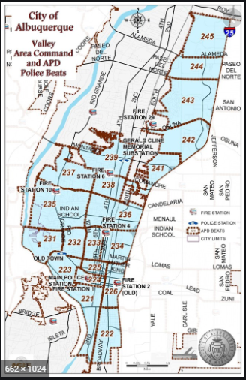 | VALLEY AREA COMMAND MONTHLY NEWSLETTER  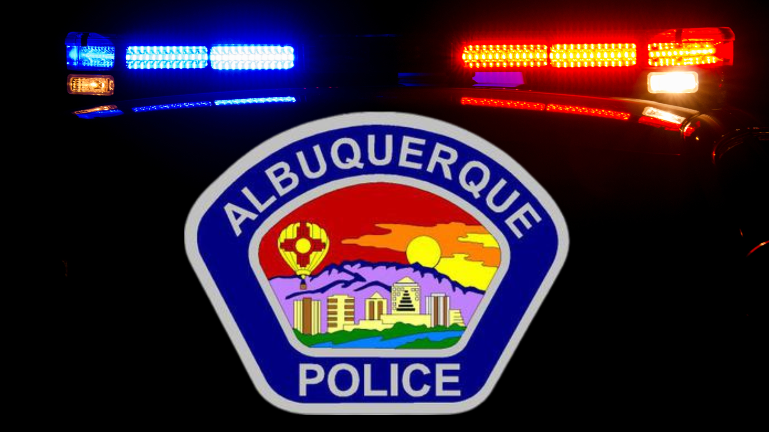  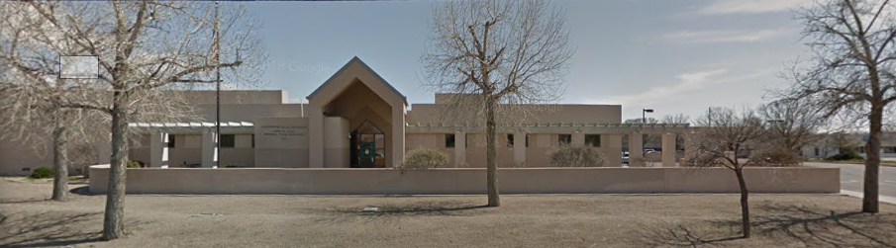  The Valley Area Command is overseen by  Commander Nick Wheeler  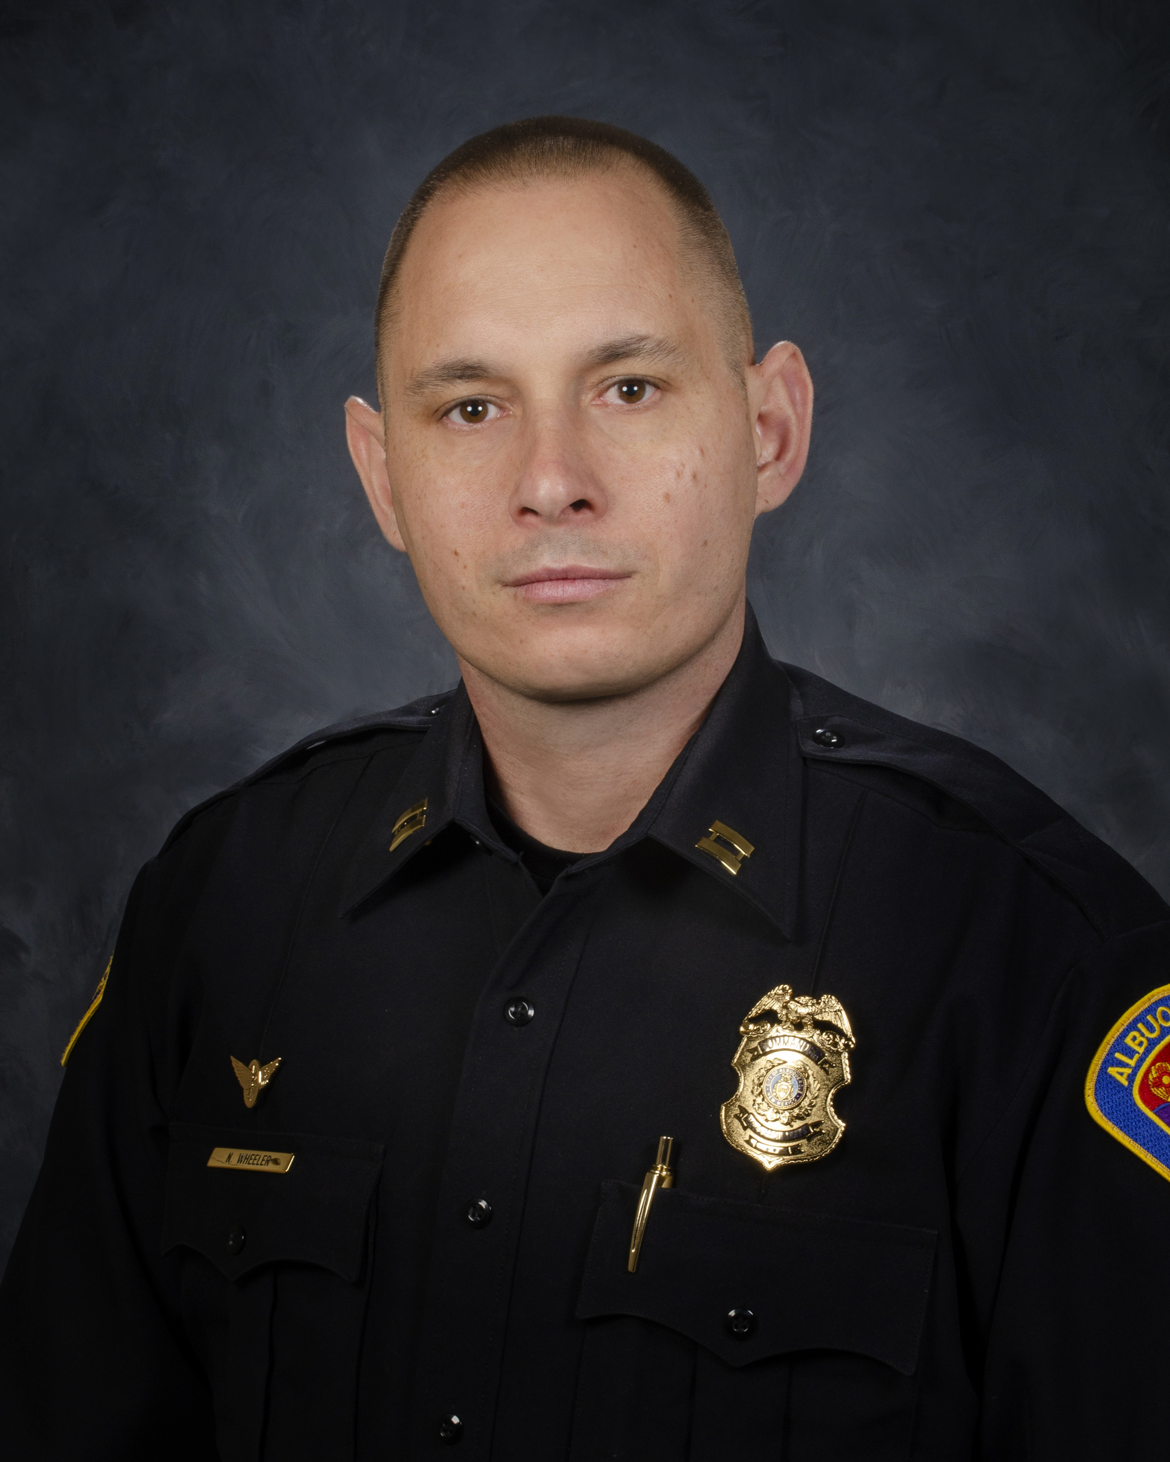
  July 2023
  Gerald Cline Substation
  5408 2nd St NW
  Albuquerque, NM 87107
  505-761-8800
  The Valley area is bordered by the Albuquerque city limits to the north and south, Interstate 25 to the east and the Rio Grande, Los Ranchos de Albuquerque, and the North Valley to the west
 | Commander’s Corner  This month we celebrate the fact that on July 4, 1776, the Second Continental Congress unanimously adopted the Declaration of Independence, announcing the colonies’ separation from Great Britain. The Constitution provides the legal and governmental framework for the United States of America. I would like to ensure that everyone remains safe throughout the month while using fireworks and shooting any firearms. Please remember that what goes up, always comes down and whatever comes down, can’t be controlled. These firearms and projectiles from firearms can strike and kill someone and/or burn down homes and businesses. Please be safe while celebrating.  Our crime categories continue to show an overall decrease. This can be attributed to the proactive police work of Valley Officers, reporting of certain crimes by community members and the outstanding communication between both. The willingness of our community members to be willing to do the right thing more often has made it so much easier for our officers to do their job.  We continue to have our Targeted Enforcement and Active Monitoring (TEAMS) overtime working in the downtown area. This has been extremely beneficial in reducing the amount of violent crime and calls for service in the downtown area during high traffic evenings.  I would again encourage everyone to attend our monthly Citizen Policing Council meetings which are held the 3rd Thursday of the month. The meetings are scheduled from 6:00pm and will conclude at 8:00pm. These meetings are a platform where you can voice any concerns, have any questions answered and to provide and positive feedback. If there is anything specific you would like to discuss, if you would like the location of the meeting or the zoom link, please reach out to Kelly Mensah via email and kmensah@cabq.gov and he would be more than willing to get you all needed information.  Please be safe and if you have any questions, please email me at nwheeler@cabq.gov.  Coffee with a Cop:  Albuquerque Police Department  Please come out and join us for coffee with a cop event at  New Mexico Museum of Natural History  July-17th-2023 (11:00 AM-1:00 PM)  Address: 1801 Mountain RD NW The  Albuquerque, NM 87109  THANK YOU  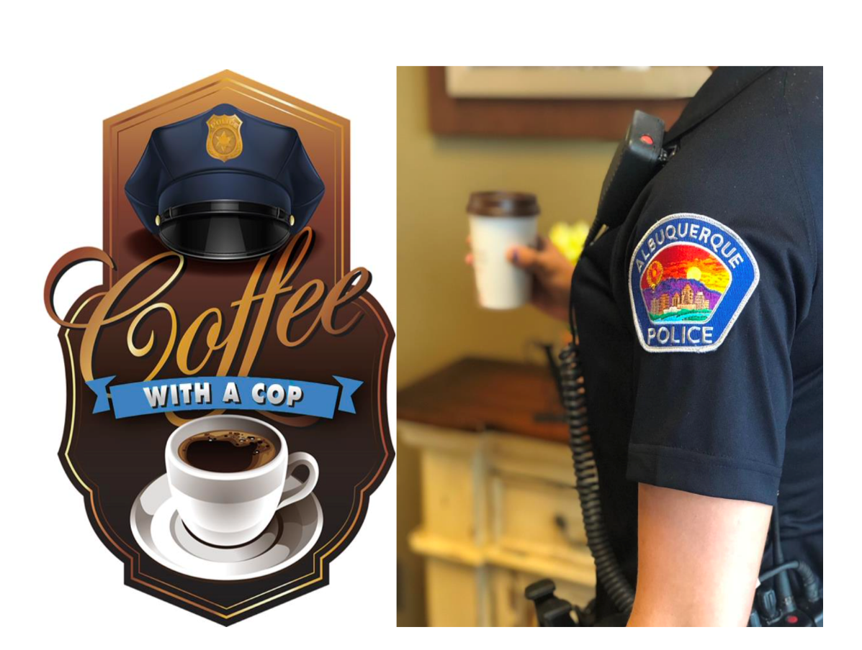  Other Services:  Sharps Disposal (Needles) – Call 311 https://www.cabq.gov/environmentalhealth/sharps-disposal  (ACS) Albuquerque Community Safety  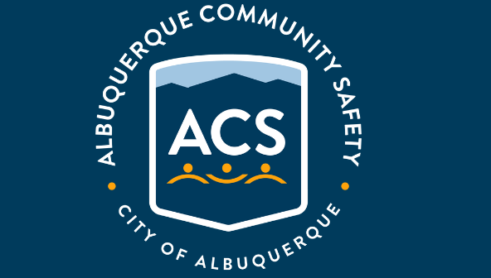  Albuquerque Community Safety Administration (ACS) – Call 311, 242-COPS or 768-4227 acs@cabq.gov – ACS sends trained professionals to non-violent and non-medical 911 calls for service involving issues such as mental/behavioral health, homelessness, and addiction as well as non-behavioral issues such as abandoned vehicles and needle pick-ups.  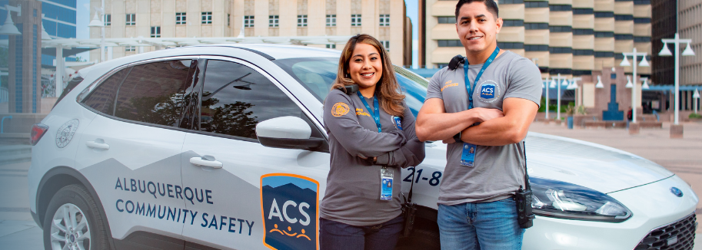
    - 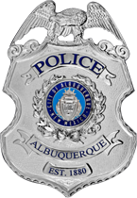
  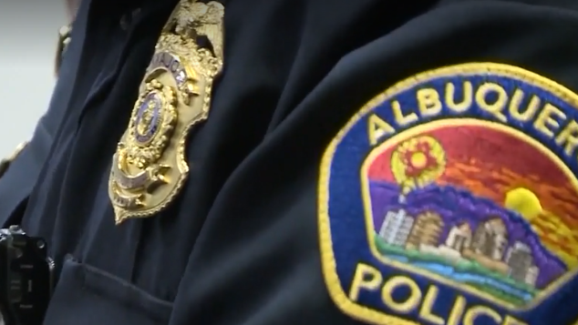
  V
  A
  L
  L
  E
  Y
  AREA
  COMMAND
  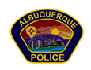
 | Valley Area Command Crime Statistics  06/01/2023 to 06/31/2023  MONTH OF June 2023  *Information Disclaimer*  This information is pulled from daily Calls for Service, which reflects all calls made to APD’s 911 Emergency Communications Center. It does not reflect all crimes that police investigate, nor the final outcome of crimes investigated. Furthermore it may not reflect the true location of crimes as they may have occurred in a different location from which they are reported.
    - Definitions
  Burglary – Unauthorized entry of any vehicle, watercraft, aircraft, dwelling or other structure, moveable or immovable, with the intent to commit a felony or theft therein.
  Robbery – Consists of the theft of anything of value from the person of another or from the immediate control of another, by use or threatened use of force or violence.
  Motor Vehicle Theft – Consists of a person taking any vehicle or motor vehicle intentionally and without consent of the owner.
  Auto Burglary | 6
  Commercial Burglary | 15
  Residential Burglary | 10
  Auto Theft | 15
  Robbery – Auto | 2
  Robbery – Commercial | 1
  Robbery – Individual | 0
  Robbery - Residential | 1

  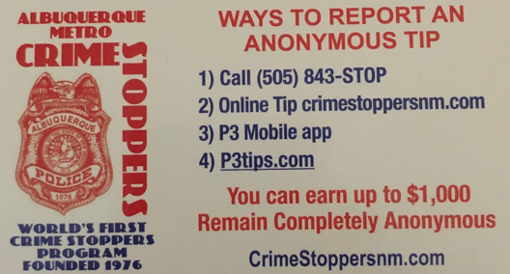  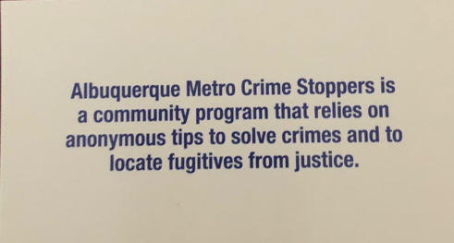  Valley Crime Prevention Specialist  Lamont Davis  5408 2nd St NW  Albuquerque, NM 87107  505-761-8805  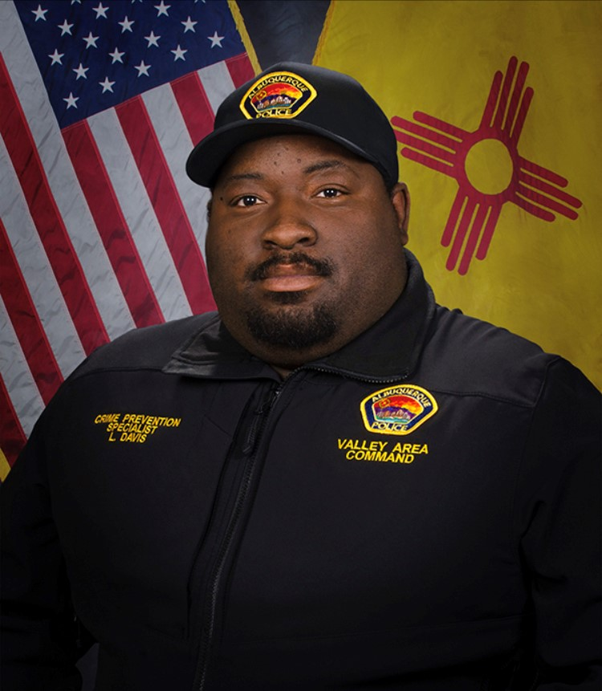  Lamont Davis, our Valley Crime Prevention Specialist is here to help answer any questions you may have related to crime prevention, neighborhood watch, or APD involved community events.   | Crime Mapping Info & (Safety TIPS)  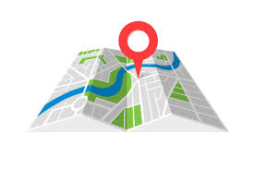  The Valley Area Command uses the Computer Aided Dispatch (CAD) data to determine  crimes that happen in the area. When a response is indicated, the information  received from the caller will be entered into the CAD for a response.  The information from the caller allows ECC staff to determine the priority  of the call, how many officers to dispatch, and it provides the officers with  vital information so they can determine what action to take as they respond  to a call for service.  Residential Burglaries  (TIP)-It is always good practice to make it look like someone is home at all times.  Turn a radio on to a talk show station when you are gone, this will make  it appear that someone is inside of your home.  Commercial Burglaries  (TIP)-If your business is closed, we recommend that you check your  property periodically, be sure to leave lights on and clean up any debris or  growth around the property. These small steps may deter a criminal.  Auto Burglaries  (TIP)-Be sure you are keeping your belongings out of site and remove anything of value. It is a great idea to pack a bag with items you need for the day and take it with you when you get out of  the vehicle.  Stolen Vehicles  (TIP)-Using devices such as kill switches, alarms, clubs and locking doors  and windows, also try to park in an area with good lighting to try to deter a criminal.  Carjacking  (TIP)- Always be aware of your surroundings. Pay special attention when you are  at a standstill such as when you are at a stop light or in a parking lot.  Keep doors locked, roll up your windows and notice who is in the immediate area.  Robbery to an Individual  (TIP)-Use situational awareness, look around, walk with confidence, make  eye contact and read peoples body language. If you do find yourself in this  situation give them whatever possession they are demanding, remember,  possessions can always be replaced – you, cannot.  Commercial Robbery  (TIP)- Train your employees to be on the lookout for suspicious behavior and  report it immediately. Start training your brain to make note of how someone  looks and what they are wearing, including their shoes. Many criminals will  change their clothing but they will not change their shoes.  Robbery By Gunpoint  (TIP)- After the robbery occurs call 911 and lock your doors.  If there are witnesses ask if they can stay to give a description of the offender.  Do not discuss what you saw with others, wait to give a description to the officer.  Residential Robbery  (TIP)- Always identify who is at the door before opening it.  Keep doors locked at all times. Keep an eye out for suspicious persons/vehicles  in the neighborhood.  Remember if you see something say something!  Homeless Encampments/Services  You can report homeless encampments by calling 311 or through the solid waste email:  sw-encampment@cabq.gov  To get more information on homeless assistance go to:  https://www.cabq.gov/family/services/homeless-services  Services Offered  There are many resources that we can provide to you, such as, informational  pamphlets, Training on topics such as personal safety,  scams, anti-bullying etc., CPTEDs (Crime Prevention Through Environmental Design)  starting a Neighborhood Watch, CFMH (Crime Free Multi-Housing) and we can  take McGruff to your public event or school or set up a table with informational  pamphlets and promotional items. All of these services are free of charge.  Crime Prevention Corner  Firework Safety  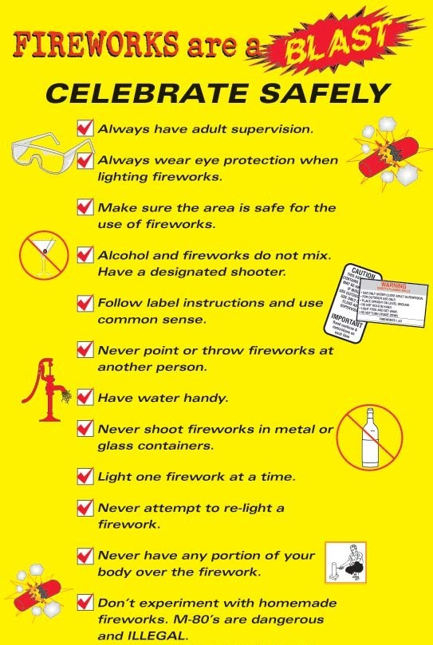  Firework Ordinance & Safety  Fireworks are strictly prohibited in and around the Bosque or Open Space Areas.  Report Illegal Fireworks  - Online  - Via the ABQ311 mobile app  - By calling 311  Using fireworks, both legal and illegal, can be extremely  dangerous to yourself and others by not following safe practices.  Be mindful of your surroundings and obey all laws pertaining to  the use of fireworks where you live. Please be considerate of  your neighbors (citizens with PTSD, elderly, young children)  and pets as loud noises can be traumatizing and disruptive.  Prohibited Fireworks  City of Albuquerque Ordinance prohibits the sale and use  of all Aerial Fireworks and Ground Audible Devices within the city limits.  - Using illegal fireworks is punishable with a citation and immediate  - confiscation of the illegal fireworks and places the community  - at risk for fires. Addresses that have been identified as using  - illegal fireworks will be issued a  - CEASE AND DESIST ORDER by mail.  - It is a misdemeanor  - A mandatory court appearance  - A fine up to $500 and 90 days in jail  - The improper use of permissible fireworks and/or the illegal use  - of aerial or ground audible devices can result in the user or  - supervising adult being found grossly negligent and  - financially responsible for damages.  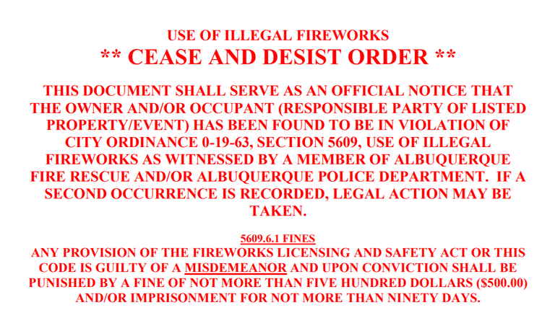  Aerial Devices  - Aerial Spinners  - Helicopters  - Mines  - Missile-type Rockets  - Roman Candles  - Shells  - Stick Type Rockets  Ground Audible Devices  - Chasers (bottle rockets)  - Firecrackers  Once ignited, aerial and ground audible devices take an  unpredictable flight path and pose a significant fire hazard to  structures and vegetation. They also possess a significant injury  potential to the user and innocent bystanders. These devices are  also disturbing to public peace.  Permissible Fireworks  If you buy fireworks from retail stores and stands within city limits,  the fireworks are legal. Read the Warning Label. If it reads "WARNING,"  it is illegal. If it reads "CAUTION," it is legal.  The following fireworks are safe and legal:  - Ground and hand held sparkling devices  - Cone Fountains  - Crackling Devices  - Cylindrical Fountains  - Flitter Sparklers  - Ground Spinners  - Illuminating Torches  - Wheels  The Safe Use of Fireworks  - Fireworks should not be used on "Red Flag Warning"  - days, as these days indicate extreme risk for fires.  - To keep current, visit weather.gov.  - What and where to buy - Always buy fireworks from a  - local vendor to ensure what you purchase is safe and  - legal for use within the city limits.  - Fireworks should only be used on paved or barren areas –  - Away from homes, vegetation and combustible materials.  - Fireworks of any kind are not allowed to be discharged in the  - Bosque, open space areas or city parks.  - Have a water source available to put out any unintended  - fires such as a charged garden hose or two 5 gallon buckets.  - Supervision - Always have an adult present and never allow  - children to use fireworks to avoid injuries and improper use.  - Follow directions - Always read and follow directions carefully.  - Disposal - Dispose of used fireworks in a bucket of water.  - Make sure they are completely cool to the touch before  - throwing them in the garbage can.  - Emergencies - If there is a fire, leave the area  - immediately and call 911.  Do not attempt to make your own fireworks as they can lead to  dangerous and unpredictable explosions and result in severe injuries.  Fireworks: Risks & Statistics  If you do not handle fireworks properly, you risk serious injuries and damages.  - Deaths and Injuries Nationwide – In 2018 there were 5 deaths  - and over 9,000 injuries, and in 2017 there were 8 deaths and over  - 12,900 injuries  - For children under 5 years of age, sparklers accounted for more  - than half of the total estimated injuries.  - NFPA report shows more than 16,000 reported fires are  - started by fireworks annually  - On the 4th of July, 2019 Albuquerque Fire Rescue had 52  - calls for outside fires during the night alone  - Albuquerque has unique wildland urban interface open  - space areas that are in constant threat of fires. These fires  - would endanger the lives of those who live nearby and many  - species of wildlife. These areas include the Westside  - Open Space area, Foothills and the Bosque.  - Fireworks can be associated with blindness, third degree burns,  - and permanent scarring.  - Fireworks can also cause life-threatening residential, motor vehicle,  - and wildland fires which can result in the user or supervising  - adult being found grossly negligent and financially  - responsible for damages.  Fireworks Patrol  Two weeks ahead of the 4th of July holiday, Albuquerque Fire Rescue  will begin patrolling throughout the city and open space areas.  These patrols help ensure the safety of our community by  preventing the sales and use of illegal fireworks within city limits.  Those who are caught will be cited and will have  a mandatory court appearance.    Valley Community Policing Council:  Hello and Welcome Everyone,  Our next meeting is on July 25th  As always we have both in-person and virtual attendance.  The link to join the meeting is:  https://cabq.zoom.us/webinar/register/WN_7Z1iT-WbR9-9-s1dEYOjiA  Our physical location is the Johnny Tapia Community Center  and we run from 6:00pm to 8:00pm.  In the not too distant future we will be rotating our meetings to  different community centers for three months at a time.  We will keep you informed.  If you need more information please contact us at cpcvalley@gmail.com.  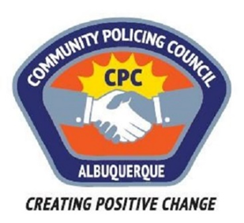  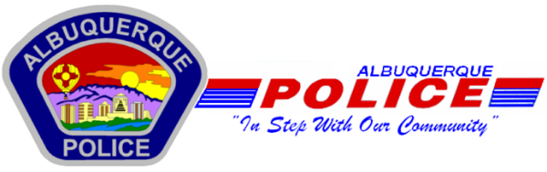  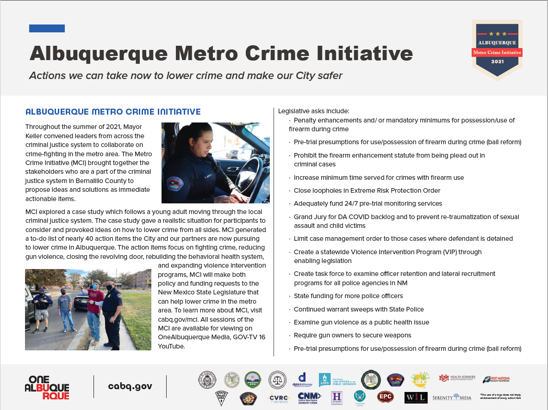  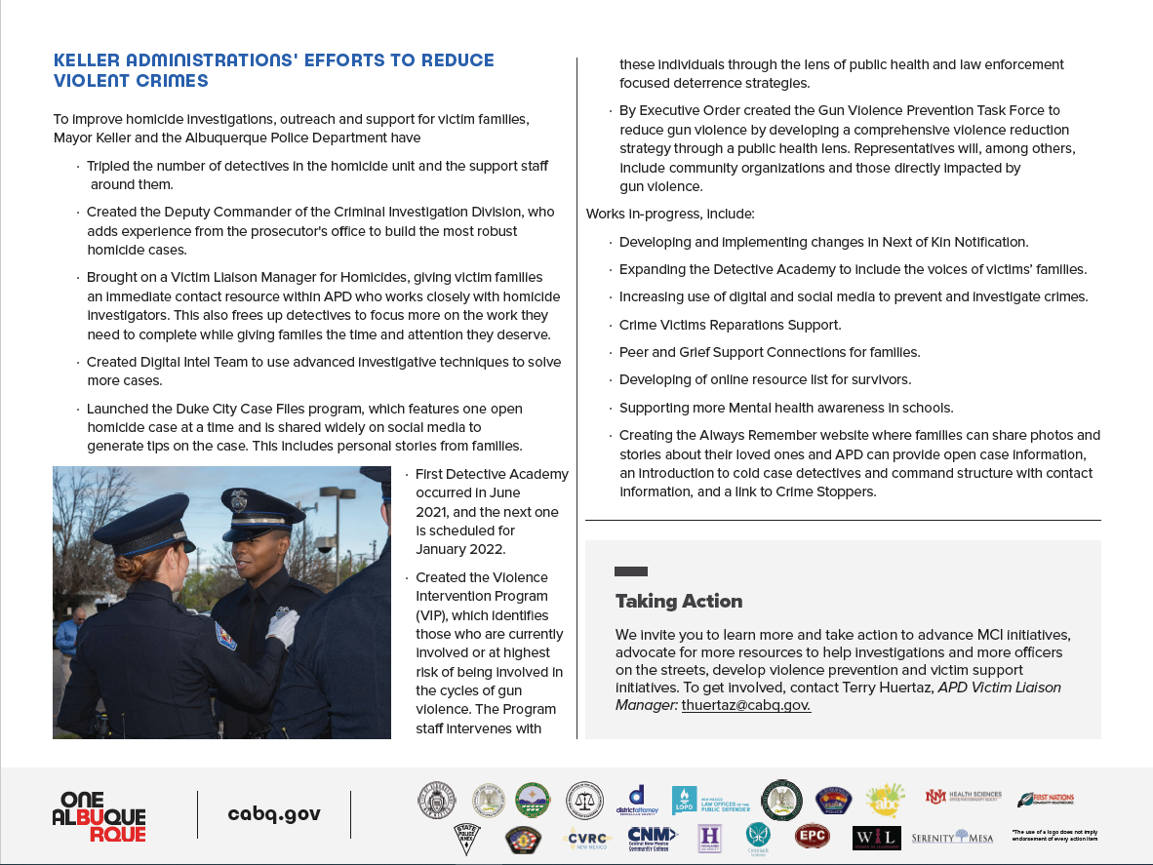
    - Crime Mapping
  On the crime mapping website you can run any crimes that you would like to look at in your neighborhood or throughout the city of Albuquerque. You can also sign up to receive alerts in your specific area.
  Crimemapping.com
 | Substation Hours  All police substations are open to the public the hours of operation are from 8:00 AM to 5:00 PM.  If you need an Accident Report form or a copy of an Accident Report you can call with your  case number to have it mailed to you via US Mail they are not provided through email.  When you come in to get a report make sure to bring in your ID and Case #.  For any other report call the substation to make sure it is available before coming by 761-8800.  The Old Town Substation is now open Monday-Thursday 8:00 AM to 5:00 PM and  on Friday 8:00 AM to 8:00 PM and on weekends from 11:00 PM to 7:00 PM.  Valley Area Command  5408 2nd St NW  Albuquerque, NM 87107  505-761-8800  Southwest Area Command  6404 Los Volcanes NW  Albuquerque, NM 87121  505-831-4705  Southeast Area Command  800 Louisiana SE  Albuquerque, NM 87108  505-256-2050  Northwest Area Command  10401 Cibola Loop NW  Albuquerque, NM 87114  505-768-4850  Northeast Area Command  8201 Osuna NE  Albuquerque, NM 87109  505-823-4455  Foothills Area Command  12800 Lomas NE  Albuquerque, NM 87112  505-332-5240  Needles/Sharps Containers/Drug Disposal  Please be advised large quantities of used needles and/or full sharps containers are not accepted  at the Valley Substation. We have a small container located in the lobby.  If you have more than a few needles the closest drop-off location  to our substation is the North Valley Public Health Office located at 7704 2nd St NW.  Call the substation nearest you to see if they accept needles/sharps.  Pills are accepted at all substations (No liquids accepted).  For more information visit: cabq.gov/police
    - File a Report
  Online Report
  cabq.gov/police/file-a- police-report-online
  (TRU )Telephone
  Reporting Unit
  242-2677 (COPS)
  APD App
  