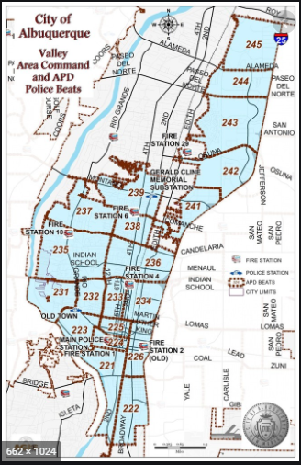 | VALLEY AREA COMMAND MONTHLY NEWSLETTER  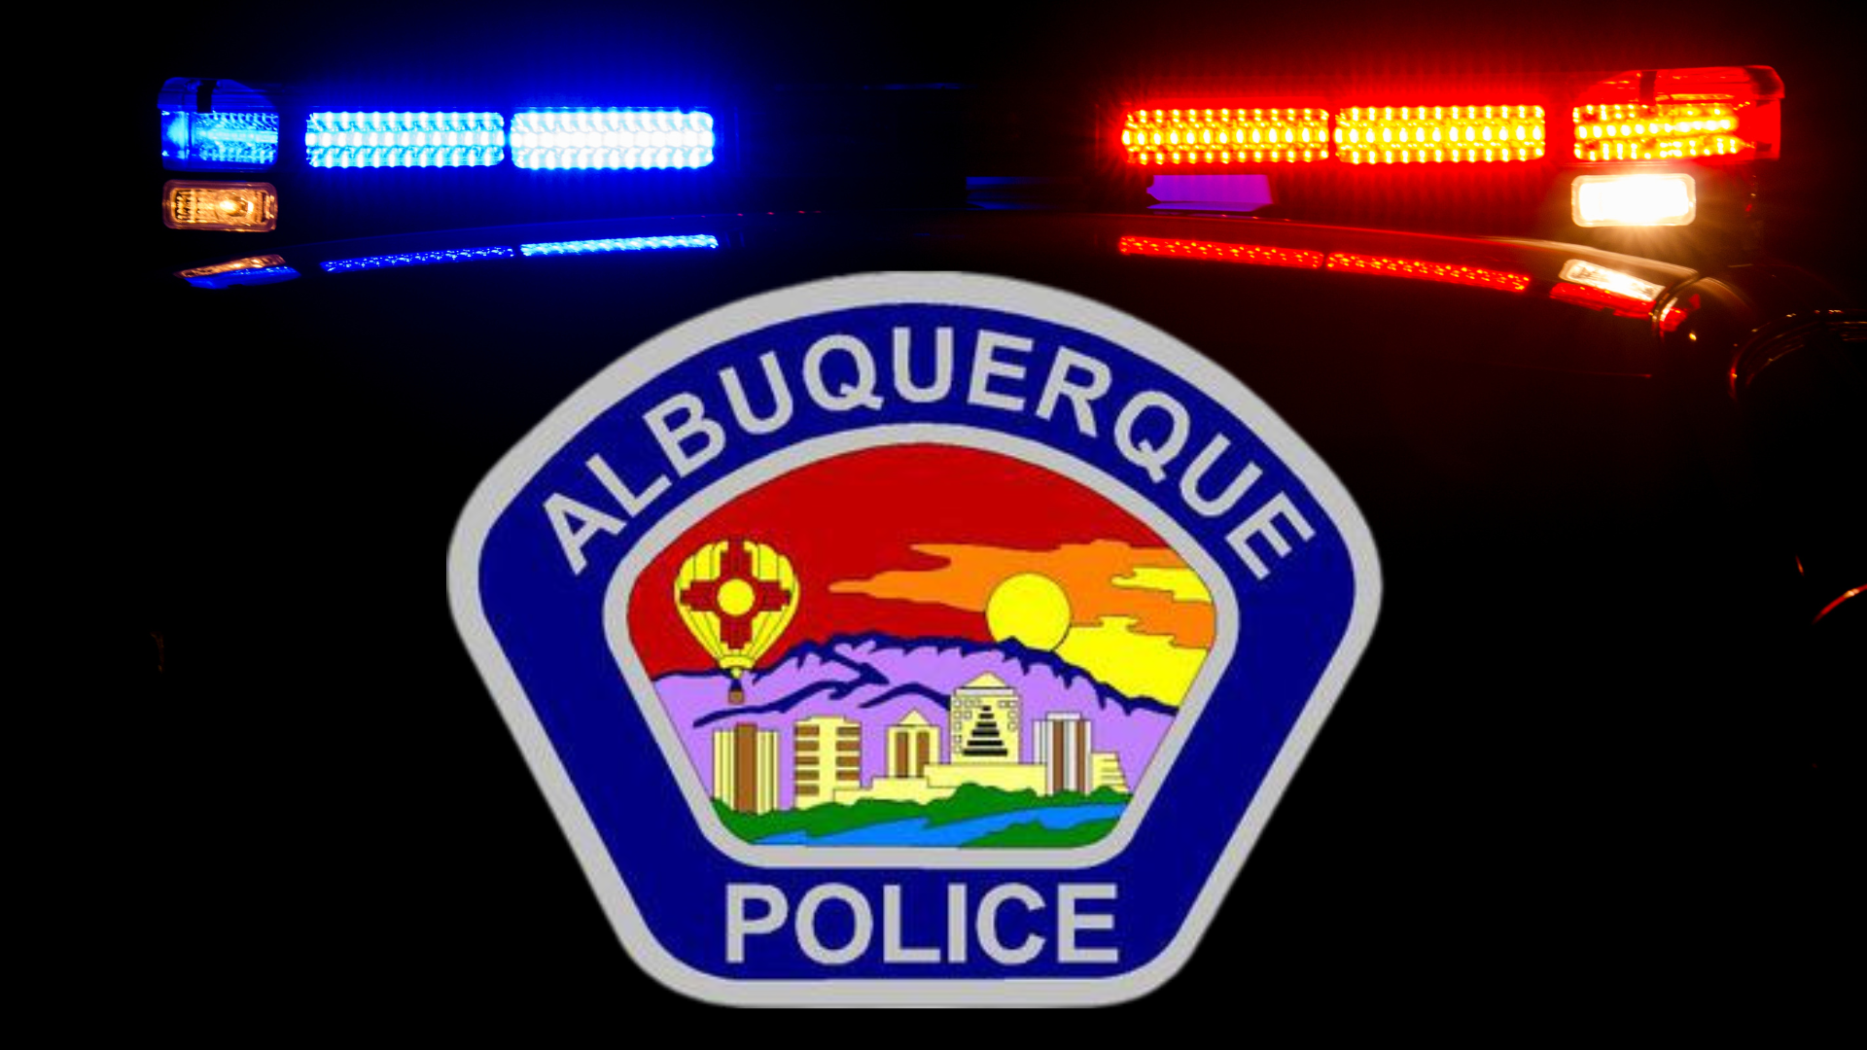  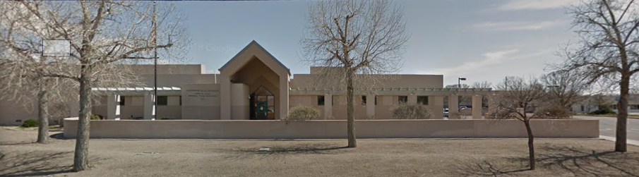  The Valley Area Command is overseen by  Commander Nick Wheeler  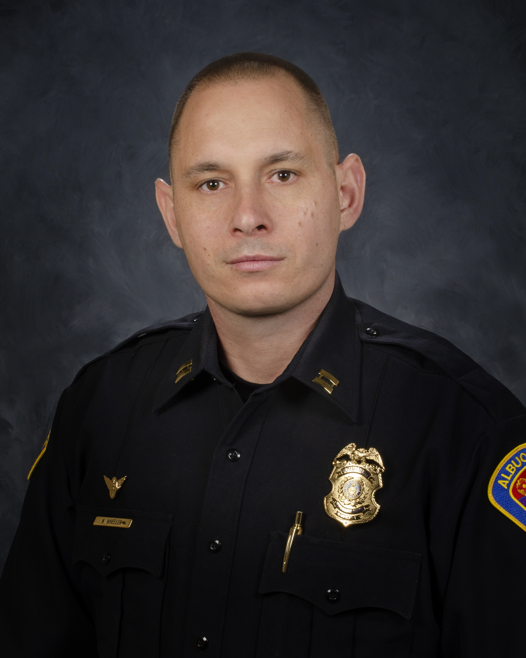
  April 2023
  Gerald Cline Substation
  5408 2nd St NW
  Albuquerque, NM 87107
  505-761-8800
  The Valley area is bordered by the Albuquerque city limits to the north and south, Interstate 25 to the east and the Rio Grande, Los Ranchos de Albuquerque, and the North Valley to the west
 | Commander’s Corner  To address some issues related to crime being committed in the parking lot located at 2nd/Central, I have been working with several departments and the Mayor’s Administration on moving our downtown food trucks into the problem parking lot. March 25 and March 26 were our first nights and it was successful in curbing problems in that lot. We will continue this or something similar to address identified issues and ensure our food truck vendors/owners are continuing to be successful.  I also have looked at some of our traffic control patterns for downtown on Friday, Saturday and Sunday evenings. Throughout April, I will be changing the traffic patterns throughout the month to gauge if change is needed to prevent traffic back-up, bad driving and any other traffic issues that arise.  1st/I-40 homeless encampment has been closed. Over 100 people who were living on the streets of Albuquerque were moved into a hotel and/or shelter for 8-12 weeks. During this time, those individuals will be assisted with mental health and drug related treatment and will be started in the process to be permanently housed. The day we closed the area was very successful. I was able to speak with around 75 individuals being housed about their feelings and reasoning they were living on the streets. It appeared to be usually related to drug abuse. The majority of those I spoke with, were ready to get off the streets forever and were grateful for what was occurring.  Please continue to report violations or concerns to the police department via or Emergency Communication Center, Police Substations or through our new, updated app which can be found in your app store. (Atlas 1). You will create an account. Once an account has been created, you will click on the myABQPD bubble and you will be able to call the police, go to our website and send a message to our team to report non-emergent situations.  I hope everyone stays safe. Please feel free to contact me if you have any questions.  Commander Nick Wheeler  Albuquerque Police Department  Valley Area Command  5408 2nd Street NW  (Office) 505-761-8800    PLEASE SUPPORT OUR WOMEN IN BLUE EVENT  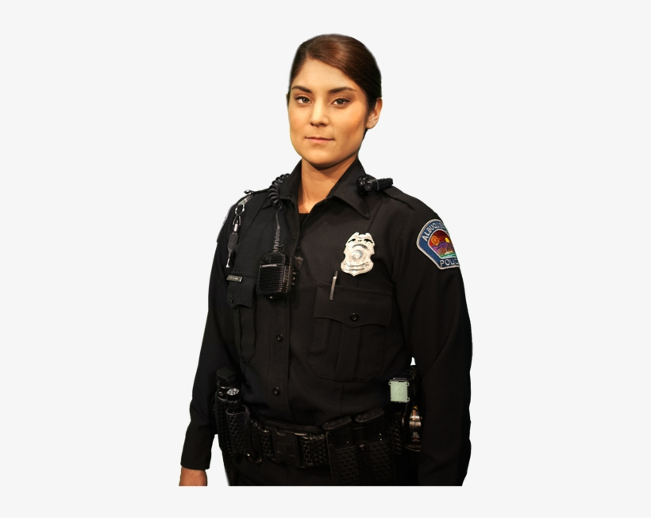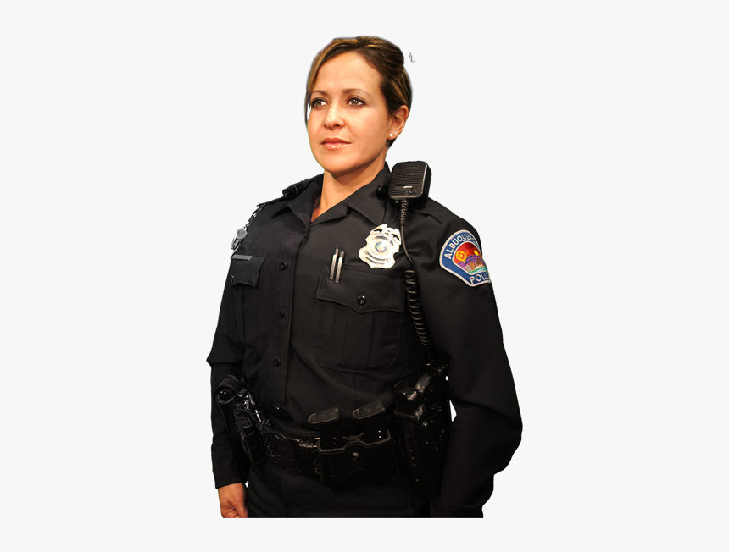  IN STEP WITH OUR COMMUNITY  ALBUQUERQUE POLICE DEPARTMENT  New TEAM Program to Increase APD Presence Downtown 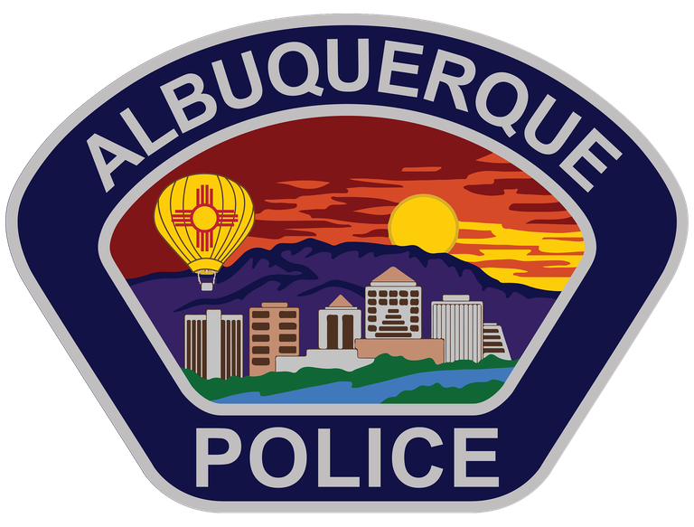$90,000 in pledges so far to help fund program  ALBUQUERQUE – The Albuquerque Police Department announced the launch of Downtown TEAM, which stands for Targeted Enforcement and Active Monitoring. TEAM will provide a better use of officer resources for greater community impact and create an increase presence in downtown Albuquerque. Officers begin working overtime for TEAM.  Many local businesses have already contributed to fund additional patrol of proactive police in the Downtown area and have reached $90,000 in pledges. Among the pledges, PNM was the first to contribute to TEAM through a grant award of $15,000.  “Curbing crime is a shared responsibility and the first order of business for any downtown revitalization work,” said Pat Vincent-Collawn, PNM Chairman and CEO. “The PNM Resources Foundation is proud to support organizations, such as TEAM, that are providing the needed resources to rebuild stronger, safer, more cohesive, vibrant, participatory communities.”  As part of a larger push to make Downtown safer and resource allocation for law enforcement, APD restructured the ability for big box retailers to contract off-duty police officers and pay for overtime services. Downtown area will be treated as a neighborhood with an acute crime problem and targeting those specific issues.  Specifically, officers working overtime for TEAM will be focused on a menu of items that are key issues in the Downtown area from DWIs to fights, modified exhaust, illegal firearms and traffic enforcement. The city has also implemented license plate readers Downtown and additional lighting was installed in alleyways. Cameras linked the APD’s Real Time Crime Center have also been installed along Central Avenue between 1st and 7th Street.  The City has been partnering with downtown businesses to provide additional police presence during times of peak call volume and based on a data driven approach to public safety. The hope is that more Downtown businesses will consider making contributions to the One Albuquerque Fund to continue TEAM long-term.  “Downtown is the heartbeat of our city and we’re pushing forward to create more opportunities to live, work, and find activities for everyone right here in our core,” said Mayor Tim Keller. “TEAM brings private partners to the table to help APD target crime where it’s happening and make people feel safe when visiting their businesses.”  “We have made significant changes to bolster our presence Downtown and have already seen the impacts of targeted enforcement, increased technology and more boots on the ground,” said Chief Harold Medina. “By implementing Downtown TEAM, we will have an even larger presence in our Downtown area to make our community feel safe whenever they come out to enjoy the area If anyone from the community or stakeholders in the Downtown area would like to donate to the One Albuquerque Fund to contribute to TEAM, they can make a donation at this link.  https://one-albuquerque-fund.snwbll.com/downtown-team-program  Community Policing  The idea is simple: Build relationships and work with communities to address their concerns and priorities.  We are successfully fighting crime when we work hand-in-hand with communities to implement solutions that keep people safe. Our officers are working with neighborhoods, business owners, faith-based organizations, schools, and more to tailor proven public safety strategies to meet the needs of specific areas. APD Community Policing comprises three key components: Problem Solving, Community Partnerships and Organizational Transformation.  Problem Solving: Solving problems means, first, identifying issues that need to be addressed and then determining resolutions and devoting effort to meeting needs for a successful outcome. The SARA (Scanning, Analysis, Response, and Assessment) model is one of the most familiar processes for problem-oriented policing (POP). APD is using this model.  Community Partnerships: Partnerships between law enforcement and the individuals and organizations they serve to develop solutions to problems and increase trust in police. APD will focus on creating partnerships with a diverse section of the Albuquerque community and will work with key community stakeholders including, but not limited to:  - Other law enforcement agencies  - Social service providers  - Business community  - Educational institutes  - Local prosecutors  - Faith-based organizations  - Neighborhood interest groups  - Youth organizations  These partnerships will identify community challenges and focus on developing a strong road map to address those challenges (problem solving).  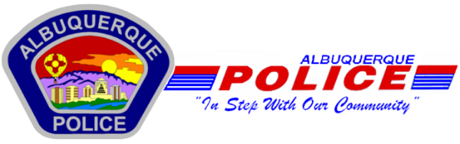  Other Services:  Sharps Disposal (Needles) – Call 311 https://www.cabq.gov/environmentalhealth/sharps-disposal  (ACS) Albuquerque Community Safety  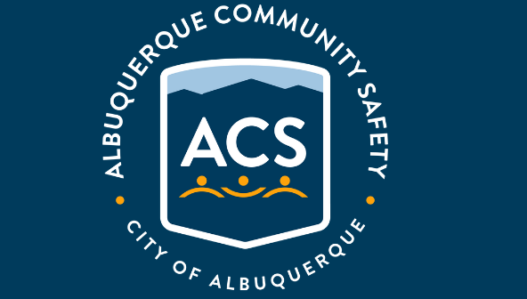  Albuquerque Community Safety Administration (ACS) – Call 311, 242-COPS or 768-4227 acs@cabq.gov – ACS sends trained professionals to non-violent and non-medical 911 calls for service involving issues such as mental/behavioral health, homelessness, and addiction as well as non-behavioral issues such as abandoned vehicles and needle pick-ups.  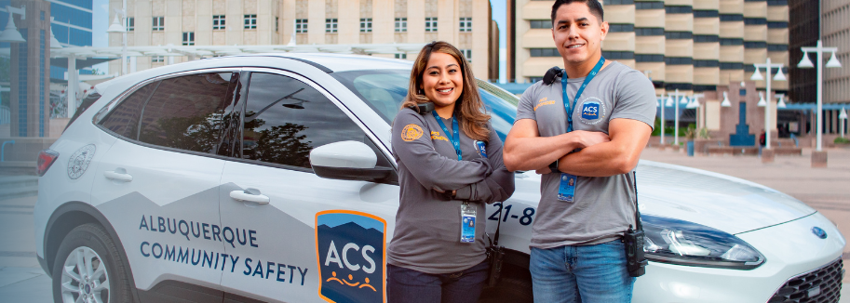
    - 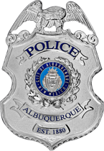
  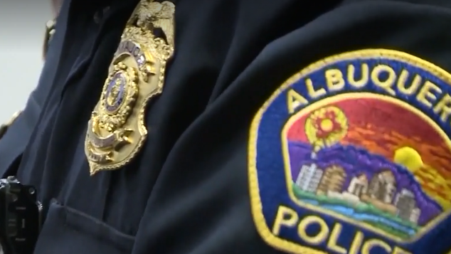
  V
  A
  L
  L
  E
  Y
  AREA
  COMMAND
  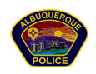
 | Valley Area Command Crime Statistics  03/01/2023 to 03/31/2023  MONTH OF March 2023  *Information Disclaimer*  This information is pulled from daily Calls for Service, which reflects all calls made to APD’s 911 Emergency Communications Center. It does not reflect all crimes that police investigate, nor the final outcome of crimes investigated. Furthermore it may not reflect the true location of crimes as they may have occurred in a different location from which they are reported.
    - Definitions
  Burglary – Unauthorized entry of any vehicle, watercraft, aircraft, dwelling or other structure, moveable or immovable, with the intent to commit a felony or theft therein.
  Robbery – Consists of the theft of anything of value from the person of another or from the immediate control of another, by use or threatened use of force or violence.
  Motor Vehicle Theft – Consists of a person taking any vehicle or motor vehicle intentionally and without consent of the owner.
  Auto Burglary | 29
  Commercial Burglary | 13
  Residential Burglary | 19
  Auto Theft | 66
  Robbery – Auto | 1
  Robbery – Commercial | 2
  Robbery – Individual | 4
  Robbery - Residential | 0

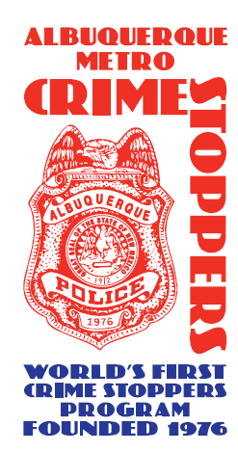  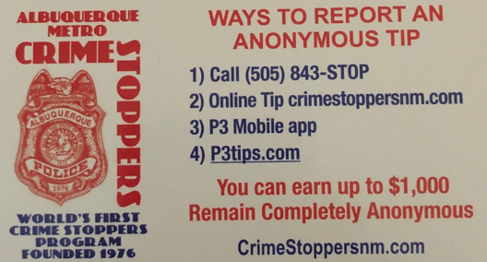  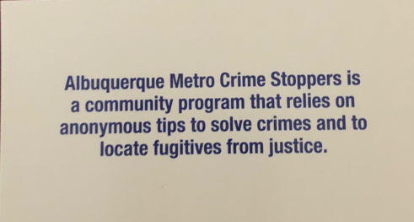  Valley Crime Prevention Specialist  Lamont Davis  5408 2nd St NW  Albuquerque, NM 87107  505-761-8805  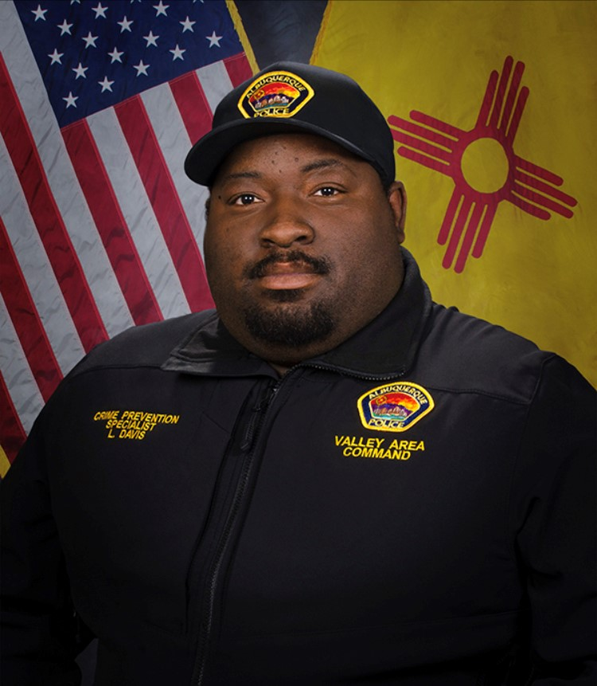  Lamont Davis, our Valley Crime Prevention Specialist is here to help answer any questions you may have related to crime prevention, neighborhood watch, or APD involved community events.   | Crime Mapping Info & (Safety TIPS)    The Valley Area Command uses the Computer Aided Dispatch (CAD) data to determine crimes that happen in the area. When a response is indicated, the information received from the caller will be entered into the CAD for a response. The information from the caller allows ECC staff to determine the priority of the call, how many officers to dispatch, and it provides the officers with vital information so they can determine what action to take as they respond to a call for service.  Residential Burglaries  (TIP)-It is always good practice to make it look like someone is home at all times. Turn a radio on to a talk show station when you are gone, this will make it appear that someone is inside of your home.  Commercial Burglaries  (TIP)-If your business is closed, we recommend that you check your property periodically, be sure to leave lights on and clean up any debris or growth around the property. These small steps may deter a criminal.  Auto Burglaries  (TIP)-Be sure you are keeping your belongings out of site and remove anything of value. It is a great idea to pack a bag with items you need for the day and take it with you when you get out of the vehicle.  Stolen Vehicles  (TIP)-Using devices such as kill switches, alarms, clubs and locking doors and windows, also try to park in an area with good lighting to try to deter a criminal.  Carjacking  (TIP)- Always be aware of your surroundings. Pay special attention when you are at a standstill such as when you are at a stop light or in a parking lot. Keep doors locked, roll up your windows and notice who is in the immediate area.  Robbery to an Individual  (TIP)-Use situational awareness, look around, walk with confidence, make eye contact and read peoples body language. If you do find yourself in this situation give them whatever possession they are demanding, remember, possessions can always be replaced – you, cannot.  Commercial Robbery  (TIP)- Train your employees to be on the lookout for suspicious behavior and report it immediately. Start training your brain to make note of how someone looks and what they are wearing, including their shoes. Many criminals will change their clothing but they will not change their shoes.  Robbery By Gunpoint  (TIP)- After the robbery occurs call 911 and lock your doors. If there are witnesses ask if they can stay to give a description of the offender. Do not discuss what you saw with others, wait to give a description to the officer.  Residential Robbery  (TIP)- Always identify who is at the door before opening it. Keep doors locked at all times. Keep an eye out for suspicious persons/vehicles in the neighborhood.  Remember if you see something say something!  Homeless Encampments/Services  You can report homeless encampments by calling 311 or through the solid waste email:  sw-encampment@cabq.gov  To get more information on homeless assistance go to:  https://www.cabq.gov/family/services/homeless-services  Services Offered  There are many resources that we can provide to you, such as, informational pamphlets, Training on topics such as personal safety, scams, anti-bullying etc., CPTEDs (Crime Prevention Through Environmental Design), starting a Neighborhood Watch, CFMH (Crime Free Multi-Housing) and we can take McGruff to your public event or school or set up a table with informational pamphlets and promotional items. All of these services are free of charge.  Crime Prevention Corner  Scams & Fraud Alerts  Types of scams and fraud alerts from the Office of Consumer Protection  Please be aware of the following scam & fraud alerts in our community:  Types of Scams  There are many types of scams listed below to find out how they work, how to avoid them, and what to do if you have experienced being scammed.  - Identity Theft  - Social Security Imposters  - IRS and Government Imposter Scams  - Grandparent Scams  - Online Dating/Romance Scams  - Tech Support Scams  - Healthcare Scams  - “You’ve Won” Scams  - Home Repair Scams  - Work-at-Home Scams  - Money Mule Scams  - Charity Scams  - Unwanted Calls  - Student Loan Debt Relief Scams  Coronavirus Scams & Information  - Coronavirus: Scammers follow the headlines (FTC)  - FBI Sees Rise in Fraud Schemes Related to the Coronavirus (COVID-19) Pandemic  - COVID Scams in Albuquerque  - Beware of Fraudulent Coronavirus Tests, Vaccines and Treatments  - Report fraudulent COVID-19 products to FDA-COVID-19-Fraudulent-Products@fda.hhs.gov  Stimulus Payment Information  - Are you concerned that an identity thief stole your stimulus check?  - Stimulus Payments on Prepaid Cards  - Prepaid Card Stimulus Money Alert  Social Security Scams  - Social Security Phone Scams  Identity Theft  Information about identity theft and how to prevent it.  How It Works  Someone gets your personal information and runs up bills in your name. They might use your Social Security or Medicare number, your credit card, or your medical insurance — along with your good name.  How would you know? You could get bills for things you didn’t buy or services you didn’t get. Your bank account might have withdrawals you didn’t make. You might not get bills you expect. Or, you could check your credit report and find accounts you never knew about.  How to Prevent It  - Protect your information. Put yourself in another person’s shoes. Where would they find your credit card or Social Security number? Protect your personal information by shredding documents before you throw them out, by giving your Social Security number only when you must, and by using strong passwords online.  - Read your monthly statements and check your credit.When you get your account statements and explanations of benefits, read them for accuracy. You should recognize what’s there. Once a year, get your credit report for free from AnnualCreditReport.com or 1-877-322-8228. The law entitles you to one free report each year from each credit reporting company. If you see something you don’t recognize, you will be able to deal with it.  - Take steps to protection your identity and credit. Go to ftc.gov/idtheft or Identitytheft.gov/SSA to learn what to do if you have been scammed.  If You Have Been Victimized by Identity Theft  - File a police report. Some businesses require a police report to remove fraudulent debts from a victim’s account. Filing a report may help you in the future if the someone uses your identity  - Create an Identity Theft Report and get a personal recovery plan at IdentityTheft.gov  - Freeze your credit report by going to website for each of the 3 big credit reporting agencies (Experian, Transunion and Equifax) and following the links to freeze your credit  - Call the three national credit-reporting organizations immediately to place a fraud alert on your name and Social Security Number:  - Equifax 1-800-525-6285  - Experian (formerly TRW) 1-800-301-7195  - Trans Union 1-800-680-7289  - Social Security Administration fraud line 1-800-269-0271  - Get more information from free identity theft resources from the FTC  Home Repair Scams  Information about Home Repair Scams.  How It Works  Someone knocks on your door or calls you. They say they can fix your leaky roof, install new windows, or provide the latest energy-efficient solar panels. They might find you after a flood, windstorm or other natural disaster. They pressure you to act quickly, might ask you to pay in cash, or offer to get you financing.  But here’s what happens next: they run off with your money and never make the repairs. Or they do shoddy repairs that make things worse. Maybe they even put you in a bad financing agreement that puts your house at risk.  How to Prevent It  Stop. Check it out. Before making home repairs, ask for references, licenses and insurance. Get three written estimates. Don’t start work until you have a signed contract. And don’t pay by cash or wire transfer.  Research the company. Ask for references from prior customers, check out the Better Business Bureau website for reports of problems.  If you lost money you should act immediately:  - Call the gift card or debit card company immediately. The contact number is on the back of the card. If reported immediately, you may be able to stop the transfer of funds, otherwise it may not be possible to stop the funds from being withdrawn. It is also important to alert the card company of fraud.  - If you sent cash, report it immediately to the postal service or whatever company you used. If you act quickly you may be able to stop delivery by giving the tracking number to the delivery company.  - If you wired the money, contact the wire service company and report the fraud.  - If you provided your bank account information or sent a check, contact your financial institution and place a stop payment on the check and alert them of the fraud.  - If you gave personal information to the scammer you may be subject to identity theft. Learn what to do.  - Report the scam to the Attorney General’s Office Toll Free 1-844-255-9210 and the State of New Mexico Construction Industries Division.  - Report home repair scams to the Federal Trade Commission.  Tech Support Scams  Information about Tech Support Scams.  How It Works  You get a call from someone who says he’s a computer technician. He might say he’s from a well-known company like Microsoft, or maybe your internet service provider. He tells you there are viruses or other malware on your computer. He says you’ll have to give him remote access to your computer or buy new software to fix it.  But is the caller who he says he is? Judging by the complaints to the Federal Trade Commission, no. These scammers might want to sell you useless services, steal your credit card number, or get access to your computer to install malware, which could then let them see everything on your computer.  Scammer have the technology to “spoof” a caller id, making it look like one Microsoft or Apple is really calling. Scammers can also post phony customer support number on-line for well-known companies.  How to Prevent It  - Hang up. Never give control of your computer or your credit card information to someone who calls you out of the blue.  - Do not click or call a number that pops up on your screen warning or a computer problem.  - Do not rely on caller id – it can easily be spoofed.  - Never share passwords with anyone who contacts you.  - Keep security software up to date.  - If you need help, contact a computer technician that you trust. Do not just rely on an online search.  If you have been scammed:  - Change any passwords you shared and scan your computer for malware.  - If you gave your credit card number, tell you credit card company and file a dispute of charges.  - Check your statement and contact your credit card company to dispute and reverse any charges for bogus services.  - If you get a call from the company for a “refund”, hang up because that could be part two of the scam.  Report scams to the Federal Trade Commission  Valley Community Policing Council:  Hello and Welcome Everyone,  Our next meeting is on April 23th  As always we have both in-person and virtual attendance. The link to join the meeting is:  https://cabq.zoom.us/webinar/register/WN_7Z1iT-WbR9-9-s1dEYOjiA  Our physical location is the Johnny Tapia Community Center and we run from 6:00pm to 8:00pm.  In the not too distant future we will be rotating our meetings to different community centers for three months at a time. We will keep you informed.  If you need more information please contact us at cpcvalley@gmail.com.  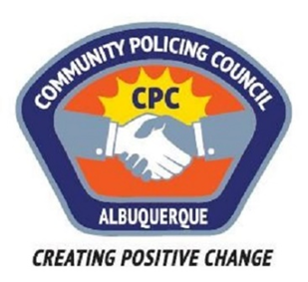  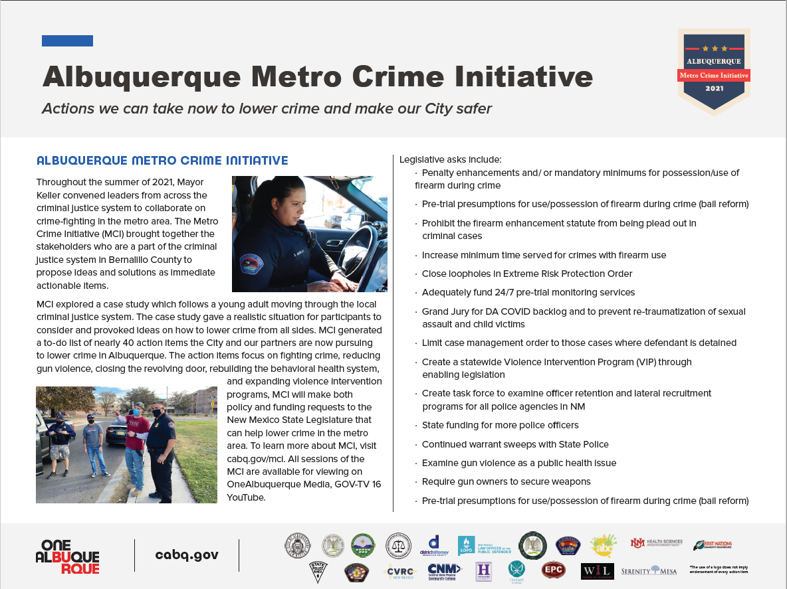  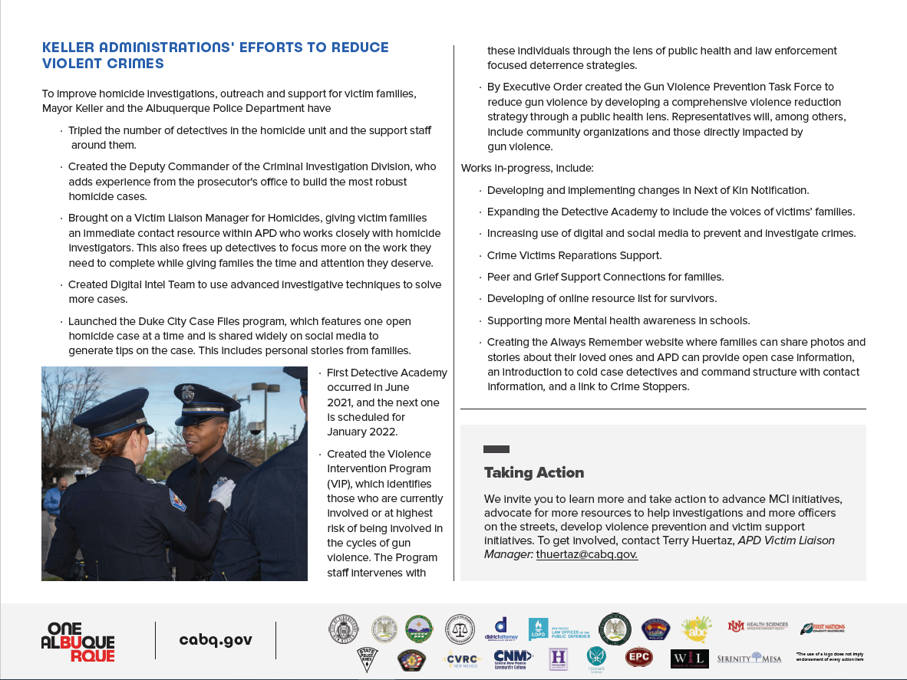
    - Crime Mapping
  On the crime mapping website you can run any crimes that you would like to look at in your neighborhood or throughout the city of Albuquerque. You can also sign up to receive alerts in your specific area.
  Crimemapping.com
 | Substation Hours  All police substations are open to the public the hours of operation are from 8:00 AM to 5:00 PM.  If you need an Accident Report form or a copy of an Accident Report you can call with your case number to have it mailed to you via US Mail they are not provided through email. When you come in to get a report make sure to bring in your ID and Case #. For any other report call the substation to make sure it is available before coming by 761-8800.  The Old Town Substation is now open Monday-Thursday 8:00 AM to 5:00 PM and on Friday 8:00 AM to 8:00 PM and on weekends from 11:00 PM to 7:00 PM.  Valley Area Command  5408 2nd St NW  Albuquerque, NM 87107  505-761-8800  Southwest Area Command  6404 Los Volcanes NW  Albuquerque, NM 87121  505-831-4705  Southeast Area Command  800 Louisiana SE  Albuquerque, NM 87108  505-256-2050  Northwest Area Command  10401 Cibola Loop NW  Albuquerque, NM 87114  505-768-4850  Northeast Area Command  8201 Osuna NE  Albuquerque, NM 87109  505-823-4455  Foothills Area Command  12800 Lomas NE  Albuquerque, NM 87112  505-332-5240  Needles/Sharps Containers/Drug Disposal  Please be advised large quantities of used needles and/or full sharps containers are not accepted at the Valley Substation. We have a small container located in the lobby. If you have more than a few needles the closest drop-off location to our substation is the North Valley Public Health Office located at 7704 2nd St NW. Call the substation nearest you to see if they accept needles/sharps. Pills are accepted at all substations (No liquids accepted).  For more information visit: cabq.gov/police
    - File a Report
  Online Report
  cabq.gov/police/file-a- police-report-online
  (TRU )Telephone
  Reporting Unit
  242-2677 (COPS)
  APD App
  