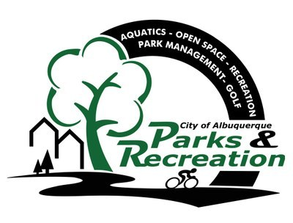 | City of Albuquerque, Parks and Recreation  2017-2018 Winter Basketball  Team Registration Checklist

All of these tasks/items need to be completed in order for your team to participate this season:

- Complete and turn in TEAM REGISTRATION FORM
Jerry Cline Recreation and Tennis Center by October 6, 2017.

- Pay the $462.00 TEAM FEE at the Jerry Cline
Tennis Center at the time you turn in your registration form. Forms of payment accepted are: cash, check, credit card.

- Pay the $50.00 USSSA sanction fee.

- Turn in a completed team roster (with all signatures
and ID numbers filled in), along with a USSSA
each player rostered, along with proof of USSSA sanction fee paid for 2017 by October 18, 2017 to the Jerry Cline Recreation and Tennis Center.

