GREATER ALBUQUERQUE RECREATIONAL
TRAILS COMMITTEE MINUTES

November 19, 2013
4:00 pm

1801 4th Street NW, Albuquerque, NM Large Conference Room

Members Present:, William Schimberg, Guy Miller, Gary W. Kelly, John Thomas, Warren Wild, Ian Maddieson, Valerie Cole

Members Absent: None

Advisory Members Present: None

Staff Members Present: James Lewis (COA - Parks and Recreation), Susannah Abbey (COA, Open Space), Christina Sandoval (COA- Parks and Recreation)

Staff Members Absent: None

Visitors Present: Carrie Barkhurst (COA-Planning), Scott Hale (GABAC), Jackie Bouker, Ayesha Burdett (New Mexico Museum of Natural History and Science), Richard Barish (Sierra Club), Esther Tenenbaum (COA - 311 Division Manager).

Call to Order and Introductions
Chairperson Ian Maddieson called the meeting to order at 4:05 p.m.

Approval of November 19, 2013 Agenda
Ian Maddieson moved to approve agenda with a second by Bill Schimberg, {Motion passes 7-0).

Approval of October 15, 2013 Minutes
Motion: Gary Kelly moved to approve the minutes with no amendments needed. Second by Bill Schimberg. {Motion passes 7-0).

General Announcements:
James passed out trail etiquette brochure made by Parks and Recreation. Will coordinate with Gabe Campos to make accessible.

Staff Reports

Susannah Abbey - City Open Space Division - Susannah described Open Space projects in the East Mountains.

November 20, 2013 Minutes Final

James Lewis- Strategic Planning and Design- James explained Paseo del Norte resurfacing project; detour may be needed. Boca Negra Dam Trail pending funding agreement. Estimate for Piedras Marcadas/Golf Course crossing needs to be adjusted prior to moving forward. Remediation being looked into where flooding is occurring on trail near Jerry Cline Tennis Facility.

Public Comment -
Richard Barish spoke about ABO, The Plan and proposed trail improvements in the
bosque.

----New--Business/Update ltems/Prese-n-tu attt«ioon n1-::>-----------------

  - Esther Tenenbaum, Division Manager, 311 Citizen Contact Center: Esther described how the 311 system works. 311 is a non-emergency call center. In regards to multi-use trails, Esther urges everyone with a Smartphone to use the ABO 311 app which is much faster and better (especially because it can tell the 311 operators the GPS coordinates of the user) than the older universal app system.
People without a smartphone can call in directly to 311 and explain the closest major cross-streets where the situation has occurred. 311 does not dispatch, therefore all illegal or potential illegal activity will be sent to the police. With emergencies call 911 and other items that police should deal with can be utilized by calling 242-COPS.

  - Ayesha Burdett, Bioscience Curator at the NM Museum of Natural History and Science: Ayesha described her role as a biologist and there was a discussion regarding trails in the bosque and potentially where a proposed trail may be located.
Susannah from Open Space discussed the possibility of condensing the multitude of soft surface trails into one more formalized soft surface trail which could actually lessen the likelihood of bird and other wildlife disturbances.

Motion: John Thomas moves that GARTC will send a communication (letter) encouraging the Mayor to put the Albuquerque bosque improvements on hold until scientific data analysis has been conducted. Second by Gary. Motion passes all in favor 7-0.

Bikeways and Trails Facility Plan Update (Carrie Barkhurst - Planning): Discussion, Action Items, and On-Going Business:
  - Discuss letter in regards to the Pedestrian/bicyclist aspect for the 25/Paseo del Norte interchange: Ian sent the letter written per the motion from the October meeting to all the heads of the Paseo/25 interchange project. He did not receive one response.

Note: Guy Miller left meeting at 5:39 pm.

Motion: John moved to empower the Chair to contact federal officials, senators, and l ocal media, regarding GARTC's position regarding the Paseo del Norte/25 i nterchange project and that previous efforts and their position were not responded to. Second by Gary. Motion passes all i n favor 6-0.

- Equestrian Comments/concerns within bosque improvement corridor: Valerie handed out and emailed comments regarding this issue.

- GARTC Letter to the Mayor and City Council on Piedras Marcadas Trail: A letter was composed by John and Gary and shared among GARTC members. An action was taken and not considered a motion. The committee voted 3-2 with one abstention to edit the letter prior to sending to City officials. Ian volunteered to edit the letter.

- Scope of Work for the PM/Golf Course Midblock Crossing: James discussed that the City is working out the design cost details with the engineering firm at the moment.

- Policing of Multi-use Trails: General discussion of police on various multi-use trails.

Sub-Committee Reports:
- Trail Naming: Nothing new to date.

- Bollard: Ian will take James's comments and integrate them into GARTC's bollard policy for December's meeting.

Adjourn: John made a Motion to adjourn at 6:11 pm. Second by Gary. All in favor; motion passes 6-0

The foregoing GARTC minutes from the November 19, 2013 GARTC meeting have been approved as written or with noted comments on December 17, 2013.

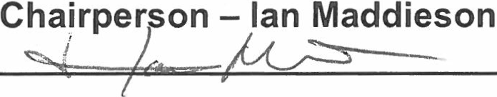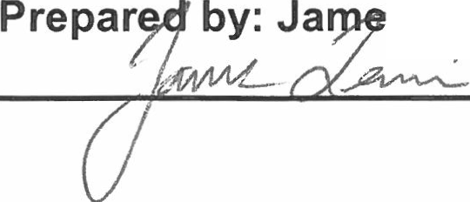s Lewis
Date
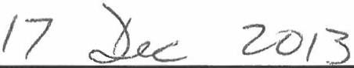12/;7/J,6 j3
I I >

Date



