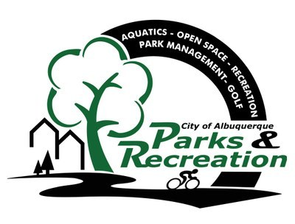
City of Albuquerque Parks and Recreation
2022 SUMMER Softball
Registration Check List

Note: Each item listed below must be completed in order for your team to participate: Teams who do not turn in the required paperwork will not receive a schedule and will have to forfeit games

REGISTRATION OPENS MARCH 1, 2022

- Complete and turn in TEAM REGISTRATION FORM to the
Jerry Cline Recreation and Tennis Center by March 25, 5:30pm, 2022.

- Pay the $990.00 TEAM FEE at the Jerry Cline Tennis Center
at the time you turn in your team registration form. Forms of payment accepted are: cash, check, credit card.

- Above items required to reserve your team spot during (Mar 1 – Mar 25)
___________________________________________________________________

- Below items due no later than April 7, 2022

Pay the $50.00 USSSA sanction fee at http://www.rctipif.org. Please go through this website ONLY as all other website registrations are not valid for the City of Albuquerque.

- Turn in a completed team roster with all signatures and ID numbers
filled in, USSSA waiver of liability form, and Code of Conduct form signed by individual participants, and proof of purchase-2022 USSSA sanction fee by April 7, 2022 to the Jerry Cline Recreation and Tennis Center. All players must sign a new USSSA waiver and CABQ Code of Conduct each year.

- Managers must attend rules and conduct meeting at Jerry Cline on
April 6 or 7 at 6:00PM, 2022.

