Wilson Middle School
Garden Handbook for [Wildcat Blooms
and the Edible Urban Forest]

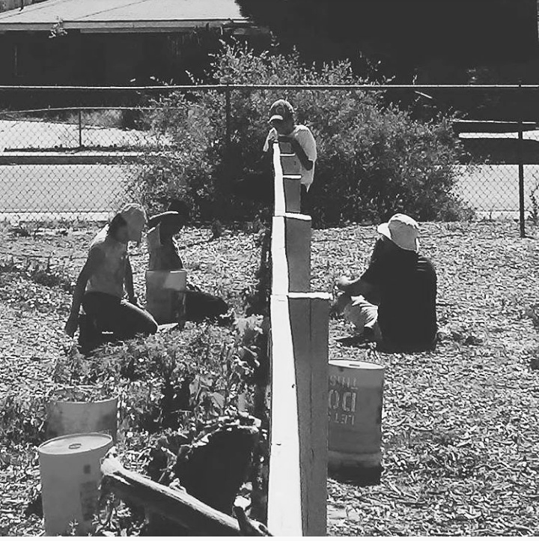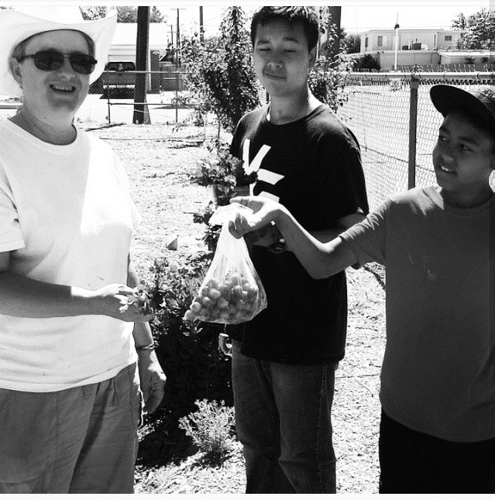

ABOUT THIS MANUAL
A. About this manual and how to use it.
School gardens in Albuquerque are a growing a vibrant movement. There are nearly 90 gardens in the district all functioning at different levels with different purposes. This Manual was developed specific to Wilson Middle School. It will provide you with information on the history of the garden(s), how they function and how they are currently used by students and staff. Although we recommend you read the manual through if you are new to your school garden initiative, you can skip to specific topics and sections using the Table of Contents.

B. Statement of Food Justice and Sovereignty
New Mexico families and students have been facing hunger and curable, dietary related diseases for generations. Although we have a $3+ billion Agriculture industry, very little of that is food for consumption, or stays in New Mexico. What we do have in our state is a rich and living Agrarian Heritage. In honoring and remembering what sovereignty is, school gardens and food is just one way to further the reclamation of our health and land. A 2015 study in NM with the Kellogg Foundation found that “schools can function as food hubs that bring production, distribution, consumption, policy, and capacity building together on a single site. Schools are also critical sites for increasing kids’ understanding of cultural foodways.”

C. Partners and the variety of Gardens
Partners in the school gardens movement include not only teachers, staff and administration; others involved are APS School Board Members, community businesses, local nonprofits, farmers, families and neighbors. Gardens and outdoor classrooms vary from basic herb pollinator gardens for observation, to full blown farm-style production spaces. Some schools even have more than one site on campus with different functions. It is important to remember that all garden spaces can function as an “Outdoor Classroom.” Classes, student groups, and clubs all utilize the gardens in different manners as well. All garden volunteers must meet APS background check requirements.

D. Different ways to organize and starting from scratch
Even if your school does not currently have a garden space, there are many ways to organize for better food in APS and your school. Some of these ways include- composting, raising awareness about local food purchasing, farmers markets, and food access, working with cafeteria staff on food preparation, organizing to improve school or district policy on getting fresher, healthier options for school meals, vending machines, or snack bars. In the Appendix there are some contacts that can help you assess the best method of beginning to organize at your school, or take what is already happening to the next level.

Table of Contents
[Create Table of Contents from “insert” tab after document is complete. Make sure all relevant sections start with a formatted header]

[Introductory paragraph to your schools garden] Wilson Middle School’s Gardens
Example: The purpose of these green spaces at our school is to feed the community and create a unique learning environment for our students. All of the infrastructure has been built by, and with students.
A goal of this garden is to feed the students, their families and the community. Usually food grown in the garden is distributed among the classrooms that help grow it. Harvests are either used in lessons or sent home with students who have worked the garden. Harvest can also be donated to the schools food bank through the Family Resource Center.
Garden Center
Example: Wilson Middle School Garden center is currently located in the 300 building. In the center of building, there is a shared lab materials space for staff. On the South end of the room you will find a desk with garden activity materials and kits. In each kit is one or more activities you can do with students relative to language arts, mathematics, science and math. There is also an additional purple binder filled with garden lesson plans. Please feel free to make additions to this resource area.
Although not a requirement but highly recommended, coordinate with the other instructor(s) if you are interested in being outside at the same time. Too many students at once doing different types of activities can quickly result in disturbing a lesson or the plants.

Garden Descriptions at [WMS]
Important note: working ON the garden VS. working IN the garden. (Refer Maps in next section with the following descriptions.)
Example: If educators/community desire to work ON the garden, that means they will be physically changing the space with gardening or structures. For those interested in working in this capacity please get approval from the lead gardening team.
If educators/community desire to work IN the garden means all students and educators are welcome to each garden space. We encourage all patrons to use the gardens for class activities that involve observation, exploring, relaxation and meditation. If confident with their knowledge of the plants and the space, we also encourage them to help keep the spaces free of trash and weeds.
Wildcat Blooms
Quick details- fruit trees, living fence, sponge beds, raised beds, production rows, compost bins, leaf corral.
FUNCTION- Some growing spaces in this garden have crops that are perennial like the sponge beds or octo-gardens, and other spaces are best for annual production like the rows or raised boxes.
Raised boxes along the North side of rows with the ability to be covered for cold-crop production. 5 sponge beds are established on the East and South side of the rows. In the sponge beds are the perennial crops (starting from the NW corner) asparagus, strawberries, Jerusalem artichokes, Egyptian crawling onions, and raspberries companion planted with elderberry. Fruit trees from starting from the East to South fence are 2 cherry, 2 Apricot, 2 apple, 2 plum and 2 peach.
Watering note: Sponge beds, fruit trees, and flower beds must receive regular water throughout the entire year.
Urban Food Forest
Quick details- pond, pathways, patio, water collection, edible foods, pollinators, wildlife attraction.
FUNCTION- This garden is ideal for observation and exploration. The patio, built completely by students is a great space to accommodate full classrooms and lead a lesson. Each region of the forest has a theme, such as native plants, shrubs, herbs, grasses, etc. Pollinators are planted throughout the area and can sometimes be mistaken for invasive weeds. Please research anything you are unsure about. The variety of pollinators make the Urban Food Forest and Wildcat Blooms a designated waystation for Monarch butterflies.
Watering note: The pond must be refilled regularly and food-producing plants must be watered more often than other pollinators, flowers, and grasses.

Water Access

Example:
There are two access points for watering. Two different types of water keys are required which are located in the locked garden shed.
One access point is a nozzle located on the outside of the 500 building on the East side of the building. Here a hose can be connected to the beginning of the drip-line irrigation system that waters the production rows in wildcat blooms.
The second access point is located in the ground concealed in a green box in the SW corner of Wildcat Blooms. The key attaches to the valve on one end and a hose on the other. Access to the main line for this source is in the ground near the SW corner of the 500 building.

Garden Agreements
Example:
When using Wilson’s school garden we ask…
- Approve all major garden decisions and projects with garden team. Everyday gardening tasks such as weeding, watering, etc. do not have to go through leadership.
- Log all garden and compost related interactions
- Perform garden and tool safety exercise with each group or classroom at least once prior to working in the garden.
- Put away and store properly all garden tools and supplies.
- Every classroom that uses the garden is responsible for contributing to regular maintenance and upkeep.
- If you would like to help weed or water other spaces please know the crop plan and follow proper weeding guidelines.
- Follow all APS guidelines for background checks and volunteers.
- We encourage all teachers to create a journal to record student experiences in the gardens.

Garden and Tool Safety
*Every class should go through this short training prior to being in the garden.*
Time: 30 minutes
Items needed: One of each tool you will be using for that day or all available to your garden
Please perform this training and go over group agreements with all groups entering the garden. It is a necessary step to ensuring successful sessions in the outdoor classroom. This can be done with the tools you will be using for that day. Tools can vary from basic shovels and hand tools, to rototillers and lawn mowers.
Purpose:
To ensure each garden participant knows how to safely use the tools using the least amount of strenuous work.

Preparation:
Gather each of the tools you wish to demonstrate. Lean them up against a fence, or lying on the ground, in a line, face down.

Activity Ideas:
- Ask students about their experiences with garden and other types of tools. Discuss why a safety training may be necessary even though there is a lot of experience in the room.
- What are all the types of tools we might use in a garden?
- Go over each tool and distinguish the different versions and characteristics. (Example: A flat head shovel versus and spade shovel. One is straight and flat and the other is curved and pointy. Spade is for digging and flat head is for scooping.)
- Ask students to demonstrate the use of a tool one at a time.
Group agreements when handling the tools.
- Tools should never go higher that the knee or hip.
- Tools should never be used to point something out.
- Tools should never be grabbed from one another.
- Tools should never be jokingly used to threaten to hurt someone else.
- If the work is too hard, then pause and consider using a new tool.
Group agreements for the outdoor classroom.
- Do not walk on or over the plants and crops.
- Do our best to help the outdoor classroom thrive.
- Stay on pathways and designated walking areas.
- Communicate to the plants and fellow gardeners with positivity.
- Make sure plants have enough water.
- Do not harvest crops before they are ready.
- Only taste harvests if there is extra and enough to share.

Silver Nightshade
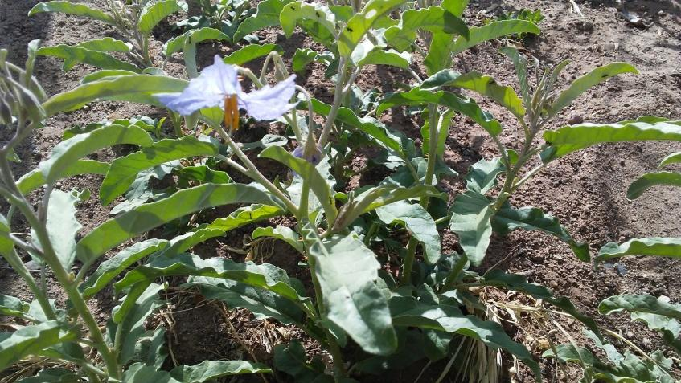
About: Although this plant is invasive in the garden and poisonous, the nightshade family includes crops like potatoes and tomatoes. This species of deadly nightshade does have medicinal properties.
Identifying characteristics: Long, wide leaves. Light green / grayish colored stems and leaves. Long, thin, reddish thorns along stems and branches. Purple flowers with small, round, green fruits. Yellow when ripe.
Removing from the garden: The stems of the plants contain long, thin, reddish thorns that easily pierce bare skin and thin gloves. Use a hand tools if possible. The seeds of the plant will spread exponentially in your garden if they are left to mature throughout the seasons. Work your way to the very bottom of the stem or even slightly below the dirt to avoid the majority of the thorns and ensure removal of root.

Kochia
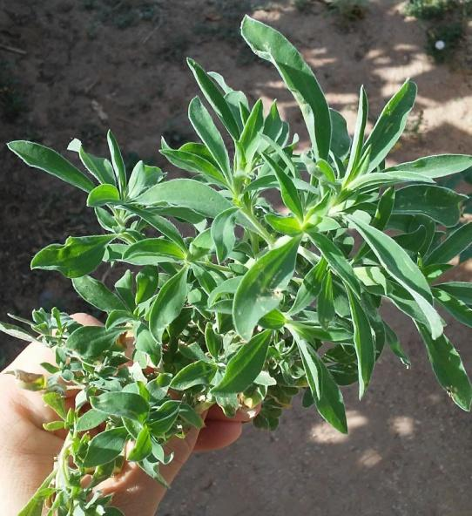
About: These plants can grow in height several centimeters a day and reach several feet before you know it. They also shed copious amounts of pollen when they are larger and are a major cause of allergies. Kochia does have some medicinal uses.
Identifying characteristics: Small thin strips for leaves with a “soft” texture. Randomly alternating stems and branches. Grows tall and/or bushy.
Removing from the garden: Kochia is best managed if plucked when plants are small seedlings. Remove completely with root because the leaves will spread and stems / base will get very strong

Wild Amaranth / Pigs Weed / Quelite Marano

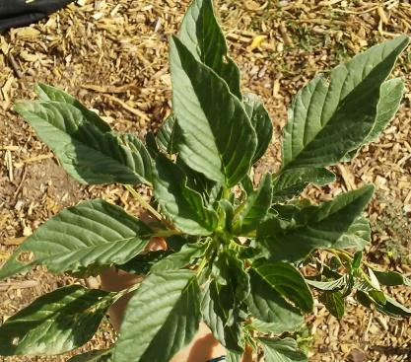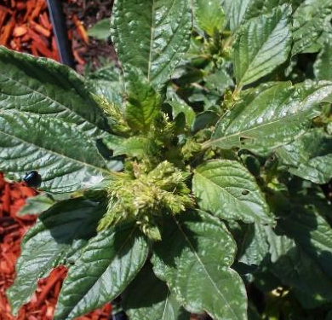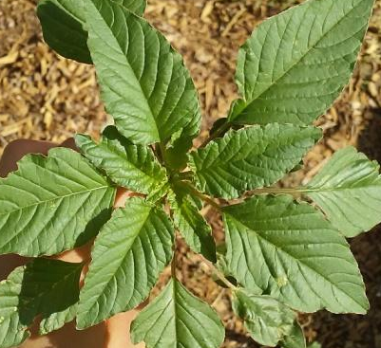
About: This invasive plant is edible when young but can quickly invade the space of your growing food. We consume the domesticated version of this plant with edible leaves, and seeds. They are a major cause of allergies because the flowers drop visible amounts of pollen at once.
Identifying characteristics: Long, pointy leaves with a smooth, bumpy texture. Thin cone shaped flowers. Sometimes stems are tinted purple.
Removing from the garden: Be sure to remove from the root because when the vegetation grows back the leaves spread out, and the stem and base are very strong. When flowers are done growing and pollinating they dry out, become very prickly and are sometimes along the stem.

Additional resources:
Field bindweed: https://navajorange.nmsu.edu/detail.php?id=15
City of Albuquerque School Gardens resource page
Albuquerque Public Schools garden resource page
Community resources list

