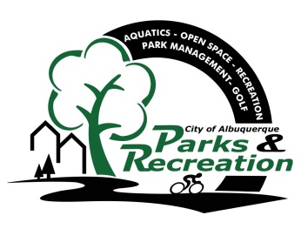
Greater Albuquerque
Recreational Trails Committee

Meeting Agenda

Tuesday, January 19, 2015
3:30 p.m. - 5:30 p.m.
Meeting Place: 7th Floor conference room, Room 7096
City Hall, Fifth and Marquette, NW

- Welcome and Introductions
- Approval of January 19, 2015 Agenda
- Approval of December 15, 2015 Minutes
- General Announcements
- GARTC Yearly Election

- New Business/Presentations (None this meeting)

•1 Discussion/Action Items/Ongoing Business –

- Bosque Nature Path/public meetings update………………………………………………………...GARTC
- Committee Member Recruitment………………………………………………………………………GARTC
- Proposed Trail Names…………………………………………………………………………….…….Planning
- Strava Data ………………………………………………………………..……………………………..MRMPO

•2 Sub-Committee Updates/Actions

- Staff Reports and Project Updates

- Public Comment
(Must be requested 24 hours prior to scheduled meeting, please email jcoffey@cabq.gov (Public input is limited
to 2 Minutes)

•3 Adjourn

- Next GARTC meeting February 16, 2016

Members:
Vacant – East At Large Representative; Ian Maddieson (Vice Chair) - Pedestrians and Hikers; Valerie Cole – Equestrians; Warren Wild - Off-Road Bicyclists (Mountain Bicyclists); Vacant – Runners and Joggers; Tyler Ashton – West At Large Representative; Kathleen Rhoad – Active Elderly; Vacant − Physically Challenged

GARTC Members: If you will not be able to attend the meeting, please call Jason Coffey at 768-5325 or email at jcoffey@cabq.gov

Staff: City – Jason Coffey – PRD, 768-5325

NOTICE TO PERSONS WITH DISABILITIES: If you have a disability and require special assistance to participate in this meeting, please contact the office at least 7 days prior to the meeting at 768-5308 (voice), or by TTY at New Mexico Relay, 1-800-659-8331.

