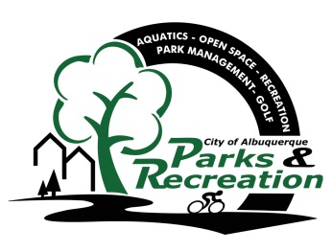
Greater Albuquerque
Recreational Trails Committee

Meeting Agenda

Tuesday, June 20, 2017
3:30 p.m. - 5:30 p.m.
Meeting Place: Parks and Recreation Administration,
1801 4th Street NW, ABQ 87102

- Welcome and Introductions
- Approval of June 20, 2017 Agenda
- Approval of May 16, 2017 Minutes
- General Announcements

- New Business/Presentations

- Bike Map Review _____________________________________Staff/GARTC
- Donated Pump Update ____________________________________ Staff

•1 Discussion/Action Items/Ongoing Business –

- Committee Member Recruitment………………………………………………………………………GARTC
- National Trails Day Project Review………………………………………………………………………Staff
- Connections From On-Street to Off-Street Facilities… …………………………………………….. GARTC

- Staff Reports and Project Updates

- Public Comment
(Must be requested 24 hours prior to scheduled meeting, please email jcoffey@cabq.gov (Public input is limited
to 2 Minutes)

•2 Adjourn

- Next GARTC meeting July 18, 2017

Members:
Vacant – East At Large Representative; Ian Maddieson - Pedestrians and Hikers; Valerie Cole – Equestrians; Warren Wild - Off-Road Bicyclists (Mountain Bicyclists); Ron Cossey – Runners and Joggers; Tyler Ashton (Vice Chair) – West At Large Representative; Kathleen Rhoad (Chair) – Active Elderly; Vacant − Physically Challenged

GARTC Members: If you will not be able to attend the meeting, please call Jason Coffey at 768-5325 or email at jcoffey@cabq.gov

Staff: City – Jason Coffey – PRD, 768-5325

NOTICE TO PERSONS WITH DISABILITIES: If you have a disability and require special assistance to participate in this meeting, please contact the office at least 2 working days prior to the meeting at 768-5325 (voice), or by TTY at New Mexico Relay, 1-800-659-8331.

