Chapter 2: The Rio Grande in Albuquerque: Defining Progress
By Rex Funk

“[Pioneers] Acclaimed the superior virtues of the frontiersman, but they strove with might and main to make an end of the frontier”. Aldo Leopold

The last 100-year history of public use of the Rio Grande illustrates the conflict between the pioneer paradigm and the desire of citizens to protect their environment. This conflict came to a head in the 1960s when reaction to two separate development proposals, one public and one private, provided the impetus for the environmental movement in Albuquerque and the beginnings of a new definition of progress.

The Rio Grande is often called the lifeblood of Central New Mexico. Without the River, Albuquerque could not have flourished; first as an agricultural region and later as a center of commerce. Prior to human occupancy, wildlife thrived in the valley, used it as major migration corridor, and evolved a complex pattern of interactions with the river which were key to the survival of many species. For centuries people co-existed with the river; accepting periodic flooding, wetlands, and cyclic drought. Early Native American farmers probably first diverted the river for irrigation. Spanish settlers developed a formalized acequia system, using gravity to irrigate their crops. The River meandered back and forth across the valley then, and there was little attempt to confine it. In contrast to the dense bosques we see today, there were extensive wetlands, often fed by arroyo runoff, and scattered copses of cottonwoods and willows. Early Anglo explorers tell of abundant waterfowl, irrigated fields and occasional haciendas and Native American settlements along the valley.

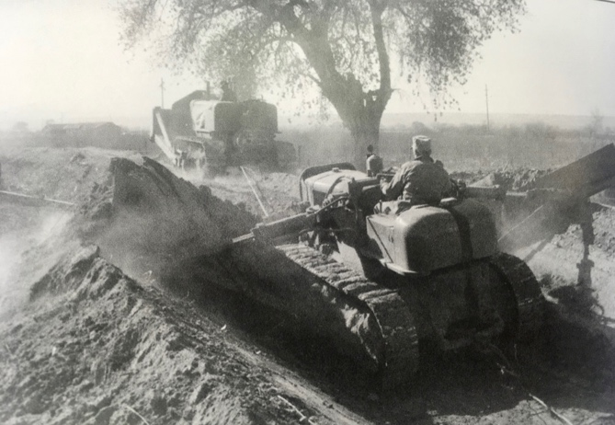
The frontier era ushered in a new paradigm based on resource exploitation. Land was a commodity used to support growth, commerce and the building of wealth (much of it exported). Such was the accepted definition of progress. Mormon settlers in Utah started the “Make the Desert Bloom” movement by controlling rivers for irrigation on a larger scale. This idea was picked up by commercial farmers on the Rio Grande, but haphazard diversion of the river for irrigation soon caused waterlogged soils and increased alkalinity. Flooding was also common. The Middle Rio Grande Conservancy District was established in 1925 to address these problems. The tri-fold mission of this special-purpose agency was flood control, irrigation, and drainage. Its jurisdiction was the Rio Grande Valley from Velarde to Elephant Butte Reservoir. It began by constructing levees to confine the river, digging riverside drains to lower the water table in the valley, and extending irrigation ditches to bring more land under cultivation. The MRGCD also dammed the Chama River, a Rio Grande tributary, creating El Vado Reservoir for water storage. In 1939, New Mexico entered into the Rio Grande Compact, which apportioned water between Colorado, New Mexico, Texas, and Mexico. Unfortunately, flow calculations were based on a wet cycle and today the River is considered over-appropriated. Engineers began to focus on ways to efficiently deliver water to downstream users and reduce “non-beneficial” uses.

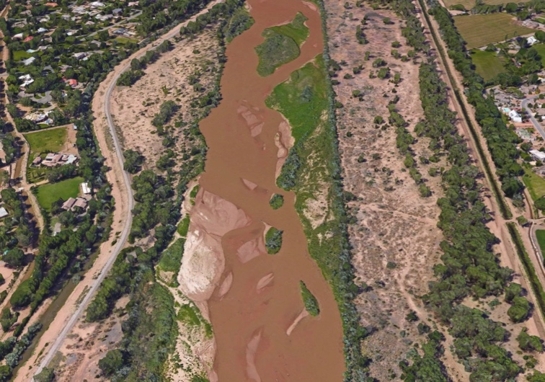
Following a disastrous flood in 1941 where much of the Valley in Albuquerque was inundated, the Federal Government became involved in efforts to tame the river. The Corps of Engineers and Bureau of Reclamation worked with the MRGCD and State Engineer to build up levees, install Kellner jetties to promote channelization and, eventually, build dams at Cochiti, Abiquiu, and on the Rio Salado to control mainstem flows and/or store runoff. These efforts resulted in changed conditions along the Rio Grande in Bernalillo County. No one would dispute the economic benefits of flood control, land reclamation, and greater availability of water in a desert climate. However, little thought was given to the impact and long-term consequences to the natural environment of the River and bosque caused by these modifications. The River was confined to a floodplain between levees which averaged 1,500 ft. wide. A 600 ft. wide channel was largely kept clear of vegetation to convey water, and, thanks to upstream dams, rarely did the river exceed the channel’s capacity and flow over the banks into the bosque. Confining the river led to siltation and gradual aggrading, which left the river “perched” higher than the surrounding valley. Without overbank flooding and wet soils, cottonwoods and other trees couldn’t get started and replace themselves. Much of the mature riparian vegetation along the river was seeded after the last big floods in 1941 and 1959 and is destined to die off. Lowering of the water table due to, channelization, drought, and pumping for urban use further stressed riparian vegetation. In addition, an estimated 25,000 acres of wetlands were eliminated between Cochiti and Elephant Butte reservoir by these projects. South of Belen, a trapezoidal low-flow channel was constructed to convey normal flows of the River, further stressing bosque vegetation in that stretch of the River.

Middle Rio Grande Water Salvage Project: A Wakeup Call

Single-focus control of the Middle Rio Grande reached a peak in the mid 1960s when the US Bureau of Reclamation proposed the Middle Rio Grande Water Salvage Project. The aim of the project was to conserve water by eliminating vegetation along the river, and to convey water more efficiently downstream for the benefit of the signatories of the Rio Grande Compact. Riparian trees such as cottonwood, willow, Russian Olive and tamarisk were considered “Phreatophytes” which transpired water into the atmosphere: a “non-beneficial” use. According to the Bureau of Reclamation, any use of water that does not result in a direct economic return is a non-beneficial use. This is also a central tenant and direct outgrowth of the Pioneer Paradigm. The project proposed mechanical clearing of such vegetation and the use of herbicides to discourage its regrowth. The herbicides of choice at the time contained chemicals being used by the military to defoliate jungles in Vietnam (often referred to as Agent Orange). A straightened trapezoidal low-flow channel would also be constructed to confine normal River flows and further deprive riparian vegetation of water.

Reaction to the Water Salvage Proposal was twofold. First, there was widespread opposition from groups such as the Sierra Club, Audubon Society, and the newly formed Citizens for Clean Air and Water. As the public was informed, opposition spread, and a movement began to preserve and enhance the natural qualities of the River and bosque in Albuquerque. The Bureau of Reclamation, not used to opposition to its projects, backed off under intense public and political pressure. Later they declared the project “Temporarily Shelved.” It has never resurfaced.

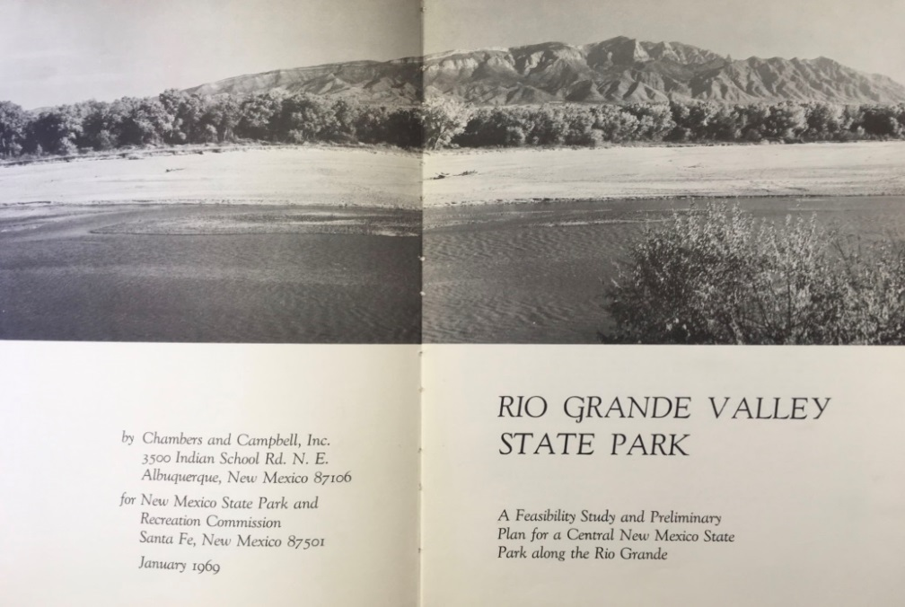
The second reaction was to play the long game by proposing an alternative use of the River. Advocates persuaded the New Mexico State Legislature to fund a feasibility study for “Rio Grande Valley State Park” which was released in 1969. The author of the study, Jerry Widdison of the consulting firm Chambers and Campbell, wrote a comprehensive review of the Water Salvage Project assessing its impacts on wildlife, ecology, aesthetics, recreation, and economics. He concluded that the project “is generally ill-conceived and unwise.” And recommended that it “not be implemented- - -“. The study went on to propose a State Park which would protect the natural character of River and bosque and provide associated recreational facilities such as a nature center, Petroglyph Park, and a shooting range on the West Mesa. None of these proposals were to preclude reasonable flood control, irrigation, and drainage functions along the river. The Rio Grande Valley State Park study became the impetus for a movement. The Bosque del Rio Grande Nature Preserve Society was formed in 1970 and worked tirelessly to advocate protection of the river. These efforts ultimately resulted in Rio Grande Nature Center State Park and Rio Grande Valley State Park which today protect over 5,000 acres of river and bosque. Chapter 7 tells the story of these efforts.

A Paper Mill on the Rio Grande?

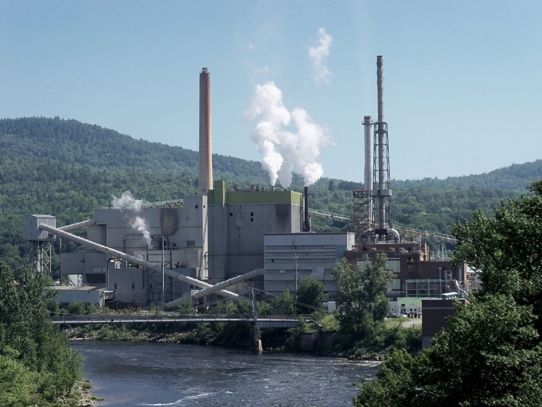
If the Water Salvage proposal was not enough to raise public awareness about the river and bosque, there was a second initiative from a private firm which further solidified the public’s resolve to protect these unique features. In the Summer of 1969, Parsons and Whittimore Corporation proposed construction of a paper mill along the River utilizing small diameter trees from surrounding mountains and water from the River. The proposal drew initial support from some economic, boosters who touted the jobs it would produce and potential gain to the local economy. It also drew vehement opposition from environmental groups including the newly formed Citizens for Clean Air and Water led by Peter Montague, a UNM Professor. The group researched the P & W company and found that they habitually developed their mills in third world countries where opposition could more easily be controlled, and local officials co-opted. Did they, opponents asked, see New Mexico in the same light? The company also had a record of polluting air and water in the vicinity of their mills and shirking responsibility for the consequences. The campaign was followed by local newspapers, and when the Company’s proposal was rebuffed in Albuquerque, they appealed to Pueblos along the river only to be turned down again. After abandoning the proposal one Parsons and Whittimore executive was quoted as saying “And so we leave the Land of Disenchantment.” More importantly, economic boosters were put on notice that the public was decidedly disenchanted with dirty industry.

Birth of a Movement

In the late 1960s local and national environmental awareness was on the rise. A new paradigm was gaining momentum. No longer was progress to be defined strictly by economic return, and previously accepted economically derived terms like “Highest and Best Use” and “Non-Beneficial” were being questioned. Environment, aesthetics, recreation, and public health were increasingly seen as valid considerations for policy decisions. The West was entering a Post-Pioneer era, and Albuquerque would become a national leader in this transition. Citizens shifted from being reactive to becoming proactive and the stage was set for the next chapter in the open space story.

What I Learned:

“Thesis, Antithesis, Synthesis Triad”. This concept, developed by German philosophers including Hagel, explains much about how political change happens. Applied to the above events, the Thesis was the Pioneer Paradigm demonstrated by the single-focus economically driven development of the Rio Grande. The Antithesis was the push-back of environmental groups to stop the Water Salvage Project and paper mill. The Synthesis was the Rio Grande Valley State Park Plan which proposed co-existence between nature preservation and recreation and flood control, irrigation, and drainage. In the end, the synthesis won out and we can see the benefits.

