Chapter 1: Early Roots and Historic Foundations of
Albuquerque’s Open Space Program
by Matt Schmader

The average Albuquerquean man, woman or child, is in need of a place within walking distance of the city where he can enjoy a breath of fresh air and a sight of a few trees, a few birds, and a little water. – Aldo Leopold, 1917

Building on Albuquerque’s physical and cultural settings, several other factors have combined to set the stage for the unique qualities of the Open Space system as it developed over the decades. Our background starts with puebloan and indigenous land ethics, which did not have a concept of land “ownership.” All lands were intended to be used equally and sustainably and could not conceivably be owned. Later, land grants, the notion of a “commons,” and urban planning all combined in ways distinctive to our city. Layered onto that base were the lives and actions of some remarkable people who saw beyond present expediencies to a clear vision for our future, with outcomes that shaped our community for generations.

Land Grants and the Idea of the Commons

The 1600s were tumultuous and troublous times throughout New Mexico. The first attempt at a true colony, started by Juan de Oñate north of Santa Fe in 1598, did not last even a dozen years due to droughts, mismanagement, and discontent. The colonial governor Pedro de Peralta was ordered to establish a royal villa as a new capital for the colony, which he did at Santa Fe de San Francisco de Asis in 1610. Missionization by the Franciscans throughout the mid-1600s resulted in much displacement of native population and related strife. Unrelenting droughts, constant intercultural fighting, and severe population losses finally culminated in the Pueblo Revolts of 1680-1696. The first years following the Revolt saw regained possession of lands and revitalized religion by indigenous groups, a status quo that could not be sustained. The Spanish crown succeeded in retaking the Nuevo Mexico territory and employed different mechanisms to maintain control. Among the most important of these means were land grants. At first, the focus was in granting lands to veterans of the military reconquest of the colony (for example, the original grant to Capitan Diego de Montoya in 1694 north of Albuquerque, which later became the Elena Gallegos grant).

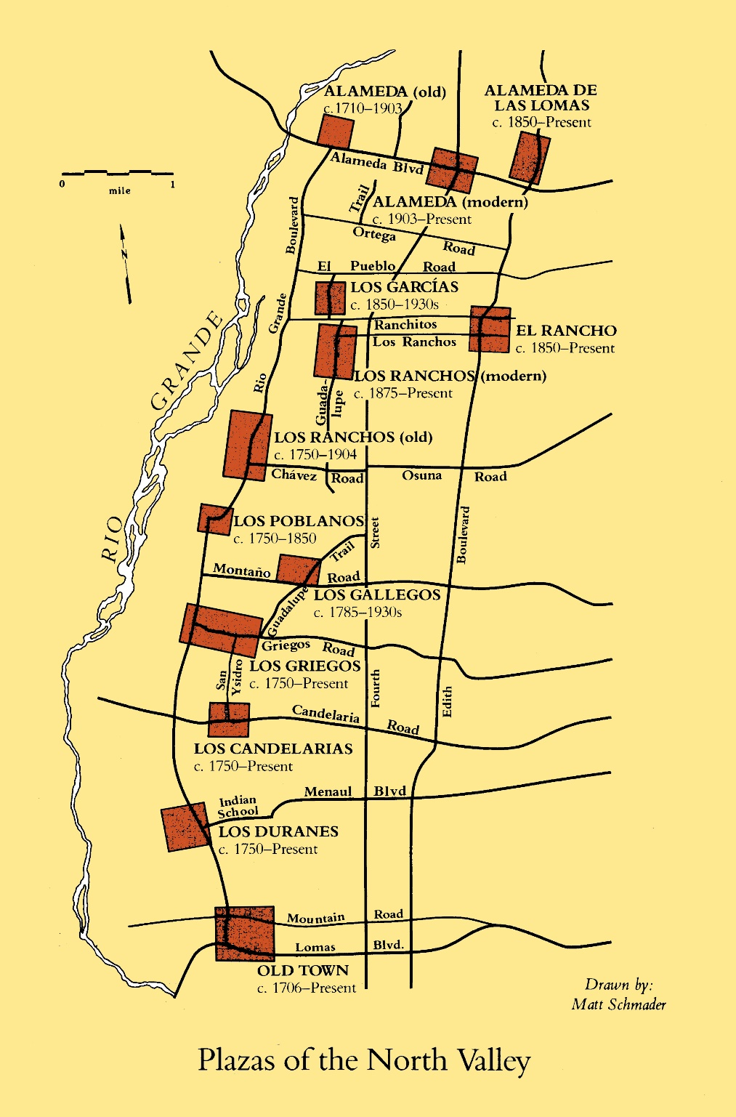
The royal villa of San Felipe Neri de Alburquerque was established in 1706 at what is now Old Town. More land grants followed, with emphasis on resettling areas surrounding the villa. Other lands were assembled into rancherías, hence the name “Los Ranchos” north of Albuquerque. No fewer than seven land grants still have remnants in the Albuquerque area: Elena Gallegos, Alameda, Atrisco, Pajarito, Los Padillas, San Pedro, and San Miguel de Carnue. Portions of all these grants are still preserved in some part of the Open Space system. Two Pueblo grants border the city—Sandia to the north and Isleta to the south. Numerous traditional communities, often associated with family names, formed around plazas and ranchos up and down the North and South Valleys (such as Los Poblanos, Los Montoyas, Los Griegos, Los Candelarias, Los Duranes).

All community land grants share a basic ingredient, which is the notion of a commons. Grants were carefully laid out to have access to waters for domestic use and irrigation, to farmlands, to grazing lands, to timberlands, and to hunting areas. Members of the grant were able to use and share these vital resources for the sustenance of the community. Thus the grant commons were needed for the lives of its people, and resources were shared by all but owned by no individuals in particular. Centuries-old institutions of the commons, ingrained in community land grants, are part of New Mexico’s deeper history and help form the basis of what we appreciate in our Open Space lands today. That is, they are lands shared for the benefit of all and not appropriated by any individual, members of a particular socioeconomic status, or narrowly-defined special interest group.

Urban planning also adds to this idea of the commons. The growth of European urban areas led to elements such as central gathering places like plazas, public parks, linear connections, trailways, and common spaces. These urban planning concepts made their way to the American colonies in planned cities like Boston, New York, Philadelphia, and Washington DC. In the western United States, urban centers developed later but had more abundant land resources with which to provide common areas. As a result, open space design was more readily incorporated on a large scale in the west and cities willing to embrace that concept now show the outcome (such as Denver, Boulder, Portland, San Francisco, and Phoenix). Albuquerque was fortunate to have been one of the cities where open space elements were introduced early in its urban growth. Three individuals exemplify this vision by their drive, ability, and resolve to shape the future of our city.

Three Visionaries – 1. Aldo Leopold

Aldo Leopold was arguably one of the most progressive thinkers ever in the field of conservation biology. His writings on land ethics, game management, and the wilderness movement are only equalled by his meticulous attention to data collection, observation, explanation, and keen awareness of the many parts that combine to make a whole ecosystem. His writings are so beautiful that they are admired and oft-quoted many decades later. His nearly legendary status as a world leader in his field, well before conservation biology emerged as a science, is rooted in his formative years and partly because he died at the relatively young age of 61. Aldo Leopold was born on January 11, 1887 in the small city of Burlington, Iowa. Burlington is located on the west bank of the Mississippi and his grandfather was responsible for building a lake at the town’s park, a fact that will be revisited later.

Albuquerque is fortunate to have played a role in Aldo Leopold’s early professional career. He started out as a young forester at the Carson National Forest in northern New Mexico in 1911 and married Estella Bergere in 1912. They moved to Albuquerque and raised their young family in a house at 14th Street and Gold, west of the country club area. From 1917 to 1919 Leopold served as secretary of the Albuquerque Chamber of Commerce, a position that enabled him to promote several ideas—the most important of which was the idea of a park along the banks of the Rio Grande. A speech given to the Game Protection Association on January 11, 1917 (his 30th birthday) was also attended by Dennis Chavez, the future beloved New Mexico senator. In that speech Leopold said, “Make a city park from Barelas to Old Town. Not a park out of cut lawns and flower beds, but a park of natural trees, grass and water—a place where the average citizen can take his Sunday walk, or go fishing, or take his family for a picnic.”

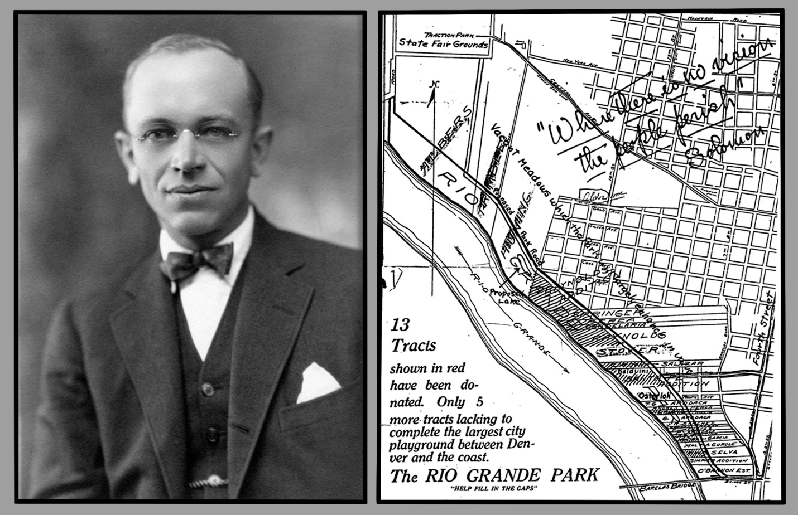
Aldo Leopold circa 1910, at the beginning of his time in New Mexico. Right, Leopold’s map boosting the idea of a Rio Grande Park 65 years ahead of its time. Note the “proposed lake” along the east bank of the river, in the left-center of the map.

Even at this early stage, Aldo Leopold had already set a goal to create something wonderful for the residents of Albuquerque. He kept at it tirelessly for two years and nearly achieved his goal. A map he made declared “only five more tracts lacking to complete the largest city playground” between Denver and Los Angeles. The map also had a proposed park road paralleling the river and a “proposed lake” at the west end of Iron Street next to the Rio Grande (a throwback to his grandfather’s lake in Burlington’s riverside park). The last five tracts, though, were owned by wealthy landholders who refused to donate any land for the project. The park idea stalled as it neared possible completion. He was, as it turns out, 65 years ahead of his time but his vision would ultimately come to pass. Eventually the land he did obtain was used as the site of the young Albuquerque zoo. But Aldo Leopold had other places to go.

By 1920 he had moved on to regional offices at the Forest Service and promptly proposed a much grander scheme, that of setting aside hundreds of thousands of acres in the Gila forest. From this idea came the first wilderness area in United States history, cementing Leopold’s legacy as the father of the wilderness movement in America.

2. Clyde Tingley
Clyde Tingley and Carrie Wooster never intended to make Albuquerque their home. On their way from Ohio to Arizona in 1910 to treat Carrie’s tuberculosis, she suffered a health emergency and the couple was forced to stop in Albuquerque. The care she received was excellent and they decided to go no further. Both would have major impacts on their new-found home.
Clyde promptly got involved in local politics, getting elected as city alderman in 1916, and starting a political career that would span over the next 40 years. Elected to the city commission in 1922, he went on to serve two terms as governor of New Mexico from 1934 to 1938 before returned to the city commission. He was the chairman of the commission, the unofficial mayor, from 1940 until 1953. Clyde Tingley died on Christmas eve 1960 at the age of 79. Carrie Tingley took her health experiences and worked on ensuring children and people of need had access to the best care available. Her work, together with Clyde’s influence, succeeded in creating Carrie Tingley Hospital, its associated children’s hospital, and a financial support foundation that thrives today.
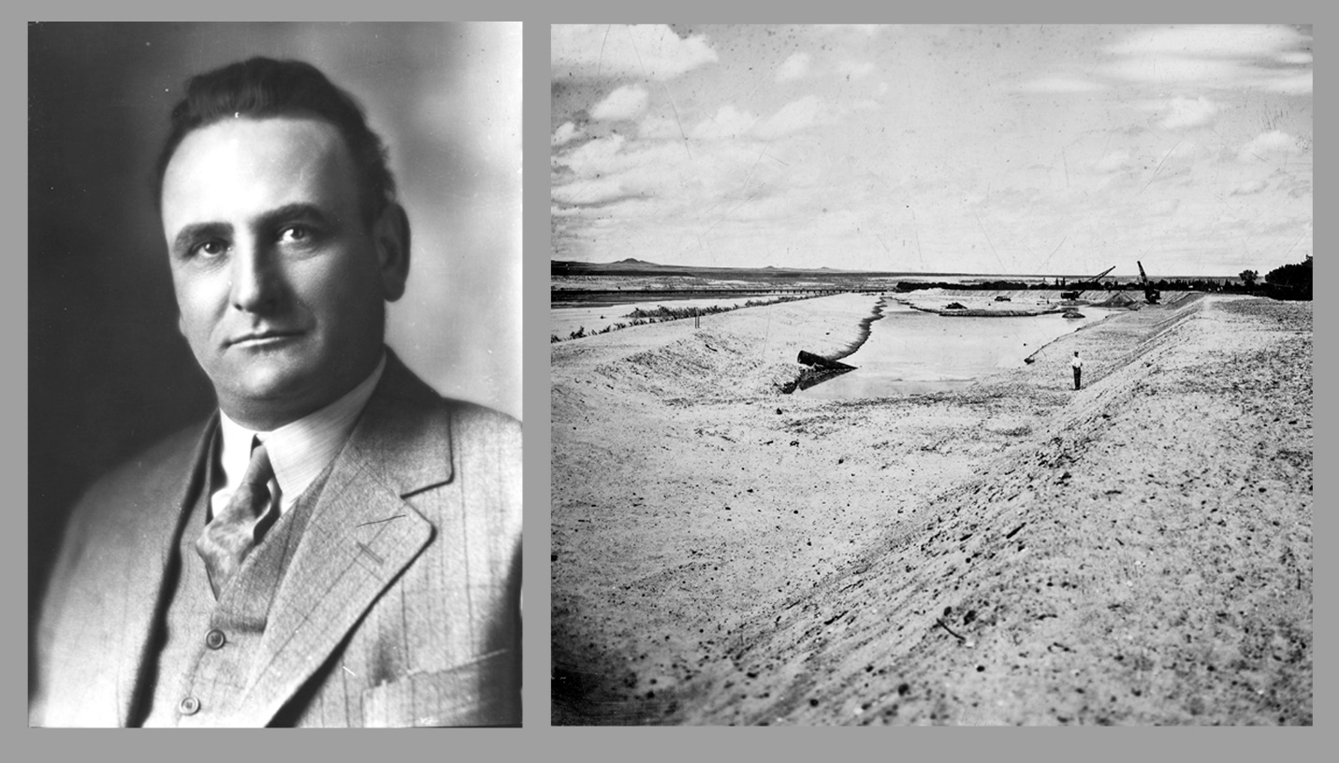
Clyde Tingley circa 1925, soon after becoming city commissioner. Tingley’s direct plea to the newly-formed Middle Rio Grande Conservancy District led to the dredging of a lake along the river, as Aldo Leopold had first suggested. Right, cranes excavating Conservancy Beach in the summer of 1931.

Among Clyde Tingley’s lasting contributions was his role in building on Aldo Leopold’s river park concept. Although documented proof of the two directly working together has yet to be found, they certainly moved in the same circles of influence. Leopold was secretary of the Chamber of Commerce at the precise time when Tingley was first elected alderman. Leopold was constantly giving speeches about his park idea in 1917 and 1918. After Leopold moved and as Tingley neared the end of his several terms on city commission in the late 1920s, Clyde Tingley got involved in a major project. He endorsed the idea of excavating an old city landfill along the east bank of river to create a lake, and taking the dredgings to make a park road. He cajoled the chief engineer of the newly-formed Middle Rio Grande Conservancy District, Fred Burkholder, to volunteer the men and machinery to do the excavation in the summer of 1931. The project put many out-of-work men on the job in the early years of the Great Depression, and the lake was finished in time for a Christmas ribbon-cutting at the end of 1931. At first called Conservancy Beach, the role of the flamboyant Tingley, who often held boat races and beauty pageants at the lake, ensured it would always be known as “Tingley Beach” (along with the park road being called “Tingley Drive”). Tingley Beach proved to be the city’s most popular recreation gathering spot until polio scares closed it as a public swimming pool in the early 1950s.

3. Bob Burgan
During the 1940s and especially as Albuquerque experienced post-World War II growth, a number of new larger parks and community centers were built. Many of these improvements were also built under Tingley’s leadership and as a result of federal funds that Tingley was able to secure. By the late 1940s there were enough parks, community centers, and swimming pools to warrant establishing a new Parks and Recreation Department. Irene Teakell was named the Parks director in 1948. The second parks department director was a young and capable Midwesterner named Bob Burgan. Burgan took the job in 1954 at the age of just 36.
Albuquerque did not have a mayoral form of governance in the 1950s; rather, it had a city manager and elected a chairman of its commission. The city manager at the time was Ed Engel, and he worked closely with Bob Burgan on a concept to plan well ahead of the city’s future growth. By the late 1950s and certainly into the early 1960s, the Bureau of Land Management (BLM) was actively disposing of what it considered to be “surplus” federal lands throughout the west. Land was made available to local governments through a program called the Recreation and Public Purposes Act (R&PP), which had been on the books since the mid-1920s.
With the BLM more actively disposing of surplus lands, Engel and Burgan decided to apply for tracts in and around the greater metropolitan area. Their idea was simple: Albuquerque would one day be a huge metropolis and large tracts of land in outlying areas would offer relief from the city and opportunities to experience the great outdoors. The application process was relatively easy and inexpensive as well—typical costs to a local government ran about $2.50 an acre to obtain what seemed to be a perpetual lease or patent. All that was needed was a little cash and a plan to show why the land would continue to serve a public purpose. Engel and Burgan were so enthusiastic abut this new initiative that they had to go to Congress to have a provision changed—a 640 acre per year limit—just so Albuquerque could apply for more land.

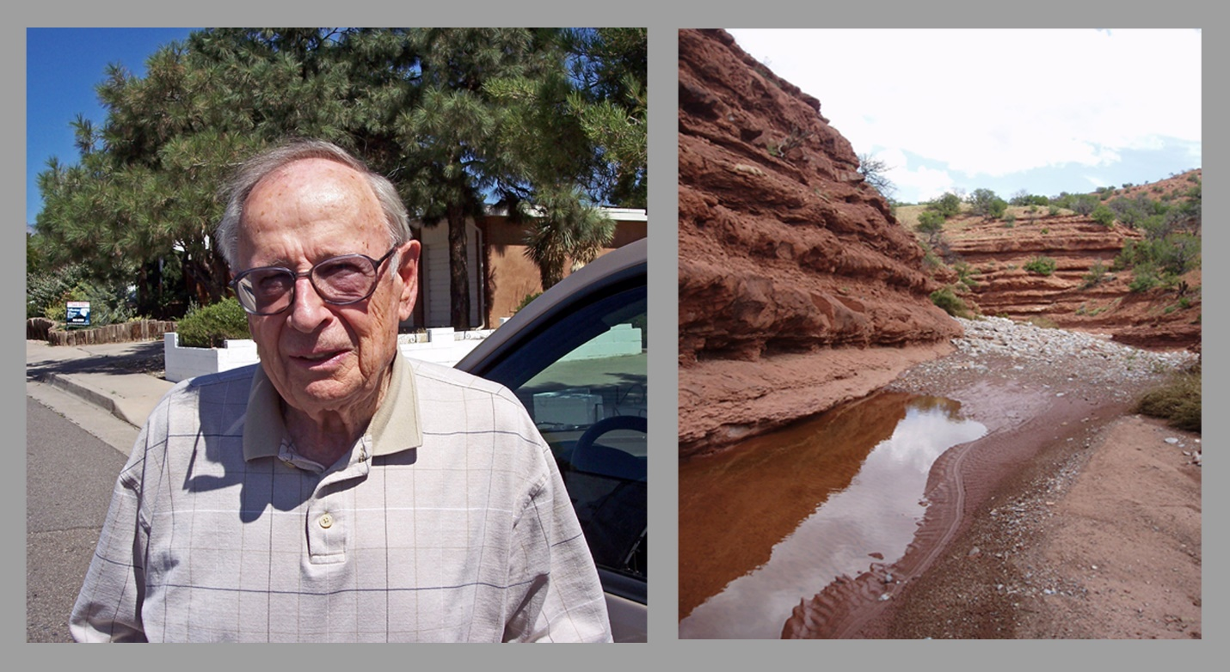
Bob Burgan, second director of the Parks and Recreation Department from 1954 until 1979. Photo taken September 2007 the day before he moved from Albuquerque to Utah. Right, Golden open space, one of the Recreation and Public Purposes Act properties Burgan helped to secure in the late 1960s.

At the time, Albuquerque did not even have a definition for what would be called “open space.” Large tracts of natural land intended to be used for low-impact recreation, such as hiking or biking, were called regional parks at the time. By whatever name, though, starting in the early 1960s and running through the 1970s, Burgan in particular was able to apply for and receive dozens of land patents from the BLM. His vision for these regional parks eventually formed the solid basis for our Open Space system today. By the late 1970s, over 8,500 acres of R&PP lands had been acquired under patent rom the federal government. These places include the Shooting Range and Grasslands Preserve, La Boca Negra park, Four Hills Park, Carolino Canyon, Gutierrez Canyon, San Antonito, and even Golden and Placitas open space preserves in Sandoval County. The question sometimes comes up as to why a city like Albuquerque would own and manage lands in another county. The answer lies in Engel and Burgan’s vision to create a greater commons for all citizens of the metropolitan area, with no limits being drawn artificially at a city boundary. When asked why Albuquerque should be the entity to take on this project, Burgan succinctly responded, “Nobody else can do the job.” His words are still true today, 50 years later.
Bob Burgan served an almost unbelievable term of office at the helm of the Parks and Recreation Department. He was director for a full quarter century, from 1954 until 1979, before handing over the reins to Orlando “Orlie” Sedillo. His focus was by no means limited to the nascent open space idea, although he is arguably the real father of the Open Space program. He helped to develop many parks and golf courses. An avid golfer, his obituary stated his “proudest accomplishments were the Los Altos, Arroyo del Oso, Puerto del Sol and Ladera golf courses, director of the Albuquerque Zoo and many tennis complexes, community centers, swimming pools, ball fields and parks.” Bob Burgan died in 2014, two days short of his 96th birthday, an unsung and not well-known but true father of the open space concept.

What I Learned:
“We Stood on the Shoulders of Giants”
All movements of any consequence do not happen without the vision of forward-thinking leaders, energetic actors, and concerted effort. Selflessness and community-minded spirit are hallmarks of causes with lasting benefit for the people. Albuquerque was shaped by its cultural background, which grew out of indigenous shared land tenure systems, later land grants, and cultural diversity. Three true giants—Aldo Leopold, Clyde Tingley, and Bob Burgan—shaped the future of our city for generations to come. Their actions would not be the end, but rather just set the stage for many other environmental heroes and unselfish individuals to step forward and create the Open Space saga. These combined actions make us who we are today.

Further Reading
Albuquerque: A Narrative History (1982) by Marc Simmons. University of New Mexico Press, Albuquerque.
Aldo Leopold: His Life and Work (2010) by Curt Meine. The University of Wisconsin Press, Madison.
Albuquerque’s Parks and Open Space (2011) by Matt Schmader. Images of America series, Arcadia Press, Charleston SC.
Aldo Leopold: Albuquerque’s first environmental planner (2010) by William M. Fleming and Matthew F. Schmader. Western Planner 31(7): 10-12.

