Candelaria Nature Preserve 2021 Plan
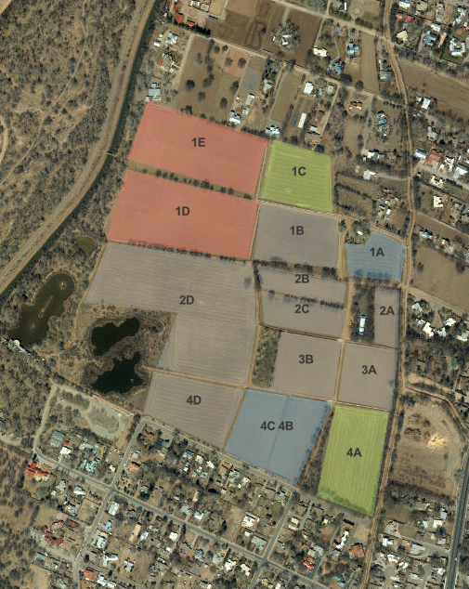
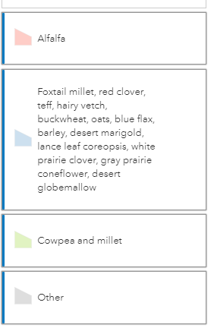
- Interactive Map
Field Conditions

Field Name | Field Work Occurring | Crop
1D 1E | Irrigation | Alfalfa
1C | Seed drill. Irrigation to establish. | Target condition is damp soil grassland. Cow Peas and Millet
1A | Strip till or disk. Irrigation. | Target condition is pollinator meadow. Foxtail millet, barley, red clover, teff, hairy vetch, buckwheat, oats, blue flax, plains coreopsis, lance leaf coreopsis, white prairie clover, gray prairie coneflower, desert globemallow. (Seed mix is available for this field but no soil prep has occurred. We are monitoring the response to irrigation. Johnsongrass, bindweed, Siberian elm all are present. Actions to suppress one problem can encourage another.)
1B | Undisturbed for soil recovery, weed control | Target condition is salt shrubland habitat.
2B 2C | Undisturbed for soil recovery, weed control | Target condition is sandbar habitat.
2D | Wetland construction | Target condition is salt shrubland habitat.
4D | Wetland construction | Target condition is salt shrubland habitat.
3A | Undisturbed for soil recovery, weed control | Target condition is salt shrubland habitat.
3B | Undisturbed for soil recovery, weed control | Target condition is blue grama habitat.
2A | Undisturbed for soil recovery, weed control | Target condition is arroyo margin habitat.
3C | Undisturbed for soil recovery, weed control | Target condition is arroyo margin habitat.
4C | Chisel plow, disk 8" to level, seed drill. Irrigation to establish. | Target condition is wildlife forage. Foxtail millet, barley, red clover, teff, hairy vetch, buckwheat, oats, blue flax, plains coreopsis, lance leaf coreopsis, white prairie clover, gray prairie coneflower, desert globemallow.
4B | Chisel plow, disk 8" to level, seed drill. Irrigation to establish. | Target condition is wildlife forage. Foxtail millet, barley, red clover, teff, hairy vetch, buckwheat, oats, blue flax, plains coreopsis, lance leaf coreopsis, white prairie clover, gray prairie coneflower, desert globemallow
4A | Seed Drill. Irrigation to establish | Target condition is wildlife forage. Cow Peas and millet
1B | Undisturbed for soil recovery, weed control | Target condition is salt shrubland habitat.
Undisturbed Soil Descriptor: Fields that are undisturbed are allowing the land to recover, increase biodiversity, maximize water storage, and minimize erosion. This practice is often utilized during drought years when there is insufficient irrigation available. These fields will be mowed to control weeds and prevent them from going to seed or spreading. Mowed material is left on the soil as a green waste mulch weed control

Narrative Statement
Candelaria Nature Preserve is being cared for using practices that are known to enhance benefits to wildlife and enhance ecological value. These practices can include the tools of agriculture. The current activities are part of a phased approach to convert these historic fields into valuable and vibrant patches of wildlife habitat. Current activities include planting for wildlife, irrigation, ecological monitoring, and public and youth engagement.
Special attention was made to select a diverse seed mix for the wildlife farming fields. The seed mix, planted in early June 2021, includes both traditional agricultural grain crops for the benefit of migratory birds and annual and perennial native wildflowers to support pollinators. These wildlife crop fields are receiving regular irrigation to ensure establishment.
Use of this diverse mix will promote greater variability in bloom, seed set, and tolerance to limited irrigation availability throughout this season. Standing crop will be given a chance to set seed and may then be strategically mowed to shatter seed and provide forage throughout the winter migratory bird season.
Perennial species will respond earlier in the next season to available winter precipitation and spring irrigation, when available. Subsequent planting in fields will be implemented through no-till seeding methods with minimal to no soil disturbance.
Despite irrigation water and frequency at a record minimum this season, other fields in the northwest of Candelaria Nature Preserve are being irrigated. Established alfalfa will rebound with verdant growth through the remainder of the summertime and provide minimal but necessary large-field habitat for migratory birds into the fall and winter of 2021/2022.
Planning for the remainder of fields dedicated to specific habitat types will be ongoing through the 2021 season with more specific details available in the fall. Managing some fields as undisturbed during the 2021 season will restore the dryland soil moisture regime of these native habitats, reduce invasive species spread and persistence, and provide conditions suitable for planting out native species in future seasons. Restoration activities in the near-term will focus on selection and purchase of available native plant materials, propagation of rare or hard-to-find species, and installation of woody debris as habitat focus areas. The Candelaria Nature Preserve is on its way toward offering greater ecological value to both wildlife and human visitors!
Thank you,
- CSWCD 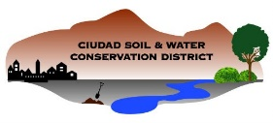and Rio Grande Return
Crop Description and Function

Crop/Species | Growth form | Ecological Function | Wildlife benefit | Notes:
Foxtail millet | Grain, medium to tall | Drought tolerant, fast growing annual | Migratory bird forage, insect and arthropod habitat | Agricultural grain – Late summer planted for fall maturation and seed production
Red clover | Small, bunching groundcover | N – fixation, soil stabilization, infiltration and perennial cover | Pollinator forage and habitat | Perennial with medium life span in cultivated fields
Teff | Grain, medium | Drought tolerant, fast growing annual | Migratory bird forage, insect and arthropod habitat | Agricultural grain – Late summer planted for fall maturation and seed production
Hairy vetch | Low, deep-rooted | N – fixation, soil stabilization, infiltration and perennial cover | Pollinator forage and habitat | Agricultural cover crop and
Buckwheat | Low, groundcover | Drought tolerant, fast growing annual | Migratory bird forage, insect and arthropod habitat | Reseeding annual with nutritious seeds
Oats | Grain, medium | Annual, biomass and mulch at end of season | Migratory bird forage, insect and arthropod habitat, nesting material | Agricultural grain – Late summer planted for fall maturation and seed production
Blue flax | Low growing native forb | Drought tolerant, fast growing perennial cover | Pollinator forage and habitat | Low cost, plentiful native seed
Crop/Species | Growth form | Ecological Function | Wildlife benefit | Notes:
Barley | Grain, medium to tall | Drought tolerant, fast growing annual | Migratory bird forage, insect and arthropod habitat, nesting material | Agricultural grain – Late summer planted for fall maturation and seed production
Desert marigold | Low growing native forb | Drought tolerant, fast growing perennial cover | Pollinator forage and habitat | Low cost, plentiful native seed
Lance leaf coreopsis | medium growing native forb | Fast growing perennial cover | Pollinator forage and habitat | Low cost, plentiful native seed
White prairie clover | Medium growing native forb | Drought tolerant, fast growing perennial cover | Pollinator forage and habitat | Low cost, plentiful native seed
Grey prairie coneflower | medium growing native forb | Drought tolerant, fast growing perennial cover | Pollinator forage and habitat | Low cost, plentiful native seed
Desert globemallow | medium growing native forb | Drought tolerant, fast growing perennial cover | Pollinator forage and habitat | Low cost, plentiful native seed
Blue gramma | Native short bunchgrass | Drought tolerant, fast growing perennial cover | Granivore forage | Low cost, plentiful native seed
2021 seed mix is selected based on availability, seasonal timing, irrigation availability and existing exotic species weed pressure. Selected mix will promote biodiversity through above and below-ground variation in growth forms, flowering and seed set, along with introduction of perennial and annual native species for pollinator forage diversity. Perennial species will benefit from reduced tillage and reseeding in subsequent seasons with no-till methods – leading to greater diversity of habitat overall.

