Ways to Safely Enjoy and Protect
the Rio Grande in Albuquerque

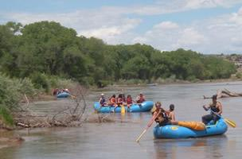

Prepared by the City of Albuquerque

Mayor Richard J. Berry

Parks and Recreation Department
Barbara Baca, Director

Open Space Division
Matthew Schmader, Superintendent

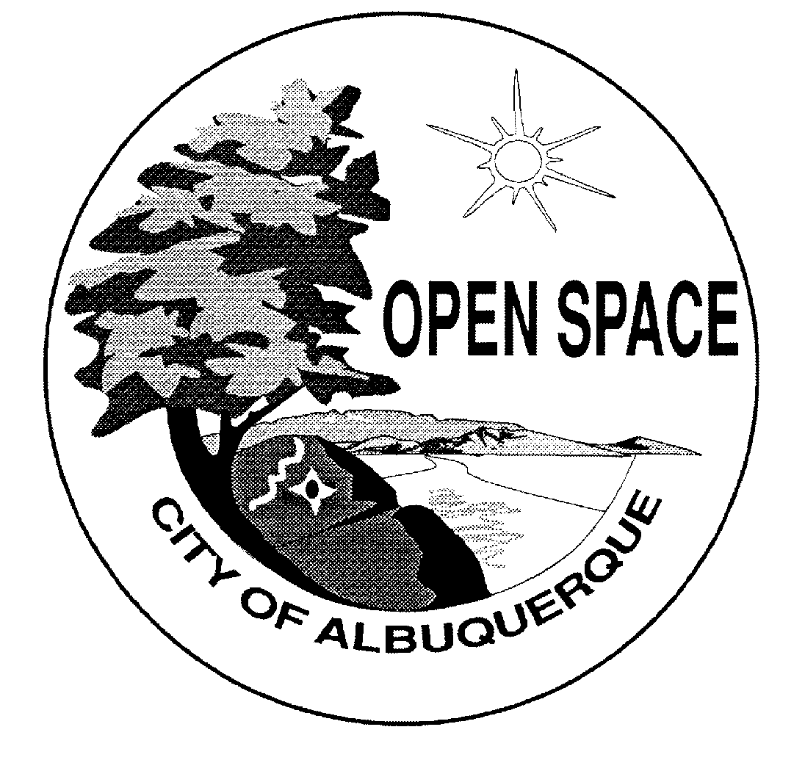
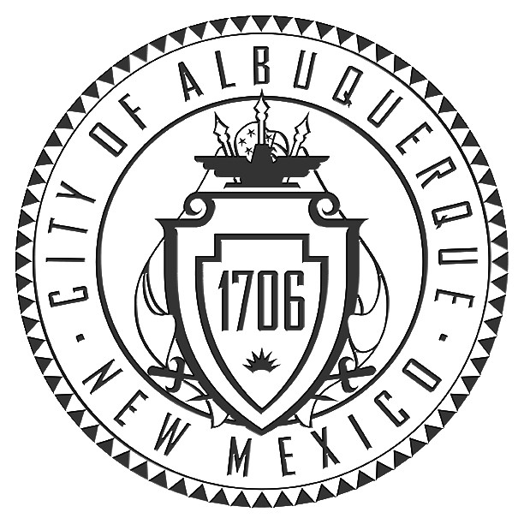

Did You Know?

- The Rio Grande in the Albuquerque area offers unparalleled opportunities to see wildlife such as Bald Eagles and Great Blue Herons, escape the urban environment, and enjoy water-based outdoor recreation with your family.
- With the proper equipment and preparation a float down the Rio Grande in a kayak, raft, or canoe is a safe and fun way for the entire family to enjoy one of our City’s most precious natural resources.
- The Albuquerque stretch of the Rio Grande generally offers calm water and no technical rapids, making this an ideal area to learn the sport of paddle craft boating.

Boating Safely in the Albuquerque Area

- Follow all New Mexico Boating Safety Regulations: Boating safety is the key to enjoying your time on the water. It is legal to float down the Rio Grande in kayaks, canoes, rafts and other non-motorized water craft. Home-made craft do not qualify as legal water craft. Boaters must follow all New Mexico State Parks boating regulations. New Mexico law mandates the wearing of a PFD/Life Jacket at all times while aboard a canoe, kayak or rubber raft. Please see the New Mexico State Parks boating website (link to: http://www.emnrd.state.nm.us/PRD/BOATINGWeb/boatingmainpagewaters.htm) for information on regulations for boaters and for more information about boating the Rio Grande.

- Check the Water and Weather Conditions: High flows during the spring runoff provide some of the best times to float the river. However, take the time to evaluate your skills before venturing out at times of extremely high or low flows. Please see the Resources Section for information on how to find out about the current water level.
Always be aware of high winds and cold temperatures when planning your trip. Sustained winds of 25 MPH or more can create difficult challenging conditions for boaters. Dress in layers, bring plenty of water, and use sun protection. Before your trip, don’t forget to inform someone of where you are going and when you plan to be back in case of an emergency. And never combine alcohol with boating.

Where Can I Launch and Take Out my Boat in Albuquerque?

In and around Albuquerque there are several places where you can access the river for boat launch and take out. Most river bridges in the Albuquerque area provide access, with some walking required from the parking areas. A canoe or kayak cart can help make it easier to transport your water craft in these cases.

Please see www.cabq.gov/openspace or call (505) 452-5200 for details on launch sites in the Albuquerque area.

Outside of Albuquerque, the west side of the Alameda Bridge is a popular place to launch. Call the Village of Corrales at (505) 897-0502 for information on launching from the west side of the Alameda Bridge. Please note that the San Juan Diversion Dam just south of the Alameda Bridge can create a hazard requiring a portage.

Ways to Enjoy the Rio in 2012

Now that you’re ready for your adventure, we suggest the following ways to get out on the Rio Grande this year.
1. Enjoy a Safe and Leisurely Float on the River
While limited conditions for boating are available in the summer and fall because of low water in the river, high water levels during the spring runoff season (roughly March through early June) provide ideal conditions to float the river. See the Resources Section on what you need to know before your trip.
2. River and Bosque Related Tours and Classes

The City of Albuquerque Parks and Recreation Department and other local organizations offer many opportunities to enjoy the river and its cottonwood river forest year round! Here is just a sample:

- The Open Space Visitor Center (OSVC) has interpretive displays about the Rio Grande and hiking trails that lead to scenic views of the river. Also, the Visitor Center offer a monthly tour of the bosque the first Sunday of each month called “Bosque Wild.” Space is limited, and reservations are recommended one month in advance. Call the Open Space Visitor Center at 897-8831 or see www.cabq.gov/openspace for more information. The Open Space Visitor Center is located at 6500 Coors Blvd. NW. The OSVC is open Tuesday through Sunday, 9:00 AM – 5:00 PM and is closed on Mondays.

- The Open Space Summer Series starts on Memorial Day weekend and includes Sunday Hikes. The Sunday Hikes are guided tours of various Major Public Open Space properties. Tours of the bosque and river related presentations are planned for 2012. Please call 452-5222 or see www.cabq.gov/openspace for a full Summer Series calendar. Planned Summer Series tours around the Rio Grande include: Bosque Bird Walks and a Bosque History River Walk.

- The River Boating Safety Presentation, part of the Summer Series, is scheduled for the weekend of June 2nd. This event requires pre-registration. See www.cabq.gov/openspace or call 452-5222 or more information.

- The City of Albuquerque Parks and Recreation Department contracts with New Mexico Kayak Instruction to offer kayaking clinics, available through the Los Altos Pool. Please see the Aquatics Division website (link to: www.cabq.gov/aquatics) for more information or call (505) 768-5342.

- The Rio Grande Nature Center State Park offers year round activities that get citizens up close and personal with Rio Grande Valley State Park wildlife including birds, bats, fish, geese, cranes, and other critters. See the Nature Center events calendar (link to: http://www.rgnc.org/activities.htm) or call (505) 344-7240 for complete information.

- Fishing in the Albuquerque area is available year round. Fishing is popular at the stocked ponds at Tingley Beach (link to: http://www.cabq.gov/biopark/tingley/), and is allowed in the Albuquerque Riverside Drains, which are stocked by the New Mexico Department of Game and Fish. (Link to: http://www.wildlife.state.nm.us/). The Rio Bravo Bridge on the northeast side has a scenic wheelchair accessible fishing pier next to the drain and plenty of parking. The Rio Grande in Albuquerque is also available for fishing. Call the New Mexico Department of Game and Fish at (505) 222-4700 for complete details of fishing in and around Albuquerque.

- Bernalillo County Open Space provides access to the Rio Grande and Bosque at several of its properties including the Durand Open Space and the Valle del Bosque Open Space. The newly developed Bachechi Open Space has an educational building which hosts year round programs. See bernco.gov/openspace or call (505) 314-0400 for more information.

- Active military personnel with base access can contact the Outdoor Adventure Programmer at the Kirtland Air Force Base Outdoor Recreation Office at (505) 846-3923 to arrange float trips. Please see www.kirtlandforcesupport.com for details.

3. Día del Río 2012

Día del Río is an annual community celebration of the Rio Grande that takes place in October at a different location each year. This year the event will take place on October 20th from 8:30am-1:00pm. The event location will be announced soon, so stay tuned! Event activities are suitable for all ages and include trail work, trash pickup, and educational tables from area organizations working to protect the Rio Grande and bosque. Other ways you participate in Dia del Rio include:

- Clean your favorite area of the bosque. Organize your own bosque cleanup the day of the event! Open Space will provide trash bags and haul off the collected trash. Call 452-5200 or email kswanson@cabq.gov to sign up your group for your own cleanup.

- Clean trash from your own boat. You can use your canoe, kayak or raft to help clean trash out of the river during Dia del Rio. You must provide your own transportation and shuttle for your boat. The Open Space Division will provide you with trash bags and will pick up the trash. If you bring your boat, you must follow New Mexico State Parks boating regulations. Boaters wishing to organize a cleanup must register with the Open Space Division. Call 452-5200 or see www.cabq.gov/openspace for more information.

4. Sponsor an Open Space River Cleanup Event!

The Open Space Division has proudly partnered with the following organizations to help protect the Rio Grande and to promote responsible recreation on the river during National River Cleanup and Dia del Rio. Please call 452-5200 or see www.cabq.gov/openspace for more information on ways your organization or business can sponsor a river cleanup or other volunteer event. Recent sponsors include:

- Recreational Equipment Incorporated (REI). www.rei.com/albuquerque
- Quiet Waters Paddling Adventures (QWPA). www.quietwaterspaddling.com
- Kirtland Outdoor Recreation. www.kirtland.af.mil
- The Rotary Club of Albuquerque. www.rotaryabq.org
- The West Central Alliance of Neighbors (WeCAN!)
- The Open Space Alliance. www.openspacealliance.org
- General Mills. www.generalmills.com
- Weston Corporation
- Stone Age Climbing Gym
- The Kickstand
- I Scream Ice Cream
- Nicodemus Wilderness Project
- 2 Wheel Drive
5. Resources

River Water Levels and Weather Conditions:

- Three USGA gauges in the Albuquerque Reach are updated with real-time water level data every fifteen minutes. (Link to: http://waterdata.usgs.gov/nwis/sw)
08329918 RIO GRANDE AT ALAMEDA BRIDGE AT ALAMEDA, NM
08329928 RIO GRANDE NR ALAMEDA, NM
08330000 RIO GRANDE AT ALBUQUERQUE, NM

- Detailed information on local weather conditions can be found on the National Weather Service website, www.weather.gov.

- The National Weather Service Tabular Forecast page provides hour by hour forecasts for weather and wind conditions here: http://forecast.weather.gov/MapClick.php?lat=35.11720&lon=-106.62500&unit=0&lg=english&FcstType=digital

- The following USGS gauge provides current water temperature just below Cochiti Dam:

http://waterdata.usgs.gov/nm/nwis/uv?cb_00010=on&cb_00060=on&cb_00065=on&format=gif_default&period=7&site_no=08317400

Boating Safety Resources:

New Mexico law mandates the wearing of a PFD/Life Jacket at all times while aboard a canoe, kayak or rubber raft. Also required per New Mexico Law while on the river in any canoe, kayak or raft:

- Proper fitting life jacket for each person on board
- One throwable safety device for each vessel
- 0n a self bailing boat a throw line is acceptable
- Bow Painter (stout line) the length of the boat
- Spare paddle
- Bailing bucket one gallon in size or hand operated bilge pump
- Whistle or horn
- No alcohol!

Please see the New Mexico State Parks boating website (link to: http://www.emnrd.state.nm.us/PRD/BOATINGWeb/boatingmainpagewaters.htm) for information on full regulations for boaters and for more information about boating the Rio Grande in the Albuquerque area.

See the New Mexico online boating safety handbook (link to http://www.boat-ed.com/nm/handbook/pfds.htm) for additional boating safety tips.

Other Local Resources/Organizations:

Below is a partial list of other organizations working to promote stewardship of the Rio Grande and responsible recreation on the river.

- Mid Rio Grande Stormwater Quality Team, www.keeptheriogrand.org

- The County of Bernalillo, www.bernco.gov/

- The Army Corps of Engineers, www.spa.usace.army.mil

- The Middle Rio Grande Conservancy District, www.mrgcd.com

- The Bosque Ecosystem Monitoring Program, www.bosqueschool.org/BEMP.aspx

- The New Mexico Outdoor Sports Guide, http://www.nmosg.com/Kayak/

- The Adobe White Water Club, www.adobeww.com

- Greater Albuquerque / Santa Fe Kayak club. http://www.meetup.com/Albuquerque-Santa-Fe-kayak-meetup/

###

