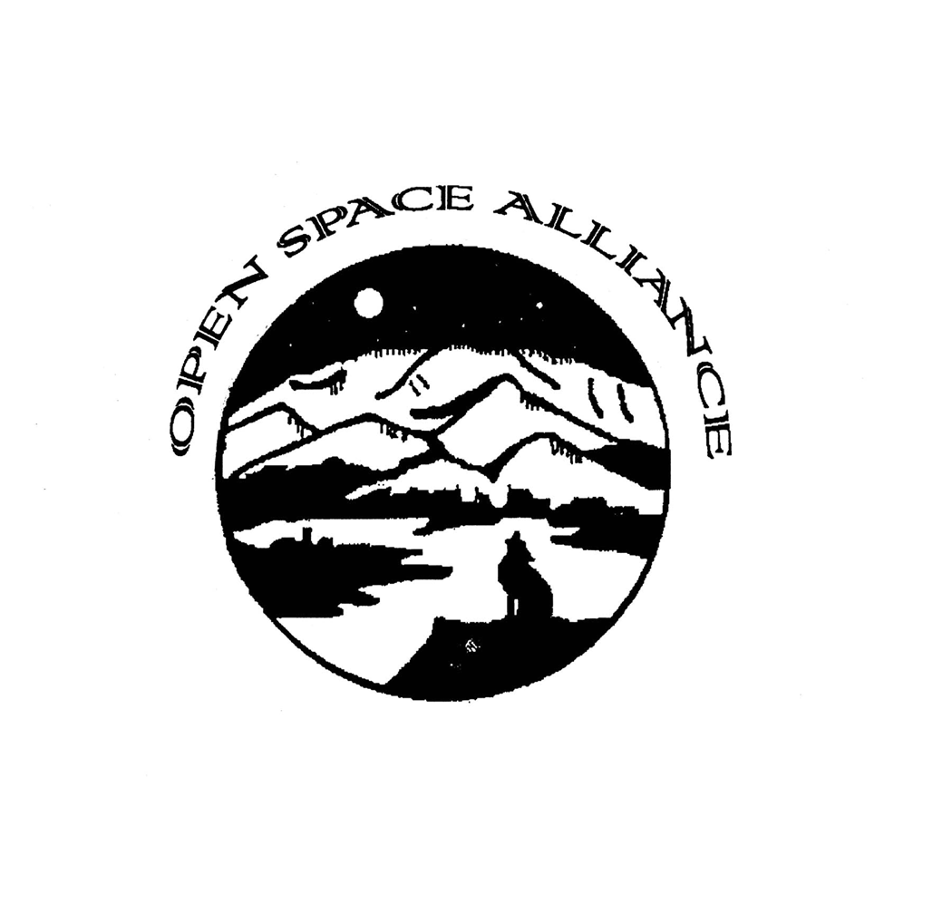

GET INTO OPEN SPACE
Transportation and Fieldtrip Grant Application
Sponsored by the Open Space Alliance, REI and the City of Albuquerque Open Space Division

INSTRUCTIONS
- Grant application review will be on an ongoing basis beginning September 1, and until the funding is exhausted.
- Each school in the Albuquerque, Rio Rancho and Corrales school districts are eligible for one (1) bus per grade level.
- All recipients of the Get into Open Space transportation and fieldtrip grant will receive a letter of instruction to prepare for the fieldtrip.
- Return the completed application to:
City of Albuquerque
Open Space Division
PO Box 1293
Albuquerque, NM 87103
ATTN: Get into Open Space

Fax: 505.897.0572

Email: jhedderig@cabq.gov

APPLICATION
- Date of Application:

- Name of school or organization:

- Location of school or organization:

- Coordinating person for group:
Name:
Title:
Address:
Phone: Fax:
Email:

- Please select which Open Space activity you wish to participate in order of preference using numbers. Note that Tree Planting is competitive and there are a limited number of projects available:

⁯Tour* ⁯Tree Planting ⁯Trash Clean Up ⁯Trail Maintenance (limit 25 people)

*Tour includes a REI PEAK program which promotes stewardship of outdoor areas

- If you are requesting a tour, select which location you wish to attend.

⁯Open Space Visitor Center ⁯Elena Gallegos Picnic Area ⁯Bosque ⁯Los Poblanos Fields ⁯Petroglyph National Monument

- Provide potential dates and times for your fieldtrip. Please provide as many dates as you can project in order of preference. Depending on the activity you wish to do and the time of year, competition can be heavy.

- Limiting 45 people per bus, how many students will be included in the field trip? Please include grade level(s) and any other demographic information you wish to share.

- How many chaperones will attend?

- State why you wish to visit Open Space and the specific student educational needs that this field trip will address (complete on a separate sheet of paper if needed).

- Explain how you will prepare students for the field trip (complete on a separate sheet of paper if needed).

- How will you evaluate the post-field trip student experience (complete on a separate sheet of paper if needed)

_______________________________________________ Date_____________________
Signature of Contact

________________________________________________ Date_____________________
Signature of School or Organization Administrative Official

