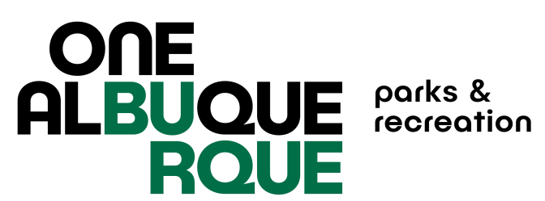

City of Albuquerque Parks and Recreation
2024 SPRING Softball
Registration Check List

Note: Each item listed below must be completed in order for your team to participate: Teams who do not turn in the required paperwork will not receive a schedule and will have to forfeit games. Paperwork must be turned in to the office – no email, fax or other electronic paperwork accepted.

REGISTRATION FEES ARE NON-REFUNDABLE ONCE REGISTRATION CLOSES

- Complete and turn in TEAM REGISTRATION FORM to the
Jerry Cline Recreation and Tennis Center by February 16, 2024 5:30pm.

- Pay the $495.00 TEAM FEE at the Jerry Cline Tennis Center
at the time you turn in your team registration form. Forms of payment accepted are: cash, check, credit card.

Pay the $50.00 USSSA sanction fee at http://www.rctipif.org. Please go through this website ONLY as all other website registrations are not valid for the City of Albuquerque. This fee is required once per year and covers spring, summer, fall seasons.

- Turn in a completed team roster with all signatures and ID numbers
filled in, USSSA waiver of liability form, Code of Conduct Form signed by individual participants, and proof of purchase of USSSA Sanction Fee for 2024 by March 1, 2024 to the Jerry Cline Recreation and Tennis Center. All players must sign a new USSSA waiver and CABQ Code of Conduct each season.

Managers must attend the rules and conduct meeting at Jerry Cline on February 27 or 28, 2024 at 6:00PM.

