ALBUQUERQUE CITY WOMEN’S GOLF CHAMPIONSHIP
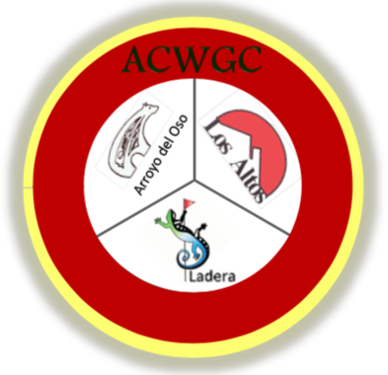
2021 Entry Form
October 12-14, 2021

CONTACT INFORMATION

Name: ____________________________________________________________________________________

Street Address: ____________________________________ City, State, ZIP: ___________________________

E-mail Address: ____________________________________________ Phone: _________________________

GHIN: __________________________ Home Course: _____________________________________________

ENTRY FEE INFORMATION

FIRST ENTRY FEE CATEGORY OPTION: Three-Day Tournament Fee (circle one, if applicable):
- Regular Adult Green Fee: $140

- Senior Green Fee (55+): $125

- Junior Green Fee (17 and under): $110

- City of Albuquerque Municipal Golf Course Annual Pass Holder or Lifetime Pass Holder: $85
Annual Pass Number (found on the back of the card): ______________________

OR SECOND ENTRY FEE CATEGORY OPTION: Senior Two-Day Tournament Fee (circle one, if applicable):
Separate Senior and Super Senior Flights are dependent on participant numbers

- Senior (70+), Tuesday, Oct. 12 and Thursday, Oct. 14, 36-holes: $110

- Super Senior (75+), Tuesday, Oct. 12 and Thursday, Oct. 14, 36-holes: $110

- City of Albuquerque Municipal Golf Course Annual Pass Holder or Lifetime Pass Holder: $85
Annual Pass Number (found on the back of the card): ________________________

*** *** *** *** *** *** *** *** *** *** ***
Entry fee includes green fees, tee gift, awards and luncheon

Carts are not required and are not included in the entry fee. Cart fee and range balls may be paid for separately at the respective golf course(s) on the day of play.

MAIL THIS FULL ENTRY FORM AND CHECK (Payable to LAWGA)
NOTE: Checks must be submitted with the entry form no later than September 24, 2021:
LAWGA – ACWGC
c/o Kathleen Rael
6327 Cliffbrush Ln NE
Albuquerque, NM 87111

