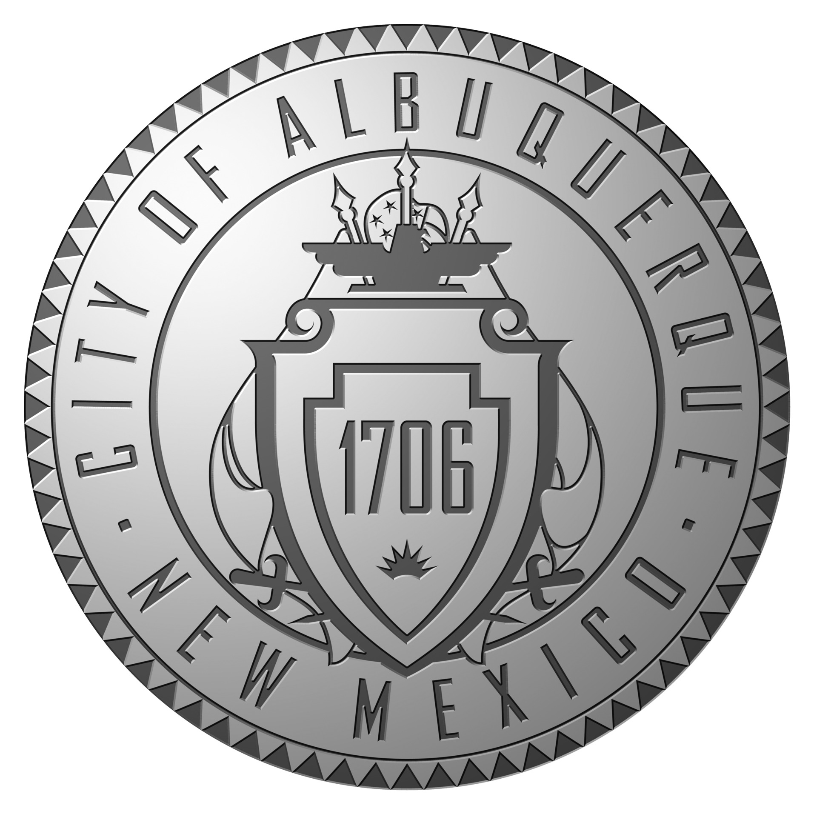
Veterans and Military Affairs Advisory Board

New Mexico Veterans’ Memorial
January 15, 2014
Minutes

- Meeting Called to Order by Chairman Roger Newall at 9:05 am
  - Present: Chairman Roger Newall, Vice Chairman Archie Garcia, , Brian Leen, Ken O’Keefe, Steve Overman, Louis Tafoya, Steve Asher
  - Absent: Elise Wheeler, Pat Gaston
  - Pending Members: Diallo Dphrepaulezz, Caroline LeBlanc, Mandy Dykman
- Approval of Minutes from December 18, 2013 Meeting
  - The December minutes were accepted with a correction to the date of Veterans Day at the Round House from Feb 4th to Feb 17th.
- Public Comments – No Public Participation
- Old Business
  - Albuquerque Employee Coins
    - No new information to update
  - Hiring Preference
    - Working on fixing GEOGOV Web application to restore information that was on the prior application format that didn’t get transferred to GEOGOV.
  - Membership
    - Welcomed 3 new Pending Members, Diallo Dphrepaulezz, Caroline LeBlanc, Mandy Dykman, along with Gary Zura all positions are filled.
  - Projects
    - No new projects were introduced
    - There was continued discussion on providing transportation for veterans to the VA Medical Center
      - Current Proposal was passed out to the members
    - The proposal will only recognize the VA Card as the possible bus pass
    - Awaiting review from Transit Department
  - Legislation
    - Talked about Legislative Agenda
      - State Veteran Cemetery Program – put Veteran Cemeteries in small outlining communities.
      - Service Member Child Custody Protection – prevent loss of custody or rights while service member is deployed on military orders
  - Military Retiree Person Income Tax Exemption – Same concept different approach – Tax Credit of 5% or $2500 on Retiree’s Military Income. Same as maximum exemption for income of $50,000.
  - Update Future Events
    - Military Day at the Round House – date Feb 17th – Veterans Council will provide Free bus transportation to event – must sign-up in advance
- New Business
  - Discussed have meeting with local Veteran Org. Leadership and also Active, Reserve and Guard leadership. Looked into have one big meeting not 1 per group.
  - Discussed a Fisher House for VA Hospital and Albq. Based Honor Flight.
- Setting of Future Meetings
- Next meeting is scheduled for Wednesday, February 19, 2014 at 9:00 am at the NM Veterans’ Memorial
- Adjourn – 10:30 am

