Edgesoft Application Process
- Log in, expand Apply for a Permit, click New Permit Wizard, and then click Open Map for Selection.
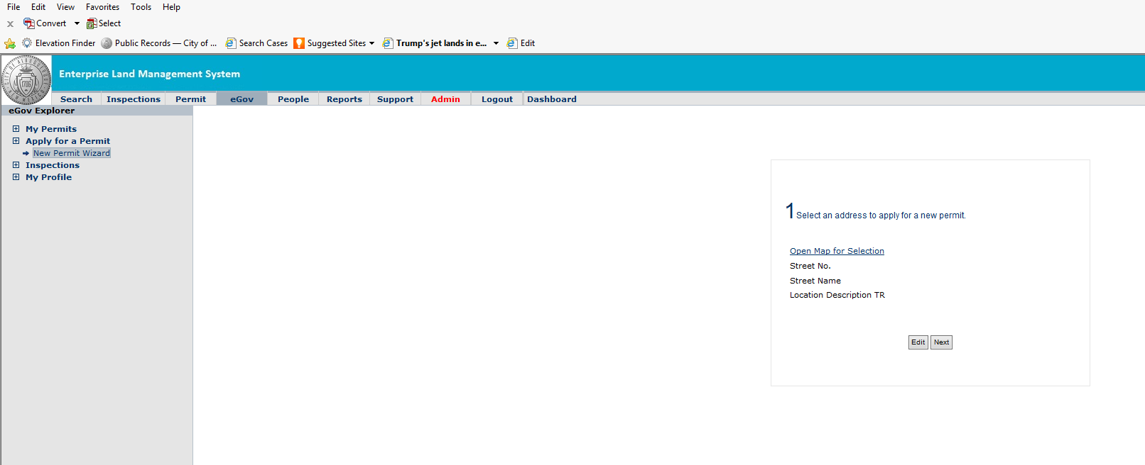

- Type in the address or intersection at the top and click search. Click draw a polyline at the top left of the page. Draw a line showing the section of roadway which will be impacted by your work zone (one mouse click to start the line, two mouse clicks to complete the line). After your line is drawn, click Select From Street at the left side of the page, place your mouse over the nearest cross-street (blue line) and click on it to auto populate this field. Then click Select To Street to auto populate the next cross-street. This describes your general location in addition to the site address which is also auto populated. You can change these fields by clicking Edit in the next screen.
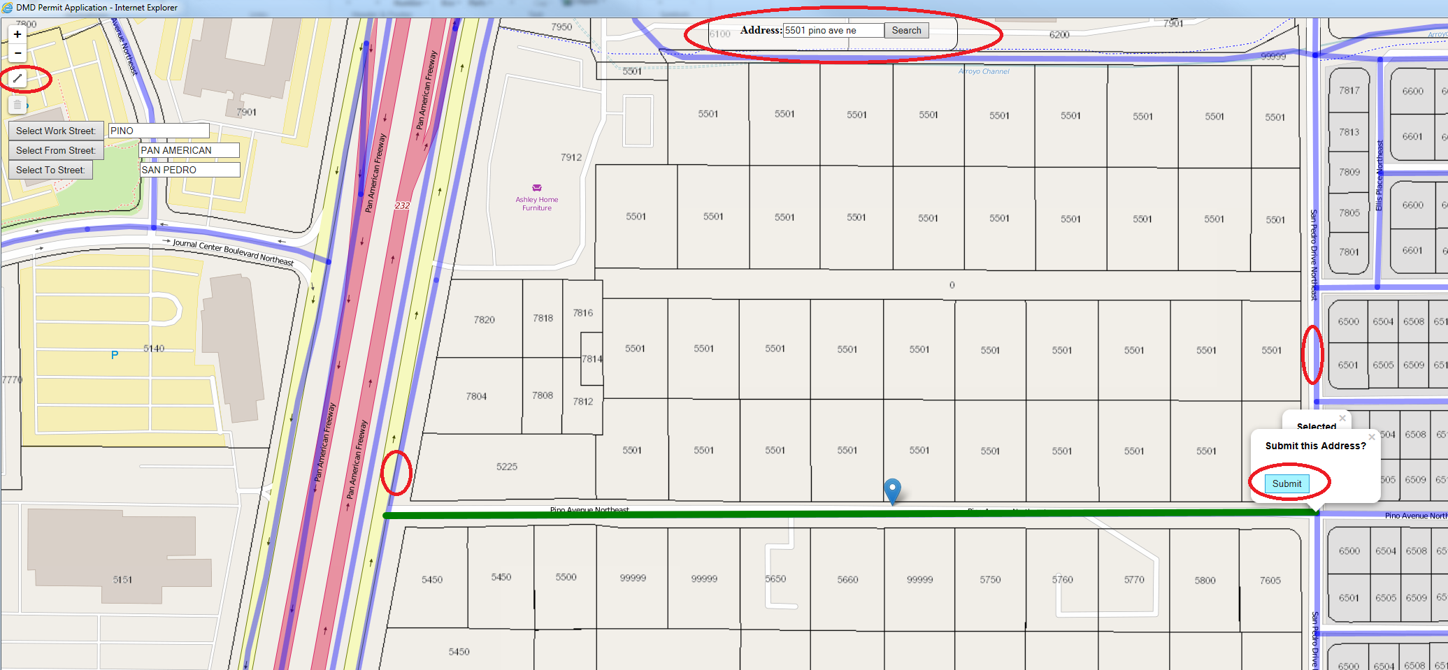

- Ensure the street number, name, and location description is correct. If not, click Edit and modify the necessary fields. Click Next if the information is correct or after you are done making your edits.
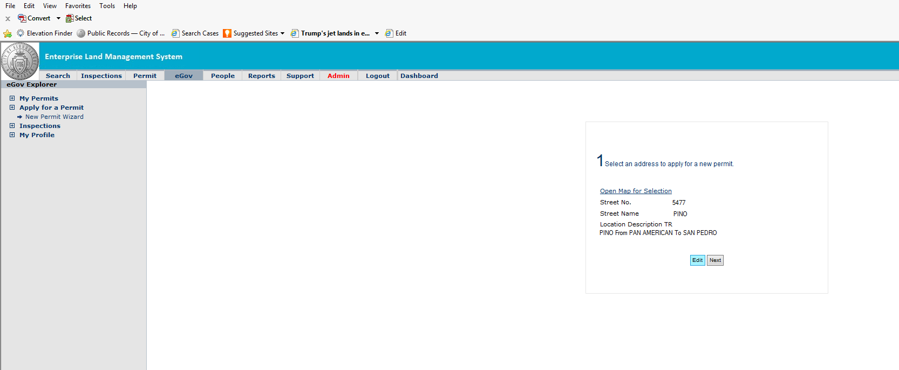

- Always choose Excavation as the activity type from the drop down on the next screen.
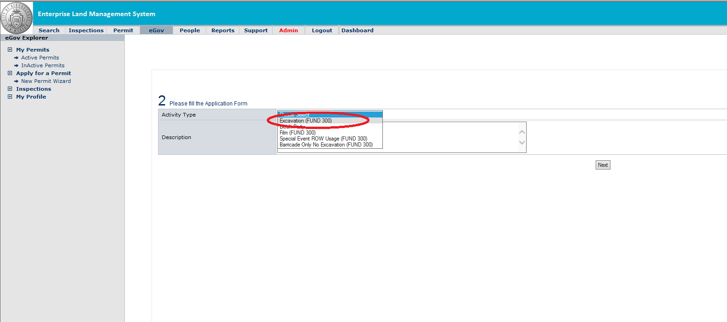

- Populate as many fields as possible in the screen shot below. Description should be short and to the point (i.e. repair water line leak). The start and end date should reflect the actual estimated construction duration. Do not type a generic duration such as 30 days because you will be charged for that duration of time. Applicant comments should include additional details needed for us to further understand the scope of work or type of closure being requested (ex.: Utility cut, remove and replace existing drive pad and two sidewalk stones). Always populate the Work Area Linear Footage field. This is the length of your work zone. Check each box which applies to the closure. If you are cutting into the roadway pavement section, populate the cut length and cut width fields. A bluestake number is not required (type NA). The Maximo Number field is for the ABCWUA only.
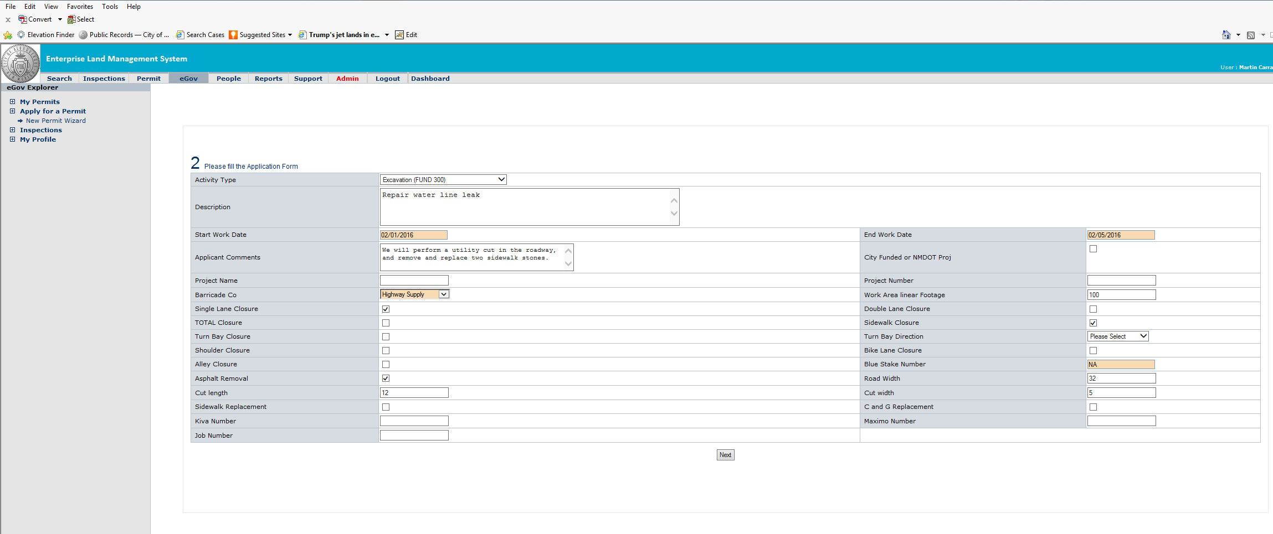

- Choose the appropriate Applicant, Contractor, Facility Owner, and Barricade Company (Other) from the drop downs shown below. If your name or company is not in the drop down, you must contact our office at 505-924-3400 and we will put you in our database. We will ensure the contractor is properly licensed, bonded, and insured for the type of work being permitted. The facility owner for sidewalks and drive pads is Property owner. Read and check off the certification boxes and click Next to proceed.
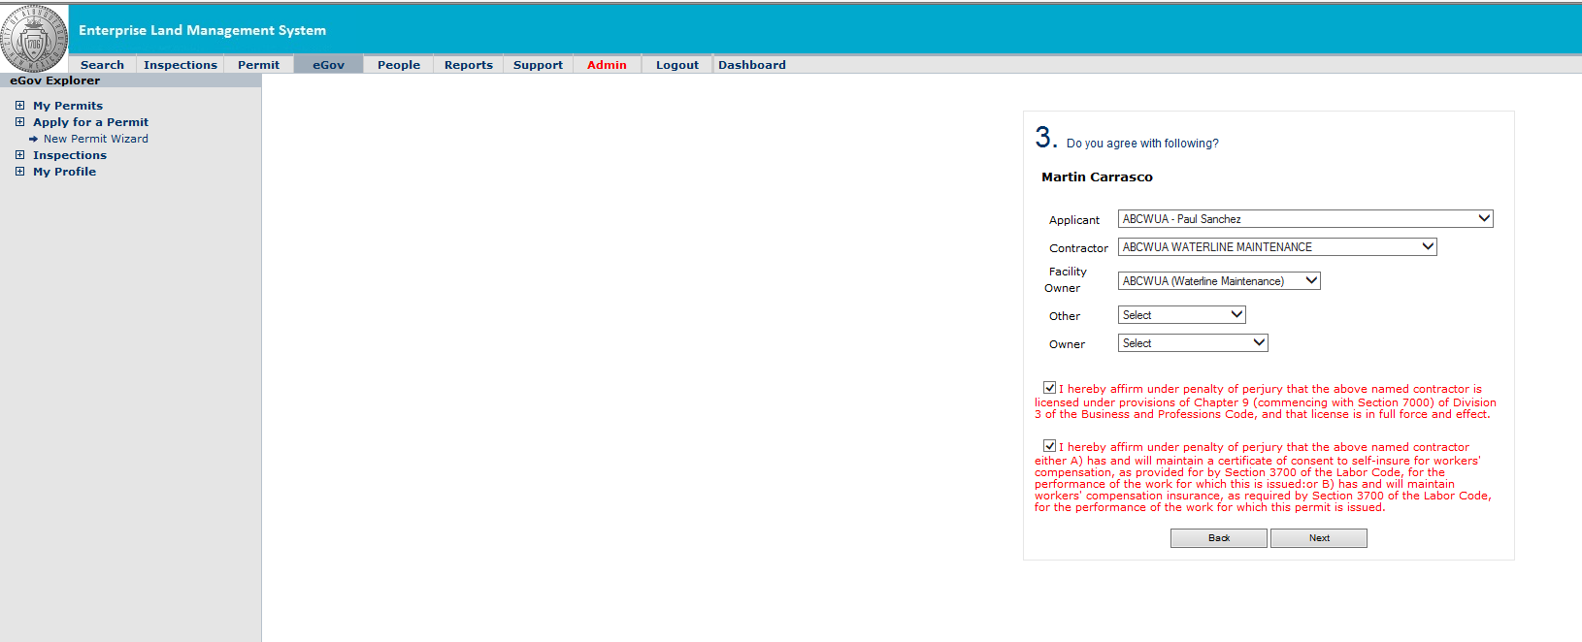

- This step allows applicants to estimate their fees. Please note the Plan Review Engineers fees may differ from your own personal estimate. Visit our website for our more information on fees. Click Next to proceed.
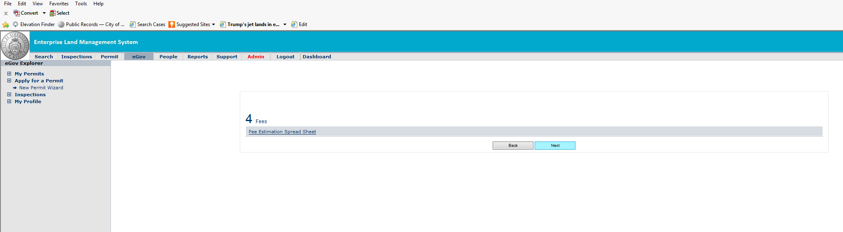

- Attach any necessary documentation (such as a Traffic Control Plan or city approved/stamped driveway curb cut) by clicking Add. When you are done, click Continue to proceed. Your application process is now complete. You will receive an email with a permit status within five (5) business days. We will contact you if we have any questions. You can pay for your permits online at payments.cabq.gov, through your Edgesoft account under My Permits, or on the first (1st) floor of Plaza Del Sol at the treasury counter. Please feel free to contact our office at 505-924-3400 between 8:00 am and 5:00 pm, Monday through Friday.
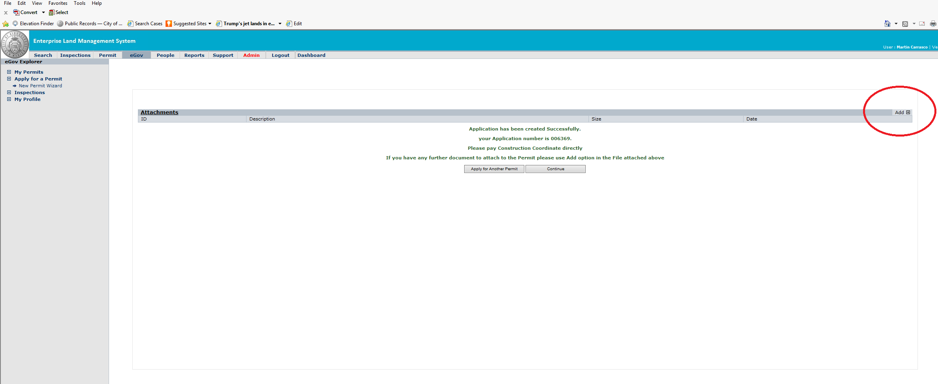
NOTE: If you experience issues with Edgesoft and are unable to apply for a permit; fill out a hard copy of the Excavation/Barricade permit application and email it along with any necessary documentation to dmdccs@cabq.gov. We will process your permit for you. The application may be found on our website (see below) under Right-of-Way Activities & Permits.
https://www.cabq.gov/municipaldevelopment/architects-engineers-contractors/construction-services

Request for Inspection
- Applicants must request an excavation inspection prior to paving. You can request an inspection by logging into your Edgesoft account, and choosing the appropriate permit under My Permits. To schedule an inspection Click on Schedule Inspection at the top right of the screen.
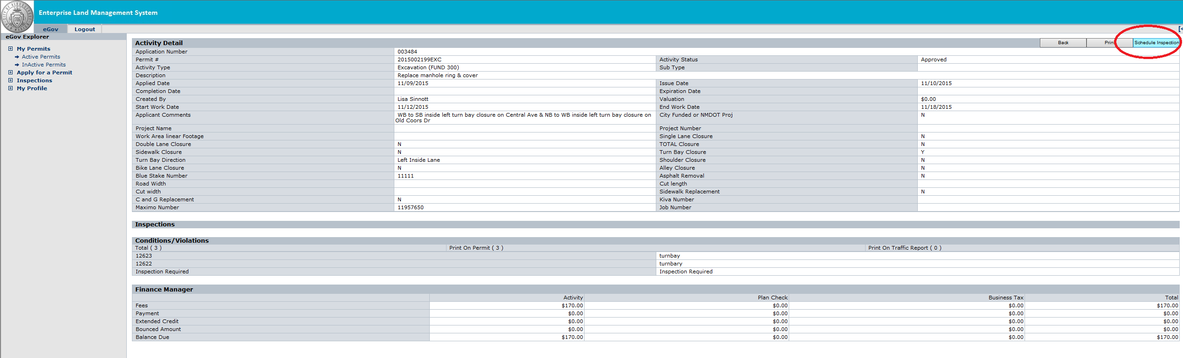

- Fill out the appropriate information on the Inspection Request screen and click on Schedule Inspection Request when complete.
NOTE: If you experience issues with Edgesoft and are unable to schedule an inspection; call the inspection hotline at 505-924-3416 and leave a voicemail stating the permit number and address which is ready for an inspection.

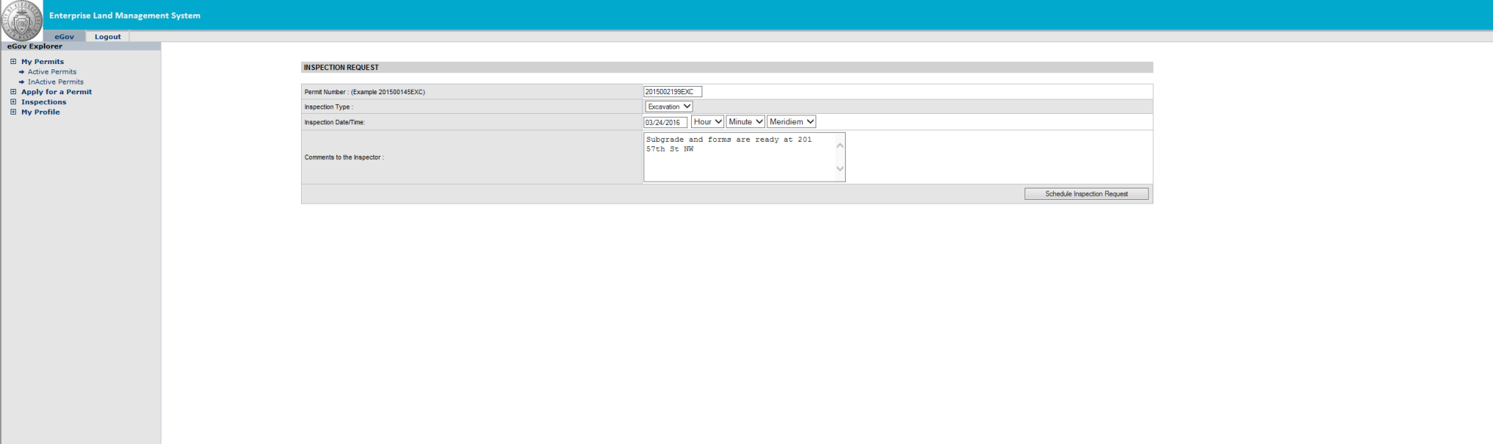

Thank You!

