Mental Health Response Advisory Committee (MHRAC)
Meeting Minutes
March 15, 2022
Via Zoom

Board Members in Attendance
Maxwell Kauffman Disability Rights New Mexico
Rachel Biggs ABQ. Health Care for the Homeless
Betty Whiton NAMI
David Ley New Mexico Solutions
Coty Maxwell APD Crisis Intervention Division
Gilbert Ramirez CABQ-Dept. of Family & Comm. Services
Laura Nguyen Albuquerque Ambulance
Matt Dietzel APD Crisis Intervention Division
Paula Burton NAMI Peer Representative
Rob Nelson APD/CIU/C.O.A.S.T
Nil Rosenbaum, MD APD Behavioral Health Division
Emily Jaramillo Albuquerque Fire Department
Robert Salazar NAMI Peer Representative

Introduction to MHRAC
The Mental Health Response Advisory Committee (MHRAC) was created by the Court Approved Settlement Agreement (CASA). We’ve been around since day one and have a focus on three areas, resources, resources being available to access different things within the city that APD and first responders can use as it impacts homelessness and mental health issues. We are also involved in training and policy; training is one of those things we made a tremendous impact on. As far as the training that is offered. Policies are one of those things where the MHRAC is involved with assisting in writing and approving and recommending policy as it relates again to the narrow focus; we think narrow, but sometimes it gets pretty wide focused on how law enforcement interacts with those experiencing homelessness and those experiencing a mental health crisis.

Roll Call, Rachel Biggs
Twelve Board Members were present (names listed above)

Welcome first-time guests
Briget Ledger
New APD CIU COAST employee

Rasma Cox
Used to attend the MHRAC meetings but haven’t in about five years.

Elizabeth Holguin
New Deputy Director, Homeless Solutions and Clinical Advisor, Family and Community Services, City of Albuquerque

Michael Trimm
Executive Director, Services and Administration for the Transgender Resource Center of New Mexico

Carlos Pacheco
Legal Department, City of Albuquerque

Elaine Maestas
Community Safety Services (ACS), CORA Responder

Nicole Smith (Introduced herself on chat)
Nurse Educator of New Mexico

Approval of meeting minutes
1st Motion –
2nd Motion –
Minutes for the February meeting were approved. No motion was offered. Minutes were approved by Rachel Biggs.

Public Comment (Two minutes per person)
Betty Whiton, NAMI Representative
Printed cards for police officers and the CIU to hand out to families of the person who is in a mental health crisis. One side of the card gives ideas for those who are in a mental health crisis; Dr. Rosenbaum who deals with people that have mental health issues helped write the card. On the other side, it has NAMI resources.

Chat
Q. Are the NAMI Card also in Spanish?

Betty
A. No, but that is a great idea, I will see if I can find somebody to translate them.

Gilbert
I am happy to reach out to someone within FCS and see if we can’t get someone to translate them. The turn-a-round might be a little while.

Mariela
ACS has someone in-house that can help and they could be done by the end of the week.

12:28 Nomination of new board members, if any, Rachel/Max
For a short time, this will be a standing item on the agenda. We are trying to populate the MHRAC; we have had some people that are coming off the committee. Max and I have been doing some outreach to some other clinical providers, behavioral health, and peers.
We’re going to nominate two (2) people tonight. Detective Cassandra Bailey who was representing the CIU for the last three or four years has asked to step down and the CIU would like to nominate Detective Cody Maxwell.

Cody Maxwell
I worked for the Mobile Crisis Team (MCT) for about two years and I am currently assigned to the Crisis Intervention Unit

Rachel
Hearing no concerns, we approve the nomination for Detective Cody Maxwell
Rachel
We have one more nomination tonight, Deputy Chief Emily Jaramillo. Emily has been attending MHRAC meetings very consistently for four years and we want to codify that relationship and bring representation from AFR. I think it’ll be a really important move forward for the committee.

DC Emily Jaramillo
I'm really excited to participate; I have been attending for four (4) years. We haven't had a representative for AFR EMS so we're hoping we can help bring our perspective.

Rachel
Hearing no concerns, we approve the nomination for Deputy Chief Emily Jaramillo

Rachel
If anyone has someone they would like Rachel and Max to talk to regarding having an interest and being able to bring something to the MHRAC, let them know. This kinda ties into our ordinance sub-committee recommendation. As we bring on new members we’re still looking into how we are going to codify some of the processes on the board. We have a two-thirds majority of voting; we still have to work out how many votes the city entity will get. Because we’re balancing it with bringing on more community members and more city folks we have really haven’t shifted the balance too much.
Having the new sub-committee will be a great place for us to hammer out some of these processes and make sure that we have a good process for voting and for nominations on how we bring people to the committee.

David Ley
Q. UNM is one of the organizations that is called out in the CASA to participate in MHRAC. Do we have a UNM representative on now?

Rachel
A. Yes, it is Bonnie Mount.

Rachel
If you are curious, there are specific entities that are called out in the CASA; you can look that up if you go to Smartcasa.org and search on mental health you will see the paragraphs that are related to MHRAC specifically.

Albuquerque Community Safety Department update, Mariela Ruiz-Angel

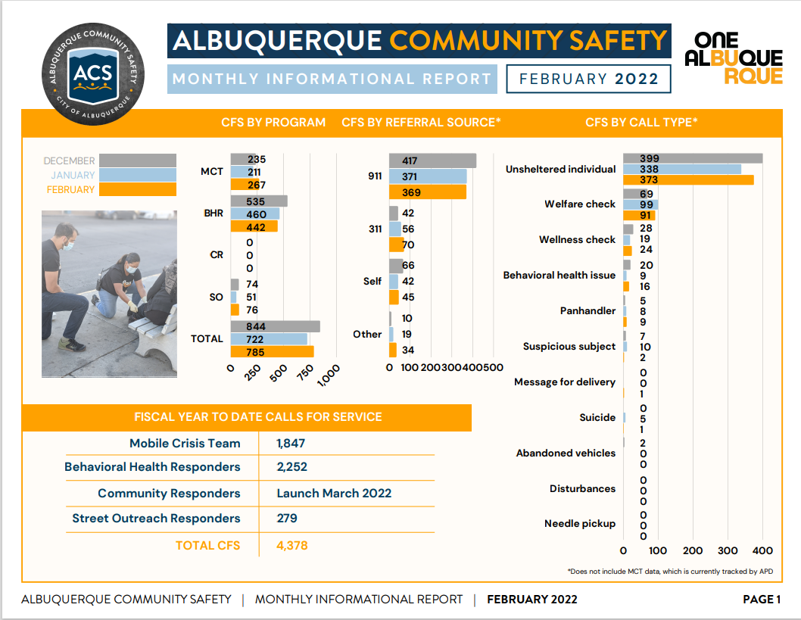

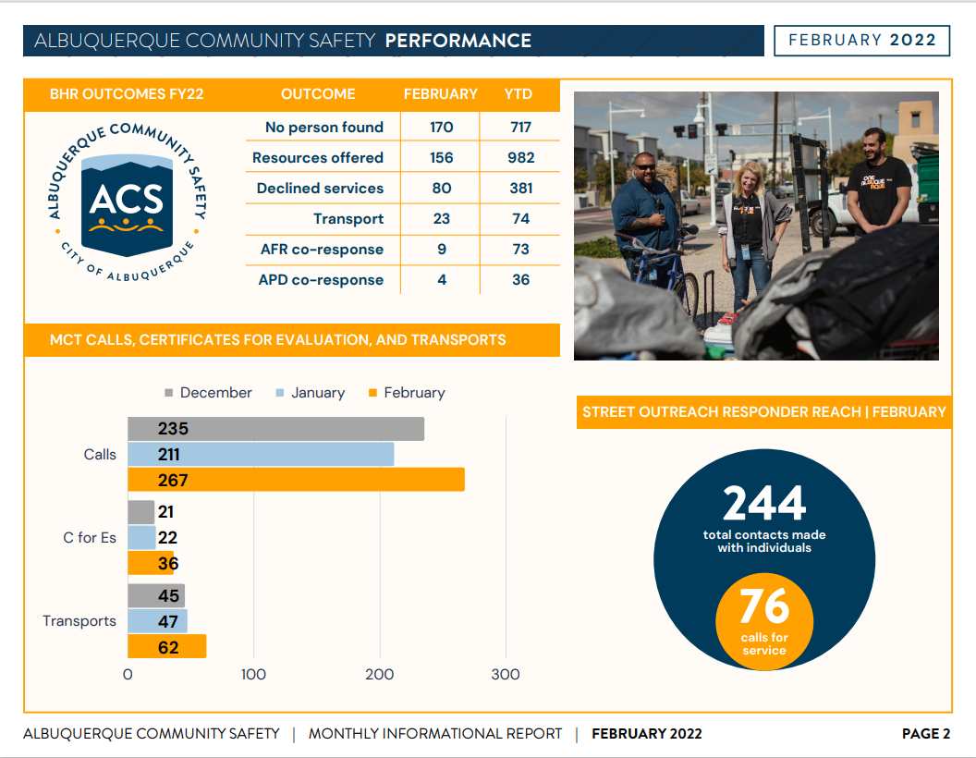
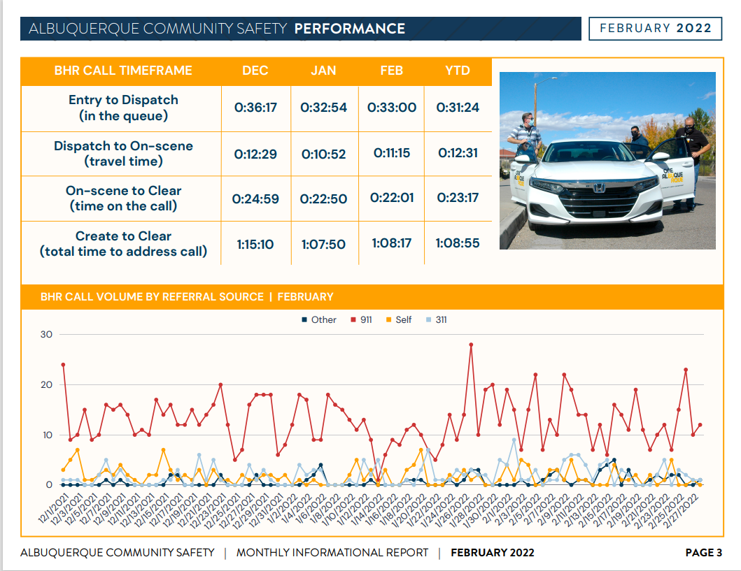

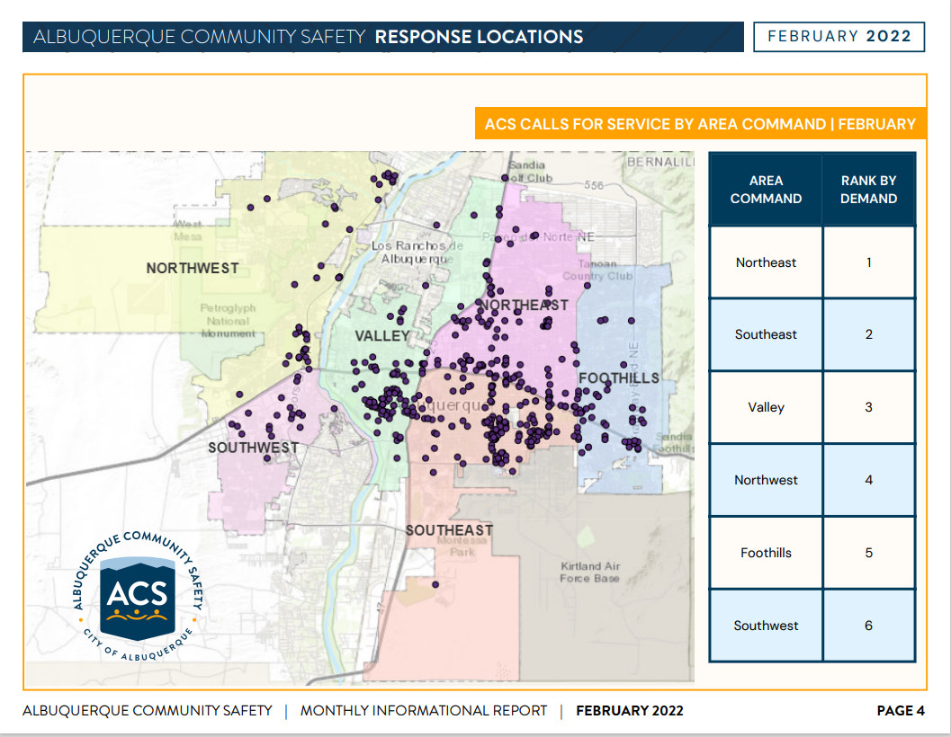
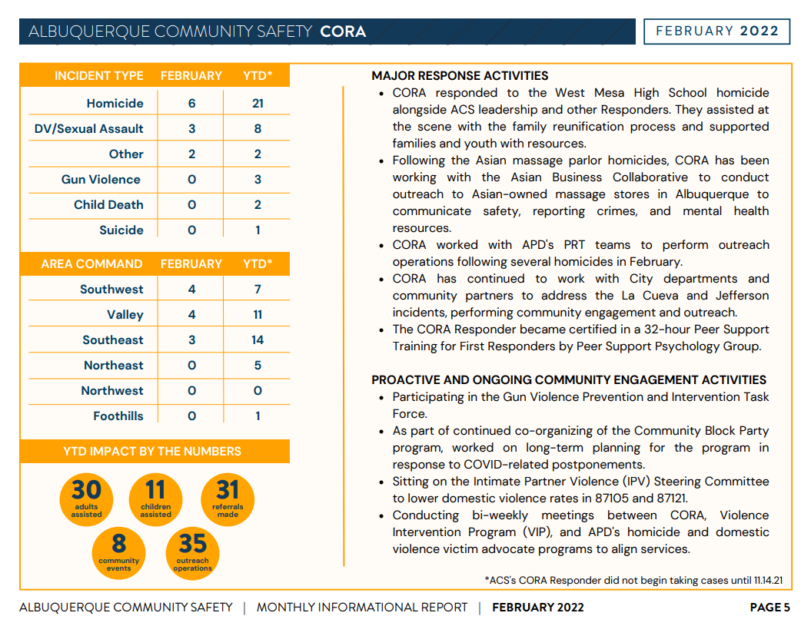

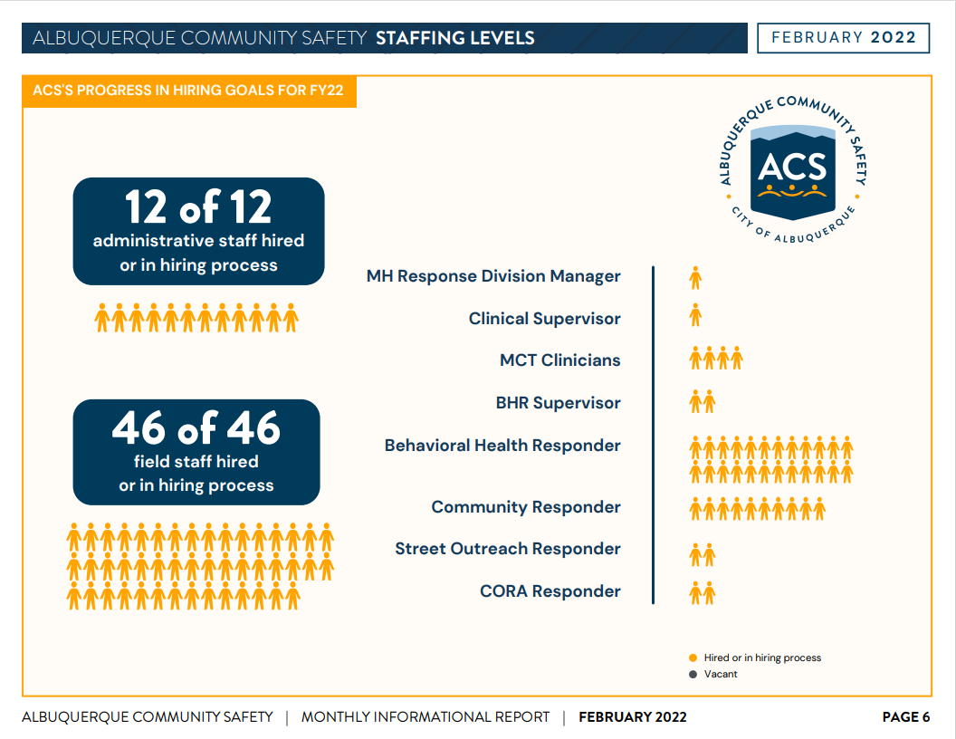
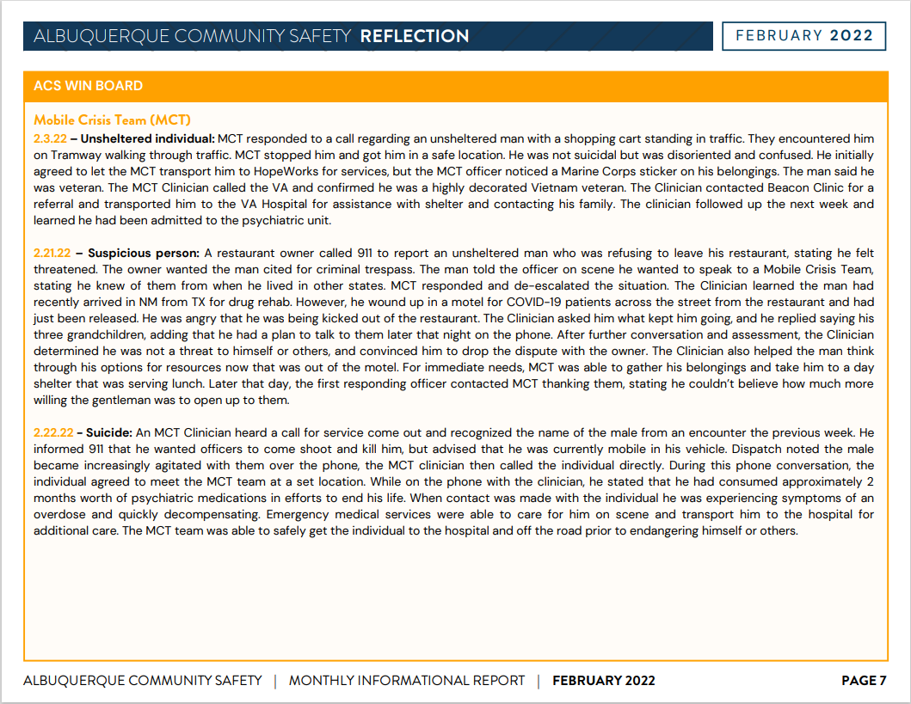

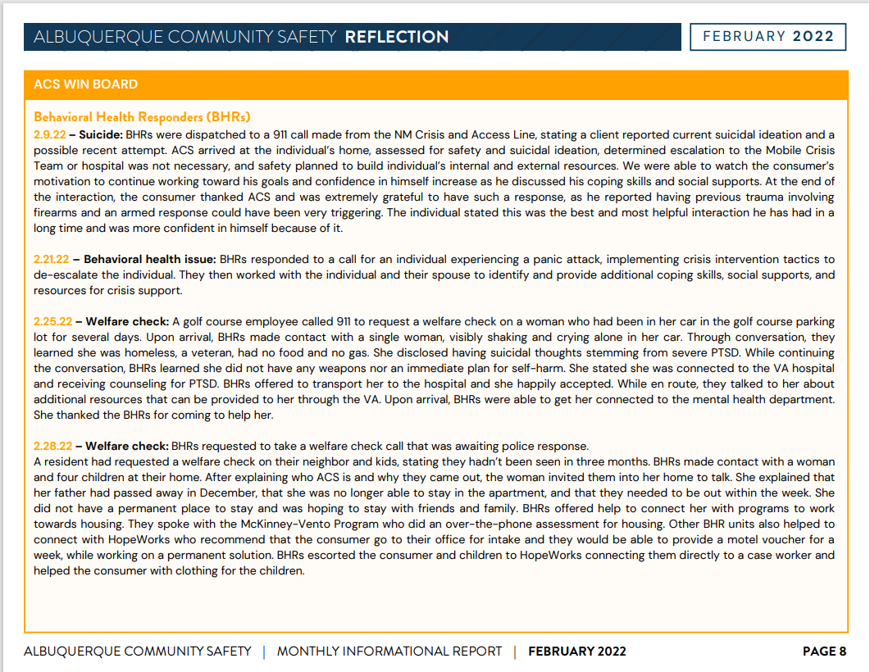
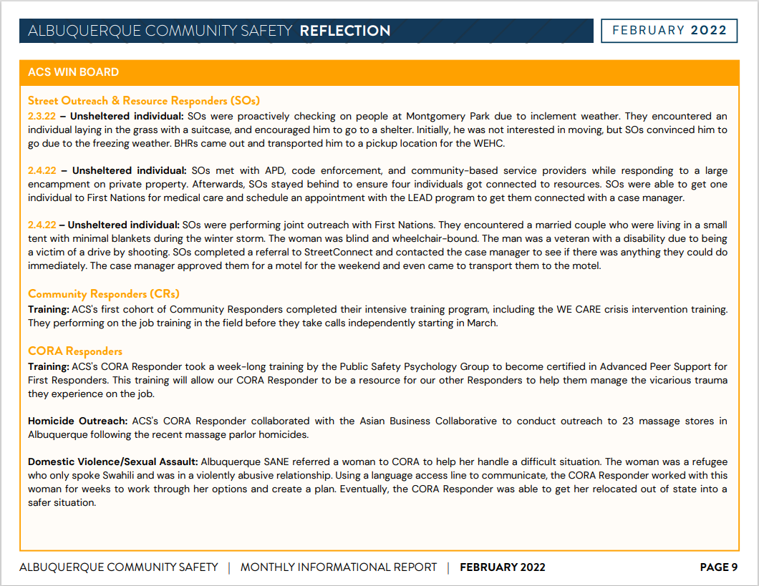

David Ley
Suggested researching what models of intervention should be used according to the community.
Max
Expressed concern over ACS /CORA responding to higher-level calls i.e. homicides and other serious crimes which could result in the staff being used as witnesses and in some cases, may have to testify against people they were trying to help.
Mariela
ACS along with the Community Oriented Response and Assistance (CORA) would like to create some sort of assistance as well as developing boundaries and recognizing and working through barriers.
Elaine
Reports her team responds within 72 hours and tailors to the needs of the individual or that community we are responding to by gathering information that is needed to figure out what is the best approach for the situation at hand.
Gibson Health Hub, Family and Community Services, Cristina Parajon


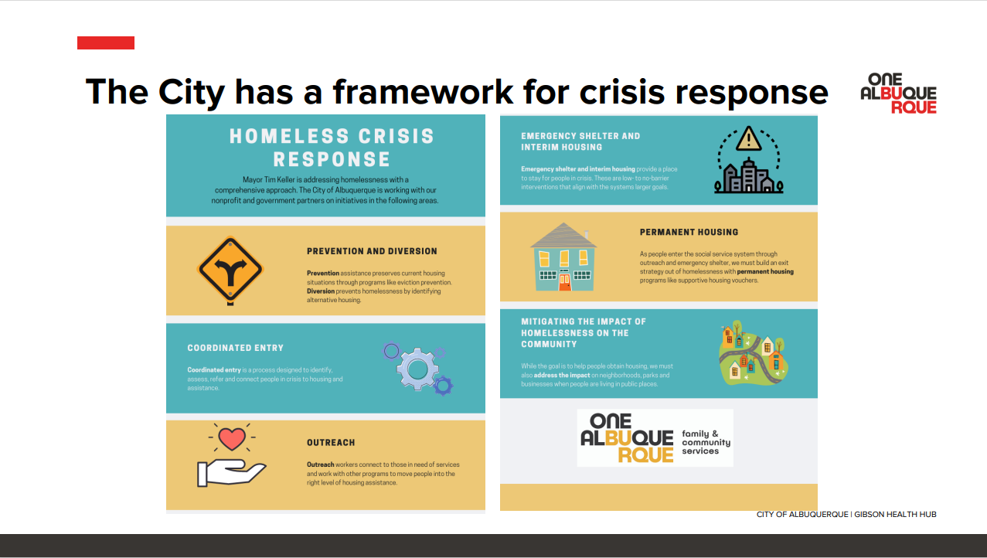
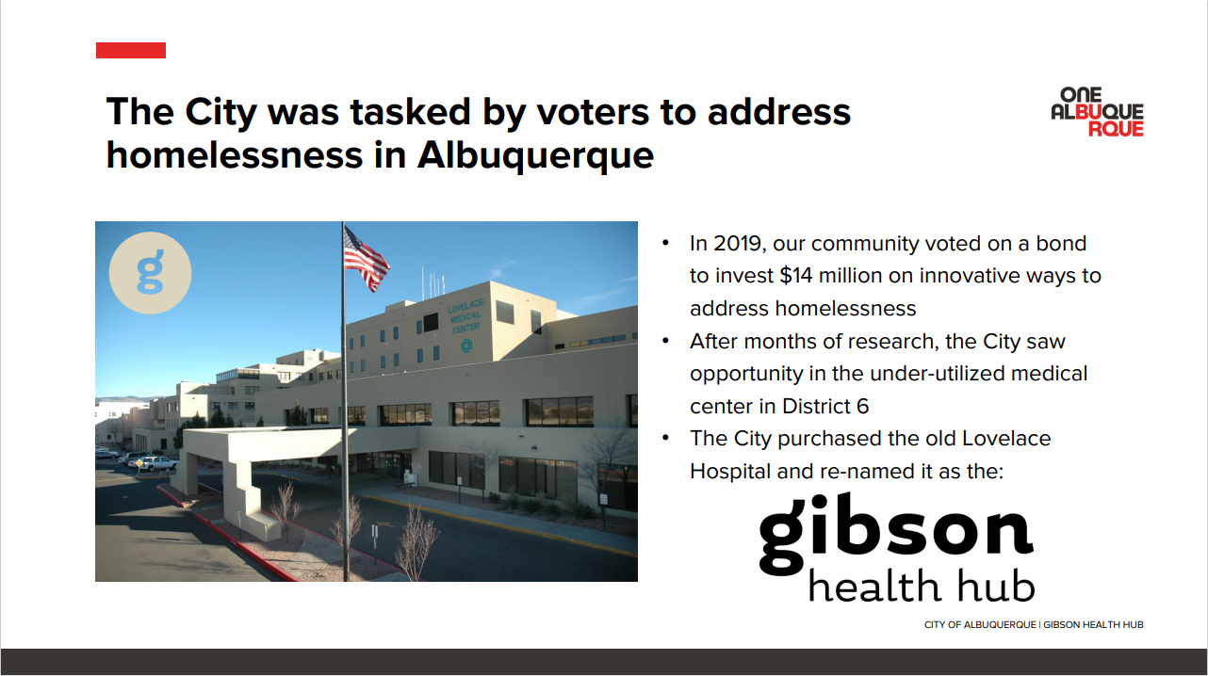

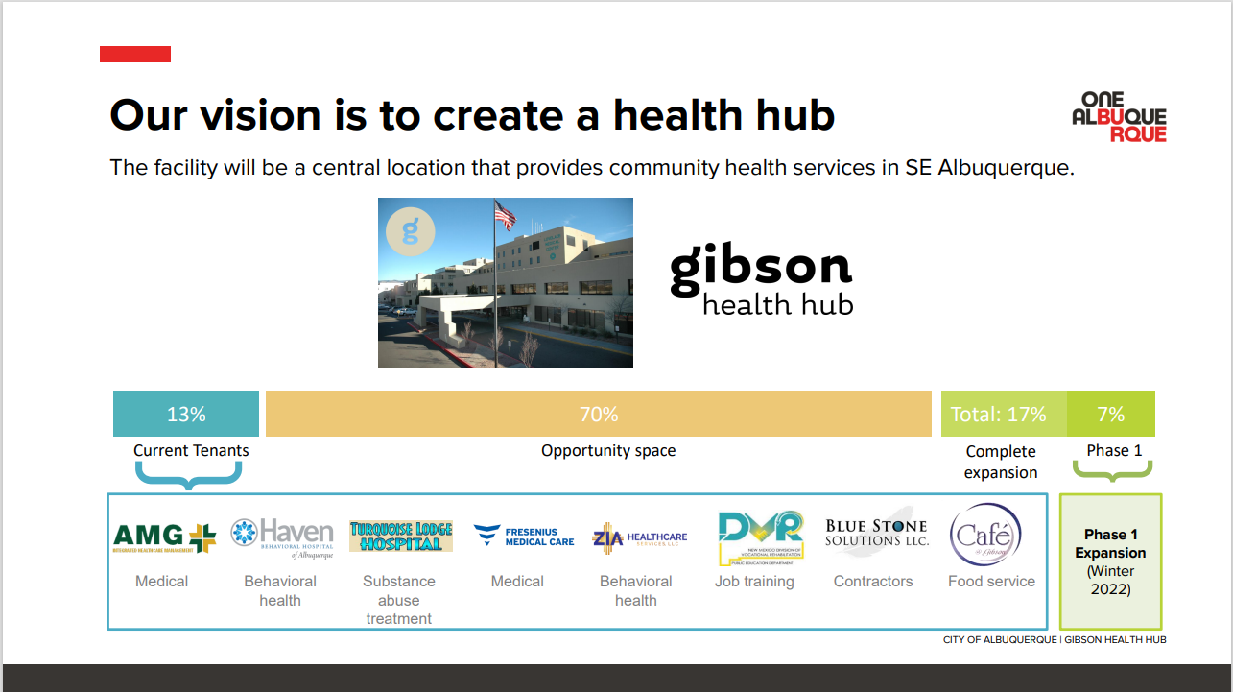
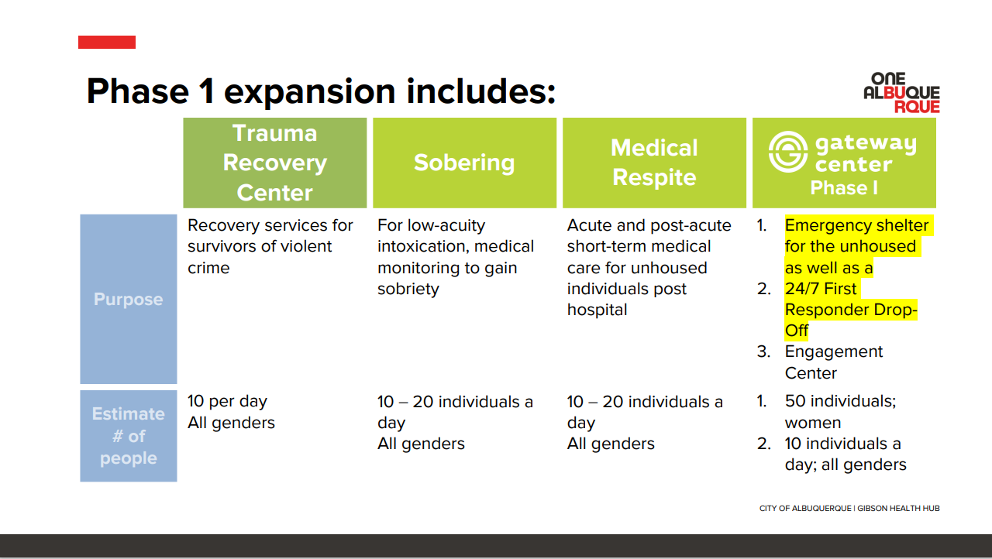

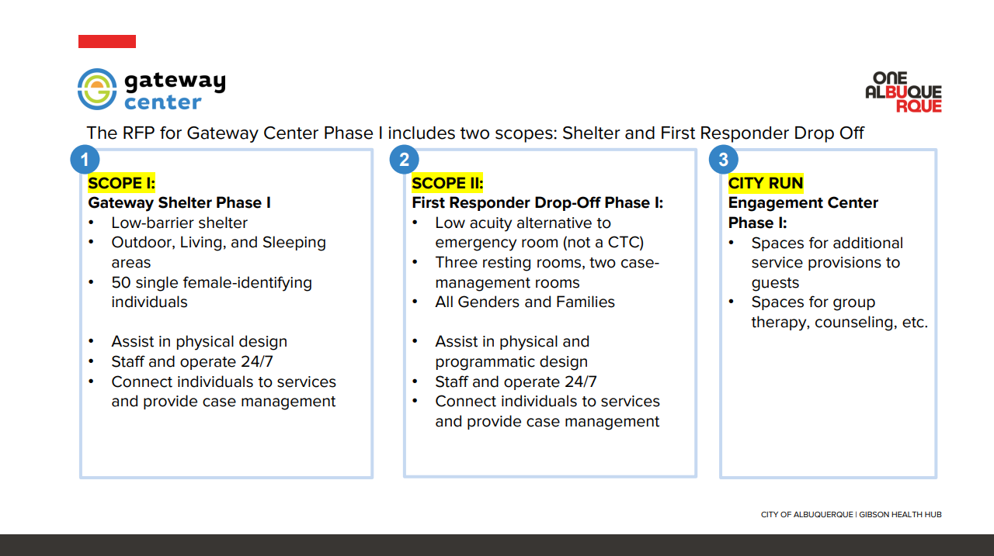
Cristina
The release of the RFP that is out for bid to nonprofits has two scopes which can be applied for separately or together:
1—Low Barrier Shelter
2—First Responder Drop Off (Low acuity alternative to the emergency room)
Max
Q. Have the protocols been developed for the procedures for First Responder Drop-Offs?

Cristina
A. No, those haven’t been developed so we’re hoping that once we bring a provider on, then we’ll work with them to develop that and definitely will be consulting with this group.

Rachael
Requested to be informed of the timeline to put it on the agenda for the policy subcommittee.

MHRAC Ordinance Subcommittee recommendation, David Ley
We’ve been talking for a little while about a forward direction of trying to work with the City of Albuquerque to establish an ordinance that would institutionalize MHRAC in the city process. My suggestion would be for Max and Rachel to spearhead, with maybe a couple of other people, not as a power play, but simply to try to achieve some efficiency and effectiveness. We would designate or delegate to this committee to engage in problem-solving or development strategies with the city attorneys and the City Council about what it would take to establish this and create this.

Rachel
I think we should just go forward if there aren’t any objections.” Since there are no objections, Max and I will go ahead and convene that subcommittee and will reach out to folks if you have a particular interest.

Law Enforcement Assisted Diversion (LEAD) Presentation, Glenn St. Onge
I am the LEAD Program Manager for Bernalillo County. A diversion program in which police officers take low-level suspects to treatment instead of jail. LEAD has 44 active clients at this time, zero have been re-arrested.
The process to address the situation in which an individual’s criminal behavior appears to stem from a behavioral health disorder and/or a substance use disorder and/or a substance use disorder where the individual would be better served in a treatment location setting, rather than in a criminal justice setting. Sworn personnel can seek such jail diversion interventions instead of arrest. LEAD is open to other anybody and everybody (NAMI, Discharge planners) to make referrals to the program. The criteria are, no violent felonies within three years, misdemeanors we take, and non-violent felony.

CIU, APD, and BSS Report and update, Commander Dietzel
What great teamwork between NM Disabilities and Rights Attorney office, COAST, as well as other entities in getting high utilizer placed in an out-of-state in a high-level care facility.

COAST Update, Rob Nelson
The COAST team has expanded by one more person; we are now a team of three covering the city. The other new thing is that we're going back to doing our weekly outreach in each of the area commands, so you'll see a bigger presence of COAST out in the community doing outreaches.

Sub-Committees Report and update
Rachel
As a reminder when we do have policies that we're reviewing at the Infoshare/Resources/Policies subcommittee, they will come here as an agenda item. We do not have any this month.

Commander Dietzel
In regards to Infoshare/Resources/Policies Sub-committee, I just started the policy revision for the extreme risk firearm protection order. You can have a restraining order against someone that prevents them from owning or buying a firearm. It was a very minor adjustment; it was literally some process things from the update that the court had.
The Board wanted to have some information about what use of force levels look like so I talked about level 1, 2, and 3 use of force. I brought the subcommittee up to speed on what each one of those force levels looks like.

David Ley
The Training sub-Committee did not meet in January; we meet every other month. The suggestion Max has about discussing with ACS some of the potential training of materials that they might look at for processing to prepare them for supporting community crises would be a good thing.

Rachel
Q. We do have regular participation from ACS on the committee, right?

David
A. Yes, ACS has been participating regularly as well as regular participation and support from the academy, CIU, and ECHO. We have a great window into all of the training that is happening within the department. And, now within the city around behavioral health.

MHRAC final discussion (5 minutes)
-MHRAC Meetings as a Webinar
We already talked about this last meeting, but one of our ideas, was to have these meetings be more of a webinar format, so there'd be a panel of committee members. And then the community could participate as you would participate in like a city council meeting or other meetings that we have on zoom right now just to help manage the transparency of who is actually on the committee who's voting who's on making the decisions and the discussion, and then we can manage public comment and poly participation.

Max
Q. Is the city still advertising our MHRAC meeting on Next Door?

Commander Dietzel
A. I know that they get posted to Social Media and I know it includes Facebook, but I am not sure about Next Door, but we do send every meeting invite to the APD media group.

Rachel
Not hearing any concerns, we can move forward and if we do not like it, we can always change it back.

Next meeting: Tuesday, April 19, 2022

