City of Albuquerque
Employee Learning Center
1 Civic Plaza NW
Basement, City Hall
(T) 505-768-3200
employeelearningcenter@cabq.gov
Registration forms must be submitted via email.
Training Registration and Approval Form

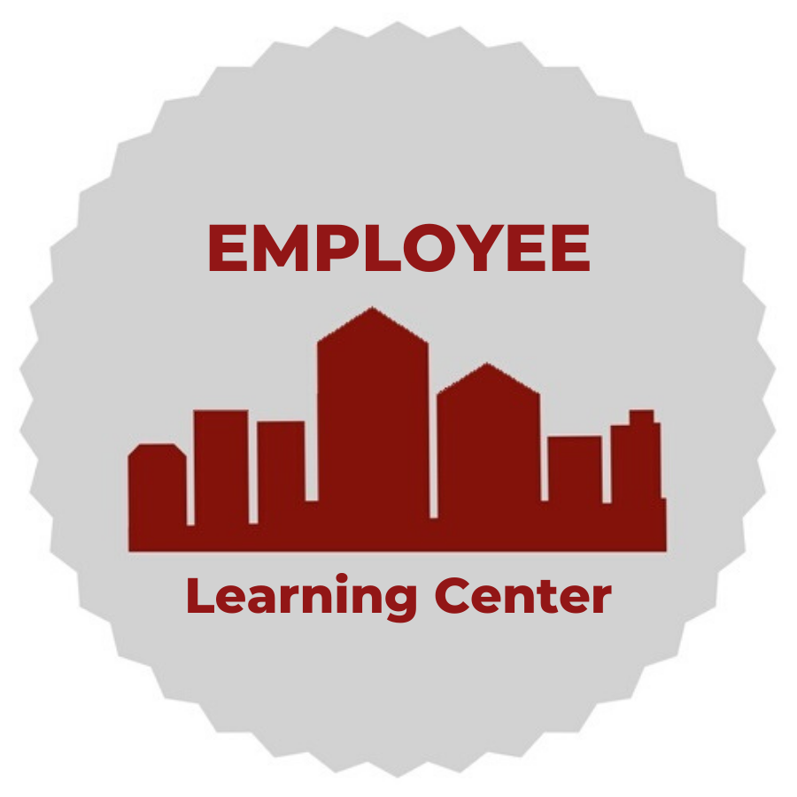

Program: Supervisor Development Program
Time: 9:00am – 5:00pm every Wednesday for 8 weeks
Location: Employee Learning Center, Basement of City Hall
Cost: $200 per participant
Session Dates (Please select one):
SDP 24-1 | SDP 24-2 | SDP 24-3 | SDP 24-4 | SDP 24-5
07/12/2023-  08/30/2023 | 09/13/2023-  11/01/2023 | 01/03/2024-  02/21/2024 | 02/28/2024-  04/17/2024 | 04/24/2024-  06/12/2024
Participant Information
Full Name: |  | Employee ID #:
Department: |  | Division:
Job Title: |  | Grade:
Work Phone: |  | Work Email:
Date of Hire: |  | Supervisor position start date:
Supervisor Information
Supervisor: | Supervisor’s Initials:
Work Email: |  | Work Phone:
Funding Source
Fund: |  | Account #:
Department #: |  | PC Bus. Unit:
PC Project: |  | PC Activity:
Source Type:

Requirements: The Director’s signature serves as approval for fees and attendance.
Director’s Name (Print) Director’s Signature Date
Please return completed signed form to employeelearningcenter@cabq.gov

