
Assured Imaging Women's Wellness of Southern AZ, LLC
7925A N. Oracle #154, Tucson, AZ 85704
(888) 233-6121 phone / (50) 572-7138 Fax
www.assuredwomenswellness.com

Patient History Form
Today’s Date: | Medical Records #: |  |  | Date of Birth:
Name (Last): |  | (MI): | (First):
Referring Physician: |  |  |  |  | MD: | DO:

Family Breast Cancer History:
Have you or your relatives listed below ever been diagnosed with breast cancer?
Self: | Age: | Mother: | Age: | Sister: | Age:
Grandmother: | Age: | Aunt: | Age: | Daughter: | Age:

Current Symptoms:
Mass or lump: | Description:
Discharge: | Description:
Enlargement/swelling: | Description:
Tenderness/pain: | Description:
Nipples retracted: | Description:
Dimpling of breast: | Description:
Axillary masses: | Description:
Other: | Description:

Procedures:
Have you had any of these procedures performed?
Breast Biopsy: | Right: Left: | Date/explain:
Lumpectomy: | Right: Left: | Date/explain:
Reduction: | Right: Left: | Date/explain:
Mastectomy: | Right: Left: | Date/explain:
Implants: | Right: Left: | Date/explain:

Medical History:
Have you recently had your breast examined by your Physician: Yes No | When:
Did your doctor or nurse practitioner find any problems with your breasts: Yes No
If yes, please explain:

Have you had a previous mammogram: Yes No |  |  | If yes, location:
Date of last menstrual period: | Age of onset: |  |  | Age Ceased:
Number of pregnancies you have had: |  | Hysterectomy: Yes No |  |  | If yes, date:
Have your ovaries been removed: Yes No |  |  | Do you take hormones: Yes No
Name of hormone supplement: |  |  | How long:

Patient Signature: | Tech Signature:
Left
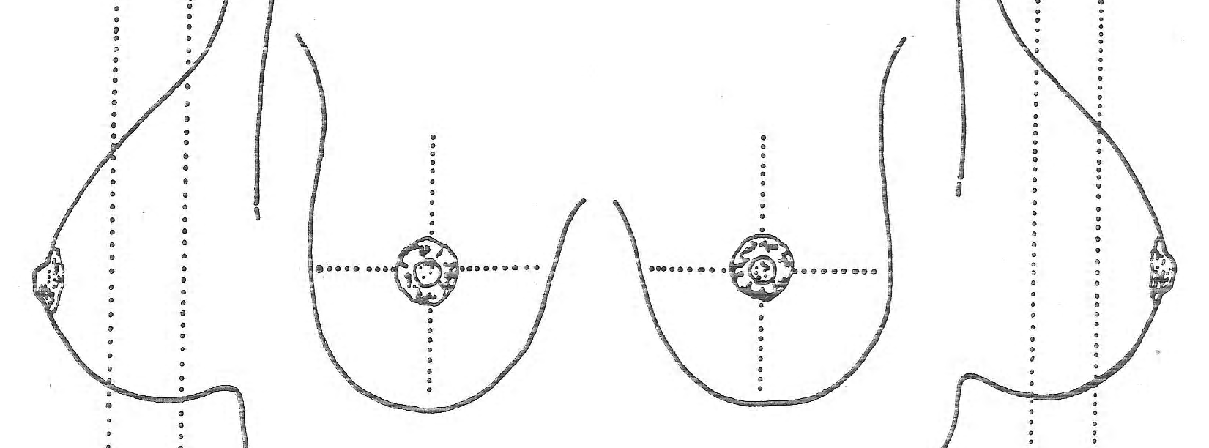
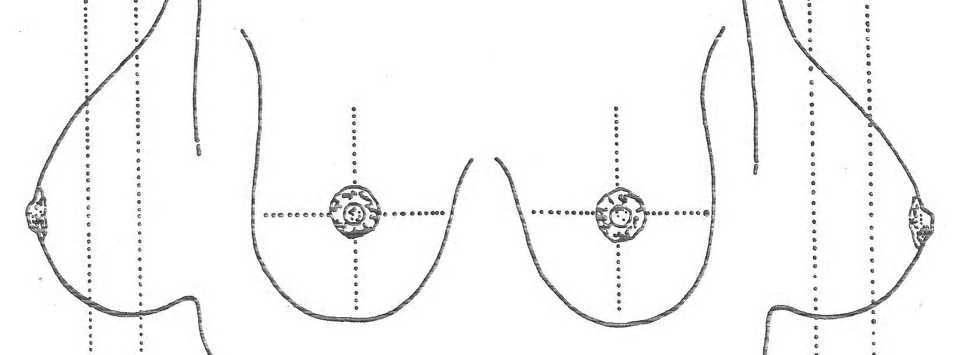
Right
Medial
Medial
Lateral
Lateral

