City of Albuquerque  Small Business  Regulatory Advisory Commission |  | 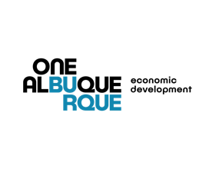
Chair: Myra Ghattas  Vice Chairman: Tim Nisly  Ex-Officio Member: Synthia R. Jaramillo  City Legal: Leigh Brunner  Staff: M. Mitchell  D. Sayers  C. Nunez  R. Griego | Commissioners: Paulette Baca  Matthew Biggs  Kenneth J. Carson  Cailyn Kilcup  Michael M. Silva Jr.

November 3, 2020
10:00 AM – 11:00 AM
Zoom Conference Call

Join Zoom Meeting
https://cabq.zoom.us/j/2126621864

Meeting ID: 212 662 1864

Find your local number: https://cabq.zoom.us/u/amS1dPDL2

AGENDA

- Approval of minutes – Chair

- Additions/deletions to agenda – Chair

- City Council Discussion

- Council Bill R-20-109 AMENDING THE AGGREGATE MAXIMUM AMOUNT OF ECONOMIC RELIEF GRANTS PROVIDED TO SMALL AND LOCAL FOR-PROFIT ORGANIZATIONS NEGATIVELY IMPACTED BY THE COVID-19 PANDEMIC THROUGH THE CORONAVIRUS, AID, RELIEF, AND ECONOMIC SECURITY ACT (CARES Act).

- Council Bill O-20-39 ENACTING THE HEALTHY FAMILIES AND WORKPLACES ORDINANCE TO REQUIRE THAT EMPLOYERS IN THE CITY PROVIDE PAID LEAVE TO EMPLOYEES

- City and Budget Committee Update – Director Jaramillo, Sr. Economic Developer Mitchell, and Small Business Office Manager Sayers

  - $10 million Small Business Economic Relief Grant

- Committee Update – Chair

  - Next steps

- Adjourn

Notice to Persons with Disabilities
If you have a disability and require special assistance to participate in this meeting, please contact Monica Mitchell as soon as possible before the meeting date at 505-768-3226.

