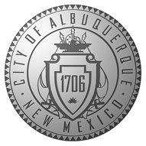

NOTICE OF POSSIBLE QUORUM OF CITY COUNCILORS

This serves as notice that a possible quorum of City Councilors may be present at an event on Friday, December 27, 2024, at 8000 Paseo del Norte NE 87122 from 4:00 PM to 8:00 PM.

If you have questions please contact the City Council Office at 505-768-3100 during business hours, Monday – Friday, 8am – 5pm or visit our website at www.cabq.gov/council.

