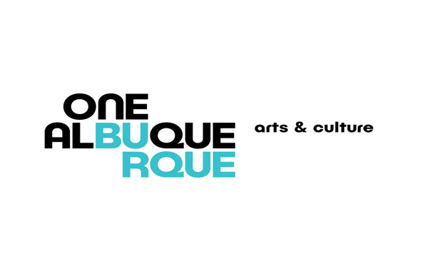

Albuquerque Museum Board of Trustees
MEETING AGENDA, Revised

Wednesday, August 10, 2022 11:30 a.m. – 1:00 p.m.

Albuquerque Museum Ventana Salon

Please note: Masks are voluntary

LUNCH WILL BE SERVED at 11:00

- Call to Order, and Authorization to Record
- Public Comment
- Approval of Board Meeting Minutes
  - June 8, 2022
- Introductions
- Nominating Committee Report
- Election of Officers
  - Per Article III, Section 1 of the Revised Bylaws
- Fiscal Planning for the Museum Cyndy Garcia
- Mechanical Issues Report Andrew Connors
- Museum Director Report, Andrew Connors
- Curators Reports
- Albuquerque Museum Foundation Report
- Adjourn

Next Regular Meeting – October 12, 2022 11:30 a.m. – 1:00 p.m.

