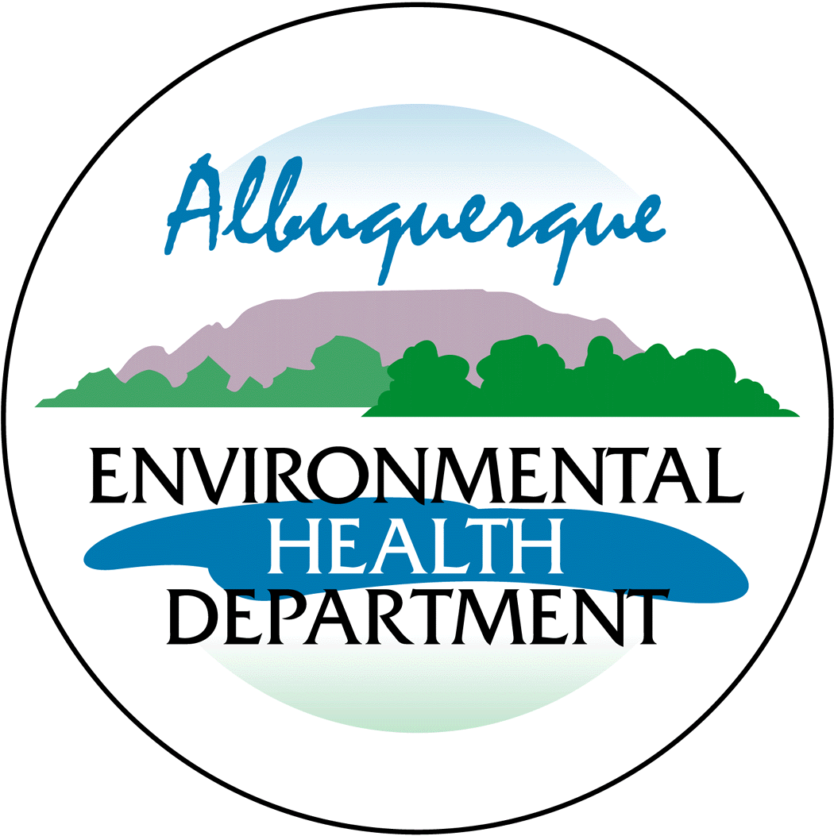
Notice of Intent to Construct

Under 20.11.41.13B NMAC, the owner/operator is required to provide public notice by certified mail or electronic mail to the designated representative(s) of the recognized neighborhood associations and recognized coalitions that are with-in one-half mile of the exterior boundaries of the property on which the source is or is proposed to be located if they propose to construct or establish a new facility or make modifications to an existing facility that is subject to 20.11.41 NMAC – Construction Permits. A copy of this form must be included with the application.

Applicant’s Name and Address:

Owner / Operator’s Name and Address:

Actual or Estimated Date the Application will be submitted to the Department:

Exact Location of the Source or Proposed Source:

Description of the Source:

Nature of the Business:

Process or Change for which the permit is requested:

Preliminary Estimate of the Maximum Quantities of each regulated air contaminant the source will emit: Net Changes In Emissions
 | Pounds Per Hour  (lbs/hr) | Tons Per Year  (tpy)
CO
NOx
NOx + NMHC
VOC
SO₂
TSP
PM10
PM2.5
VHAP
Initial Construction Permit (Only for permit Modifications or Technical Revisions)
 | lbs/hr | tpy | Estimated Total TPY
CO | +/- | +/-
NOx | +/- | +/-
NOx + NMHC | +/- | +/-
VOC | +/- | +/-
SO₂ | +/- | +/-
TSP | +/- | +/-
PM10 | +/- | +/-
PM2.5 | +/- | +/-
VHAP | +/- | +/-

Maximum Operating Schedule:

Normal Operating Schedule:

Current Contact Information for Comments and Inquires:
Name:
Address:
Phone Number:
E-Mail Address:

If you have any comments about the construction or operation of the above facility, and you want your comments to be made as part of the permit review process, you must submit your comments in writing to the address below:

Environmental Health Manager
Permitting Division
Albuquerque Environmental Health Department
Air Quality Program
PO Box 1293
Albuquerque, New Mexico 87103
(505) 768-1972

Other comments and questions may be submitted verbally.

Please refer to the company name and facility name, as used in this notice or send a copy of this notice along with your comments, since the Department may not have received the permit application at the time of this notice. Please include a legible mailing address with your comments. Once the Department has performed a preliminary review of the application and its air quality impacts, if required, the Department’s notice will be published on the City of Albuquerque’s website, https://www.cabq.gov/airquality/air-quality-permits and mailed to neighborhood associations and neighborhood coalitions near the facility location or near the facility proposed location.

