High Wind Event of April 26, 2012
Data Flagging and

EPA Concurrence Documentation

City of Albuquerque
Environmental Health Department
Air Quality Program

This page is intentionally blank
High Wind Event of April 26, 2012

As required by the “Treatment of Data Influenced by Exceptional Events”

EPA is requiring that States submit appropriate documentation which demonstrates why a particular event should be considered exceptional for the affected area. The EPA will review the documentation submitted by States concerning high wind events and will make decisions concerning whether to exclude the data as being influenced by an exceptional event on a case-by-case basis.
This Analysis will present:
- Documentation of the event showing clear causal relationship between the measured exceedance or high value and the natural wind event. The type and amount of documentation provided will be sufficient to demonstrate that the natural event occurred, and that it impacted a particular monitoring site in such a way to cause the PM10 concentrations measured.
- Through local media, email and facsimile the public was informed of the high wind event.
- AQP requires control measure implementation for surface disturbance operations, and that AQP enforcement personnel enforced fugitive dust permits and the requirements of AQR 20.11.20.
- This high wind event analysis was made available for public review and comment.
- This high wind event analysis was submitted to the U.S. EPA Region 6 for review and concurrence.
This Analysis will answer the 6 technical elements listed under the EER (Exceptional Event Rule):
- whether the event was not reasonably controllable or preventable (nRCP)
- whether there was a clear causal relationship (CCR)
- whether there would have been no exceedance or violation but for the event (NEBF)
- whether the event affects air quality (AAQ)
- whether the event was caused by human activity unlikely to recur or was a natural event (HAURL / Natural Event)
- whether the event was in excess of normal historical fluctuations (HF)

This page is intentionally blank
Table of Contents
Analysis Preamble 4
Actions Taken by the City of Albuquerque 17
Conclusion 30
Appendix A - Part 20 Fugitive Dust Control 1

This page is intentionally blank

Analysis Preamble
High Winds were observed for Sunday April 26, 2012. At one AQP air monitoring station the 24 hour Standardized PM10 values exceeded the PM10 24 hour National Ambient Air Quality Standard (NAAQS). Data collected by the AQP show verification by the National Weather Service (NWS) that high winds did occur. On the date the NWS submitted a High Wind Warning that was reported by all television news media outlets within the City of Albuquerque and the County of Bernalillo. Media outlets reported sustained winds of 40 mph with gusts of 75 mph or greater possible. The National Weather Service reported wind gusts in the range of 60-75 miles per hour.

One monitoring stations reported PM10 values exceeding the National Ambient Air Quality Standard of 150 µg/m³.

Date | Site | POC | Value
4/26/2012 | 35-001-0029 | 3 | 342.9 | µg/m³

The event occurred on Thursday April 26th at approximately 14:00 and ended approximately 18:00. The event lasted approximately 4 hours and had a significant impact on the South Valley station.

Peak winds at the three sites exceeded the 25 mph threshold:
Site | Max 1 minute wind | Max 5 minute wind | Max hourly wind
South Valley (35-001-0029) | 36.2 (15:17) | 30.3 (15:14) | 26.28 (15:00)

The following media reports show the widespread damage and disruption due to the high winds:

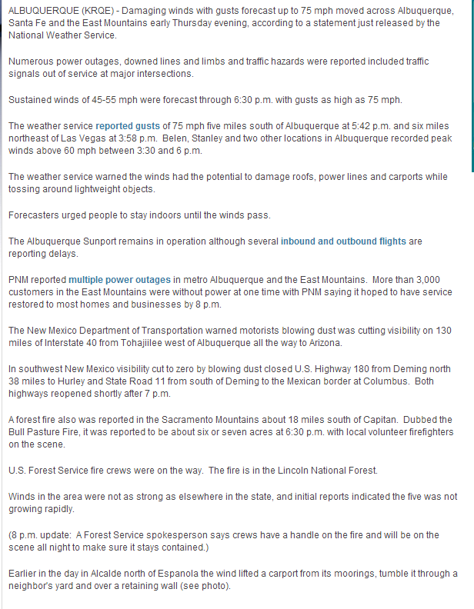
http://www.krqe.com/weather/dangerous-winds-target-santa-fe-abq

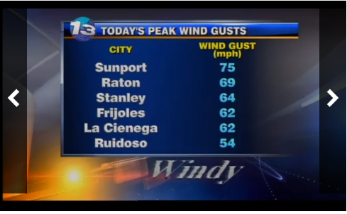

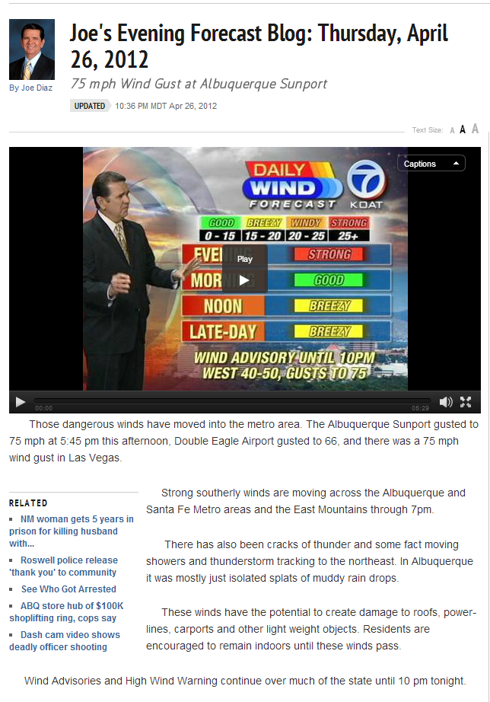
http://www.koat.com/weather/Joe-s-Evening-Forecast-Blog-Thursday-April-26-2012/-/9155310/12035080/-/lj6h5o/-/index.html
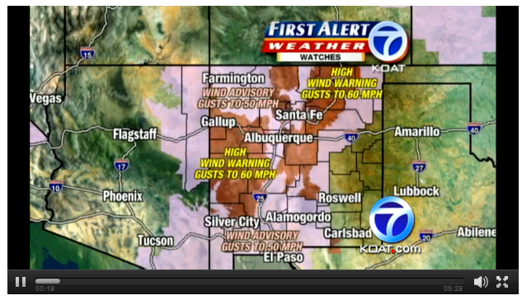

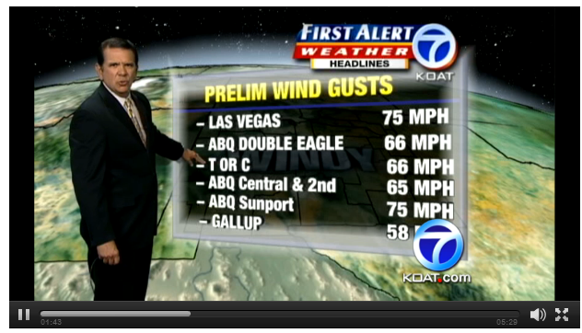


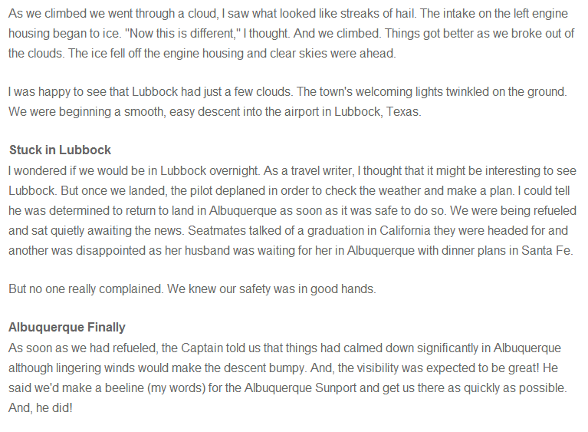

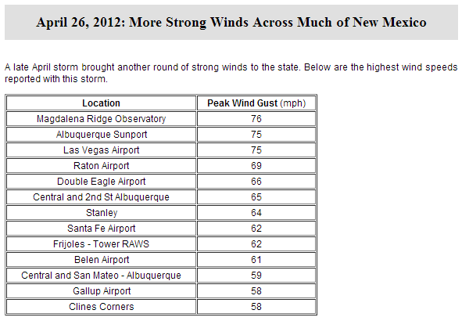
Albuquerque locations
http://www.srh.noaa.gov/abq/?n=climonhigh2012aprsigevents

The AQP issued a Wind Advisory stating the following:
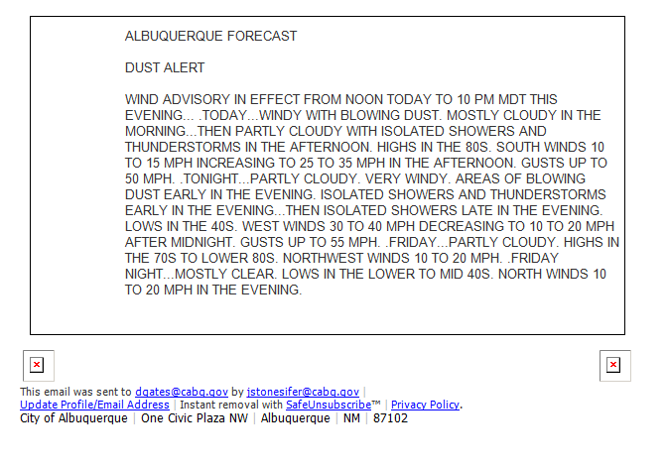
Actions Taken by the City of Albuquerque
In 2004 the Albuquerque/Bernalillo County Air Quality Control Board put into place the Albuquerque/Bernalillo County Air Quality Regulation (AQR) 20.11.20 NMAC (Fugitive Dust Control, revised March 2004) and developed reasonably available control measures (RACM) for those businesses involved in active anthropogenic surface disturbance activities within Bernalillo County. Development of the regulation involved stakeholder input and public comment. Protection of the public health is the foundation upon which this document is based. See appendix A for AQR 20.11.20.

In conjunction with AQR 20.11.20 the AQP notifies businesses and contractors of potential high winds greater than 20 miles per hour. A notice reminds businesses and contractors that they are required to follow their individual permits and the requirements of AQR 20.11.20.

With the implementation of AQR 20.11.20 the AQP has an active fugitive dust program that works with businesses and contractors in permit implementation and enforcement activities. During any high wind event enforcement staff are mobilized to contact and evaluate surface disturbance activities and implement enforcement of permit and AQR 20.11.20 requirements.

The City of Albuquerque also has a 311 Citizen Contact Center (CCC) where citizens can call in and submit a complaint or service request. The 311 CCC receives numerous complaints and requests for inspector action concerning blowing fugitive dust during elevated winds.

On April 26, 2012 the City’s 311 CCC received seven (7) dust complaints concerning the April 26, 2012 event. The following materials are the 311 CCC public complaints and the City staff actions and responses to those public complaints.

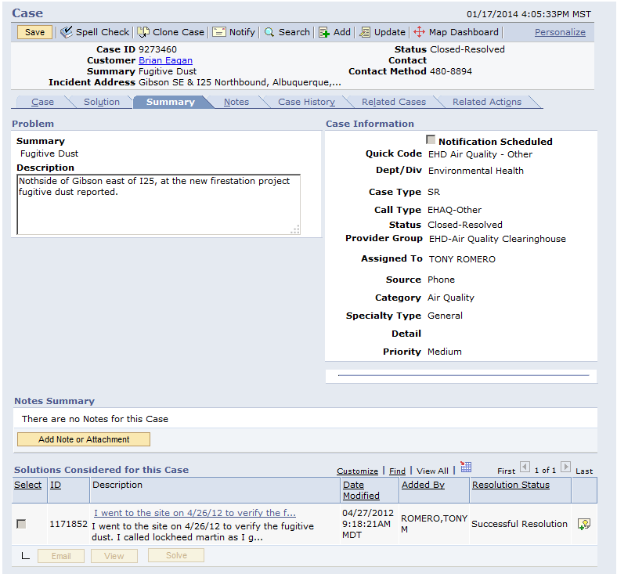
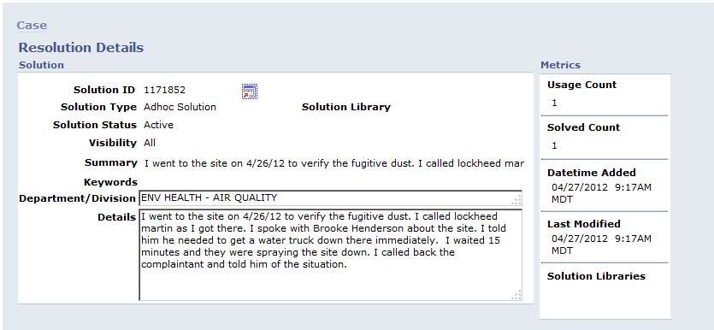
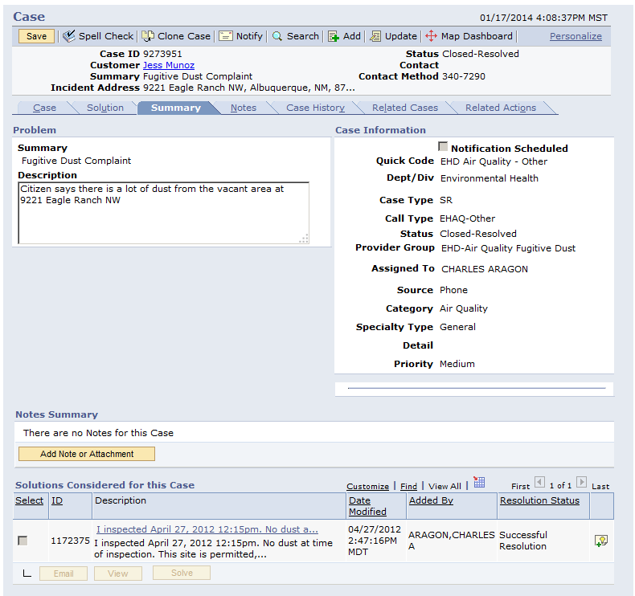
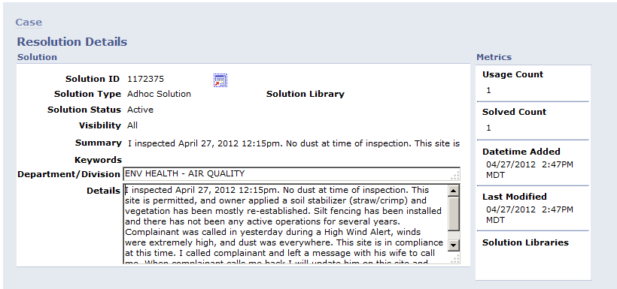
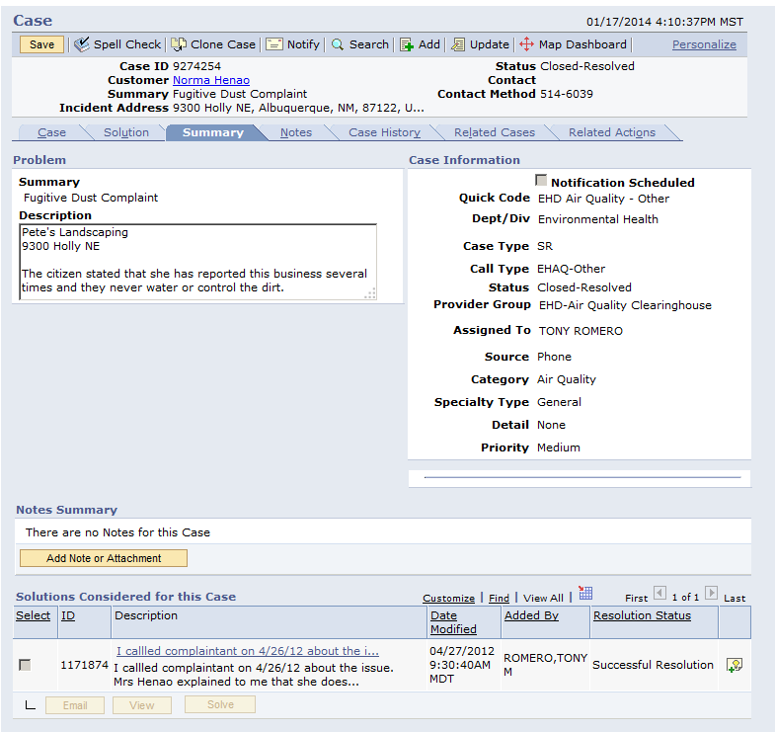
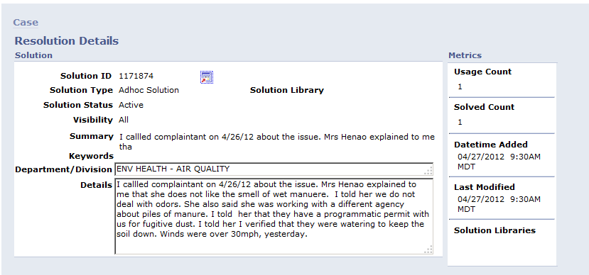
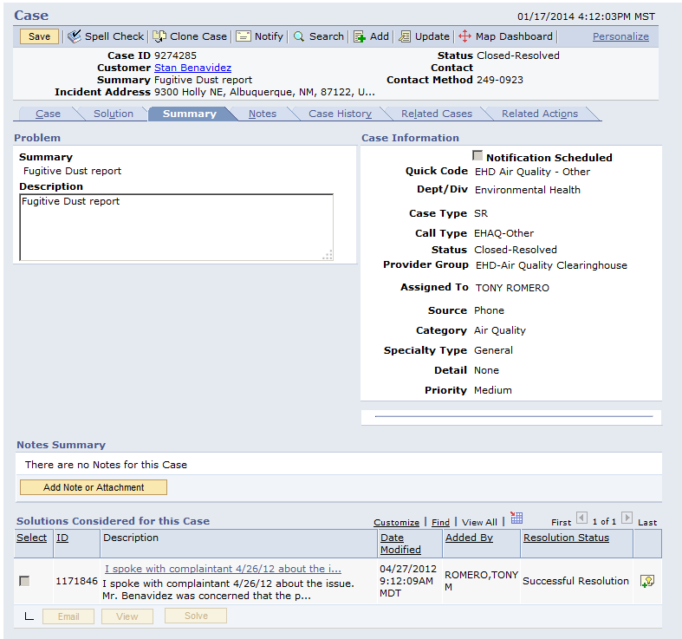
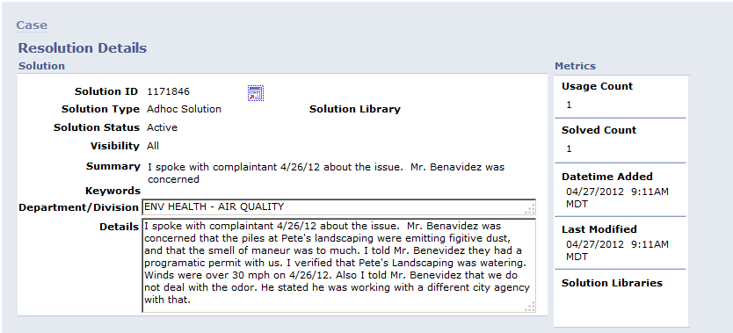
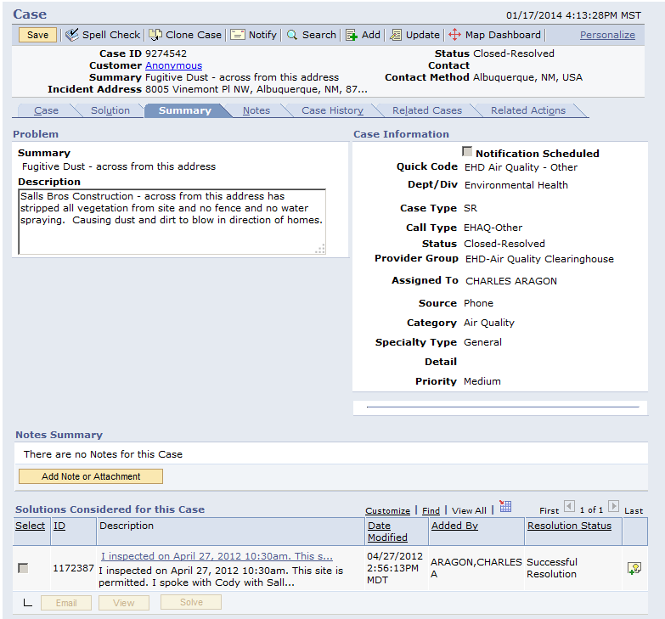
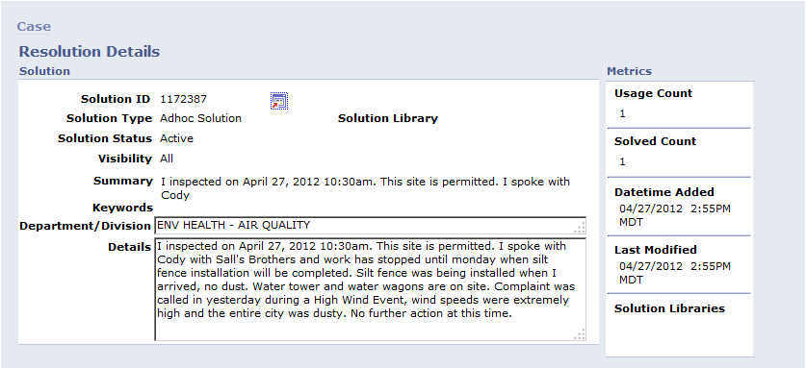
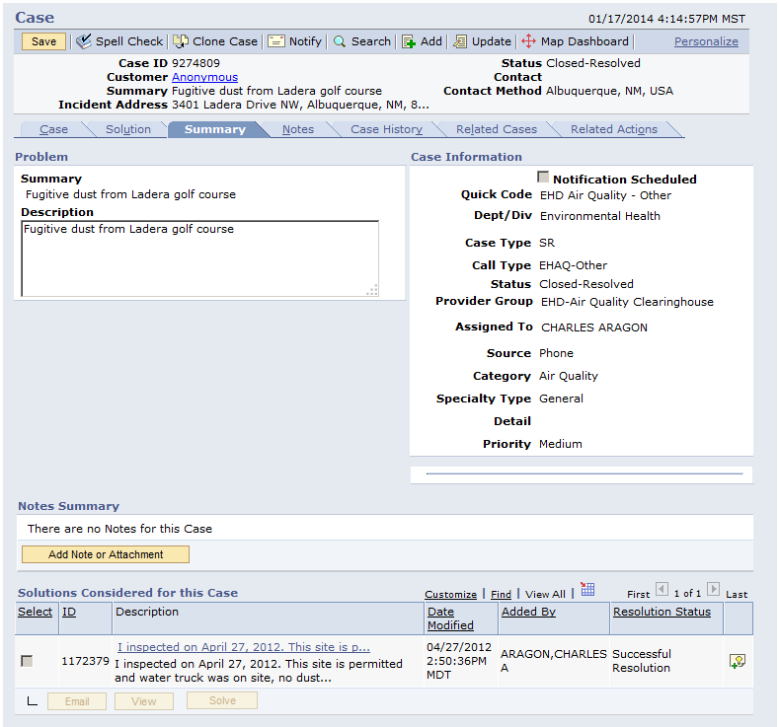
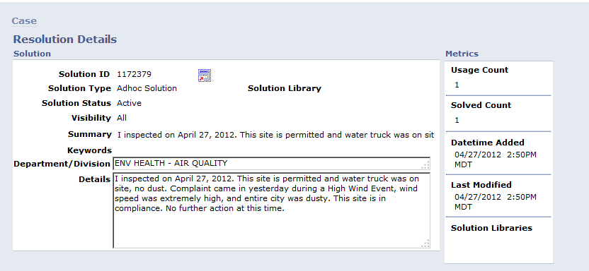
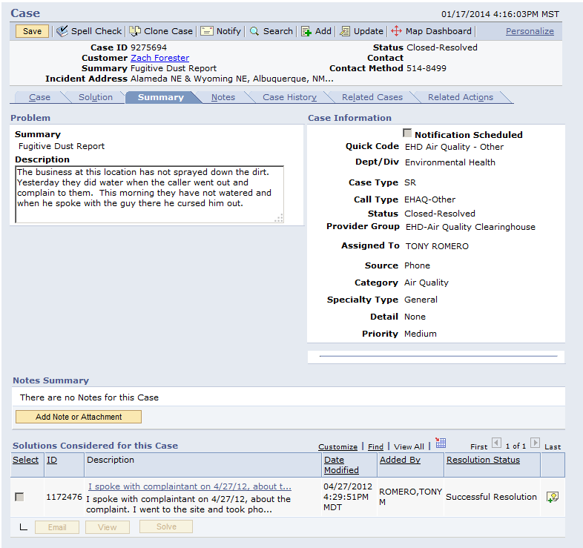
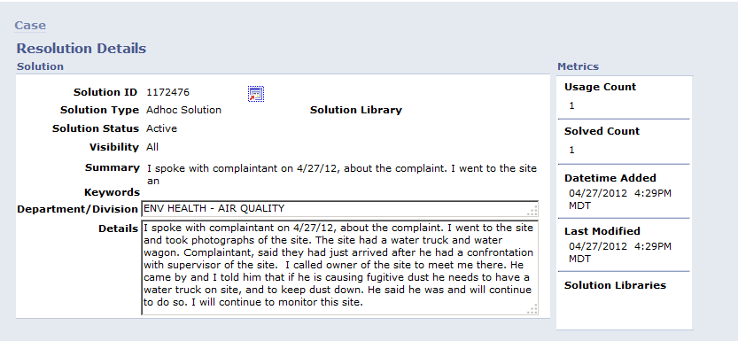
Site Evaluation, 2ZV (35-001-0029)
Site 2ZV was established to monitor PM10 in a potential sensitive are of the County. The site also monitors for PM2.5 (for AQI purposes), Carbon Monoxide and Ozone. For PM10 the site is listed in the AQS database as meeting SLAMS siting criteria starting January 1, 2011.

The sites features include to the immediate north a mixture of agricultural, small commercial and residential structures. To the far north lies the metro area of the City of Albuquerque.

To the east lies several commercial and residential properties, most of the commercial properties comprise junk yards and other automotive recycling facilities. Farther to the east lies the Tijeras Arroyo that can often channel easterly winds from the Monzano Mountains into the Rio Grande valley. Also to the east are Kirtland Air Force Base and Albuquerque Sunport airport.

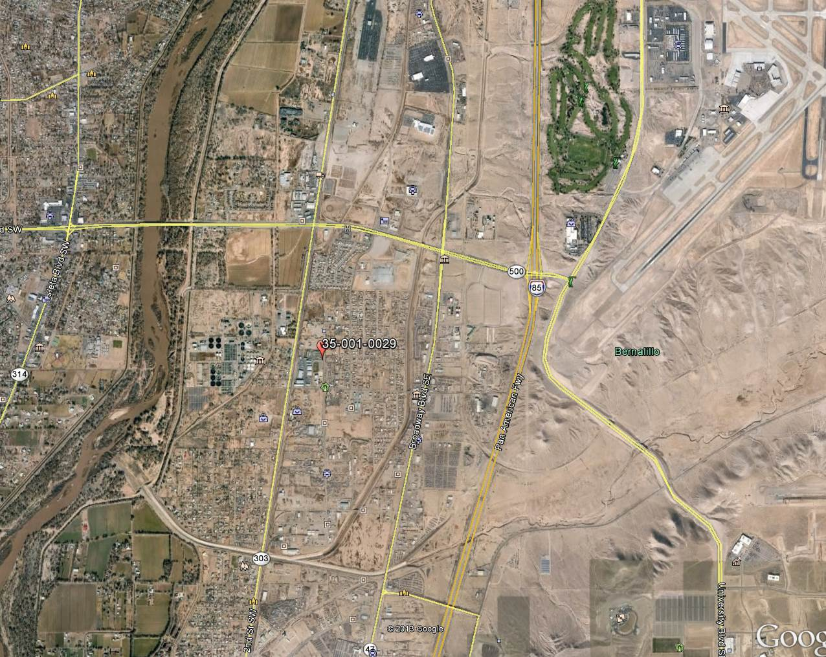
The South is comprised mostly of mixed residential and agricultural land. To the West lies the Rio Grande (River), immediately to the west is also the waste water treatment facility serving the metro City of Albuquerque and much of Bernalillo County.
Prolonged drought conditions have also increased the prevalence of windborne dust in the area. 2011 saw only 4.72 inches of rain and 2012 saw only 5.46 inches of rain. The average annual rainfall for the Albuquerque area is 9.45 of rain (30 year normal). 2011 will go down as tied for the 9th warmest year on record since 1893 and was the 7th driest on record since 1892. 2012 was the 16th driest year on record, going back to 1892 and was the warmest year on record since 1892.
High Wind Observations
High Winds were observed for the day of April 26, 2012 at site 2ZV (350010029). This site operated one Thermo continuous TEOM 1400a monitor for PM10.

Equipment Located at each Site
Site | POC 1
South Valley (35-001-0029) | Thermo 1400a

The collocated Thermo 2025 sampler at Jefferson did not run during this event.

The 24 hour high values for the site is listed below:

Date | Site | POC | Value
4/26/2012 | 35-001-0029 | 3 | 342.9 | µg/m³ SC

The event occurred on Thursday April 26th at approximately 14:00 and ends approximately 18:00.

Peak winds at the site are as follows:
Site | Max 1 minute wind | Max 5 minute wind | Max hourly wind
South Valley (35-001-0029) | 36.2 (15:17) | 30.3 (15:14) | 26.28 (15:00)

Winds are in excess of the 25 mph

Correlation Results:
Site | WS/PM10 Correlation Value
2ZV (35-001-0029) | 0.77

There is a strong correlation between the wind speed data and PM10 data for site 2ZV (35-001-0029).

The data presented here is PM10 standardized temperature and pressure (STP).

2ZV (35-001-0029) Wind Rose Charts:
Wind Rose of Wind Direction and Wind Speed –
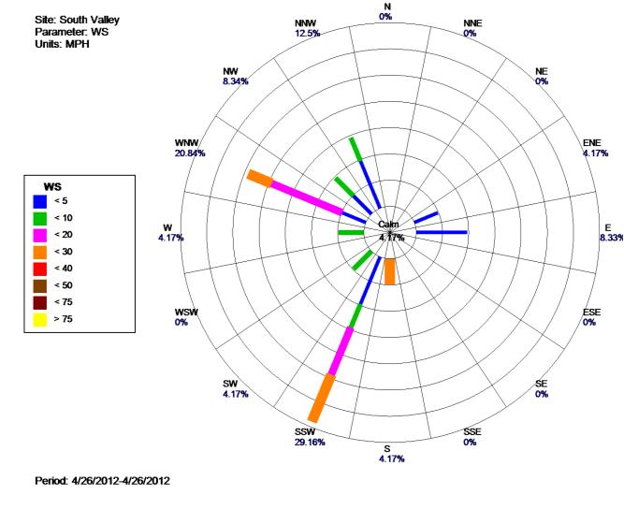
Wind Rose of Wind Direction and PM10 Concentration –

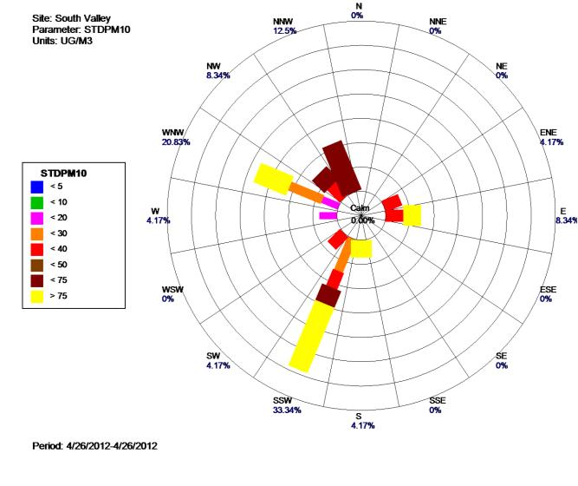
Site specific graph showing PM2.5 increasing as wind speed increases for site 2ZV (35-001-0029).
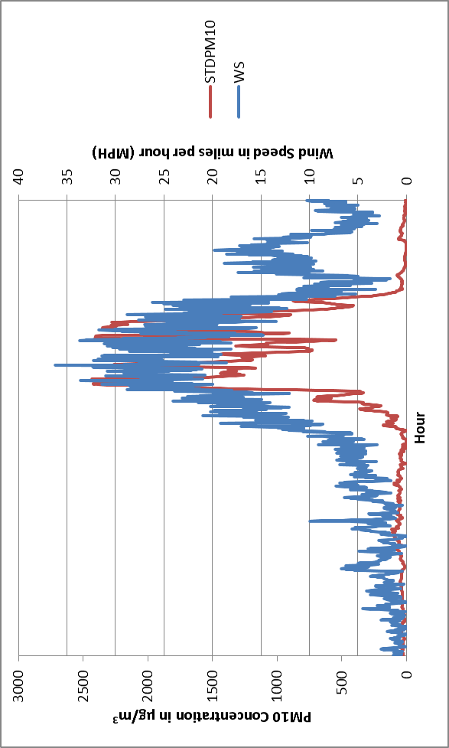

Enforcement Activities
The Fugitive Dust Program is staffed by three full-time enforcement personnel. In addition to the Fugitive Dust Program staff the AQP also has four additional enforcement personnel available for high wind event enforcement activities.

Enforcement personnel were available to address fugitive dust concerns during the April 26. 2012 wind event.

Due to the severity of the event dust abatement activities and reasonably available control measures (RACM) were overwhelmed. As reported by the NWS, on the day of the event wind gusts were recorded at 75 mph at the NWS site KABQ (Albuquerque International Airport).

Enforcement personnel were sent to cover their respective areas and verify that during the event that the businesses or contractors were following the requirements of their fugitive dust permit and the requirements of AQR 20.11.20. As required by AQR 20.11.20 that it is “MANDATORY during a high wind event that all active operations that are capable of producing fugitive dust be stopped.”

Conclusion
The AQP has presented data that a weather event produced very high winds on April 26, 2012. The high winds overwhelmed RACM and efforts to reduce air borne particulate matter around the South Valley Air Monitoring Station. There is a clear and causal relationship of the exceedance values and the high winds. Due to the April 26, 2012 exceptional event the AQP requests EPA concurrence of the appropriately flagged data.
- Documentation of the event shows a clear causal relationship between the measured exceedance or high value and the natural wind event. The wind event was sufficient to overwhelm industry standard RACM in use at the time of the event.
- Through local media, email and facsimile the public was informed of the high wind event.
- AQP activated control measure implementation for surface disturbance operations, and the AQP enforcement personnel enforced fugitive dust permits and the requirements of AQR 20.11.20.
- This high wind event analysis was made available for public review and comment.
- This high wind event analysis was submitted to the U.S. EPA Region 6 for review and concurrence.
Answers to the EER Technical Questions:
- whether the event was not reasonably controllable or preventable (nRCP)

There are a few factors that make this event not reasonably controllable or preventable:
- Winds were in excess of 25 mph. In fact wind speeds reached gusts of over 35 mph and sustained hourly average winds in excess of 30 mph as monitored at the site.
- The City of Albuquerque has in place controls requiring developers to reduce the potential amount of dust leaving their properties. Those requirements were in place during this event and City personnel reminded developers of their permit requirements. Even with reasonably available control measures requirements in place, as noted by Appendix A - Part 20 Fugitive Dust Control, those controls were overwhelmed by the severity and length of this wind event.

- whether there was a clear causal relationship (CCR)

- Calculated correlations between the wind speed and PM10 concentrations show that there is a clear correlation between the two. If the winds had not been blowing in excess of 25 mph for a sustained period of time (the entire event last approximately nine hours) then the particulate matter would not have been lofted and sustained resulting in an excess of particulate matter in the air.
- Wind Rose charts also show that the severity of the winds shows clear causal relationship between the wind speed, wind direction and the particulate matter during the event.

- whether there would have been no exceedance or violation but for the event (NEBF)

- The City of Albuquerque and Bernalillo County area typically experiences elevated winds in the spring. The area often experience winds that may reach the 25 mph threshold yet few if any of these winds result in an event exceeding the NAAQS.
- New Mexico has also experienced a prolonged drought and in calendar year 2012 Bernalillo County was below 50% of its expected rainfall. In evaluating previous years where Bernalillo County has experienced high winds with typical rainfall the area rarely exceeds the NAAQS.
- Typical high winds in Bernalillo County last a few hours. This even lasted nine hours and impacted three sites across Bernalillo County.

- whether the event affects air quality (AAQ)
- The event that lasted nine hours and impacted three sites in Bernalillo County. The event also affected air quality across New Mexico. Particulate matter was seen suspended in the air for an extended period of time throughout Bernalillo County and surrounding counties.

- whether the event was caused by human activity unlikely to recur or was a natural event (HAURL / Natural Event)
- The event was a natural event. Elevated winds lasted for an unusually long period of time and generated wind born particulate matter for an extended period of time.
- In potential situations where human activity was involved the RACM in place, as required, was overwhelmed by the severity of the winds and the length of time the event lasted.
- whether the event was in excess of normal historical fluctuations (HF)
- The Event was in excess of normal historical fluctuations. Typical wind speeds experienced at the different sites over the past five years are listed below:

South Valley (35-001-0029)
Year | Highest annual one hour wind speed Date | Highest annual one hour wind speed | Highest April one hour Wind speed | Avg. April Wind Speed
2008 | 3/16/08 | 27.81 | 20.7 | 6.5
2009 | 4/4/09 | 25.43 | 26.3 | 7.1
2010 | 4/29/10 | 28.60 | 28.6 | 7.4
2011 | 12/1/11 | 33.27 | 25.3 | 7.8
2012 | 3/18/12 | 31.80 | 26.2 | 9.78

- Highest April wind speeds experienced at the South Valley site are 20.7 mph to 28.6 mph. Since 2008 wind speeds at the South Valley site tended to remain consistently in the upper 20 mph. What is interesting is that the average April wind speed for the site is approximately 2-3 mph higher than all other previous years as listed above. This shows an uncommon increase in wind speed for the month of April 2012.

Frequency Distribution of Hourly Wind Speed and PM10 Data, Annual data

South Valley
2012 wind (n=8772) event and associated PM10 (n=7607). The high PM concentrations from 4/26/2012 occurred in the top 2% of the data.
2012
Percentile | 10 | 25 | 50 | 75 | 90 | 95 | 99 | 100
Windspeed | 1.4 | 2.2 | 3.9 | 6.6 | 10.6 | 13.1 | 19.7 | 31.8
PM10 | 9.6 | 15.2 | 24.3 | 39.1 | 66.2 | 93.9 | 254.9 | 2036.1
2011
Windspeed | 1.5 | 2.3 | 4 | 7.1 | 11.7 | 14.5 | 19.8 | 33.2
PM10 | 5.9 | 9 | 14.6 | 24.1 | 41.2 | 57 | 128.6 | 2046
2010
Windspeed | 1.4 | 2.3 | 4 | 6.9 | 10.9 | 13.6 | 19.3 | 28.6
PM10 | 5.4 | 8.8 | 15.3 | 26.2 | 44.4 | 65.7 | 168.8 | 1632.2
2009
Windspeed | 1.4 | 2.3 | 4 | 7 | 11 | 13.7 | 18.9 | 26.3
PM10 | 7.7 | 12.5 | 20.6 | 33.4 | 54.3 | 76.9 | 175.5 | 2274
2008
Windspeed | 1.4 | 2.3 | 4.2 | 7.3 | 11.4 | 13.9 | 18.5 | 27.8
PM10 | 7.9 | 12.8 | 22.1 | 37.2 | 63.2 | 96.1 | 294.8 | 2208.6

Frequency Distribution of Hourly Wind Speed and PM10 Data, April data

April, 2012
Percentile | 10 | 25 | 50 | 75 | 90 | 95 | 99 | 100
Windspeed | 1.8 | 2.7 | 4.4 | 7.2 | 11.9 | 15.4 | 20.8 | 26.2
PM10 | 9.6 | 14.9 | 22.8 | 34.9 | 60.4 | 88.7 | 456.1 | 987.5
April, 2011
Windspeed | 2.3 | 3.7 | 6.4 | 11.4 | 15 | 18.1 | 23.1 | 25.3
PM10 | 6.4 | 9.7 | 13.1 | 19.6 | 34.6 | 52.1 | 135.9 | 314.0
April, 2010
Windspeed | 1.8 | 3.3 | 5.9 | 10.4 | 15 | 17.8 | 22.3 | 28.6
PM10 | 8.2 | 14.2 | 23.9 | 40.1 | 77.5 | 140 | 344 | 649.5
April, 2009
Windspeed | 2.0 | 3.3 | 5.6 | 10.1 | 14.7 | 17.9 | 21.2 | 26.3
PM10 | Equipment was offline for the month of April
April, 2008
Windspeed | 1.8 | 3.2 | 5.6 | 8.8 | 13.2 | 15.5 | 18.8 | 20.7
PM10 | 15.3 | 21.2 | 32.5 | 53.2 | 88.4 | 125.7 | 237.1 | 607.9

The April 2012 data is similar to all the other years April data except that the PM10 values at the 99th and 100th percentile are significantly higher than previous years. This shows that the high wind event impacted the site outside of what is a normal April and is was in excess of normal historical fluctuations.
This page is intentionally blank

Appendix A - Part 20 Fugitive Dust Control
TITLE 20 ENVIRONMENTAL PROTECTION
CHAPTER 11 ALBUQUERQUE - BERNALILLO COUNTY AIR QUALITY CONTROL BOARD
PART 20 FUGITIVE DUST CONTROL

20.11.20.1 ISSUING AGENCY: Albuquerque - Bernalillo County Air Quality Control Board. P.O. Box 1293, Albuquerque, New Mexico 87103. Telephone: (505) 768-2601.
[20.11.20.1 NMAC - Rp, 20.11.20.1 NMAC, 3/17/08]

20.11.20.2 SCOPE:
A. 20.11.20 NMAC is applicable to all sources of fugitive dust in Bernalillo county, unless otherwise exempt.
B. Exempt: 20.11.20 NMAC does not apply to sources within Bernalillo county that are:
(1) located on Indian lands over which the Albuquerque - Bernalillo county air quality control board lacks jurisdiction;
(2) hard rock mining pits and operations contained within the mining pit and permitted pursuant to the state of New Mexico Mining Act; for the purposes of 20.11.20 NMAC, sand and gravel mining operations are not exempt;
(3) emergency maintenance operations that are intended to address an imminent threat to property or persons; however, reasonably available control measures must be employed once the emergency has been addressed, if appropriate, and a report of all activities shall be filed with the department no later than 10 days after the incident has been concluded and the department shall determine if additional action, including a permit application submittal, is required before additional non-emergency activities occur at the site; and
(4) stationary source operations subject to 20.11.41 NMAC, Authority to Construct, or 20.11.42 NMAC, Operating Permits, that produce fugitive dust as defined in 20.11.20 NMAC, but only if the source of fugitive dust is addressed and controlled through permit conditions required by a 20.11.41 NMAC or 20.11.42 NMAC permit; however construction at a stationary source site, whether it involves new construction or a site modification, is subject to 20.11.20 NMAC.
C. Conditionally Exempt: The following five sources of fugitive dust emissions in Bernalillo county shall be conditionally exempt from the requirements of 20.11.20 NMAC, unless the department determines that the fugitive dust emitted from a conditionally exempt source’s active operations or inactive disturbed surface area may adversely and significantly affect human health within Bernalillo county:
(1) areas zoned for agriculture and used for growing a crop;
(2) bicycle trails, hiking paths and pedestrian paths, horse trails or similar paths used exclusively for purposes other than travel by motor vehicles;
(3) unpaved roadways on privately-owned easements serving residential dwellings;
(4) lots smaller than three-quarters of an acre used for any purpose; and
(5) unpaved roadways within properties used for ranching, or properties owned or controlled by the United States department of energy or department of defense, or United States department of agriculture forest service lands or United States department of interior park service lands if the public does not have motor vehicle access to the roadways.
[20.11.20.2 NMAC - Rp, 20.11.20.2 NMAC, 3/17/08]

20.11.20.3 STATUTORY AUTHORITY: 20.11.20 NMAC is adopted pursuant to the authority provided in the New Mexico Air Quality Control Act, NMSA 1978 Sections 74-2-4, 74-2-5; the Joint Air Quality Control Board Ordinance; Bernalillo county Ordinance No. 94-5, Sections 4 and 5; and the Joint Air Quality Control Board Ordinance, Revised Ordinances of Albuquerque 1994 Sections 9-5-1-4 and 9-5-1-5.
[20.11.20.3 NMAC - Rp, 20.11.20.3 NMAC, 3/17/08]

20.11.20.4 DURATION: Permanent.
[20.11.20.4 NMAC - Rp, 20.11.20.4 NMAC, 3/17/08]

20.11.20.5 EFFECTIVE DATE: March 17, 2008, unless a later date is cited at the end of a section.
[20.11.20.5 NMAC - Rp, 20.11.20.5 NMAC, 3/17/08]

20.11.20.6 OBJECTIVE: To ensure that every person shall use reasonably available control measures or other effective measures on an ongoing basis to prevent or abate fugitive dust, if the fugitive dust may with reasonable probability injure human health or animal or plant life or as may unreasonably interfere with the public welfare, visibility or the reasonable use of property, as required by 20.11.20 NMAC.
[20.11.20.6 NMAC - Rp, 20.11.20.6 NMAC, 3/17/08]

20.11.20.7 DEFINITIONS: In addition to the definitions in 20.11.20.7 NMAC, the definitions in 20.11.1 NMAC apply unless there is a conflict between definitions, in which case the definition in 20.11.20.7 NMAC shall govern.
A. “Active operations” means any anthropogenic activity that is capable of generating, or generates fugitive dust, including but not limited to: bulk material storage, handling or processing; earth moving; soil or surface disturbance (e.g. discing, trenching, blading, scraping, clearing, grubbing, topsoil removal); construction, renovation, or demolition activities; movement of motorized vehicles on any paved or unpaved roadway or surface, right-of-way, lot or parking area; or the tracking out or transport of bulk material onto any paved or unpaved roadway.
B. “Anthropogenic” means human-caused changes in the natural or built condition of the environment.
C. “Bulk material” means sand, gravel, soil, aggregate or any other inorganic or organic solid material capable of creating fugitive dust.
D. “Business day” means Monday through Friday, except city of Albuquerque holidays.
E. “Construction activity” means any activity preparatory to or related to building, altering, rehabilitating, demolishing or improving property that results in a disturbed surface area, including but not limited to grading, excavation, loading, crushing, pavement milling, cutting, clearing, grubbing, topsoil removal, blading, shaping, dry sweeping, blasting and ground breaking.
F. “Crop” means an agricultural plant harvested for consumption, utilization or sale.
G. “Disturbed surface area” or “surface disturbance” means the natural or manmade area of the earth’s surface that, as a result of anthropogenic activity, may become a source of transported material, track-out, or visible fugitive dust.
H. “Division” means the city of Albuquerque air quality division or its successor agency.
I. “Dust suppressant” means hygroscopic materials, or non-toxic chemical stabilizers used to reduce or control fugitive dust emissions during suspended operations and as a long term reasonably available control measure.
J. “Earth moving activity” means grading, cutting, filling, soil disturbance (e.g. discing, trenching, blading, scraping, clearing, topsoil removal, grubbing), soil mulching, loading or unloading of dirt or other bulk materials, including adding to or removing from open storage piles or stockpiles of bulk materials.
K. “Fugitive dust” or “dust” means organic or inorganic particulate matter. Water vapor, steam, or particulate matter emissions emanating from a duct or stack of process equipment are not fugitive dust.
L. “Fugitive dust control construction permit” or “permit” means a fugitive dust control permit approved by the department and issued pursuant to 20.11.20 NMAC that contains an approved fugitive dust control plan and authorizes active operations to begin when the permit is signed by a division manager, supervisor, scientist, field operations officer or health specialist.
M. “Fugitive dust control plan” or “plan” means the part or portion of the fugitive dust control construction permit or programmatic permit application that details the reasonably available control measures and other effective measures the permit applicant commits to use to reduce the quantity of visible fugitive dust, transported material, or track-out leaving the property or area under the control of the permittee and shall include contingency fugitive dust control measures, which shall be a requirement of every fugitive dust control permit.
N. “Greenwaste” means organic matter including, grass clippings, leaves, weeds, small shrub or tree limb cuttings, brush, stumps, and soils.
O. “High wind event” means a condition announced by the department consisting of wind speeds of approximately 30 miles per hour or greater that, when accompanied by dry soil conditions, that is likely to result in widespread reduced visibility due to blowing fugitive dust and that may result in elevated monitored particulate levels that may cause or contribute to an exceedance or violation of the national ambient air quality standards.
P. “Inactive disturbed surface area” means any disturbed surface area on which active operations have been suspended.
Q. “Large area disturbance” means a project or development, totaling more than 25 acres upon which active operations have been conducted and includes areas used for storage of bulk material, building or construction materials, machinery or vehicles.
R. “Open storage pile” means the accumulation of bulk material that is not fully enclosed, covered or chemically stabilized.
S. “Owner or operator" means a person who owns, leases, operates, controls, or supervises a source that directly or indirectly produces or is capable of producing fugitive dust.
T. “Parking lot” or “parking area” means a location where motor vehicles routinely park whether or not the area is zoned for parking.
U. “Paved” or “paving” or “paved roadway” means asphalt, recycled asphalt, concrete or asphaltic concrete, routinely-maintained asphalt millings, or combinations thereof, that cover a surface traveled or used by motor vehicles.
V. “Permittee” means a person and all legal heirs, successors, and assigns who has applied for and obtained a fugitive dust control construction or programmatic permit issued by the department pursuant to 20.11.20 NMAC.
W. “Person” means an individual, firm, partnership, corporation, association, organization, company, joint stock association, business trust, owner, or body politic, including a municipality, local, state or federal government agency or political subdivision, and includes an employee, officer, operator, contractor, supplier, installer, user, leaseholder, trustee, receiver, assignee or other person acting in a similar representative capacity with the authority to control transported material or emissions of particulate matter generated at a disturbed surface area or generated by activities associated with a disturbed surface area or inactive disturbed surface area.
X. “Privately-owned” means real property that is not wholly or partially owned, leased or otherwise controlled by a federal, state or local government or governmental agency or political subdivision.
Y. “Programmatic permit” means a fugitive dust control permit valid for up to five years issued to a permittee that performs routine maintenance or routine ongoing active operations on real property, but does not include full depth reconstruction of a roadway or substantial removal and replacement of a manmade facility. A programmatic permit shall include an approved fugitive dust control plan and shall be effective when signed by a division manager, supervisor, scientist, field operations officer or health specialist.
Z. “Property line” means the exterior boundary of real property, as indicated by plats, plot maps or other indication of ownership limits.
AA. “Publicly-maintained” means under the jurisdiction of, or maintained by a federal, state, or local government or governmental agency or political subdivision.
BB. “Publicly-owned” means real property that is wholly or partially owned, leased or otherwise controlled by a federal, state or local government or governmental agency or political subdivision. Publicly-owned real property includes easements and rights-of-ways, streets, roadways, sidewalks, alleys and other public ways, parks, irrigation and drainage facilities, and any other publicly controlled real property that can be the source of fugitive dust.
CC. “Reasonably available control measure” or “control measure” means a device, system, process modification, apparatus, technique, work practice, or combination thereof, that mitigates fugitive dust and includes the measures in 20.11.20.23 NMAC and any other regulatory control program that results in equivalent protection of a disturbed surface or inactive disturbed surface area, whether or not the purpose of the control measure is to mitigate dust or to meet another requirement of 20.11.20 NMAC or any other statute or regulation.
DD. “Responsible person” means the person designated in a fugitive dust control permit application or permit amendment who agrees to be and shall be responsible for complying with 20.11.20 NMAC, and with the permit and plan to the extent specified in the permit.
EE. “Short cut” means a non-dedicated roadway or route used by motor vehicle drivers to save time by avoiding use of a dedicated and authorized roadway.
FF. “Silt” means bulk material that passes through a 200-mesh screen using the ASTM-D 2487-93, “classification of soils for engineering purposes (united soil classification system)” method, or most current ASTM (American society for testing and materials) method. Material that will pass through a 200-mesh screen is 74 microns or less in size.
GG. “Source” or “source of fugitive emissions” means the origin of fugitive dust emissions.
HH. “Stabilized” or “stabilization” means ongoing practices that are sufficient to prevent elevated monitored particulate levels that may cause or contribute to an exceedance or violation of the national ambient air quality standards by meeting the objective established in 20.11.20.6 NMAC and the requirements of the general provisions established in 20.11.20.12 NMAC.
II. “Stockpile” means the depositing of bulk material by mechanical means for the purpose of creating a pile formation on top of an existing natural or man-made surface.
JJ. “Stop work order” means an order issued by the department pursuant to the provisions of 20.11.20 NMAC that requires a person to cease active operations.
KK. “Track-out” or “tracking” means bulk material deposited by a motor vehicle or vehicles upon an unpaved or paved publicly or privately owned roadway if the bulk material can become airborne due to mechanical or wind action.
LL. “Transfer of permit” means an agreement approved in writing by the department that meets the conditions outlined in Paragraphs (1) through (6) of Subsection D of 20.11.20.14 NMAC.
MM. “Transported material” means particulate matter transported by wind, water or other action that, once deposited, can become airborne due to mechanical or wind action.
NN. “Unpaved roadway” means an unpaved route traveled by a motorized vehicle.
OO. “Visible fugitive dust” means airborne particulate matter from a source, resulting in particulate matter emissions that can be detected by the human eye or a detection method approved by the department. Visible fugitive dust can be an indicator of PM₁₀.
PP. “Visible fugitive dust detection method” means the method described in 20.11.20.26 NMAC, which is one method used to determine compliance with 20.11.20 NMAC.
[20.11.20.7 NMAC - Rp, 20.11.20.7 NMAC, 3/17/08]

20.11.20.8 VARIANCES: A person may request a variance from 20.11.20 NMAC in accordance with the procedures established in 20.11.7 NMAC.
[20.11.20.8 NMAC - Rp, 20.11.20.8 NMAC, 3/17/08]

20.11.20.9 SAVINGS CLAUSE: An amendment to Fugitive Dust Control, 20.11.20 NMAC, which is filed with the state records center and archives shall not affect actions pending for violation of a city or county ordinance, or prior versions of 20 NMAC 11.20 and 20.11.20 NMAC, Airborne Particulate Matter, 20.11.20 NMAC Fugitive Dust Control, or a permit. Prosecution for a violation of a prior statute, ordinance, part or permit shall be governed and prosecuted under the statute, ordinance, part or permit wording in effect at the time the violation was committed.
[20.11.20.9 NMAC - Rp, 20.11.20.9 NMAC, 3/17/08]

20.11.20.10 SEVERABILITY: If any section, subsection, sentence, phrase, clause or wording of 20.11.20 NMAC or the federal standards incorporated herein is for any reason held to be unconstitutional or otherwise invalid by any court or the United States environmental protection agency, the decision shall not affect the validity of remaining portions of 20.11.20 NMAC.
[20.11.20.10 NMAC - Rp, 20.11.20.10 NMAC, 3/17/08]

20.11.20.11 DOCUMENTS: Documents incorporated and cited in 20.11.20 NMAC may be viewed at the Albuquerque environmental health department, 400 Marquette NW, Albuquerque, NM.
[20.10.20.11 NMAC - Rp, 20.11.20.11 NMAC, 3/17/08]

20.11.20.12 GENERAL PROVISIONS:
A. Each person shall use reasonably available control measures or any other effective control measure during active operations or on inactive disturbed surface areas, as necessary to prevent the release of fugitive dust, whether or not the person is required by 20.11.20 NMAC to obtain a fugitive dust control permit. It shall be a violation of 20.11.20 NMAC to allow fugitive dust, track out, or transported material from any active operation, open storage pile, stockpile, paved or unpaved roadway disturbed surface area, or inactive disturbed surface area to cross or be carried beyond the property line, right-of-way, easement or any other area under control of the person generating or allowing the fugitive dust if the fugitive dust may:
(1) with reasonable probability injure human health or animal or plant life;
(2) unreasonably interfere with the public welfare, visibility or the reasonable use of property; or
(3) be visible for a total of 15 minutes or more during any consecutive one hour observation period using the visible fugitive dust detection method in 20.11.20.26 NMAC or an equivalent method approved in writing by the department.
B. Failure to comply with 20.11.20.12 NMAC, a fugitive dust control permit, plan, term or condition shall be a violation of 20.11.20 NMAC.
C. Prior to issuing a fugitive dust control construction permit authorizing commencement of active operations, the department shall:
(1) document, in the form of photographs in electronic or hard copy formats or video recordings, the conditions of the properties that are closest to the property subject to the permit and any other properties the department believes are appropriate;
(2) maintain the documentation for one year after completion of the permitted project;
(3) include in the permit a requirement that the permittee remedy damage to real properties caused by a violation of the permit; and
(4) make the documentation available as evidence, upon request, to all parties involved in a property damage dispute allegedly caused by fugitive dust.
D. A permittee whose violation of 20.11.20 NMAC results in fugitive dust being deposited upon real property beyond the limits of the permitted area shall take all actions necessary to remedy damage caused by a violation proven with credible evidence. Such remedies may include, but not be limited to, compensation, removal of the fugitive dust and/or repair of any damage after obtaining permission from property owners or operators before doing any remedial work on the damaged property. It shall be a separate violation of 20.11.20 NMAC to fail to remove the fugitive dust and repair the damage as specified in a written schedule or any extension agreed to by the permittee and the owner of the damaged property. If the parties cannot agree to a schedule, the department may establish deadlines and failure to comply with the deadlines shall be a separate violation of 20.11.20 NMAC. No violation will occur if the failure to perform the corrective action is for reasons beyond the control of the person performing the work including without limitation acts of God or government preemption in connection with a national emergency or if the owner of the allegedly damaged property refuses to grant reasonable permission and access to conduct the remediation activities.
E. Stockpiles shall be no higher than 15 feet above the existing natural or man-made grade that abuts the stockpile, unless otherwise approved in advance and in writing by the department.
F. Each person shall comply with all applicable provisions of the Clean Air Act, the New Mexico Air Quality Control Act, joint air quality control board ordinances, regulations of the board, and permits issued by the department.
[20.11.20.12 NMAC - Rp, 20.11.20.12 NMAC, 3/17/08]

20.11.20.13 FUGITIVE DUST CONTROL PROGRAMMATIC PERMITS:
A. A fugitive dust control programmatic permit is required for single or multiple facility locations to address real property totaling three-quarters of an acre or more that is subject to routine maintenance, routine surface disturbance activities, or routine ongoing active operations. A programmatic permit application and fugitive dust control plan shall be submitted on forms provided by the department. Programmatic permits are valid for up to five years. The permittee shall pay the annual programmatic permit fee required by 20.11.2 NMAC, Fees, for each year covered by the programmatic permit. Receipt of the annual fee by the department shall result in an automatic annual renewal of the programmatic permit. A new programmatic permit application and fugitive dust control plan shall be submitted every five years or sooner if the surface disturbance activities or fugitive dust abatement strategies are modified. A filing and review fee is not required for a programmatic permit.
B. A person responsible for sloped (i.e. slopes having a steepness of three-to-one or steeper) and bottom portions of interior and riverside drains and canals used for irrigation purposes, and arroyos and public flood control facilities subject to routine maintenance or repair, sedimentation and water erosion shall obtain either a variance as provided by 20.11.7 NMAC or a programmatic permit as provided by Subsection A of 20.11.20.13 NMAC if the person does not elect to submit an application and obtain a fugitive dust control construction permit pursuant to 20.11.20.14 NMAC.
C. No signs or photographic documentation shall be required for the permits or activities subject to 20.11.20.13 NMAC. Appropriate permit application documentation shall be determined by the department.
[20.11.20.13 NMAC - Rp, 20.11.20.13 NMAC, 3/17/08]

20.11.20.14 FUGITIVE DUST CONTROL CONSTRUCTION PERMITS:
A. A person who does not elect to obtain or who does not qualify for a fugitive dust control programmatic permit pursuant to 20.11.20.13 NMAC and who plans to conduct active operations that will disturb three-quarters of an acre or more shall comply with either Subsection A or B of 20.11.20.18 NMAC and obtain a fugitive dust control construction permit. No active operations shall commence until a department manager, supervisor, scientist, field operations officer or health specialist signs the fugitive dust control construction permit (permit) and a copy of the signed permit is available at the site of active operations. A permit shall consist of a complete permit application a fugitive dust control plan, any appended documents, any conditions attached to the permit by the department, and a signature and effective date affixed by a department manager, supervisor, scientist, field operations officer or health specialist.
B. The permittee shall comply with the terms of the permit unless the department approves a transfer of the permit or issues a new permit for the active or inactive disturbed surface area of operation to a new permittee. If three-quarters of an acre or more of the real property that is subject to the permit is transferred or sold the new owner is responsible for complying with either 20.11.20.13 NMAC or 20.11.20.14 NMAC unless exempt. Upon receipt of an amended permit signed by a department manager, supervisor, scientist, field operations officer or health specialist, the permittee who transferred or sold the real property no longer will be responsible for control of fugitive dust originating from the real property that has been transferred or sold. Permit amendment fees shall be paid as required by 20.11.20.14 NMAC.
C. If a person other than the permittee will be responsible for complying with the permit and 20.11.20 NMAC, then the permittee shall designate the responsible person or persons in the permit application who shall be responsible for active operations and inactive disturbed surface areas to the extent specified in the application. Before a responsible person shall be liable for a violation of the permit or 20.11.20 NMAC, the responsible person shall agree in writing to accept responsibility for compliance with the permit conditions. The responsible person shall be the first person the department attempts to contact regarding a violation of the permit or 20.11.20 NMAC. In addition, the department may approve, in writing, a permit amendment that adds or changes the responsible person who has agreed in writing to be responsible for complying with the permit and plan, to the extent specified in the permit. If the responsible person and permittee fail to comply with the provisions of 20.11.20 NMAC, the owner or operator, if different from the responsible person or permittee, shall be responsible for compliance with the permit.
D. An approved permit shall be valid for one year from the date of issuance by the department or until the project expiration date provided in the permit application, whichever is longer, but no more than five years from the date of issuance. If the project plan, expiration date, total disturbed surface area, completion date or the proposed control measures change in any manner, an amended or new permit is required. At least 10 business days before the expiration date, a fugitive dust control permit shall be renewed by the then-current permittee, or the permit shall expire as of the expiration date. Permit amendment or renewal fees shall be paid as required by Subsection H of 20.11.20.14 NMAC. Permits may be transferred to legal heirs, successors, and assigns, who shall become the new permittee. Permit transfers may qualify as an administrative amendment if:
(1) the department has received, on a form provided by the department, a written transfer agreement signed by the current and new permittee, and, if different than the new permittee, by the owner of the real property subject to the permit;
(2) a specific date of the transfer of the permit and plan responsibility, coverage, and liability is established in the transfer agreement;
(3) the department has determined that no change to the permit and plan other than the administrative change is necessary;
(4) the new permittee and owner have submitted the application information required by 20.11.20.15 NMAC if changes have been made to the permit and plan as deemed necessary by the department;
(5) no grounds exist for permit termination, as otherwise provided by 20.11.20 NMAC; and
(6) the transfer agreement has been approved in writing by the department.
E. After a permit is issued and before the start of active operations, the permittee shall install and maintain a project sign provided by the department or a project sign that meets the requirement of 20.11.20.14 NMAC. The department will establish uniform design guidelines for the sign to ensure that the sign is reasonably legible to the public. If the required information is provided in an existing project sign that has been established for another purpose, an additional sign shall not be required to comply with 20.11.20 NMAC. At a minimum, the sign shall contain the following:
(1) project name;
(2) permittee name;
(3) phone number of designated responsible person or owner;
(4) subcontractor name (optional);
(5) subcontractor phone number (optional);
(6) air quality division phone number;
(7) fugitive dust control permit number; and
(8) total acres of area to be disturbed.
F. The permittee or responsible person shall make the permit available to all employees, agents, sub-contractors, and other persons performing work in the area of active operations or inactive disturbed surface areas to assist in maintaining compliance with 20.11.20 NMAC. The permittee or responsible person shall explain the requirements of the permit to appropriate employees, contractors and agents working at the site. Upon request, the permittee shall provide information regarding how to obtain a copy of the permit from the department.
G. It is the responsibility of the permittee or responsible person to ensure that the permit or amended permit contains current contact information and that a copy is maintained at the work site and is provided to the department upon request. Failure to maintain and provide up-to-date contact information shall be a violation of 20.11.20 NMAC.
H. The department may amend or renew the permit if requested to do so by the permittee. No fee shall be charged for amending or renewing a permit, unless there will be an increase in the number of acres subject to surface disturbance. Both the department and the permittee must sign an amended permit before it will be effective. The department is not required to sign a renewed permit unless the renewed permit increases the number of acres subject to surface disturbance. An amended or renewed permit that involves an increase in the number of acres subject to surface disturbance shall require payment of fees as required by 20.11.2 NMAC.
[20.11.20.14 NMAC - Rp, 20.11.20.14 NMAC, 3/17/08]

20.11.20.15 FUGITIVE DUST CONTROL CONSTRUCTION PERMITS; MINIMUM PERMIT APPLICATION REQUIREMENTS: Proposed fugitive dust control construction permit applications shall be submitted on forms provided by the department. Fugitive dust control plans may be submitted in any format including a copy of a program that complies with any other statute or regulation so long as the plan provides reasonably available control measures whose purpose is to mitigate fugitive dust and the plan meets the objectives of 20.11.20 NMAC. If extraneous information is supplied that does not apply to mitigation of fugitive dust, then the dust control measures shall be clearly identified in the plan or the permit application shall be deemed incomplete and shall be rejected. An incomplete permit application shall be processed as described in Subsection C of 20.11.20.18 NMAC. Proposed fugitive dust control permit applications shall include the following:
A. name, address, telephone number and fax number of permittee;
B. owner’s name, address, telephone number and fax number if different from permittee;
C. if different than the permittee, the name, address, telephone number and fax number of the responsible person who is agreeing to, and shall be responsible for activities on the permitted site; the department shall first attempt to contact the responsible person regarding a violation of the permit;
D. anticipated project start date which shall be no fewer than 10 business days from the department’s receipt of the permit application for areas containing greater than three quarters of an acre but no greater than 25 acres, and no fewer than 20 business days from the department’s receipt of the permit application for areas containing more than 25 acres;
E. anticipated project completion date;
F. project description;
G. project location including, if available, street address, major cross streets or nearby intersection;
H. total area of disturbance in acres or square feet;
I. a check or money order for the fees due, calculated using the tables provided on the permit application form, payable to the ‘city of Albuquerque permits program’ (fund 242);
J. a description of the sequencing of the active operations, if phasing is used to reduce the total disturbed area at any time;
K. estimated total volume of bulk material being handled in cubic yards, including any bulk material being imported, exported or relocated;
L. location from which bulk material is being imported to the site and a statement regarding whether the site where the imported material originates will have a separate fugitive dust control permit, or provide written information to the department as soon as known;
M. location to which bulk material from the site is being exported and a statement regarding whether the site to which the material is to be exported will have a separate fugitive dust control permit, or provide written information to the department as soon as known;
N. whether an approved drainage plan exists pursuant to city of Albuquerque or Bernalillo county ordinances and, upon request by the department, provide a copy of the drainage plan;
O. site map (e.g. zone atlas page, aerial photograph);
P. type of work being performed and appropriate reasonably available control measures, as described in 20.11.20.23 NMAC, or other effective control measures proposed to be used in the fugitive dust control plan;
Q. a statement that effective contingency fugitive dust control measures shall be taken by the permittee if the control measures required by Subsection P of 20.11.20.15 NMAC are not effective in maintaining compliance with 20.11.20 NMAC;
R. a commitment to comply with provisions of Subsection B of 20.11.20.16 NMAC if the permittee chooses to preserve the ability to qualify for a high wind affirmative defense;
S. high wind contingency measures that will be implemented when high winds occur;
T. a description of the actions the permittee will take to mitigate damage caused by fugitive dust if generated by active operations or an inactive disturbed surface area on the permitted site;
U. other proposed conditions;
V. signature of the permittee, and, if a different person, signature of the owner, operator and/or any responsible person certifying that the information in the fugitive dust control permit application is true, accurate and complete, and certifying that all actions necessary to comply with 20.11.20 NMAC will be taken, including suspending active operations if necessary to comply with the provisions of 20.11.20 NMAC; and
W. a statement regarding whether bulk material will be stockpiled at the project site, the dimension of each stockpile, and the reasonably available control measures or other effective control measures that will be used at the stockpile area to comply with 20.11.20 NMAC.
[20.11.20.15 NMAC - Rp, 20.11.20.15 NMAC, 3/17/08]

20.11.20.16 HIGH WIND EVENT REQUIREMENTS; HIGH WIND EVENT AFFIRMATIVE DEFENSE:
A. General requirements: during a high wind event, all persons responsible for fugitive dust control activities on publicly or privately-owned real property where active operations are occurring or inactive disturbed surface areas exist shall use reasonably available control measures or other effective measures to prevent fugitive dust from leaving the property. All such persons shall implement the control measure required by Paragraph (5) of Subsection C, of 20.11.20.16 NMAC.
B. High wind affirmative defense: if the department initiates an administrative enforcement action against either a permittee or a responsible person, or both (respondent) alleging a violation of a permit or 20.11.20 NMAC during a high wind event, the respondent may assert an affirmative defense in the enforcement action if the respondent establishes by credible evidence that respondent complied with the requirements established in Subsection C of 20.11.20.16 NMAC. In order to successfully assert the affirmative defense, during the entire duration of a permit the respondent shall utilize the applicable controls described in Subsection C of 20.11.20.16 NMAC, regardless of whether or not a high wind event exists, with the exception of Paragraph (5) of Subsection C of 20.11.20.16 NMAC, which shall be required during a high wind event. The affirmative defense shall not be available if respondent has failed to diligently perform the control measures specified in Paragraphs (1) through (5) of Subsection C of 20.11.20.16 NMAC. The availability of the affirmative defense shall not change the respondent’s potential liability for any damage caused by fugitive dust leaving the permitted property, and the affirmative defense shall not change the permittee’s obligation to remove fugitive dust originating from the permitted source, or otherwise remedy the damage, as required by Subsection D of 20.11.20.12 NMAC. The board, its members, and employees and officials of the city of Albuquerque and the county of Bernalillo shall not incur individual liability for damage to persons or property caused by fugitive dust leaving the permitted property.
C. Mandatory control measures: to assert a high wind event affirmative defense as described in Subsection B of 20.11.20.16 NMAC, a permittee shall utilize the applicable control measures in Paragraphs (1) and (2) of Subsection C of 20.11.20.16 NMAC on an ongoing basis. Without prior notice to the department, the permittee may use the measure in Paragraph (3) of Subsection C of 20.11.20.16 NMAC in place of the measure in Paragraph (1) of Subsection C of 20.11.20.16 NMAC. After receiving written permission from the department, the permittee may substitute the measures in Paragraph (4) for the measures in Paragraphs (1) and (2), or (2) and (3) of Subsection C of 20.11.20.16 NMAC. All permittees, whether or not they intend to assert a high wind affirmative defense, shall implement the measure in Paragraph (5) of Subsection C of 20.11.20.16 NMAC during a high wind event.
(1) Use of wet suppression sufficient to attain and maintain eighty percent of the optimal moisture content of the soil as determined by a proctor analysis performed by a certified public or private materials testing laboratory. For proctor analyses, either the standard proctor (ASTM D-698) or the modified proctor (ASTM D-1557) may be used. Daily, representative testing of the soil moisture content shall be taken on exposed new surfaces after the top one-half to one inch of the soil is removed at the sampling area. Three times each day, at intervals that are equally spaced throughout the work day, the respondent shall test and record the soil moisture content at three separate representative locations on the permitted property, which will result in a minimum of nine tests each day. To demonstrate compliance, any set of three tests shall average 80 percent of the optimal moisture content of the soil and no individual test shall be less than 70 percent of the optimal moisture content of the soil. Failure to meet the soil moisture content standards as required by Subsection C of 20.11.20.16 NMAC for any set of three tests shall require that the respondent immediately apply necessary control measures at the portion or portions of the representative area where the soil moisture content tested as insufficient, and re-test the same representative locations, as necessary, until the soil moisture content complies with the standards as required by Subsection C of 20.11.20.16 NMAC. The respondent or the department shall use a reasonably accurate commercially-available instrument to determine soil moisture content. Where possible, methods for determining soil moisture content shall be consistent with ASTM standards (e.g. ASTM D-1556-90 - sand cone test, ASTM D2922-91 - nuclear density). All tests for soil moisture content shall be documented and retained for the duration of the permit, and shall be made available to the department upon request.
(2) Use of properly-maintained fabric fencing material around the perimeter of the disturbed surface area with openings no wider than necessary to allow vehicles to enter or exit the area. The fencing material shall be anchored approximately six inches below the surface on the bottom edge, and when installed shall be approximately 24 or more inches above the existing natural or man-made surface. The fence shall be installed in a durable manner. For example, one durable installation method involves use of steel T-posts spaced approximately eight to 10 feet apart with steel mesh wire used as a reinforcement backing to the fabric. Use of fabric fencing standards associated with the national pollutant discharge system may be approved by the department if they are consistent with the requirements of Paragraph (2) of Subsection C of 20.11.20.16 NMAC. The department may also approve alternative fencing material if it provides equal or better control of fugitive dust. Alternatives may include solid walls or sturdy fences that effectively control fugitive dust. To maintain effectiveness of the fence, fugitive dust that accumulates on either side of the fencing shall be removed promptly.
(3) Use of chemical dust suppressants applied in amounts, frequency and rates recommended by the manufacturer, and maintained as recommended by the manufacturer sufficient to substantially reduce fugitive dust leaving the fugitive dust source while active operations are idle, usually used when active operations are suspended for more than 48 hours.
(4) A department-approved alternative dust control measure or measures that provide fugitive dust control that is equal to or better than measures in Paragraphs (1) and (2), or (2) and (3) of Subsection C of 20.11.20.16 NMAC. Before a permittee may substitute an alternative control measure, the department must approve the control measure in writing as a permit amendment.
(5) Stopping active operations that are capable of producing fugitive dust.
D. Active operations during an announced high wind event: The department shall use national weather service (NWS) data, recorded at either the Albuquerque international airport (Sunport) or Double Eagle II airport, in order to determine forecasted or actual wind speeds when announcing that a high wind event may or will occur. Wind velocity measurements taken in the field by the department, the responsible person, or permittee shall be taken at a representative active operation area on the permitted property or by the department within 200 feet of the permitted property being evaluated to determine whether active operations can be continued, resumed or initiated. Wind measurement results shall be documented and retained throughout the duration of the permit, and shall be made available to the department and the permittee and/or person responsible for controlling fugitive dust at the permitted property. A continuous one-hour wind velocity measurement with an average wind speed of less than 20 miles per hour, along with on-site stable soil conditions and effective dust control measures, as stated in the fugitive dust control plan, shall be sufficient to allow active operations during an announced high wind event. However, fluctuations in average wind speed and high wind gusts may re-occur and can cause ineffective dust control during active operations, which may result in a violation of 20.11.20 NMAC. Therefore, the responsible person or permittee shall continuously assess wind conditions and on-site soil conditions during an announced high wind event and shall maintain the reasonably available control measures which include stopping active operations as required by Paragraph (5) of Subsection C of 20.11.20.16 NMAC.
E. Limitations on use of affirmative defense: A respondent may not assert the affirmative defense described in 20.11.20.16 NMAC:
(1) against an action for injunctive relief; or
(2) to prohibit the EPA or a citizen’s group from taking an enforcement action.
[20.11.20.16 NMAC - Rp, 20.11.20.16 NMAC, 3/17/08]

20.11.20.17 FILING, REVIEW AND INSPECTION FEES: The fees required by 20.11.20 NMAC are located in 20.11.2 NMAC, Fees. The filing and review fee portion of the total permit application fee due when a fugitive dust control construction application is filed is non-refundable.
[20.11.20.17 NMAC - Rp, 20.11.20.17 NMAC, 3/17/08]

20.11.20.18 FUGITIVE DUST CONTROL CONSTRUCTION PERMIT APPLICATION PROCESSING:
A. A person who is required to submit a fugitive dust control construction permit (permit) application and plan for active operations that will disturb at least three-quarters of an acre, but no more than 25 acres, shall submit the permit application and plan with the applicable fees to the department no fewer than 10 business days prior to the start of active operations. Within 10 business days of the department receiving the permit application, plan and fees, the department will approve the permit, approve the permit with conditions or deny the permit.
B. A person who is required to submit a permit application and plan for active operations that will disturb more than 25 acres shall submit the permit application and plan with the applicable fees to the department no fewer than 20 business days prior to the start of active operations. Within 20 business days of the department receiving the permit application, plan and fees, the department will approve the permit, approve the permit with conditions or deny the permit.
C. The fugitive dust control plan may be in any form including a copy of a program that complies with any other statute or regulation so long as the plan provides reasonably available control measures whose purpose is to mitigate fugitive dust and the plan meets the objectives of 20.11.20 NMAC. If the plan does not specifically enumerate the control measures proposed to mitigate fugitive dust, the permit application shall be deemed incomplete and shall be rejected. If an incomplete application is rejected, a new or amended application may be filed and the time limits in Subsections A or B of 20.11.20.18 NMAC shall apply as if the initial application had not been filed.
D. If all requirements of 20.11.20 NMAC have been met by the applicant, the department shall issue a permit to the permittee, which shall authorize commencement of active operations. If the department has not approved, denied, or notified the applicant regarding the permit application within 30 business days of the department’s receipt of the permit application, plan and fees, then the permit shall be automatically approved and operations may commence if the permittee uses the reasonably available control measures and fugitive dust control plan as submitted in the application. However, if the measures and plan are not effective, the department may initiate an enforcement action for violation of 20.11.20 NMAC.
[20.11.20.18 NMAC - Rp, 20.11.20.18 NMAC, 3/17/08]

20.11.20.19 PUBLIC AND PRIVATE UNPAVED ROADWAYS, SHORT-CUTS AND UNPAVED PARKING AREAS:
A. No unpaved roadway greater than one-quarter mile in length and no unpaved parking areas may be constructed or allowed to be constructed or reconstructed on any publicly-owned land or privately-owned real property, unless the owner has applied for and received a permit pursuant to 20.11.20.13 NMAC or 20.11.20.14 NMAC. Owners in possession of a valid fugitive dust control permit that wish to construct additional unpaved roadways shall apply for an amendment to their permit which shall include payment of any fees required by 20.11.2 NMAC. In addition, no unpaved short-cut of any length on private or public property may be constructed or be allowed to remain usable when it is evident the short cut is being used by motor vehicle drivers to save time by avoiding use of a dedicated and authorized roadway. A variance from Subsection A of 20.11.20.19 NMAC may be granted by the board in a manner consistent with the variance procedures provided in 20.11.7 NMAC.
B. Owners or operators shall use reasonably available control measures on all unpaved roadways and unpaved parking areas and shall comply with the general provisions established in 20.11.20.12 NMAC.
C. Public unpaved roadway; complaints. If the department receives a fugitive dust complaint regarding an unpaved public roadway, the department will forward the complaint by hand delivery, inter-office mail delivery or certified mail, return receipt requested, to the governmental agency responsible for maintenance of the roadway. Within 45 calendar days from the date the complaint was received by the responsible agency, the responsible agency shall make a reasonable effort to address the complaint, and the governmental agency shall provide the department with a written report of the actions taken to resolve the complaint. Failure of the responsible agency to submit a timely report shall be a violation of 20.11.20 NMAC.
[20.11.20.19 NMAC - Rp, 20.11.20.19 NMAC, 3/17/08]

20.11.20.20 ABRASIVE PRESSURE BLASTING OPERATIONS: A person who performs abrasive pressure blasting operations shall employ reasonably available control measures or other effective control measures at all times to comply with 20.11.20.12 NMAC and shall substantially reduce fugitive dust emissions that are leaving the property where the abrasive pressure blasting operations are taking place. A person who is conducting abrasive pressure blasting operations is not required to obtain a fugitive dust control permit from the department. However, stationary source permitting regulations, such as 20.11.41 NMAC and 20.11.42 NMAC, may apply to pressure blasting operations.
[20.11.20.20 NMAC - Rp, 20.11.20.20 NMAC, 3/17/08]

20.11.20.21 CONTROL OF GREENWASTE MATERIAL: To prevent greenwaste from becoming ground up by the abrasive action of tires, which may then be entrained into the atmosphere as particulate matter, all persons causing, directing or authorizing greenwaste to be deposited on publicly-owned real property shall promptly remove or cause the removal of the greenwaste.
[20.11.20.21 NMAC - Rp, 20.11.20.21 NMAC, 3/17/08]

20.11.20.22 DEMOLITION AND RENOVATION ACTIVITIES; FUGITIVE DUST CONTROL CONSTRUCTION PERMIT AND ASBESTOS NOTIFICATION REQUIREMENTS: No person shall demolish any building containing over 75,000 cubic feet of space without first delivering to the department a fugitive dust control construction permit application and fugitive dust control plan with the fee required by 20.11.2 NMAC. No active operations shall commence until a department manager, supervisor, scientist, field operations officer or health specialist signs a fugitive dust control construction permit and a copy of the signed permit is available at the site of active operations. Failure to obtain a fugitive dust control construction permit prior to commencement of demolition activities as described in 20.11.20.22 NMAC shall be a violation of 20.11.20 NMAC. All demolition and renovation activities shall employ reasonably available control measures at all times, and, when removing asbestos containing materials (ACM), shall also comply with the federal standards incorporated in 20.11.64 NMAC, Emission Standards for Hazardous Air Pollutants for Stationary Sources. A person who demolishes or renovates any commercial building, residential building containing five or more dwellings, or a residential structure that will be demolished in order to build a nonresidential structure or building shall file an asbestos notification with the department no fewer than 10 calendar days before the start of such activity. Written asbestos notification certifying to the presence of ACM is required even if regulated ACM is not or may not be present in such buildings or structures. Failure to provide proper asbestos notification shall be a violation of the requirements of 20.11.64 NMAC. Knowingly violating provisions of 20.11.64 NMAC is a fourth-degree felony pursuant to the New Mexico Air Quality Control Act, 74-2-14.C.3 NMSA 1978.
[20.11.20.22 NMAC - Rp, 20.11.20.22 NMAC, 3/17/08]

20.11.20.23 REASONABLY AVAILABLE CONTROL MEASURES FOR FUGITIVE DUST: The permittee may include in the permit application one or more of the reasonably available control measures included in 20.11.20.23 NMAC or one or more alternative fugitive dust control measures, including measures taken to comply with any other statute or regulation if the measures will effectively control fugitive dust during active operations or on inactive disturbed surface areas. At minimum, all projects requiring a fugitive dust control construction permit shall utilize paved or gravel entry/exit aprons, steel grates or other devices capable of removing mud and bulk material from vehicle traffic tires, and erect a properly-maintained fabric fencing material around the perimeter of the disturbed surface area with openings no wider than necessary to allow vehicles to enter or exit the area. The fencing material shall be anchored approximately six inches below the surface on the bottom edge, and when installed shall be approximately 30 or more inches above the existing natural or man-made surface. To maintain effectiveness of the entry/exit apron, steel grate or other similar device (device), accumulated materials shall be removed promptly. To maintain effectiveness of the fence, fugitive dust that accumulates on either side of the fencing shall be removed promptly.
A. Unpaved roadways:
(1) paving using recycled asphalt, routinely-maintained asphalt millings, asphaltic concrete, concrete, or petroleum products legal for such use;
(2) using dust suppressants applied in amounts, frequency and rates recommended by the manufacturer and maintained as recommended by the manufacturer;
(3) using wet suppression; or
(4) using traffic controls, including decreased speed limits with appropriate enforcement; other traffic calming methods, vehicle access restrictions and controls; road closures or barricades; and off-road vehicle access controls and closures.
B. Paved roadways:
(1) cleaning up spillage and track out as necessary to prevent pulverized particulates from being entrained into the atmosphere;
(2) using on-site wheel washes; or
(3) performing regularly scheduled vacuum street cleaning or wet sweeping with a sweeper certified by the manufacturer to be efficient at removing particulate matter having an aerodynamic diameter of less than 10 microns (i.e. PM₁₀).
C. Trucks hauling bulk materials on public and private roadways:
(1) using properly secured tarps or cargo covering that covers the entire surface area of the load;
(2) preventing leakage from the truck bed, sideboards, tailgate, or bottom dump gate;
(3) using wet suppression to increase moisture content of the bulk materials being hauled;
(4) using dust suppressants applied in amounts, frequency and rates recommended by the manufacturer; or
(5) maintaining a minimum of six inches of freeboard from the rim of the truck bed; freeboard means the vertical distance from the highest portion of the load abutting the bed and the lowest part of the top rim of the truck bed.
D. Active operations in construction areas and other surface disturbances:
(1) Short term control measures may include:
(a) wet suppression;
(b) dust suppressants applied in amounts, frequency and rates recommended by the manufacturer and maintained as recommended by the manufacturer;
(c) watering the site at the end of each workday sufficiently to stabilize the work area;
(d) applying dust suppressants in amounts, frequency and rates recommended by the manufacturer on the worksite at the end of each workweek if no active operations are going to take place over the weekend or if active operations stop for more than two consecutive days;
(e) starting construction at the location that is upwind from the prevailing wind direction and stabilizing disturbed areas before disturbing additional areas;
(f) stopping active operations during high wind; or
(g) clean up and removal of track-out material.
(2) Long term control measures may include:
(a) site stabilization using dust suppressants applied in amounts, frequency and rates recommended by the manufacturer and maintained as recommended by the manufacturer;
(b) reseeding using native grasses as specified in 20.11.20.24 NMAC;
(c) xeriscaping;
(d) installing parallel rows of fabric fencing or other windbreaks set perpendicular to the prevailing wind direction either onsite or on a nearby property with the permission of the nearby property owner;
(e) surfacing with gravel or other mulch material with a size and density sufficient to prevent surface material from becoming airborne;
(f) mulching and crimping of straw or hay as specified in Subsection D of 20.11.20.24 NMAC;
(g) installing permanent perimeter and interior walls;
(h) using conventional landscaping techniques; or
(i) clean up and removal of track-out material.
E. Bulk material handling:
(1) using spray bars;
(2) applying wetting agents (surfactants) to bulk material;
(3) using wet suppression through manual or mechanical application;
(4) adding dust suppressants to bulk materials in amounts, frequency and rates recommended by the manufacturer and maintained as recommended by the manufacturer;
(5) stopping bulk material handling, processing, loading or unloading during high wind conditions;
(6) reducing process speeds; or
(7) reducing drop heights.
F. Industrial sites:
(1) paving roadways and parking area with recycled asphalt, asphaltic concrete, concrete, or petroleum products legal for use;
(2) performing regularly scheduled vacuum street cleaning or wet sweeping;
(3) regularly using wet suppression on unpaved areas;
(4) using dust suppressants applied in amounts, frequency and rates recommended by the manufacturer, and maintained as recommended by the manufacturer;
(5) installing wind breaks;
(6) installing enclosures;
(7) installing on-site anemometers to measure wind speed; the anemometer should trigger a suitable warning mechanism such as a strobe light or an audible alarm (that will not violate any applicable noise ordinance) to notify on-site personnel of high wind conditions;
(8) increasing wet suppression applications before and during high wind conditions; or
(9) stopping active operations during high wind conditions.
G. Demolition and renovation activities when asbestos-containing materials are not present:
(1) using constant wet suppression on the debris piles during demolition;
(2) using water or dust suppressants on the debris pile, applied in amounts, frequency and rates recommended by the manufacturer;
(3) using enclosures;
(4) using curtains or shrouds;
(5) using negative pressure dust collectors; or
(6) stopping demolition during high wind conditions.
H. Milling, grinding or cutting of paved or concrete surfaces:
(1) constantly using wet suppression;
(2) continuous wet sweeping during milling, grinding, or cutting operations;
(3) using dust suppressants applied in amounts, frequency and rates recommended by the manufacturer, and maintained as recommended by the manufacturer;
(4) using enclosures; or
(5) using curtains or shrouds.
I. Pressure blasting operations:
(1) using non-friable abrasive material;
(2) using curtains, enclosures or shrouds;
(3) using negative pressure dust collectors;
(4) using constant wet suppression;
(5) maintaining ongoing clean up of abrasive material; or
(6) stopping active operations during high wind conditions.
J. Spray painting and other coatings:
(1) using enclosures that comply with applicable fire codes; or
(2) using curtains, enclosures or shrouds.
K. High wind contingency measures:
(1) installing and using on-site anemometers to measure wind speed; the anemometer should trigger a suitable warning mechanism such as a strobe light or an audible alarm that will not violate any applicable noise ordinance to notify on-site personnel of high wind conditions;
(2) using constant wet suppression;
(3) using dust suppressants applied in amounts, frequency and rates recommended by the manufacturer;
(4) using wetting agents or surfactants on disturbed areas, bulk materials or stockpiles;
(5) slowing down process; or
(6) shutting down active operations.
L. Stockpile Formation:
(1) Active stockpiles:
(a) applying wet suppression on a regular basis;
(b) utilizing wind breaks (fabric fencing or other materials);
(c) reducing vehicle speeds or using other traffic calming measures (e.g. sculpted piles); or
(d) restricting access to stockpile areas during non-work hours.
(2) Inactive stockpiles:
(a) maintaining a stable outer crust over stockpile area;
(b) using dust suppressants applied in amounts, frequency and rates recommended by the manufacturer, and maintained as recommended by manufacturer;
(c) restricting access to stockpile areas; or
(d) utilizing wind breaks (fabric fencing or other materials).
[20.11.20.23 NMAC - Rp, 20.11.20.23 NMAC, 3/17/08]

20.11.20.24 NATIVE GRASS SEEDING AND MULCH SPECIFICATIONS:
A. If the fugitive dust control permit includes provisions to revegetate a disturbed area, the permittee may use the specifications described in 20.11.20.24 NMAC. When properly applied and maintained, these specifications have provided reasonably successful results in the past in Bernalillo county. They are included here as a reference for permittees and others who choose to use native revegetation as a long-term reasonably available control measure. However, use of these specifications does not guarantee success. Failure of any revegetation method as a long-term reasonably available control measure requires re-application or other control method approved by the department. The disturbed area shall maintain compliance with 20.11.20 NMAC.
(1) The native seed species used and rate of application should be as provided in Subsection F of 20.11.20.24 NMAC.
(a) If the area to be seeded is along a recreational trail of any type, the seed mixes for either type of soil listed in Subsection F of 20.11.20.24 NMAC should not include four-wing saltbush and the seeding rate should be reduced by one pound per acre.
(b) Seeds may be pre-mixed by a seed dealer. Each pre-mixed bag of seed should be sealed and labeled by the seed dealer in accordance with federal seed laws and New Mexico department of agriculture labeling laws. The label should include: variety, kind of seed, lot number, purity, germination, percent crop, percent inert, percent weed (including noxious weeds), origin, test data and net weight. Federal seed laws require that analysis shall be no older than five months for seed shipped interstate and no older than nine months for seed shipped intra-state.
(c) 48 hours before seeding, the owner or operator should give written notice to the department by hand delivery or facsimile, requesting inspection of the sealed seed bags to be used. The department may inspect the sealed seed bags and labels.
(2) Fertilizer and soil amendments: unless otherwise specified in the fugitive dust control permit, no fertilizer or other soil amendments are required on areas to be reseeded.
(3) Mulch: areas to be reseeded should be mulched as described below unless otherwise specified in the permit.
(a) Hay mulch: perennial native or introduced grasses of fine-stemmed varieties should be used unless otherwise specified in the plan. At least 65 percent of the herbage by weight of each bale of hay should be 10 inches in length or longer. Hay with noxious seed or plants should not be used. Rotted, brittle, or moldy hay are not considered acceptable. Marsh grass or prairie hay composed of native grass of species to be seeded is considered acceptable. Tall wheat grass, intermediate wheat grass, switch grass, or orchard hay will be acceptable if cut prior to seed formation. Marsh grass hay should be composed of mid and tall native, usually tough and wiry grass and grass-like plants found in the lowland areas within the Rocky Mountain region. Hay should be properly cured prior to use. Hay that is brittle, short fibered or improperly cured is not considered acceptable. Hay mulch should be crosshatched crimped to minimum depth of two inches.
(b) Straw mulch: small grain plants such as wheat, barley, rye, or oats should not be used. Alfalfa or the stalks of corn, maize or sorghum are not considered acceptable. Material which is brittle, shorter than 10 inches or which breaks or fragments during the crimping operation are not considered acceptable. Straw mulch should be crosshatched crimped to minimum depth of two inches.
(c) Gravel mulch: gravel mulch should be a maximum of three-quarter to one inch in diameter and must have been crushed or screened with a minimum of one angular face. Experience has demonstrated that gravel mulch provides very successful results on steep slopes and other areas that may be difficult to stabilize.
(d) Erosion control mats, fabric or blankets: the type of erosion control mats, fabric or blankets used should be specified in the fugitive dust control permit.
B. Seed bed preparation:
(1) Prior to starting seed bed preparation, the final grades of all earthwork should be inspected and certified by a New Mexico licensed engineer, and a copy of the certification should be delivered to the department:
(a) no soil preparation should be performed when the surface is wet or muddy or when the soil is so moist that the soil is not fully loosened by the discing operation;
(b) if erosion, crusting or re-compaction occurs in an area before seeding, mulching and crimping are successfully completed, the area should be reworked, beginning with seedbed preparation.
(2) Mechanical preparation: the seedbed should be loosened to a minimum depth of six inches by disc or harrow. Areas of heavy or compacted soil may require additional preparation by chiseling or ripping if discing alone does not result in preparation to the full minimum depth of six inches. The soil should be worked to a smooth surface and should be free of clods, stones four inches in diameter and larger, and debris or foreign material that could interfere with seeding or crimping operations.
(3) Hand preparation: areas which cannot be prepared with mechanized equipment because of small size, irregular shape or slope may be prepared to a minimum depth of two inches using hand tools or a rototiller, as specified in the permit.
C. Seeding:
(1) Should not start until the seed bed preparation has been inspected and certified by a New Mexico licensed engineer, a New Mexico licensed landscape architect, or other professional approved by the department (e.g. a department certified erosion control specialist). Notice in writing or by facsimile providing certification pertaining to the seed bed preparation should be given to the department at least 48 hours prior to beginning seeding operations so that the department has an opportunity to inspect the site. No seeding operations should be conducted when steady wind speeds exceed 10 miles per hour.
(2) Seed application:
(a) Drill seeding: drill seeding is highly recommended. Seed should be applied with a “rangeland” type seed drill equipped with packer wheels. Seed should be drilled to a maximum depth of one-half inch. Direction of seeding should be across slopes and on the contour whenever possible.
(b) Broadcast seeding: seed may be applied using the broadcast method when size, irregular shape, or slope exceeding three to one, prevents the use of a seed drill. Seed may be broadcast by hand or by a mechanical seeder provided that the seed is evenly distributed over the seeding area. Areas that are broadcast seeded should be seeded at a rate that is double the rate used for drill seeding. Areas of broadcast seeding should be hand raked to cover seed.
(c) Seeding with gravel mulch: areas to be gravel mulched should be seeded at double the standard seed rate with one-half the seed applied prior to application of gravel and one-half of the seed applied on the surface of the gravel. Water should be applied in a quantity sufficient to wash seed from the surface and into the gravel.
(d) Hydro seeding: hydro seeding with native grass will normally only be successful on areas that will be irrigated.
D. Hay or straw mulching:
(1) All seeded areas should be mulched unless otherwise specified in the fugitive dust control permit. On seeded areas that are level or have slopes that are a ratio of three to one or less, any of the four types of mulching below may be used. On erosion control areas or slopes steeper than a ratio of three to one, only gravel mulch or erosion control materials should be used.
(2) Hay mulch should be applied at a minimum rate of one and one-half tons per acre of air dry hay.
(3) Straw mulch should be applied at a minimum rate of two and one-half tons per acre of air dry straw.
(4) Hay or straw mulch should be crosshatched crimped into the soil to a minimum depth of two inches.
(a) The mulch should be spread uniformly over the area either by hand or with a mechanical mulch spreader.
(b) When spread by hand, the bales of mulch should be torn apart and fluffed before spreading.
(c) Mulching should stop when wind speeds exceed 15 miles per hour.
(d) The mulch should be wetted down and allowed to soften for approximately 15 to 20 minutes prior to crimping.
(e) A heavy disc should be used to crimp or anchor the mulch into the soil to a minimum depth of two inches. A mulch-tiller with flat serrated discs at least one-quarter of an inch in thickness, having dull edges with discs spaced six inches to eight inches apart or similar equipment should be used. The discs should be of sufficient diameter to prevent the frame of the equipment from dragging the mulch.
(f) The crimping operations should be across the slope where practical, but not parallel to prevailing winds. In general, crimping should be in a north-south direction or in tight interlocking “S” curves to avoid straight east-west crimp lines.
(g) If small grain straw mulch is used, the mulch should be crimped in two directions in a cross-hatch pattern.
(5) Gravel mulch: gravel mulch should be laid evenly by hand or by equipment to a thickness of two inches.
(6) Erosion control mats, fabric or blankets: the type of erosion control mats, fabric or blankets used should be as specified in the fugitive dust control permit. Anchoring of the erosion control materials should be consistent with the manufacturer’s recommendations.
(7) Upon completion of the reseeding project, the permittee should deliver written notice to the department in a timely manner, certifying completion of seeding project.
E. Protection of native grass seeded area: the person, owner or operator who has elected to use native seeding as a control measure shall be responsible for protecting and caring for the seeded area until plants are fully established. After project completion, the owner or operator shall repair any damage to seeded areas caused by pedestrian or vehicular traffic or vandalism. During periods of low rainfall, supplemental watering may be required to successfully establish the native grass seed. Because the owner is responsible for the fugitive emissions leaving the property, failure of the reseeding project shall not be a defense to enforcement of 20.11.20 NMAC. The owner or operator may find it necessary to reseed or use other reasonably available control measures to bring the property into compliance. The department strongly recommends that any area being seeded or mulched be adequately fenced and posted to prevent trespass traffic.
F. Seed specifications and rates should be used as established by the most recent edition of “city of Albuquerque standard specifications for public works construction - native grass seeding” section as updated by the city or as approved in writing by the department.
G. Variations in seeding due to special environmental conditions: the owner or operator may use a different seeding mixture in order to address special environmental conditions that make it unlikely for success of the reseeding effort. Use of an annual rye (Lolium sp.) or cool season grasses (e.g. barley at 10 pounds per acre) may be added to the seed specification in order to help stabilize soils, especially for disturbed areas comprising 25 acres or more when a significant amount of the publicly-owned land or privately-owned real property is not expected to be built upon within one year.
[20.11.20.24 NMAC - Rp, 20.11.20.24 NMAC, 3/17/08]

20.11.20.25 REVIEW MEETING: TIMELY PETITION FOR HEARING BEFORE THE BOARD: If a permit applicant or permittee (requestor) asks the department to meet informally to review and reconsider the department’s decision regarding the applicant’s permit application in the manner provided by 20.11.20.25 NMAC, the process shall not extend the 30-day deadline for filling a timely petition for a hearing before the board as provided by 20.11.81 NMAC. If a requestor is adversely affected by, or disagrees with the department’s decision regarding the requestor’s permit application, the requestor may request an informal review meeting to discuss the department’s decision. The request shall be in writing or on a form provided by the department. Within five business days after the requestor receives the department’s decision regarding the permit application, the requestor shall deliver the written request to a division manager. Within five business days after a division manager receives the request, a division manager or designee shall hold an informal review meeting with the requestor and an additional division representative (e.g. the person assigned to the permit application review) in an attempt to resolve disagreements. Within two business days after the informal review meeting, a division representative shall mail, hand deliver or deliver by facsimile a statement to the requestor stating whether the department has changed its decision regarding the permit application, and, if so, specifying the change and the reason for the change. A person who participated in a 20.11.20 NMAC permitting action before the department and who is adversely affected by the decision made by the department, may follow the procedures described in 20.11.81 NMAC to petition for a hearing before the board.
[20.11.20.25 NMAC - Rp, 20.11.20.25 NMAC, 3/17/08]

20.11.20.26 VISUAL DETERMINATION OF FUGITIVE DUST EMISSIONS: The following method, hereafter called the “visible fugitive dust detection method”, is used to visually determine the total amount of time that fugitive dust emissions are visible during a continuous one-hour observation period. If a trained department observer records visible fugitive dust crossing a property line of the property being investigated, for a total of 15 minutes or more during a continuous one-hour period, a violation of 20.11.20 NMAC has occurred. The observer does not have to be certified in procedures found in 40 CFR 60, Method 9, Visual Determination of the Opacity of Emissions from Stationary Sources (EPA Method 9). However, the observer shall receive training regarding how to identify a violation of 20.11.20 NMAC that is caused by anthropogenic activities and to distinguish fugitive dust that emanates from a source that is not required by a board regulation other than 20.11.20 NMAC to obtain a permit. Training shall consist of attendance at and completion of the lecture portion of a Method 9 certification course and familiarity with the written materials provided during the course. The method described in Subsections A through D of 20.11.20.26 NMAC does not require the opacity of emissions to be determined during the observation period.
A. To correctly perform this method, the observer shall use two stopwatches. One stopwatch shall be used to record the continuous one-hour time period during which the observation is conducted. This period shall be known as the “observation period.” The second stopwatch shall be used to record the total accumulated amount of time that visible fugitive dust is crossing a property line during the observation period. The second stopwatch shall establish the “visible fugitive dust emission time”.
B. Prior to the observation, the observer shall:
(1) determine the location of potential fugitive dust source(s) and the location of the downwind property line for the source;
(2) sketch the location of the fugitive dust source(s), and, when available during the observation, record the observer’s location on a copy of the fugitive dust control permit map or aerial photograph;
(3) sketch or photograph the location of the downwind property line and physical features that help define the property line;
(4) sketch or photograph the observer’s location during the observations;
(5) sketch the position of the sun relative to the observer;
(6) document that the visible fugitive dust is not originating from an upwind source other than the source being evaluated; and
(7) maintain a minimum distance of at least 15 feet from the visible fugitive dust being observed, and a maximum distance of no more than one-quarter mile away.
C. The observer shall record:
(1) observer’s name and affiliation;
(2) date of observation;
(3) company name, property owner or operators, if known;
(4) description of the fugitive dust sources;
(5) wind speed and direction (explain method of determining the wind speed, i.e., hand-held anemometer); and
(6) sky conditions.
D. The observer shall record the time of day when the observation begins. The observer shall start the first stopwatch to begin recording the observation period and shall observe along the property line. With the second stopwatch, the observer shall record the length of time visible fugitive dust is crossing the property line. The observer shall stop the second stopwatch when the visible fugitive dust is no longer detected crossing the property line. The observer shall continue this procedure during the continuous one-hour observation period or until the visible fugitive dust emission time totals 15 minutes or greater during the continuous one-hour observation period, which is a violation of 20.11.20 NMAC. The observer shall record the time of day when the observation ends. If the observer determines that the visible fugitive dust being observed is of an intensity that may cause immediate danger to human health or safety, then, before the observation period is completed, the observer shall attempt to immediately contact the responsible person, permittee or owner.
[20.11.20.26 NMAC - Rp, 20.11.20.26 NMAC, 3/17/08]

20.11.20.27 ENFORCEMENT:
A. All persons shall use control measures that are effective in maintaining compliance with 20.11.20 NMAC. Violation of a fugitive dust control permit or fugitive dust control plan approved by the department is a violation of 20.11.20 NMAC. If a violation occurs or is occurring, the department may issue a verbal warning, issue a written warning, initiate an administrative enforcement action and assess an administrative civil penalty, and take all other actions authorized by law and equity, including issuing a stop work order as authorized by 20.11.20.27 NMAC.
B. If the department determines a person has violated or is violating a requirement or prohibition of 20.11.20 NMAC, the department may initiate an administrative enforcement action and assess an administrative civil penalty for a past or current violation, or both, as authorized by 74-2-12.A.(1) NMSA. As also authorized by 74-2-12.A.(2) NMSA and 74-2-12.1 NMSA, the department may commence a civil action in New Mexico district court for appropriate relief, including a temporary or permanent injunction. In addition, as authorized by 74-2-14 NMSA, the department also may commence or cause a criminal action to be commenced.
C. As authorized by 74-2-12.H NMSA, in connection with an administrative enforcement action, the director may issue subpoenas for attendance and testimony of witnesses and the production of relevant papers, books and documents and may adopt rules for discovery procedures.
D. If a person (requestor) asks the department for an informal review meeting to consider the department’s decision regarding an administrative compliance order in the manner provided by 20.11.20.27 NMAC, the process shall not extend the 30-day deadline for submitting a written request to the department director requesting a public hearing as provided by 74-2-12.C NMSA. If a person receives an administrative compliance order from the department, that person (“requestor”) may request an informal review meeting to discuss the administrative compliance order. The request shall be in writing or on a form provided by the department. The requestor shall deliver the written request for an informal review meeting to the director and a division manager within five business days after the requestor has received the administrative compliance order. Within five business days of receiving the request, a division manager or designee shall hold an informal review meeting with the requestor and a division representative (e.g. division manager, compliance officer, or person issuing the order) in an attempt to resolve the administrative compliance order. Within two business days after the informal review meeting, a division representative shall mail, hand deliver or deliver by facsimile a statement to the requestor with the department’s final decision regarding the administrative compliance order and the reasons for the decision. If the requestor is adversely affected by the final decision made by the department, the requestor may follow the procedures described in Subsection E of 20.11.20.27 NMAC.
E. A person who receives an administrative compliance order and chooses not to sign the compliance order or similar document as requested by the department, and comply with its terms, may request a hearing consistent with 74-2-12.C NMSA. The decision following the hearing may be appealed consistent with 74-2-9.A NMSA.
F. Payment of an administrative civil penalty shall not prevent the department from taking additional enforcement actions, if the violation is repeated or an additional violation occurs. Payment of an administrative civil penalty for a prior or additional violation shall not be a defense to a subsequent action taken by the department to resolve an additional violation. Actions by the department may include suspension or revocation of a permit, as provided by 74-2-12.B NMSA, and issuance of a stop work order.
G. The permittee or responsible person as identified in the permit shall take all actions required by the permit to prevent a violation of 20.11.20 NMAC, including stopping active operations, if necessary. If the permittee or responsible person as identified in the permit fails to take all required actions, the owner or operator, if different, shall take all actions required to prevent or satisfactorily resolve a violation of 20.11.20 NMAC, including stopping active operations, if necessary.
H. The department may issue a stop work order, which shall suspend all active operations except for the required application of reasonably available control measures. The department also may revoke a permit issued by the department if the permittee fails to implement the reasonably available control measures required by the fugitive dust control permit.
I. If a person fails to obtain a permit as required by 20.11.20 NMAC, the department may issue a stop work order which shall require all active operations at a site to stop except for application of reasonably available control measures.
J. The stop work order, which shall be effective 24 hours after the person, permittee, owner, operator, or responsible person named in a permit receives the stop work order, unless an earlier deadline for stopping work or other activities is imposed by the department for good reason. The stop work order shall remain in effect until the person, permittee, owner, operator, or responsible person named in the permit demonstrates to the satisfaction of the department that the activities of the person, permittee, owner, operator or responsible person named in the permit comply with the provisions of 20.11.20 NMAC.
[20.11.20.27 NMAC - Rp, 20.11.20.27 NMAC, 3/17/08]

20.11.20.28 PUBLIC OUTREACH AND TRAINING:
A. The department shall provide or approve public education regarding reducing fugitive dust. The department shall maintain an electronic information system using the Internet in order to provide access to the general public and regulated business community regarding fugitive dust control programs, activities, regulations, regulatory requirements, forms and information.
B. The department shall implement a program to provide training at no cost to individuals who are or may be required to comply with provisions of 20.11.20 NMAC. Approximately twice per year, the department shall provide or approve training workshops on fugitive dust and its control to persons who conduct or participate in projects involving active operations and to other interested persons. When a person attends the training and successfully passes a test, the department or approved trainer shall issue a certificate stating that the person has successfully completed the training.
[20.11.20.28 NMAC - Rp, 20.11.20.28 NMAC, 3/17/08]

20.11.20.29 COMPLAINTS: The department shall respond to complaints from residents, businesses and others in a timely manner, but in no case shall the initial response take longer than three business days.
[20.11.20.29 NMAC - Rp, 20.11.20.29 NMAC, 3/17/08]

HISTORY OF 20.11.20 NMAC:
Pre-NMAC History: The material in this part was derived from that previously filed with the commission of public records - state records center and archives.
Regulation No. 8, Airborne Particulate Matter, filed 3/24/82.
Regulation No. 8, Airborne Particulate Matter, filed 2/17/83.

History of Repealed Material:
20 NMAC 11.20, Airborne Particulate Matter (filed 5/29/96); repealed 3/1/04.
20.11.20 NMAC, Fugitive Dust Control (filed 1/28/04) repealed 3/17/08.

Other History: Regulation No. 8, Airborne Particulate Matter (filed 2/17/83) was renumbered and reformatted into first version of the New Mexico Administrative Code as 20 NMAC 11.20, Airborne Particulate Matter, effective 12/01/95.
20 NMAC 11.20, Airborne Particulate Matter (filed 10/27/95) replaced by 20 NMAC 11.20, Airborne Particulate Matter, effective 07/01/96.
20 NMAC 11.20, Airborne Particulate Matter (filed 5/29/96) renumbered, reformatted and replaced by 20.11.20 NMAC, Fugitive Dust Control, effective 3/1/04.
20.11.20 NMAC, Fugitive Dust Control (filed 1/28/04) replaced by 20.11.20 NMAC, Fugitive Dust Control, effective 3/17/08.

This page is intentionally blank

