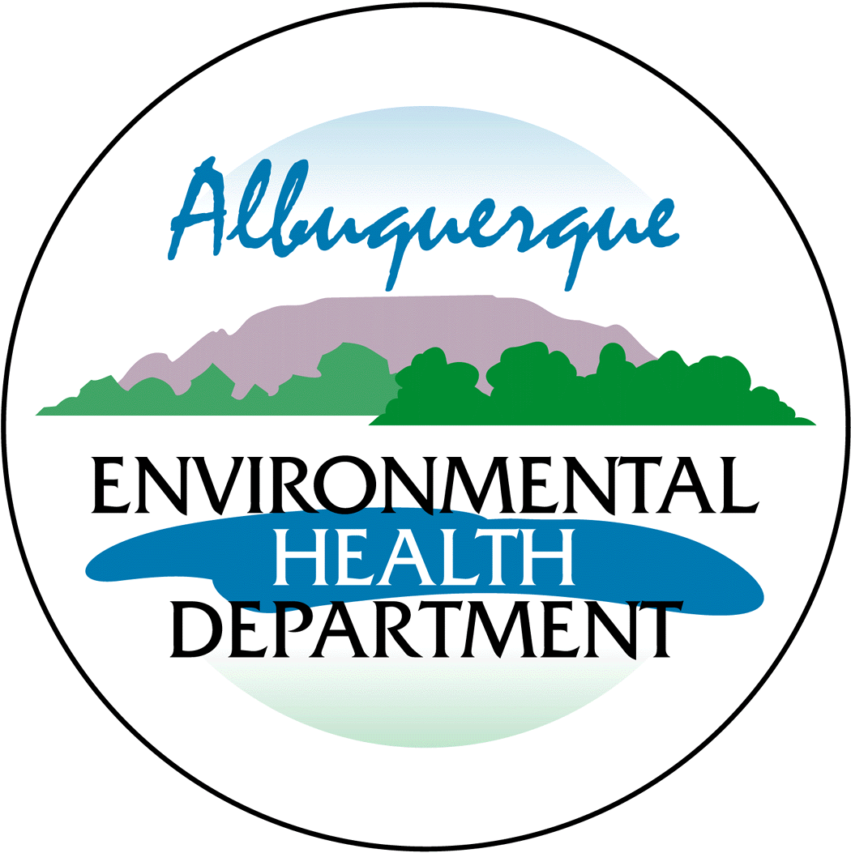
City of Albuquerque

Environmental Health Department

Air Quality Program

Public Notice Sign Guidelines

Any person seeking a permit under 20.11.41 NMAC, Authority-to-Construct Permits, shall do so by filing a written application with the Department. Prior to submitting an application, the applicant shall post and maintain a weather-proof sign provided by the department. The applicant shall keep the sign posted until the department takes final action on the permit application; if an applicant can establish to the department’s satisfaction that the applicant is prohibited by law from posting, at either location required, the department may waive the posting requirement and may impose different notification requirements. A copy of this form must be submitted with your application.

Applications that are ruled incomplete because of missing information will delay any determination or the issuance of the permit. The Department reserves the right to request additional relevant information prior to ruling the application complete in accordance with 20.11.41 NMAC.

Name: _____________________________________________________________
Contact:____________________________________________________________
Company/Business: __________________________________________________

⁯ □ The sign must be posted at the more visible of either the proposed or existing facility entrance (or, if approved in advance and in writing by the department, at another location on the property that is accessible to the public)

⁯ □ The sign shall be installed and maintained in a condition such that members of the public can easily view, access, and read the sign at all times.

⁯ □ The lower edge of the sign board should be mounted a minimum of 2’ above the existing ground surface to facilitate ease of viewing

⁯ □ Attach a picture of the completed, properly posted sign to this document

⁯ □ Check here if the department has waived the sign posting requirement.
Alternative public notice details:

