NextRequest Guide – REQUESTER | 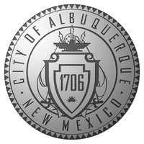

Work Instruction
CREATING A GUEST ACCOUNT FOR NEXTREQEST:
- Go to Abqrecords.cabq.gov
- Click on REQUEST A PUBLIC RECORD:
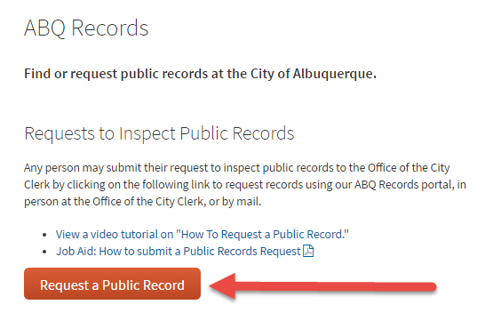
- Click MAKE REQUEST:
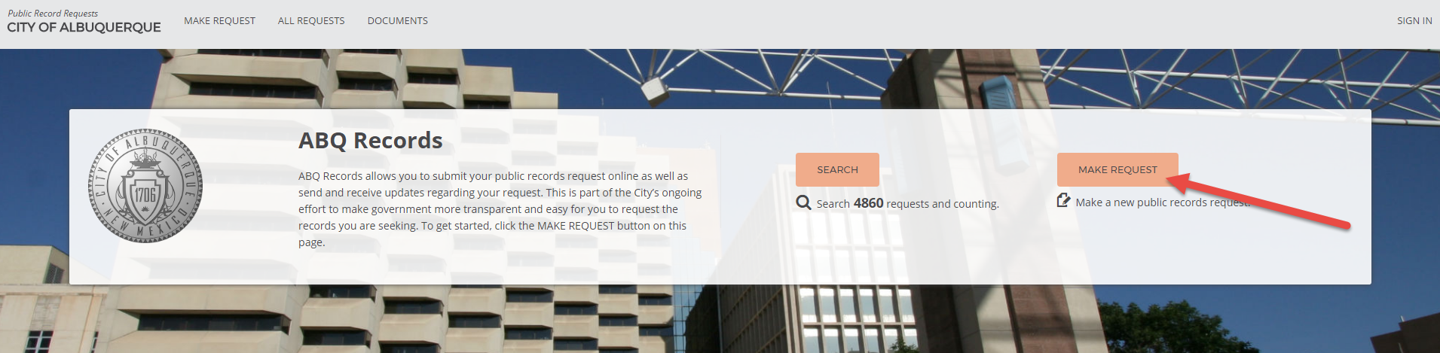
- Enter request on the MAKE REQUEST page:
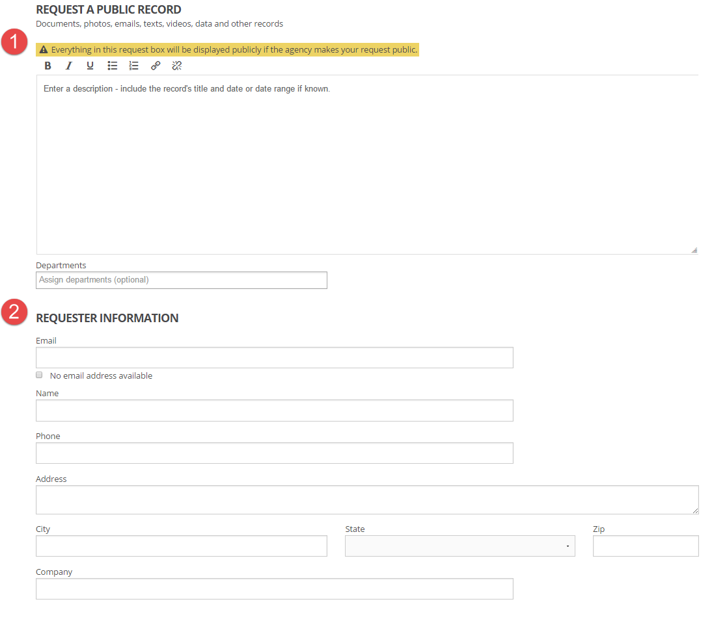

- Create your password:
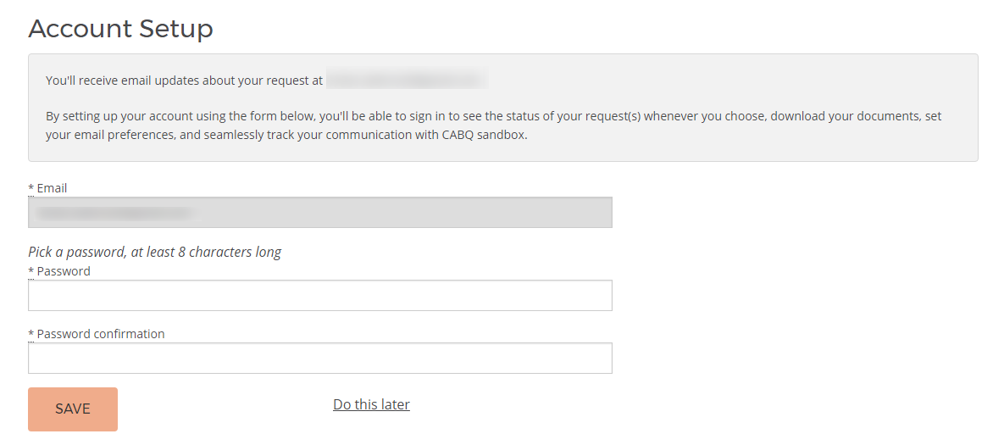

- Refer to your email to confirm email address:
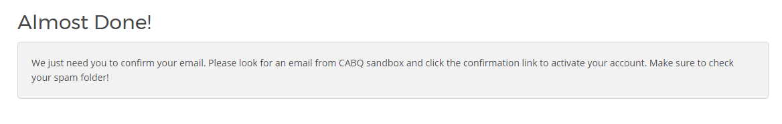

- Click on the CONFIRM MY ACCOUNT link:

- Enter your sign in you just created:
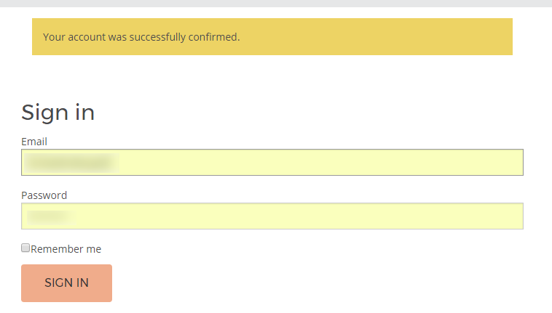

VIEWING YOUR REQUEST AND CORRESPONDENCE
- Refer to the notification in your email with the request ID, and click on the link with the request number:
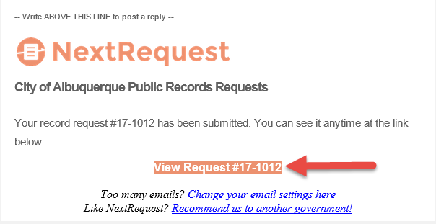

- Click SIGN IN to sign into your profile:
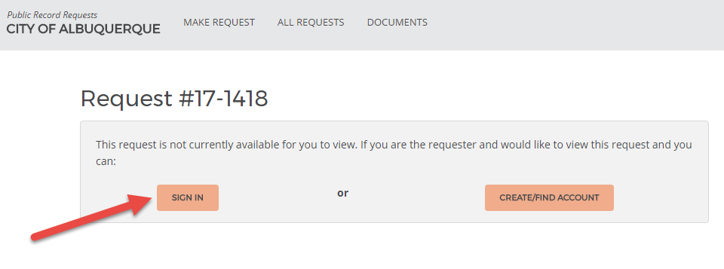

- Enter your email and password:
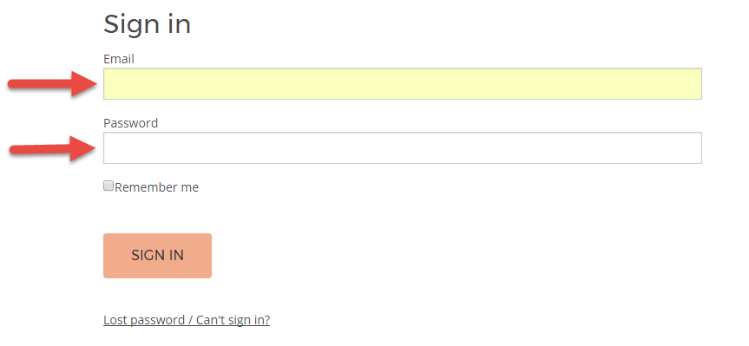
- Click SIGN IN:
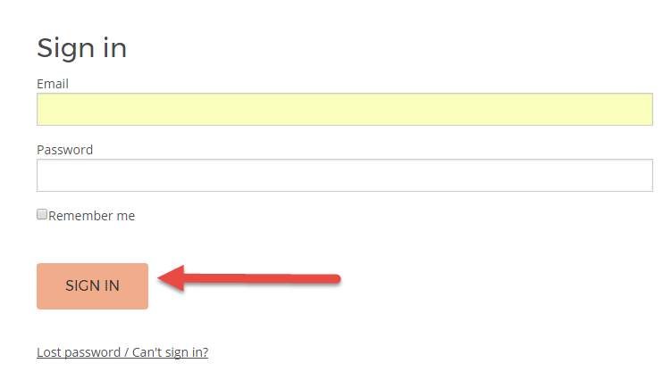
- View your request:
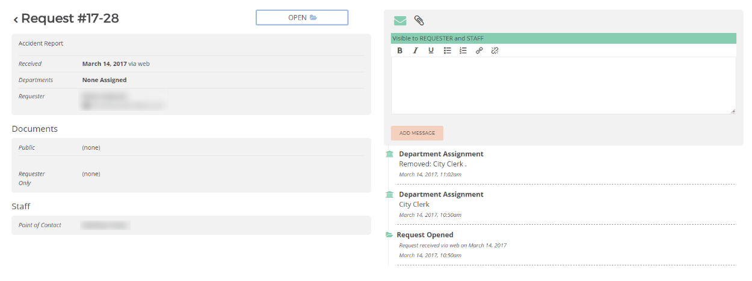
SEND A MESSAGE TO CITY OF ALBUQUERQUE RECORDS CUSTODIAN (STAFF)
- Click on the envelope icon:
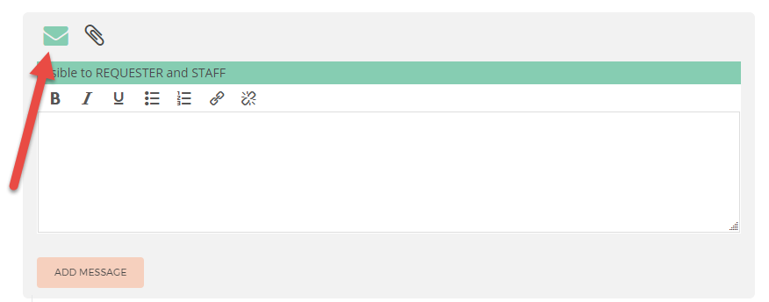
- Type your message:
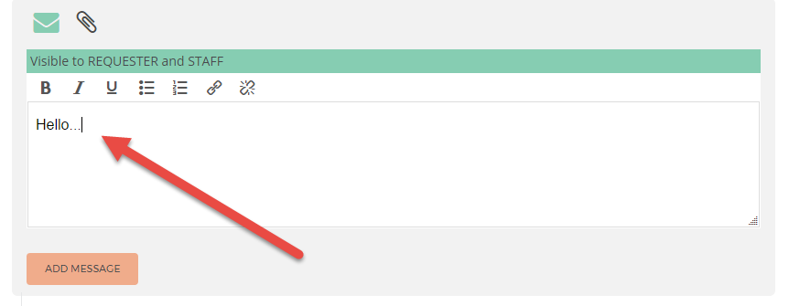

- Click ADD MESSAGE:
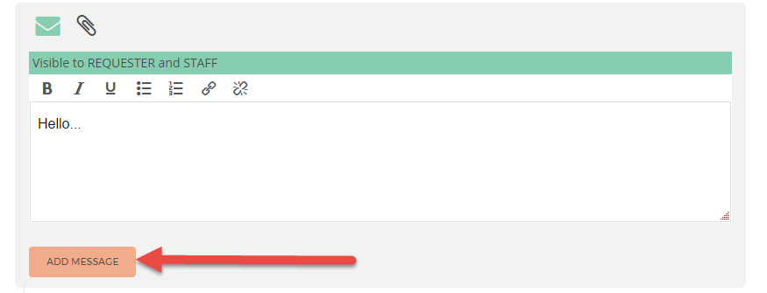
UPLOADING AN ATTACHMENT
- Click on the paperclip icon:
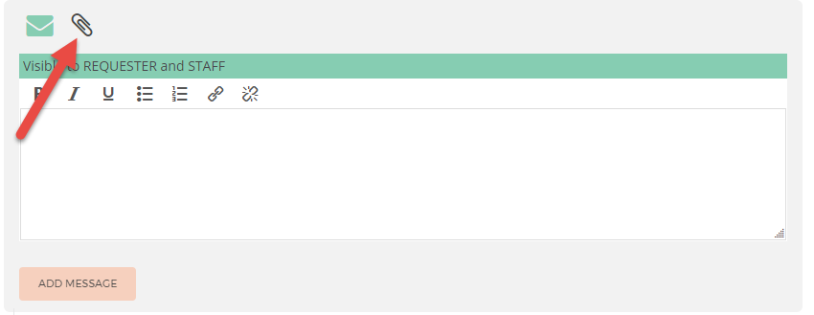

- Click UPLOAD FILES:
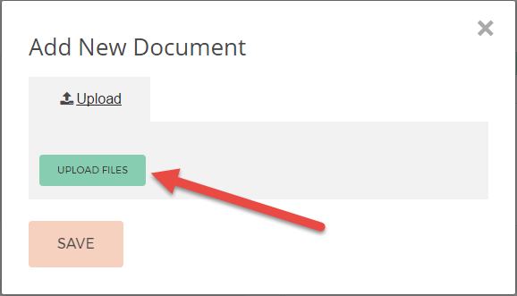

- Click on document that you want to attach from your library (operating systems may vary):

- Click SAVE:
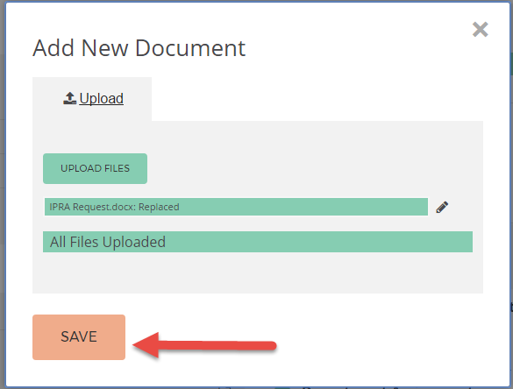

- Attachment will appear under the DOCUMENTS section:
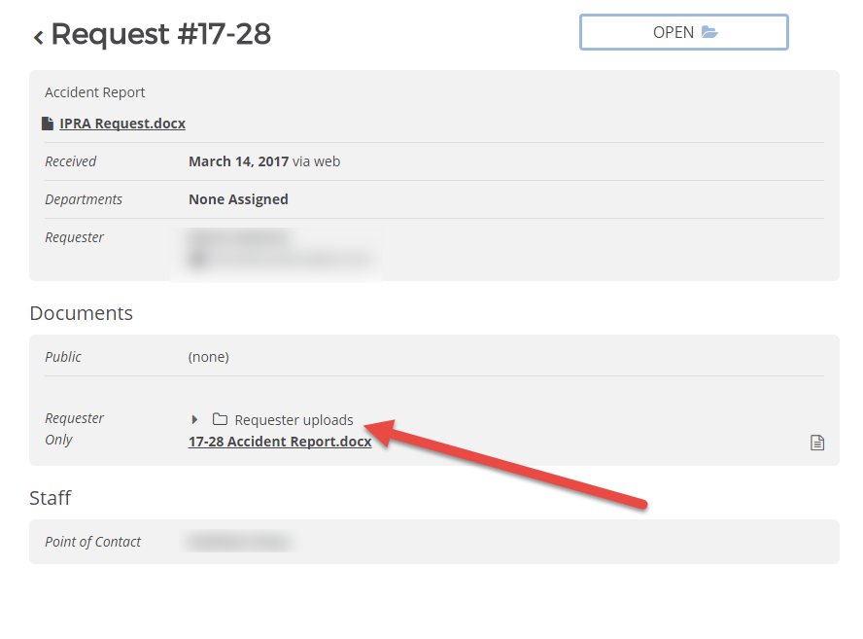

VIEWING RESPONSIVE RECORDS TO YOUR REQUEST
- Click on the link(s) to download the record under DOCUMENTS:
