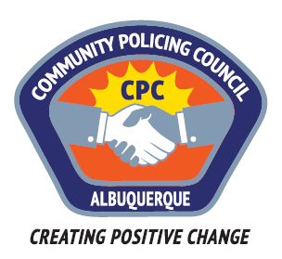

Valley Area Command Community Policing Council

AGENDA

August 24th, 2017

APD Training Center
5412 Second St. NW
Albuquerque, NM

6:00pm Call to Order
Determination of a Quorum
Approve Agenda
Approve June 22, 2017, Meeting Minutes

6:15pm Panel Discussion consisting of groups that have formed as a reaction in the downtown area and are looking for possible solutions.

7: 15pm Comments, questions, etc. for panelists and police.

8:00pm Meeting Adjourned

Next Meeting: September 26, 2017

