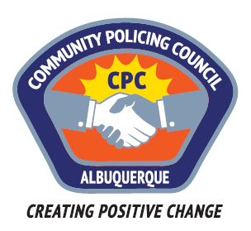
Valley Area Command Community Policing Council
AGENDA
March 23, 2017 6-8PM
APD Training Academy; 5412 2nd St NW
1. Call to order – Edwina Kiro
2. Roll call
3. Approval of agenda
4. Approval of minutes
5. Guest Speaker: Celina Espinoza; Director of Communications APD- Updates to the Community on APD’s Progress and new goals for the City concerning CASA

6. Q & A

7. Public Comment
8. Adjournment

Next meetings: April 27th, May 25th, June 22nd, July 27th, August 24th, Sep 28th, Oct 26th

