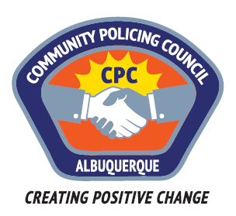
Southwest Area Command Community Policing Council
AGENDA
Wednesday, February 8, 2017
6:00pm – 7:30pm
Patrick J. Baca Library; 8081 Central Ave NW

1. Call to order – Michael Zocholl (interim Chair)
2. Roll call
3. New business: Guest speaker -Michelle Campbell: new APD Commander of the Southwest Area Command; Update on the Southwest area command and current operations

4. Open issues; Old Business
a. Removal of officers Michelle Campbell & Toby Gallegos as voting members (as per the new CPC guidelines officers and/or City employees cannot be voting members of a CPC board)
b. Michael Zocholl: Recommendation on house alarms
c. Future recommendations & guest speakers
5. Ed Harness-Civilian Police Oversight Agency update
6. Nicole Chavez-Lucero/Celina Espinoza- APD updates

7. Adjournment

***The council will adjourn to go into Executive session to interview two new applicants
Next meeting: Wednesday, March 8th 6-7:30PM

