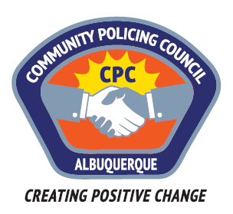

Valley Area Command Community Policing Council

AGENDA

June 22 , 2017

APD Training Center
5412 Second St. NW
Albuquerque, NM

6:00pm Call to Order
Determination of a Quorum
Approve Agenda
Approve May 25, 2017, Meeting Minutes

6:15pm Panel Discussion on “Immigrant Friendly Resolution and Police/Immigrant Relations”

Panel Members:
Isaac Benton, Chair of the ABQ City Council
Justice Remer-Thymer, Director of the NM Faith Coalition of Immigrant Justice;
Danile Vega, Faith Coalition Staff Member

7:45pm Discussion regarding CPC Recommendation

8:00pm Meeting Adjourned

Next Meeting: July 27: Police Service Aide Panel and other subject TBD

