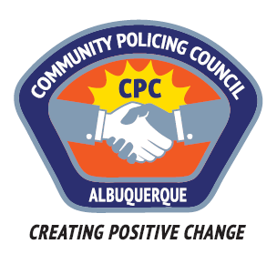

Foothills Area Command Community Policing Council

AGENDA

Monday 13 March 2017 6:00pm – 7:50pm
Holiday Park Community Center
11710 Comanche Road NE, Albuquerque, NM 87111
- Call to order—Carolyn Wilson, Chair
- Introductions of Council and Visitors
- Review/amendment/approval of Agenda
- Review/correction/approval of Minutes from February 13th meeting *
- APD Communications—
  - Report on crimes in the Foothills Crime Report from APD
  - Reports from Celina Espinoza and/or Nicole Chavez-Lucero
- Featured Speakers: Crime Prevention and School Safety
Presenter--Jill Garcia, Crime Prevention Specialist, Foothills Area Command
Panelists—Officer Mick Rael, School Resource Officer
A Foothills Field Officer (TBD)
- Pulse of the Neighborhoods—reports from CPC members and citizens
- Recommendations
- Other business
  - Recruitment of new CPC members
  - Recommendations for speakers
- Adjournment
Next meeting: Monday 10 April 2017 6-7:50 pm Holiday Park Community Center
Comments or questions:
Carolyn Wilson, CPC Chair (505) 710-6074 carowilson23@msn.com
Doug Brosveen, CPC Vice-Chair (505) 263-1022 dbrosveen@msn.com
Philip Crump, CPC Facilitator (505) 989-8558 philip@pcmediate.com

* Minutes of the prior CPC meeting are reviewed and approved via email and then posted at http://www.cabq.gov/police/community-policing-council/community-policing-council-minutes

