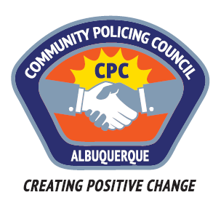

MEETING MINUTES
SOUTHWEST AREA COMMUNITY POLICING COUNCIL
Wednesday, September 13, 2017
6:00 PM
NORTH DOMINGO BACA MULTIGENERATIONAL CENTER
CLASSROOM 5
ALBUQUERQUE, NM

In Attendance:
- Michal Zocholl, Chair
- Don Burns – Co-Chair
- Jan Lapitz – Council Member
- Larry Lapitz - Council Member
- Mary Driscoll – Council Member
- Ron Kemp - APD crime presentation
- John Russo - Council Member
- Lt. Jenn Perez – APD
- Detective Whigham
- Celina Espinoza, APD Director of Communication
- Yvette Marentes, CPC Admin

Approximately ___ members of the public were in attendance.

- Call to Order
- Roll Call
- Approval of Agenda
- Approval of August minutes
- Crime Update * (APD)
- Old business
- New Business
- Budget
- Business Cards
- Ideas for recruiting new voting members
- New on Proposals
- Guest Speaker Body camera presentation
- Questions **
- Adjourn

* Relevant questions will be allowed during the report time with APD

** Public comments and questions are welcome following the presentation. Audience members will be limited to 2 minutes. Follow-up questions/comments will only be allowed after all audience members desiring to participate may do so.

